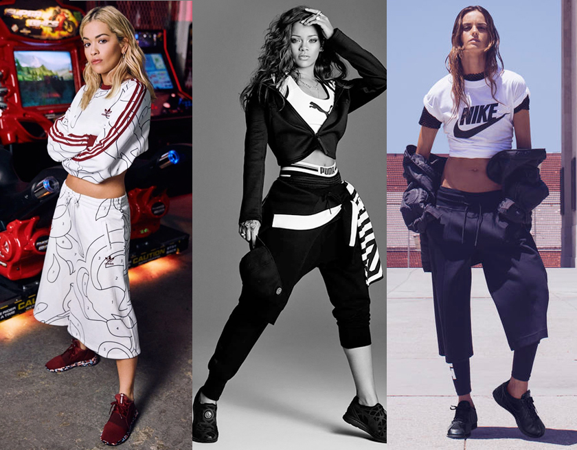

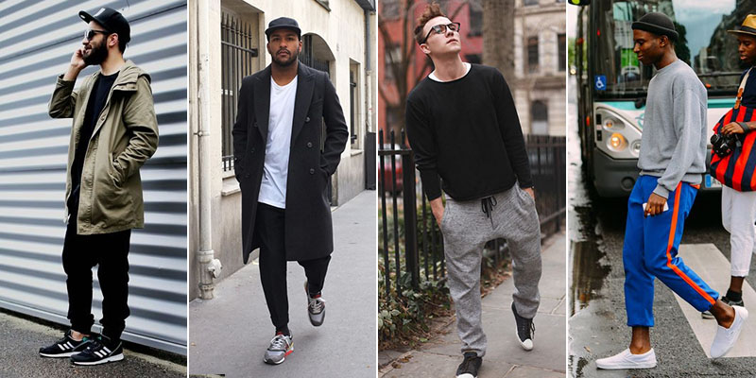

The global ‘athleisure’ boom
Corey Walters | Sales and Merchandise Management | 29/03/2018

Executive Summary
Athleisure wear is currently seeing a significant boom in the fashion industry, the purpose of this report will be to look at some of the reasons why this is, the report will show the reader how non-traditional fashion retailers have adapted to the athleisure trend and sportswear becoming fashionable, how brands must identify changing trends and who is an ‘athleisure wear consumer’ if they want to compete in the industry, how forecasting techniques such as trend and sales forecasting are critical to a brands success,. The report will show the reader why ‘In store experiences’ and a ‘store layout’ are important to consumers and how they have been implemented by retailers selling athleisure wear products, the report will look analyze whether social media has been a driving force behind the growth in athleisure looking at social media influencers and seeing if they have been a help or hinderance, the report will go on too look at how an organizations ethical processes can effect a consumers trust in a brand and finally the report will analyze whether the athleisure trend is just a fad or whether it is here to stay.

Table Of Contents
- Introduction ………………………………………..……...….. 3
- Sportswear becoming fashionable ………………..…….3/4
- Changing trends and the ‘athleisure consumer’ ………….…….…5/6
- The importance of Forecasting…………………………………….…….6/7
- ‘In store experiences’ a key marketing tool in the rise of athleisure?..............................................................................7
- Is a store Layout and atmosphere important to engaging consumers?............................................................................8
- Social Media, the driving force behind the athleisure rise?......9/10
- Social media influencers, help or hinderance?.........................10/12
- Have ethical processes been a part of the growth of athleisure wear brands?...................................................................................12/13
- Athleisure wear, just a fad or here to stay?.............................13/14
- Conclusion………………………………………………………………………14
- References………………………………………………………………………15/19
- Appendices……………………………………………………………………..20
Appendix 1…………………………………………………………………..20
Appendix 2…………………………………………………………………….21
Appendix 3……………………………………………………………………..22

- Introduction
One of the biggest trends in the fashion and retail worlds today is the rise of "athleisure" - athletic apparel that people can wear in non-athletic settings.” (Petro, 2015). There are a plethora of mitigating factors behind the rise of this trend, this report will critically evaluate the global ‘athleisure’ boom firstly looking at how sportswear has become fashionable and how the integration of active leisure wear has seen nontraditional retailers include sportswear in their outlets, it will go onto look at who is an athleisure consumer and how changing trends can disrupt the market, next the report will look at the importance of forecasting such as sales and trend forecasting and how these are vital for success in the athleisure wear sector, the report will look in depth at whether a store layout is important to engage consumers, Social media is a big influencer in many industries, this report will ask the question of if it has contributed to the growth of athleisure looking in depth at whether athleisure wear brands and retailers have adapted social media strategies which have contributed to the growth of the industry, strategies such as social media influencers, next the report will look at athleisure wear brands/retailers ethical process and whether these have had an impact on consumers perception/purchase intention. Finally, the report will look at the current situation of athleisure and analyze whether it is just a fad or whether it has potential to keep growing.

- Sportswear becoming fashionable
In recent years ‘athleisure wear’ has seen a surge in demand worldwide. One of the main reasons behind this is that “sportswear” has now become the new “streetwear” meaning that active wear has now become fashionable to wear for everyday attire “Sportswear and streetwear are merging, as designers and consumers alike are eluding traditional categorization within fashion” (Fenn,2017).
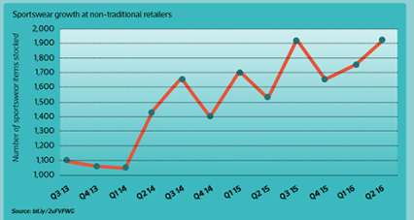
Figure 1- Sportswearat Non-traditional retailer’s graph

(CIM,2016)

Because of the integration of active and leisure wear, the clothing industry market has seen exponential growth in non-traditional retailers stocking sportswear in their outlets as seen in Figure 1 which shows a near 90% growth in sportswear stocked at non-traditional retailers from Quarter 3 in 2013 to quarter 2 in 2016. An example of this seen within the clothing retail industry is Levis where they recreated their womenswear jeans with etra stretch, Top Shop who collaborated with beyonce on its Ivy park athletic wear collection and retailers like New look, H&M and even sainsburys launching patterned yoga pants to take a bite of the market (Armstrong, 2016). The author would argue that with all the diverse retailers competing for a share of the market, supply could become excesive and with research showing consumers lifestyle demands change excessively this could cause a strain on the supply chain format “Changes in consumer lifestyle and consequent demands for newness have exerted pressure on the established chain formant. As we have moved into the twenty first century, retailers have shifted focus from competitive advantage from price towards fast respocse to changing fashion trends and consumer demands” (Barnes and Greenwood,2006, p 260). With the athleisure trend being a global phenomenon and with different types of retailers serving different market segments this can present many supply chain challenge due to its dynamic nature. “There is a strong tendancy for established brand retailers to use intergrated networks and for value brand retailrs to use non-intergrated forms often managed through retailer agesnts and current industry knowledge.”(Mcarthy and Jayarathne, 2012, p878). Some differing aspects can be established brand retailers in regards to the nature of the product will typically have prouducts with high complexity in operations and embellishments, whereas as value brand retailers typically hae proudcts with simle operations and much fewer embellishments.
3.0 Changing Trends and the ‘Athleisure’ consumer
With the athletic apparel industry currently going through a boom stage, industry leaders such as Nike and Adidas have identified which consumers are most lucrative and are going after them these include teens and Young women “Activewear now comprises 28% of teen’s apparel spending, women in their 20s and 30’s are largely driving the ‘athleisure trend’ in which customers buy leggings with the intent of wearing them to the gym, errands and brunch. “(Lutz, 2015). The fashion industry is always changing and retailers within this industry need to constantly keep up with current and future trends if they want to be successful “Todays fashion market is highly competitive and the constant need to ‘refresh’ product ranges means that there is an emergence of current trend merchandise and fashion retailers are encouraging consumers to visit their stores more frequently.” (Bhardwaj and Fairhurst, 2010, p166). An example of where this has been implemented by a fashion retailer would be JD sports where they have capitalized on the popularity on athleisure wear and have made themselves an attractive brand where the most on-trend products are available within store and as a result consumers are more inclined to visit stores more frequently “Exclusivity deals with brands especially, Nike and Adidas help JD to attract customers despite intense competition from online rivals and allow it to charge higher prices” (Sullivan, 2017). However, the brand in some cases has taken a “Here today, gone tomorrow” strategy with some of their products such as the Yeezyboost 350 trainer (refer to appendix 1) which had limited availability in certain stores in 2015. Some would argue that having limited availability deals like this would promote faster purchase decisions from consumers “Previous studies found that limited availability promotes consumer purchase decisions and reduces further search intention because of the intensified desire to acquire a product.” (Aggarwal and Vaidyanathan 2003; Ong 1999, cited in Byun and Sternquist, 2012, p223). However, caution must be taken and understanding their customers buying decisions and how these can be triggered, affected and disrupted must be taken. If all these steps are taken and a brand creates ‘product shortage’ sale which is strategically created it can prove to be a quite successful marketing technique. A study on fast-fashion examining consumers perception to scarce conditions, it was found that it promoted urgent buying decisions “Strategically scarce conditions should threaten consumer’s freedom to delay a buying decision, thus triggering psychological reactance and creating an urgency to buy the scarce product which precedes impulse buying behaviors (Gupta, 2013, p121). However, one disadvantage of using this sort of technique is that it can damage the customer loyalty relationship "By putting to much pressure on your customers to act, they may feel like that organizations are not letting them make their own choices. It Is guaranteed a sure-fire wat to break ties with loyal customers while manipulating new visitors.” (Johnson,2017)
- The importance of forecasting
As trends and consumer buying decisions are constantly changing within the fashion industry, the importance of forecasting is even more prevalent. Having a good forecasting system in place in retail inventory planning is a critical factor for companies especially in the fashion industry where overstocking or understocking due to bad forecasting can take place which can accumulate losses for the organization, one technique organizations cake is a sales forecasting approach which basically means estimating future sales of a product, this can prove to be a difficult task especially in the fashion industry “It is well argued that sales forecasting is a very difficult task in fashion retailing because fashion product’s demand is highly volatile with ever-changing taste of the consumers taste and the fashion products’ lifecycle is short.” (Liu et al, 2013, p1). Trend forecasting is another technique used where possible upcoming trends are identified through past sales or current market growth. In relation to the athleisure boom the bigger brands picked up on this trend through trend forecasting, for example Adidas created a new product line called adidas athletics which would bridge the gap between athlete’s style and fitness performance (Green, 2016). This was too competing with the already successful Nike sportswear. An example of missing of bad forecasting would be Under Armour as they missed the athletic apparels shift to more fashionable clothing and as a result stock tumbled 30% in 2017 “The company’s more technical clothing offerings were out of step with the lifestyle products desired by consumers and that as a result its ability to return to its former glory is unknown.” (Green, 2016). Research suggests that the athleisure trend is here to stay “The red-hot athleisure trend has led many retailers to unveil their own collections in recent years. Now there’s more evidence its not losing steam, demand for sport leisure styles surged 17% last year to $9.6 billion in sales” (Cheng, 2018). The author suggests that it will be the brands who can identify trends early and create innovative new products in this sector that will be the ones that succeed
- ‘In store experiences’ a key marketing tool in the rise of athleisure?
“Selling a product is incomplete without communicating its image. To build long term brand loyalty, in addition to the quality of the product, right image is very much needed. (Pillai et al, 2011, p2). As mentioned earlier some of the driving forces behind the rise of athleisure has been young women and teens. Research shows that people in the 18 to 35 brackets like to shop in a physical store “A new report suggests that contrary to popular assumptions millennial shoppers like going to stores a great deal, and 50% prefer going to them as a primary means of shopping.” (Klara, 2017). “Shopping behaviors and preferences are understood in the context of generational expectations and experiences” (Mooring, 2004, cited in Harris, Stiles and Durocher, 2011, p28) Research shows that millennials enjoy ‘experiences’ with brands and they seek ‘in store shopper moments’ “According to US millennial shoppers 2017 survey 82% of millennials say its important for retailer to have terrestrial stores, They desire brand and product interaction that can only be experienced in store.” (Davies, 2017). One of the industry leading athleisure brands has recently revolutionized the in-store experience by coming up with a new innovative concept of a digital retail experience where in store the “Nike boot room” (refer to appendix 2) is a holistic concept which enables consumers to experience products in a new way by providing information about boots on a digital screen where they can see products availability, comparative charts using RFID technology in combination with 3D cameras supporting user interaction. The author believes this is an excellent marketing technique to engage with consumers particularly millennials as they are known to be one of the most tech-savvy generations. Another innovative in store experience used by a recently new athleisure wear provider is the usage of smart mirrors (refer to appendix 3) at ralph Lauren outlets, smart mirrors allow customers to photo/video themselves in an outfit and try on different combinations like on a tablet but can see what the outfit would look like on themselves, in regards to positive aspects for the retailer, smart mirrors can gather information about a customers tastes and offer recommendations to buy other outfits in store which could potentially increase profitability for retailers, this could be lucrative for athleisure wear brans for example the smart mirror wile showing the customer wat a tracksuit would look like on them, could offer suggestions off trainers which would go with the outfit. Smart mirrors can also gain customers email addresses which can enhance engagement opportunities for future sales.

- Is a store Layout and atmosphere important to engaging consumers?
“Store atmospheric attributes (including color, lighting, sales personnel, music, etc.) form the overall context within which shoppers make decisions of shop selection and patronage, these attributes affect the image of a store.” (Singh, Katiyar and Verma, 2014, p15). One of the athleisure wear retailer which have become attuned to the need for a positive atmosphere in store are JD Sports in recent years they opened an outlet and changed their store layout to include a stylish floor, a mini department store feel to the store, Neon lighting and more technology such as large screens for potential customers to engage with, this gave the shop a buzz and energy which customers described as the store being more in tune with its target market where design and technology are high up on the agenda. They have let their brands have a real presence in store under the master JD brand. (Priestley,2014). This store layout has been replicated in other stores nationwide and as a result of letting brands particularly the athleisure wear section have a commanding presence within their stores JD Sports has seen significant revenue growth in recent years “The chain is benefiting from the current trend for ‘Athleisure’ clothes, revenue jumped 41% to £1.3 billion and profit rose 33% to £102.7 million” (Williams-Grut, 2017). In contrast to a positive store atmosphere and layout, a negative layout can have detrimental effects to an organization’s competitiveness within their sector. An example of this would be Sports direct where the layout of the store and the atmosphere has come under constant criticism “The quality of sports direct product offering is poor, and a great deal of a shopping experience is how things look when you enter the store, staff need to be proud and happy to work there. Never going to happen at Sports direct” (Stevens,2017). Even though Sports Direct sell similar products to JD sports and in some cases for a much-reduced price including athleisure wear, research shows that they have fallen behind in regards to market value “Sports Direct is now valued at £2.1bn by the stock exchange while JD is worth £2.2bn. Apart from negative publicity afflicting sports direct, JD is increasingly viewed as having superior product lines” (Goodley, 2016) , this proves the point that a good store layout and atmosphere is a key component in attracting customers to your store and influencing purchase intentions.

- Social Media, the driving force behind the athleisure rise?
“Marketing communication using social media such as twitter, Facebook and YouTube has already been evaluated as business take off tools for fashion brands” (Kim and Ko, 2012, p1480). Athleisure wear brands have used social media as an influencer to engage and connect with consumers quite extensively. Social media is also seen as a platform for new brands to build a following and become reputable within the industry and promote their products through the platform. An example of this where this has been done quite successfully within the athleisure wear market would be the rise of ‘Gymshark’, where they have capitalized on the recent popularity of stylish fitness apparel and have used social media successfully in creating a community feel about the brand. Gym shark initiated a strategy of using social media particularly using brand ambassadors for the company particularly those with large followers on platforms such as Instagram and YouTube where they could be seen wearing ‘gymshark’ products. “Gymshark teams up with fitness people/channels that have vast numbers of followers, it allows them to reach a large number of people with their advertising at just a fraction of the cost” (Haemers, 2016, p30). Figure 2 illustrates the gym shark strategy into a graph:
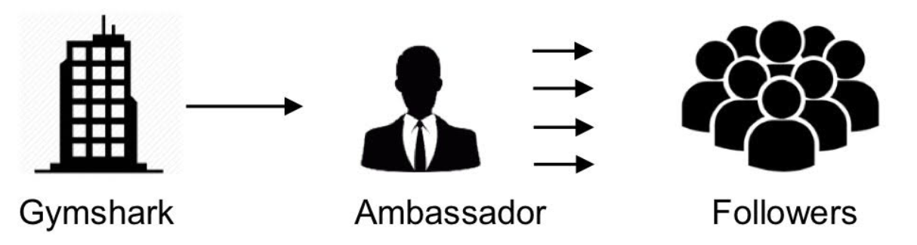
Figure 2- Gymshark Brand Ambassador strategy

(Haemers, 2016)
The way they gymshark became very lucrative and successful in the fitness apparel industry was that they created more than just a brand, they put an emphasis on creating a community including ambassadors which could do the work for them for a relatively low price, which as a result saved costs which could be used to invest more into the company. In recent years many brands have used social media marketing activities to enhance customer equity. According to Lemon et al. (2001) cited in Ivanauskiene and Aurskeviciene (2010) “customer equity is described as discounted sum of life-time value of existing potential customers of an organization, customer equity concept encourages organizations to consider customers the major source of current and future cash flows and customer life-time value is a key goal of marketing strategy” (Ivanauskiene and Auruskeviciene, 2010, p541). In recent years fashion brands including athleisure wears providers such as Nike and adidas have used their social media platforms not only to advertise their products on, but as a way to engage with consumers, they achieve this by posting daily update and compelling and engaging materials, which can be commented on, shared and liked by their vast range of followers, research shows that strategies such as this have a positive effect on customer equity “It is indicated that fashion brands marketing activity using social media platforms entertains customers by offering a free variety of contents as well as social network activity, and enables customized information searching” ( Kim and Co, 2012 ,p1483). In contrast to this sometimes-social media can have a negative effect on a brands image, for example in the food industry, McDonalds to tap into the use of hashtags on the social media platform twitter by using the hashtag #McDstories to engage with followers and promote farmer stories that give a positive image of the brand. However, twitter users began hijacking the hashtag and use it to create a negative image of the brand by sharing bad service, quality problems, the hashtag is still in use today “McDonalds had paid for the privilege of having their hashtag promoted on the twitter homepage, but they quickly realized this wasn’t helping their brand” (Hill,2012). An example of an athleisure wear brand using social media to engage with followers, but it having a negative impact would be Nike, in 2011 as a way to engage with consumers Nike would regularly post fun facts on the social media platform Facebook, one of these updates was “Fact: Friends don’t let friends wear shoes with five toes, however this caused outrage as it was found a large portion of the Nike audience on social media have tried those type of shoes and respect the innovation” (Bishop, 2011). With all things considered the author believes that social media can be used in a variety of different ways such as engaging with potential, current and future customers, however caution must be taken as a bad post or update on one of these platforms can create a negative brand image and sometimes these perceptions are hard to rectify
- Social media influencers, help or hinderance?
Another marketing tool which has become quite prevalent in recent year especially within the athleisure wear sector would be the use of social media influencers as a marketing strategy used by organizations to promote their brand. “Influencer marketing concentrates on working with key leaders in the market, leaders which can decode and forward the marketing message of the brand to their followers” (Gashi, 2017, p7). One of the more popular type of leaders used as an influencer are celebrities, the reason why they are used as that in some cases they have a significant number of followers and their perception of a brand and them being affiliated with a brand through can have massive effects on consumer engagement/purchase decisions. “Social media influencers are known as third parties which through their recommendations. images and other content they share on social media, these can heavily affect consumers opinions, attitudes and actions and as a result effect their purchase decisions.” (Uzunoglu and Kip, 2014; Szigmigin and Piacentini, 2015 cited in Gashi, 2017, p8). An example of where this has been implemented would be Adidas linking with superstar model Kendal Jenner where she has promotes the brand on social media. This is quite a lucrative partnership for Adidas as Jenner is known for being one of the most famous social media influencers in the world which as a result can bring a significant amount on potential new consumers for the adidas brand. Another type of leader used as an influencer are people known as social media influencer, a social media influence is a person who has established themselves on a particular or multiple social media platforms who has a large audience and can endorse a brands product which can influence their audience into purchase intention/decisions. Shrimp (2008) cited in Lim, Radzol, Chea and Wong (2017) stressed that “A match up between an endorser and the brand is the most fundamental goal in achieving consumers purchase intention. Thus, a perfect match will significantly strengthen the advertising results” (Shrimp, 2008 cited in Lim, Radzol, Chea and Wong, 2017, p23). An example of where this has been used in the athleisure sector is smaller brands such as ‘Outdoor voices’ to stand out from bigger competitors like Nike they adopted a new approach “By using social media influencers on Instagram they show their followers how their brand clothing helps them achieve their clothes, they know their target market are busy parents so they use influencers who match up to this” (Borza, 2017). The author believes this a very well thought out marketing technique by identifying their customers and using influencers who match up, this will make their followers be able to resonate with the brand more, it is also quite a good technique to use Instagram to showcase the brand as because of the visual nature of the platform and these social media influencers being known as ‘instafmous’ research has shown that having products endorsed on that particular platforms by influencers has positive effects on consumer behavior towards the brand “Instafamous users possess visibility and popularity similar to traditional celebrities, but also appear more relatable to consumers because they live typically normal lives, therefore they can be very effective ambassadors for the brands looking to increase their awareness on the social media sphere” (Neal, 2017, p7). However, in contrast to this not everyone agrees that social media influencers have a positive effect on the brands image. A recent research study initiated by Prize promotion agency in the UK found that influencer marketing campaigns actually damages public perceptions of brands “The report entitled ‘Under the influence’ found that 44% thought it was damaging to society, 61% brands were not being transparent about their use of influencers while another 61% felt that boastful social media influencers don’t have to disclose they are being paid to affiliate with a brand” (Griggs, 2018). This shows that sometimes issues such as transparency and boastful influencers can be a hinderance to a brand trying to promote themselves positively, therefore it is important when undertaking this type of marketing campaign that organization be as transparent as possible with the public and ensure they choose an influencer who is a good match for their brand and can showcase it positively.
- Have ethical processes been a part of the growth of athleisure wear brands?
“Research has shown that ethical perceptions affect consumer loyalty towards retailers and brands” (Diallo, Lambey-Checchin, 2015, p435). This shows that having good ethical process in all areas of the business is an important factor in both retaining customers and creating new ones. Organizations who show they have good ethics from things like treatment of staff, making sure they don’t harm the local environment through their manufacturing process etc. If an organization is able to do this then they create trust between themselves and the consumer “Trust is one of the most significant predictors of loyalty, customer perceptions of ethical behavior influence trust directly.” (Valenzuela et al, 2010 cited in Diallo, Lambey-Checchin, 205, p438). An example of where good ethics has been used by a small athleisure wear brand is Vyayama who produce eco-activewear with an emphasis on yoga apparel, they have shown that they have good ethics by firstly making their products ecofriendly and also ensuring that their manufacturing facility does not harm the local environment “Vyayama is based in New York City and manufactures from Portugal, promising a clean internal water treatment system within their facility that in no way negatively impacts their local environment.” (Fallon, 2017). However in contrast to good ethics creating a positive brand image, an example of where bad publicity in regards to ethics have created a bad image to an athleisure wear brand would be the allegations of child labor and sweatshops, and have been criticized for outsourcing manufacturing to the lowest cost countries to keep prices down with conditions inside the factories inhumane “Workers at a Nike converse shoe factory in Indonesia say they are being physically and mentally abused, workers at the sukambi plant, about 60 miles from Jakarta, say supervisors frequently throw shoes at them, slap them in the face, kick them and call them dogs and pigs” (Mail Online, 2011). Bad publicity such as this can have disastrous effects of the general publics perception of a brand which as a result can have a negative effect on purchase intention and customer loyalty. However, since this article came out Nike have taken steps to improve their ethical processes and have changed their image in the public sphere “Nike has successfully transformed its tarnished image to become a recognized sustainability leader and footwear company for environmental and social performance, including its labor record” (Robertson, 2017). The author believes it is a critical component for brands who want to succeed in the athleisure wear industry to maintain good ethical processes and the ones who have shown this have proved to be successful and have contributed to the growth of athleisure wear in general. The author believes that as the majority of brands that sell athleisure wear products try to maintain ethical processes it has contributed towards the growth of the industry because consumers are more aware of how their shopping habits can have on the environment and the consensus from the general public is that they are more likely to choose from brands they believe are have good ethics “Research shows that a third of consumers are now choosing to buy from brands they believe are doing social or environmental good”(Chiswick, 2017).
- Athleisure wear, just a fad or here to stay?
There has been much debate about whether athleisure is just another fashion fad or whether it is here to stay long term. Some would argue that it is not just a trend it is a fundamental shift in the fashion industry such as Todd Snyder, the former head of menswear at J. Crew where he thinks “Athleisure is an “evolution” as opposed to a trend or a fad, people have changed the way they dress, athleisure is not going to go away for at least 10 years” (Green, 2017). However others would disagree and believe that athleisure has run its course and will slowly disintegrate it’s way out of the fashion industry market with other trends possibly making a comeback, Quo Vadis Capital founder John zolidis is quoted saying “ The athleisure fashion trend came to a screeching halt at the beginning of 2018, analysists believe that the athleisure cycles is moving past its peak and ‘denim’ has started to make resurgence” (Green, 2017). The author suggests that currently the athleisure wear sector has a dominant position within the fashion industry, however if it wants to continue to grow in the long-term brands will have to be creative and create innovative products which entice an everchanging consumer to buy them, another important factor will be creating engaging marketing content which will raise awareness of athleisure to the mass market.
- Conclusion
The athleisure wear sector of the fashion industry has seen significant growth in recent years, this report began by looking at how sportswear has become fashionable in recent years it was found that there was 90% growth in sportswear sold at non-traditional retailers from 2013 to 2016 some of the reasons non-traditional retailers seen the rise of this trend and wanted a bite of the market so included athleisure wear products within their stores. Leading athleisure wear brands such as Nike and Adidas identified lucrative athleisure wear consumers such as teens and young women, JD has also capitalized on the popularity of the trend and has introduced the most attractive athleisure wear products in their stores. Forecasting techniques such as trend and sales forecasting are important factors as not to over or understock which is prevalent in the fashion industry, some of the bigger brands such as Adidas picked up on the athleisure trend early and introduced their own line called ‘adidas athletics’. Providing ‘In store experiences are just important to consumers as the products they are buying, ways in which brands have introduced these experiences In their outlets are innovative ideas such as smart mirrors. A store layout is also important to engage consumers, JD has picked up on this and used attractive neon lighting and more technology for consumers to engage with in store. Social media has been a driving force behind the rise of athleisure wear for example the brand “Gymshark” has used social media as a way to engage with consumers and create a community which has proved very successful, social media influencers such as ‘instafamous’ users have proved successful marketing tools for brands to use. Having good ethical processes has proved to increase the publics trust in a brand and as a create a positive brand image. Finally much debate has been over whether athleisure is a fad or here to stay, the general consensus is that it will be around for a while longer and if brands keep identifying what consumers want and are able to create innovative athleisure wear products the trend will be here potentially over a much longer term.

- References
Armstrong, A. (2016). The rise of athleisure: how the high street is cashing in on office-to-gym wear. [online] The Telegraph. Available at: https://www.telegraph.co.uk/business/2016/09/17/the-rise-of-athleisure-how-the-high-street-is-cashing-in-on-offi/ [Accessed 25 Feb. 2018].
Barnes, L. and Greenwood, G. (2006). Impact of Product Variety on Supply Chain in Fast Fashion Apparel Industry. Journal of Fashion Marketing and Management, 10(3), p.260.
Bhardwaj, V. and Fairhurst, A. (2010). Fast fashion: response to changes in the fashion industry. [Article] DOI: 10.1080/09593960903498300, The International Review of Retail Distribution and Consumer Research.
Bishop, T. (2011). Nike Running: A Social Media Mistake. [online] MyLeftOne. Available at: https://myleftone.com/2011/09/20/nike-running-a-social-media-mistake/ [Accessed 16 Mar. 2018].
Borza, E. (2017). Lessons from Athleisure: How Small Brands Can Use Instagram Influencers | Makerâ€™s Row Blog. [online] Makerâ€™s Row Blog. Available at: https://makersrow.com/blog/2017/03/how-small-brands-use-instagram-influencers/ [Accessed 19 Mar. 2018].
Byun, S. and Sternquist, B. (2012). Here Today, Gone Tomorrow: Consumer Reactions to Perceived Limited Availability. The Journal of Marketing Theory and Practice, [online] 20(2), p.223. Available at: http://dx.doi.org/10.2753/mtp1069-6679200207 [Accessed 1 Mar. 2018].
Cheng, A. (2018). Here are some more signs athleisure trend still has legs. [online] Forbes.com. Available at: https://www.forbes.com/sites/andriacheng/2018/02/09/here-are-some-more-signs-athleisure-trend-still-has-legs/ [Accessed 5 Mar. 2018].
Chiswick, G. (2017). Ethical Shopping: Are We Really on Board? [online] HuffPost UK. Available at: https://www.huffingtonpost.co.uk/guy-chiswick/ethical-shopping-are-we-r_b_18329650.html[Accessed 20 Mar. 2018].
CIM. (2018). Infographic â€“Â the global athleisure boom. [online] Available at: https://exchange.cim.co.uk/infographic/the-global-athleisure-boom/ [Accessed 8 Mar. 2018].
Davies, B. (2017). Fashion and the Millennial Shopper - Medallion Retail. [online] Medallion Retail. Available at: https://medallionretail.com/fashion-and-the-millennial-shopper/ [Accessed 7 Mar. 2018].
Diallo, M. and Lambey-Checchin, C. (2015). Consumers€™ Perceptions of Retail Business Ethics and Loyalty to the Retailer: The Moderating Role of Social Discount Practices. Journal of Business Ethics, [online] 141(3), pp.435-438. Available at: http://dx.doi.org/10.1007/s10551-015-2663-8 [Accessed 20 Mar. 2018].
Fallon, L. (2017) 5 Empowering Activewear Brands to Shop at Instead of Lulemon. Available at: http:/verilymag.com/2017/03/ethical-athleisure-companies-satva-manduka {Accessed 20 Mar. 2018}
Fenn, D. (2017). How sportswear became the new streetwear. [online] global blue. Available at: http://www.globalblue.com/destinations/germany/berlin/how-sportswear-became-the-new-streetwear [Accessed 22 Feb. 2018].
Gashi, L. (2017). Social media influencers â€“why we cannot ignore them an exploratory study about how consumers perceive the influence of social media influencers during the different stages of the purchase decision process. MSc.
Goodley, S. (2016). Sports Direct falls behind JD Sports as bad publicity takes its toll. [online] the Guardian. Available at: https://www.theguardian.com/business/2016/mar/24/sports-direct-falls-behind-jd-sports-as-bad-publicity-takes-its-toll [Accessed 10 Mar. 2018].
Green, D. (2016). Adidas is launching a new athleisure line to take on Nike. [online] Business Insider. Available at: http://uk.businessinsider.com/adidas-is-launching-a-new-athleisure-line-to-take-on-nike-2016-9 [Accessed 8 Mar. 2018].
Green, D. (2016). Under Armour is still paying for a mistake that will take years to fix. [online] Business Insider. Available at: http://uk.businessinsider.com/under-armour-still-facing-problems-2017-5 [Accessed 20 Mar.2018].
Green, D. (2017). Athleisure is not just a trend â€” it's a fundamental shift in how Americans dress. [online] Business Insider. Available at: http://uk.businessinsider.com/athleisure-is-more-than-a-trend-2017-2?r=US [Accessed 20 Mar. 2018].
Green, D. (2017). Millennials have a new shopping preference that should terrify Lululemon and Athleta. [online] Business Insider. Available at: http://uk.businessinsider.com/athleisure-is-dying-2017-8 [Accessed 20 Mar. 2018].
Griggs, I. (2018). Influencer marketing damages public's perception of brands, survey finds. [online] Campaignlive.co.uk. Available at: https://www.campaignlive.co.uk/article/influencer-marketing-damages-publics-perception-brands-survey-finds/1457318 [Accessed 19 Mar. 2018].
Gupta, S. (2013). The Psychological Effects of Perceived Scarcity on Consumers€™ Buying Behaviour. Ph.D. University of Nebraska-Lincoln.
Haemers, I. (2016). Success Story of a Young Fitness Brand: Social Media influence as an indicator of success in the fitness industry. MSc. Universitat de Barcelona.
Harris, K., Stiles, J. and Durocher, J. (2011). How does visual merchandising affect consumer affective response? [Review] http://digitalcommons.fiu.edu/cgi/viewcontent.cgi?article=1501&context=hospitalityreview.
Hill, K. (2012). McDStories: When A Hashtag Becomes A Bashtag. [online] Forbes.com. Available at: https://www.forbes.com/sites/kashmirhill/2012/01/24/mcdstories-when-a-hashtag-becomes-a-bashtag/ [Accessed 16 Mar. 2018].
Ivanauskiene, N. and Auruskeviciene, V. (2010). Customer Equity Model from Customer and Organisation Perspective. Lithuania, p.541.
Johnson, C. (2017). How Not to Use Scarcity Marketing. [online] Business 2 Community. Available at:https://www.business2community.com/marketing/not-use-scarcity-marketing-01832485 [Accessed 2 Mar. 2018].
Kim, A. and Ko, E. (2012). Do social media marketing activities enhance customer equity? An empirical study of luxury fashion brand. Journal of Business Research, [online] 65(10), pp.1480-1486. Available at: http://dx.doi.org/10.1016/j.jbusres.2011.10.014 [Accessed 12 Mar. 2018].
Klara, R. (2017) Contrary to Popular Belief, Millennial Shoppers Actually Like Going to Brick-and-Mortar Stores. Available at : http://www.adweek.com/brand-marketing/contrary-to-popular-belief-millennial-shoppers-actually-like-going-to-brick-and-mortar-stores/ {Accsessed 6 Mar.2018}
Lim, X., Radzol, A., Chea, A., Wong, M (2017). The Impact of Social Media Influencers on Purchase Intention and the Mediation Effect of Customer Attitude. Asian Journal of Business Research,7(2), p23.
Liu, N., Ren, S., Choi, T., Hui, C. and Ng, S. (2013). Sales Forecasting for Fashion Retailing Service Industry: A Review. [Article] http://dx.doi.org/10.1155/2013/738675, Volume 23. P.1.
Lutz, A. (2015). Athletic wear companies are going after these 3 types of people. [online] Business Insider. Available at: http://uk.businessinsider.com/athletic-apparel-companies-customers-2015-3?r=US [Accessed 27 Feb. 2018].
MacCarthy, B. and Jayarathne, P. (2012). Supply network structures in the international clothing industry: differences across retailer types. International Journal of Operations & Production Management, [online] 33(7), p.878. Available at: http://dx.doi.org/10.1108/ijopm-12-2011-0478 [Accessed 25 Feb. 2018].
Mail Online. (2011). Nike workers 'kicked, slapped and verbally abused' at factories making Converse. [online] Available at: http://www.dailymail.co.uk/news/article-2014325/Nike-workers-kicked-slapped-verbally-abused-factories-making-Converse-line-Indonesia.html [Accessed 20 Mar. 2018].
Neal, M. (2017). Instagram Influencers: The Effects of Sponsorship on Follower Engagement with Fitness Instagram Celebrities. MSc. Rochester institute of technology.
Petro, G. (2015). Forbes Welcome. [online] Forbes.com. Available at: https://www.forbes.com/sites/gregpetro/2015/09/16/lululemon-nike-and-the-rise-of-athleisure/ [Accessed 26 Feb. 2018].
Pillai, R., Iqbal, A., Umer, H., Maqbool, A. and Sunil, N. (2011). Design, effectiveness and role of visual merchandising in creating customer appeal. [Paper]https://mpra.ub.uni-muenchen.de/30365/, Bahrain.
Priestley, H. (2014). JD Sports Takes Shopper Marketing Up A Level with Flagship Store | The Market Creative. [online] The Market Creative. Available at: https://themarketcreative.com/jd-sports-takes-shopper-marketing-up-a-level-with-flagship-store/ [Accessed 9 Mar. 2018].
Robertson, L. (2017). How Ethical is Nike? [online] Goodonyou.eco. Available at: https://goodonyou.eco/how-ethical-is-nike/ [Accessed 28 Mar. 2018].
Singh, P., Kativar, N. and Verma, G. (2014). Retail Shop ability: The Impact of Store Atmospherics & Store Layout on Consumer Buying Patterns. International Journal Of scientific research, 3(8), p.15.
Stevens, B. (2017). Exclusive: 77% of people think Sports Direct can never become the â€œSelfridges of sport€. [online] Retail Gazette. Available at: https://www.retailgazette.co.uk/blog/2017/10/77-people-think-sports-direct-can-never-become-the-selfridges-of-sport/ [Accessed 10 Mar. 2018].
Sullivan, C. (2017). JD Sports profits propelled by fashion for sportswear. [online] Ft.com. Available at: https://www.ft.com/content/baf5b2ae-1e82-11e7-a454-ab04428977f9 [Accessed 28 Feb. 2018].
Williams-Grut, O. (2017). The 'Athleisure' fashion trend helped JD Sports boost sales 41%. [online] Business Insider. Available at: http://uk.businessinsider.com/jd-sports-interim-results-revenue-profit-up-athleisure-2017-9 [Accessed 10 Mar. 2018].

- Appendices
Appendix 1
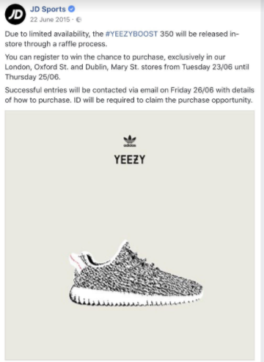
JD Limited availability Yeezyboost 350 trainer ad

Appendix 2
Nike Boot room experience
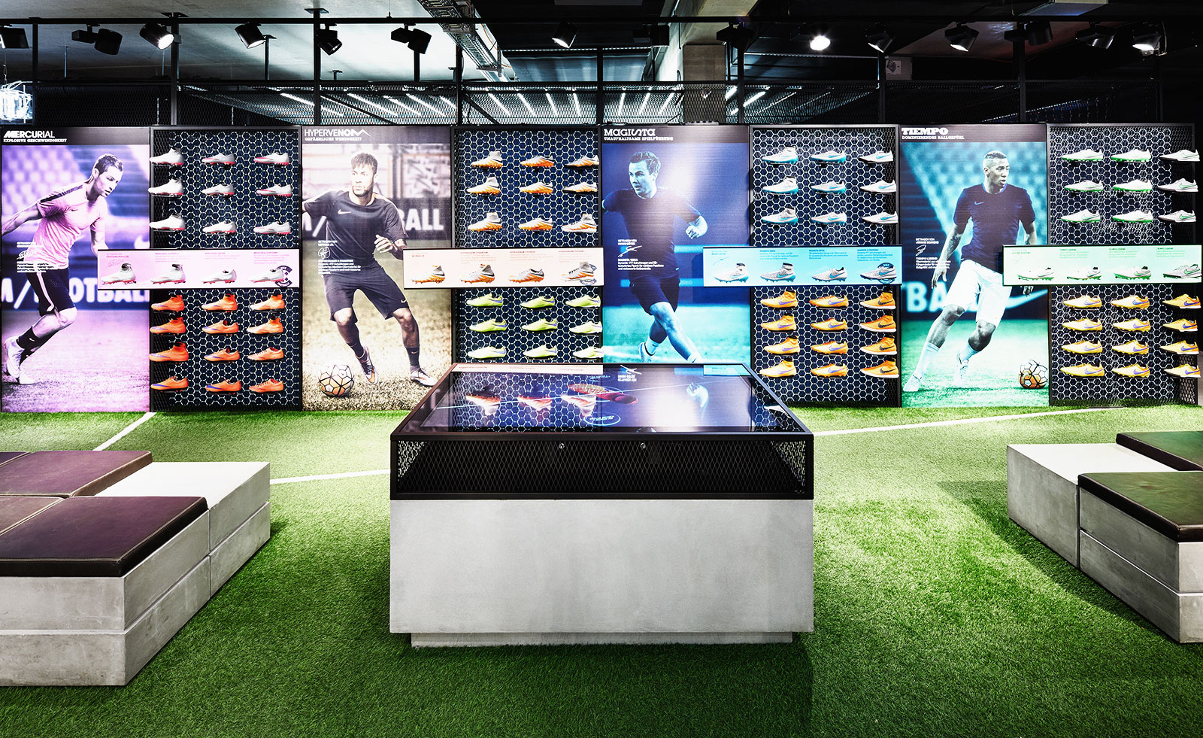

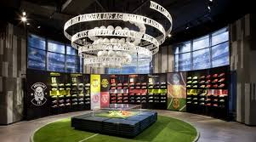
Appendix 3
Ralph Lauren Smart Mirrors


