Transition Handbook

A Practical Guide for Transition into the Nursery Setting

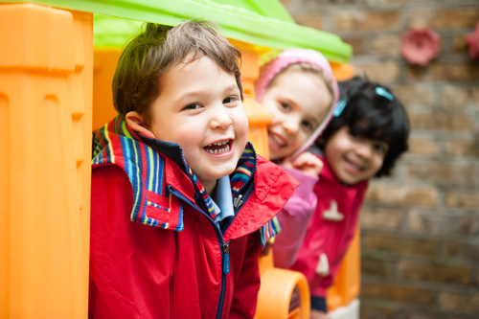
Hopes and Dreams Montessori Nursery (2016)

CONTENTS PAGE
- Introduction
- Aims and Outcomes
- A Smooth Transition Process
- Attachment and relationships
- Learning and Development
- The Importance of Play
- Inclusion
- Safeguarding

Introduction
This handbook is for the use of any staff member working within the Early Years Foundation Phase classes. Its purpose is to act as a guide for any practitioner who becomes involved, or has contact, with the Nursery children joining the combined Nursery and Reception class at Spittal V.C. School. The aim of the handbook is to help staff create a smooth transition for each individual and their families in order to obtain the best outcome for each learner with a focus on building relationships with families and the individual. In addition, it should also help to maintain consistency between staff with the aim of creating a secure foundation from which the child can grow and develop from their experiences, (Waller and Davis ed. 2014).
It is important to recognise the impact a transition can have on a child at any stage of their life (Children's Workforce Development Council, 2010). Bronfennbrenner (cited in Brooker, 2008) states that transitions can have a significant and long term effect on the development of a child. There is a need to provide support for the child, parents and caregivers around each child from all professionals within the setting that they have contact with. It can be a challenging time but with careful management it can be a smooth process ultimately leading to the best outcome for each individual child (Department for Education and Employment, 2010).

Aims and Outcomes
The aim for staff members is to help each individual child feel happy, self-confident and secure in their new setting by providing positive attitudes and a sense of belonging, (DfEE, 2010). This is also supported by Brostrom, (2002) cited in Brooker,(2008) who states that a child needs to feel 'suitable' within a school through a sense of well-being and belonging. Brooker (2008) goes further by explaining the '3 R's' which stand for resilience, resourcefulness and reciprocity as suitable outcomes following a transition, by empowering individuals to be strong and competent and able to handle new experiences with confidence.

A Smooth Transition Process
What is a transition?
A transition is any change to a child's usual environment or role within that environment, (Children's Workforce Development Council, 2010). This handbook specifically refers to the transition into the Nursery at age 3 into a joint Nursery and Reception Class. Some children may be transitioning from a playgroup or childminder but for some it may be their first time separating from their primary caregiver and going from home into a group learning setting which will be discussed in further detail in the following chapters.
Communication Links
Communication is crucial to aid a child's success when transitioning, this is carried out through links with home, the child's family and other settings working together in partnership. Without this cooperation from all involved in the child's life their experience will become disjointed and may result in a lack of progress in their developmental learning (Waller and Davis, (2014). CWDC, (2010) and CfEE, (2010) both agree that in order to provide a suitable environment in which children can grow and learn, professionals must communicate effectively with parents and children, to build trust, develop positive relationships and show mutual respect for each other.
All members of staff play a vital role in this communication both directly and indirectly and there are school procedures put in place to help deal with this in an effective manner.
- The class teacher acts as key worker to their pupils and will discuss any issues that may arise with the parent, either at the end of the school day or by setting up a meeting as necessary.
- If you have any concerns that you feel need discussing further, raise them first with the class teacher, then alternatively you can speak to the deputy head or the head teacher.
- All pupils have a home/school contact book in which both teachers, LSA's and parents can communicate through on a daily basis regarding any needs of the child that need to be met.
- Every week a school newsletter is sent home to all families so that they feel involved in the school community.
- A text message service is available from the office when there is a change of events.
- Parents can now communicate with their child's class teacher instantly through an online class dojo messaging service.
- In the event of any urgent communication needed, for example, a head injury, then a parent must be contacted by telephone immediately.

The Needs of the Child
Tickell (2011) reports that each child is unique and has individual needs that should be taken into consideration within the Early Years setting. Professionals should understand the different ways in which children learn and tailor activities to suit the needs of the individual.
Therefore, it is important to understand the children that you are working with. All children that enter the setting will have provided a comprehensive Nursery induction form that asks parents to provide an extensive description of the things that play an important role or are significant to that child's life. Take the time to familiarise yourself with this key information, such as, significant people in that child's life, toys or games they enjoy, fears or anxieties, familiar places they go. All of this key information from their primary caregiver who knows them best will help to build up a picture of the individual and enable you to meet their needs in the Nursery setting.
If the needs of the child can be met through working in partnership then this will help aid a smooth transition as supported by Waller and Davis, (2014). As well as communicating with parents, the school also has close links with the local playgroup and arranges 5-6 visits throughout the year which are very beneficial to familiarise the newcomers to the setting and the staff, (CWDC, 2010). It is a good chance to start building positive relationships with the new Nursery children that will be shortly arriving at the setting. Take the time to introduce yourself, be friendly and approachable, provide suitable age appropriate games and activities. Be positive and encouraging and give praise where you can. All of these actions will help the child build a positive attachment to the setting and to the key workers within the class.
Bowlby's studies of Attachment theory, (1969)(cited in Crawley, 2014) are significant to the process of transitions in many ways. Firstly, Bowlby's theory suggests that infants are predisposed to display an attachment behaviour to a primary carer, usually a mother or father, who will provide safety and security. This is because as an infant we are predominantly helpless and we have the instinct of survival. This bond needs to be reciprocal in order to develop a secure attachment and are therefore able to recreate the attachment process again in the future through this model of behaviour. Research suggests (Bowlby, 1973, 1980; Ainsworth et al. 1978 as cited in Crawley 2014) that if this early attachment is not formed and a negative experience is developed then attachment issues will develop in future relationships. This will result in the child being unable to recreate a positive attachment, it can affect their confidence and self-reliance and feelings of trust.
For a child that has not yet had the experience of leaving their parent or primary care giver, they may find it incredibly difficult at first and need more reassurance than other children who have been in another early years setting. Through patience and support for the child and the parent involved you can help them both to ease into their new roles and to participate within the new class (CWDC, 2010).
It is important for the child to develop a bond of attachment with staff and key workers at the setting by developing a rapport with the individual, so that they are able to feel safe, secure, confident and develop independence. This is done by a number of ways of effective communication appropriate to the age of the child (CWDC, 2010) which will be discussed further in the next chapter.

Learning and Development
There are many different aspects of learning and development to consider through which adult-child interactions and relationships with the individual learner play an integral role. The importance of forming bonds and attachments with the child is the key to their progress and development. For ease of reading this will be broken down into sections, however, the Early Years Foundation Phase (2010) takes a holistic approach to child development, which means you must consider the whole child through all developmental areas, and these are all interwoven and inseparable. You cannot consider one without the other, development in all areas occurs in each child continuously, and at seemingly different rates per individual. These different stages of development do not happen in isolation from each other but they are all linked (Doherty and Hughes, 2014).

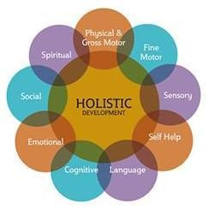
Holistic Development (date unknown)

The aim of this diagram is to remind you to consider the whole child in your approach to learning and development and not to focus on one key element at a time. We are looking to develop a happy, confident, and independent child through all areas of development.
The Welsh Assembly Government (cited in Crawley 2014) has provided a framework that includes seven areas of learning which are as follows;
- Personal and Social development, well being and cultural diversity
- Language, literacy and communication skills
- Mathematical development
- Welsh language development
- Knowledge and understanding of the world
- Physical development
- Creative development
It is widely recognised the importance of 'play' as a key role in children's learning (Crawley, 2014; Welsh Assembly Government, 2002; Play Wales, 2016) and as such it is now a huge part of the Early Years Foundation Phase curriculum.

The Importance of Play
In the Play Policy Wales set out by the Welsh Assembly Government, (2002) it states that children have an innate instinct to play and it is extremely beneficial to every child's development, it is how we grow our social interactions and learn about our surrounding environment and culture. Every child must be given opportunities to learn through play. There are now many theories surrounding learning through play.
Tickell, (2011) suggests in her report that there should be opportunities for adult- led as well as child initiated play within the classroom and the outdoors. This follows Vygotsky idea, (cited in Crawley, 2014) of the zone of proximal development that suggests that children learn though observation as well as experience.
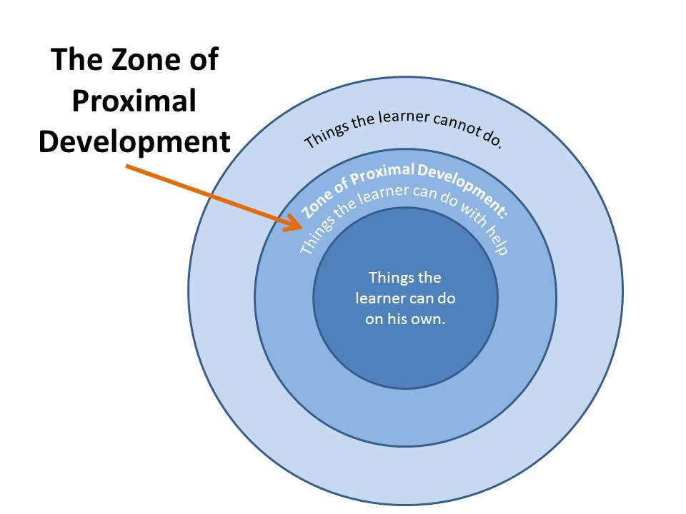
In practical application this model suggests that you are to work alongside a child to assist in their learning, acting as 'scaffolding' (Bruner, 1974-75;1983 cited in Crawley 2014) until they are capable of completing a task independently and no longer need your guidance. For example building a block of towers with help until they can join the blocks themselves.
Other theorists such as Piaget (cited in Crawley 2014) and Montessori, (Hopes and Dreams Montessori Nursery, 2016) believe that children play an active role in their own learning and the adult or professional should act as facilitator to the child. That through giving them a rich environment and the correct tools for experimentation and exploration they are able to direct their own learning. The child should feel comfortable to take calculates risks and make mistakes within the safety of a secure environment. Be sure to stand back and allow the individual to make mistakes they can learn from as long as they are not causing danger to themselves or others.
They value the voice of the child being recognised as a valid opinion and by being active in the decision making process of their own learning they are able to feel empowered and grow their self-esteem and gain confidence in their own influence of their environment. This is known as agency. A key worker can facilitate this through communication with the individual and employ a tool known as sustained shared thinking. During interactions with the child they are to encourage a dialogue with the child of what they are doing trying to achieve and facilitating a train of thought. (Crawley,2014).

Inclusion
The Early Years Foundation Phase curriculum guidance (DfEE, 2010) states that no child should be excluded and there should be an atmosphere of inclusion to every child in order to create a sense of belonging and understanding. Steps should be taken to ensure all children have a good outcome and feel part of a class. If you are working with a particular individual who may find class involvement difficult you may need to give them a bit of extra support to help them feel confident to take part in class activities. Remain calm and speak in a clear voice to communicate with them.

Safeguarding Children
Safeguarding is an integral part of working with children and vulnerable people and we have a duty of care to the child involved, (CWDC, 2010). If a child discloses information to you or you have any other concerns you have a duty of responsibility to report it. School policies are in place so that you are aware of what action to take. In the first instance you can speak to the class teacher or line manager, ie, head teacher. If you are not comfortable to do so there is a Safeguarding board in the staff room which has all the details you will need, including relevant forms and phone numbers for you to contact the local services and authorities personally. CWDC, (2010) promotes the cooperation of multiagency which means that schools and any other services that an individual comes into contact with are able to communicate and work together for the consistency and benefit of the child.

Reference List

Brooker, L. (2008) Supporting Transitions in the early Years [online] Mcgraw - Hill Education, Uk https://books.google.co.uk/books?hl=en&lr=&id=GtxEBgAAQBAJ&oi=fnd&pg=PP1&dq=transition+to+nursery+early+years+theories&ots=3F3B9nUjti&sig=VCWoj59W30I614_MCDEu6tAw8OU#v=onepage&q=transition%20to%20nursery%20early%20years%20theories&f=false [Accessed: 24/10/2017]
Children's Workforce Development Council, (2010) Common Core of Skills and Knowledge for the Children's Workforce [Accessed online] http://moodle.uwtsd.ac.uk/pluginfile.php/86466/mod_resource/content/1/Common%20core%20of%20skills%20and%20knowledge%20for%20the%20childrens%20workforce.pdf [Accessed:29/10/2017]
Crowley, K. (2017) Child Development, a practical introduction. 2nd edn. London: Sage Publications LTD
Department for Education and Employment, (2010) 'Curriculum Guidance for the Foundation Stage, Principles for Early Years Education' [Accessed online] London; Qualifications and Curriculum Authority http://moodle.uwtsd.ac.uk/pluginfile.php/86492/mod_resource/content/1/Curriculum-guidance-for-the-foundation-stage-Principles-for-early-years-education.pdf [Accessed: 24/10/2017]
Doherty, J. and Hughes, M. (2014) Child Development Theory and Practice 0-11.(2nd edn.) Harlow: Pearson Education Limited
Holistic Development (date unknown) https://www.google.co.uk/search?tbm=isch&q=holistic+approach+early+years+diagram&chips=q:holistic+approach+early+years+diagram,online_chips:holistic+development&sa=X&ved=0ahUKEwiYg5CH_6HXAhUDBsAKHTXKAfcQ4lYIKSgD&biw=1366&bih=662&dpr=1#imgrc=mrvVKjawTFg0eM: [Accessed: 1/11/2017]
Hopes and Dreams Montessori Nursery (2016) Having Fun In Our Garden [online] https://www.hopesanddreams.co.uk/ [Accessed: 29/10/2017]
Play Wales (2016) 'Promoting physical activity through play in Early Years settings' [Accessed online] http://moodle.uwtsd.ac.uk/pluginfile.php/86479/mod_resource/content/1/play.pdf [Accessed: 2/11/2017]

Tickell, C. (2011) The Early Years Foundations for Life, Health and Learning. [Accessed online] http://dera.ioe.ac.uk/14796/7/The%20Early%20Years%20Foundations%20for%20life%20health%20and%20learning_Redacted.pdf [Accessed: 1/11/17]
Waller, T. and Davis, G. (ed.) (2014) An Introduction to Early Childhood. London: Sage Publications Ltd.
Welsh Assembly Government, (2002) Welsh Assembly Government's Play Policy [Accessed online] Crown Copyright http://moodle.uwtsd.ac.uk/pluginfile.php/86481/mod_resource/content/1/playpolicye.pdf [Accessed: 18/10/2017]

