BMSW4004
Problem Solving and Decision making

Student ID:2026346
Student name:RAZVAN-BOGDAN-TRUFIA

Table of Contents
Task 1 Presentation 3
Task 2 Report 17
Introduction 17
Nature and impact of absenteeism 17
PESTLE analysis 18
Political factors 18
Economic factors 19
Social factors 19
Technological factors 19
Legal factors 19
Environmental factors 20
Cause-and-effect analysis 20
Problem identification 20
Main cause 21
Solutions for absenteeism 22
Attendance policy 22
Good attendance award 22
Flexible work schedule 23
Reduce workplace stress 23
Fostering team culture 23
Confirming uniform work distribution 23
Conclusion 23
References 24

Task 1 Presentation

Generally, absenteeism refers to absence from duty or absence in the workplace frequently without good reason is absenteeism (Araujo, et al 2019). It is a stressful situation for all who are involved. The absence of a worker has a vast effect that impacts the team's workload and management. It occurs when a worker does not attend the workplace due to time. Lots of factors work behind absenteeism such as illness, family emergency, workplace harassment, or any other reason. Organizations face huge losses because of absenteeism.

It is very crucial for an organization to know which type of absenteeism occurs in the organization. An organization that can quickly identify the type of absenteeism will be able to reduce it quickly. There are various types of absenteeism such as authorized absenteeism, unauthorized absenteeism, wilful absenteeism, absenteeism caused by circumstance, etc. (Markussen, et al 2011).

After analysing absenteeism it is found there are mainly two types of factors is behind absenteeism. One is workers' personal reasons and another is professional reasons and both have a vast impact on workers. Personal factors are illness, family emergencies, depression, injuries, childcare, eldercare, stress, burnout, and low morale. Due to one of these issues workers may be unable to go to work. Professional factors are over-utilization, workplace harassment, fewer opportunities for professional growth, bullying, low compensation, poor supervision etc. (Kocakulahet, al 2016). The HR department should give high attention to these issues.

The effects of absenteeism on the workplace are huge. It damages productivity, overall morale, and finance. But it depends on the organization's size, employees, and employee’s roles. However, each organization can realize the effects of absenteeism. It is common in each organization for absenteeism to increase costs. When absenteeism occurs in the organization, the authority replaces that worker. For new recruits costs are increased. The absence of a single employee impacts the productivity of the entire team and organizations face low productivity (Eriksen,et al 2016). In addition, it demotivates the employees. Absenteeism leads to lower consumer satisfaction because it deteriorates the product or service quality.

As absenteeism lowers the organization's growth, so the organization should calculate the absenteeism rate.1.5% absence rate is a healthy rate while above 4% is indicates a high absenteeism rate. To calculate an employee's absence rate organizations have to take the number of unexcused absences during a period of time then divide it by the total period finally, to get a percentage it has to multiply by one hundred (Wang, et al 2017).

A certain rate of absenteeism brings some positivity to an organization. Generally, a 1.5% of absenteeism rate is a healthy absenteeism rate. So it has some advantages such as it brings discipline to the organization. As a result, employees' work efficiency increases. It motivates employees and improves the training system. In addition, it helps to make a better absenteeism policy (Mikami, et al 2017).

A hospital is a health care institution, where people go to take medical care. So it is a sensitive place. If absenteeism occurs its consequence is very terrible. It provides low-quality services which lead to low consumer satisfaction. There are lots of key factors that encourage absenteeism in hospitals such as poor working conditions, excessive work pressure, emotional burden, concern about health safety, occupational hazards, etc. (Marques, et al 2015). Employees of the hospital are impacted by absenteeism. Which is seen in employees' performance. Absenteeism forces low productivity, fewer skills, reduction in motivation, and low morale.

Absenteeism at the hospital is very fatal and impacts daily activities. It hampers the organization's reputation and brings low consumers satisfaction. Basically, when absenteeism occurs it increases organization costs and on the other hand, provides poor quality of service. In hospitals sometimes because of absenteeism death rate goes high rate. Lack of coordination is seen in various departments (Kottwitz, et al 2018). The most important thing is it creates low morale among the worker. In a word, it creates an indiscipline situation.

A PESTLE analysis is an effective tool that helps to identify the macro-environmental factors of an organization. PESTLE stands for Political, environmental, Social, Technological, Legal, economic, factors (Lee, at al 2014). It helps an organization to fix strategy and systematic evaluation of a business's prospects, risks, and opportunities. In the case of, absenteeism PESTLE analysis helps to find which macro-environmental factors contribute to the complex problem. Political factors affect labour law, corruption, and change in drug importing policy. As a result, hospitals face a huge problem in human resources management, and because of corruption chaos is seen everywhere. Change in drug policy also affects organizations' normal operations. Economic factors are consumer confidence, infrastructural development, increase costs. Low consumer confidence hampers an organization's reputation which has a vast impact on the organization. It hampers the economic growth of an organization. Low acceptance, increase in the mortality rate, negative attitudes are social factors. Excess dependency on technology and risk of technical are appeared in organizations because of absenteeism. For hospitals, waste management is a very important environmental factor.

Fish bone analysis on absenteeism helps to identify reasons behind the absenteeism. Actually, fishbone diagram is a visualization tool for grading the potential causes of a problem (King et al 2020). By analysing fishbone diagram a clear concept is appear about the reasons of absenteeism in the Mid Cheshire Hospitals NHS Foundation Trust (MCHT).

Flexible work schedule, good attendance award, reduce workplace stress, fostering team culture, confirming uniform work distribution, allocating resources proactively etc. are the Solution for absenteeism (Badubi, 2017) . By implementing those strategy the Mid Cheshire Hospitals NHS Foundation Trust (MCHT), can reduce absenteeism.

Absenteeism plays a profound financial effect on an organization. Absenteeism also plays a vast impact on the service of hospitals. However, it is not possible to solve a hundred percent absenteeism but some initiatives can keep it at a minimum level. To reduce absenteeism Mid Cheshire Hospitals NHS Foundation Trust (MCHT) should apply these strategies such as attendance policy, making flexible work schedules, awarding, confirming uniform work distribution, fostering team culture. After implementing those strategies to reduce absenteeism this organization should monitor how staff reacts to those strategies

Task 2 Report

Introduction
It is very common seen for an HR manager to find one or two empty seats for employees in the workplace. As an HR manager one may approve the leave application of an employee so that this employee can have some time for personal needs(Ticharwa, et al 2019). But often it is seen in various organizations that without any prior notice employees are absent in the workplace. It may acceptable in some circumstances. If such kind of absence rises at a high rate and regularly, it becomes an issue. This issue is known as absenteeism. Generally, absenteeism refers to absence from duty or absence in the workplace frequently without good reason (Markussen, et al 2011). It is a stressful situation for all who are involved. The absence of a worker has a vast effect that impacts the team's workload and management. It is really hard to go to work each day. So organizations accept this reality and follow some leave policies for workers. Absenteeism occurs when a worker does not attend the workplace in due time. For organizations, it is a matter of serious concern because it leads to low morale among employees and low productivity. Lots of factors work behind absenteeism such as illness, family emergency, workplace harassment, or any other reason. Organizations face huge losses because of absenteeism.

Nature and impact of absenteeism
Generally, 1.5% absence rate is considered a healthy rate but it turns alarming when it goes above 4%(Eskildsen, et al 2021). It is very crucial for an HR manager to know which type of absenteeism occurs in the organization. An organization that can quickly identify the type of absenteeism will be able to reduce it quickly. There are various types of absenteeism but the most common are four types absenteeism such as authorized absenteeism, unauthorized absenteeism, wilful absenteeism, absenteeism caused by circumstance. After analyzing absenteeism it is found there are mainly two types of factors is behind absenteeism. One is workers' personal reasons and another is professional reasons and both have a vast impact on workers(Gangai16, 2016). Personal factors are illness, family emergencies, depression, injuries, childcare, eldercare, stress, burnout, and low morale. Due to any of these issues a worker might not go to work. Professional factors are over-utilization, workplace harassment, fewer opportunities for professional growth, bullying, low compensation, poor supervision, etc. The HR department has to give high attention to these issues. What will happen if absenteeism occurs in the hospital? A hospital is a health care institution, where people go to take medical care. So it is a sensitive place. If absenteeism occurs its consequence is very terrible. It provides low-quality services which lead to low consumer satisfaction. There are lots of key factors that encourage absenteeism in hospitals such as poor working conditions, excessive work pressure, emotional burden, concern about health safety, occupational hazards, etc. Employees of the hospital are impacted by absenteeism which is seen in employees' performance. Absenteeism forces low productivity, fewer skills, reduction in motivation, and low morale. Absenteeism at the hospital is very fatal and impacts daily activities. Basically, when absenteeism occurs it increases organization costs and on the other hand, provides poor quality of service (Kocakulah,et al 2016). In hospitals sometimes because of absenteeism death rate goes high rate. Lack of coordination is seen in various departments. The most important thing is it creates low morale among the worker. When absenteeism occurs in the hospital, sometimes the authority replaces that worker to reduce work pressure. New recruit leads to extra costs because the organization pays the salary of both new staff as well as staff who is absent. The absence of a single employee impacts the productivity of the entire team and an organization like a hospital face excessive pressure on the patient. Employees face a huge workload. On the other hand, patients do not get the required service. In fact, absenteeism demotivates the employees and deteriorates the product or service quality(Mudaly, et al 2015).

PESTLE analysis
A PESTLE analysis is an effective tool that helps to identify the macro-environmental factors of an organization. PESTLE stands for Political, environmental, Social, Technological, Legal, economic factors (Perera, 2017).It helps an organization to fix strategy and systematic evaluation of a business's prospects, risks, and opportunities. In the case of, absenteeism in hospital PESTLE analysis helps to find which macro-environmental factors contribute to the complex problem.

Political factors
Political factors indicate how the authority of the government interferes with a country's economy. The key points of political factors are tax policy, environmental law, labour law, tariffs, trade restrictions, and political stability(Hartmann, et al 2018). An organization like a hospital is also influenced by political factors. Labour law, change in trade police especially drug importing policy, corruption among authorities greatly hampers a hospital's regular activity. And it turns more terrible when absenteeism arises among the hospital’s employees. It increases costs and deteriorates hospitals' services and reputations.

Economic factors
The economic situation of any country greatly affects any type of organization. So a hospital is also affected by economic factors. Economic factors are included exchange rate, inflation, interest rate, economic growth and decline, labour cost, cost of living, consumer confidence, etc(Lee,et al 2014). An issue like absenteeism has a vast impact on the economy because it increases costs, lower consumers’ confidence and hampers infrastructural development.

Social factors
Those factors that affect people's lifestyles are social factors. It also affects decision-making. Social factors are related to the culture and demographic trends of society. Various social norms are key to identifying consumers' attitudes. So health Consciousness, attitudes, cultural aspects & perception, populations’ growth rates, etc. are factors to be considered. When absenteeism is seen in a hospital it greatly affects patient attitudes because of absenteeism hospital is unable to provide quality service(Miraglia,et al 2021). It is often seen because of absenteeism mortality rate goes high in hospital. As a result, the patient showed negative attitudes and the hospital faces low acceptance.

Technological factors
Technological factors play a significant role in hospitals. Technological factors include research and development activity, technological incentives, automation, logistics support, information and communication resources etc.(Rastogi, et al 2016). Absenteeism forces hospital authorities to depend on various technology more to maintain communication with the patient sometimes showing a negative result. Moreover, any type of flaw in technology may increase more difficulties.

Legal factors
There is often uncertainty appears in legal factors. Changing existing laws or introducing new laws forces organizations to bring change in daily activity. Health and safety, consumer rights and laws, Employment laws, equal opportunities, Regulations and standards are legal factors(Rastogi, et al 2016). If a hospital does not have any absenteeism policy this hospital will face problems with action against absenteeism. Authority must have knowledge about regulations and standards as well as employment laws.

Environmental factors
Environmental factors consider the effect of the organization on the surrounding environment and ecological impacts on the organization. Environment protection laws, energy consumption, pollution, disposal laws are included in environmental factors(Shtal, et al 2018). Each of the hospitals gives high attention to waste management. But often because of absenteeism hospitals could not manage waste which is very harmful to patients and staff.

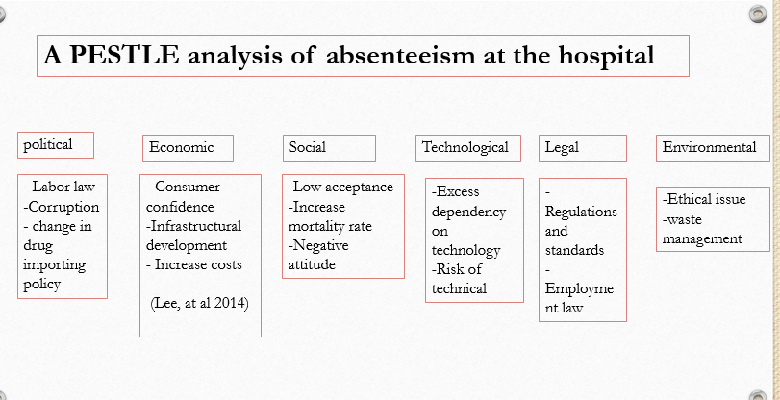
Figure 1 PESTLE analysis

Cause-and-effect analysis

Problem identification
Mid Cheshire Hospitals NHS Foundation Trust (MCHT) is facing a problem with its staff. The problem is absenteeism. Unfortunately, this problem is increasing steadily. The HR department of the trust wants to reduce absenteeism because it was costing the Trust a huge amount of money each year. In addition, absenteeism leads to poorer quality of service(Jinnett, et al 2017).

Main cause
After analyzing absenteeism in Mid Cheshire Hospitals NHS Foundation Trust (MCHT) it is clear that four main factors are behind absenteeism. These factors are the environment, employees, technological support and methods. The environment of the hospital is poor, especially, there is no good quality food facility for staff. Those staff who work in night shift face problems with food. On the other hand, hospitals require more staff because every day staffs have to handle a huge number of patients which is out of the present staff’s capability. The number of the required equipment is not sufficient. In addition, most of the equipment’s are backdated. As a result, work pressure increases at a high rate. Workers do not get enough transportation which is one of the important reasons for absenteeism. An indiscipline work schedule also encourages absenteeism(Kottwitz, et al 2018). The work schedule of the hospital is not disciplined. As hospital worker staffs have to face various emotional situations that also forces absenteeism. So staff required enough motivation. But there is a lack of enough motivation. Employees are unable to handle unexpected situations or workloads. Sometimes wrong work schedule is also responsible for absenteeism.
The poor employee management system is also responsible for absenteeism(Badubi, 2017). Sometimes management assigns the wrong task and a wrong work schedule which encourages the employee to absence the hospital. Those staff whose skills level is poor have a tendency to be absent in hospital. The staff does not know how to handle work pressure. As hospital staff always have to maintain some health restrictions and regulations. But some staff feel bored following this regulation and those staff do not go to the hospital according to their work schedule. It happens because the hospital does not provide enough training for staff.

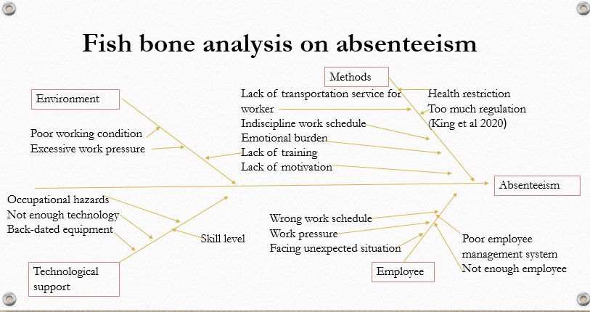
Figure 2 Fish bone analysis

Solutions for absenteeism
It is not possible to completely solve absenteeism in the workplace(McGrandle,et al 2017). For various reasons often employees will have unscheduled absences. But some initiatives can improve employee attendance. Each of the steps is important to ensure the best working environment and state clear attendance rules. Some strategies are given below for Mid Cheshire Hospitals NHS Foundation Trust (MCHT) to reduce staff absenteeism.

Attendance policy
To reduce absenteeism it is very important to inform staff of what is expected from staff in terms of attendance (Cucchiella, et al 2014). So this organization needs a policy with a clear state of how the staff will report absences, how this organization will follow up on unsanctioned absences and what the consequences are for excessive absenteeism.

Good attendance award
In order to reduce absenteeism rewarding will be a great tool for good attendance. It is mentionable that there can be perfectly legitimate reasons for being absent.

Flexible work schedule
A flexible work schedule will help to solve many common causes of absenteeism. It is an excellent idea to ensure staff well-being (Lara,et al 2018). So the authority should offer a flexible work schedule for staff.

Reduce workplace stress
Stress affects the quality of work and it also leads to increase absenteeism. Working at a hospital staff often confronts various emotional situations, so the organization should focus to reduce workplace stress.

Fostering team culture
Team culture helps to reduce absenteeism. Teamwork gives a sense worker to belonging and a feeling to connect with the team, as a result, workers are able to realize the value of the role workers play (Damart, et al 2016). So the tendency of absent from the workplace is reduced. So this organization should be fostering a team culture.

Confirming uniform work distribution
Being overworked leads to absenteeism so this organization has to ensure uniform work distribution among the staff.

Conclusion
Absenteeism plays a profound financial effect on an organization. Absenteeism also plays a vast impact on the service of hospitals. However, it is not possible to solve a hundred percent absenteeism but some initiatives can keep it at a minimum level. To reduce absenteeism Mid Cheshire Hospitals NHS Foundation Trust (MCHT) should apply these strategies such as attendance policy, making flexible work schedules, awarding, confirming uniform work distribution, fostering team culture. After implementing those strategies to reduce absenteeism this organization should monitor how staff reacts to those strategies.

References
Badubi, R.M., 2017. A critical risk analysis of absenteeism in the work place. Marketing, 2(6), pp.32-36.
Cucchiella, F., Gastaldi, M. and Ranieri, L., 2014. Managing absenteeism in the workplace: the case of an Italian multiutility company. Procedia-Social and Behavioral Sciences, 150, pp.1157-1166.
Damart, S. and Kletz, F., 2016. When the management of nurse absenteeism becomes a cause of absenteeism: a study based on a comparison of two health care facilities. Journal of Nursing Management, 24(1), pp.4-11.
Eskildsen, J.K., Frederiksen, A. and Løkke Møller, A.K., 2021. Employee absence in public and private organizations. Applied Economics, 53(21), pp.2416-2432.
Gangai16, K.N., 2014. Absenteeism at workplace: What are the factors influencing to it?.
Hartmann, D. and Hattingh, T.S., 2018. In dis tree–4 what?. South African Journal of Industrial Engineering, 29(3), pp.1-11.
Jinnett, K., Schwatka, N., Tenney, L., Brockbank, C.V.S. and Newman, L.S., 2017. Chronic conditions, workplace safety, and job demands contribute to absenteeism and job performance. Health Affairs, 36(2), pp.237-244.
Kocakulah, M.C., Kelley, A.G., Mitchell, K.M. and Ruggieri, M.P., 2016. Absenteeism problems and costs: causes, effects and cures. International Business & Economics Research Journal (IBER), 15(3), pp.89-96.
Kottwitz, M.U., Schade, V., Burger, C., Radlinger, L. and Elfering, A., 2018. Time pressure, time autonomy, and sickness absenteeism in hospital employees: a longitudinal study on organizational absenteeism records. Safety and health at work, 9(1), pp.109-114.
Lara, J., Noble, K., Pelika, S. and Coons, A., 2018. Chronic Absenteeism. NEA Research Brief. NBI No. 57. National Education Association.
Lee, A., Mills, S. and Sidhu, D., 2014. The external and internal context. CIPD-Kogan Page.
Markussen, S., Røed, K., Røgeberg, O.J. and Gaure, S., 2011. The anatomy of absenteeism. Journal of health economics, 30(2), pp.277-292.
McGrandle, J. and Ohemeng, F.L., 2017. The conundrum of absenteeism in the Canadian public service: A wicked problem perspective. Canadian Public Administration, 60(2), pp.215-240.
Miraglia, M. and Johns, G., 2021. The social and relational dynamics of absenteeism from work: a multilevel review and integration. Academy of Management Annals, 15(1), pp.37-67.
Mudaly, P. and Nkosi, Z.Z., 2015. Factors influencing nurse absenteeism in a general hospital in D urban, S outh A frica. Journal of nursing management, 23(5), pp.623-631.
Perera, R., 2017. The PESTLE analysis. Nerdynaut.
Rastogi, N.I.T.A.N.K. and Trivedi, M.K., 2016. PESTLE technique–a tool to identify external risks in construction projects. International Research Journal of Engineering and Technology (IRJET), 3(1), pp.384-388.
Shtal, T.V., BURIAK, M.M., AMIRBEKULY, Y., UKUBASSOVA, G.S., KASKIN, T.T. and TOIBOLDINOVA, Z.G., 2018. Methods of analysis of the external environment of business activities. Revista Espacios, 39(12).
Ticharwa, M., Cope, V. and Murray, M., 2019. Nurse absenteeism: An analysis of trends and perceptions of nurse unit managers. Journal of nursing management, 27(1), pp.109-116.

