
APPENDIX GA36c

LEVEL 6 ASSESSMENT SPECIFICATION

Student name: | Joseph Bushell | Student ID number: | 1800307
Programme: | Primary
Module: | Principles of Pedagogy
Module code: | M6X01438/C | Contribution to Overall Module Assessment (%): | 100%
Lecturer: | Siân Brooks | Internal Verifier: | Siân Brooks
Assignment Title: | ‘Describe a learning event which has happened during your recent school experience. Reflect upon what took place, connecting events to theories of learning and teaching. Make recommendations about how you could improve your own practice in the light of this. Produce a poster to illustrate how you would develop the elements of an effective learning environment.’ | Word count (or equivalent): | 5,000 or equivalent.
Submission deadline: | 17/10/18 | Return date of provisional marks & written feedback: | 14/11/18
Submission method: | All written assessments, where practical and possible, must be submitted via Turnitin unless otherwise instructed by the Lecturer. (Please DO NOT put this assessment specification into Turnitin or it will match many similarities with other students’ submissions.)  Alternative submission method (if applicable):  Late submission of the assessment will result in a late penalty mark. Penalties for late submission: Up to one week late, maximum mark of 40%. Over one week late, 0%. Only the Extenuating Circumstances Panel may approve a change to submission dates.
Academic honesty / referencing: | Academic honesty is required. In the main body of your submission you must give credit to authors on whose research and ideas your work is based. Append to your submission a reference list that indicates the books, articles, etc. that you have used, cited or quoted in order to complete this assessment.

Module Learning Outcomes
(from module syllabus)
1. understand, synthesise and evaluate the main theories that underpinning learning, behaviour and assessment in the primary school
2. reflect critically on how learning theories inform the planning and provision of high quality learning environments, demonstrating a clear understanding of how theory and practice are interrelated
3. organise knowledge and learning through the use of a range of information sources, and present work appropriately.

‘Describe a learning event which has happened during your recent school experience. Reflect upon what took place, connecting events to theories of learning and teaching. Make recommendations about how you could improve your own practice in the light of this. Produce a poster to illustrate how you would develop the elements of an effective learning environment.’

Introduction

This assignment is going to look at and focus on key observations made within a primary school. It will contain detailed descriptions and evaluations of a learning event that has occurred within a classroom setting. This learning event will be critically analysed, compared and contrasted with current literature of learning and teaching.
My learning event took place in a primary school in the centre of Swansea. This was a two-form entry school with 26% free school meals (FSM) and according to Schoolguide.co.uk, 2018, the national average FSM is 18.9%. There are 417 pupils in the school, with 18% having Additional Learning Needs (ALN). The school’s previous Estyn inspection in 2015 showed that the school’s performance and their learning experiences were good (Estyn.gov.wales, 2018).

My observation at the primary school was focused on ages 7-8 in Key stage 2 (KS2). The KS2 class contained 25 pupils and 2 adults (1 teacher and 1 Learning Support Assistant LSA). To ensure confidentiality, ethical considerations were considered before my observation took place. The pupils, teachers and name of the school have been removed. The schools safeguarding policy required no consent to take pictures of the pupils’ work.

During the past three years working in a primary school I observed a variety of key elements within everyday teaching and learning. One area in particular took my interest was the new vision of Professor Graham Donaldson’s curriculum (Donaldson, 2015), which looked at how children learn and are assessed using different strategies throughout the phases.

Part 1- Observation

I was able to draw on my previous experiences and come up with an idea of a particular Assessment for Learning (AFL) strategy that I wanted to observe. AFL is a relaxed approach embedded in all areas of teaching and learning, delivered in a variety of different styles by the teacher (Wiliam, 2011). There are two types of assessment: Formative and Summative. Wiliam (2011) defined formative assessment as “the process used by teachers and students to recognise and respond to student learning in order to enhance that learning, during the learning.” Formative assessment is a system that teachers use to measure student grasp of specific topics and skills they are teaching. It’s also used to recognise pupil misunderstandings and errors while the lesson is being taught (Wiliam, 2011). Summative assessment is an assessment of pupils at the end of topics, during mid-terms and at the end of the year. They are designed to assess the level of pupils’ learning of that topic and evaluate the progress made (Wiliam, 2011.).

Within this area of teaching and learning I have chosen to focus on the process of how children learn through self-assessment which is an important component of formative assessment (Wiliam, 2011). Self-assessment is the process of an individual reflecting and assessing their learning through making decisions about an aspect of their performance (Faragher, 2014). To ensure I had sufficient and reliable evidence for my observation I used distinct analytical techniques including: written records of what was happening, asking the teacher and children questions, listening to conversations between the teacher and children, taking photographs and reading through children’s work books.

The learning event took place during a numeracy lesson as a whole class focusing on addition. To capture aspects of the classroom as a written record I used a note pad and pen. I thought this was an appropriate method, because it was unobtrusive and put less pressure on the teacher, pupils and LSA. The purpose of written records is to gather qualitative, detailed, descriptive and narrative information to help the observer summarise what occurred (Complexneeds.org.uk, 2018). I also used audio recordings, a form of digital media, an extremely beneficial technique to refer back to certain aspects of the learning event and to ensure consistency in supporting my written records. This was also used as a back-up source in case I missed any key verbal information and allowed me the opportunity to take less notes and become more involved. I took photographs of numeracy books to evidence a visual representation of what self-assessment looks like inside the pupil’s books (Complexneeds.org.uk, 2018). I would have preferred to have filmed the event to provide more clarity to my observations. However, I chose not to because Msu.edu (2018) states that children being video recorded would result in a change of their behaviour, which would impact my findings.

The teacher began the lesson using a quick practical warm up method, asking the class to form a human circle in the middle of the classroom. The aim was to count to thirty using the two times table. The teacher requested the class to ‘slap’ their fists every time they added on two. I thought this was a useful way of learning the two times table, because the children used an action to trigger a response. However, there were disadvantages to using this method. Some children were mimicking what another child was saying, rather than thinking to add two on each time. This could have been due to the teacher moving through the activity at a fast pace and not taking lower abilities into consideration. Once the warm up activity finished the teacher sat the whole class down in front of the white board. The teacher called this ‘thinking time’, where the children were asked to think back to the previous numeracy lesson and discuss with the person sitting next to them what they did. I thought this was a fitting way for the teacher to use a formative assessment technique called ‘think, pair, share’. This method is for children to discuss and share what they have learnt with a partner, they then feedback to the teacher what they know (Strebe, 2015). This enabled the children to self-assess what they have learnt and tell the teacher what they remembered from the previous numeracy lesson. Figure 1 below shows the feedback pupil A gave in response to the teacher’s question.

Teacher | ‘who would like to share what we learnt in maths yesterday?’
Pupil A | ‘We had to pick different numbers from the board and add them to 100’.
Teacher | ‘That’s it we had to had them to 100. We also had different challenges, didn’t we? What else did we do?
Pupil A | ‘We had to add 1, 10 or 100 to a three-digit number’
Teacher | ‘Exactly, we are going to build on what we learnt yesterday, and partition three-digit numbers to help us add 1, 2- and 3-digit numbers to it.’
Figure 1 Dialogue of pupil reflecting back to previous numeracy lesson.

Once the teacher recognised the children recalled what they did in the previous lesson, they were asked to show a ‘thumbs up’ or a ‘thumbs down’ if they were confident with the level difficulty on the subjects of adding and partitioning. I saw this approach as a useful quick and easy way for children to self-assess on whether they found it difficult, okay or easy and it enabled the teacher to identify what children would need more support. This approach could also be seen as unreliable as some children could be surrounded by others who have their thumbs up, which could lower their confidence levels resulting in the child not truthfully self-assessing how they feel about the activity (Wiliam, 2011). The activity then extended into a focused task called the ‘Addition Challenge’ (figure 6) which had to be completed in the children’s work books. The aim was to add two numbers together to make a total. During this activity, Pupil B had added two difficult numbers together and came up with the right answer. The teacher asked Pupil B to explain the method they used to work it out. Pupil B then responded in the following dialogue (figure 2). Once the child had fed back to the teacher, the teacher rewarded the child with praise. I noticed the child smiling with a sense of pride. I believe this was seen as a positive reaction because the child’s self-esteem clearly had been lifted by the teacher. This could lead to the child being more motivated when dealing with future tasks. Maslow’s Hierarchy of Needs highlights that motivation and self-esteem must be satisfied for pupils needs higher up the pyramid (Taormina and Gao, 2013), see figure 4. This dialogue between the teacher and pupil is a great example of self-assessment, where the pupil is able to assess their own learning by reflecting back on the process they used to solve the sum.
This moment brought me to the decision to focus my attention on this particular learning event. I was intrigued as to how self-assessment can impact children’s learning.

Teacher | ‘How did you add these two numbers together to get that answer?’
Pupil B | ‘I partitioned both numbers into place value columns. Next, I added the hundreds together, then the tens and then the units’

Figure 2 Dialogue of pupil B assessing their work, explaining how they came to that answer

I was extremely fortunate to be observing this age group, because during the numeracy lesson the children were also being trained on how to self-assess their work. According to (Black and Wiliam, 2010) if formative assessment is to be productive, pupils should be trained in self-assessment so that they can understand the main purposes of their learning and thereby relinquish what they need to do to achieve.
Through this AFL approach children develop a strong cognitive attribute called metacognition. Metacognition is when learners must reflect on their learning and intentionally apply the results of reflection to further their learning (Pritchard, 2008). According to Hacker, (Dunlosky and Graesser, 2009), students who are educated about how they learn and acknowledge effective and ineffective learning strategies should not only enhance the accuracy of their metacognitive decisions but improve their self-regulated learning. The process of children developing their thinking can be viewed as a cycle (figure 3), this demonstrates the teacher can use the learning and feed it into the following lesson.
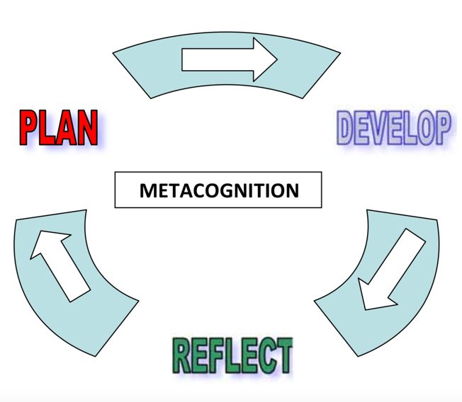

Figure 3 Metacognition cycle (Griffithjones.amdro.org.uk, 2018)

The teacher used a smiley face self-assessment technique (figure 7) where the child would colour in how difficult they found the task. I felt this wasn’t a reliable method as the children were unsure whether the smiley faces meant they enjoyed the activity or how difficult it was. At the end of the lesson the teacher asked the children to self-assess their work and indicate whether they received support. This was carried out by putting an ‘S’ or putting an ‘I’ for doing the work independently. It was important to do this at the end of the lesson whilst it was fresh in their memory. The teacher then asked the children to place their books in the green, yellow or red pile to indicate how difficult they had found the activity. The teacher then implied they would arrange to revisit the work and go through it with them. I found there were advantages and disadvantages to this method. The advantages were that it was an organised and systematic way of identifying what children needed differentiated work for future activities and they could then sort the child into ability groups. The disadvantages were, as mentioned earlier, the children may have self-assessed incorrectly and put their book in the pile on whether they enjoyed the activity, or they may have not understood what was asked by the teacher. Also, a child may have felt embarrassed that their peers found the work easy and therefore put their book with their fellow peers’ books. To avoid any misjudgement by the children the teacher would then check the work to see if the child understood and had been sincere in their self-assessment. Once the work has been reviewed the they would then leave a comment for the child to sign to say they have read the feedback given.

Part 2: Connect to theory

The majority of teachers are proficient in offering opportunities in order to progress children’s learning. However, it is common for teachers not to understand the theory behind the pedagogy (Pritchard, 2008). Therefore, it is important to reflect upon my learning experience, understand and apply it, for my development as a future practitioner.

There have been many theories on ways in which human beings learn. There are three key perspectives on how children learn that have made a huge impact within the practice of teaching over the past decade. These are the Constructivist, Humanist and Behaviourist approaches (Pritchard, 2008). For children to be able to learn, the adult must be able to transfer their knowledge in an understandable way. However, the adult cannot get the best learning out of the children without knowing how they learn and knowing what they already do and don’t know (Briggs, 2012). Teachers need to know about their pupils’ progress and difficulties with learning, so they can adapt their work to meet their needs (Black and Wiliam, 2010). Teachers can find out what they need to know through observing, discussing and assessing pupils’ work. This therefore indicates that self-assessment is becoming ever more important within education.

Constructivists view learning as “the result of mental construction”. They believe learning occurs when “new information is built into and added onto an individual’s current structure of knowledge, understanding and skills”, (Pritchard, 2008).

Jean Piaget (1896-1980) was viewed as one of the most prominent people of a cognitive constructivist approach. According to Piaget, children are born with a very basic mental structure that has been inherited and evolved, where all learning and knowledge is constructed. Piaget believed children’s cognitive development happens through four developmental stages: Sensorimotor, Preoperational, Concrete operational and Formal operational. According to Piaget, the Sensorimotor stage is estimated to occur in children between 0-2 years. It is where simple reflexive behaviour gives way to ability to form knowledge and to create patterns and chains of behaviour (Pritchard, 2008). The Preoperational stage is estimated to occur between the ages of 2-7 years. It is where children are egocentric and are unable to consider events from another person’s point of view. It is also where children use a ‘symbolic’ thought process and imagination begins to develop. Referring back to the observations made, the Preoperational stage had been supported by the teacher creating a ‘symbolic’ self-assessment form, where the children used their knowledge and understanding of associating symbols with meanings to colour in the smiley faces that represented difficulty levels of the task. The Concrete operational stage is estimated to occur between the ages of 7-11 years. Here, children begin to use logical thought about physical operations and they become more able to take another’s point of view and consider other perspectives. This stage is interesting because when the teacher asked Pupil B (figure 2) to reflect on the work they produced, they were able to use a logical thought process to break down their learning and feed it back to the teacher using language skills. The final stage is the Formal operational, estimated to occur from 11+ years, where the children are able to think logically and theoretically. This is considered the pinnacle stage of intellectual development, and it’s considered that even though children still have very little knowledge, their thought processes are as developed as they are ever likely to be. These stages feed into a child’s metacognition development, and therefore develops their thinking further to construct their own learning through self-assessment. Despite this perspective corresponding with self-assessment, it acknowledges children’s optimum learning occurs when they actively configure their own understanding.

In reference to Maslow’s Hierarchy of Needs (figure 4), motivation and self-esteem are things to consider when assessing pupils. As mentioned earlier, the teacher questioned Pupil B’s answer for the pupil to reflect on their knowledge and understanding, which then led to the teacher rewarding the pupil by responding with positive praise. This can be seen as a positive because increasing the pupil’s self-esteem can lead to the pupil taking on more difficult future tasks. When the classroom’s ethos is to focus on rewards such as praise, stickers, grades or class ranking, pupils look for ways to obtain the best marks rather than to improve their learning by spending time and energy looking for clues to the right answer (Black et al., 2011). This approach can be linked with the behaviourist learning theory. Behaviourism is based around the central notion of a reaction being made to a particular stimulus, which in a classroom context is a teacher rewarding a pupil (Pritchard, 2008). In relation to the observation, this could have been seen as a negative, because when the teacher asked the children to self-assess their work and put their books into three difficulty piles. The pupils may have put their books in the ‘I understand’ pile because they seek reward from the teacher.

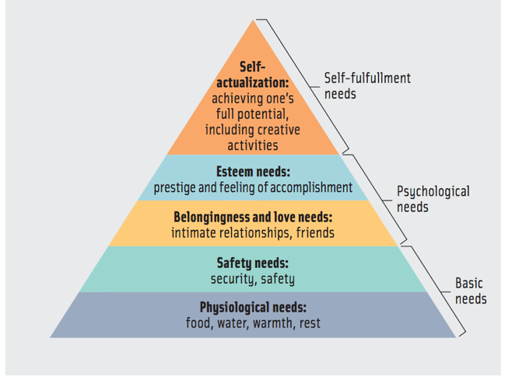

Figure 4 Maslow’s Hierarchy of Needs Accessed at: (Anon, 2018)

Another constructivist, Lev Vygotsky (1924), agreed with Piaget’s view that learning happens internally, and children learn through being active. He didn’t agree that children progress through specific stages of development at specific ages or that children are “lone scientists”. Vygotsky was a social constructivist who believed learning is a socially meditated activity where children work with others socially to make meaning for themselves (Pritchard, 2008). He believed social learning precedes development. Whereas Piaget believed development must inevitably precede their learning (Falchikov et al., n.d.). Social constructivism is concerned with the importance of collaboration with others, such as a group of fellow pupils, one pupil, LSA or the teacher. It views social interaction as the primary means by which learners construct new meanings, (Palincsar, 1998). Therefore, by children talking, it becomes the vehicle by which ideas are considered, shared and developed (Pritchard, 2008). As mentioned earlier, Pupil A and Pupil B were able to converse and discuss ideas with fellow pupils during the ‘think, pair, share’ method about what they had learnt previously. The teacher conversed with them through questioning to help stimulate their self-assessment to support their learning.
This shows social constructivism is essential for the teacher to know how the children learn, how to structure their teaching and for the children to construct their learning socially by using others around them. These social interactions are with what’s known as a more knowledgeable other (MKO). According to Pritchard (2008), the role of a more knowledgeable other within a school setting is usually the teacher. The teacher’s role is to engage individuals or groups in a dialogue and facilitate the development of learning and understanding.

Jerome Bruner was someone who also followed Vygotsky’s line of interest and used the concept of ‘Scaffolding’ to highlight the way that one person can become very intimately, and productively involved in someone else’s learning (Mercer, 1995). Vygotsky developed a concept known as the zone of proximal development (ZPD). The ZPD (figure 5) is used to describe the learners current or actual level of development, so the idea is individuals learn best when working together. The ZPD shows that the support of an MKO could potentially be that extra push a learner needs to get into the ‘What I can do’ zone (Shabani, Khatib and Ebadi, 2010). Early in a learner’s learning process, a pupil will require much assistance in accomplishing a task that is in the upper end of their zone. Through practice and experience, the pupil will be able to accomplish independently what they were able to accomplish before with much assistance (Doolittle, 1997). As mentioned earlier, during the learning event the teacher and LSA (MKO) would indicate whether that child received support ‘S’ or did the work independently ‘I’. This would benefit the child when self-assessing, by being able to review what work they could do with support (MKO) and acknowledge how they’ve progressed to doing work independently. This would lead to their psychological needs being satisfied with a feeling of accomplishment in accordance to Maslow’s Hierarchy of Needs (Maslow, 2013).

Learning.gov.wales (2018) states that self-assessment will only work if the teacher (MKO) ‘coaches’ the learner in self-evaluation through: modelling questions, engagement and, processes and strategies. During the observation the teacher (MKO) would ‘coach’ the children during the lesson on the correct self-assessment process. They would also feed questions to the pupils whether its 1:1, in a group or as a class to stimulate the children’s reflection on previous knowledge and assess the situation. However, this is only effective if children are taught the correct process and understand how to self-assess. Black and Wiliam (2010) states that the main problem with self-assessment is pupils can only assess themselves when they have a sufficiently clear picture of the targets such as a success-criteria or learning objective, that their learning is meant to attain. Without support, how would the pupil know what the MKO is asking of them? Consequently, it is inappropriate and ineffective to ask a pupil to carry out self-assessment without some guidance (Briggs, 2012). This was an issue in the classroom because the children were unsure what the ‘smiley faces’ meant, and the self-assessment wasn’t completed accurately by the children. For self-assessment to work efficiently and effectively, Black and Wiliam (2010) acknowledges when the learner is striving to learn, assessment feedback about the effort has three elements: recognition of the desired goal, evidence about present position, and some understanding of a way to close the gap on what they need to know. All three must be understood by the learner before they can act to improve learning.

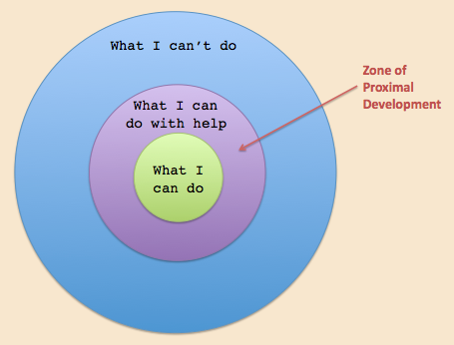

Figure 5 Zone of Proximal development (Accessed at: Innovativelearning.com, 2018)

Conclusion

To conclude, the learning event I observed has provided me with knowledge and understanding to improve my future teaching practice. I’ve acknowledged that self-assessment is becoming an essential component of classroom work and its development can raise standards of achievement (Black and Wiliam, 2010). For self-assessment to be effective I will stimulate children’s metacognition to enable learners to critically reflect on their learning and intentionally apply what they have learnt to assess their own learning (Pritchard, 2008). As the adult, I will ensure children are taught on how to self-assess their learning through the scaffolding approach. Once self-assessment becomes automatic the ‘scaffolding’ will be removed through modelling questions, engaging the pupils and providing a clear picture of the processes and strategies in place. The pupils will then use this skill to understand the main purposes of their learning and grasp what they need to do to achieve (Black and Wiliam, 2010).
Whilst there are merits in both Piaget’s and Vygotsky’s theories on constructivism, for self-assessment to be effective, it cannot solely depend on one theorists view. As a future practitioner I will take on board certain aspects of constructivism as well as other learning theories.

Part 3: Reflect and Innovate

Children spend the majority of their school time within a classroom-based learning environment. The classroom environment is one of the most important factors affecting student learning. Students learn better when they view the learning environment as positive and supportive (Gardner, 2013). A positive environment is where pupils feel a sense of belonging, trust others, take risks, build social skills, and ask questions (Gardner, 2013). The classroom environment shapes teaching, learning and assessment (Gardner, 2013). To create a positive, successful ethos within the classroom, Professor Graham Donaldson’s four purposes (figure 5) will be considered (Donaldson, 2015). My ideal learning environment is based on a year two classroom and covers aspects that link with Donaldson’s four purposes. For these purposes to be implemented, the classroom must first be adapted to suit. Maslow’s Hierarchy of Needs acknowledges humans’ basic needs are to feel safe and secure before they can develop. My learning environment will consider the safety, security and well-being of the children (Maslow, 2017).
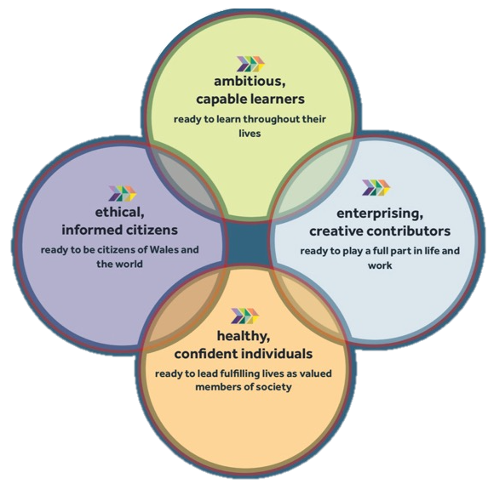

Figure 5 Professor Graham Donaldson’s four purposes (Donaldson, G. (2015). Successful Futures. [online].

A Humanistic theorist called Maria Montessori believed classrooms should be filled with readily available and well organised learning materials. She believed the ideal learning environment should be aesthetically pleasing and only include things that the teacher wants the child to experience and engage with (Montessori, 2013). Maria Montessori created the Montessori Method, this approach emphasised individuality and independence in learning. She believed children are seen as inherently curious and learning driven and children should be allowed choices, therefore preparing them to become independent learners. Children are able to discover the world around them through a physical approach rather than information being ‘thrown’ at them in a classroom (Montessori, 2013). As a result, this approach links in with outdoor learning (Figure J).

Children nowadays lead indoor, sedentary lives whilst at home and teachers taking learning outdoors is gaining significance (Learning.gov.wales, 2018). Learning outside the classroom is best seen not as a subject but as a tool for teaching and learning (Waite, 2011). Outdoor learning can be exploited through all subjects to improve engagement, building a rapport with staff and pupils and to improve pupils cultural and environmental awareness (Waite, 2011). This has been proven to benefit the pupil in their long-term learning, development, health and well-being (Learning.gov.wales, 2018). However, in the majority of schools outdoor learning isn’t considered a priority with the pressure of the crowded curriculum and teachers struggle to find time for learning outside the classroom (Waite, 2011). This begs the question, ‘does there need to be an emphasis on learning outside the classroom?’.
Providentially, the foundation phase accommodates outdoor learning to enrich all attributes of children’s development socially, physically, creatively and culturally. If these attributes are developed, then children become better learners and retain that learning (Learning.gov.wales, 2018). This places a greater importance on the use of the outdoor learning environment throughout the school phases. Forest schools is an approach that accommodates the foundation phases pedagogy of outdoor learning (Knight, 2013). As supported by (Montessori, 2013,), the Forest Schools approach encourages children to explore their environment and challenge themselves. This also links in with Piaget’s theory of children being “lone scientists” where they can construct their own learning through exploring their environment and come to their own conclusions from what they learn (Pritchard, 2008). In accordance with Maslow’s Hierarchy of Needs (figure 4) the concept of Forest Schools can lead to children strengthening their confidence and self-esteem when tackling new situations and tasks (Knight, 2013). Other outdoor learning opportunities can be carried out through play. Play has been defined as “freely chosen, self-determined and without adult intervention” (Whitehead, 2011). Singer, Hirsh-Pasek and Golinkoff (2006) recognises that play provides children to be creative and spontaneous. My ideal outdoor learning environment would include apparatus like a Timber Trail (O) which facilitates children’s play by enabling them to develop characteristics of a physically literate individual, including motivation, fine motor skills, confidence, environmental and interpersonal engagement, self-knowledge and self-expression (Johnston and Nahmad-Williams, 2014).

One of Donaldson’s four purposes is for children to be healthy, confident individuals (Donaldson, 2015). Therefore, ideally my learning environment would include a ‘Snack Shack’ (P) which would also endorse the healthy schools’ scheme. The focus of this would be for children to prepare healthy snacks and run the business of selling these snacks within the playground. As a result, children engage in real-life experiences where they are able to take risks. Expanding research is signifying the outdoors is the ideal learning environment for experimental learning by offering the children opportunities to be creative, to move around, be noisy, socialise and take risks (Learning.gov.wales, 2018).

The use of digital apparatus (B, D, N) in my learning environment has become essential to everyday teaching and learning (Learning.gov.wales, 2018). The use of ICT is a key aspect within the Digital Competence Framework (DCF), embedded into the new curriculum by Graham Donaldson. Professor Donaldson argued that computer programming and ICT in all classes should be as important as literacy and numeracy (Donaldson, 2015). “Digital competence is the set of skills, knowledge and attitudes to enable confident, creative and critical use of technologies and systems. It will enable pupils to be a digital confident citizen, to interact and collaborate digitally and help computational thinking” (Learning.gov.wales, 2018). Due to the way modern society is progressing and the expectations of employers, digital skills are becoming increasingly imperative according to Learning.gov.wales (2018), resulting in an increased pressure on schools and teachers to integrate ICT in teaching and learning activities. This can be a challenge to some practitioner’s own knowledge (Olofsson, Lindberg and Fransson, 2018). I have chosen to include the use of digital tablets (D) because according to (Olofsson, Lindberg and Fransson, 2018), digital tablets are a flexible and multimodal ICT tool to support students’ learning. Research has shown that the use of digital tablets prepares students for life and work in the twenty-first century and has made a positive impact on students’ motivation for learning (Olofsson, Lindberg and Fransson, 2018). Research also states using these devices can help pupils develop their oracy skills. For example, in my learning environment digital tablets will be available to use with a green screen (N) across different subject areas. These resources can be used to support Professor Donaldson’s enterprising, creative, contributors’ purpose (Donaldson, 2015). A scenario is where the teacher is delivering a welsh lesson focused on the weather, they could design a carousel cross-curricular task where children can independently create their own weather channel. The children can use the tablets to evidence their creative work through videos or photographs (Beauchamp, 2015). This links to Jerome Bruner’s ‘scaffolding’ conception where the teacher will set the activity and apply the scaffold (support) until the pupils can independently carry out the task (Mercer, 1995). However, if the teacher isn’t competent on the use of digital tablets and apparatus, the pupils cannot become digitally competent themselves. ICT can also be under-utilised, and teachers can miss out on the wider benefits technology brings as a tool to enhance all areas of education (Elston, 2007).
In order for these focused areas to be utilised, carousel learning will become the primary method of learning. The carousel learning system will use all areas of the classroom. It is a communicative and interactive opportunity for participants/students to get up and move around a room in a circular fashion (Uticaschools.org, 2018). In a carousel, students work in small groups and move from station to station (areas in the classroom), discussing each task as they go. It is a useful tool to integrate practical learning into everyday teaching to give pupils a break from sitting on chairs, encouraging and supporting group work (Nicurriculum.org.uk, 2018). A study carried out by Yusmanto, Soetjipto and Djatmika (2017), found carousel learning could increase pupils higher order thinking skills as well as social learning outcomes. The carousel system allowed pupils to have time to think, discuss and to receive scaffolding. This supports Vygotsky’s theory of social constructivism where pupils can work together collaboratively in order to develop their learning (Pritchard, 2008).
This system is particularly effective within the foundation phase through continuous, enhanced and focused provisions. The focused provision is led by the teacher or LSA to work with either a group or individuals and involves high quality adult child interaction focusing on specific planned activities (Thomas and Lewis, 2016). The continuous and enhanced provisions allow the pupils to gain additional, enhanced, cross-curricular and enriched learning opportunities in relation to a specific topic. For example, the two focus groups are to practise number bonds to 10 with the adult, whilst the other provisions are independent with one group using the computers practising number bonds on maths games to enhance their digital competence and another group focusing on physical literacy to improve their fine and motor skills in relation to the topic (Thomas and Lewis, 2016). These grouped activities rotate like a carousel after a period of time. Carousel is used in its best practice, when the activities have a clear purpose (Assembly.wales, 2018). The content and level of support match children’s needs. However, even though children are being active from moving to each station, if the activities are poorly organised, these activities do not necessarily offer children possibilities to deepen their learning or explore their understandings thorough meaningful contexts (Arthur and Cremin, 2018). Learning must be well designed to be meaningful and in line with the goals, in accordance with what students need to prepare for their future (Yusmanto, Soetjipto and Djatmika, 2017).

My ideal learning environment
Appendix

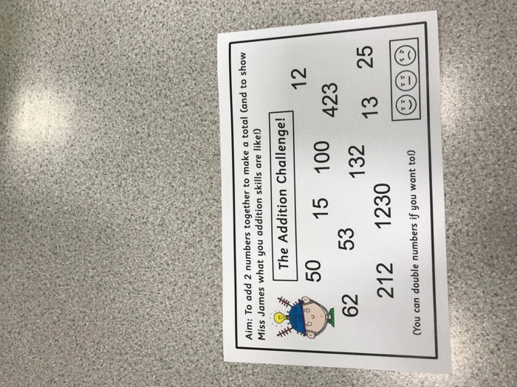

Figure 6 ‘Addition Challenge’

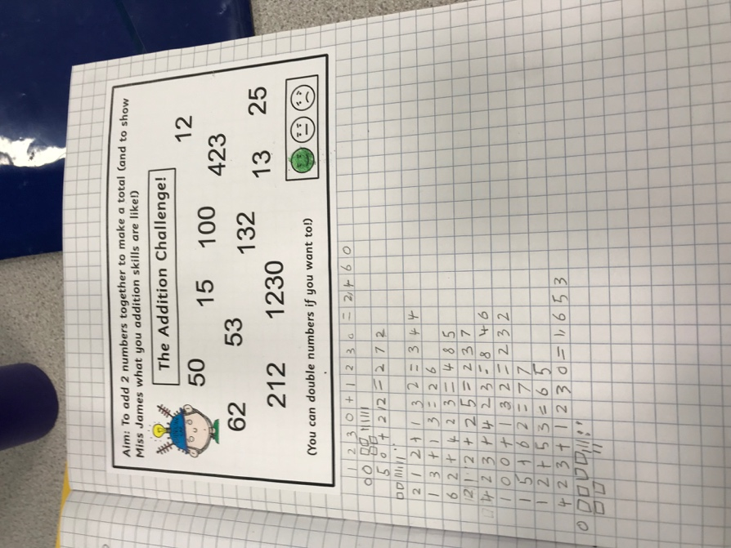
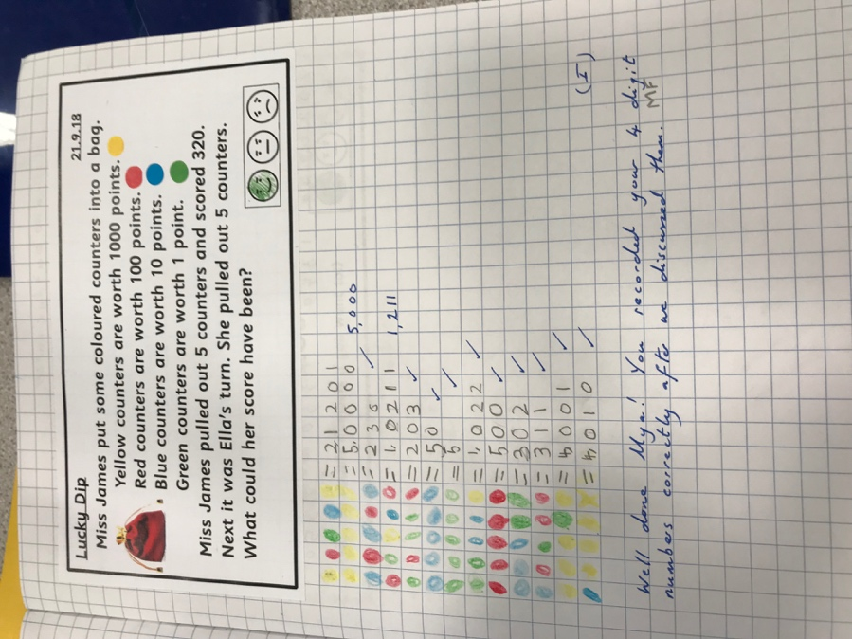
Figure 7 Smiley face self-assessment method

Bibliography

Anon, (2018). [image] Available at: http://www.ast.org/pdf/308.pdf [Accessed 6 Oct. 2018].

Arthur, J. and Cremin, T. (2018). Learning to teach in the primary school. London: Routledge, Taylor and Francis Group.

Assembly.wales. (2018). [online] Available at: http://www.assembly.wales/Laid%20Documents/GEN-LD8838%20-%20Annual%20Report%20of%20Her%20Majesty’s%20Chief%20Inspector%20of%20Education%20and%20Training%20in%20Wales%202010-2011-13032012-231494/gen-ld8838-e-English.pdf [Accessed 16 Oct. 2018].

Beauchamp, G. (2015). ICT IN THE PRIMARY SCHOOL. [S.l.]: TAYLOR & FRANCIS.

Black, P., Harrison, C., Lee, C., Marshall, B. and Wiliam, D. (2011). Assessment for learning. Berkshire: Open University Press.

Briggs, M. (2012). Assessment for learning and teaching in primary schools. Exeter: Learning matters.

Complexneeds.org.uk. (2018). [online] Available at: http://complexneeds.org.uk/modules/Module-2.4-Assessment-monitoring-and-evaluation/All/downloads/m08p110b/observational_methods.pdf [Accessed 16 Oct. 2018].

Doolittle, P.E (1997). Vygotsky's Zone of Proximal Development as a theoretical foundation for cooperative learning. Journal on excellence in teaching, 8 (1), 83-103.

Donaldson, G. (2015). Successful Futures. [online] Available at: http://file:///Users/josephbushell/Downloads/Donaldson%20Report%20-%20Successful%20Futures%20-%20Independent%20Review%20of%20Curriculum%20and%20Assessment%20Arrangements%20in%20Wales.pdf [Accessed 14 Oct. 2018].

Elston, C. (2007). Using ICT in the primary school. London: Paul Chapman Pub.

Estyn.gov.wales. (2018). [online] Available at: https://www.estyn.gov.wales/sites/default/files/documents/Inspection%20report%20St%20Thomas%20Community%20Primary%20School%202014%20%28English%20only%29.pdf.pdf.pdf.pdf.pdf.pdf.pdf.pdf.pdf.pdf.pdf.pdf.pdf.pdf.pdf.pdf.pdf.pdf.pdf.pdf.pdf.pdf.pdf.pdf.pdf.pdf.pdf.pdf.pdf [Accessed 4 Oct. 2018].

Faragher, S. (2014). Understanding assessment in primary education.

Falchikov, N., Blythman, M., Boud, D. and Brent, R. (n.d.). Learning together.

Gardner, J. (2013). Assessment and learning. London: SAGE Publications Ltd.

Griffithjones.amdro.org.uk. (2018). Griffith Jones School - Curriculum. [online] Available at: http://www.griffithjones.amdro.org.uk/home/information/curriculum/ [Accessed 4 Oct. 2018].

Hacker, D., Dunlosky, J. and Graesser, A. (2009). Handbook of metacognition in education. New York [N.Y.]: Routledge.

Innovativelearning.com. (2018). Zone of Proximal Development. [online] Available at: http://www.innovativelearning.com/educational_psychology/development/zone-of-proximal-development.html [Accessed 4 Oct. 2018].

Johnston, J. and Nahmad-Williams, L. (2014). Early childhood studies.

Knight, S. (2013). Forest school and outdoor learning in the early years. Thousand Oaks, CA: SAGE Publications.

Learning.gov.wales. (2018). [online] Available at: http://learning.gov.wales/docs/learningwales/publications/130429how-to-develop-thinking-en.pdf [Accessed 4 Oct. 2018].

Learning.gov.wales. (2018). [online] Available at: http://learning.gov.wales/docs/learningwales/publications/130429how-to-develop-thinking-en.pdf [Accessed 4 Oct. 2018].

Learning.gov.wales. (2018). [online] Available at: http://learning.gov.wales/docs/learningwales/publications/160831-dcf-your-questions-answered-en.pdf [Accessed 14 Oct. 2018].

Learning.gov.wales. (2018). [online] Available at: http://learning.gov.wales/docs/learningwales/publications/141013-further-steps-outdoors-en.pdf [Accessed 14 Oct. 2018].

Learning.gov.wales. (2018). [online] Available at: http://learning.gov.wales/docs/learningwales/publications/130215play-activeen.pdf [Accessed 14 Oct. 2018].

Maslow, A. (2017). A Theory of Human Motivation. Lanham: Dancing Unicorn Books.

Mercer, N. (1995). The guided construction of knowledge. Clevedon, Avon, England: Multilingual Matters.

Montessori, M. (2013). The Montessori Method. Lanham: Start Publishing LLC.

Msu.edu. (2018). Obs. Methods. [online] Available at: https://msu.edu/~mandrews/mary/obs__methods.htm [Accessed 4 Oct. 2018].

Nicurriculum.org.uk. (2018). [online] Available at: http://www.nicurriculum.org.uk/docs/key_stage_3/ALTM-KS3.pdf [Accessed 16 Oct. 2018].

Olofsson, A., Lindberg, O. and Fransson, G. (2018). Students’ voices about information and communication technology in upper secondary schools. International Journal of Information and Learning Technology, 35(2), pp.82-92.

Palincsar, A. (1998). SOCIAL CONSTRUCTIVIST PERSPECTIVES ON TEACHING AND LEARNING. Annual Review of Psychology, 49(1), pp.345-375.

Prtichard, A. (2008). Ways of learning. London: Routledge.

Rolfe, G., Freshwater, D., Jasper, M. (2001) Critical reflection in nursing and the helping professions: a user’s guide. Basingstoke: Palgrave Macmillan.

Schoolguide.co.uk. (2018). St Thomas Community Primary School review | School Guide. [online] Available at: https://www.schoolguide.co.uk/schools/st-thomas-community-primary-school-swansea [Accessed 4 Oct. 2018].
Shabani, K., Khatib, M. and Ebadi, S. (2010). Vygotsky's Zone of Proximal Development: Instructional Implications and Teachers' Professional Development. English Language Teaching, 3(4).

Singer, D., Hirsh-Pasek, K. and Golinkoff, R. (2006). Play=learning. Oxford: Oxford University Press.

Strebe, J. (2015). Engaging mathematics students using cooperative learning. [Place of publication not identified]: Routledge.

Taormina and Gao (2013). Maslow and the Motivation Hierarchy: Measuring Satisfaction of the Needs. The American Journal of Psychology, 126(2), p.155.

Thomas, A. and Lewis, A. (2016). An introduction to the foundation phase.

Uticaschools.org. (2018). [online] Available at: https://www.uticaschools.org/site/handlers/filedownload.ashx?moduleinstanceid=270&dataid=273&FileName=Leading%20with%20Diversity%20Language.pdf [Accessed 16 Oct. 2018].

Waite, S. (2011). Children learning outside the classroom. London: SAGE.

Whitehead, M. (2011). Physical literacy. London: Routledge.

Wiliam, D. (2011). Embedded formative assessment.

Yusmanto, H., Soetjipto, B. and Djatmika, E. (2017). The Application of Carousel Feedback and Round Table Cooperative Learning Models to Improve Student’s Higher Order Thinking Skills (HOTS) and Social Studies Learning Outcomes. International Education Studies, 10(10), p.39.

