Name: Scott Thomas
Student number: 2015683
Course title: Electrical & Electronic Engineering
Module: Changemakers: Creativity and Value Creation
Module code: ACCA5033
Assignment Title: Assignment 2:Project Outcomes

Assignment 2 – Presentation
Link to video - (915) Assignment 3 Presentation - YouTube

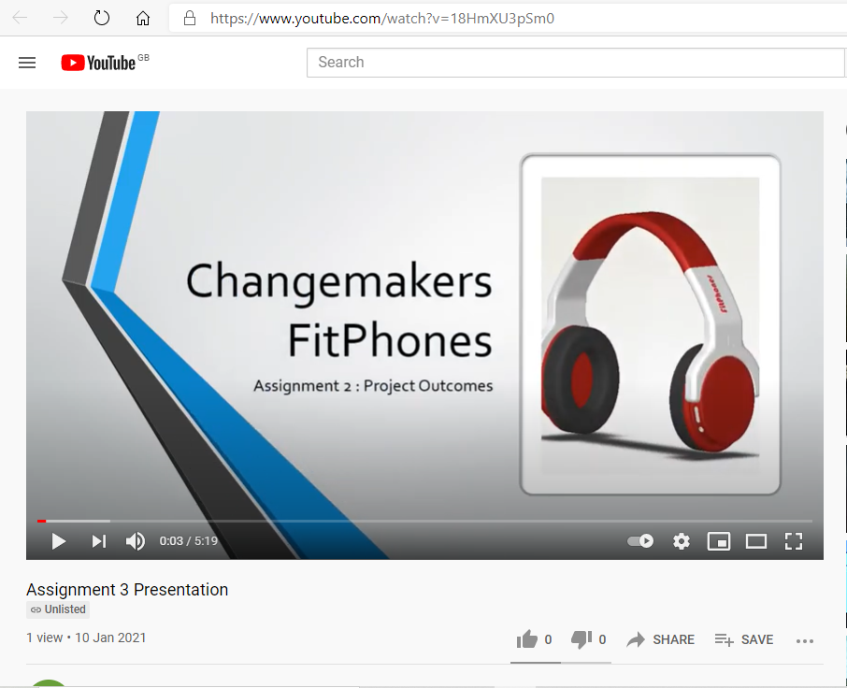
References
[12] Acrylonitrile Butadiene Styrene (ABS Plastic): Uses, Properties & Structure (specialchem.com)
[13] Polyvinyl Chloride PVC: Properties, Benefits & Applications (bpf.co.uk)

