Appendices
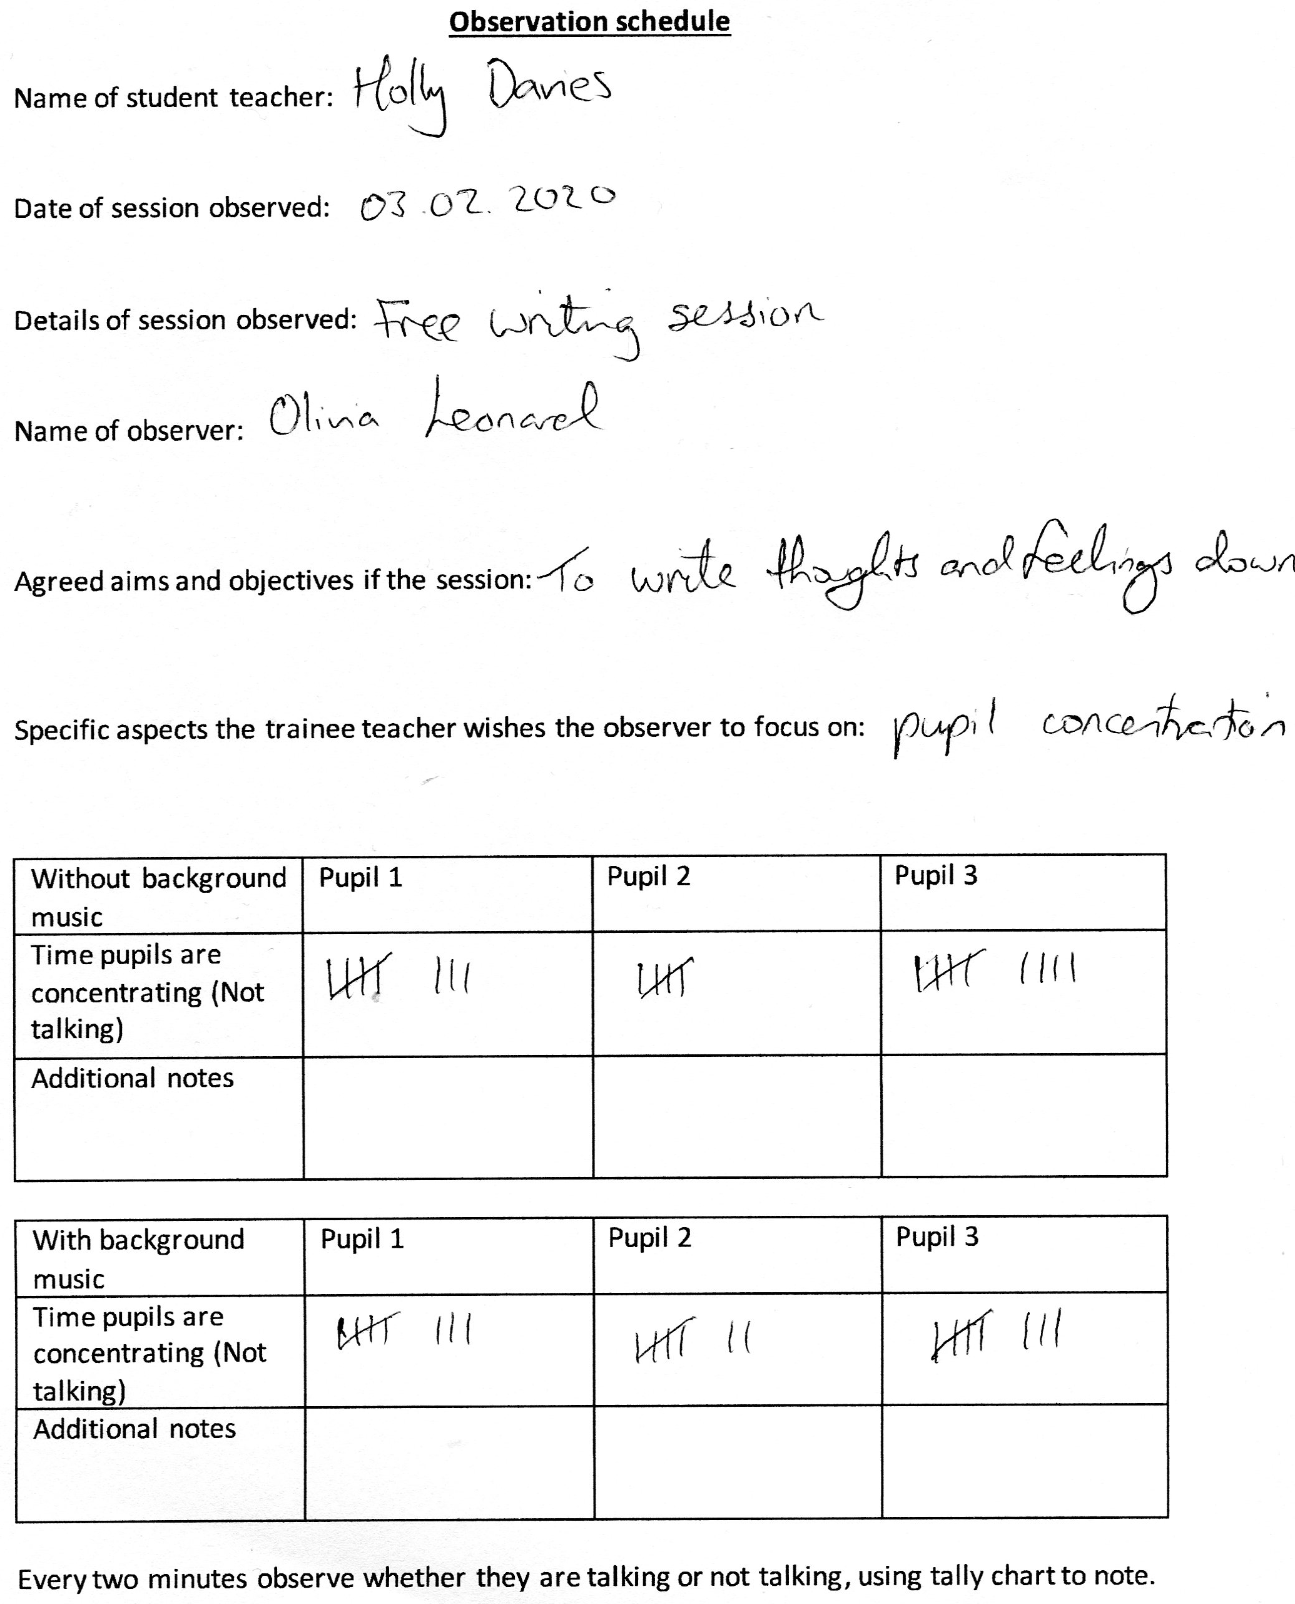
Appendix 1
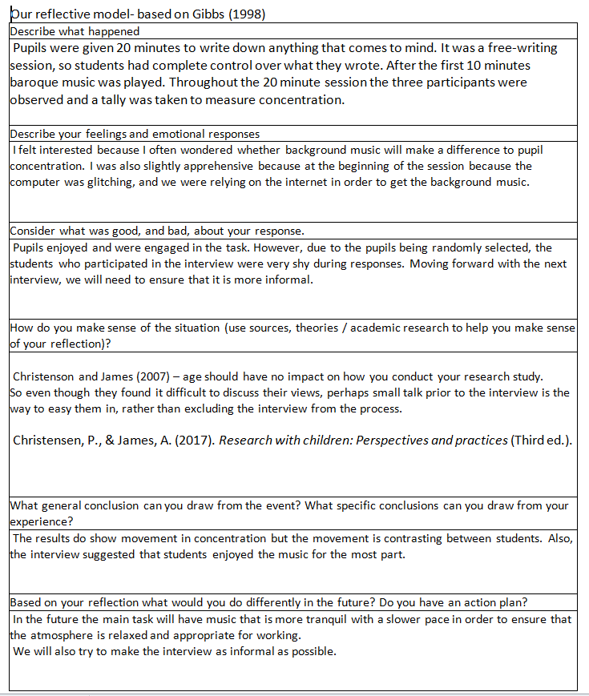
Appendix 2
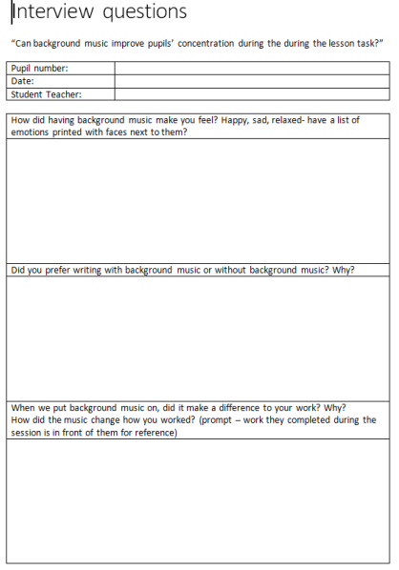
Appendix 3

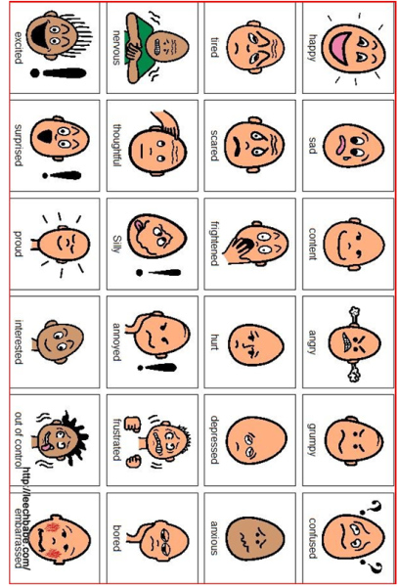

Appendix 4
Year 2/ 3 transcription.
Interviewer 2: How did the background music make you feel? I’ve got some pictures here for you of emotions if you want to have a little look at those. Child 1 how did it make you feel?
Child 1: relaxed.
Interviewer 1: And you child 2, how did the background music make you feel?
Child 2: confused.
Interviewer 1: And Child 3? How did it make you feel?
Child 3: relaxed.
Interviewer 1: Wonderful, thanks. Right, so, Child 3, did you prefer writing with background music or without it?
Child 3: With the music.
Interviewer 2: So why did you like having the background music on?
Child 3: It was relaxing and helped me concentrate.
Interviewer 2: child 2 did you prefer the lesson with or without the background music?
Child 2: With the music on
Interviewer 2: Why do you think that is?
Child 2: I don’t know
Interviewer 2: That’s okay. Child 1, which did you prefer, with the background music or without?
Child 1: With
Interviewer 2: Why was that?
Child 1: It helped me.
Interviewer 2: Okay, lovely, and when we put background music on, did it make a difference to your work child 3?
Child 3: Not really
Interviewer 2: Why was that?
Child 3: I don’t know
Interviewer 2: That’s okay, don’t worry.
Interviewer 1: What about you Child 1? Did it make a difference to your work do you think?
Child 1: No
Interviewer 1: No? Do you have a specific reason why?
Child 1: Because it makes me like, it makes me concentrate more.
Interviewer 1: Fantastic.
Interviewer 2: And Child 2, did the background music make a difference to your work?
Child 2: No.
Interviewer 2: No? And why do you think that is?
Child 2: I don’t know.
Interviewer 2: You don’t know? That’s alright.
Interviewer 1: Fab. So… do you think, did it change the way how you work? So not making a difference to your work, but how you work?
Child 1: No
Child 3: It kind of um…you could like.
Interviewer 2: It’s okay, you don’t have to say anything if you don’t want.
Interviewer 1: That’s alright. Did you have any other questions?
Interviewer 2: Did you enjoy the session?
All: Yes.
Interviewer 2: Did you like getting to write down everything you thought of?
Child 1+2: yes.
Interviewer 2: Would you like to do something like that again?
All: Yes.
Interviewer 2: Brilliant.
Child 3: You could just write anything, and everything.
Interviewer 2: Exactly. Right, well done.
Interviewer 1: You’ve done super.
Interviewer 2: Break time already, so if you all want to go over to your class now ready to go out, that would be great.
Interviewer 1: Thanks, you’ve been wonderful.

Appendix 5
Year 2/3 observation results
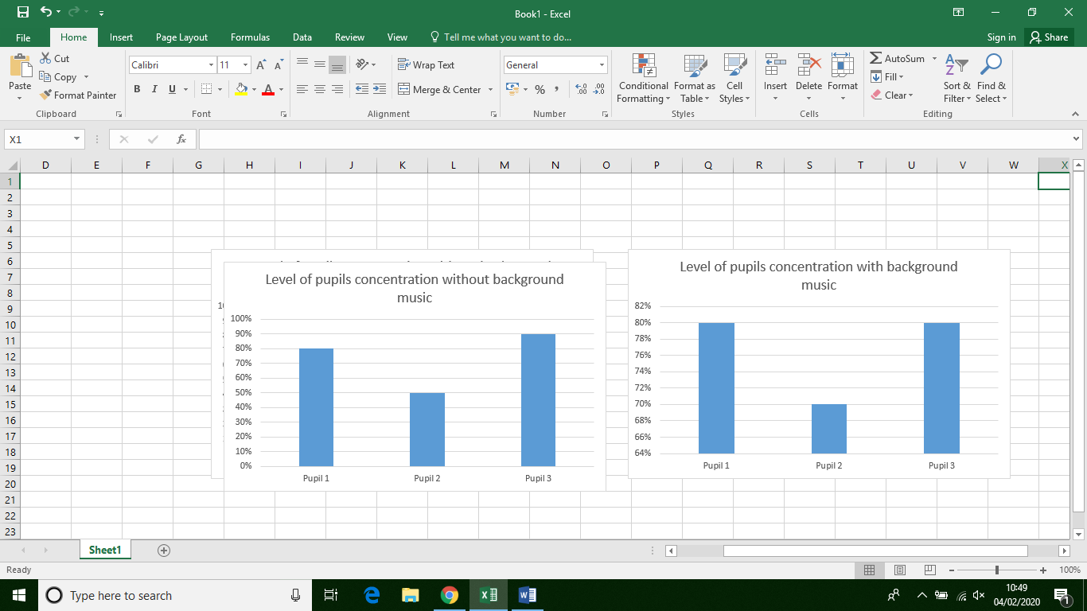

Appendix 6
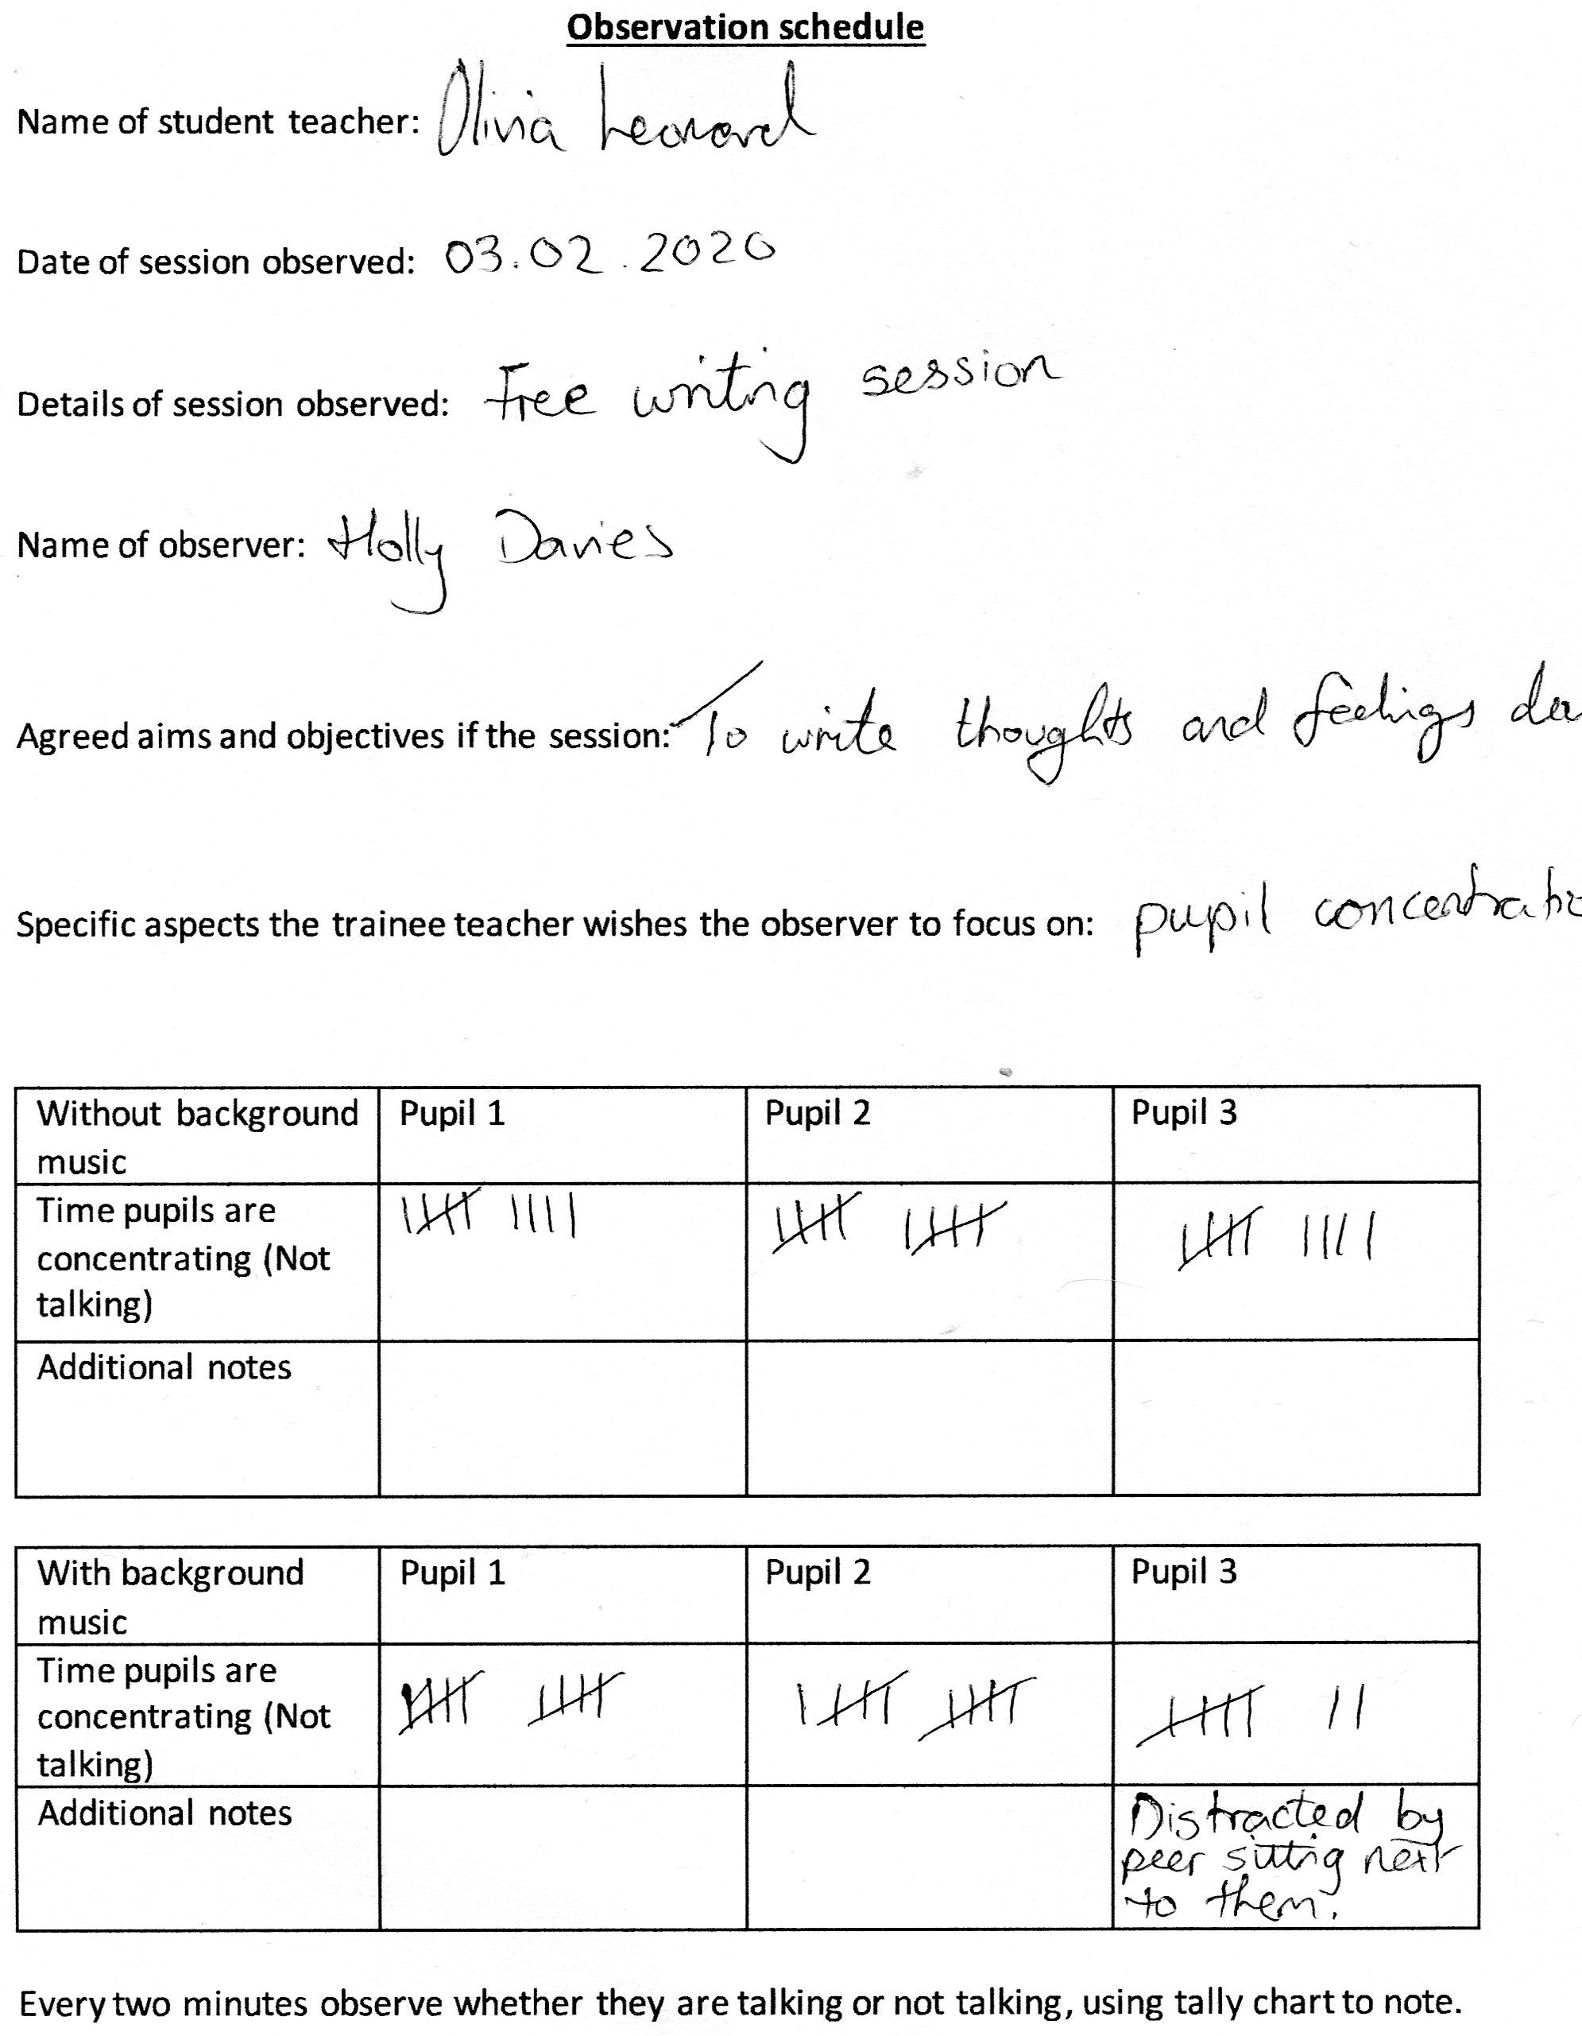

Appendix 7
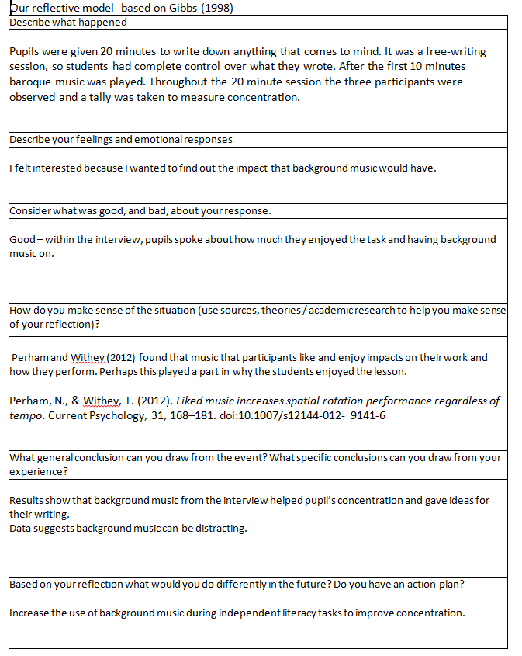
Appendix 8
Year 4/5 transcription.
Interviewer 1: How did having background music make you feel? Happy, sad, relaxed-Have a look at this list of emotions.
Pupil 2: I felt relaxed because it made me feel happy and cheerful.
Pupil 3: It calms me down when I hear the music, yeah say I was angry because my sister stepped on my toys, I just listen to that music and I feel better.
Interviewer 2: oh lovely.
Interviewer 1: What about you pupil 1?
Pupil 1: If I was worried or something I would listen to it and it would calm me down.
Interviewer 1: So the music would help to calm you down, brilliant.
Interviewer 1: So, pupil 2, did you prefer writing with background music or without background music?
Pupil 2: uuh, probably with it on because it made me feel relaxed and that I could write anything.
Interviewer 1: Fantastic.
Interviewer 2: Pupil 3 what about you?
Pupil 3: I preferred it with the background music because it just, like, helps me write, say if it was a hard word, I would just write it how I think it is and if there was not the background music I would have just stopped their thinking the whole time.
Interviewer 2: Nice okay.
Interviewer 1: And what do you think pupil 1?
Pupil 1: umm, It’s like, I preferred it with background music because if I find something quite worrying it made me feel more like calm.
Pupil 2: It kind of makes me feel like I can flow for a bit longer.
Interviewer 1: Lovely.
Pupil 2: And then when I’m thinking about it, I am with the music it makes me think about different things than I was before.
Interviewer 2: So it helped you actually to think about different things based on the music?
Pupil 2: Yeah.
Interviewer 2: Oh that’s cool.
Pupil 2: Because that kind of gave me the idea, what to write.
Interview 1: ohh.
Interviewer 1: We put background music on. Did it make a difference to you work? Why?
Pupil 2: It kind of made me, umm, it made me think that I can do it and that I can. And if I do it once I know I can do it. It helped me to think positive.
Interviewer 1: Fantastic
Interview 2: Pupil 3?
Pupil 3: First I was just writing and writing because I thought I need to get this done, but when I heard the music I got relaxed and I got more ideas.
Interview 1: Very interesting.
Pupil 1: It also makes me write positive and happy stuff rather than writing sad and scared things.
Interviewer 1: How did the music change how you worked? Like not what you were writing but how you worked?
Pupil 2: Uh it kind of made me feel like, it, that I could write in longer sentences and that I did not have to be as rushed.
Interviewer 2: Oh so that good to know, so you kind of relaxed into it a bit when the music went on and you slowed down a bit.
Pupil 2: Yeah because it, because I was struggling to write things but then suddenly I thought of something and I wrote it down quite quick. The music came on and then it kind of slowed me down and I was slowly doing it.
Interviewer 2: So do you think you would like background music on in more lessons?
All pupils: Yes.
Interviewer 2: Are there certain types of lessons that you don’t think you would want it on? Like do you think for maths, do you think it would be as helpful?
All pupils: No
Pupil 3: Maybe
Pupil 1: Maybe in English because it is like writing like a story.
Pupil 3: I think maybe not welsh.
Pupil 2: Because if I was in maths I would be thinking and then, it would just make me feel quite umm, like I wouldn’t be able to hear myself think.
Interviewer 2: Oh so it would be distracting?
Pupil 2: It would be distracting, as with, because then I would try and just work it out quite quickly in maths and then I can work it out instead I would find it harder if there was something in the background, distracting me. Like when there’s music on in a different class, it makes me feel a bit like uh.
Pupil 3: I think when it is the right music then it helps in maths like if it’s really punky music that wouldn’t work very well.
Interviewer 2: So do you think punky music would work in English, fast paced and that as well?
Pupil 3: umm no.
Pupil 2: I don’t think really fast music is good like if you.
Pupil 3: Makes you rush
Pupil 2: If like you meditate, if you look up that you can sometime find just music, like water.
Pupil 1: If it was a fast song it would make you think like I have to rush this and finish this before this song ends and it’s going to end quite soon.
Interviewer 2: Right so it would impact the way that you write, in that the fast song you would right quickly. That’s amazing!

Appendix 9

Year 4/5 observation results


