Oliver Richards

Pembrokeshire College
Introduction to web and database concepts

Contents
Introduction 2
Requirements 2
Implementation 3
Website screenshots 3
Validation 6
Evaluation 8
Evaluation of completed website 9
Usefulness 9
Search Engine Optimization (SEO) 9
Accessibility 10
References 11
Appendices 12

Introduction
This report will document the research I will conduct into web development and a website that I will create. Various aspects of web development, such as usability, accessibility, and search engine optimization, which I will use on my website, will be evaluated, and the code I produce will be validated.

Requirements
The website I have chosen to create is a lineup of all the BMW M cars as well as a table showing statistics of a range of other BMW car models. Its purpose is to provide a section of detailed writing about the selected M cars as well as an image slideshow for each. This subject matter is a niche area of BMW due to their extensive lineup of vehicles and the intended target audience is people who want to find out more information or learn about the M lineup. I aim to make it a very BMW themed whilst keeping it simplistic to ensure that it is easy to use whilst catching the user’s attention. I will also aim to make my website with the best practices possible, meaning that I will use clean and well-written code so that it works quickly and effectively. I will also make my content clear and understandable so that anyone will be able to use my website.

Implementation

Website screenshots
Page 1
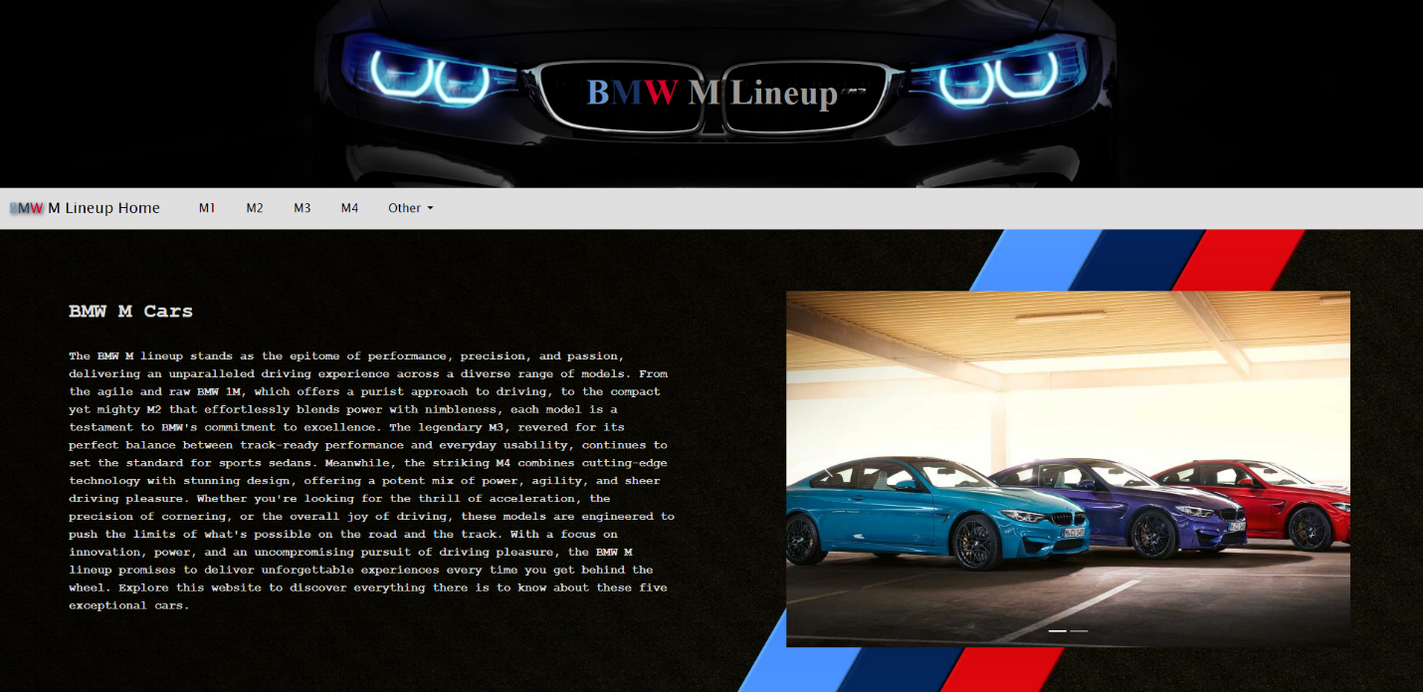
This is the home page of my website; I have a very simple layout consisting of the image at the top, the navigation bar, the background, text on the left, and an image carousel on the right. I used Bootstrap documentation to create the navbar and carousel using their framework. [1]

Page 2, 3, 4, and 5
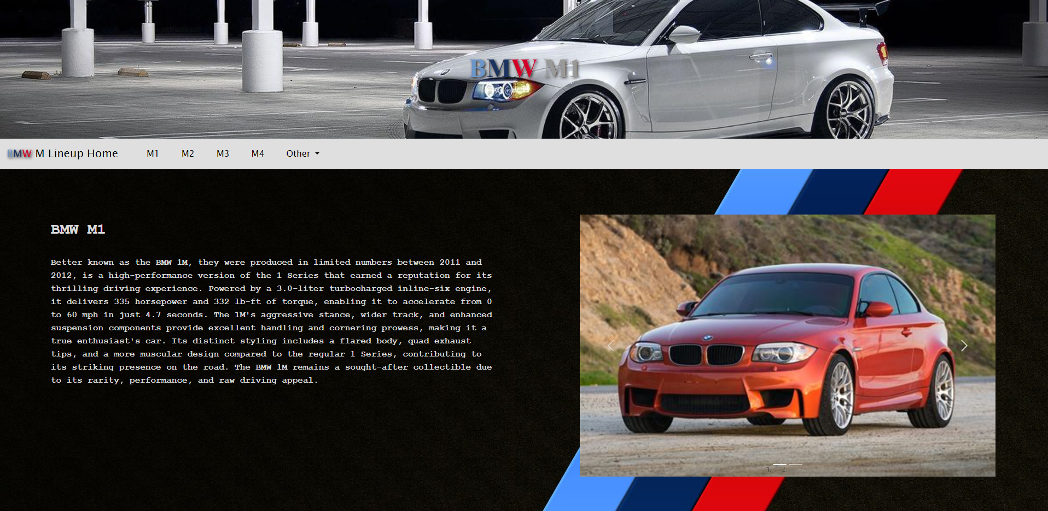

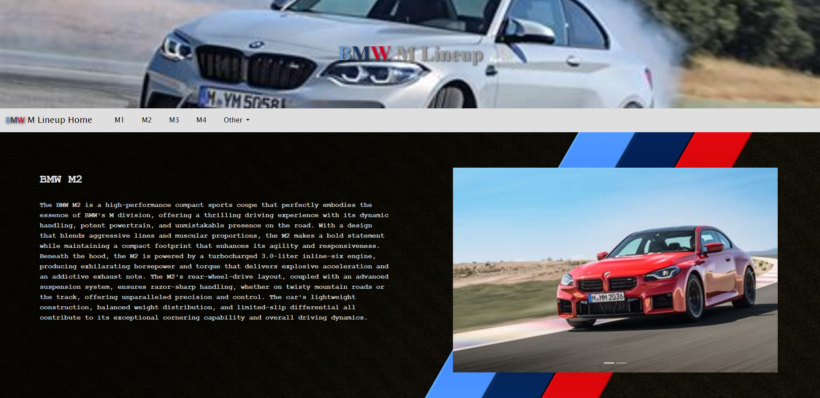
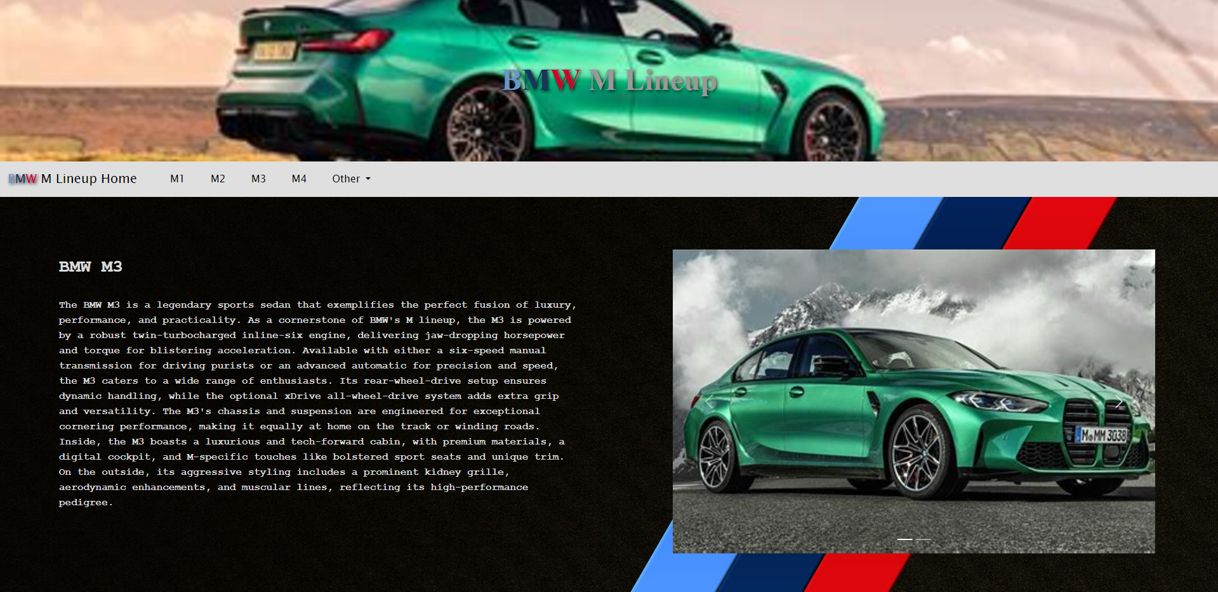

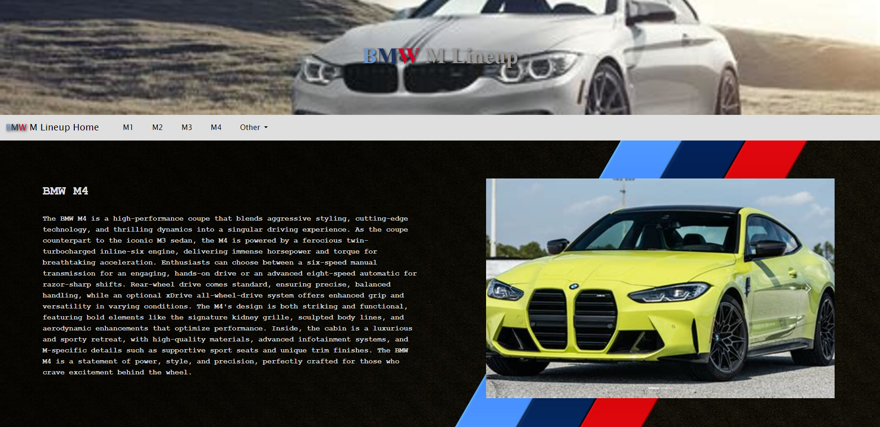
The M1, M2, M3, and M4 pages all follow the same layout as the home page except the top image, text and image carousel are unique to each page. Having the same layout on each page makes it easier to make as the same classes can be used on my CSS page.

Page 6
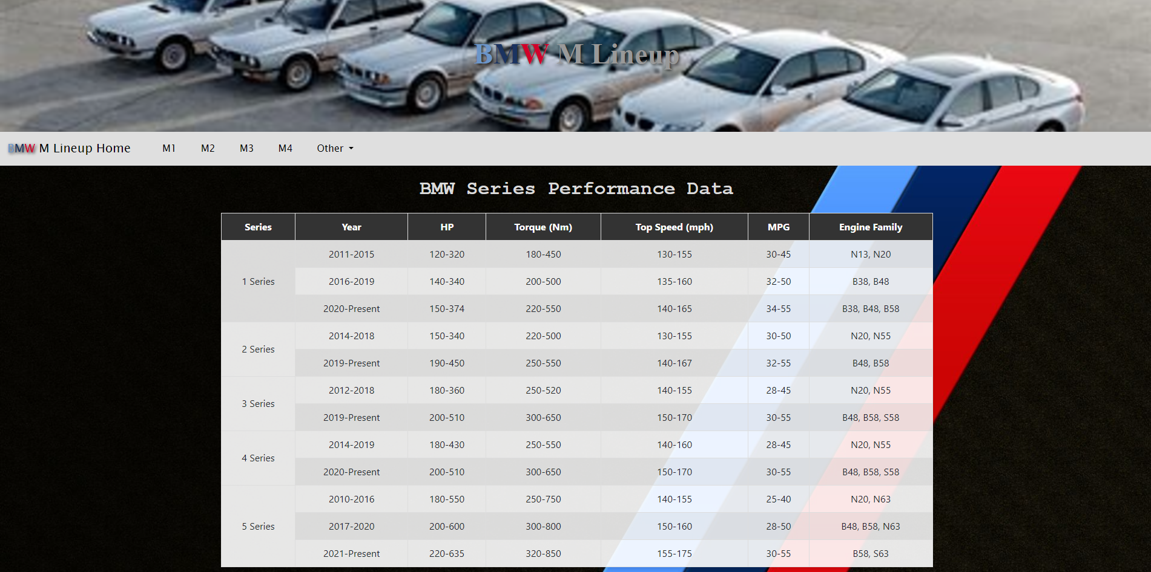
To implement some variety into the website I created a large HTML table. I chose to use raw HTML and CSS rather than Bootstraps table guide using their framework. [2]

Validation
HTML - Page 1
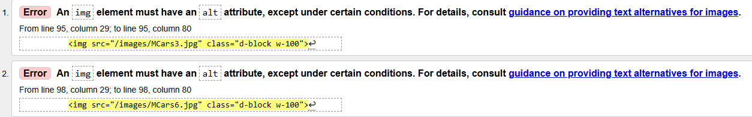
When validating my first page I came across this error. I had not added the alt tag to the images on my carousel on the page. This tag is important as it provides information on what the image is in case it cannot be displayed. Luckily, it is an easy fix, and I updated my code to include these on each image.
HTML – Pages 1, 2, 3, 4, and 6
All the rest of my HTML did not contain a single error or warning which will help improve website usability and user satisfaction.
CSS

My CSS style sheet also did not contain any errors. When making a style sheet it is likely that no errors will be made as it is for designing the look of the website and if any small details are missed, there will likely not be anything that will cause an error.

Evaluation
The quality of a website can be based on many things however the website’s usability, accessibility, and search engine optimization are some of the most important ways of measuring this.
What makes a website ‘usable’ depends on the goals and nature of the site, “In general terms, websites that are usable provide well-organized, useful, easy-to-navigate information in a well-structured format.” [3] If a website can provide all of these then it will promote user retention and satisfaction – this then can lead to people coming back to the website in the future and giving recommendations to others, which is especially important to businesses. ‘Prioritizing Web Usability’ by Jakob Nielson and Heo Loranger is a book which contains studies of users and how websites that focus on a user-centric design rather than the preferences of designers and organizations are much more successful. Nielson describes users as “ruthless and mercenary” and that “If your site makes things hard, they’ll leave and never come back”. [4] The key findings from the book are that user experience, meeting user needs, simplicity, and first impressions are essential for a successful website. All of these are focused on the user over any other aspect of the website, but this principle has not aged at all. “Designing and developing websites without the end users in mind can drastically affect the overall user experience, no matter how fancy a website is.” [5] – This is an extract from a website that was published 19 years after the ‘Prioritizing Web Usability’ book was published, and it can be seen that a user-centric design to a website is still the most important factor.
“The power of the web is in its universality. Access by everyone regardless of disability is an essential aspect.” [6] Web accessibility is ever growing in popularity and encompasses all disabilities that can affect web access such as: physical, visual, speech, and neurological. Web accessibility is not only for people with disabilities, some people can only access the web through a small screen such as mobile phones or smart watches, and some people struggle with slow internet connection. Jim Thatcher, an expert on web accessibility, published a book, again in 2006, called ‘Web Accessibility: Web Standards and Regulatory Compliance’. The main themes and concepts in the book are web standards and guidelines, legal compliance, assistive technologies, and practical implementation. He explains that “Accessibility is not a feature, it’s a fundamental aspect of a web experience that should be integrated from the start” [7]. Making a website highly accessible will also improve the number of people who use it as it will out compete with similar websites but with lower levels of accessibility. To help content developers make their pages more accessible, the Web Content Accessibility Guidelines (WCAG) was developed by individuals and organizations from all around the world. It has a goal of “Providing a single shared standard for web content accessibility that meets the needs of individuals, organizations, and governments internationally.” [8] WCAG 2.0 was published in 2008 and is approved as an ISO standard (ISO/IEC 40500). WCAG 2.2, which is the newest version of WCAG which has an extra guideline and several new success criteria over WCAG 2.0, is likely to be approved as an ISO standard after June 2025.
Search Engine Optimization (SEO) is important for a website as it can affect how successful it is and the number of people who view it. “It’s the process of improving your site to increase the chance that it will show up in relevant searches on search engines like Google.” [9] SEO can be broken into three key principles: On-page optimization, off-page optimization, and technical optimization. [10] On-page is the process of ensuring that the content on the site is relevant and gives a good user experience. Off-page is where the enhancing of the site’s search engine rankings through things such as high-quality backlinks to help build a reputation. Finally, technical optimization is a behind the scenes process like making well structured code which works across all search engines. It is important to ensure these three principles are all implemented into a website before it is published to reach the best level of SEO. “Factors such as visibility and high ranking on search engines’ results page remain crucially important for media organizations.” [11] This is taken from Andreas Veglis’ ‘Search Engine Optimization’ in which he covers a range of subjects closely related to SEO as well as SEO itself. It includes the two previously discussed subjects: website usability and accessibility and explains how they are both important for SEO as they help build a reputation for a website.

Evaluation of completed website

Usefulness
Before a websites usefulness can be determined, it must be functional – “The functionality of a website refers to its ability to perform key tasks efficiently, such as loading quickly, displaying content responsively, enabling easy navigation and supporting interactive features.” [12] As can be seen on all pages on my website, I have a navigation bar which contains links to all other pages, these links work effectively, and the pages are loaded in quickly and seamlessly. The carousel on almost all pages of my website also has great functionality as the arrows used to navigate through the images also work quickly and without error. My website has great usability as all pages are easy to use and it has a very simple look and feel, this means all the content can be seen on each page without the need to scroll (apart from the table on the statistics page) so it makes it easy for the user to find what they are looking for. However, if I were to make any changes, I would change the color of the arrows on the carousel to make them more visible as they currently blend in quite well with some of the images. I would also include more content as currently, there is not enough to retain a user’s attention for a long period of time and also not enough to get reoccurring users.

Search Engine Optimization (SEO)
Search Engine Optimization is important in general for increasing the number of users on a website, however, on-page SEO in particular is especially important for gaining reputation from good user-experience. Some factors that contribute towards on-page SEO are good site content, key words, images, and title tags. [13] Although there is not a considerable amount of content on each of my pages, all of it contains a lot of key words related to the topic and my title tags are all appropriate for the content. As well as the written content on each page there are also multiple images – the carousels that I have included on my website also mean I could add extra relevant images to each page.

Accessibility
The four main principles of web accessibility are: Perceivable, Operable, Understandable, and Robust. [14] I have implemented perceivability onto my website by using plain colors and simple font. A perceivable website also needs a text contrast ratio of at least 7:1 [15]. Using a contrast checker, I discovered that my contrast ratio is 14.41 which is AAA accessibility level. WCAG 2.1 specifies heavily that a website needs to be keyboard operable: “All functionality of the content is operable through a keyboard interface without requiring specific timings for individual keystrokes.” [15] This is something that I need to further work on as my website does not have any keyboard functionality. My website also needs to be understandable meaning my content must be clear and concise for every user, also “Keep the web design and content structure constant throughout your website” [16] As can be seen on my website, all my pages have the same structure (apart from the stats page) so that users do not become confused when using it. Lastly is robustness, in short this means that a website should have the most reliable and clean code possible so that it “runs smoothly across other platforms and browsers.” [17] My website runs perfectly on all browsers that I tested; these were Chrome, DuckDuckGo, Firefox, and edge - This is likely due to the simplicity of my code. The final tool I used to test the assess the accessibility of my website was lighthouse which is part of dev tools. As shown below, it performed well in every category it checks meaning that my website shows a high level of accessibility. The only point that it noted down to be changed was a header tag (h2) which was above another header tag (h1) on my statistics page. This is a simple fix, but it could be avoided by better HTML page design which I will aim to achieve in the future.
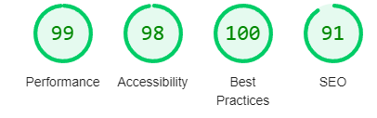

References

[1] | Bootstrap, "Get started with Bootstrap," Bootstrap, [Online]. Available: https://getbootstrap.com/docs/5.3/getting-started/introduction/. [Accessed 19 January 2025].
[2] | Bootstrap, "Tables," Bootstrap, [Online]. Available: https://getbootstrap.com/docs/5.3/content/tables/#overview. [Accessed 19 January 2025].
[3] | C. Holst, "Website Usability Best Practices (Backed By Research)," Baymard.com, [Online]. Available: https://baymard.com/learn/website-usability. [Accessed 17 January 2025].
[4] | J. Nielson and H. Loranger, Prioritizing Web Usability, California: New Riders, 2006.
[5] | Ramotion, "Website Usability 101: Definition, Principles and Methods," ramotion.com, 17 April 2023. [Online]. Available: https://www.ramotion.com/blog/website-usability/. [Accessed 17 January 2025].
[6] | S. L. Henry, "Introduction to Web Accessibility," w3.org, 7 March 2024. [Online]. Available: https://www.w3.org/WAI/fundamentals/accessibility-intro/. [Accessed 17 January 2025].
[7] | J. Thatcher, Web accessibility : web standards and regulatory compliance, New Jersey: FriendsofED, 2006.
[8] | S. L. Henry, "WCAG 2 Overview," w3.org, 12 December 2024. [Online]. Available: https://www.w3.org/WAI/standards-guidelines/wcag/. [Accessed 22 January 2025].
[9] | Digital Culture Network, "What is Search Engine Optimisation (SEO)?," digitalculturenetwork, [Online]. Available: https://digitalculturenetwork.org.uk/knowledge/what-is-search-engine-optimisation-seo/. [Accessed 22 January 2025].
[10] | C. Melinn, "What Is SEO And How Does It Work?," digitalmarketinginstitute, 27 February 2024. [Online]. Available: https://digitalmarketinginstitute.com/blog/what-is-seo. [Accessed 22 January 2025].
[11] | A. Veglis and D. Giomelakis, Search Engine Optimization, Basel: MDPI, 2021.
[12] | T. Molnar, "9 Important Website Functionalities Vital For Ranking," fitdesignldn, [Online]. Available: https://www.fitdesignldn.com/post/functionalities-of-a-website#:~:text=Website%20functionality%20is%20a%20cornerstone,visitors%20and%20keep%20them%20engaged.. [Accessed 23 January 2025].
[13] | K. Lyons, "On-Page SEO: What It Is and How to Do It," Semrush, 15 December 2023. [Online]. Available: https://www.semrush.com/blog/on-page-seo/. [Accessed 25 January 2025].
[14] | WillowTree Staff, "The Four Principles of Accessibility," Willow Tree, [Online]. Available: https://www.willowtreeapps.com/craft/the-four-principles-of-accessibility. [Accessed 28 January 2025].
[15] | w3.org, "Web Content Accessibility Guidelines (WCAG) 2.1," w3.org, 12 December 2024. [Online]. Available: https://www.w3.org/TR/WCAG21/#contrast-enhanced. [Accessed 28 January 2025].
[16] | Accessibility Spark, "4 Principles of W3C Web Content Accessibility," Accessibility Spark, 18 September 2022. [Online]. Available: https://accessibilityspark.com/4-principles-of-w3c-web-content-accessibility/. [Accessed 30 January 2025].
[17] | ADA for web, "Introduction to POUR - Four Principles Of Web Accessibility," ADA for web, 22 June 2022. [Online]. Available: https://adaforweb.com/four-principles-of-web-accessibility/. [Accessed 30 January 2025].

Appendices
Page 1
<!doctype html>
<html lang="en"> <!--Specifies the document type and language-->

<head>
<meta charset="utf-8">
<meta name="viewport" content="width=device-width, initial-scale=1"> <!--Makes the page scalable on all devices-->
<title>BMW M Lineup</title>
<link href="https://cdn.jsdelivr.net/npm/bootstrap@5.3.3/dist/css/bootstrap.min.css" rel="stylesheet"
integrity="sha384-QWTKZyjpPEjISv5WaRU9OFeRpok6YctnYmDr5pNlyT2bRjXh0JMhjY6hW+ALEwIH" crossorigin="anonymous"> <!--Bootstap link-->
<link href="style.css" rel="stylesheet" type="text/css"> <!--Link to stylesheet-->
</head>

<body>
<header> <!--Header of the page which contains the background and page title-->
<h1 class="homePageImage topBackground">
<span class="B">B</span><span class="M">M</span><span class="W">W</span><span class="Silver"> M
Lineup</span> <!--Spans are used to give individual letters a class to change their colour-->
</h1>
</header>
<nav class="navbar sticky-top navbar-expand-lg"> <!--Bootstrap navbar-->
<div class="container-fluid">
<div class="navbar-brand">
<a class="navbar-brand" href="Index.html"><span class="B">B</span><span class="M">M</span><span
class="W">W</span><span> M Lineup Home</span> <!--Link to the home page-->
</a>
</div>
<ul class="nav navbar-nav me-auto mb-lg-0"> <!--An unordered list with links to the rest of the pages -->
<li>
<div class="container-lg">
<a class="navMLinks nav-link" href='m1.html'>M1</a>
</div>
</li>
<li>
<div class="container-lg">
<a class="navMLinks nav-link" href='m2.html'>M2</a>
</div>
</li>
<li>
<div class="container-lg">
<a class="navMLinks nav-link" href='m3.html'>M3</a>
</div>
</li>
<li>
<div class="container-lg">
<a class="navMLinks nav-link" href='m4.html'>M4</a>
</div>
</li>
<li class="nav-item dropdown"> <!--A dropdown list on the navbar-->
<div class="container-md">
<a class="navMLinks nav-link dropdown-toggle" role="button" data-bs-toggle="dropdown">
Other
</a>
<ul class="dropdown-menu">
<li><a class="navMLinks dropdown-item" href="statsTable.html">Super Stats Table</a></li> <!--Link to the stats page-->
</ul>
</div>
</li>
</ul>
</div>
</nav>
<section>
<div class="bodyBack"> <!--This div contains all of the content of the page-->
<div class="pageleft"> <!--This div contains all of the content on the left side of the page-->
<br>
<h3 class="MCars">BMW M Cars</h3>
<br>
<p class="MCars">The BMW M lineup stands as the epitome of performance, precision, and passion,
delivering an unparalleled driving experience across a diverse range of models. From the agile and
raw BMW 1M, which offers a purist approach to driving, to the compact yet mighty M2 that
effortlessly blends power with nimbleness, each model is a testament to BMW's commitment to
excellence. The legendary M3, revered for its perfect balance between track-ready performance and
everyday usability, continues to set the standard for sports sedans. Meanwhile, the striking M4
combines cutting-edge technology with stunning design, offering a potent mix of power, agility, and
sheer driving pleasure. Whether you're looking for the thrill of acceleration, the precision of
cornering, or the overall joy of driving, these models are engineered to push the limits of what's
possible on the road and the track. With a focus on innovation, power, and an uncompromising pursuit
of driving pleasure, the BMW M lineup promises to deliver unforgettable experiences every time you
get behind the wheel. Explore this website to discover everything there is to know about these five
exceptional cars.
</p>
</div>
<div class="pageright"> <!--This div contains all of the content on the right side of the page-->
<br>
<br>
<div id="homeCarousel" class="carousel slide" data-bs-ride="carousel"> <!--Bootstrap carousel-->
<!-- Indicators on the carousel-->
<ol class="carousel-indicators">
<li data-bs-target="#homeCarousel" data-bs-slide-to="0" class="active"></li>
<li data-bs-target="#homeCarousel" data-bs-slide-to="1"></li>
</ol>

<!-- Wrapper for carousel slides -->
<div class="carousel-inner">
<div class="carousel-item active">
<img src="/images/MCars3.jpg" alt="Image of M Cars" class="d-block w-100">
</div>
<div class="carousel-item">
<img src="/images/MCars6.jpg" alt="Image of M Cars" class="d-block w-100">
</div>
</div>

<!-- Left and right arrows -->
<button class="carousel-control-prev" type="button" data-bs-target="#homeCarousel"
data-bs-slide="prev">
<span class="carousel-control-prev-icon" aria-hidden="true"></span>
<span class="visually-hidden">Previous</span>
</button>
<button class="carousel-control-next" type="button" data-bs-target="#homeCarousel"
data-bs-slide="next">
<span class="carousel-control-next-icon" aria-hidden="true"></span>
<span class="visually-hidden">Next</span>
</button>
</div>
</div>
</div>
</section>
<script src="https://cdn.jsdelivr.net/npm/bootstrap@5.3.3/dist/js/bootstrap.bundle.min.js"
integrity="sha384-YvpcrYf0tY3lHB60NNkmXc5s9fDVZLESaAA55NDzOxhy9GkcIdslK1eN7N6jIeHz" crossorigin="anonymous">
</script> <!--Bootstraps JavaScript link-->
</body>
</html>

Page 2
<!doctype html>
<html lang="en">

<head>
<meta charset="utf-8">
<meta name="viewport" content="width=device-width, initial-scale=1">
<title>BMW M1</title>
<link href="https://cdn.jsdelivr.net/npm/bootstrap@5.3.3/dist/css/bootstrap.min.css" rel="stylesheet"
integrity="sha384-QWTKZyjpPEjISv5WaRU9OFeRpok6YctnYmDr5pNlyT2bRjXh0JMhjY6hW+ALEwIH" crossorigin="anonymous">
<link href="style.css" rel="stylesheet" type="text/css">
</head>

<body>
<header>
<h1 class="M1Image topBackground">
<span class="B">B</span><span class="M">M</span><span class="W">W</span><span class="Silver"> M1</span>
</h1>
</header>

<nav class="navbar sticky-top navbar-expand-lg">
<div class="container-fluid">
<div class="navbar-brand">
<a class="navbar-brand" href="Index.html"><span class="B">B</span><span class="M">M</span><span
class="W">W</span><span> M Lineup Home</span>
</a>
</div>
<ul class="nav navbar-nav me-auto mb-lg-0">
<li>
<div class="container-lg">
<a class="navMLinks nav-link" href='m1.html'>M1</a>
</div>
</li>
<li>
<div class="container-lg">
<a class="navMLinks nav-link" href='m2.html'>M2</a>
</div>
</li>
<li>
<div class="container-lg">
<a class="navMLinks nav-link" href='m3.html'>M3</a>
</div>
</li>
<li>
<div class="container-lg">
<a class="navMLinks nav-link" href='m4.html'>M4</a>
</div>
</li>
<li class="nav-item dropdown">
<div class="container-md">
<a class="navMLinks nav-link dropdown-toggle" role="button" data-bs-toggle="dropdown">
Other
</a>
<ul class="dropdown-menu">
<li><a class="navMLinks dropdown-item" href="statsTable.html">Super Stats Table</a></li>
</ul>
</div>
</li>
</ul>
</div>
</nav>
<section>
<div class="bodyBack">
<div class="pageleft">
<br>
<h3 class="MCars">
BMW M1
</h3>
<br>
<p class="MCars">
Better known as the BMW 1M, they were produced in limited numbers between 2011 and 2012, is a
high-performance version of the
1 Series that earned a reputation for its thrilling driving experience. Powered by a 3.0-liter
turbocharged inline-six engine, it delivers 335 horsepower and 332 lb-ft of torque, enabling it to
accelerate from 0 to 60 mph in just 4.7 seconds. The 1M's aggressive stance, wider track, and
enhanced suspension components provide excellent handling and cornering prowess, making it a true
enthusiast's car. Its distinct styling includes a flared body, quad exhaust tips, and a more
muscular design compared to the regular 1 Series, contributing to its striking presence on the road.
The BMW 1M remains a sought-after collectible due to its rarity, performance, and raw driving
appeal.
</p>
</div>
<div class="pageright">
<br>
<br>
<div id="homeCarousel" class="carousel slide" data-bs-ride="carousel">
<!-- Indicators -->
<ol class="carousel-indicators">
<li data-bs-target="#homeCarousel" data-bs-slide-to="0" class="active"></li>
<li data-bs-target="#homeCarousel" data-bs-slide-to="1"></li>
</ol>

<!-- Wrapper for slides -->
<div class="carousel-inner">
<div class="carousel-item active">
<img src="/images/1M1.jpg" class="d-block w-100">
</div>
<div class="carousel-item">
<img src="/images/1M2.jpg" class="d-block w-100">
</div>
</div>

<!-- Left and right controls -->
<button class="carousel-control-prev" type="button" data-bs-target="#homeCarousel"
data-bs-slide="prev">
<span class="carousel-control-prev-icon" aria-hidden="true"></span>
<span class="visually-hidden">Previous</span>
</button>
<button class="carousel-control-next" type="button" data-bs-target="#homeCarousel"
data-bs-slide="next">
<span class="carousel-control-next-icon" aria-hidden="true"></span>
<span class="visually-hidden">Next</span>
</button>
</div>
</div>
</div>
</section>
<script src="https://cdn.jsdelivr.net/npm/bootstrap@5.3.3/dist/js/bootstrap.bundle.min.js"
integrity="sha384-YvpcrYf0tY3lHB60NNkmXc5s9fDVZLESaAA55NDzOxhy9GkcIdslK1eN7N6jIeHz" crossorigin="anonymous">
</script>

</body>
</html>

Page 3
<!doctype html>
<html lang="en">

<head>
<meta charset="utf-8">
<meta name="viewport" content="width=device-width, initial-scale=1">
<title>BMW M Lineup</title>
<link href="https://cdn.jsdelivr.net/npm/bootstrap@5.3.3/dist/css/bootstrap.min.css" rel="stylesheet"
integrity="sha384-QWTKZyjpPEjISv5WaRU9OFeRpok6YctnYmDr5pNlyT2bRjXh0JMhjY6hW+ALEwIH" crossorigin="anonymous">
<link href="style.css" rel="stylesheet" type="text/css">
</head>

<body>
<header>
<h1 class="M2Image topBackground">
<span class="B">B</span><span class="M">M</span><span class="W">W</span><span class="Silver"> M
Lineup</span>
</h1>
</header>
<nav class="navbar sticky-top navbar-expand-lg">
<div class="container-fluid">
<div class="navbar-brand">
<a class="navbar-brand" href="Index.html"><span class="B">B</span><span class="M">M</span><span
class="W">W</span><span> M Lineup Home</span>
</a>
</div>
<ul class="nav navbar-nav me-auto mb-lg-0">
<li>
<div class="container-lg">
<a class="navMLinks nav-link" href='m1.html'>M1</a>
</div>
</li>
<li>
<div class="container-lg">
<a class="navMLinks nav-link" href='m2.html'>M2</a>
</div>
</li>
<li>
<div class="container-lg">
<a class="navMLinks nav-link" href='m3.html'>M3</a>
</div>
</li>
<li>
<div class="container-lg">
<a class="navMLinks nav-link" href='m4.html'>M4</a>
</div>
</li>
<li class="nav-item dropdown">
<div class="container-md">
<a class="navMLinks nav-link dropdown-toggle" role="button" data-bs-toggle="dropdown">
Other
</a>
<ul class="dropdown-menu">
<li><a class="navMLinks dropdown-item" href="statsTable.html">Super Stats Table</a></li>
</ul>
</div>
</li>
</ul>
</div>
</nav>
<section>
<div class="bodyBack">
<div class="pageleft">
<br>
<h3 class="MCars">BMW M2</h3>
<br>
<p class="MCars">
The BMW M2 is a high-performance compact sports coupe that perfectly embodies the essence of BMW's M
division, offering a thrilling driving experience with its dynamic handling, potent powertrain, and
unmistakable presence on the road. With a design that blends aggressive lines and muscular
proportions, the M2 makes a bold statement while maintaining a compact footprint that enhances its
agility and responsiveness. Beneath the hood, the M2 is powered by a turbocharged 3.0-liter
inline-six engine, producing exhilarating horsepower and torque that delivers explosive acceleration
and an addictive exhaust note. The M2's rear-wheel-drive layout, coupled with an advanced suspension
system, ensures razor-sharp handling, whether on twisty mountain roads or the track, offering
unparalleled precision and control. The car's lightweight construction, balanced weight
distribution, and limited-slip differential all contribute to its exceptional cornering capability
and overall driving dynamics.
</p>
</div>
<div class="pageright">
<br>
<br>
<div id="homeCarousel" class="carousel slide" data-bs-ride="carousel">
<!-- Indicators -->
<ol class="carousel-indicators">
<li data-bs-target="#homeCarousel" data-bs-slide-to="0" class="active"></li>
<li data-bs-target="#homeCarousel" data-bs-slide-to="1"></li>
</ol>

<!-- Wrapper for slides -->
<div class="carousel-inner">
<div class="carousel-item active">
<img src="/images/M21.jpg" class="d-block w-100">
</div>
<div class="carousel-item">
<img src="/images/M22.jpg" class="d-block w-100">
</div>
</div>

<!-- Left and right controls -->
<button class="carousel-control-prev" type="button" data-bs-target="#homeCarousel"
data-bs-slide="prev">
<span class="carousel-control-prev-icon" aria-hidden="true"></span>
<span class="visually-hidden">Previous</span>
</button>
<button class="carousel-control-next" type="button" data-bs-target="#homeCarousel"
data-bs-slide="next">
<span class="carousel-control-next-icon" aria-hidden="true"></span>
<span class="visually-hidden">Next</span>
</button>
</div>
</div>
</div>
</section>
<script src="https://cdn.jsdelivr.net/npm/bootstrap@5.3.3/dist/js/bootstrap.bundle.min.js"
integrity="sha384-YvpcrYf0tY3lHB60NNkmXc5s9fDVZLESaAA55NDzOxhy9GkcIdslK1eN7N6jIeHz" crossorigin="anonymous">
</script>

</body>
</html>

Page 4
<!doctype html>
<html lang="en">
<head>
<meta charset="utf-8">
<meta name="viewport" content="width=device-width, initial-scale=1">
<title>BMW M Lineup</title>
<link href="https://cdn.jsdelivr.net/npm/bootstrap@5.3.3/dist/css/bootstrap.min.css" rel="stylesheet"
integrity="sha384-QWTKZyjpPEjISv5WaRU9OFeRpok6YctnYmDr5pNlyT2bRjXh0JMhjY6hW+ALEwIH" crossorigin="anonymous">
<link href="style.css" rel="stylesheet" type="text/css">
</head>

<body>
<header>
<h1 class="M3Image topBackground">
<span class="B">B</span><span class="M">M</span><span class="W">W</span><span class="Silver"> M
Lineup</span>
</h1>
</header>
<nav class="navbar sticky-top navbar-expand-lg">
<div class="container-fluid">
<div class="navbar-brand">
<a class="navbar-brand" href="Index.html"><span class="B">B</span><span class="M">M</span><span
class="W">W</span><span> M Lineup Home</span>
</a>
</div>
<ul class="nav navbar-nav me-auto mb-lg-0">
<li>
<div class="container-lg">
<a class="navMLinks nav-link" href='m1.html'>M1</a>
</div>
</li>
<li>
<div class="container-lg">
<a class="navMLinks nav-link" href='m2.html'>M2</a>
</div>
</li>
<li>
<div class="container-lg">
<a class="navMLinks nav-link" href='m3.html'>M3</a>
</div>
</li>
<li>
<div class="container-lg">
<a class="navMLinks nav-link" href='m4.html'>M4</a>
</div>
</li>
<li class="nav-item dropdown">
<div class="container-md">
<a class="navMLinks nav-link dropdown-toggle" role="button" data-bs-toggle="dropdown">
Other
</a>
<ul class="dropdown-menu">
<li><a class="navMLinks dropdown-item" href="statsTable.html">Super Stats Table</a></li>
</ul>
</div>
</li>
</ul>
</div>
</nav>
<section>
<div class="bodyBack">
<div class="pageleft">
<br>
<h3 class="MCars">BMW M3</h3>
<br>
<p class="MCars">
The BMW M3 is a legendary sports sedan that exemplifies the perfect fusion of luxury, performance,
and practicality. As a cornerstone of BMW's M lineup, the M3 is powered by a robust
twin-turbocharged inline-six engine, delivering jaw-dropping horsepower and torque for blistering
acceleration. Available with either a six-speed manual transmission for driving purists or an
advanced automatic for precision and speed, the M3 caters to a wide range of enthusiasts. Its
rear-wheel-drive setup ensures dynamic handling, while the optional xDrive all-wheel-drive system
adds extra grip and versatility. The M3's chassis and suspension are engineered for exceptional
cornering performance, making it equally at home on the track or winding roads. Inside, the M3
boasts a luxurious and tech-forward cabin, with premium materials, a digital cockpit, and M-specific
touches like bolstered sport seats and unique trim. On the outside, its aggressive styling includes
a prominent kidney grille, aerodynamic enhancements, and muscular lines, reflecting its
high-performance pedigree.
</p>
</div>
<div class="pageright">
<br>
<br>
<div id="homeCarousel" class="carousel slide" data-bs-ride="carousel">
<!-- Indicators -->
<ol class="carousel-indicators">
<li data-bs-target="#homeCarousel" data-bs-slide-to="0" class="active"></li>
<li data-bs-target="#homeCarousel" data-bs-slide-to="1"></li>
</ol>

<!-- Wrapper for slides -->
<div class="carousel-inner">
<div class="carousel-item active">
<img src="/images/M31.jpg" class="d-block w-100">
</div>
<div class="carousel-item">
<img src="/images/M32.jpg" class="d-block w-100">
</div>
</div>

<!-- Left and right controls -->
<button class="carousel-control-prev" type="button" data-bs-target="#homeCarousel"
data-bs-slide="prev">
<span class="carousel-control-prev-icon" aria-hidden="true"></span>
<span class="visually-hidden">Previous</span>
</button>
<button class="carousel-control-next" type="button" data-bs-target="#homeCarousel"
data-bs-slide="next">
<span class="carousel-control-next-icon" aria-hidden="true"></span>
<span class="visually-hidden">Next</span>
</button>
</div>
</div>
</div>
</section>
<script src="https://cdn.jsdelivr.net/npm/bootstrap@5.3.3/dist/js/bootstrap.bundle.min.js"
integrity="sha384-YvpcrYf0tY3lHB60NNkmXc5s9fDVZLESaAA55NDzOxhy9GkcIdslK1eN7N6jIeHz" crossorigin="anonymous">
</script>
</body>
</html>
Page 5
<!doctype html>
<html lang="en">

<head>
<meta charset="utf-8">
<meta name="viewport" content="width=device-width, initial-scale=1">
<title>BMW M Lineup</title>
<link href="https://cdn.jsdelivr.net/npm/bootstrap@5.3.3/dist/css/bootstrap.min.css" rel="stylesheet"
integrity="sha384-QWTKZyjpPEjISv5WaRU9OFeRpok6YctnYmDr5pNlyT2bRjXh0JMhjY6hW+ALEwIH" crossorigin="anonymous">
<link href="style.css" rel="stylesheet" type="text/css">
</head>

<body>
<header>
<h1 class="M4Image topBackground">
<span class="B">B</span><span class="M">M</span><span class="W">W</span><span class="Silver"> M
Lineup</span>
</h1>
</header>
<nav class="navbar sticky-top navbar-expand-lg">
<div class="container-fluid">
<div class="navbar-brand">
<a class="navbar-brand" href="Index.html"><span class="B">B</span><span class="M">M</span><span
class="W">W</span><span> M Lineup Home</span>
</a>
</div>
<ul class="nav navbar-nav me-auto mb-lg-0">
<li>
<div class="container-lg">
<a class="navMLinks nav-link" href='m1.html'>M1</a>
</div>
</li>
<li>
<div class="container-lg">
<a class="navMLinks nav-link" href='m2.html'>M2</a>
</div>
</li>
<li>
<div class="container-lg">
<a class="navMLinks nav-link" href='m3.html'>M3</a>
</div>
</li>
<li>
<div class="container-lg">
<a class="navMLinks nav-link" href='m4.html'>M4</a>
</div>
</li>
<li class="nav-item dropdown">
<div class="container-md">
<a class="navMLinks nav-link dropdown-toggle" role="button" data-bs-toggle="dropdown">
Other
</a>
<ul class="dropdown-menu">
<li><a class="navMLinks dropdown-item" href="statsTable.html">Super Stats Table</a></li>
</ul>
</div>
</li>
</ul>
</div>
</nav>
<section>
<div class="bodyBack">
<div class="pageleft">
<br>
<h3 class="MCars">BMW M4</h3>
<br>
<p class="MCars">
The BMW M4 is a high-performance coupe that blends aggressive styling, cutting-edge technology, and
thrilling dynamics into a singular driving experience. As the coupe counterpart to the iconic M3
sedan, the M4 is powered by a ferocious twin-turbocharged inline-six engine, delivering immense
horsepower and torque for breathtaking acceleration. Enthusiasts can choose between a six-speed
manual transmission for an engaging, hands-on drive or an advanced eight-speed automatic for
razor-sharp shifts. Rear-wheel drive comes standard, ensuring precise, balanced handling, while an
optional xDrive all-wheel-drive system offers enhanced grip and versatility in varying conditions.
The M4's design is both striking and functional, featuring bold elements like the signature kidney
grille, sculpted body lines, and aerodynamic enhancements that optimize performance. Inside, the
cabin is a luxurious and sporty retreat, with high-quality materials, advanced infotainment systems,
and M-specific details such as supportive sport seats and unique trim finishes. The BMW M4 is a
statement of power, style, and precision, perfectly crafted for those who crave excitement behind
the wheel.
</p>
</div>
<div class="pageright">
<br>
<br>
<div id="homeCarousel" class="carousel slide" data-bs-ride="carousel">
<!-- Indicators -->
<ol class="carousel-indicators">
<li data-bs-target="#homeCarousel" data-bs-slide-to="0" class="active"></li>
<li data-bs-target="#homeCarousel" data-bs-slide-to="1"></li>
</ol>

<!-- Wrapper for slides -->
<div class="carousel-inner">
<div class="carousel-item active">
<img src="/images/M41.jpg" class="d-block w-100">
</div>
<div class="carousel-item">
<img src="/images/M42.jpg" class="d-block w-100">
</div>
</div>

<!-- Left and right controls -->
<button class="carousel-control-prev" type="button" data-bs-target="#homeCarousel"
data-bs-slide="prev">
<span class="carousel-control-prev-icon" aria-hidden="true"></span>
<span class="visually-hidden">Previous</span>
</button>
<button class="carousel-control-next" type="button" data-bs-target="#homeCarousel"
data-bs-slide="next">
<span class="carousel-control-next-icon" aria-hidden="true"></span>
<span class="visually-hidden">Next</span>
</button>
</div>
</div>
</div>
</section>
<script src="https://cdn.jsdelivr.net/npm/bootstrap@5.3.3/dist/js/bootstrap.bundle.min.js"
integrity="sha384-YvpcrYf0tY3lHB60NNkmXc5s9fDVZLESaAA55NDzOxhy9GkcIdslK1eN7N6jIeHz" crossorigin="anonymous">
</script>
</body>
</html>
Page 6
<!doctype html>
<html lang="en">

<head>
<meta charset="utf-8">
<meta name="viewport" content="width=device-width, initial-scale=1">
<title>BMW M Lineup</title>
<link href="https://cdn.jsdelivr.net/npm/bootstrap@5.3.3/dist/css/bootstrap.min.css" rel="stylesheet"
integrity="sha384-QWTKZyjpPEjISv5WaRU9OFeRpok6YctnYmDr5pNlyT2bRjXh0JMhjY6hW+ALEwIH" crossorigin="anonymous">
<link href="style.css" rel="stylesheet" type="text/css">
</head>

<body>
<header>
<h1 class="StatsImage topBackground">
<span class="B">B</span><span class="M">M</span><span class="W">W</span><span class="Silver"> M
Lineup</span>
</h1>
</header>
<nav class="navbar sticky-top navbar-expand-lg">
<div class="container-fluid">
<div class="navbar-brand">
<a class="navbar-brand" href="Index.html"><span class="B">B</span><span class="M">M</span><span
class="W">W</span><span> M Lineup Home</span>
</a>
</div>
<ul class="nav navbar-nav me-auto mb-lg-0">
<li>
<div class="container-lg">
<a class="navMLinks nav-link" href='m1.html'>M1</a>
</div>
</li>
<li>
<div class="container-lg">
<a class="navMLinks nav-link" href='m2.html'>M2</a>
</div>
</li>
<li>
<div class="container-lg">
<a class="navMLinks nav-link" href='m3.html'>M3</a>
</div>
</li>
<li>
<div class="container-lg">
<a class="navMLinks nav-link" href='m4.html'>M4</a>
</div>
</li>
<li class="nav-item dropdown">
<div class="container-md">
<a class="navMLinks nav-link dropdown-toggle" role="button" data-bs-toggle="dropdown">
Other
</a>
<ul class="dropdown-menu">
<li><a class="navMLinks dropdown-item" href="statsTable.html">Super Stats Table</a></li>
</ul>
</div>
</li>
</ul>
</div>
</nav>
<section>
<div class="bodyBack">
<div class="container">
<h2>BMW Series Performance Data</h2>
<table> <!-- BMW Stats Table -->
<thead> <!-- Table column headers -->
<tr>
<th>Series</th>
<th>Year</th>
<th>HP</th>
<th>Torque (Nm)</th>
<th>Top Speed (mph)</th>
<th>MPG</th>
<th>Engine Family</th>
</tr>
</thead>
<tbody> <!-- Table rows -->
<!-- 1 Series -->
<tr>
<td rowspan="3">1 Series</td> <!-- rowspan decides how many rows the particular row covers -->
<td>2011-2015</td>
<td>120-320</td>
<td>180-450</td>
<td>130-155</td>
<td>30-45</td>
<td>N13, N20</td>
</tr>
<tr>
<td>2016-2019</td>
<td>140-340</td>
<td>200-500</td>
<td>135-160</td>
<td>32-50</td>
<td>B38, B48</td>
</tr>
<tr>
<td>2020-Present</td>
<td>150-374</td>
<td>220-550</td>
<td>140-165</td>
<td>34-55</td>
<td>B38, B48, B58</td>
</tr>
<!-- 2 Series -->
<tr>
<td rowspan="2">2 Series</td>
<td>2014-2018</td>
<td>150-340</td>
<td>220-500</td>
<td>130-155</td>
<td>30-50</td>
<td>N20, N55</td>
</tr>
<tr>
<td>2019-Present</td>
<td>190-450</td>
<td>250-550</td>
<td>140-167</td>
<td>32-55</td>
<td>B48, B58</td>
</tr>
<!-- 3 Series -->
<tr>
<td rowspan="2">3 Series</td>
<td>2012-2018</td>
<td>180-360</td>
<td>250-520</td>
<td>140-155</td>
<td>28-45</td>
<td>N20, N55</td>
</tr>
<tr>
<td>2019-Present</td>
<td>200-510</td>
<td>300-650</td>
<td>150-170</td>
<td>30-55</td>
<td>B48, B58, S58</td>
</tr>
<!-- 4 Series -->
<tr>
<td rowspan="2">4 Series</td>
<td>2014-2019</td>
<td>180-430</td>
<td>250-550</td>
<td>140-160</td>
<td>28-45</td>
<td>N20, N55</td>
</tr>
<tr>
<td>2020-Present</td>
<td>200-510</td>
<td>300-650</td>
<td>150-170</td>
<td>30-55</td>
<td>B48, B58, S58</td>
</tr>
<!-- 5 Series -->
<tr>
<td rowspan="3">5 Series</td>
<td>2010-2016</td>
<td>180-550</td>
<td>250-750</td>
<td>140-155</td>
<td>25-40</td>
<td>N20, N63</td>
</tr>
<tr>
<td>2017-2020</td>
<td>200-600</td>
<td>300-800</td>
<td>150-160</td>
<td>28-50</td>
<td>B48, B58, N63</td>
</tr>
<tr>
<td>2021-Present</td>
<td>220-635</td>
<td>320-850</td>
<td>155-175</td>
<td>30-55</td>
<td>B58, S63</td>
</tr>
</tbody>
</table>
</div>
</div>
</section>
<script src="https://cdn.jsdelivr.net/npm/bootstrap@5.3.3/dist/js/bootstrap.bundle.min.js"
integrity="sha384-YvpcrYf0tY3lHB60NNkmXc5s9fDVZLESaAA55NDzOxhy9GkcIdslK1eN7N6jIeHz" crossorigin="anonymous">
</script>
</body>
</html>
Style sheet
/* All pages headers */
.topBackground {
text-align: center; /* Aligns text to the center */
font-family: 'Helvetica Neue'; /* Sets the font family */
background-size: cover; /* Background covers the page */
background-position: center; /* Centers the background */
background-repeat: no-repeat; /* Stops the background repeating itself */
color: white; /* Sets the text colour */
padding: 100px; /* Sets position of the text */
text-shadow: 2px 2px 5px rgba(0, 0, 0, 0.7);
font-size: 3em;
font-weight: bold;
margin: 0;
}

/* All pages top background image */
.homePageImage {
background-image: url('images/angelEyes.jpg');
}

.M1Image {
background-image: url('images/M1.Jpg');
}

.M2Image {
background-image: url('images/M2-Top.jpg');
}

.M3Image {
background-image: url('images/M3-Top.Jpg');
}

.M4Image {
background-image: url('images/M4-Top.Jpg');
}

.StatsImage {
background-image: url('images/StatsTop.Jpg');
}

/* Navbar */
.navbar {
background-color: rgb(223, 223, 223);
font-family: 'Lucida Sans', 'Lucida Sans Regular', 'Lucida Grande', 'Lucida Sans Unicode', Geneva, Verdana, sans-serif;
}

.navMLinks {
color: black;
}

/* Font colours */
.B {
color: rgb(107, 150, 201);
text-shadow: 2px 2px 5px rgba(0, 0, 0, 0.832);
}

.M {
color: rgb(27, 51, 96);
text-shadow: 2px 2px 5px rgba(0, 0, 0, 0.832);
}

.W {
color: rgb(209, 0, 42);
text-shadow: 2px 2px 5px rgba(0, 0, 0, 0.832);
}

.Silver {
color: rgb(153, 153, 153);
}

/* PAGE LAYOUTS */
/* Background */
.bodyBack {
background-image: url(images/MBackground.jpg);
background-size: cover;
background-position: left;
background-repeat: no-repeat;
overflow: auto;
}

/* Left of content sections */
.pageleft {
float: left;
width: 50%;
padding: 50px;
margin-top: 20px;
}
/* Text on the left of pages */
.MCars {
font-family: 'Courier New', Courier, monospace;
font-weight: bold;
margin-left: 5%;
color: rgb(218, 218, 218);
}

/* Right of content sections */
.pageright {
float: left;
width: 50%;
padding: 5px;
margin-top: -30px;
}
/* homeCarousel */
#homeCarousel {
max-width: 100%;
margin: 0 auto; /* Centers the carousel horizontally */
height: 600px;
transform: scale(0.8); /*Scales the carousel down a little bit */
transform-origin: center center;
}

.carousel-inner {
height: 100%; /* Makes the inner container fill the height of the carousel */
}

/* Style for the images inside the carousel */
.carousel-item img {
object-fit: cover;
height: 600px;
width: 100%;
}

/* h2 tag used on the stats page */
h2 {
text-align: center;
margin-bottom: 20px;
margin-top: 20px;
font-family: 'Courier New', Courier, monospace;
font-weight: bold;
color: rgb(218, 218, 218);
}

/* Stats Table */
.container {
width: 90%;
max-width: 1200px;
margin-bottom: 100px;
}

table {
width: 100%;
border-collapse: collapse;
background: rgba(255, 255, 255, 0.9);
box-shadow: 0 4px 6px rgba(0, 0, 0, 0.1);
}

th,
td {
padding: 10px;
text-align: center;
border: 1px solid #ddd;
}

thead {
background-color: #333;
color: #fff;
}

tbody tr:nth-child(odd) {
background-color: rgba(0, 0, 0, 0.05); /* Changes the colour of every other row in the table */
}

