HND Construction management
Site Waste Management plan
Oliver Rhys Hearne
1911293



Contents

- Introduction
- Project scope
- Site layout
- Works description
- Roles and responsibilities
- Identification of waste types
- Waste volumes
- Minimisation of waste
- Waste carriers/ waste disposal
- Waste management cost
- Review/ improve

Paxton Street Car Park development
Waste management plan
Introduction
All producers of waste have a legal responsibility to make sure that waste produced on their sites is transported and disposed of by correctly licensed companies or individuals. This is known as the Waste Duty of Care and was made law by the Environmental Protection Act 1990.
The Site Waste Management Plan is a company requirement required before the start of works. A SWMP sets out how resources will be managed and waste controlled at all stages during a construction project. A SWMP will not only to record how much waste a project produces and how it is disposed of but also set out how a the project plans to reduce the amount of waste arising by efficient design and work practices. (Global environment solutions, 2012)
The Site Waste Management Plan is a series of forms which will ensure that sites collect and record the correct waste data so that Buckingham Group Contracting will comply with the regulations and laws regarding waste management and disposal on construction (and demolition) sites, as well as record strategies for waste minimalisation.

Project waste management plan endorsement
Document author | Oliver Rhys Hearne  26/3/2020
Engineer/ Waste manager | TBC  26/3/2020
Declaration
The project manager will take all reasonable steps to ensure that
- All waste is dealt with according the SWMP
- All sub-contractors are made aware of and work to the SWMP
Project manager signed -
Anticipated work
The total duration for the works is fifteen weeks for ground works/ foundations/ floors and new build of the twenty floor superstructure will take an additional thirty weeks and all snagging. Project to start on the 22/06/2020 – works to be completed by December 2021

Site layout

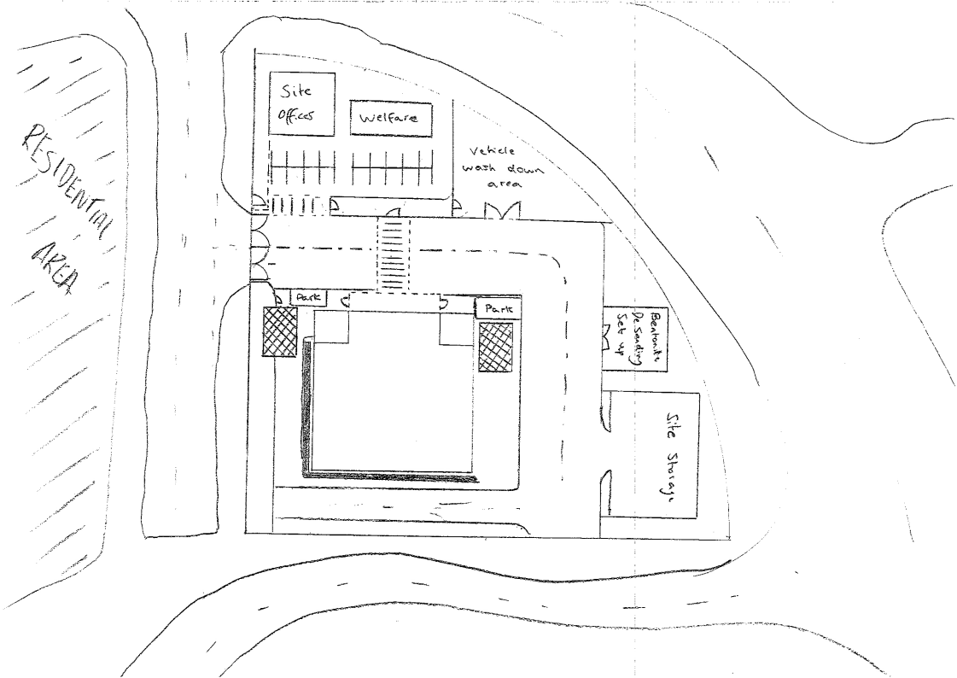
Welfare facility which will create waste in separate area from site offices/ main construction site.

Main on site waste area. All separate recycling skips to be set up in the area. All hazardous waste to be kept within a storage container which is kept locked.
Bentonite sanding area set up is separate to site waste area.

Project Outline
Excavation - excavating a narrow trench to the required depth (10m) and filling the trench with bentonite. The trench is supported from the use of bentonite. Bentonite is made up of clay materials which act as an exchange for the sediments in the trench. We create a perimeter slurry trench and then fill it with bentonite slurry from tanks. Excavation can then begin, the slurry will flow downward providing the necessary support and separation. Reinforced cages with then be placed into the trench created. The concreting of the trench takes place through tremie pipes which will then displace the bentonite into the surround slurry trench. (Modern Methods of Construction -Details and Applications, 2017) This will be carried in sections along the wall until it is complete. After bentonite is used it is to be stored in a safe contained system and removed from site by contractor using diaphragm walling machinery. Any other substances such as sand will also be transported away from site to be re used in the process somewhere else.
Columns - Drill down to the required depth using an auger, driven by a rotating bore. Bentonite will then be poured into the excavation to provide support to the column until the steel frame is installed. Reinforced steel column frames to be fabricated to be placed into the excavation. Concrete to be poured into the excavation working with the bentonite to push other materials from the column. The columns are then left to set before excavation further commences. (Bored Piles, 2019).Tie in columns to ground floor slab using reinforced concrete where steel joints are made into the columns. Dig the shafts from ground level by using the grab. Construct reinforced concrete floor G-1 and tie into the basement columns/ diaphragm walls. Leave one temporary and one permanent gap as above to provide access to the floors below. Repeat the above process for the floors remaining G-2 + G-3.
Superstructure - The superstructure works is primarily steel frame construction with a ground bearing floor slab. The external walls are constructed from a masonry block cavity construction. Internal partitions will be blockwork and the building finishes on all facades will be cladded using curtain walling. The connection of unitised curtain walling systems to the edge of the steel framed building is made by specific connection systems that attach to the top of the slab. This will then hold the cladding in position on the end of the building. The cladding of the building will be split into curtain walling and glazing. The windows are attached by spiders that connect to the corners of 2 or 4 glass panes, and provide sufficient articulation at these points. The posts or beams that are usually in the form of circular hollow sections CHS. We will then use a double tie system, which is used when the ties on one side are outside of the building, and both sets of ties act in tension.

Personnel for SWMP
Role | Name / time of work | Name / time of work | Name / time of work | Name / time of work | Name / time of work | Name / time of work
Waste Manager
Project Manager
Document Author
Site Engineer
Construction Manager
Sub-contractor supervisor

Document history
Issue | Date | Person | Amendment and reason
1
2
3
4
5
6

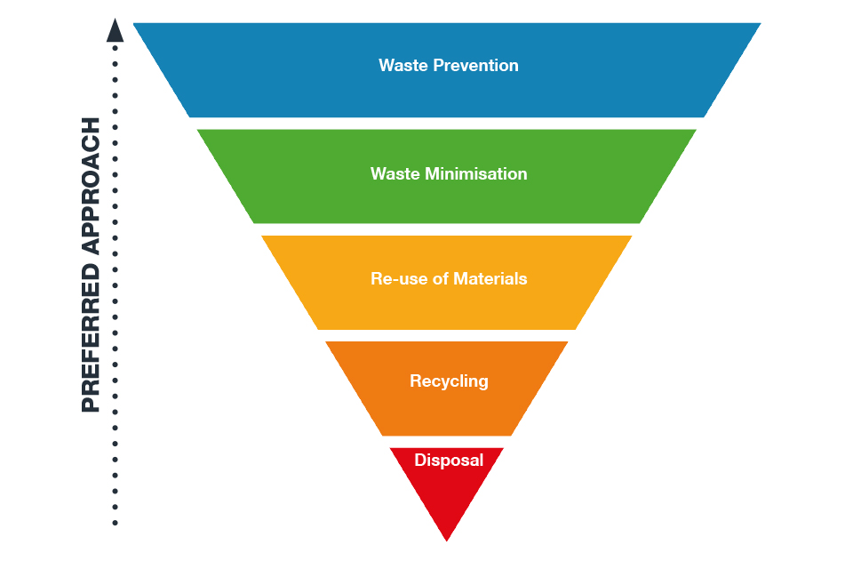

(Executvie summary, n.d.)
Types of waste identified

Excavation
Soil – 17 05 04 Total = 10,565.21 M³
Set Concrete – 17/01/01 = 174.93 M³

Basement / Foundation
Concrete – 17-01-01 –
Concrete to be ordered as per the required amount for the basement 5350M³. Should not be much waste concrete as worked out correctly. Any leftover concrete will be used in site set up areas such as crane bases. If more than anticipated concrete is ordered and arrives on site arrangement for concrete to go to different sites.
Steel 20 – 01- 40 – off cuts from reinforced steel frames to accumulate through the construction of the foundations and basement. Allowance made for removal from site.

Superstructure
Concrete 17 – 01 – 01
All concrete to be ordered and checked so there is no over ordering, any left over concrete to be used up elsewhere in the project where possible. Any left over to be directed to other sites.
Steel 20 – 01 – 01 – All pre-fabricated steel should all be cut to size and fixed on site. Very little waste should be created due to off site fabrication. Any waste created to be placed in the correct waste skip on site set up.

Cladding
Glass 10 – 11 – 12 – all glass to be manufactured off site for the cladding of the building. All glass will be cut to size so no off cuts created. All glass ordered for the job so no excess. If excess does occur contractor to take away from site to reuse.
Curtain walling 17 -04 -02 all curtain walling to be manufactured off site for the cladding of the building all panels to be made to size, allowances to be made for cuts. All cuts to be disposed of in the onsite skip. Very little waste created.
Waste codes - (EWC Codes, 2015)

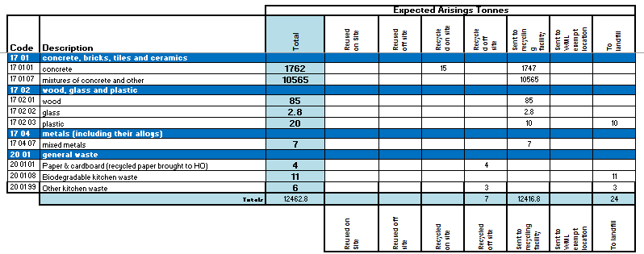

Budget
Type of waste | volume | Number of skips | Cost per skip | Total cost
concrete | 1742m3 | 220 | £140 | £30800
steel | Allowance | 4 | £185.00 | £740.00
packages | Allowance | 2 | £150.00 | £300.00
soil | 10,565m3 | 550 | £120.00. | £66000
COSHH Disposal | Allowance | 5 | £200.00 | £1000
TOTAL |  |  |  | £98840

Waste minimisation Hierarchy

Waste Type | code | Sources on Site | How will Hierarchy of Waste be applied? |  | Phase
 |  |  | Hierarchy | Action required during construction/design
Wood | 17 02 01 | Hoarding, | Reduce | Minimise wastage by placing accurate orders and re-use where possible. | Construction
Plastics | 17 02 03 | Pipe cuts | Reduce | Minimise wastage of pipe cuts, design to consider standard lengths, use environmentally friendly suppliers and request minimum packaging on orders. | Construction
Mix construction and demo wastes not contain any hazardous substances | 17 09 04 | General Waste | Reduce | Reduce waste by accurate orders of materials and quantities, re-use where possible | Construction
Concrete | 17 01 01 | Foundations | Reduce | Accurate orders. Try to reuse on elsewhere on site for hardstanding/capping | Construction
Soil and stones other than those mentioned in 17 05 03 | 17 05 04 | site clearance | Reduce | Reduce material be transported off site by profiling soft landscaping areas to incorporate as much existing material as possible. | Construction
Biodegradable kitchen waste | 20.01.08 | Welfare | Disposal | Segragate Waste on site | Construction
Other Kitchen waste | 20.01.99 | Welfare | Reduce | Organise kerb side collections of canten / domestic waste to reduce waste entering 'general / mixed" stream | Construction
Paper & cardboard | 20.01.01 | Office and packaging | Reduce | Encourage “Think before you print”. Use drawings on screens as appose to printing. | Construction
Gypsum-based construction materials other than those mentioned in 17.08.01 | 17.08.02 | Partition walls | Reduce | Using standard dimensions to reduce off cuts. | Design & Construction
Tiles and ceramics | 17.01.03 | Washroom fit out | Reduce | Using standard dimensions to reduce off cuts. | Construction

Waste Facility schedule
Waste Carrier Name | Location/ Address | Waste Carriers License No | Expiry
Dyfed Waste | Dafen Ind Est, Llanelli, Dyfed. SA14 8NS | CBDU015373 | 14/04/2022
Stenor | Kings Dock, Swansea. SA1 8QT | CBDU8911 | 24/01/2020
Brisco Waste Disposal Ltd | 89 Ystrad Road, Fforestafch, Swansea SA5 4BU | CBDU4410

Waste carrier Schedule

Waste Facility Name & Operator | Waste Type | Location/ Address | Permit/ License No
Dyfed Waste | CONSTRUCTION | Dafen Ind Est, Llanelli, Dyfed. SA14 8NS | EPR/DP3098FN
Stenor | CONSTRUCTION / MUCK AWAY | Ystrad Road  Swansea  SA5 4NE | EPR/AB3392HL
SY Pumps | EFFLUENT | Severn Trent Water Ltd Bromsgrove STW, Aston Road, Bromsgrove, Worcestershire, B60 3EX | WEX087027

Lessons Learned
Document author | Print Name: .........................................  Signature: … ……………………………………….  Date: …………………………………
Waste manager | Print Name: .........................................  Signature: … ……………………………………….  Date: …………………………………
Declaration
The Project Manager can confirm that:
- All waste identified in this PWMP has been disposed/transferred
- Key waste processing have been carried out under the direction of a SQEP for Waste Management.
Project Manager | Print Name: .........................................  Signature: … ……………………………………….  Date: …………………………………

Appendixes

Calculations
Concrete for basement
Cavity wall 30 x 10 x 1.5 = 450m³
Four walls = 1800m³
Floors = 30 x 30 x 1 = 900m³
Three floors = 2700m³
Foundation = 30 x 30 x 1.5 = 1350m³

Excavation calculations
Mixed concrete/ tarmac
30 x 30 x 1 = 900m³
900m³ x 2.4 t/m³ = 2160t
2160t/ 1.24 = 1741.93m³

Assumed soil
30 x 30 x 9 = 8100
8100 x 1.5 = 12150
12150 / 1.15 = 10,565.21

Bibliography
Bored Piles. (2019, May 15). Retrieved from Designing Buildings wiki: https://www.designingbuildings.co.uk/wiki/Bored_piles
Chudley, R. (1988). Building Construction handbook. In R. Chudley, Building Construction handbook. Billing & sons Ltd.
EWC Codes. (2015, July). Retrieved from pure planet recylcing : https://www.pureplanetrecycling.co.uk/list-of-waste/
Executvie summary. (n.d.). Retrieved from gov.uk: https://www.google.com/search?q=site+waste+hierarchy&rlz=1C1GCEU_enGB873GB873&source=lnms&tbm=isch&sa=X&ved=2ahUKEwiYxPvc4MLoAhUGSxUIHQunANsQ_AUoAXoECA0QAw&biw=1366&bih=657#imgrc=RFKJcGmRm1M-4M
Global environment solutions. (2012, November 15). Retrieved from SLR: http://www.eaststaffsbc.gov.uk/MVM.DMS/Planning%20Application/623000/623015/P-2012-01467%20Environmental%20Statement%20-%20Technical%20Appendix%203.6%20Site%20Waste%20Management%20Plan%20&%20Waste%20Implementation%20Plan.pdf
Holmes, R. (n.d.). Introduction to civil engineering construction. In R. Holmes, College of estate management.
Modern Methods of Construction -Details and Applications. (2017, 9 14). Retrieved from The Constructor : https://theconstructor.org/construction/modern-methods-of-construction/17487/

