University of Wales Trinity Saint David

Wales Institute of Science & Art



NVH Analysis
Ride, Handing and NVH (ACHA6003)

Bleddyn Williams
2104564
March 2023

Contents
1 Introduction 2
2 Task 1: Investigation of NVH Concepts, Measurement, and Effects on Humans 3
2.1 Selection of a suitable mechanical system 3
2.1.1 Excitation orders present in the Ford Sigma 5
2.2 Component Harmonic Resonance 5
2.3 Measurement of Mechanical Vibration and Acoustic Air Pressure 6
2.3.1 Mechanical Vibration Measurement 6
2.3.2 Acoustic Air Pressure Measurement 7
3 Task 2: Analysis of Measured NVH Data 8
3.1 Order Tracking 8
3.1.1 Engine Orders 1-10 8
3.1.2 Orders present between 1000-4500Hz. 11
3.2 Harmonic Resonance 15
4 Conclusion 18
5 References 19

Introduction
In automotive engineering, the 4-cylinder Ford Sigma engine’s performance and user experience hinge significantly on Noise, Vibration and Harshness (NVH) control. This assignment centres on undersdtanding NVH in the context of this specific engine.
Task 1 starts by selecting the Ford Sigma eninge as the focal mechanical system, seeking to identify excitation orders within its various subsystems. Component harmonic resonance, affecting specific engine components due to these orders will be explored. Additionally, the evaluation of methods to meadutre mechanical vibration and acoustic air pressure will be tailored to the nuances of this engine.
Task 2 involves practical NVH analysis using data from the 4-cylinder Ford Sigma engine. The Dewesoft NVH analysis software will assist in the identifying separate orders and detecting resonances specific to this engine.

Task 1: Investigation of NVH Concepts, Measurement, and Effects on Humans

Selection of a suitable mechanical system
The 4-cylinder Ford Sigma engine holds a prominent place in automotive engineering, known for its efficiency across various Ford vehicle models. At its core, the engine’s primary excitation generator stems from the combustion process, powering the engines pistons and the crankshaft rotation. This excitation generates both desired power and unintended vibrational effects.
Numerous critical subsystems within the Ford Sigma engine bear the impact of these excitation orders. The rotating assembly, including the crankshaft, connecting rods, and pistons, experiences reciprocating and rotaitional forces. The valvetrain, comprising camshafrs and valve components, undergoes cyclical forces due to the cam profiles and valve movements. Additionally, auxillary systems such as cooling, fuel delivery, and exhaust components are affected by these subsequent reverberations. Further rotational vibrations would be visible throughout the powertrain assembly to the transmission system. however, as shown in the Figures 1- below. The engine is being measured on an engine stand without the transmission so the expected rotational vibration from the transmission is discounted.
The measurement configuration and methodology is in line with the Dewesoft User Manual (Dewesoft, 2021).
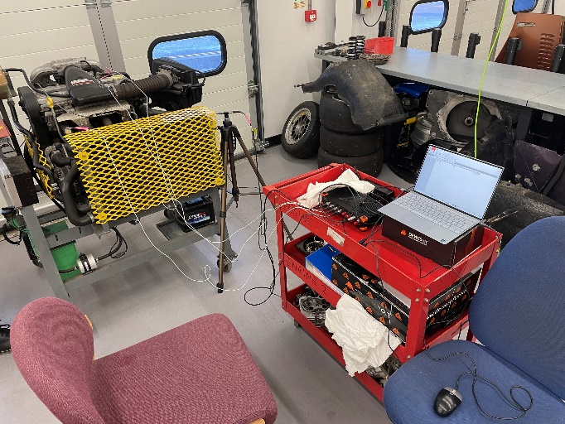
Figure 1 - Engine Recording Station
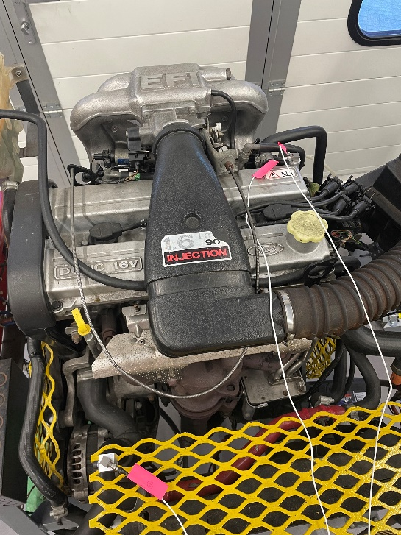
Figure 2 - Accelerometer and Microphone Placement (Top if Engine)
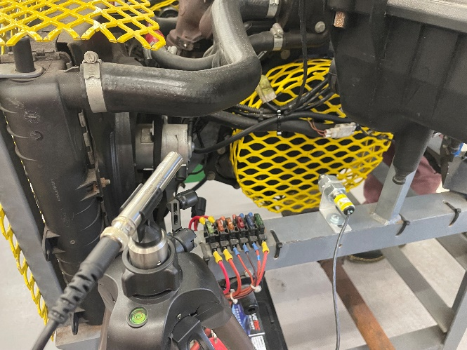
Figure 3 - Crankshaft Accelerometer placement.
While essential for functionalitity, these subsystems can also create undersirable vibrations and noise. Harmonic resonaces may aride when excitation frequencies match component natural frequencies, potentially affecting NVH levels and engine durability.
This assignment aims to understand how excitation orders influence Ford Sigma engine subsystems comprehensively. The focus on this engine provides a practical context to explore NCH concepts, measurement techniques, and their automotive implications. By examining these aspects within the Ford Sigma framework, insights into NVH management specific to this system will be illuminated.

Excitation orders present in the Ford Sigma
The excitation orders I expect to see from the Ford Sigma engine data are as follows in table 1.
Table 1 - Engine Component/Events and expected orders.
Component/Event | Order
Camshaft Rotation | 0.5
Crankshaft Rotation | 1
Combustion Cycle | 2
Inertia Cycle | 3
Atmospheric Pressure Cycles (during coast down) | 4
Compression | 2
Flywheel Rotation | 1
Auxiliaries | 20-60

These are a general assumption of what I expect to see in a linear scenario without the influence of harmonic resonance causing component vibration.

Component Harmonic Resonance
Component harmonic resonance in automotive engineering refers to a situation where aprecific parts of a vehicle, vibrate excessively due to forces generated by the engine or other mechanisms. Each component in a car has its natural frequency at which it tends to vibrate when energy is applied. When the frequency of these forces aligns closely with a compnent’s natural frequency, it causes the part to vibrate excessively, leading to potential stress, excessive wear, or failure over time.
This resonance issue is crucial because the vibrations from the engine or other moving parts can affect different parts of the vehicle, such as the suspension, exhaust, body panels, and interior elements. To manage this problem, engineers use several techniques:
- Damping: This involves using materials that absorb excess energy or vibrations to reduce the effects of resonance.
- Stiffness adjustment: Engineers modify the stiffness or materials of a component to change its natural frequency and avoid resonance with the vibrations.
- Isolation methods: They employ mounts or buffers to physically separate components, minimising the transfer of vibrations.
- Computational Simulations: Engineers use computer tools to predict and address resonance during the design phase.
- Testing and Validation: Rigorous testing of prototypes helps identify potential resonance problems, allowing for necessary design adjustments.
Understanding and managing component harmonic resonance is essential to ensure the durability, reliability, and overall performance of vehicle parts/ by preventing excessive vibrations and potential failures, engineers enchance the safety and quality of the driving experience for the vehicle users.

Measurement of Mechanical Vibration and Acoustic Air Pressure

Mechanical Vibration Measurement
Sensors are vital for measuring automotive vibrations. Accelerometers and microphones serve as common tools, and were the tools used during the measurement of the Ford Sigma engine.

Accelerometers
These devices detect vibrations through acceleration forces from the engine operation or road conditions. Selection criteria include sensitivity, frequency range, durability, and robustness. Vital for detecting engine vibrations in the up/down and left/right movements, accelerometers can cover the egnines vibrational range in both vertical and lateral movements. Proper mounting is essential to prevent interference or distortion in measurement.
It is known from theory that “only 20% of the accelerometer natural frequency is useful for measuring the acceleration of vibrating object” (Kumar, 2014), this is represented in Figure below.
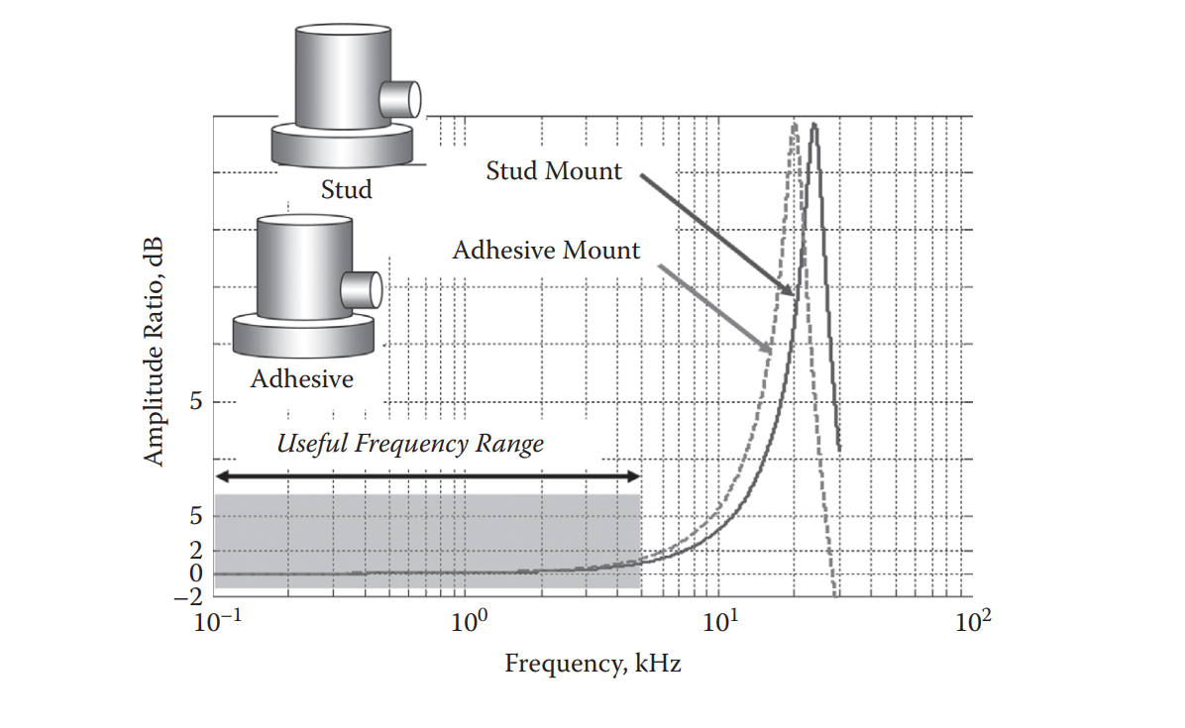
Figure 4 - Mounting natural frequency of an accelerometer (Kumar, 2014)

Acoustic Air Pressure Measurement

Microphones
While primarily for sound, microphones can detect some vehicle vibrations, especially those within the cabin. However, the use of the microphone during the engine testing was to detect frequency response to the varying inputs on the engine. Microphones serve to measure acoustic air pressure across the engine rev range. This information can be interpreted as a change in sound energy as the various inputs are applied to the engine. “Microphones convert sound energy into electrical energy”(Dewesoft, 2021) enabling engineers to interpret the soundwaves of a component to identify faults or unpleasant levels of sound.

Task 2: Analysis of Measured NVH Data

Order Tracking
“Order tracking a widely used tool for analysis of vibrations generated in a vehicle drivetrain component” (Brandt and Lagö, 2005), therefore since the objective of this report is to identify component noise and vibrations order tracking will help identify which components are causing problematic vibrations which may be harmful to the vehicle user. “A common way to plot FFT and Order data/RPM maps is by using a waterfall plot” (Brandt A, 2011). “the order tracking method is used to extract the harmonic components related to the rotational frequence of the machine” (Dewesoft, 2022) in this case, the engine.
“A factor times the rotational speed is called an order” (Brandt. A, 2011), the 1st order will represent one rotation of the engine’s crankshaft (representing a full rotation and 2 of the 4 engine strokes). Therefore, the camshaft will be order 0.5 since it rotates at half the speed of the crankshaft. Since the Accelerometer was positioned to record the vibrations of the crankshaft, this 1st order is the reference order.

Engine Orders 1-10
As shown in Figure 5 below, the largest number of vibrations are occurring within the first 1000Hz, these are orders 1-10, shown in Figure 6. Clearly these will be orders directly related to the engine components due to the level of excitation. Clearly the primary excitation order is the 2nd order, therefore this order has an event that occurs twice per rotation. Clearly then this order represents the firing events of the engine.

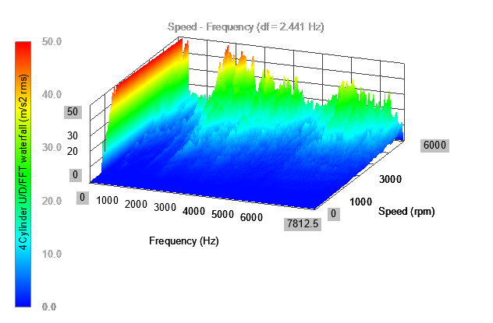
Figure 5 - FFT Waterfall of the Engine
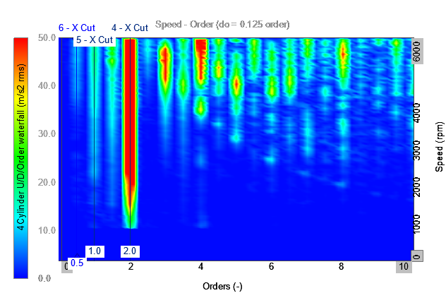
Figure 6 – Order Waterfall (First 10 Orders)
Naturally the next order that would be expected to be of the highest excitation following the 2nd order would be the 4th order which would represent the rotations of the engine crankshaft during induction and exhaust. The nature of the reciprocating engine under inertia would have a greater excitation than that of a compression stroke order but less than 2nd order during combustion. Figure 6 accurately represents this assumption. Following this the 3rd order would follow, which is represented in Figure 6, this would represent the excitation caused by the angular velocity imbalances of the flywheel during the inertial (non-firing) events of the crankshaft, which occurs 3 times per rotation. These account for the main excitation events; however, the figure shows some unexpected excitation which is caused by harmonic resonance which will be discussed below.
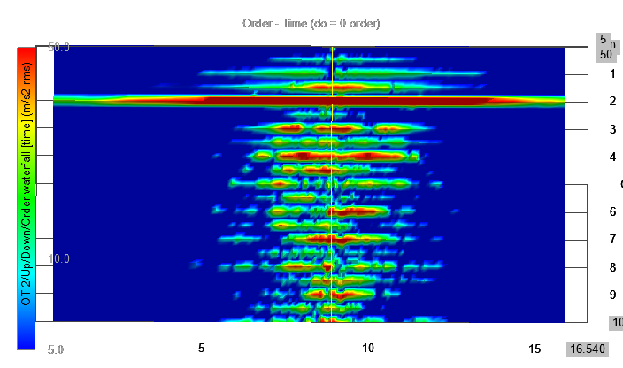
Figure 7 - Excitation during Orders in time domain.
Analysing the excitation in the time domain shows some insightful data which represents the engine balance during run up (acceleration and combustion) and coast down (liftoff and inlet vacuum). Here in figure 7 its clear in order 5.5 & 8 for example, there is greater excitation during run up. Whereas, during coast down, there is greater excitation during the 6th order. Clearly these orders are influenced by the combustion events of the engine since this is the most significant change between the two states. It is therefore the duty of the engineer to balance these events to ensure there isn’t excessive wear on the engine components.

Orders present between 1000-4500Hz.
When analysing the FFT (Fast Fourier Transform) waterfall (Figure 5) to gain an understanding of this engine clearly the next group of orders with relatively similar excitation is between 1000-4500Hz (Figure 8), these orders are identified as orders 10 – 65, demonstrated in Figure 9.

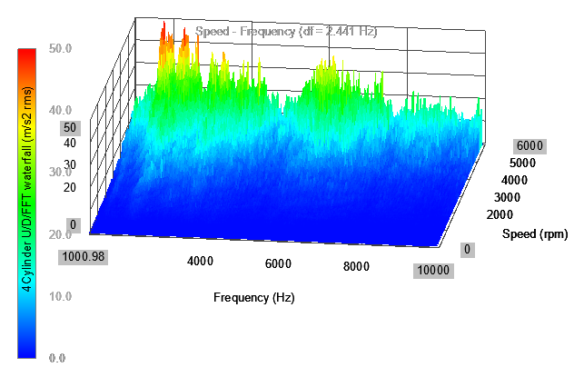
Figure 8 - FFT Waterfall 1000-10000 Hz
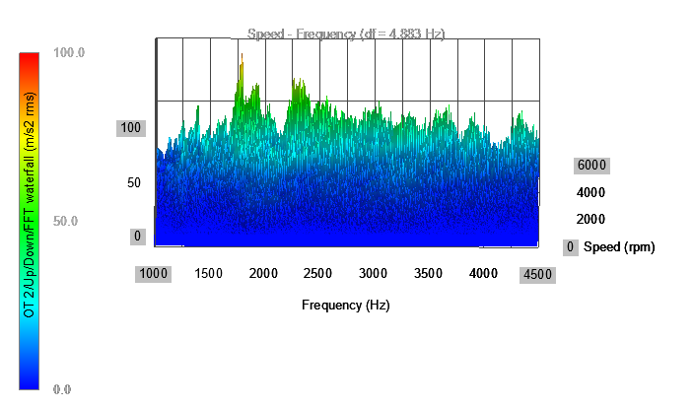
Figure 9 - Frequency Range 1000-4500Hz.
Clearly demonstrated in Figure 10 there is significant vibration occurring at 1800Hz (peak) continuing at a lesser scale until 1950Hz then returning to this level of vibration between 2250-2300Hz. When using (Tuma, 2014) methodology of analysing order tracking by focusing on multispectral peaks as demonstrated in Figure 11, the components related to this vibration are occurring at 18, 19.5 and 24 times crankshaft rotation. Due to the ratio of these components rotation to crankshaft it can be assumed to be related to the engine auxiliary components via the component pulleys.
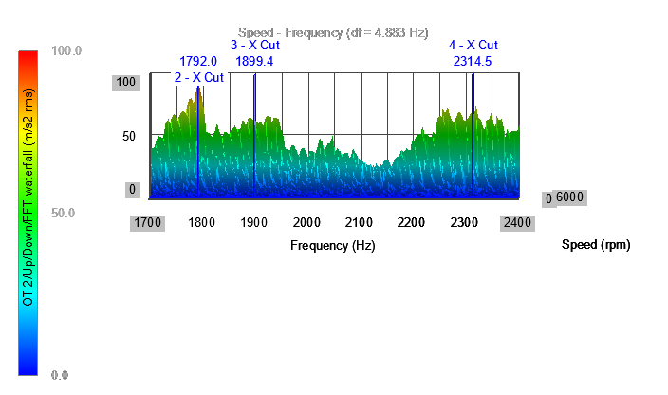
Figure 10 - Selected area of Figure 5 (1700-2400Hz)
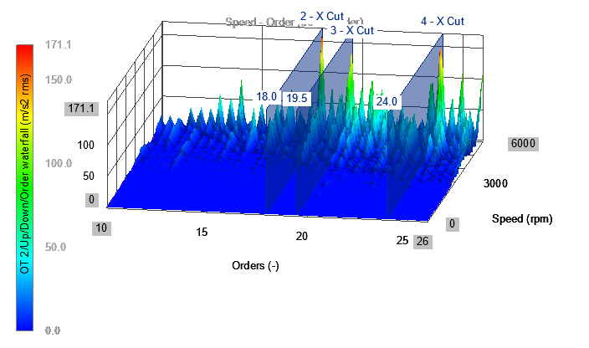
Figure 11 - Orders experiencing large excitation.

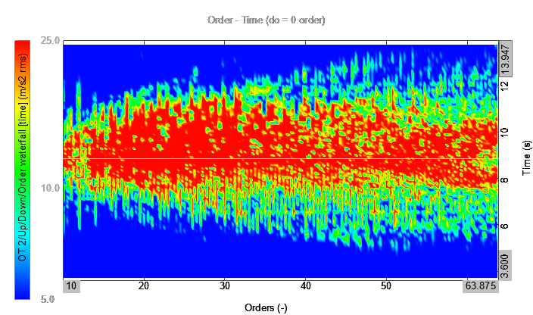
Figure 12 - Order Excitation in time domain.
Clearly based on the assumption made above that most of the orders within the range 10 – 64 being auxiliary component based, these components are experiencing greater vibrations and stress during the coast down in comparison to the run up as demonstrated by figure 12. Here clearly there is a greater distribution of vibration following peak RPM. This would make sense, if we used an alternator as an example, since it is a parasitic load driven directly from the crankshaft. This components resistance to turn imposes more stress on the auxiliary belt and engine’s ability to rotate the alternator pulley without combustion, relying on the inertia transferred to the flywheel to maintain engine rotation.

Harmonic Resonance
As well as structural vibrations (above), harmonic resonance is of “particular interest of rotating machinery because they amplify vibrations” this need to be identified since it can “often cause very high vibration levels and sometimes disaster” (Brandt A, 2011). When studying a waterfall plot, structural vibrations can be identified as peaks in a straight line as shown in figures 1, 4, & 7, where as “structural resonance will often be visible as peaks at fixed frequencies”(Brandt A, 2011) as demonstrated in Figure 13. Furthermore, as demonstrated in figure 14, harmonic resonance can be visible as “hyperbolic curves” on an order to RPM plot (Bruel and Kjaer, 1999),(Tuma, 2014).

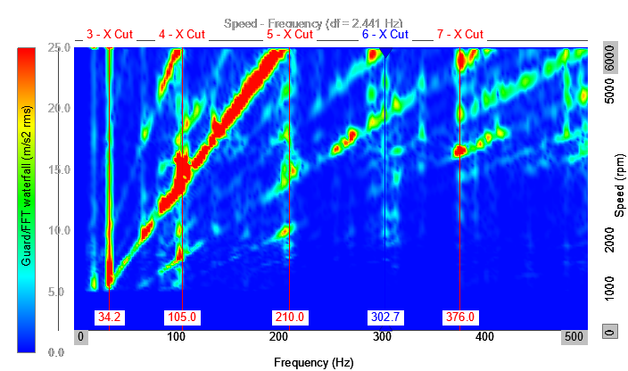
Figure 13 – FFT Waterfall Plot (Guard) Freq. 0-500Hz.
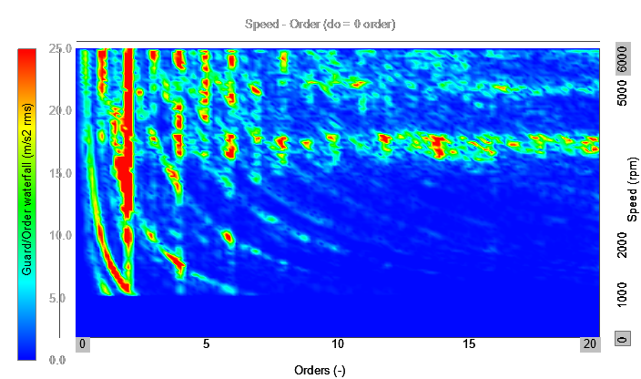
Figure 14 - Resonance displayed on Order Tracking Waterfall Plot (Guard)
When discussing the orders representative of the engine components (1-10) on the section 3.1.1 above, anomalies were identified that oppose linear vibration of components, an expectation identified by (Mason, 2023) that was suspected to be caused by resonance. In the figure 15 below, clearly at frequencies 129.4, 280.8 & 393.1 Hz there is greater excitations across the respective orders that vibrate at that frequency. “Since the most prominent feature of resonance is displacement. In most mechanical and structure systems, large displacements indicate undesirably large strains and stresses, which can lead to the failure of the system” (Rao S, 2017). Clearly this could be an issue since it is occurring at the engine component orders. This can be reduced by using damping methods or greater balancing of the crankshaft. However, these costly methods must be viable and since the vibration increase is minimal and would have little effect to the fatigue life of the component, these measures wouldn’t be viable for mass production road vehicles.
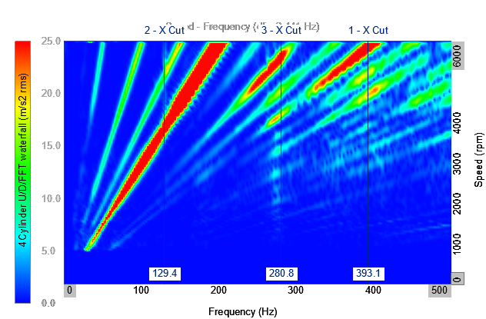
Figure 15 - Resonance displayed between 0-500Hz (FFT Waterfall plot)

Conclusion
Following the engine, its respective components as well as the auxiliary components, there is clear vibrational spikes because of harmonic resonance once the primary excitation of the engine influences the component respective natural frequency. Whilst the internal components of the engine would prove costly to dampen and reduce the influence of resonance the cost would be more viable and cost effective to damping the effect on the engine auxiliary components. As for the damping and analysis of the guard and its component imbalance it must be considered that the guard isn’t an accurate representation of how the engine bay behaves, therefore, the evidence cannot be used to justify any damping of the engine bay. However, it does indicate the kind of vibration that would need to be investigated and its affect of the engine bay and connected components. There was also some vibration profiles between 4500-1000Hz, however these were low in comparison and “up to an acceptable level” based on (Rao S, 2017) analysis.

References
Brandt. A (2011) Rotating Machinery Analysis.
Brandt, A. and Lagö, T. (2005) Main Principles and Limitations of Current Order Tracking Methods.
Bruel and Kjaer (1999) ‘Technical Review: Characteristics of the Vold-Kalman Order Tracking Filter (BV0052)’,
Dewesoft (2021a) ‘Dewesoft-SIRIUS-Manual-EN’.
Dewesoft (2021b) Sound pressure measurement.
Dewesoft (2022) Order Tracking Measurement and Analysis.
Kumar (2014) Vibration Analysis, Instruments, and Signal Processing, Taylor & Francis Group, Milton.
Mason, C. (2023) ‘How To Analyse Noise & Vibration In Rotating Machines’, 2023 .
Rao S (2017) 9.4 Balancing Of Rotating Machines 827.
Rao S (2017) ‘Mechanical Vibrations in SI Units_----_(9.8_Control_of_Natural_Frequencies)’, 2017
Tuma, Jiri. (2014) Vehicle Gearbox Noise and Vibration : Measurement, Signal Analysis, Signal Processing and Noise Reduction Measures. Wiley.

