CULTURAL AWARENESS

Module code :BMIH 5003
Lecturer,Rodrigo Aguilera

Student number 2114996
Cornelia Dumitrescu

Executive summary

The study is based on managing the guest experience of international visitors. In order to improve guest experience, UK hotels are much more focused on cultural intelligence and sensitivity. This is because, through this factor, they can provide maximum satisfaction to Indian visitors. Hofstede's cultural dimensions model is followed by the hotel as it includes six dimensions of culture. The housekeeping department of the hotel can greet the Indian visitors while cleaning the room and from research, it can be said that it provided positive results with respect to these hotels. As per the rules of the hotels, the staff is not allowed to speak loudly in spite of getting improper behavior from visitors.

Table of Contents
Introduction 4
Importance of cultural intelligence and sensitivity for hotel personnel 4
Different hotel departments and adoption of service delivery according to cultural norms 5
Do's and Don'ts of Hotel Staff 6
Recommendation 6
Conclusion 7
References 8

Introduction
Guest experience is a very important matter to the hotel because it has a close connection with the growth of the hotel. This study will discuss the importance of cultural intelligence and sensitivity for hotel personnel in the UK. Different hotel departments and the adoption of service delivery according to the cultural norms of India will be elaborated on as well. Based on the discussion, the do's and don'ts of staff will be presented in tabular form.

Importance of cultural intelligence and sensitivity for hotel personnel
Hotel staff should have cultural intelligence and sensitivity to make guests feel comfortable in this hotel. In other words, it can be said that the importance can be mentioned on the grounds of providing the maximum level of satisfaction to the visitors (Abo-Murad and Abdullah, 2019). When hotel staff gives priority to the culture of other countries, the visitors feel more connected with the hotel and it helps in engaging visitors with the hotel for a longer period of time. Cultural sensitivity is helpful on the ground of marketing and maintaining a proper image as well.
In order to improve cultural intelligence and sensitivity, it is important to take the help of cross-cultural theories and models. Hofstede's cultural dimensions model is adopted by many hotels in the present times. The model includes six cultural dimensions and it can be well understood from the following figure.
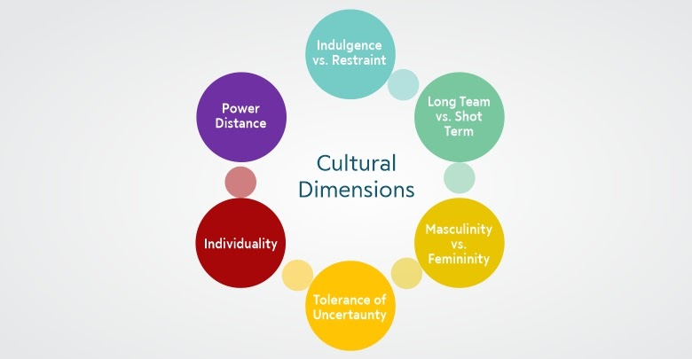
Figure 1: Hofstede's cultural dimensions model
(Source: Rheenen, 2020)
Power distance: The attitude of the authority is considered under this dimension. The UK hotel will not create any kind of discrimination against Indian visitors because there are differences in culture between the two countries.
Indivisuam: Independence and interdependence loyalty towards one or a group are considered under this dimension. Various cultures of India are considered by the UK hotel. Therefore the hotel is very much focused on research work (Yang et al. 2022).
Masculinity Vs femininity: With the help of masculinity, the UK hotel is focused on assertiveness and material rewards. Considering femininity, modesty, cooperation, and caring traits are improved through which Indian visitors can be treated well.
Tolerance of uncertainty: The uncertainty index is quite low for the hotel because in order to improve knowledge about cultural factors, much focus is given to research and development work.
Indulgence Vs restraint: Under this dimension, it is checked whether the Indian visitors are not required to control their desires. The hotel can provide food and other factors according to the culture of India.

Different hotel departments and adoption of service delivery according to cultural norms
Front office department: This department performs functions like reception, reservation, and registration among others. While doing all these tasks, different visitors can behave differently. It is said that there are several Indians who are quite rude and therefore conflict may arise while registration. However, the front office staff should not lose their patience while doing their work (Kuo et al. 2020).
Housekeeping department: Speaking “namaste" or "namaskar" is a cultural norm in India. Therefore the housekeeping staff can say “namaste” or “namaskar" to Indian visitors while going to their rooms to clean or maintain. The visitors may feel more connected in this case.
Food and beverage department: There are different cultural foods of India such as Khichdi is a national dish (Abo-Murad et al. 2019). Apart from that, Masala dosa, Dal makhani, Biriyani, Stuffed paratha, Dhokla, Barfi, and Pani puri are some of the cultural foods that can be presented to the visitors according to their choice.
HR department: This department should hire such employees who have ideas about the culture of different countries. As the UK hotel is mainly focused on Indian visitors, the employees should have profound knowledge and understanding of various cultural norms of India (Francois Koukpaki et al. 2020). It includes greeting them and understanding their behavior and taboo.

Do's and Don'ts of Hotel Staff
Do’s | Don'ts
- Greet them with their cultural norms while selling them inside or outside the hotel.  - Ask them whether they are satisfied with the service of the hotel or not  - Ask them if they want to provide any kind of information about their culture  - Treat all kinds of Indian visitors in the same way so that no visitors can feel discrimination in the hotel.  - Present all the cultural food in a proper way with the help of proper dishes.  - Ask them about the menu that can be served to them which is not in general rendered by the hotel. | - Do not speak loud with the Visitors even if their behavior with the staff is not proper.  - Do not force them to talk about their culture while asking for information about it.  - Never express any kind of distress under having issues with any kind of cultural norms.
Table 1: Do's and Don'ts of Hotel Staff
(Source: Self-created)

Recommendation
- In order to deal with international visitors, it is very important to have different kinds of skills. Therefore the UK hotels must check whether the employees have a maximum number of skills or not. If it is found that employees have a lack of skills, this issue should be mitigated with the help of training.
- The existing and new staff in the hotel should be encouraged so that they have constant research about cultural factors of the country. This is due to the fact that competition has increased in the present times. The hotel can take initiative so that the cultural intelligence of staff can be developed more.

Conclusion
The overall discussion helps in understanding the significance of improving cultural intelligence in the coming future. If the business strategy can be linked with the cultural factors of the visitors, facing success is not a difficult thing for UK hotels. The hotels are focused on Indian visitors and this country is full of culture. For having knowledge of the culture of this country and implementing it in a proper direction, research work must be focused.

References
Abo-Murad, M., Abdullah, A. K., and Jamil, R. (2019). Effect of the organisational culture on crisis management in hotel industry: A qualitative exploration. International Journal of Entrepreneurship, 23(2), 1-18.
Abo-Murad, M., and Abdullah, A. K. (2019). Turnover culture and crisis management: Insights from Malaysian hotel industry. Academy of Strategic Management Journal, 18(2), 1-14.
Francois Koukpaki, A. S., Adams, K., and Oyedijo, A. (2020). The contribution of human resource development managers to organisational branding in the hotel industry in India and South East Asia (ISEA): a dynamic capabilities perspective. Employee Relations: The International Journal, 43(1), 131-153.
Kuo, N. T., Cheng, Y. S., Chang, K. C., and Ying, W. H. (2020). Establishing a measurement scale for safety culture in the hotel industry. Journal of Hospitality and Tourism Management, 42, 12-28.
Rheenen, L.van (2020) Hofstede's cultural dimensions, Hofstede’s cultural dimensions. Available at: https://www.trainerslibrary.org/hofstedes-cultural-dimensions/ (Accessed: February 28, 2023).
Yang, H., Cheung, C., and Li, W. (2022). Intercultural communication competency practices in the hotel industry. Journal of China Tourism Research, 18(1), 162-184.

