9/6/2019
RELECTIVE ESSAY

PSCHOLOGY DR GULMAR ALI BMHP4003
PAULINE BURRELL 1809580

Contents Table

- Contents page
- Introduction
- Integrity – Despair
- Carl Rogers theory
- Albert Bandura cognitive theory
- Albert Bandura cognitive theory
- Abram Maslow hierarchy of needs
- Review of existing literature
- Self-reflection
- Conclusion
- References

INTRODUCTION:
In this essay, I will be reflecting on theories and perspectives of different life spans and linking them to my role as a Health Care Worker. Exploring different psychological viewpoints and the impact it has on individuals’ behaviour and wellbeing in old age. I will also be evaluating the importance of taking care of myself, as working in Health and Social Care can be very demanding and I will be applying different psychological theories to assess different service users.
Eric Erickson’s.: Psychosocial theory of development stages integrity verses despair in old age and how the human mind assesses wellbeing. As people get older they begin to evaluate their lives. If they conclude their assessment with integrity they will feel happy if they have lived their life accomplishing their true aspiration with their family and career prospects.
They will have a feeling of gratification knowing they have fulfilled their goals and having a sense of pride and the mission that have completed with the objectives at home and at work. For that reason they are able to reflect throughout their life and face it with clarity understanding and peace of mind.

Integrity:
I have worked with service users in the past who shows integrity very professional how they speak, able to explain things from their past in full details remembering detailed information and situations. One lady in particular she was 92 years old and worked before as a school teacher. Her mobility had deteriorated needing minimal support with personal care in the mornings and domestic tasks however she was able to prepare ready meal, do crosswords, read books and newspaper kept a daily diary and interacted well with others. In addition she had her adult off spring who spoke highly of her and that she was a good mother to them. They support her on a rota system which showed unconditional positive regards towards her which made her feel cared and loved for which enhanced the feeling of integrity in her later stages of life.

Despair:
Some people have feelings of regret, hopelessness that their life had no contribution to society or significant meaning. They do not have no sense of gratitude pondering on how they could have lived their lives differently, not spending enough time with family and more time at work. Those factors had consequences on their relationships with their spouse in an unhappy marriage. I have perceived working with certain service users and their off springs where unconditional positive regards was not shown therefore their relationship was strained with a noted distance between them. This was consolidated by certain behaviour perceived when the adult off spring should have been able to do certain duties and task within the home considering they lived there. Unfortunately those children had no unconditional positive regards and this had an impact on the care provided for them later life. (Griggs R. A., 2012)

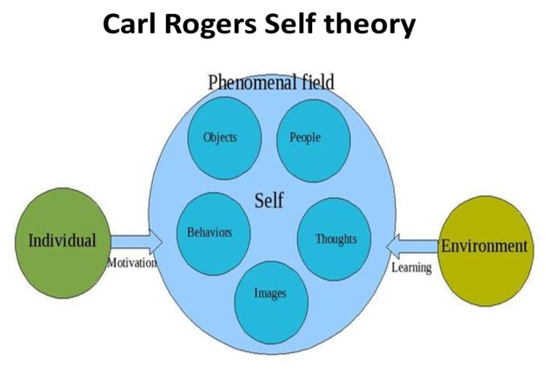
The phenomenal field is a person personal reality which includes external objects such as personal processions house, cars also internal thoughts and emotions. The current self that changes with time that is impacted by the environment and the individual core self. The field has five factors that feed into thoughts, images, people, object and behaviours. The person’s inspirations and surroundings both act on their phenomenal field and therefore this impacts on a person’s behaviour especially with conditions such as dementia. (Humanistic Approaches)

I work with service users who suffer with different stages of dementia which affects their behaviours and thoughts pattern. Their cognitive ability to perform everyday tasks is hindered and therefore they need extra support in order to have suitable quality of life.
They can become verbally abusive and challenging physically making situations difficult to deal with, in my experience keeping clam is the only way for them to regain control. Some have short term memory loss and they will speak about something and not remember a short time after unaware of what they are saying. They remember things from their past when they were younger however they also see things or people talking as if they are present. People living with dementia often develop distressing behavioural and psychological symptoms (BPSD) that can affect their quality of life and the capacity of family carers and staff providing support at home. (Braun, 2017) ‘Behaviour that challenges or ‘distressing behaviour’ that may be a communication of unmet needs’. Symptoms may include aggression, risky and apparently strange behaviours, wandering or walking, agitation, apathy or emotional distress. These can affect the ability to sustain everyday activities, and reduce quality of life (Kales, Gitlin, & Lyketsos, 2015).

Albert Bandura Social Cognitive Theory:

Bandura social cognitive theory focuses on what creates human behaviours. There are five cognitive factors environment, social norms access in the community, influence on others and behaviours. Cognitive theory examined the interactive relation between individual’s beliefs, actions, self-perception, and aspirations, purposes which directly shapes their behaviours. What individuals think, believe and feels affects how they behave. Therefore service user’s cognitive capacity to remember hinders their ability to look after themselves on a daily basis needing support from others.

The capacity to exercise control over the nature and quality of one's life is the essence of humanness. Human agency is characterised by a number of core features that operate through remarkable and useful consciousness. These include the progressive allowance of agency through intentionality and consideration, self-regulation by self-reactive influence. The self-reflectiveness about one's capabilities, quality of functioning, and the meaning and purpose of one's life pursuit’s (Bundura, 2001).

My experience as a health support worker with clients who suffer from Parkinson disease and other cognitive disorders depending on the severity some are able to perform everyday task on their own but suffer from memory loss (short/long term). An example of long term memory loss can include unable to recognise family and even their own children. Furthermore minor/major events unable to be remembered this can impact on their quality of life and celebrating milestones from their past.
Some service users are incapable to live alone in properties with stairs due to having regular falls. Others live in sheltered accommodation all on one level with cares visiting daily also 24 hours on call security. While supporting them I ensure their medication is taken, they have had breakfast or evening meals. Some service users do not require personal hygiene as they are able to carry out tasks for themselves. Even though some may suffer from short term memory loss they are able to reflect on the past and assess their lives.

Abram Maslow Hierarchy of Needs:
It is important to consider service users’ current levels of need, the different needs of service users and caregivers, the degrees of behavioural change expected at different levels of need. Insights from Maslow’s model can help developers, researchers, providers, and consumers in the process of producing, evaluating, recommending, and purchasing care/technologies for older adults. One particular challenge is that assistive technologies may undermine esteem needs by limiting independence. Scales to measure levels of need can help characterise which needs are most relevant for different individuals, and can be used to ensure that technologies address users’ need (Griggs R. , 2014).
I work with service users who have reached self-actualization this level does not require anything principally than accepting who you are and have taken the necessary stages throughout their lives. Becoming the best person they and fully developing skills to discover strength by motivating themselves to reach their full potential. Some people have a tendency to be self-conscious, able to judge situations correctly acceptance of self and embrace others for who they are. Some service users may not be physically or mentally able at present however, reflecting back on their lives have reached their full fulfilment with gratification. Observing their home environment pictures, upkeep and having a caring family or friend network.
Service users whose cognitive capacity has deteriorated physically or mentally can hinder their perception of not reaching self-actualization having an impact on their spiritual state of mind. Some drink and smoke excessively, no family or friends to speak with, no living spouse and the inner self emotionally affected crying a lot of the time feeling worthless, isolated, lonely not want to live any more

Resilience factors are important for individuals the table below outlines necessary factors needed to feel fulfilment.
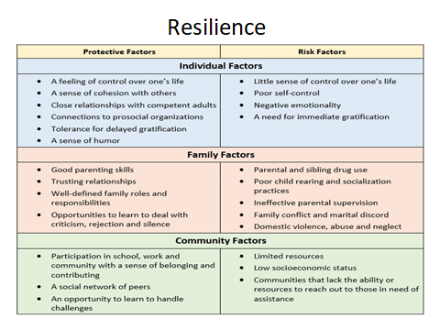

Review of existing Literature

Memory cafés offer information and support in a relaxed setting. They let people meet up with others with dementia. Individuals can attend with a carer and there are occasionally professional carers available to talk to in confidence. Imaginative workshops doing arts and crafts or music workshops allow individuals to continue doing the hobbies they enjoy or learn new ones while meeting new people.

Specialist support groups can put you in contact with others so that you can talk about how you are feeling, and give guidance on what to expect in the future. Cognitive Stimulation Therapy (CST) is a short-term programme for people with mild to moderate dementia and usually runs twice weekly for 7 weeks following diagnosis. Group members take part in expressive and encouraging activities, proven to help maintain memory and mental functioning.
Day centres can provide company and activities to do. Some are for older people with or without dementia and others are just for those with more advanced dementia. (Age uk love later life, 2019)

My Self Reflection:

This term semester has been a very interesting inspirational pathway self-discovery journey of self and realisation for my own growth. I have faced many difficult challenges throughout my life however it has not been a long time studying but has made me more aware of individual’s behaviour patterns when dealing with them and a better understanding of the support or therapy needed to help their psychological wellbeing.

The lectures have given me an in depth understanding of service user’s behaviours and some of the challenging behaviours I encounter, learning about different psychology theories principles and how they apply in my role as a health care support worker. In my role I always give my best showing empathy, commitment and trustworthiness to my work and service users. In my personal life when giving those qualities sometime no gratitude is shown in return however whatever I do is from the heart with no expectation or reward.

It is important to be mindful of my own wellbeing as well as others, I need to be fit and well otherwise I would not be useful to others if I am burnt out and stressed. I have experienced in my professional and private life, the importance of mindfulness the minds state of awareness in the present moment to control thoughts rather than be controlled by them. I meditate; exercise/ yoga read positive books to keep my mind, body and soul in its true state of balance without any judgemental attachments objectively checking in on my inner self.
Having self-efficacy, resilience, mental alertness to self-empowerment, competence, spirituality which influences my state of mind conscious or unconscious. I am not just the physical body but connect everything together to shape my belief systems and a strategy to transform a belief pattern which enables inner strength. I have realised there is no end to distress the way I see life however I have to take charge, set boundaries discard toxic situations and people that causes problems. I now focus on things I am good at which brings meaning to my life taking responsibility without judgement. I have learnt to accept myself for who I am and if I make a mistake I am determined to retry. Being open and transparent to situations not always about strength but willing to learn and embrace change with gratitude, achieving knowledge to greater and better places in my life.

CONCLUSION:

In my conclusion after reviewing all my researches, reading and different theories from Erickson, Rogers Bandura and Maslow.
Erickson has improved my professional practice on the development stages individuals go through in old age with feelings of integrity and despair when reflecting back on their lives.
Rogers has enlightened my perspective theory on the concepts of having unconditional positive regards accepting and approving of others without having any conditions attached whether I like them or not.
Bandura has given me awareness of social cognitive theory on emphases what creates human behaviours their beliefs and views.
Maslow has made me be conscious of the different level of importance to a person individuals needs at various stages of life.

I have gained more understanding and come to the conclusion that for health and social care to be improved professional training is got to be where carer workers know what and how to handle challenging behaviours from service users and gain more knowledge on ways to improve services and clients satisfaction.

Bibliography
Age uk love later life. (2019). Retrieved September Friday, 2019, from https://www.ageuk.org.uk/information-advice/health-wellbeing/conditions-illnesses/dementia/getting-care-and-support/
Braun, A. (2017). Sage Journals. Dementia, Volume 18 (6), 1963–1975.
Bundura, A. (2001). Social Cognitive Theory: An Agentic Perspective. Annual Review of Psychology, Vol. 52:1-26 , 1-26.
Griggs, R. (2014). Pschology a Concsie introduction. Florida: Worth.
Griggs, R. A. (2012). Psychology A Concise Introductin (fourth ed.). New york: worth.
Humanistic Approaches. (n.d.). Retrieved September Friday, 2019, from https://courses.lumenlearning.com/msstate-waymaker-psychology/chapter/humanistic-approaches/
Richard, A. G. (2014). Psychology a Concise Introduction (Fourth ed.). Florida: Worth.

