Student name: | Vaibhavikumari Solanki | Student ID number: | 2511313
Programme: | MSc Data and Artificial Intelligence
Module: | Advanced Statistical Programming
Module code: | ACCA7022 | Contribution to Overall Module Assessment (%): | 50%
Lecturer: | Dr. Aliyu Sambo | Internal Verifier: | Prof. Nik Whitehead
Assignment Title: | Data Analysis | Word count (or equivalent): | 3000
Submission deadline: | 2 pm, Friday, 20/03/2026 | Return date of provisional marks & written feedback: | Monday, 20/04/2026

Table of Contents
Task 1: Code 3
Data Import and Summary 3
Exploratory Data Visualisation 6
Correlation Analysis 9
Hypothesis Testing 11
Group Comparison Across Seasons 14
Task 2: Reflective Summary 17
Approach and Analytical Rationale 17
Visualizations 17
Challenges and Things Learned 18
Improvements for Future Work 18
References 19
Appendices 21
Appendix 1: Use of Generative AI (ChatGPT) 21
Appendix 2: Source Code 22

Task 1: Code

Data Import and Summary
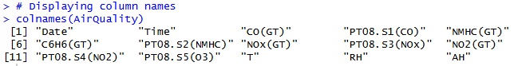
Figure 1: Displaying the column names
The data has been loaded within an R dataframe named AirQuality, and the data manipulations are performed using this dataframe. The “colnames(AirQuality)” function is used to retrieve the names of the variables that are saved as character vectors to verify that the way the columns are internally labelled. This ensures that all variables used in analysis and visualisation are accurately aligned with the dataset. The dataset has 15 variables, whereby some are temporal (Date, Time), some variables measured pollutant concentrations (CO(GT), NMHC(GT), C6H6(GT), NOx(GT) and NO2(GT)) as well as sensor response variables (preferred prefix PT08) and meteorological variables (T, RH and AH).
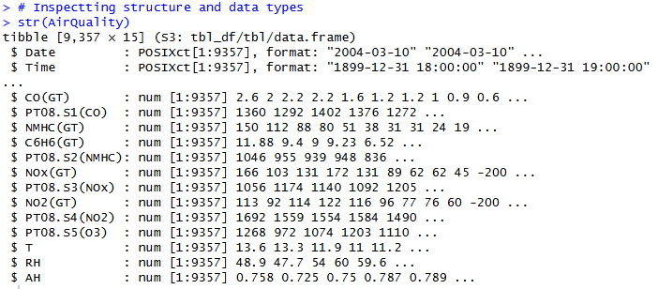
Figure 2: Data types
The str(AirQuality) function provides the internal structure of the data with the class, dimensions, and types of data of the variables. The data of 9357 observations is stored in 15 variables in the tbl_df format. This is compatible with “tidyverse” printers, and “tbl_df” does not require further organisation. There are temporal variables Date and Time, which have a format “Date and Time POSIXct” that allows chronological sorting, time-based selection and aggregation. All the pollutant and meteorological variables are stored as numeric vectors, all of which allow them to be directly analysed using statistical functions, correlation analysis and hypothesis test without requiring data type conversion.
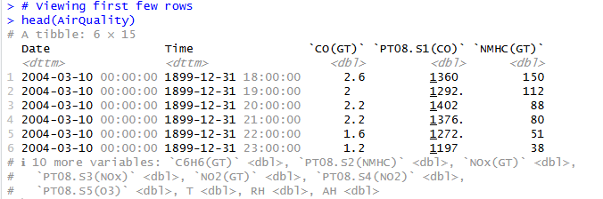
Figure 3: First few rows
The “head(AirQuality)” function is used to show the first few rows of the dataset, giving a direct preview of the values of each column, which are stored and formatted. The result of the data table output indicates that date and time are stored in date-time object format, whereas the concentration of pollutants and meteorological variable values are in numeric “(<dbl)” vectors format. This format also enables instant checking of the range of values, decimal values and row consistency. The tabular view also indicates that there is a particular hour to which an observation can be attributed, which is in favour of time series analysis.
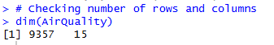
Figure 4: Number of rows and columns checking
The “dim(AirQuality)” function has been used to give the dimensions of the entire dataset and return as a numeric vector with two elements: the number of observations and the number of variables. The results “[1] 9357 15” show 9357 rows and 15 columns. The presence of this structure proves that the dataset includes a significant amount of hourly data, which makes it possible to infer statistical conclusions and explore time series. That 15 variables are present indicates a multivariate design comprising the concentrations of the pollutants, sensor outputs and meteorological factors.
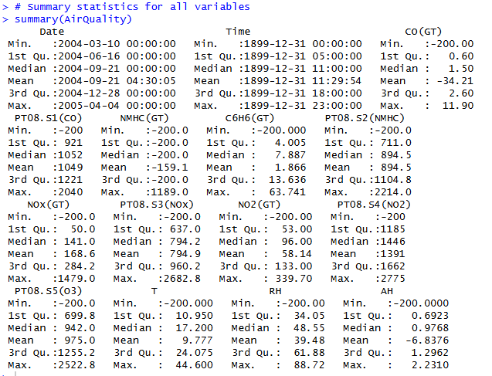
Figure 5: Descriptive statistics for all variables
The “Summary(AirQuality)” function is used to generate descriptive statistics of each variable based on the type of data it has. In the case of date-time variables, the summary statistics of the minimum, first quartile, median, mean, third quartile, and maximum timestamps are presented, which testify to the time range of the period between March 2004 and April 2005 and the proportion of hours across different hours of the day.
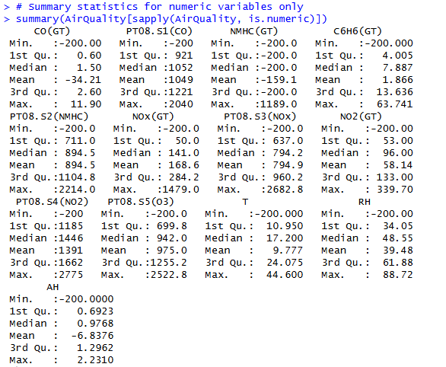
Figure 6: Descriptive statistics for all numeric variables
The expression “sapply(AirQuality, is.numeric)” applies the “is.numeric” function to each column in the dataset and returns a logical vector indicating which variables are stored as numeric data types (Aslam and Imdad Ullah, 2023). The logical index is a type of indexing that is used to subtract the data frame to only keep quantitative columns, eliminating date-time variables (Guo et al. 2023). The summary function is then used to generate descriptive statistics of each of the numeric variables selected that include minimum, first quartile, median, mean, third quartile and maximum values.

Exploratory Data Visualisation
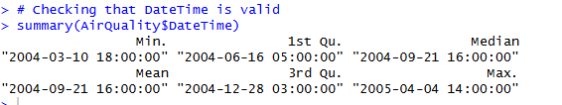
Figure 7: Date and time validation
The expression AirQuality[AirQuality == -200] <- NA replaces every occurrence of -200 with NA, converting numerically coded missing values into R’s standard missing data representation. The statistical functions automatically omit such observations in case of “na.rm= TRUE”. The function “format(AirQuality%H:M:S)” has been used to show the hour, the minute, and the second values of the time variable as character strings using the format (AirQuality, Time, percent) command (Ibarra et al. 2023). These time values are combined with the formatted date using paste(), producing complete date-time character strings suitable for conversion into a unified date-time object.
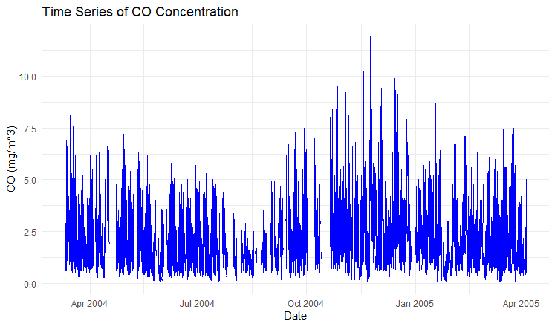
Figure 8: Time Series analysis of CO(GT)
The time series plot is used to plot the DateTime part on the horizontal axis and the CO(GT) concentration part on the vertical axis, and the continuity of time is maintained by the use of geomline that connects sequential observations of a time-dependent set (Linardatos et al. 2023). Such an arrangement ensures that hourly measurements are shown chronologically so that any short-term variation can be identified on a case-by-case basis, and the long-term variation can be identified. Continuous line geometry is the one which reflects variations in intensity and frequency during the study period.
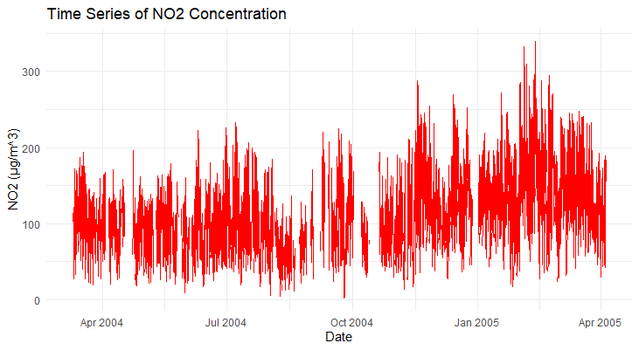
Figure 9: Time Series analysis of NO2(GT)
Structural mapping of “NO2(GT)” time series, utilising the same mapping, time (DateTime) on the x-axis and concentration of “NO2” on the y-axis, and “geomline()” is used to show continuous movement in an hour. Formatting of axes would also be consistent, so that other pollutant plots are also comparable (Edwards et al. 2025). The graphical intensity of ups and downs indicates the presence of high-frequency variations, and the greater upward movements between the last months of 2004 show the concentration phases. The values that are above 300 ug/ m3 point out extreme pollution episodes.
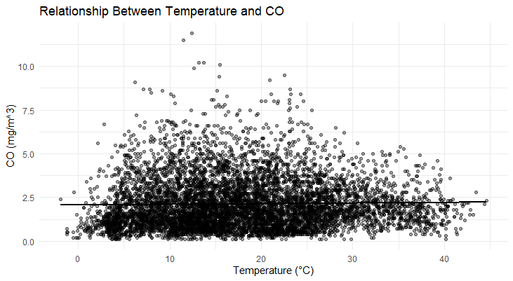
Figure 10: Temperature vs CO(GT)
The scatterplot places the Temperature (deg C ) in the x-axis and the CO(GT) on the y-axis using geompoint with paired points assumed to be the temperature and CO observations, respectively. This is a coordinate-based visualisation, which depicts the dispersion, clustering, and the possible linear relationship among the variables. Incorporation of geomsmooth fits a least-squares regression line, providing the estimation of the conditional mean of CO(GT) as offered by temperature (Onofri, 2025). The small upward slope depicts a low positive linear association, whereas the wide dispersal above and below the fitted line represents the high variability.
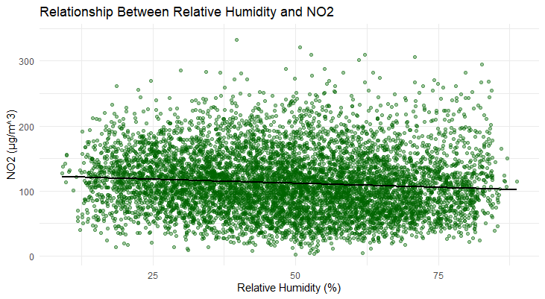
Figure 11: Relative Humidity vs NO2(GT)
The scatterplot correlates Relative Humidity (%) with the horizontal axis and NO2(GT) concentration with the vertical axis using geompoint(), which plots each combination of observation as a single coordinate. The line fitted has a negative slope, which shows a weak inverse linear relationship (Shen et al. 2024). Extensive vertical distribution at all humidity levels is a sign of high variability and weak predictability. The setup allows the evaluation of the effect of moisture in the atmosphere on the patterns of NO2 concentration and the possible effects of chemical interactions.

Correlation Analysis
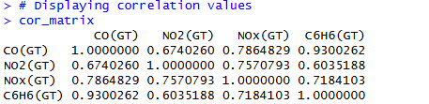
Figure 12: Displaying correlation values
“CO(GT)”, “NO2(GT)”, “NOx(GT)”, and “C6H6(GT)” are four numeric pollutant variables selected from the dataset to ensure that the analysis focuses on meaningful quantitative measures. The pairwise linear associations are obtained from the resulting symmetric matrix (Choi et al. 2024). There is also a strong relationship between CO(GT) and C6H6(GT) (0.93), meaning that the concentrations of both pollutants vary closely together. There is a significant positive correlation between NOx(GT), NO2(GT), and CO(GT), which indicates that these have a common source of emissions and also that the emissions are vulnerable to the same variations with time.
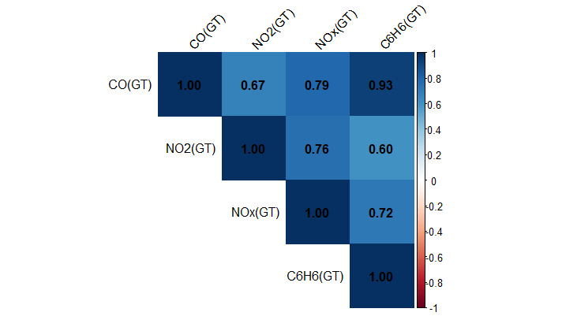
Figure 13: Visualising correlation using a heatmap
The heatmap is showing the correlation matrix calculated by using correlation coefficients as a colour gradient with strength as a measure of the linear magnitude and direction. Pearson computing the values is performed, and the values are calculated as a symmetric matrix. The cells represent the strength of the pair-wise relationship among pollutants, where dark colours represent even more positive relationships. Numbers cast over numerical entities provide the fingertip numerical values, traded off against visual representations. The diagonal shows a unit value, which indicates perfect self-correlation.
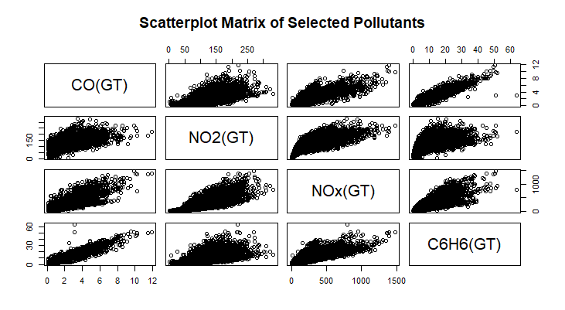
Figure 14: Scatterplot Matrix of Selected Pollutants
The scatterplot matrix shows the pairwise relationships of the chosen pollutants by plotting several bivariate scatterplots in a grid format (Adza et al. 2023). All the off-diagonal plots plot one variable against the other and do not aggregate the data. Variables are designated in diagonal panels so that the structure is clear. This arrangement allows assessing the direction, form, and strength of all combinations of associations. The analysis of linear clustering of CO(GT), NOx(GT), and C6H6(GT) shows that there are strong positive associations between the three components, which is in line with the common sources of emissions.

Hypothesis Testing
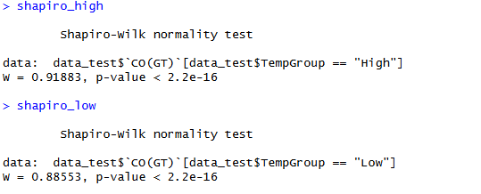
Figure 15: Normality Testing of CO Concentrations Prior to Hypothesis Testing
The “shapiro.test ()” function is used to test whether a numerical sample is normally distributed through a comparison between the ordered sample values and the expected normal values. The Shapiro–Wilk statistic (W) is used to measure the degree of deviation from normality, with values closer to 1 which indicates a distribution closer to normal. The obtained W values of 0.91883 and 0.88553, combined with p-values less than 0.001, indicate that both groups significantly deviate from a normal distribution.
Null Hypothesis (H0): CO(GT) in all temperature groups is normally distributed.
Alternative Hypothesis (H1): The values of CO(GT) in at least one of the groups of temperatures are not normally distributed.
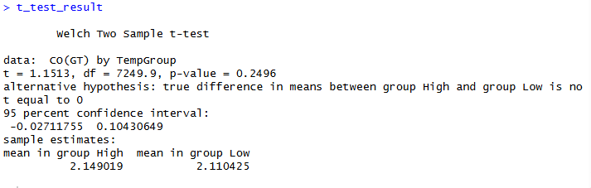
Figure 16: Welch t-Test Output for CO Concentration by Temperature Group
The Welch two-sample t-test is implemented using the t.test() function with a formula interface to compare the means between groups without assuming equal variances. Calculation of the test statistic (t = 1.1513) and associated degrees of freedom (7249.9) is done using the sample means variation compared to internal variation. As the p-value (0.2496) exceeds the 0.05 significance level so the null hypothesis cannot be rejected. Therefore, there is no statistically difference in mean CO concentrations between the High and Low temperature groups.
Null Hypothesis (H0): μHigh − μLow = 0
Alternative Hypothesis (H1): μHigh − μLow ≠ 0
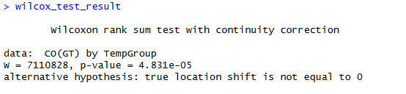
Figure 17: Wilcoxon Test Results for CO
The wilcox.test(CO(GT) ~ TempGroup, data = data_test) function performs the Wilcoxon rank-sum test, which is a non-parametric substitution, and this equivalent statistic results in a comparison of central tendencies, but does not require normal distribution. The p-value of 4.831e-05 is lower than 0.05, thus showing that there is a statistically significant difference in distribution between the High and Low temperature groups.
Null Hypothesis (H0): There exists no difference in distribution (median location) of CO(GT) between temperature groups.
Alternative Hypothesis (H1): There is a difference in the distribution of (median location) CO(GT) between temperature groups.
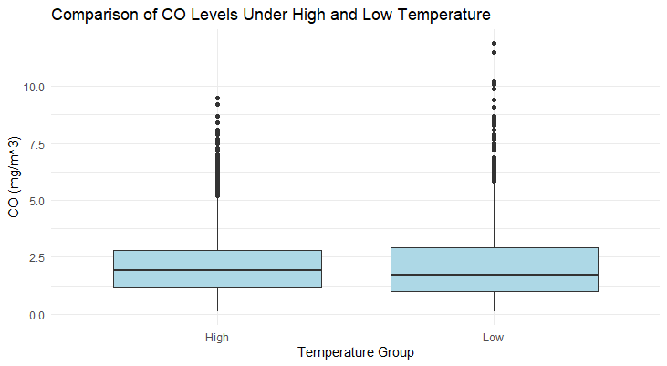
Figure 18: Comparison of CO levels under High and low temperatures
Temperature groups are plotted as the x-axis, and CO(GT) concentration as the y-axis using the geom_boxplot (), which summarises the distributions using median, interquartile range, and whiskers. The line shown in the middle is the median, and the boundaries of the boxes depict the 25th and 75th percentiles. Whiskers also reached non-outlier ranges, and isolated points represent extreme values. Similar median values indicate that there is no large disparity in the central tendency across groups, and the fact that the outer quartile ranges overlap indicates similar dispersion.

Group Comparison Across Seasons
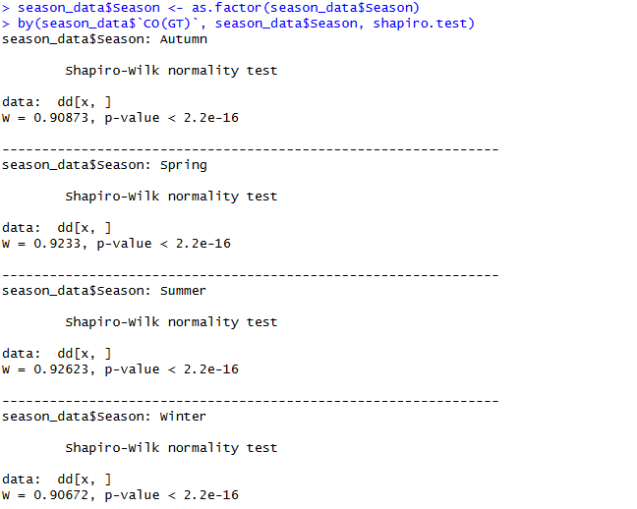
Figure 19: Shapiro-Wilk Test for CO Across Seasons
The following expression format(seasondata$Date, “%m”) is used to eliminate the month element of each date and converts the character value into a numeric, which is further used in making logical comparisons. The by-function is used to apply “shapiro.test” individually on the data in each level of CO(GT), to produce independent tests of normality. Reported W values fall in the range of 0.90672 to 0.92623, and the p-values are less than “2.2e-16”.
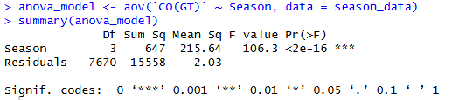
Figure 20: Performing one-way ANOVA
The analysis of variance model specified as “aov(CO(GT) ~ Season, data = seasondata)” partitions the total variability in CO(GT) into two components: variation attributable to differences between seasons and residual variation within seasons. The factor Season consists of four categorical levels, which results in three degrees of freedom for the between-group effect. The sum of Squares season (647) includes the amount of variation in the seasonal difference that is explained, and the residual sum of squares (15558) is the amount that cannot be explained within groups. Mean Squares are calculated by dividing the sums by the corresponding degrees of freedom, and the F statistic (106.3) equals the ratio of between-group to within-group mean squares. The results indicate that the p-value = “2e-16” is statistically significant in indicating season-to-season differences in mean CO(GT) concentrations.
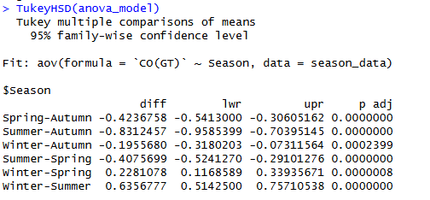
Figure 21: POST-HOC test
Once the ANOVA indicates statistical significance, the TukeyHSD(anovamodel) function conducts pairwise post hoc comparisons to determine specific differences between group means. The test uses the mean silver differences between all the seasonal pairs and adjusts the level of error of the family-wise as established by the Honestly Significant Difference process of Tukey. Each comparison provides the estimated mean difference (diff), the lower and upper bounds of the 95% confidence interval (lwr and upr), and the adjusted p-value (p adj). Confidence limits which do not contain zero are an indication of statistically significant differences. Adjusted p-values of all seasonal comparisons indicate that there is a significant difference in CO(GT) among seasons, as all adjusted p-values are below 0.001.
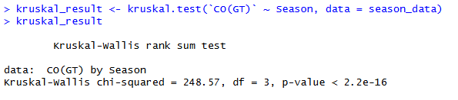
Figure 22: Kruskal-Wallis Results for Seasonal CO Comparison
The Kruskal-Wallis rank sum test is a variant of the non-parametric version of the one-way ANOVA that does not rely on the assumption of normal distribution. Groups of values of CO(GT) are categorised into seasonal groups through the formula interface, and all the values are ranked together. The test statistic is derived by tallying the variation between the average ranks among two or more groups, and it follows a chi-squared distribution, with the degrees of freedom being equal to the difference between the total number of groups and one.
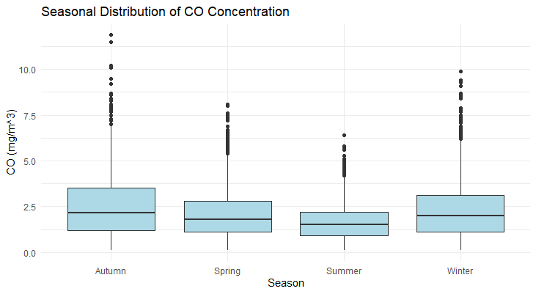
Figure 23: Seasonal distribution of CO concentration
Seasonal boxplots are grouped distributional comparisons of CO(GT) concentrations that are categorised by the factor variable Season. The boxes show the interquartile range of a given season, with the medians showing the levels of the central concentration. Seasonal differences in median height indicate a change in the average pollutant. The larger the boxes in Autumn and the Winter, the larger the variability and the smaller the boxes in the Summer, the smaller the dispersion. The outlier points that are located to the right of the upper whiskers are the events of high concentration that are not routine.

Task 2: Reflective Summary

Approach and Analytical Rationale
The data analysis on the “AirQualityUCI” dataset has been performed in a structured and systematic workflow. The analysis has started by performing data inspection and preparation, followed by an exploratory visualization, correlation analysis, and inferential statistics analysis. The initial phase of the analysis is aimed at analysing the internal structure of the dataset with the help of functions such as “colnames()”, “str()”, “dim()” and “summary()”. There is a specific focus that put on the data cleaning process. In the data cleaning phase, the missing values have been identified, which is 200, and it is are changed to “NA” to avoid the impact of the results of the descriptive statistics and hypothesis testing (Agbangba et al. 2024). The process shows the essence of validating and pre-processing data before performing quantitative analysis because the wrong or poorly coded values can undermine inferential validity.

Visualizations
Data visualization is an important aspect of the analytical process and it makes the distribution of form patterns and relations easier. The CO(GT) and NO2(GT) are plotted as time-series diagrams because the data is resolved on an hourly basis, which makes a chronological representation which is an absolute necessity. The comparison of “ggplot()” and “geom” lines allows identifying both short-term and seasonal trends. It shows the increased level of pollutants in cold seasons. Scatter plots are created to query the correlations between the pollutants and weather conditions, such as Temperature and Relative Humidity (Mohammed, 2024). These variables are continuous, coordinate -based scatterplots can be a suitable way of assessing dispersion, clustering and possible linear dependencies. Regression with the help of “geom_smooth(method = “lm”)” is used to increase interpretability through trend direction and trend magnitude summary. Correlation relationships are further represented in the form of a heatmap. In the heatmap, more than one pair-wise relationship can be evaluated at a given time. The positive correlation between the CO(GT) and C6H6(GT) shows that there is a universal source of emission, which is a result of combustion.

Challenges and Things Learned
A number of issues are experienced in the analysis stage. The existence of coded missing values means that they have to be identified and corrected in order to exclude bias in future statistical calculations. Besides this, the Shapiro-Wilk test on normality reveals that there are strong nonparametric violations of normality in most variables, thus raising doubts about the parametric assumptions. The Welch two-sample t-test has not revealed statistically significant difference between temperature strata CO concentrations, but the Wilcoxon rank-sum test result has shown difference, a significant part of which is in the alignment of the method of analysis with the actual assumptions of the data (Pham and Nguyen, 2024). This experience supports the theoretical difference between parametric and non-parametric methodologies and the necessity to test the assumptions before making an inferential judgement.

Improvements for Future Work
Future research could incorporate more advanced time-series analysis techniques, such as seasonal decomposition and regression-based forecasting, that can also explore the question of time dynamics in greater depth. Diagnostics processes, multicollinearity tests and effect-size estimation, can be incorporated to contribute to the strength of the interpretation. Enhancement of graphical illustrations can further increase visual clarity such as by enhanced axis formatting and facet layouts. Employing cross-validation or residual diagnostics can further improve the reliability and generalisability of the analytical results.

References
Adza, W.K., Hursthouse, A.S., Miller, J. and Boakye, D., 2023. Exploring the joint association of road traffic noise and air quality with hypertension using QGIS. International journal of environmental research and public health, 20(3), p.2238.
Agbangba, C.E., Aide, E.S., Honfo, H. and Kakai, R.G., 2024. On the use of post-hoc tests in environmental and biological sciences: A critical review. Heliyon, 10(3).
Aslam, M. and Imdad Ullah, M., 2023. Working with Data. In Practicing R for Statistical Computing (pp. 45-82). Singapore: Springer Nature Singapore.
Choi, S., McMaster, K.L., Kohli, N., Shanahan, E., Birinci, S., An, J., Duesenberg-Marshall, M. and Lembke, E.S., 2024. Longitudinal effects of data-based instructional changes for students with intensive learning needs: A piecewise linear–linear mixed-effects modeling approach. Journal of Educational Psychology, 116(4), p.608.
Edwards, T.D., Wong, Y.K., Jeong, C.H., Wang, J.M., Su, Y. and Evans, G.J., 2025. Comparison of methods for resolving the contributions of local emissions to measured concentrations. Atmospheric Measurement Techniques, 18(9), pp.2201-2240.
Guo, J., Peng, J., Yuan, H. and Ni, L.M.S., 2023. HXPY: A high-performance data processing package for financial time-series data. Journal of Computer Science and Technology, 38(1), pp.3-24.
Ibarra, A.M., González-Vidal, A. and Skarmeta, A., 2023. PLEIAData: consumption, HVAC, temperature, weather and motion sensor data for smart buildings applications. Scientific Data, 10(1), p.118.
Linardatos, P., Papastefanopoulos, V., Panagiotakopoulos, T. and Kotsiantis, S., 2023. CO2 concentration forecasting in smart cities using a hybrid ARIMA–TFT model on multivariate time series IoT data. Scientific reports, 13(1), p.17266.
Mohammed, M.O., 2024. Multivariate Analysis for Characterization of Air Pollution Sources: Part 1 Prior Data Screening and Underlying Assumptions. Polish Journal of Environmental Studies, 33(4).
Onofri, A., 2025. Extending Regression Models. In Field Research Methods in Agriculture: An Introduction with R (pp. 205-229). Cham: Springer Nature Switzerland.
Pham, N.Q. and Nguyen, G.T., 2024. Assessing air quality using multivariate statistical approaches. Civil Engineering Journal, 10(2), pp.521-533.
Shen, X., Yan, K., Zhu, D., Hu, Q., Wu, H., Qi, S., Yuan, M. and Qian, X., 2024. Inverse machine learning framework for optimizing gradient honeycomb structure under impact loading. Engineering Structures, 309, p.118079.

Appendices

Appendix 1: Use of Generative AI (ChatGPT)
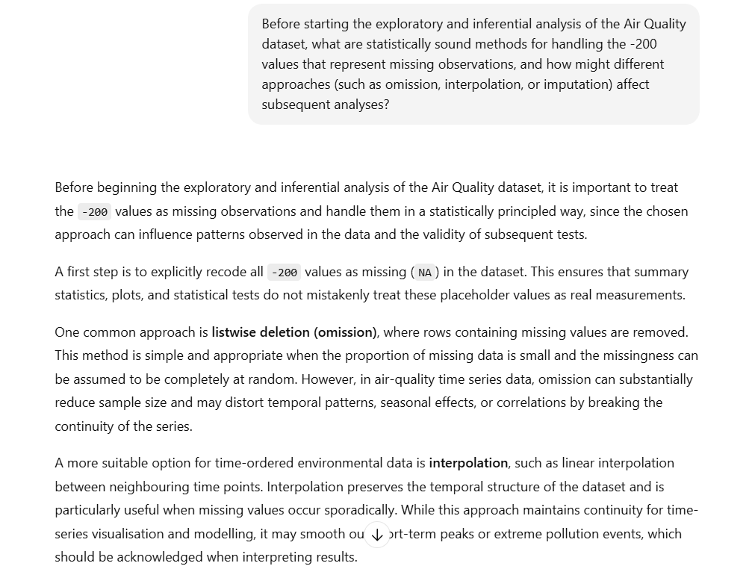
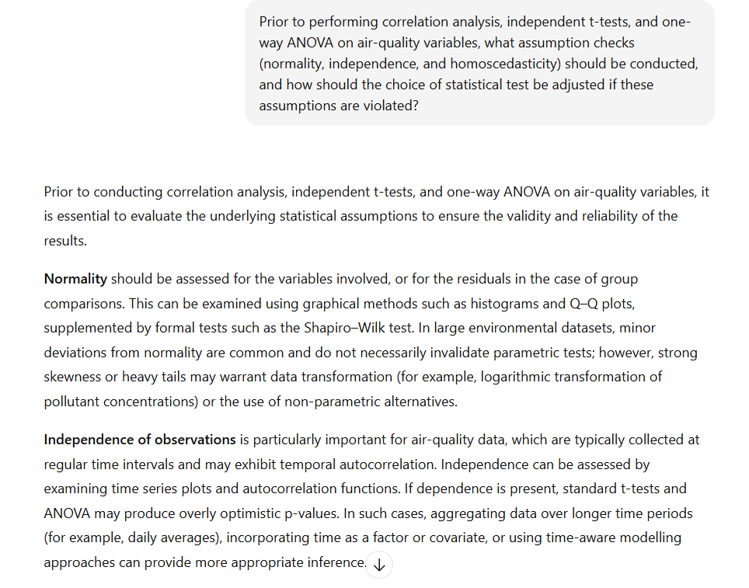
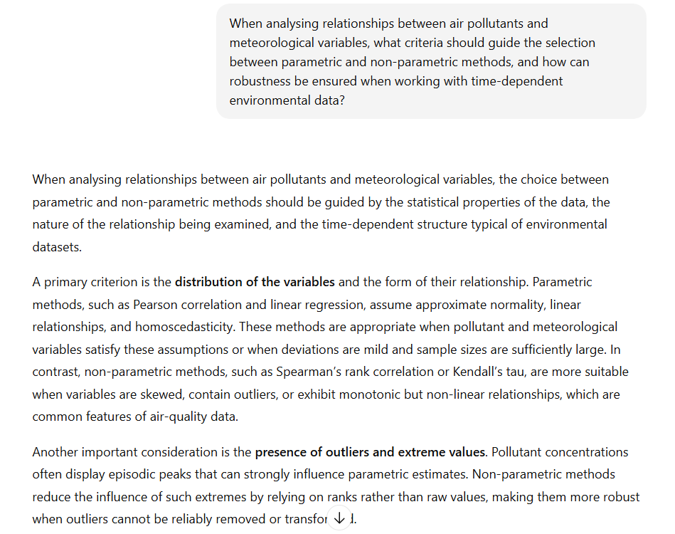

Appendix 2: Source Code
“
##==========================
## Importing required libraries
##==========================

library(readxl)
library(ggplot2)
library(corrplot)

##==========================
## Data Importing and Summary of the data
##==========================

# -----------
# DATA IMPORTING
# -----------

# Setting file path
file_path <- "D:/AirQualityUCI.xlsx"

# Importing dataset into a data frame
AirQuality <- read_excel(
path = file_path
)

# ------------------
# CHECKING COLUMN NAMES
# ------------------

# Displaying column names
colnames(AirQuality)

# ----------------
# CHECKING DATA TYPES
# ----------------

# Inspectting structure and data types
str(AirQuality)

# --------------
# FIRST FEW ROWS
# --------------

# Viewing first few rows
head(AirQuality)

# ------------------
# DATASET DIMENSIONS
# ------------------

# Checking number of rows and columns
dim(AirQuality)

# ----------------------------
# DESCRIPTIVE STATISTICS
# ----------------------------

# Summary statistics for all variables
summary(AirQuality)

# Summary statistics for numeric variables only
summary(AirQuality[sapply(AirQuality, is.numeric)])

##=============================
## EXPLORATORY VISUALISATION
##=============================

# ---------------------------------------------------
# HANDLING MISSING VALUES (-200 indicates NA)
# ---------------------------------------------------

AirQuality[AirQuality == -200] <- NA

# -----------------------------------------
# CREATING PROPER DATETIME VARIABLE
# -----------------------------------------

time_only <- format(AirQuality$Time, "%H:%M:%S")

AirQuality$DateTime <- as.POSIXct(
paste(format(AirQuality$Date, "%Y-%m-%d"), time_only),
format = "%Y-%m-%d %H:%M:%S",
tz = "UTC"
)

# Checking that DateTime is valid
summary(AirQuality$DateTime)

# ------------------------------
# TIME TRENDS OF TWO POLLUTANTS
# ------------------------------

# ---- Time Series: CO(GT) ----
ggplot(AirQuality, aes(x = DateTime, y = `CO(GT)`)) +
geom_line(color = "blue", na.rm = TRUE) +
labs(title = "Time Series of CO Concentration",
x = "Date",
y = "CO (mg/m^3)") +
theme_minimal()

# ---- Time Series: NO2(GT) ----
ggplot(AirQuality, aes(x = DateTime, y = `NO2(GT)`)) +
geom_line(color = "red", na.rm = TRUE) +
labs(title = "Time Series of NO2 Concentration",
x = "Date",
y = "NO2 (µg/m^3)") +
theme_minimal()

# --------------------------------------------
# RELATIONSHIPS BETWEEN POLLUTANTS AND WEATHER
# --------------------------------------------

# ---- Temperature vs CO(GT) ----
ggplot(AirQuality, aes(x = T, y = `CO(GT)`)) +
geom_point(alpha = 0.4) +
geom_smooth(method = "lm", color = "black", se = FALSE) +
labs(title = "Relationship Between Temperature and CO",
x = "Temperature (°C)",
y = "CO (mg/m^3)") +
theme_minimal()

# ---- Relative Humidity vs NO2(GT) ----
ggplot(AirQuality, aes(x = RH, y = `NO2(GT)`)) +
geom_point(alpha = 0.4, color = "darkgreen") +
geom_smooth(method = "lm", color = "black", se = FALSE) +
labs(title = "Relationship Between Relative Humidity and NO2",
x = "Relative Humidity (%)",
y = "NO2 (µg/m^3)") +
theme_minimal()

##========================
## CORRELATION ANALYSIS
##========================

# ------------------------------
# SELECTING POLLUTANTS FOR ANALYSIS
# ------------------------------
# Selecting four major pollutants for correlation analysis

pollutants <- AirQuality[, c("CO(GT)", "NO2(GT)", "NOx(GT)", "C6H6(GT)")]

# Removing rows with missing values
pollutants_clean <- na.omit(pollutants)

# ------------------------------
# CALCULATING CORRELATION MATRIX
# ------------------------------
# Pearson correlation is appropriate because variables are continuous

cor_matrix <- cor(pollutants_clean, method = "pearson")

# Displaying correlation values
cor_matrix

# -----------------------------------
# VISUALISING CORRELATION USING HEATMAP
# -----------------------------------

corrplot(cor_matrix,
method = "color",
type = "upper",
addCoef.col = "black",
tl.col = "black",
tl.srt = 45)

# ------------------------------
# SCATTERPLOT MATRIX
# ------------------------------

pairs(pollutants_clean,
main = "Scatterplot Matrix of Selected Pollutants")

##===============================
## HYPOTHESIS TESTING (T-TEST)
##===============================

AirQuality[AirQuality == -200] <- NA

# Selecting relevant variables
data_test <- AirQuality[, c("CO(GT)", "T")]

# Removing missing values
data_test <- na.omit(data_test)

# ------------------------------------------
# CREATING TWO CONDITIONS (HIGH vs LOW TEMP)
# ------------------------------------------
# Using median split to classify temperature levels

median_temp <- median(data_test$T)

data_test$TempGroup <- ifelse(data_test$T > median_temp,
"High", "Low")

data_test$TempGroup <- as.factor(data_test$TempGroup)

# ----------
# HYPOTHESES
# ----------

# H0 (Null Hypothesis):
# There is no difference in mean CO levels between
# high-temperature and low-temperature conditions.

# H1 (Alternative Hypothesis):
# There is a significant difference in mean CO levels
# between high and low temperature conditions.

# ------------------------------------------
# CHECKING NORMALITY (ASSUMPTION FOR T-TEST)
# ------------------------------------------

shapiro_high <- shapiro.test(data_test$`CO(GT)`[data_test$TempGroup == "High"])
shapiro_low <- shapiro.test(data_test$`CO(GT)`[data_test$TempGroup == "Low"])

shapiro_high
shapiro_low

# ---------------------------
# PERFORMING APPROPRIATE TEST
# ---------------------------

# If both groups approximately normal → need to use independent t-test
# Otherwise → need to use Wilcoxon rank-sum test

t_test_result <- t.test(`CO(GT)` ~ TempGroup,
data = data_test,
var.equal = FALSE)

t_test_result

# Non-parametric alternative
wilcox_test_result <- wilcox.test(`CO(GT)` ~ TempGroup,
data = data_test)

wilcox_test_result

# ----------------------------
# VISUALISING GROUP DIFFERENCE
# ----------------------------

ggplot(data_test, aes(x = TempGroup, y = `CO(GT)`)) +
geom_boxplot(fill = "lightblue") +
labs(title = "Comparison of CO Levels Under High and Low Temperature",
x = "Temperature Group",
y = "CO (mg/m^3)") +
theme_minimal()

##=============================
## SEASONAL GROUP COMPARISON
##=============================

# Selecting relevant variables
season_data <- AirQuality[, c("Date", "CO(GT)")]

# Removing missing values
season_data <- na.omit(season_data)
# -------------------------
# CREATING SEASON VARIABLE
# -------------------------

# Extracting month from Date
season_data$Month <- as.numeric(format(season_data$Date, "%m"))

# Assigning seasons
season_data$Season <- ifelse(season_data$Month %in% c(12,1,2), "Winter",
ifelse(season_data$Month %in% c(3,4,5), "Spring",
ifelse(season_data$Month %in% c(6,7,8), "Summer",
"Autumn")))

season_data$Season <- as.factor(season_data$Season)

# ----------------
# STATE HYPOTHESES
# ----------------

# H0 (Null Hypothesis):
# Mean CO concentrations are equal across all seasons.

# H1 (Alternative Hypothesis):
# At least one season has a significantly different
# mean CO concentration.

# ------------------
# CHECKING NORMALITY
# ------------------

by(season_data$`CO(GT)`, season_data$Season, shapiro.test)

# ------------------------
# PERFORMING ONE-WAY ANOVA
# ------------------------

anova_model <- aov(`CO(GT)` ~ Season, data = season_data)

summary(anova_model)

# --------------
# POST-HOC TEST
# --------------

TukeyHSD(anova_model)

# --------------------------
# NON-PARAMETRIC ALTERNATIVE
# --------------------------

kruskal_result <- kruskal.test(`CO(GT)` ~ Season, data = season_data)

kruskal_result

# -------------------------
# VISUALISING USING BOXPLOT
# -------------------------

ggplot(season_data, aes(x = Season, y = `CO(GT)`)) +
geom_boxplot(fill = "lightblue") +
labs(title = "Seasonal Distribution of CO Concentration",
x = "Season",
y = "CO (mg/m^3)") +
theme_minimal()
”

