

UNIVERSITY OF WALES:TRINITY SAINT DAVID
SCHOOL OF BUSINESS
LONDON CAMPUS
Impact of Advanced Technology on Supply Chain Management in Fashion Industry UK.

VISIONS FOR THE FUTURE:
Theoretical Perspective
on Management
LCDB7006
Word Count:7,571

TABLE OF CONTENTS
1. Introduction……………………………………………………………………………….4
2. Overview of Supply Chain Management, Fast Fashion and Advance Technology
2.1. Supply Chain Management (SCM)……………………………………………………5-6
2.2 Fast Fashion Vs Traditional Supply Chain Management……………………………6-7.
2.3. Advance Technology in SCM……………………………………………………………8
3. Reasons of Implementing Advance technology in Fashion Supply Chain Management Systems.
3.1. Emergence of New Consumer Buying Cycle……………………………………........9
3.2. Need of Flexibility in every stage of SCM……………………………………………10
3.3. Demand for Quality & Transparency in SCM……………………………………10-11
3.4. Customer Expected Mass Customization Product………………………………...12
3.5. The rise of digitally driven Ecosystem in SCM…………………………………12-13
4. How technology Enhanced the organizational structure of Fashion Supply Chain System
4.1 Building AI (Artificial Intelligence) Powered Organizational Structure……………………………………………………………………………..…13-14.
4.1.2. From experience-based, leader-driven decision making to data-driven decision making at the front line……………………………………………………………..14-15
4.2. Implementing Cloud Computing and EDI to Ease the Information Sharing Across Organization……………………………………………………………………………15-16
4.3. Implementation of Tracking Technology in Easing Management Systems…………………………………………………………………………………….16
4.4. E commerce Changed the Traditional Models of Organizational Structure……..17
5. Adoption of Supply Chain Strategies with the use of Technology by Fashion Retailers
5.1. Agile and Lean Supply Chain Methodology……………………………………18 -20
5.2. Omni-Channel Strategies Adopted by Fashion Retailers to Provide Best Customer Experience………………………………………………………………………………20-22
5.3. How Fast Fashion Retailers-Zara & H&M Enhanced Supply Chain Strategies in their Management system with the use of Technology
5.3.1. Vertically Integrated SCM system………………………………………………….23
5.3.2. Enhanced Retail Store Environment with Technology…….…………………23-24
5.3.3. Lean Inventory Management…………………………………………………….24-25
5.3.4.. Customer Oriented Retailer…………………………………………………………..25
6. Future Vision of Advance Technology in Fashion Industry
6.1. Personalized Designer Clothes with Artificial Intelligence……………………26-27
6.2. Smart Clothes………………………………………………………………………27-28
6.3. Shopping through Virtual Mirrors…………………………………………………28-30
6.4. Tech Shopping Centre………………………………………………………………..30
7. Conclusion…………………………………………………………………………….34-35
8. References…………………………………………………………………………….36-40

- Introduction
Today Technologies are becoming readily available and expected to provide a competitive advantage for any organization with the aim of helping to achieve more effective and efficient management across the supply chain management processes. It is also believed that the organizations that are more likely to get benefit from the advancement of the technologies are those who can manage and utilize it appropriately within their own internal management structure and embed it along their standard operating (SOP) procedures in order to fulfill the expectations and requirements of their trading partners. Currently, the fashion markets? (industry) face very high pressure in order to provide quality products and services to consumers with shorter possible lead times with minimum price and this was further exacerbated by the digitization of the fashion industry and the choices it offers which has led to the emergence of ‘fast fashion’ concept.
According to Mc Kinsey Global fashion index, the fashion industry has seen huge sales growth to nearly tripled between the years 2016 and 2018 which reported from 1.5 percent between 3.5 to 4.5 percent in U.K. (Mckinsey & Co., 2017). According to the report, the fashion industry of U.K. contributed £ 32 billion in 2018 to the economy as compared to last year, which is 5.4% increase (Sliegh, 2018). The UK Fashion industry is a big employment of giving around 890,000 job opportunities to the industry and it is recognized as equivalent to Financial sector of UK. (Sliegh, 2018).
The aim of this paper is to evaluate the various factors of advanced technology impacting on fashion supply chain management and looked looking challenges faced by organizations to implement and change supply chain system .The author of this paper review number of technologies such as RFID,AI, Touchscreens, Bock Chain, ERP System, EDI and how they are implemented in the Supply Chain Management System in the fashion sector to achieve competitive advantage .The author also revealed some views about how the fashion industry will look like in Future.

2. Overview of Supply Chain Management, Fast Fashion and Emergence of Disruptive technology in SCM
2.1. Supply Chain Management.
The supply chain management concept has been developed by Peter ducker’s (1962) in an article of ‘the economy’s dark continent’ where he expressed his views about distribution was one of the key areas in supply chain to achieve target and save costs for the organization(Sparks, 2010). After next two decades, the other areas such as warehouse, transport ,inventory management were also being considered as important departments of supply chain system in 1980’s rather than separated and enabled by technology (Sparks, 2010).To elaborate the concept of supply chain management, other author supported and said that it consists of all the parties involved such as manufactures, supplier, transporter, warehouse and retailers to fulfill customer request(Basak et el 2014).
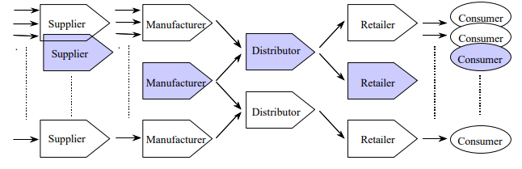
Exhibit1: Schematic diagram of Supply Chain(Shaded) within the total supply chain network.
Source: Vorst 2014
Supply Chain Management is defined as linking all the supply interacting organizations into two-way communication system to effectively manage high quality inventory as described in above figure (Vorst 2014).

2.2. Fast Fashion vs. Traditional Supply Chain System
Fast Fashion is defined as a business strategy to provide new fashion products into store by reducing the processes involved in the buying cycle and lead time(Ciarniene and Vienazindiene, 2014).The concept of Fast Fashion has been developed in Europe, where teenagers and young adult women who desire to buy trendy and inexpensive clothes and can easily be available from small retail shops and boutique (Ciarniene and Vienazindiene, 2014).Fast Fashion chains such as Zara, Topshop and H&M have grown quicker than the industry as a whole and acquired the market share by fulfilling customer expectations to provide clothes with shorter lead time (Ciarniene and Vienazindiene, 2014).On the Contrary, traditional supply chain system was complex and had longer lead time to deliver products to the retail stores(Bhardwaj and Fairhurts,2010)
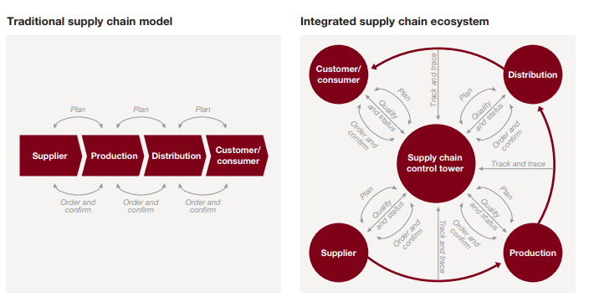

Exhibit 2: Digitial Supply Ecosystem Vs Traditional
Source: Schrauf and Berttram, 2016
As shown in above diagram, the author elaborates and states that there was difficult in traditional times due to long lead time, where whole supply chain took 18 months to deliver the products for a new season (Lipol, 2015). The average lead time for the apparel industry in the 1980’s was about 66 weeks from manufacture to deliver to the stores.(Lipol, 2015).Unlike the business concept of traditional, integrated supply chain system has been developed in 1990’s and retailers were succeed to shorten the lead time by 2-6 weeks for the whole process and it is denoted as demand driven supply chain management(Detexcorp, 2019). It is also believed that this could only be achieved through the implementation of quick response and agile supply chains (Detexcorp, 2019).
The author further elaborates that the demand driven supply chain system can be maintained at the same level, if retailers would able to provide latest trendy clothes to the consumers and make them repeated customer. (Detexcorp, 2019). The retailers must focus on Fast fashion objectives to retain their customers which are as follows (Detexcorp, 2019):
- Focus on increase sales online and physical stores.
- To keep the prices minimum with good quality for the products
- Focus to maintain stock levels.
- Need to improve cash flows.
- Reduction in total cost to buy goods.
- Retail store traffic should be increased.
- Gain Competitive advantage.
- Trendy seasonal clothes every year.
2.3. Emerging Technologies for Supply chain management
The technology has transformed the retail environment significantly due to growing interest of consumers towards digital technology (Vecchi,2017). Several studies stated that current trends in the fashion industry are associated with digital revolution (Vecchi,2017). Fashion retailers are adopting digital technologies across their online and physical stores to fulfill consumer demand (Vecchi,2017).The rapid expansion of Ecommerce business in 2000, with the increase of internet usage and retailers has started developing their e-fulfillment distribution networks (Kayikei, 2019).
Additionally other author supported and state that the transformation has begun from Industry 3.0 in 1970’s with the beginning age of information sharing and emerged Industry 4.0 platform in 2000.(Schrauf and Berttram , 2016).The Fashion industry started using digital marketing and social media in 2000 to promote their products and developing their markets to do business through ecommerce to enhance customer experience(Schrauf and Berttram , 2016). The new ecosystem has developed which is based on advance technologies such as cloud computing, big data, 3D printing, augmented reality, Internet of Things, RFID, touchscreens, mobile apps and others. (Schrauf and Berttram, 2016).
3.Reasons of Implementing Advanced technology in Fashion Supply Chain Management Systems
The technology implementation becomes necessary in all internal processes of supply chains around the world. The author of this paper identified the challenges faced by organizations due to demand has changed significantly which enforced them to adopt digitally driven supply chain system.
3.1. Emergence of New Consumer Purchasing Behavior.
The author states that social media is the biggest contribution in changing buying behavior of consumers. Currently consumers follow the strategy of ‘See Now, Buy Now’ which impacted organizations to imposed this strategy with the availability of the products in physical stores as well as online to acquired target markets (Gulberti, 2018).Do the organizations overcome these challenges? The evidence stated that companies such as Kate Spade and Fenwick can identify customer needs with the use of ERP systems by controlling their stock and collection of samples (Gulberti, 2018). On the other hand, some of the companies can observe trends with the use of sample tracking tools before product launch and plan productions ahead to reduce potential losses and optimize resources (Gulberti, 2018).
According to Business Fashion report, the consumers are now mobile obsessed which revealed that mobile data traffic has increased from desktop (Mskinsey & Co. (2017). The report states that half of millennial spent three hours per day on the devices and six hours per week on searching their apparel items through mobile (Mskinsey & Co. (2017). The huge opportunity to target consumers who are doing shopping through internet was captured by Fast Fashion stores such as Zara, Topshop ,Newlook,H&M by giving choices to shop from digital wardrobes, pay by app and also deeply engaged with them through social media (Mskinsey & Co. (2017).
3.2. Need of Flexibility in Every Stage of Supply Chain System
The other reason to implement automated systems at every stage of supply chain system was flexibility required to achieve Fast Fashion Strategy (Gulberti, 2018). The requirement of resolve issues such as timely delivery, less or no rejection of the products, raw material procurement on time which are mostly faced by the Fashion stores (Gulberti, 2018). The implementation of automated systems which helped measuring the accurate data in every stage to achive high level of efficiency. for the organizations to overcome to achieve Fast Fashion Strategy is requirement of flexibility in internal processes of supply chain system (Gulberti, 2018). The ability to rapidly respond on these challenges would result in meeting profit goals for the organization (Gulberti, 2018).
3.3. Demand for Quality and Transparency in the SCM.
The another factor which is responsible for the organizations to make changes in the supply chains are quality and transparency (Fashion Revolution.org, 2019).According to the report, it has been stated that Fashion revolution has the power to influence the brands to become more transparent due to customer would like to take knowledge of the supplier/manufacturer of the product.(Fashion Revolution.org, 2019).The survey has been conducted on 200 global fashion brands 2019(Exhibit 3) about the disclosure of their suppliers, supply chain policies ,social and environmental impact and found that that average score is 21% which cleared that there is still less transparency and more work need to be done (Fashion Revolution.org, 2019).

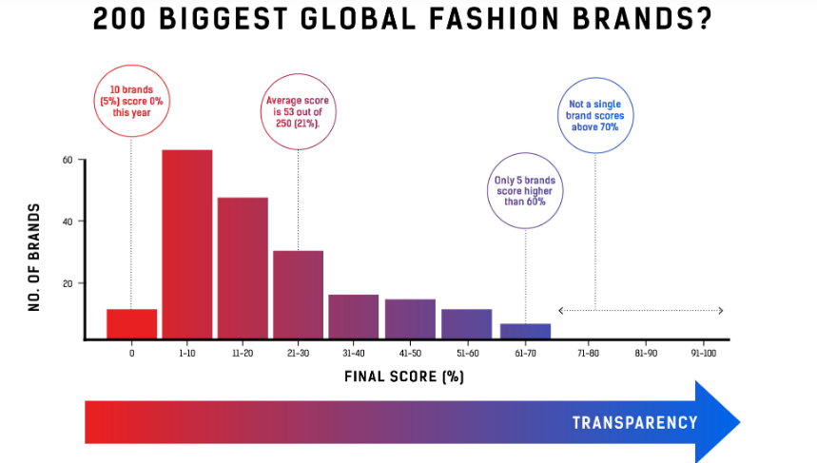

Exhibit 3: Fashion Transparency Index 2019.
Source: Fashion Revolution.org, 2019.

The above figure shows that only top five brands scored 60% for the transparency, three out of five are Adidas, Reebok and Patagonia and no other major brands got score above 70%(Fashion Revolution.org, 2019).The fashion industry considered as non-transparent due to secrecy and opaqueness but disruptive technologies made them more transparent(Fashion Revolution.org, 2019). Transparency is essential to build reputation for the customers and, they should consider suppliers, who met working conditions such as human rights are respected and environment is safe (Fashion Revolution.org, 2019). It is to be believed that there is a need of radical paradigm shift to change the system in a positive and fundamental way (Fashion Revolution.org, 2019).

3.4. Customer Expected Mass Customized Products
The another big reason for implementation of technology due to rapidly changing fashion concept in the minds of customers.(Nayak et al., 2015).The customers required customized products according to their preference of color, fabric and design, which challenges manufacturer and retailer to become more flexible in their internal systems to produce clothing items according to customer specifications(Nayak et al., 2015).Mass customization benefits to the customer and organization both ,customers could get their personalized choice clothes and manufacturer could get competitive cost in the marketplace due to less production and inventory management(Nayak et al., 2015).Are there any organizations who are providing such kind of services in today’s era? (Nayak et al., 2015). The author said that the companies are limited with these services such as as Levi Strauss, Swimwear, Second Skin and custom foot (Nayak et al., 2015).
Now the question arises Are organization able to succeed with more flexibility in their internal systems? (Nayak et al., 2015). The author explained that despite of more flexibility required at manufacturing system to produce customized products in comparison with mass production, but it gives cost effectiveness due to less volume production.(Nayak et al., 2015). However, there are some issues occurred in customization for every organization such as quick response and cost effectiveness which could only be achieved by redesign their machining system with advanced technology (Nayak et al., 2015).
3.5. The Rise of Digitally Driven Supply Chain Ecosystem
The Supply chains in today’s world are no longer simpler linear chains and processes ,they are now considered to be more complex networks with the flow of information and products within and between departments through different networks which linked organizations, industries and economies at one place (Millar,2015). The author further explained by supporting the concept that linear supply chain is no longer adequate to describe the nature of complex international networks where suppliers, partners and customers all together collaborate for the efficient movement of products, services and information flow around the globe(Millar,2015). The strategic, complex and global nature of the supply chains remind us that we are in the era of Global Supply Chain Ecosystem (Millar,2015).
The Fast Fashion retailers are disrupting markets today by providing strong value propositions to the consumer (Consulting.ey.com, 2016). The retailers are focusing to strengthen their whole supply chain ecosystem with the approach of integrated broad network of suppliers and customers to develop new products and the best example is Zara which is fully derived their ecosystem digitally with vertical integration (Consulting.ey.com, 2016).

4. How technology Enhanced the organizational structure of Fashion Supply Chain System
The author of this paper evaluates all the major changes which are happening due to disruptive technologies in every stage of Supply chain management system from the past years. The author explained that how technology is shaping the whole fashion industry from traditional supply system and now it became integrated digitally driven supply ecosystem where every system is worked with Internet of Things.
4.1. Building AI (Artificial Intelligence) Powered Organizational Structure
Artificial intelligence is reshaping fashion industry where employees could predict new styles and Fashion trends according to the history of customer purchase with the help of this approach. (Walch, 2019).The author described that Artificial Intelligence was first coined by John McCarthy in 1956 and after that countless definitions has been proposed but if we conclude all of them in simple term then it is described as computer as a digital device can be used with the right software to solve human problems(Gesing, Peterson and Michelsen, 2018).According to business of Fashion report, the demand forecast by AI-based approach would help to decrease 50% errors (Walch, 2019).On the contrary, other author suggested that AI-based supply chain systems could be dangerous for human(Thomas.net, 2018). The vehicles which are self-driving or autonomous driven by complex AI algorithms which allows to monitor surrounding sound of humans and if there will be incorrect prediction it could be fatal for people (Thomas.net, 2018).
4.1.2. From experience-based, leader-driven decision making to data-driven decision making at the front line.
AI is denoted as black box in today’s fashion industry where you feed data and get instant results (Kellett, 2018). Decision processes would be shifted completely from manual complex method to AI system (Fountaine, McCarthy and Saleh, 2019). Experienced human can easily make decision by their own with the help of supported data feed by the system without any approval from their senior manager(Fountaine, McCarthy and Saleh, 2019) .The author also stated that to adopt AI based approach, employees should have trust and empowered to make decisions as it changed the traditional top-down hierarchical approach in the organization(Fountaine, McCarthy and Saleh, 2019). AI can play a vital role in monitoring competitor price’s and then made ideal price to generate revenue (Kellett, 2018). According to the survey, almost three quarters of fashion retailers are going to spend in Artificial Intelligence in the next 24 months (Kellett, 2018). Online giant Alibaba who is involved heavily in fashion sector has already spent $15bn in Research & development in 2018 to become a leader in Artificial Intelligence (Kellett, 2018).

4.2. Implementing Cloud Computing and EDI to Ease the Information Sharing Across Organization
Cloud Computing
Cloud computing services are cost effective, flexible and visible throughout the supply chain process(Toka and Aivazidou, 2014).Cloud computing platform play a Vitol role in demand forecasting where companies can gather sales data through internet, employees can perform basic analytics to get accurate statistical demand forecast(Toka and Aivazidou, 2014).The combination of cloud computing with EDI will be very effective to plan the order on the basis of demand (Toka and Aivazidou, 2014).The process is very simple as when the demand generated by customers, distributers send it to the public cloud, where everyone throughout the supply chain could able to watch and process accordingly(Toka and Aivazidou, 2014).The author supporting the concept of its effectiveness and state that gives benefit in logistics tracking operations to different partners throughout the supply chain(Toka and Aivazidou, 2014).The biggest advantage of cloud computing services that the companies do not require any investment to implement cloud system software as it is run by external provider with ERP (Enterprise Resource Planning)(Toka and Aivazidou, 2014).On the contrary, one of the biggest challenge faced by companies are security and privacy when using cloud based approach (Toka and Aivazidou, 2014).
EDI (Electronic Data Interchange)
EDI (Electronic Data Interchange) is explained as the movement of information between buyers and seller through electronically with the purpose of transactions and to improve customer service by enhancing the performance of delivering the products(Masudin and Kamara, 2017) .EDI has many benefits some of them are reduced paperwork, quick information receipt, increase financial flows and reduction in inventories(Masudin and Kamara, 2017). However some researchers argued that EDI can benefit in mostly quick deliveries but there has no evidence that it has a huge impact on customer and supplier relationship to exchange information frequently to improve customer satisfaction (Masudin and Kamara, 2017).But in spite of the arguments on the relationship, the EDI system has seen biggest impact when companies exchanging invoices, delivery information, orders via electronically to the supplier to any location wherever they are located which helps to strengthen the relationships (EdicomGroup, 2017). There are biggest brands who rely on EDI are Harrods, Cortefiel, and Printemps which are the popular fashion brands (EdicomGroup, 2017). EDI can give benefit of faster response times and saved administrative cost to the organization (EdicomGroup, 2017). According to survey total of 10% sales has been accounted by electronically in the fashion sector where 23.2% increase in ecommerce worldwide (EdicomGroup, 2017). It also enhances greater visibility throughout the process of supply chain management and effective working procedures in the organization (EdicomGroup, 2017).
4.3. Implementation of Tracking Technology in Easing Management Systems.
Tech Management Control System
Fashion industry is entering into next era of technology where goods are being produced using hyper-rapid manufacturing system, which are going to be traced with the use of advance tech inventory management tools(CBINSIGHTS, 2018).The adoption of RFID (Radio Frequency Identification technology) is increasing around the global fashion brands (CBINSIGHTS, 2018). According to author, it is defined as wireless method used to identify items and there is no requirement for visual contact in regard to read or written (Azevedo, 2012). The communication capabilities through employees are clearer as the involvement of electronic information with physical items (Azevedo, 2012. RFID tags are used in digital catalogues which are cheap, no batteries required, and these are denoted as smart stickers (Azevedo, 2012. The signals are strong which can read from some distance away and it lessens the time. (Azevedo, 2012).
This technology helps in maintaining better inventory management and reduce related costs as it provide capability to track and trace items which leads to improve efficiency in the fashion supply chain system(Azevedo, 2012.Additionally,this technology benefits to fashion supply chain partners to use pull strategy to increase the speed of delivery along with adoption of product customization strategy(Azevedo, 2012).
From Centralized Supply Chain to Decentralized System
Block chain is defined as a database which is used to store all transactions across whole supply chain system, and it is decentralized (Retail News, 2019). It is more transparent as compared to tradition supply chain system, which was centralized and non-standardized, where data sharing is minimal (Retail News, 2019). With the use of block chain technology data cannot be manipulated once it entered (Retail News, 2019). This technology helps organization to create end to end digital histories in all their products by giving unique digital ID or token number at their inventory level (Retail News, 2019). There are very less fashion brands that are using this technology such as Martine Jarlgaard based in London producing collections of smart label and New York Fashion brand Baby ghost (Retail News, 2019).

4.4. E commerce Changed the Traditional Models of Organizational Structure
The products currently are being tracked by using latest technologies such as RFID and block chain would never be used in traditional retail stores (Mintel Press Office, 2017). The companies are now moving to D2C (Direct to consumer) model as consumers are now embracing online shopping as compared to go to physical stores (Mintel Press Office, 2017). According to the report, technology has witnessed demise of some of the stores such as JC Penny closed 140 stores in 2017(Mintel Press Office, 2017).According to report, it has seen that consumers are buying apparel more on online in comparison from stores which is 16.2 billion sales of fashion clothing, accessories and footwear (Mintel Press Office, 2017). In addition to the line ,the online sales of fashion industry has revealed a huge growth from 17% in 2013 to 24% in 2017(Mintel Press Office, 2017).However, the total sales of fashion was 1.3% only in 2017 whereas online fashion sales continue to grow(Mintel Press Office, 2017). There has been a prediction for the next five years; the online fashion market sale will reach 79% in 2022(Mintel Press Office, 2017).
The emergence of new distribution strategies such as brick and mortar model disrupt the long process of delivery and it enhance inventory management system.(CBINSIGHTS, 2018).Now online strategy is in its boom as pop ups ,kiosks and D2C came into existence(CBINSIGHTS, 2018).D2C model has disrupted middle man retailer and succeed with the strategy of ‘SEE –NOW BUY-NOW’ (CBINSIGHTS, 2018). The other Ecommerce strategy using by Ever lane’s company is ‘Choose What You Pay’ feature where they ask from customer to recommend price according to the past season and then they allocate their production (CBINSIGHTS, 2018). The traditional brand like Tommy Hilfiger also moving to more D2C -focused strategy (CBINSIGHTS, 2018).
.

5. Adoption of Supply Chain Strategies with the use of Technology by Fashion Retailers
5.1. Agile and Lean Supply Chain Methodology
The author explained that Fashion retailers are adopting lean and agile supply chain methodology in order to follow customer centric approach. So quick response has emerged which is an operational strategy that provides wide range of products by modifying organizational system with the fast flow of information across value chain (Ciarniene and Vienazindiene, 2014). The author further elaborate the strategies by stating that the companies would like to catch order winning criteria in the marketplace to get competitive advantage (Ciarniene and Vienazindiene, 2014 The cycle time reduced via eliminate waste is the key idea to increase customer value. This is the most prominent way by using lean manufacturing techniques to cut cycle time throughout supply chain and achieved competitive advantage in the fashion market (Ciarniene and Vienazindiene, 2014). On the other hand, agile supply chain strategies where companies use market knowledge and a virtual cooperation to get profitable opportunities (Ciarniene and Vienazindiene, 2014).The author further states that the companies who are slow to react and would not able to adopt new strategies lead to loss markets (Ambe, 2010).
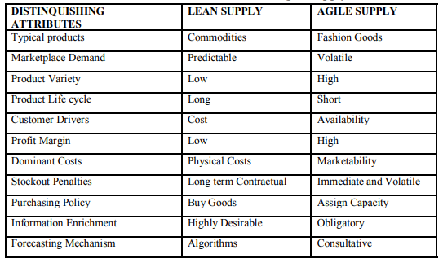
Exhibit 4: Attributes of Lean and Agile Supply
Source: (Ambe, 2010)
The performance of supply chain management is driven by matching supply to demand thereby decrease in costs simultaneously to satisfy consumers(Ambe, 2010).Supply chain strategies could be distinguished where the companies have to accept uncertainty and develop new strategies to meet demand as clearly defined from above table(Ambe, 2010).

5.2. Omni-Channel Strategies Adopted by Fashion Retailers to Provide Best Customer Experience
The second most important strategies are adopting by Fashion retailers to provide products to the customer in a seamless way. (Kayikei, 2018). The Omni channel strategy for the organizations is defined as, where customer can easily order through mobile device while travelling and pick an order from store near by their location on the same day (Kayikei, 2018).
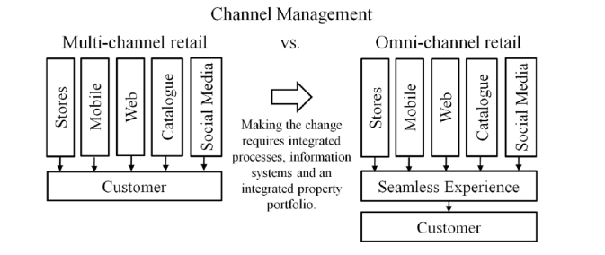
Exhibit 5: Omni Channel Retail
Source: Kayikei, 2018
The retailers in this case need to be more holistic view about the products available at inventory level in Omni channel environment to fulfill their orders from any location and ship them to any area where products are needed (Kayikei, 2018). On the other hand, multi-channel approach where customers contact retailers independently through different channels such as social media, that approach is not successful in giving seamless experience as it is difficult to provide information to the customer (Kayikei, 2018).
Supporting the concept of Omnichannel retailing, author described that retailers are now shifting from cost-centric approach to customer value creation approach to achieve their goals of achieving high sales and capture markets (Ishfaq et al ,2016). The organizations have to overcome one of the biggest challenges for this strategy to implement that they could increase engagement between supply chain system along with the other retail entities which seems to be more comprehensive (Ishfaq et al ,2016). Retailers must go beyond to achieve customer centric approach by applying better alignment within the departments and every stage of operations (Ishfaq et al ,2016). According to survey, there are top ten retailers who are best in their digitization, retailer Mango is best in using Omni channel strategy and Topshop denoted as number one digital Genius (Halliday, 2016).
5.3. How Fast Fashion Retailers-Zara & H&M Enhanced Supply Chain Strategies in their Management system with the use of Technology
To explain this, author of this paper has chosen the super responsive Fast Fashion Retailers-Zara and H&M to give more depth understanding of technologies worked for both.
The two biggest names of fast fashion retailers are H&M and Zara, the parent company of Zara named Inditex has reported 7% growth in profits in 2017 where as H&M has seen fallen by 62% in the first quarter of 2018(Taylor, 2018).H&M had better deals for the shoppers (Taylor, 2018).The biggest star is denoted as Zara which has estimated worth $100 billion market capital in 2015 and only Nike is accounted to come closer(Taylor, 2018).The operational theme adopted by Zara is agile strategy implemented at every stage from product development to retail throughout the supply chain(Taylor, 2018)..
5.1. Vertically Integrated SCM System
Zara’s growth strategy achieved through diversification with vertically integrated system by enhancing supply chains and reducing lead times to two weeks only in comparison to Fashion Industry as a whole (Trade gecko, 2018). The retail giant is delivering fashionable, trendy clothes through control and integrated process which is known as Just in Time production (Trade gecko, 2018). Zara has in-house production which helps them to reserve their capacity of 85% for seasonal adjustments for supply (Trade gecko, 2018).H&M is also similar vertical coherent but their designers follow trend setters and they mostly follows music festivals for vintage looks(The Irish Times, 2019). H&M lead time is double in comparison with Zara, so it has considered to be slow brand for fast fashion market and suppliers may compromise in regard with quality due to get benefit of high profit margin(The Irish Times, 2019).H&M is also seeing more pressure in regard with price for their budgeted clothes with Primark for their Germany market(The Irish Times, 2019).
5.3. Enhanced Retail Store Environment with Technology
Managers from H&M are focusing much of their time on warehouse automation; Meta data analysis and RFID technology where employees can easily find the location of clothes inside and move them quickly according to shortages and oversupply (The Irish Times, 2019). On the contrary, Inditex has already implemented these technologies across all Zara operations for the fast movement (The Irish Times, 2019). The Fast fashion Company Zara is using RFID technology around their 1,000 stores worldwide and states that it saved the amount of time which was difficult to achieve earlier times where employees took 40 hours to scan bar codes from the items on the rack one by one but now they can finish the work within 5 hours with RFID chips(CBINSIGHTS, 2018). According to retailer Zara, this tech is very effective, so they bought 500 million RFID chips as these are reusable as well (CBINSIGHTS, 2018).

5.4. Lean Inventory Management System
Zara has strong strategy of lean from raw material to finished goods in managing inventory level to remove dead stock or excess inventory in their warehouse (Trade gecko, 2018). Zara is following Inventory optimization model strategy which states that the company will be delivering products to their every retail store twice a week to maintain stock level system (Trade gecko, 2018). The stock for every product will be limited and very strict so that all stores could get only items which are currently require (Trade gecko, 2018).On the contrary, H&M has struggled to sold approximate $4.3 billion of inventory in 2018, the main big reason of slow supply chains and low level of technology adopted at inventory levels which is almost equal to traditional supply chain systems (Kondraci, 2018).
5.5. Customer Oriented Retailer
Zara excels their brand image and revenue with the use of pulling customers strategy as compared to H&M which works on pushing its brand and products out to the user (Danziger, 2018. The main big difference between both brands are Zara evolved with using innovative and competitive strategies to attract customers such as new improvised marketing strategy of 4E’s- Experience replaces product, Exchange is new price,Evangalism is now promotion and Every place Is new place, whereas H&M still focused on old marketing strategy of 4P’s-Product,Price,Promotion and Place(Danziger, 2018). Zara is giving higher exchange value to the loyal customers with the higher profit margins (Danziger, 2018). The Company is pulling customers and recognizes them as brand influencer to improve in various aspects of their business (Danziger, 2018). For instance, Zara has high social media followers, 25million on Facebook, 16 million on Instagram and over one million on Twitter (Danziger, 2018).
According to author of this report, Zara is the most quickest fashion brand and managed well with agility in every stage of supply chain whereas H&M need to improve in their supply chain systems to compete in the Fast Fashion market have to adopt and invest in latest technologies otherwise it will be too late and they can even lost from the market. Zara believed customer should get treated like a king whereas H&M have less focus around customer but more focus on profit which make the company behind in the race of Fast Fashion even though they have adopted advanced technology. According to author’s perspective of this paper, the proper implementation of new technology will give benefit to the organization and could give better results to capture markets.

6. Future Vision of Technology in Fashion Industry
The author of this paper said that there is a huge opportunity of technology in fashion industry in today and Future .According to report, the retailers are spending in huge amount of money which has increased by 3.6% in 2019 globally and that could be continue for next two years(McDonald, 2018). The online and mobile shopping are becoming disruptive forces and predicted that retail Ecommerce giant Alibaba and Amazon will take 40% of market share in 2021 which would be increased by 33% from the past year in 2017 (McDonald, 2018).
6.1. Future Organizational Internal Process of SCM with Technology
Technology make customer life easier due to increase usage of social media and it is also considered to be the most influential factor on Generation Z, they wanted to design and customized their own clothes with budgeted price. (Makulova, 2018).
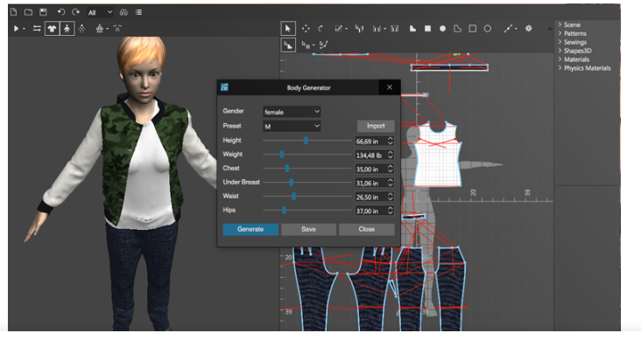
Exhibit 6: 3D Modeling
Source: Makulova, 2018
The future of fashion will be fast, efficient in every manner, sustainable and ethical. The shopping would take less time due to the usage of advance technology in future. The process of shopping would be shorter time period of 5 minutes as Gen Z would design their clothes online and then order .The possibility of replace or return the product would be very less due to developed by technology where user submit all his/her body measurements on the system and it lead to 100 % fit to the body.(Makulova, 2018).The whole organization structure would be technology integrated system and employees would complete the process of products within 2-3 days due to whole supply chain operations job will be completed by robots, 3D technology and drones delivery. (Makulova, 2018).

6.2. Internet of Things Future Market
Smart clothes technology would be new technology in the future. The Fashion Companies will introduce new designs which would change the way of Fashion today. The IT companies are innovating new ways of connecting clothes to the smart phones which enabled clothes to connect with wearable technology to communicate through body and Fashion retailers are very interested to implement at their end (Behr, 2018).

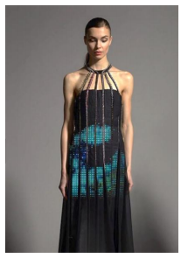
Exhibit 7: LED Dress by CuteCircute
Source: Behr, 2018

To elaborate the concept, the author described that the fabric used in the clothes will connect with sensor technology to provide more accurate data of body such as heart rate, lung activity which would be helpful for sportsperson(Behr, 2018The startup company named loomia has designed clothes which provide heat in the clothes and glow up at certain situations(Behr, 2018). London based company CuteCircute made a twitter dress which will change color when a person receives twitter message as shown in above exhibit (Behr, 2018). The companies such as Google and Levi Strauss is taking a step further, they are planning to make a cloth which will be attached to Smartphone, for instance Levi’s Jacket when a person wipe off on the sleeves of the jacket, it will automatically play a music, navigation system will start or person can even get a call from smart phones (Behr, 2018).Furthermore, the wearable tech market is a fast moving market which will be worth $30bn globally in year 2020(Verdict.co.uk, 2019).

6.3. Tech Future Shopping
According to the survey, it has been estimated that AR and VR market is growing very fast and it would hit the revenue of $150bn by year 2020. (Quytech, 2018). Another survey conducted of people approximate 1,013 of age between 19-49 and found that 44% of them were very interested in Virtual Reality (Quytech, 2018). The virtual mirror is also act as virtual fitting rooms with the combination of two technologies such as RFID and augments reality. (Quytech, 2018. In this case, the customer can try clothes in front of virtual mirror and there will be no need to practically try clothes in the fitting rooms as seen in below picture. (Quytech, 2018).

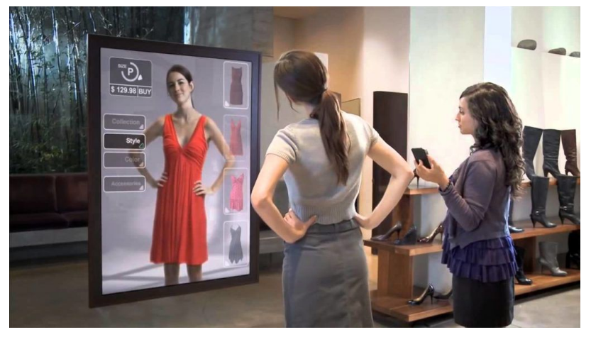
Exhibit 8: Interactive Mirrors
Source: Quytech, 2018
The fashion companies are now exploring their business with the use of various technologies such as augmented reality, virtual mirrors and wearable technologies (Verdict.co.uk, 2019). One of the big ecommerce giant Amazon are now experimenting virtual mirrors where customers can try clothes while sitting at home via online (Verdict.co.uk, 2019). The mirror would create a blended image as it has in built cameras, projectors and mix of displays (Verdict.co.uk, 2019). It then generates a model while scanning the environment around and then examined the face and eyes of the customer to see a reflection of the object (Verdict.co.uk, 2019). When the whole process is completed then the real product will be created while transmitting that virtual clothes and scene through the mirror (Verdict.co.uk, 2019).
6.4. Future High-Tech Shopping Stores
The possible shopping center of the future hanging sensory gardens and Artificial Intelligence enabled walkways which gives consumer a fantastic shopping experience (Verdict.co.uk, 2019). This will completely change the way we do shopping in current era and in the traditional times (Verdict.co.uk, 2019). The shopping malls in future would be built with high technology and it has been seen through the research that one of the agencies named Westfield’s ‘Destination 2028’ is going to test . (Verdict.co.uk, 2019).
It has been declared that today customers want more personalized products, companies are now innovating new business models to give them more personal experience (Bain, 2017). Due to emergence of more online shopping, now retailers are looking ways to provide enhanced facilities in-store to the customers so that they could get benefit from both ways (Bain, 2017). One of the sports companies, Adidas they are testing 3D knitted machines to design sweaters in their pop –up shops with the use of body scanner within a matter of hours (Bain, 2017). The companies wanted to change retail experience where transparency is the priority (Bain, 2017). Thus, in this way companies can add another value to their business by combining in-store customization into physical (Bain, 2017).

7. Conclusion
Supply Chain systems are complicated to develop fully digitally for every organization and many companies are not yet succeeded in implementing those techniques in their processes. Some of the digital applications are not being used globally yet but there will be chances to develop in the next 5 to 10 years. Companies who has already adopted and working to improve their standards totally digitization will be in the race from difficult to benefit advantage in the era of Industry 4.0 .The companies will not only get advantage in regard with greater efficiency but also increase their market share, customer satisfaction and revenue streams. Digitization is opening more opportunities for the companies to implement new innovative business models. The new world of Digitization allows fashion companies to share information transparently where buyer and supplier can easily generate effective results.
The emergence of latest technologies helped organizations to reduce their lead time, which is necessary in the age of fast fashion, where fashion is not limited on seasonal basis. Digital world benefits to both-organizations and customers, because it creates more transparent behavior between every level and enhances engagement level between customers and retailers. The companies are also testing new techniques where customers visit the store and in front of their eye’s clothes will be ready by 3D printing. Advance technology not only give good fortune but also have some adverse effects as consumers are no longer interested in physical experience and it could have more worst in future, where Generation Z is more digitized.
The author of this paper analyzed the fashion supply chain systems in comparison with traditional way of working and focus was to understand the how technology impacted in every stage of the supply chain system. Overall, the whole process has changed from start of the product until delivery, which is quick, responsive and agile as compared to traditional supply chain management.

8.References
Ambe, I. (2010). Agile Supply Chain: Strategy for Competitive Advantage. [online] 4. Available at: http://isma.info/uploads/files/005-agile-supply-chain-strategy-for-competitive-advantage.pdf [Accessed 1 May 2019].
Bain, M. (2017). A fantastical new world of high tech, high concept stores is here. [online] Available at: https://qz.com/956745/retail-experiments-from-farfetch-nike-and-amazon-offer-visions-of-the-store-of-the-future/ [Accessed 7 May 2019].
Basak, A., Seddiqe, M., Islam, M. and Faruk, M. (2014). Supply Chain Management in Garments Industry. Global Journals of Management and Business Research, [online] 14(11). Available at: https://globaljournals.org/GJMBR_Volume14/4-Supply-Chain-Management-in-Garments.pdf [Accessed 20 Apr. 2019].
BBC News. (2018). Retailers shut 2700 shops in first half of the year. [online] Available at: https://www.bbc.co.uk/news/business-46142025 [Accessed 8 May 2019].
Behr, O. (2018). Digital Innovation in the Fashion Industry. Journal of Technology and Innovation Management, [online] 2(1). Available at: http://file:///C:/Users/Compaq/Downloads/JTIM_2018_002_1_DigitalInnovationintheFashionIndustry.pdf [Accessed 8 May 2019].
Bhardwaj, V. and Fairhurst, A. (2010). Fast Fashion: Response to Changes in the fashion Industry. [online] 20(1). Available at: https://www.researchgate.net/publication/258418199_Fast_Fashion_Response_to_changes_in_Apparel_Industry [Accessed 21 Apr. 2019].
CBINSIGHTS. (2018). The Future of Fashion: From Design to Merchandising. [online] Available at: https://www.cbinsights.com/research/fashion-tech-future-trends/#prd [Accessed 26 Apr. 2019].
Ciarniene, R. and Vienazindiene, M. (2014). Agility and Responsiveness Managing Fashion Supply Chain. International Strategic Management Conference. [online] Available at: https://core.ac.uk/download/pdf/82112308.pdf [Accessed 22 Apr. 2019].
Consulting.ey.com. (2016). The rise of digitally driven supply chain ecosystem. [online] Available at: https://consulting.ey.com/the-rise-of-the-digitally-driven-supply-chain-ecosystem/ [Accessed 25 Apr. 2019].
Danziger, P. (2018). Why Zara Succeeds. [online] Forbes. Available at: https://www.forbes.com/sites/pamdanziger/2018/04/23/zaras-difference-pull-people-in-not-push-product-out/#5475edf123cb [Accessed 11 May 2019].
Detexcorp. (2019). Fast Fashion Retail Success in Today's E-Commerce Supply Chain. [online] Available at: https://www.datexcorp.com/fast-fashion-retail-success-in-todays-e-commerce-supply-chain/ [Accessed 21 Apr. 2019].
EdicomGroup. (2017). Growth of ecommerce driving use of EDI in Fashion Industry. [online] Available at: https://www.edicomgroup.com/en_US/news/10312-growth-of-e-commerce-driving-use-of-edi-in-the-fashion-industry.html [Accessed 3 May 2019].
Fountaine, T., McCarthy, B. and Saleh, T., 2019. Building the AI Powered Organization. [online] Available at: <https://hbr.org/2019/07/building-the-ai-powered-organization> [Accessed 27 April 2020].
Gesing, B., Peterson, S. and Michelsen, D. (2018). Artificial Intelligence in Logistics. [online] DHL Customer Solutions & Innovation. Available at: https://www.logistics.dhl/content/dam/dhl/global/core/documents/pdf/glo-artificial-intelligence-in-logistics-trend-report.pdf [Accessed 2 May 2019].
Gorepati, K. (2016). Zara's Agile Supply Chain is the source of its competitive advantage. [online] Available at: https://www.digitalistmag.com/digital-supply-networks/2016/03/30/zaras-agile-supply-chain-is-source-of-competitive-advantage-04083335 [Accessed 11 May 2019].
Grut, W. (2017). How the internet is remaking the British High Street. [online] BusinessInsider.com. Available at: https://www.businessinsider.com/future-british-high-street-internet-brexit-retail-2017-8?r=US&IR=T [Accessed 9 May 2019].
Gulberti, G. (2018). 3 reasons the supply chain in the fashion industry is changing. [online] Launchmetrics.com. Available at: https://www.launchmetrics.com/resources/blog/fashion-industry-supply-chain [Accessed 22 Apr. 2019].
Halliday, S. (2016). UK Fast fashion stores top L2's digital index. [online] Fashion Network.com. Available at: https://uk.fashionnetwork.com/news/UK-fast-fashion-stores-top-L2-s-digital-index-Topshop-is-number-one,752203.html#.XNSMo_kzbDc [Accessed 27 Apr. 2019].
Holland, D. (2017). [online] Retail Dive. Available at: https://www.retaildive.com/news/report-ultra-fast-fashion-players-gain-on-zara-hm/443250/ [Accessed 10 May 2019].
Ishfaq, R., Gibson, B. and Defee, C., 2016. How Retailers Are Getting Ready For Omnichannel World. [online] Available at: <https://www.supplychainquarterly.com/topics/Strategy/20160624-how-retailers-are-getting-ready-for-an-omnichannel-world/> [Accessed 4 May 2020].
Kayikei, Y. (2018). E-commerce in logistics and supply chain management. [online] Research gate. Available at: http://file:///C:/Users/Compaq/Downloads/E-Commerce-in-Logistics-and-Supply-Chain-Management%20(1).pdf [Accessed 20 Apr. 2019].
Kellett, S. (2018). How to use Artificial Intelligence in Online Fashion Retail. [online] Exponea.com. Available at: https://exponea.com/blog/impact-artificial-intelligence-online-fashion-retail/ [Accessed 3 May 2019].
Kondraci, C. (2018). Next Gen Supply Chain:H&M low Tech Approach to Inventory Management. [online] Available at: https://www.mmh.com/article/nextgen_supply_chain_hms_low_tech_approach_to_inventory_management [Accessed 10 May 2019].
Makulova, N. (2018). The concious Future of Fashion Retail. [online] Available at: https://nataliyamakulova.com/the-conscious-future-of-fashion-retail-e926a87ce9ea [Accessed 4 May 2019].
Masudin, I. and Kamara, M. (2017). EDI and Demand Forecasting. [online] 18(2). Available at: http://file:///C:/Users/Compaq/Downloads/Electronic_Data_Interchange_and_Demand_Forecasting.pdf [Accessed 4 May 2019].
McDonald, C. (2018). Retail Tech will grow 3.6% in 2019. [online] Available at: https://www.computerweekly.com/news/252451508/Retail-tech-spending-will-grow-36-globally-in-2019-predicts-Gartner [Accessed 13 May 2019].
Milevo, G. (2019). How Augment reality is redefining Fashion Industry. [online] Arpost.co. Available at: https://arpost.co/2019/02/11/how-augmented-reality-is-redefining-the-fashion-industry/ [Accessed 27 Apr. 2019].
Mintel Press Office. (2017). Brits Hangup Online Fashion. [online] Available at: https://www.mintel.com/press-centre/fashion/uk-online-sales-of-clothing-fashion-accessories-and-footwear-grow-by-17-in-2017 [Accessed 25 Apr. 2019].
Mskinsey & Co. (2017). The state of fashion 2018. [online] Available at: https://cdn.businessoffashion.com/reports/The_State_of_Fashion_2018_v2.pdf [Accessed 3 May 2019].
Nayak, R., Padhye, R., Wang, L., Chatterjee, K. and Gupta, S. (2015). The role of mass customization in apparel industry. International Journal of Fashion Design, [online] 8. Available at: https://www.researchgate.net/publication/277969002_The_role_of_mass_customisation_in_the_apparel_industry [Accessed 23 Apr. 2019].
Quytech. (2018). How Virtual Mirror Technology will change the way you shop. [online] Available at: http://www.quytech.com/blog/how-virtual-mirror-technology-will-change-the-way-you-shop/ [Accessed 11 May 2019].
Retail News. (2019). Blockchain in the business of Fashion. [online] Available at: https://www.retailnews.asia/blockchain-in-the-business-of-fashion/ [Accessed 26 Apr. 2019].
Schrauf, S. and Berttram, P. (2016). How digitization makes the supply chain more efficient, agile and customer focused. [online] pwc. Available at: https://www.strategyand.pwc.com/media/file/Industry4.0.pdf [Accessed 20 Apr. 2019].
Sleigh, S. (2018). The UK Fashion industry is worth £32 billion to UK Economy. [online] Evening Standard. Available at: https://www.standard.co.uk/fashion/uk-fashion-industry-32-billion-uk-economy-british-fashion-council-caroline-rush-a3934781.html [Accessed 3 May 2019].
Sparks, L. (2010). Supply chain Management and Retailing. An International Journal, [online] 11, p.2. Available at: https://stirlingretail.files.wordpress.com/2011/04/sparks-in-scfij-final-proofs.pdf [Accessed 20 Apr. 2019].
Taylor, J. (2018). We visited H&M and Zara to see which one is better store. [online] Business Insider. Available at: https://www.businessinsider.com/hm-zara-compared-photos-details-2018-5?r=US&IR=T [Accessed 10 May 2019].
The Irish Times. (2019). [online] Available at: https://www.irishtimes.com/business/retail-and-services/h-m-too-slow-for-fast-fashion-world-1.3030729 [Accessed 10 May 2019].
Thomas.net. (2018). [Online] Available at: https://news.thomasnet.com/featured/the-pros-and-cons-of-an-ai-based-supply-chain/ [Accessed 12 May 2019].
Toka, A. and Aivazidou, E. (2014). Cloud Computing in Supply Chain Management: An Overview. [online] Research Gate. Available at: http://file:///C:/Users/Compaq/Downloads/igi_global_book_chapter_toka_2012.pdf [Accessed 2 May 2019].
Tradegecko. (2018). Zara Supply Chain Analysis. [online] Available at: https://www.tradegecko.com/blog/zara-supply-chain-its-secret-to-retail-success [Accessed 8 May 2019].
Verdict.co.uk. (2019). [online] Available at: https://www.verdict.co.uk/future-of-fashion-tech/ [Accessed 11 May 2019].
Vorst, V., 2014. Supply Chain Management: theory and Practices. [online] Available at: <http://file:///D:/Downloads/SupplyChainManagementbijdrageJackvanderVorstv10.pdf> [Accessed 27 April 2020].
Walch, K. (2019). AI in fashion design and retail takes center stage. [online] TechTarget. Available at: https://searchenterpriseai.techtarget.com/feature/AI-in-fashion-design-and-retail-takes-center-stage [Accessed 3 May 2019].
Wen, X., Choi, T. and Chung, S. (2018). Fashion Retail Supply Chain Management. International Journal of Production Economics. [online] Available at: https://www.researchgate.net/publication/328711222_Fashion_Retail_Supply_Chain_Management_A_Review_of_Operational_Models [Accessed 3 May 2019].

