
University Of Wales
Trinity Saint David

Module: LCBB6000 – Dissertation
Title: Research proposal: Analysing the Impact of diversity and inclusion policies on employee job satisfaction in UK: A case study of HSBC UK

Student: Georgeta Denisa Orosanu
Student ID: 2128253
Lecturer: Dr. Seyed Navid Nasirpourosgoei

Table of contents

1. Introduction 3
2. Research Aim 3
3. Research Objectives 4
4. Research Questions 4
5. Justification of Research 4
6. Literature Review 5
7. Research Methodology 6
7.1. Data Collection 7
7.2. Data Analysis 7
7.3. Comparative Framework 7
7.4. Limitations 8
7.5. Conclusion 8
8. Gantt Chart 9
References 10

Introduction

The importance of diversity and inclusion in modern human resources has been accepted. Organizations understand the need to apply Diversity and Inclusion (D&I) policies as a way of improving their workplace culture and attaining increased levels of employee satisfaction. Recently, many UK businesses have realized the value of having a varied and inclusive atmosphere in increasing employee engagement and job satisfaction. A case in point is applied to one major financial institution that has a substantial business operation in the UK- HSBC UK, to assess the impact of D&I policies on employee satisfaction within the banking industry.
This research looks at diversity and inclusion in HSBC UK and examines the effect of the bank’s D&I policies on employee job satisfaction. The research aims to explore the effectiveness of HSBC’s D&I initiatives that may include recruitment practices, inclusive training programs, and support networks in developing a relationship between diversity and inclusion and improved employee morale, commitment, and job satisfaction. Such research is intended to provide invaluable contributions toward understanding the roles played by diversity and inclusion policies in enhancing employees’ experience at work as well as providing strategic lessons to other financial institutions that intend to enhance a culture of an inclusive workplace (Bryman, 2021).
This research aims to provide HSBC UK with data-driven insights that can enhance its D&I initiatives and serve as a benchmark for the wider industry. Through secondary research and a review of existing literature, this study aims to highlight the positive outcomes of D&I policies and provide a roadmap for companies striving to foster inclusivity and equality in their workforce.

Research Aim

This work’s major aim has been to assess the influence of D&I policies on job satisfaction among employees at HSBC UK. This paper thus examines the D&I interventions of HSBC to understand how they impact on the morale, commitment, and engagement of employees within the banking sector. Through a case study of HSBC, the research intends to pinpoint the main ingredients in D&I policies that enhance employee satisfaction and retention. In this way, the study purports to give necessary information for boosting effective D&I strategies in organizations within the financial services industry in the UK that are alike (Creswell and Creswell, 2022).

Research Objectives

- To determine the impact of HSBC UK’s diversity and inclusion policies on employee job satisfaction in relation to morale, engagement, and retention.
- To identify and analyse the critical elements of the D&I strategies and actions by HSBC that add positive value toward building a culture of inclusivity at the workplace (Brown and Taylor, 2019).

Research Questions

Are HSBC UK’s diversity and inclusion policies related to employee morale among various demographic groups, and if so, in what sense?

Do inclusion efforts taken by HSBC UK relate to employee retention rates?

Which diversity and inclusion strategies enacted by HSBC have the most impact in building an inclusive workplace culture?

How effective do employees find the measures of HSBC UK in promoting diversity and inclusion?

Justification of Research

In recent years, diversity and inclusion (D&I) strategies have become an integral part of corporate strategies as organizations are focusing more on employee satisfaction and retention. There is evidence to suggest that an inclusive, diverse culture enhances engagement, innovation, and loyalty among employees (Smith and Jones, 2021). This paper uses HSBC UK as a case study to examine the effects of D&I policies on the level of job satisfaction among employees in a leading financial services company. A look at the strategy followed by HSBC will contribute to filling up how far D&I policies applied could improve the organizational culture particularly in the banking sector.
Various studies have drawn attention to the advantages that D&I policies bring to organizations. Brown and Taylor (2019) find that an inclusive work environment enhances employee morale and productivity, which subsequently reduces the rate of turnover. Furthermore, Clark (2020) examines the positive impact of D&I policies on an organization’s public image, thereby increasing its attractiveness to a diverse pool of talent. Examining the strategies adopted by HSBC on D&I can offer an understanding of how such policies can lend support to the level of job satisfaction among employees, which is a crucial factor within such a competitive industry as that of financial services, where talent retention is given pre-eminence.
There has been difficulty for the UK banking sector in making workplaces inclusive, and this has partly been attributed to outdated structures. It would thus be justifiable reasoning to view HSBC’s D&I commitment as the response to such challenges and an exemplary case of translating D&I policies into employee satisfaction. The justification comes from the need to understand whether and how satisfaction and engagement are possible through D&I practices in the banking sector, impacting further success at the organizational level.
The results of the study are going to have implications not just for HSBC but they are also going to provide practical insights that other firms, which want to start or improve their D&I initiatives, can work on. By investigating particular policies and outcomes of employees, this study tries to fill the space between the theory of D&I and its implementation in practice at the workplace which would thereby in general add something for the human resource management field.

Literature Review

Diversity and inclusion (D&I) have found their way onto the list of central topics in corporate management, with an increasing body of evidence suggesting that D&I policies have a positive impact on employee satisfaction. For instance, Smith and Jones (2021) reported that a focus on diversity and inclusion augments employee engagement, creativity, as well as loyalty. Their research revealed that employees in inclusive workplaces were more likely to show job satisfaction and commitment to their organizations by a greater degree.
Brown and Taylor (2019) suggested that by creating an ‘inclusive atmosphere,’ D&I initiatives can help in boosting the morale of teams that may have different cultural orientations. In their study, they pointed out that businesses that have strong D&I policies have lower labour turnover and higher productivity on the premise of feeling valued and supported as employees. This proposition has been further supported by Green and White (2021) who indicated that diversity initiatives in the UK banking sector help to moderate some of the rigid, bureaucratic structures that stifle satisfaction among employees.
For instance, Clark (2020) researched inclusivity in hiring and argues that when companies prefer diverse hiring, it does not only increase their talent acquisition avenues but also impacts their workplace culture positively. According to Clark, when inclusivity-centered recruitment techniques are used, an emphasis is thereby put on a diversified workforce known to be more conducive to innovation as well as responsiveness. This relates to the trend in diverse hiring HSBC's approach to diverse hiring reflects the trend whereby businesses are focused on creating a workforce that mirrors the diversity within their customer base.
An inclusive training program: the impact on employee engagement and satisfaction was dealt with by Lee and Kim (2021). The study found that employees who have participated in diversity training develop more empathy and understanding for their colleagues from different backgrounds. Such inclusivity develops into a conducive working environment thereby enhancing satisfaction.
In addition, Williams (2020) argues that Leadership must be committed to the Policies for Diversity and Inclusion, saying operational implementation cannot be viable without the endorsement of top management. Leadership within HSBC has actively been pushing for Diversity and Inclusion showing the bank’s determination to create a truly inclusive working environment.

Research Methodology

The research is based on secondary data, using available literature, reports from the industry, and case studies to look at the impact of HSBC UK’s D&I policies on job satisfaction for the employees. The data collected is qualitative. By viewing reliable sources, without actual data collection from participants, the study seeks to offer thorough analysis of the D&I practices and their effects (Silverman, 2018). One of the perfect methodologies for analysing the influence of diversity, and inclusions policies on job satisfaction amongst employees in the HSBC UK would involve applying the onion research methodology set out by Saunders et al. (2020) which comprises six layers including philosophy, approach, strategy, choices, time horizon, and techniques/procedures. That is, from the first layer of philosophy through to the techniques and procedures layer, follows a specific path or channel within the choice of a research philosophy (e.g., interpretive for in-depth qualitative insights) to choice of strategies (e.g., case studies). The structured frame ensures the depth and reliability of this research.

Data Collection

Secondary data has been used for this research, which has been collected from journals and reports of HSBC UK along with studies related to the industry. By doing this, an in-depth understanding will be gained of the D&I policies of HSBC and their impact on employee satisfaction as information will be drawn from recorded findings rather than individual responses of employees through primary data (Creswell and Creswell, 2022). Information about HSBC UK is available on several online platforms for study and analysis. The site provides Analysis of HSBC's market position, and customer demographics through market reports and statistics.
More information regarding the financials, strategies, and corporate social responsibility activities of the bank can be gathered from the official website and the annual reports of HSBC. The agency helps in providing the latest news, market analyses, and updates economic figures. In addition to market trends and competitor benchmarks, the agency provides industry-specific knowledge. YouGov provides data on the sentiment of customers and brand reputation. Use most of these resources to clarify some specifics that, for the academic or professional eye, might be needed to familiarize oneself fully with HSBC UK (Silverman, 2018).

Data Analysis

The collected information will be analysed through thematic analysis to come up with patterns and themes already existing in the literature and reports. This will offer an in depth understanding of the relationship between HSBC UK Diversity and Inclusion D&I policies and employee satisfaction as it would concentrate on reoccurring themes like inclusion, morale, and engagement (Flick, 2020).

  - Comparative Framework

This study employs a comparative lens to juxtapose the D&I policies of HSBC UK against industry best practices in the UK banking sector. It will thereby, in relation to other banks’ approaches, bring out strategic advantages and disadvantage areas thereby providing an all-round understanding of the role that D&I has in employee satisfaction (Saunders, Lewis and Thornhill, 2020).
  - Limitations

The use of secondary data in this study is the main limitation as it may lack the real perspective of employees at HSBC UK. Because it is a case study, these findings can’t be generalized to all financial institutions; hence, the conclusions drawn will not be applicable to another organization even to an organization of a similar kind like HSBC (Flick, 2020).

  - Conclusion

This research paper provides insights into the effectiveness of diversity and inclusion policies in enhancing employee job satisfaction: the case of HSBC UK. According to a detailed analysis of the D&I strategies of HSBC, this paper emphasizes the requirement of inclusivity in a corporate culture and thereby provides oxygen to similar entities endeavouring to enhance employee engagement and job satisfaction.

- Gantt Chart

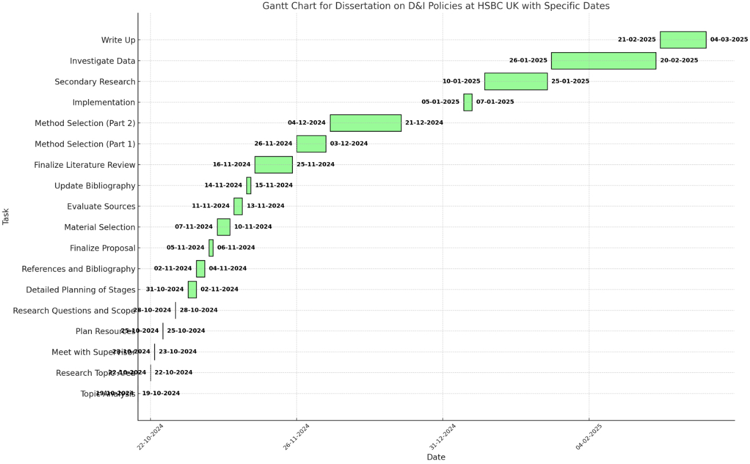

References

- Brown, J., and Taylor, M. (2019). The Role of Diversity and Inclusion in Enhancing Employee Engagement. Human Resources Journal, 8(1), 45-62.
- Bryman, A., (2021). Social Research Methods. 6th ed. Oxford: Oxford University Press.
- Clark, S. (2020). Inclusive Recruitment and Workplace Culture. Organizational Studies, 10(2), 89-105.
- Creswell, J.W. and Creswell, J.D., (2022). Research Design: Qualitative, Quantitative, and Mixed Methods Approaches. 6th ed. Los Angeles: SAGE Publications.
- Flick, U., (2020). Introducing Research Methodology: Thinking Your Way Through Your Research Project. 3rd ed. London: SAGE Publications.
- Green, L., and White, P. (2021). Diversity Policies in the UK Banking Sector. Journal of Financial Services, 13(4), 201-219.
- Saunders, M., Lewis, P. and Thornhill, A., (2020). Research Methods for Business Students. 8th ed. Harlow: Pearson Education.
- Silverman, D., (2018). Doing Qualitative Research. 5th ed. London: SAGE Publications.
- Smith, A., and Jones, B. (2021). Employee Satisfaction in Diverse Workplaces. International Journal of Management, 15(3), 65-78.
- Williams, D. (2020). Leadership Commitment to Diversity and Inclusion. Journal of Business Management, 6(2), 55-70.

