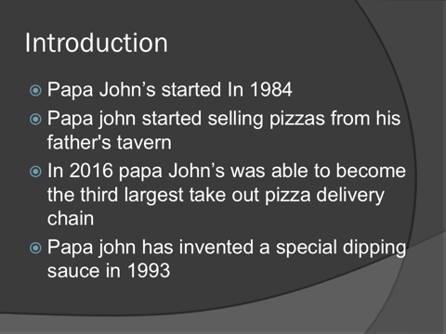
Sinead Amodubello (1916043)
Reference- Menalitch satisfying your needs to know
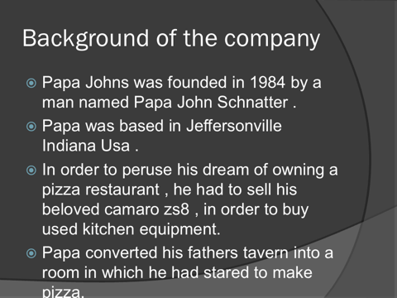
Introduction:In 1984 John Schnatter came to a conclusion that he was passionate about making pizza. John didn’t have enough funds at that time to be able to open a big restaurant of his desire so what he went and done was he transformed a broom closet in the back of his dads tavern in Jeffersonville, Indiana into a room to make pizza. But before you can start anything you will need the correct equipment to make pizza. John went and sold his Camaro ZS8. Now he was able to go on and start selling pizza. Johns pizza stated to get popular around and people loved his pizza he then had enough money for him to now go and open up his own personal restaurant. Papa johns is the creator of side dipping sauce that a lot of today’s pizza restaurant now globally use this has been one of Papa John’s trademark ever since. Things even get much more better for Papa Johns. In 1993 Papa John then went public and then just a year after that the company had over 500 stores. Then four years after that Papa John’s had opened a total of 1,500 stores. With the success of his company john Schnatter was able to now get the Camaro ZS8 he sold to start of his business. In 2016, Papa johns was able become the third largest take out and pizza delivery pizza chain in the USA. Papa john’s then went and signed a contract with ESPN Regional Television to become the title sponsor of the annual Papajohns.com bowl in 2006 the bowl is a college post season football bowl game. Papa Johns sponsored the event until 2010. John earned a huge amount of money his camaro was 250,000 he was so wealthy he worked so hard and got it.

Damian Sadowski
Student id number: 1917606
Background of the company:
Papa john was founded in 1984 by a man named papa john schnatter he lived in United States of America Jeffersontown, Indiana. He had knocked out a broom closet in the back of his fathers tavern micks lounge. He then sold his camaro (car) to buy $1,600 dollars worth of pizza equipment he then started selling pizzas to the taverns customers out of the converted closet . His pizzas proved sufficiently popular, that same year he moved into an adjoining space . After many years of being a successful business owner in 2009 schnatter required the camaro back and offered $250,000 dollars in return this is because the car was dear to his heart and also showed his accomplishments .
In 2016 papa johns pizza was announced to be the third largest take out and pizza delivery restaurant chain in the united states of America. Not always was papa so successful in 2014 the total sales net margin was only 4.6% his competition dominos pizza on the other hand had 8.2% . The company headquarters are based in jeffersontown kentucky of louisville. The slogan is better ingredients better pizza papa john. Papa johns has over 5,199 establishments of which 4,456 are domestically operated in 50 states and in 45 countries . In 2017 John Schnatter stepped down from being ceo and has been replaced by ceo Steve Ritchie, now papa John Schnatter is only the chairman of the company .
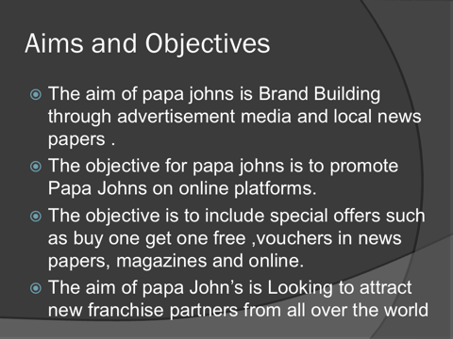
In 2018 schnatter was heard using a racist term “nigger” which then led him to be fired from the company, he is no longer chairman of papa johns. He then filed a lawsuit against papa johns pizza for them to give him access to the companies books and records. It was sad for the Americans to see the founder of the company fired but his actions where unacceptable and he had to be punushed by being fired. In march 2019 nba hall of Famer Shaquille O’Neal joined papa johns board of directors and became a spokesman for the bench .
Damian sadowksi
Student id number: 1917606
Aims and objectives:
The aims of Papa John's is to build their brand through online advertisement. Doing so will bring a lot of clients because people use a lot of social media. Advertising in places like Facebook, Twitter, Instagram is very beneficial as hundreds thousands of people can now see Papa John's pop up Everywhere Which unknowingly will make them crave Papa John's pizza
Another aim of Papa John's is to attract new potential franchise partners from all over the world. What this means is the franchisor owns the trademark and operating system for the franchise. The franchisee is licensed to use both the trademark and the operating system according To the terms and conditions set before in the franchise agreement, both are obligated to follow the contract rules.The franchisor teaches the franchisee how to operate accordingly to the system they have. Contractual relationship .
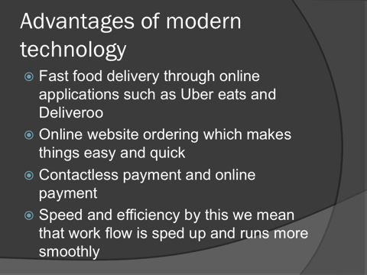
Papa johns objectives are to include special offers such as buy one get one free, attach vouchers in news papers, magazines and online . To utilize this they can advertise on billboards and Tv adverts so they can attract people to their deals and stores. Everyone daily reads a newspaper or magazine, they can stumble upon a discount voucher which is nice for the person but then he or she is drawn to papa johns and wants to buy food at one of the stores . This can now be a regular customer to the store if the food is enjoyed. Special deals are a great way to attract customers, a deal like buy one get one free is great because a lot of people use this deal , it is mostly used for low cost products . Free delivery is also great because people don’t have to spend money on deliveries which attracts them to the store, loyalty card , package deals these are some of the other great ways to attract customers.

Misha Rutkowski
Student ID number: 1917609
Advantages of the modern technology:
One of the advantages of the modern technology is food delivery services.
Through online applications such as uber eats and deliveroo, These companies help franchises such as McDonald's, KFC, subway to deliver food to their customers .This was never an option before companies like uber eats collaborated with food branches , now people/Customer can get their Favorite fast food deliver via the internet without leaving their homes/Workplace.

Ordering online has never been easier than now by this I mean when you access papa John's website the layout and navigation is very easy and customers friendly. It had a variety of preset pizzas in the menu or you can make your own pizza with a variety of toppings at your disposal. You can also see all the deals they have for example buy one get one free . Every page of the website is very user friendly, easy and quick.

Online payment on papa John's website is easy and versatile by versatile I mean there is different types of payment accepted such as PayPal, credit card, apple pay.
Contact less payment is also helpful when you get your food delivered you can pay with a contact less credit card or with your phone using apple pay at this point you do not have to use cash.

Speed and efficiency by this I mean that the restaurant runs smoothly as when food gets ordered it is quickly accepted on a Ipad interface. It is very quick and efficient
because the order is already made and only needs to be accepted . Before this was
Introduced it would take a while before an
Order was made because customers would have to call in and make an order.
Phone reception could go low and the phone would break up and the customers would have to recall. The order would have to be written down and then confirmed and passed on to the pizza makers. With this new efficient way of ordering it cuts the time and make the orders easy. It makes things alot easier for the customer and papa John's employees.

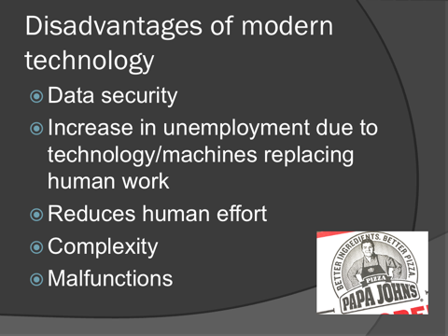
Misha Rutkowski
Student ID Number: 1917609
Disadvantages of the modern technology:
One of the downsides of modern technology is data security. Data security is a disadvantage because you can get hacked when you are hacked all data is exposed to the hacker and it's a dangerous place to be in as your accounts and all encrypted information is exposed , they can steal your hard earned money and also identity.

The other disadvantages is that there is an Increase of unemployment because of technology to be more specific, machines . For example there are more and more self checkout services. In McDonald's you do not need to be served By someone, you can use the self checkout Service. In other supermarkets it's the same case which puts cashiers at risk of losing their jobs.

Another disadvantage is that technology reduces human effort . Meaning people are too dependent on technology. This is because people have become lazy. For example there is a product called Alexa you do not need to do anything to research all you do is say "Alex does technology reduce human effort" and the system will research and tell you everything there is to know on that subject.

A disadvantage is also the complexity of today's technology for example older or elderly it is hard for them to catch on to today's technology such as smart phones/ smart electrical equipment. These products have alot of technology crammed into them. Some elderly people have a problem using smart products because technology progresses really fast. PC's and computers also have evolved and certain people find it hard to use . Technology has evolved so much and quickly that not all people have caught up yet.
Malfunction is one of the disadvantages because problems can occur in technology Such as you can get a virus on your PC and computer can get shut down and not workProperly. Also some professors or hardware can get destroyed and your product can stop working immediately.Batteries in products such as phones and laptops can drain and not work properly if incorrectly used.
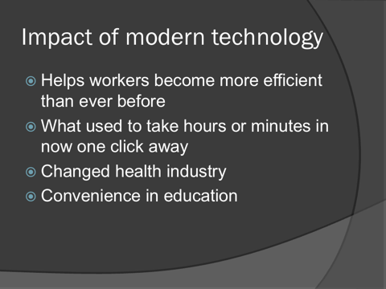
Krystian sadowski
Student id number : 1917607
Impact of modern technology:
Impact of modern technology helps workers more efficient than ever before, by this I mean speed and efficiency . It helps workers work fast and smooth without putting as much time and effort compared to how technology used to be . Furthermore modern technology has impacted people in a very positive way as they can work with full capacity at the fraction of the time .
What used to take hours or minutes is now one click away for example if you wanted to order a pizza you would have to call . In this case it could take up to 20 minutes or so , now it takes a few seconds as the order is already made online in some cases it is already paid for , at this point the employee just has to accept the order on the screen in front of him , its literally in an instant which makes for a quick and easy experience.
Modern technology has made a huge impact on the health industry. One of the reasons being , health records are now digitized . Electric health records replaced outdated paper records this has had a huge impact in the medical world . Not only can patients access their records but they are now one click of a button away, it is also insured that any mistakes are caught out quickly. The other impacts it had are lower health care cost , ease of work flow and greater patient care.
The impact of modern technology has impacted the education system in a positive way, for example research has never been easier. Students no longer need to look for books in the library now they can access the internet via the computer and access the digital encyclopedia and obtain the research they need . For primary school kids educational games and videos are very helpful and useful .
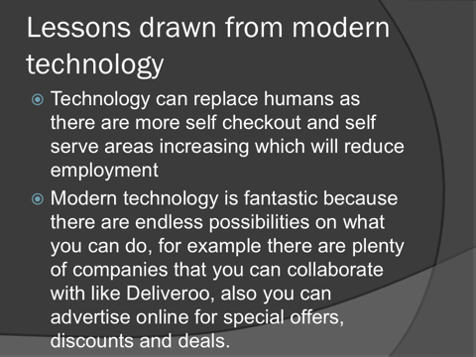
Krystian sadowski
Student ID Number: 1917607
Lessons drawn from modern technology:
Technology can replace humans as there are more self secure areas increasing which will reduce employment. This is because technology is expanding in a really
fast way , more and more machines are being introduced such as self scan service
And this is putting people out of work . These machines were introduced to make orders fast and smooth or in other cases buying groceries is cut half the time , however all these great machines are lowering employment. These machines work in this order , first you select without you won't to eat at the restaurant/ fast food
Place then simply pay and that's it. It very simple and easy to use that is why alot of people use these machines. If the kitchen was run by machines no employees would be needed that's the downside to machines at the restaurant.

Modern technology is fantastic because there are endless possibilities on what you can do , for example there are plenty of companies that you can collaborate with as a fast food chain or a restaurant such as deliveroo, also you can advertise online for special offers , discounts and deals.

To elaborate collaboration with other companies is a fantastic way give customers what they want. What I mean by this is a while ago you could not order KFC or McDonald's, now with introduction of companies like deliveroo or ubereats you can have your favorite food delivered home.

Advertising online is a great way to let your customers know what is new with the company or restaurant. For example letting your customers know what deals you have on certain items on the menu or if you have any discount available.
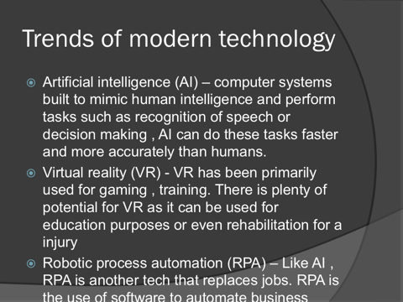
Trends of modern technology:
Artificial intelligence (AI): This is computer systems built to mimic human intelligence and perform tasks, such as recognition of speech or decision making, A1 can do these tasks faster and more accurately than humans. This is because the computer is programmed perfectly in order to not make any mistakes and it can continue doing so without error. A1 can make decisions as a human would, because it is very well engineered. Recognition of speech is now more common as it is integrated in many device’s such as mobile phones, gaming consoles and many more. Speech recognition can do many things for example you can unblock your smart phone using your voice and it is encrypted with the users voice, no one else can unlock your phone. It is also used it voice commands by this i mean you can activate siri on your Iphone using your voice, it seems but it is crammed endless information as it is connected to the internet, it can also do simple tasks like set an alarm or book a birthday in the calendar even something simple as play music.

Virtual reality (VR):
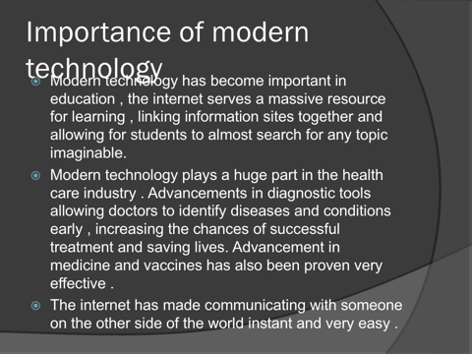
VR has been primarily been used for gaming and training. There is plenty of potential for VR as it can be used for education purposes or even rehabilitation for a injury. VR is useful to rehabilitate upper and lower in patient that suffer from strokes and other neurological injuries, some therapist use VR to manipulate the image on screen to make the patients limb appear to be moving faster and more accurately than in real life. VR can also be used for indoor training for example you can have a full on hardcore training session in your living room which is very health beneficial, some people use this platform to lose body weight.
Santiana Rutkowska
Student number:1917604
Importance of modern technology:
modern technology has become important in education, the internet serves a massive resource for learning. Linking information sites together and allowing for students to almost search for only topic imaginable for example students no longer need to go to the library and study different subjects from many different books. Now they can learn all that information via the internet.

Modern technology plays a huge part in the health care industry advancements in diagnostic tool allowing doctors to identify diseases and conditions early for example doctors can now identify cancer very quickly and deal with the illness. They have many methods of doing this, some of which are laboratory tests, image testing and biopsy. Advancements in medicine and vaccines have also been proven very effective, vaccines are very helpful to mankind because they help not to spread any diseases although there are many kinds, for example for chicken pox ( varicella), Diphtheria, whooping cough and Rotavirus (RV) there are many more.

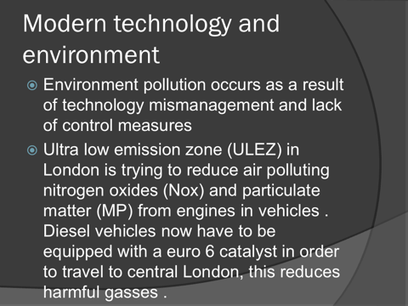
The internet has made communicating with someone on the other side of the world instant and very easy. For example using skype, the main purpose of skype is to connect people. People from around the world can connect through many different ways. People can now connect through one or two ways, audio or video. You can also use texting through skype. Skype is also used for business purposes for example to have a business conference call. Facebook is also one the application which can be used to connect with people. There are many other platforms that do similar things such as instagram, Twitter, FaceTime on Iphone and whatsapp. All these great ways to connect with people can now be done in a instant. Technology has evolved into a fantastic thing and without it nothing would be the same

Modern technology and environment
Sinead Bello
(1916043)
• Carbon emissions, mostly carbon dioxide and carbon monoxide, are Greenhouse gasses that are produced by people. Greenhouse gasses are gasses in the atmosphere that trap and reflect heat and radiation back to the planet's surface. It is known that over the last century, the amount of greenhouse gasses in the atmosphere has increased due to carbon emissions, and that they are contributing to Global warming.
Carbon emissions get released into the atmosphere from things like cars, airplanes, power plants and factories. They also get released by people like you when you use a vehicle or electricity created from burning fossil fuels. The computer you are using to read this is generating electricity, and so is your mobile phone, PlayStation, and Xbox. We are all guilty of enjoying and spending our time on these things that are not exactly economically friendly, but if we were all smarter about how we use technology, we can all reduce our Environmental impact.

A lot of technology that we use every day take a lot more resources and power that they most likely need to, by using and manufacturing them can create a huge disaster. These are a few ways that today’s technology can be harmful to our environment

• Pollution- water, heat, Air and noise pollution this can all be cause by producing and using technology.
• Waste- manufacturing technology creates a large amount of waste, and phones computers so on get thrown out when they all break or become outdated. This is all called techno trash, all these electrons They all contain all types of hazardous materials these are all very unsafe for our environment. They all need to be disposed by
using special types of methods.
• Health hazards- Using toxic materials that can be harmful to our health can cause cancer, and technology addiction can lead to other health problems like obesity and carpal tunnel syndrome.

(Reference) Environmental Issues

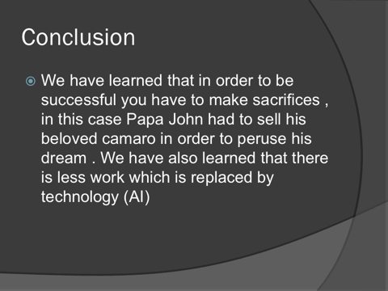
Conclusion:
In conclusion we have learned that in order to be successful you have to make some sacrifices, technology has become a very important part of any human life , technology is important to us because it has effected the medical industry in a very positive way . Technology has also effected todays eduction systems , technology has become such a crucial part of our life’s . The internet is also one of the things that people in the 21st century would not be able to live without .

