Assignment 2: Continental Hotel Budget

Table of Contents
Task 1 3
Task 2 4
Introduction 4
Understanding of traditionally based budget and zero-based budget 4
The process of zero-base budget 5
Sustainability of the budgeting control support 7
Conclusion 8
References 9

Task 1
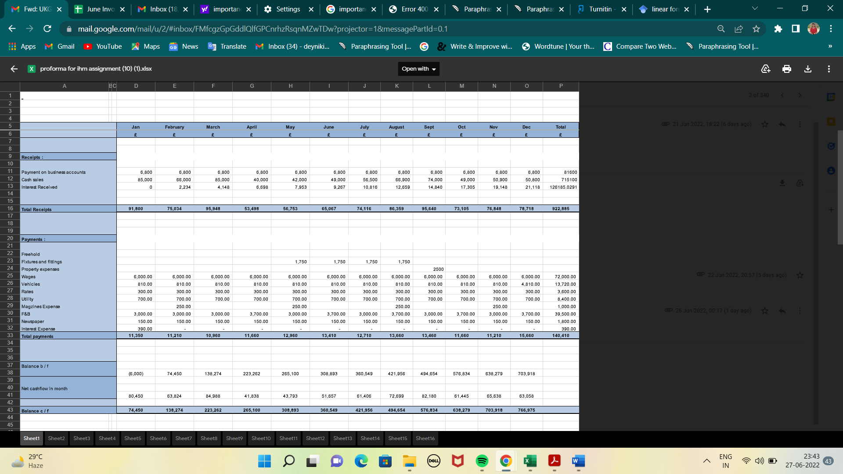
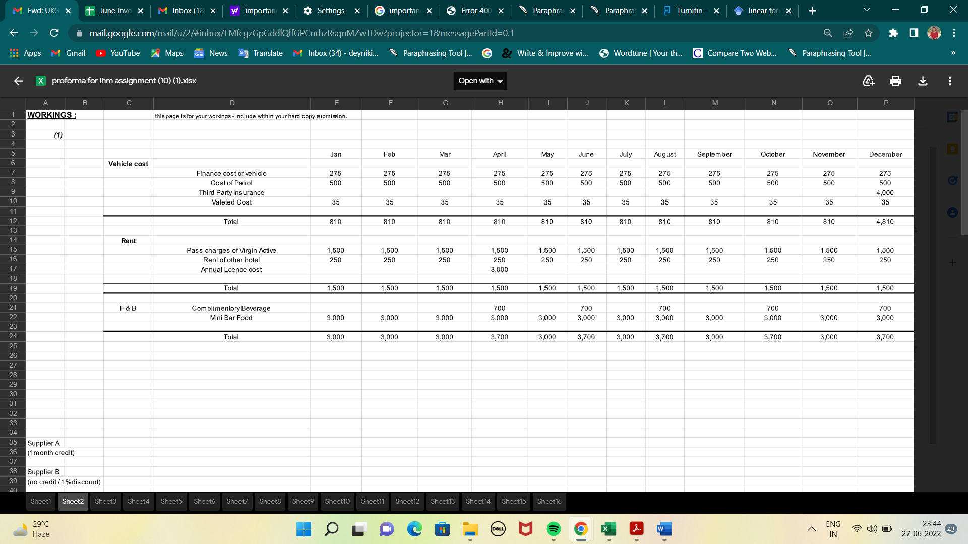

Task 2

Introduction
In management accounting, zero-based budgeting refers to creating the budget from scratch or with a zero-base. It necessitates reassessing each line item on the cash flow statement and providing documentation for each expense a department will incur. As a result, the definition is as follows: "A technique of financial planning, that also includes just shifting the expenditure related while accounting for changes in company operations, where all costs again for the new phase are calculated based on actual costs which need to be accumulated rather than on the written in various." With this plan, each activity must be supported by an explanation of the money it will bring in for the business (Emerling and Wojcik-Jurkiewicz, 2018). In this report the understanding of traditional-based budget and zero-base budget. After that, the process of the zero-base budget and how this can be implemented will be discussed. At last, the budgeting control support sustainability will be evaluated.

Understanding of traditionally based budget and zero-based budget
Traditional budgeting is built upon the budget from the preceding year. By updating the budget from the prior year and altering the expenses in response to inflation rates, consumer demand, market conditions, etc., the budget for the current year is produced. The earnings and costs from the prior year are included in the budget for the current year (Hijal-Moghrabi, 2019). Only expenses that go beyond the budget from the prior year must be justified in more traditional budgeting. The traditional budgeting strategy has both advantages and disadvantages. Let's start by examining its advantages.
- It is easy to put into practice. Since there haven't been many changes from the prior year, the budget may also be produced more quickly. Managers can save time by using this technique of working.
- Most businesses are accustomed to undertaking budget planning in this archaic way. An organization's operations become more reliable when financial activities are integrated and everybody is aware of what needs to be done (Strong, 2019).
- This budgeting supports decentralisation inside the organisation, much to how banks operate. Any branch that is not connected to the main office is able to set its own prices and implement modifications, provided that it abides by the restrictions.
- Since they begin with the budget from the previous year, these budgets are easy to establish (Sallam and Ji, 2019). The budget from the year before merely has to be modified to meet the requirements of the budget for the current year.
With zero-based budgeting (ZBB), resources are allocated based on effectiveness and necessity rather than past expenditure patterns. Since no expenditures are automatically added to the budget, management develops a budget from the beginning that only takes the operations and expenses which are necessary to run the firm. For inclusion in the budget, all costs must be justifiable. The finished product has a strong business case and fits with the company's broader business strategy or business plan (Ibrahim, 2019). Questioning presumptions and looking at expenses, improves operational efficiency and performance. There is a far higher likelihood of reducing costs if the increase in the standard budgeting percentage can be avoided.

The process of zero-base budget
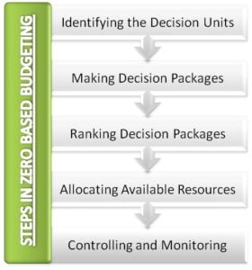
Figure: Process of zero-base budget
(Source: Zhang et al., 2021)

- Identifying the Decision Units
Choosing the decision unit is the process's first and most important stage in zero-based budgeting. A decision unit is any act or collection of acts that can be meaningfully and separately identified as such. When we say something was "independent," we mean it wasn't dependent on any other procedures to be completed. As a result, each decision-making body will be separate from the others (Zhang et al., 2021). In a firm, decisions are made by many departments. Each cost centre, which comprises the offices of marketing, manufacturing, human resources, research and development, etc., functions as a unit of decision-making.
Each budget line item has to be supported by this process. Each decision unit's management is responsible for defending the costs and needed budgetary allocation. The manager's justification shouldn't be based on the spending of his decision unit from the previous year or the budget for the previous quarter. Zero-based budgeting requires starting from scratch, thus additionally, the argument for the necessary funding should be new.
- Making Decision Packages
Decision bundles that are easier to handle have been generated from the previously entered option units. These decision packages need to be in line with the objectives of the business. Each decision-making package functions as a potent, independent financing proposal (Saliterer et al., 2019). Each decision package outlines the operations, activities, and functions of the proposal including its need, the concrete and intangible advantages that will result from its execution, missed opportunities if money is not provided, etc. A specific decision package must include the following details:
- The project that the decision package was made for.
- The bigger decision unit's goals and objectives, of which it forms a part
- The decision package's goals include determining if the assignment is necessary.
- Analysing the job's technical and operational feasibility while considering a potential alternative strategy.
- Ranking Decision Packages
This is the third level of the zero-based costing method. At this level, the importance and priority of each decision package inside a decision unit and between decision units is graded. To optimally distribute limited resources, decision package priorities are established. The cost-benefit analysis is used to rank the decision package possibilities. Throughout this process, all alternative possibilities are assessed in order to determine the best and most affordable solutions. The decision package can either be accepted or rejected by top management. Decision packages are only permitted if they would aid the firm in achieving its goals (Ibrahim, 2019). The management also makes sure that each decision package's charges are precise and reasonable.
- Allocating Available Resources
This zero-based budgeting step incorporates the prior phase. Funds are allocated in this phase among the decision packages that were evaluated in the previous round. Therefore, it is possible to say that financial decisions are being made at this same moment. Funding and other resources are distributed in accordance with the appraisal of decision packages. Decision packages that are more likely to succeed therefore be paid more. This ensures that the limited resources are used as effectively as possible.
- Controlling and Monitoring
There is now a budget that is fully zero-based. Throughout this phase, the decision package's effectiveness and outcomes are monitored and evaluated (Ibrahim, 2019). By evaluating the effectiveness of the decision packages, management may decide whether or not the resource allocation is accurate.

Sustainability of the budgeting control support
A key lever for maintaining sustainable growth is the techniques and strategies used to disperse public funding. Two examples of recent international commitments to regional and global sustainable development objectives developed with the intention of promoting national policy responses are the Sustainable Development Goals (SDGs) and the Paris Agreement on Climate Change. The OECD is experimenting with novel ways to budget planning and preparation, promoting openness and public engagement, and supporting monitoring and assessment procedures in order to assist countries in this position comply with domestic and international commitments. One of these projects, the Paris Collaborative on Green Budgeting, works closely with governments to match fiscal policies with environmental and climatic objectives. Green budgeting strives to raise decision-makers, the public's, and the government's understanding of the environmental impacts of budgeting decisions (Masini et al., 2021). An accurate understanding of the long-term consequences of policies may have an impact on decisions about resource distribution and income production by taking into consideration the interests of both the current and future generations as well as concerns about resource sustainability. Data on how budget decisions affect the environment, however, could be lacking or used inconsistently. In 2018, 20% of the OECD countries under evaluation reported the environmental and climatic implications of certain spending decisions. Only Germany and Italy went further and detailed how the execution of the budget as a whole will affect the environment. It would promote the alignment of incentives and a reasonable, environmentally informed approach to policy making backed by financial considerations if environmental issues were integrated throughout all policy and budget areas, from the environment to transportation, healthcare, and money (Rebrowa et al., 2020). In the vast majority of OECD nations, climate change is taken into account in the budget programmes of the ministry with primary responsibility. A few nations that constantly include climate change while formulating their financial policies are Canada, Finland, and Ireland. Along with enhancing openness and accountability of progress towards environmental goals and other international obligations, performance data related to the budget may help to foster a more methodical reflection on sustainability.

Conclusion
Because zero-based budgeting is a cost-control technique, the implementation methods must be done carefully and correctly. It must be properly explained how the funds would be used by each department and how they would help the business as a whole. The zero-based budgeting procedure is time-consuming, but it provides the most organised manner to distribute money inside a corporation. The choice to use zero-based planning should take into account the organization's strategy and goals; it is not only an accounting problem. A zero-based budget can assist organisations in reducing expenses, but it also has the power to substantially alter the organization's culture and ideas.

References
Emerling, I. and Wojcik-Jurkiewicz, M., 2018. The risk associated with the replacement of traditional budget with performance budgeting in the public finance sector management. Ekonomicko-manazerske spektrum, 12(1), pp.55-63.
Flume, M., Bardou, M., Capri, S., Sola-Morales, O., Cunningham, D., Levin, L.A., Postma, M.J. and Touchot, N., 2018. Approaches to manage ‘affordability’of high budget impact medicines in key EU countries. Journal of market access & health policy, 6(1), p.1478539.
Hijal-Moghrabi, I., 2019. Why Is it So Hard to Rationalize the Budgetary Process? A Behavioral Analysis of Performance-Based Budgeting. Public Organization Review, 19(3), pp.387-406.
Ibrahim, M.M., 2019. Designing zero-based budgeting for public organizations. Problems and Perspectives in Management, 17(2).
Ibrahim, M.M., 2019. Designing zero-based budgeting for public organizations. Problems and Perspectives in Management, 17(2).
Masini, C., Gallegati, D., Gentili, N., Massa, I., Ciucci, R. and Altini, M., 2021. The Challenge of Sustainability of High-Cost Oncological Drugs: A Budgeting Model in an Italian Cancer Center. International Journal of Environmental Research and Public Health, 18(24), p.13413.
Rebrowa, N., Kovalev, A., Frik, O. and Sargsyan, G., 2020. Budgeting as an Instrument of Increasing Competitiveness and Sustainability of Mining Enterprise. In E3S Web of Conferences (Vol. 174, p. 04054). EDP Sciences.
Rebrowa, N., Kovalev, A., Frik, O. and Sargsyan, G., 2020. Budgeting as an Instrument of Increasing Competitiveness and Sustainability of Mining Enterprise. In E3S Web of Conferences (Vol. 174, p. 04054). EDP Sciences.
Saliterer, I., Sicilia, M. and Steccolini, I., 2018. Public budgets and budgeting in Europe: state of the art and future challenges. The Palgrave handbook of public administration and management in Europe, pp.141-163.
Sallam, G. and Ji, B., 2019, April. Joint placement and allocation of virtual network functions with budget and capacity constraints. In IEEE INFOCOM 2019-IEEE Conference on Computer Communications (pp. 523-531). IEEE.
Strong, E.T., 2019. " The Jaws of Mars are Traditionally Wide... And His Appetite Is Insatiable": Truman, the Budget, and National Security (Doctoral dissertation, Miami University).
Zhang, L., Wu, Y. and Huang, K., 2021, August. Driving Benefit Based on the Zero-base Budget Under the 3G (Garantia) Capital Model. In 1st International Symposium on Innovative Management and Economics (ISIME 2021) (pp. 247-254). Atlantis Press.

