
Natalia Dimitrova 2123042

Module Leader: Alfred Mensah and Nadeem Mirza
The Global Business Environment
BA Business Management; Module Code: LCBB4005

Introduction
Over the past couple of years, the world has faced difficulties with day-to-day activities and a normal lifestyle due to the COVID-19 pandemic. Drastic changes were made when referring to the business sector, which led to drastic shifts in people’s lives as well. Many businesses changed their work style, to remote mode, in addition, to following regulations and restrictions. However, not every business managed to survive, some due to major capital losses, others because they were not capable of moving the business online. The focus of this work is shifted mainly to a particular industry – the automobile one, specifically on one brand – Tesla. Tesla has proven to be one of the most innovative and quickly developing companies for the past 10 years, in business in common as well as a singular company. The revenues of most automobile production and distribution companies show that there are not so drastic changes due to the pandemic. Tesla has shared their company statistics showing the changes which seemed drastic as it had let the curves make an obvious turn of regression for a short period of time. Elon Musk has used many different strategies to support and develop further his companies, mainly on his own, or relying on a certain circle of friends rather than investing in marketing, which made tesla as a company even more interested in the market.

The strategies analysis
Tesla was founded in 2003 and started its production of future cars straight away, however, as the company is tightly related to the name of its CEO – Elon Musk, he is not its founder or even the first CEO. Musk invested 6.5 million USD in 2006 investing in Tesla, which led to him becoming a chairman of the board of Directors, therefore, soon after he became CEO. (C. Pom, 2020). Relying on personal relations and connections, Musk started gaining capital for Tesla in the form of investments, as well as presenting the company shares on the stock market, which made him reach more success with its operation and future development.
Tesla as a company does not rely on any type of advertising and marketing. The strategies used by its CEO, are focused on promoting its features, like nice interior, high-speed reach, and gas reduction, as the automobiles are fully electric charged. By reaching people and promoting the car, as the vehicle that saves the planet, and at the same time is a sports car that allows drivers to follow their status. There is a psychological method that was used by Musk, which made Electric cars a symbol of status (J. Clinehens, 2020), therefore, electric cars stopped being associated with the well-known Toyota Prius, and became prestige in the eyes of the people. Using his charisma Elon Musk interacts with the public constantly, which gives him the freedom to influence people’s opinions and attract active listening from their side. This statement shows that self-confidence, applied knowledge, and good connections can be vital for one’s success. By using his advantage, and taking the risk of investing in Tesla, which was facing bankruptcy in 2006, Musk created a megatrend based on making people believe that electric cars can be exclusive and luxurious.
Elon Musk kept Tesla going further through ups and downs, for the past 15 years. His strategies are completely based on his confidence in the product which made him become admired by the people. His belief in the potential of Tesla made a statement for the company itself on the market and developed a large following capacity. In 2020 when the pandemic started spreading and many businesses started closing or reconstructing their working process, Tesla was reaching peak after peak. In the Q2 of 2020, the company submitted a net profit of 104 million USD (Business Standard, 2020). At the beginning of 2021, was reported the 4Q results of Tesla’s annual net profit. BBC says:” While many car firms were hit hard in 2020 by the coronavirus pandemic, Tesla bucked the trend”. Tesla’s electric vehicle sales have increased by 35% despite the pandemic in 2020 has stated Dalila Ouerghi from Fastmarkets. Even facing great success, Tesla’s CEO, has exposed to the public every development made within their technology department, showing that Musk is confident in the quality of the product, however, this overconfidence shows that Musk shares the belief that the company is unbeatable by its rivals and potential ones. This exposition and oversharing might threaten the company allowing the market itself to welcome new and cheaper products developed by competing companies, which had accessed the public information.
In many ways Elon Musk’s confidence in the product has helped the company, however, even reaching extraordinary success throughout the pandemic, the company shares started dropping prices on the market. The reason for that was, that lower net profit rates were registered. Every investor on the market is interested in the net profit, therefore when it starts dropping down, investors often sell their shares back to the market. As a result, fewer shareholders lead to lower company values overall. However, even throughout this little crisis, Tesla managed to stay on top of the automobile industry.
Tesla as a company has been focusing on developing further and setting targets to achieve success. In the beginning when Musk stepped as CEO the company was barely surviving on the market and was possibly about to extinct from the market. The difference was made when the product was looked at from a different perspective and its potential was evaluated. Using a different approach, Musk made Tesla one of the most innovative and best investments for a business, simply using influence supported by his strong beliefs.
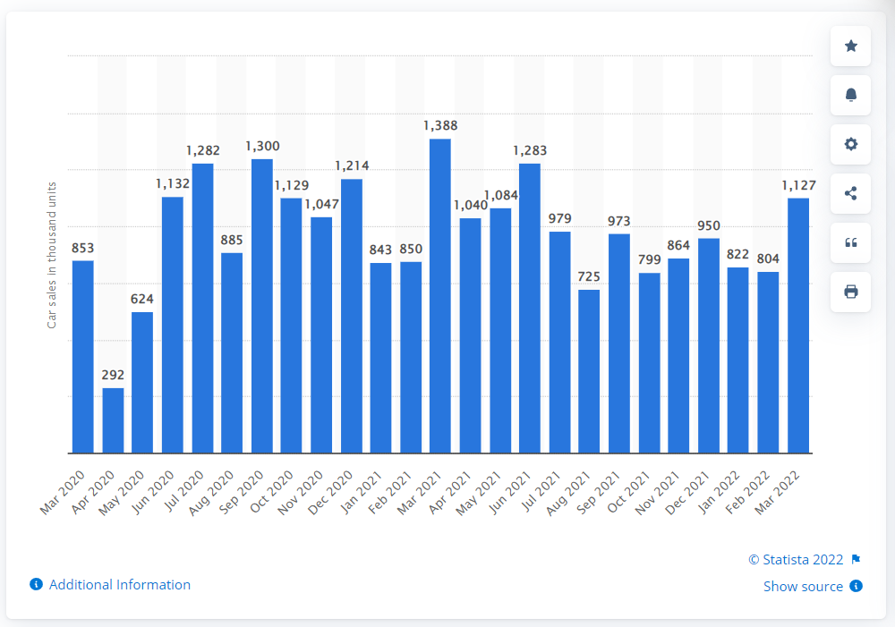
Due to the Covid-19 pandemic, every industry was struggling, and the entire Global Business Environment’s working process was obstructed. Focusing on the facts, many businesses are related to the trading and logistics sectors, which made sales and increasing profits almost impossible as the sectors weren’t operating properly.
Elon Musk created the brand, adding prestige to its name, and attracting customers by promoting that green energy is the new lux. The prices of the Tesla cars are higher than regular, which means that it is not easily affordable by anyone. However, Musk’s strategy has shifted the focus on Tesla products and presented it as an ultimate investment, which is 100% worth it. The long-lasting life of the batteries is proving that the products are not only keeping the environment safe by using greener energy but cost less to their owners than gas-fuelled engine cars. Electric vehicles are charged usually once a week and the cost of a fully charged battery is around 10 GBP. Even considering the exchange rates the expenses on the car are completely worth the initial investment. The “space” car is offering not only cheaper fuel but also takes off additional surcharges from their owner’s pocket. In many capital cities, the movements for a greener planet are strongly supported, and electric vehicles are on the pedestal. An easy example is London’s Ultra Low Emission Zone, which has been established to contain cleaner, breathable air for the residents and workers as well as a healthier environment.
The psychological methods used by Elon Musk lead him through using the full capacity of chances he could meet on the path from making the initial investment of 6.5 million USD, to gaining annual revenue of 500 million USD by the end of 2020 in the middle of a global pandemic. The confidence he had, inspired people to believe in him and the decisions he was taking, therefore people were willing to invest and buy his products. Upholding the charisma and appointing it to a direction where it can be useful made Musk the face of the innovation. Not only for the customers but for the people taking part in the production process who are committed to the development of more and more products and research, has built Tesla’s ultimate team, to lead it to success.
Throughout the years of product research and development, Tesla’s products had some issues, that appeared within the vehicles, which obstructed its financial success, however, the CEO, as well as the development team, had focused on working non-stop to overcome those issues and make the product better, and unbeatable on the market. The “working non-stop” strategy was fuelled simply by Musk’s beliefs in the potential of the product and the capabilities of his team. The years 2018-2019 might not have been the best for the company, however, this weakness and financial losses were used as motivation to create a product that is going to be strongly wanted by customers and hardly overcome by rival companies.
Many risks have been taken, from the team’s management side, as mentioned in the published online charts and maps, showing the entire development of the products, which might be extremely risky, for any start-up company, however, the brand has managed to reach the level of ultimate success where the survival mode has been passed through and forgot. The evaluation of potential risks has shown that Elon Musk has created developments that can hardly be topped up, and even though, there might be sights of arrogance within the methods used in promoting the company, most of its products sooner or later will become a vital part of our lives.

Conclusion
Tesla has been in survival mode since the beginning of the company's founding. It was about to face bankruptcy and be taken off the market, when the businessman Elon Musk decided to invest in it, after seeing its potential. The main idea of the Tesla Model was to produce electric supercars, which provide their users with the feeling of a nice luxury vehicle and the economy of a Toyota Prius. Elon Musk has applied different strategies in promoting tesla relying all on his knowledge, beliefs, and connections. Following his ideas and methods Musk, lead the company to ultimate success, where the set targets are achieved, bringing in the desired net profit, which is one of the most important targets for companies that are part of The Stock Market. Throughout the years of product development, the company has met different struggles, in the forms of defective batteries, etc., and managed to fix those issues, making the product more and more desirable. Elon Musk’s strong beliefs and charismatic behaviour have helped him, in addition, to build relationships with the market, proving that his opinion is vital and of high importance, more and more people started to believe in him as a person, therefore in the products he invents and invest in. Becoming valued and admired for his actions, gave musk the power to influence people, therefore increasing his sales even throughout a global pandemic. Creating a brand and stating its place on the market is not easy for most start-ups, or companies that are just about to commit bankruptcy. Elon Musk managed to convince people of his beliefs making Electric the new Luxury and proving that their investment in his belief is like a loan with a 0% interest rate, the same as his 0% investment in the marketing department for Tesla. Using simple psychology, Musk makes fortune by convincing people to follow a trend that he innovated with his innovation. Twisted, but successful.

References
Brinkman, J., Navarro, I. and Harper, D., 2014. Unlocking the Business Environment. 1st ed. Taylor and Francis.
Clinehens, J., 2022. The Psychology Behind Elon Musk’s $0 Marketing Strategy for Tesla. [online] Medium. Available at: <https://medium.com/choice-hacking/the-psychology-behind-elon-musks-0-marketing-strategy-for-tesla-102309e6c2b7> [Accessed 7 May 2022].
Corpbiz. 2022. International Business Environment (IBE) - Corpbiz Advisors. [online] Available at: <https://corpbiz.io/learning/international-business-environment-ibe/amp/> [Accessed 3 May 2022].
Grundy, T., 2006. Understanding Michael Porter The Essential Guide to Competition and Strategy. John Wiley & Sons, Ltd.
Guy, F., 2009. The Global Environment of Business. Oxford University Press, pp.8-34.
Investopedia. 2022. Trade Liberalization Explained. [online] Available at: <https://www.investopedia.com/terms/t/trade-liberalization.asp> [Accessed 2 May 2022].
Magretta, J., 2012. Understanding Michael Porter. Boston, Mass.: Harvard Business Review Press, pp.85-93.
Malmgren, I., 2016. Quantifying the Societal Benefits of Electric Vehicles. 1st ed. [ebook] Available at: <https://www.mdpi.com/2032-6653/8/4/996/pdf> [Accessed 1 May 2022].
Otter, D. and Whetherly, P., 2011. The Business Environment : Themes and Issues. 2nd ed. Oxford University Press, pp.3; 204-228; 32-62.
Ouerghi, D., 2021. Tesla's EV sales increase over 35% in 2020 despite Covid-19 setbacks. [online] Fastmarkets. Available at: <https://www.fastmarkets.com/insights/teslas-ev-sales-increase-over-35-in-2020-despite-covid-19-setbacks> [Accessed 2 May 2022].
Pettus, M. and Helms, M., 2008. Government Inclusion in Porter’s Diamond: The Case of Argentina. [online] Hbs.edu. Available at: <https://www.hbs.edu/ris/Publication%20Files/20170524%20Strategy%20Keynote_%20v4_full_final_2814963a-c8ca-457d-8ee6-69e8b57921ea.pdf> [Accessed 2 May 2022].
PTI, A., 2020. Tesla overcomes Covid-19 shutdown to post surprise profit of $104 mn in Q2. [online] Business-standard.com. Available at: <https://www.business-standard.com/article/international/tesla-overcomes-covid-19-shutdown-to-post-surprise-profit-of-104-mn-in-q2-120072300123_1.html> [Accessed 4 May 2022].
Sathre, R. and Gustavsson, L., 2021. A lifecycle comparison of natural resource use and climate impact of biofuel and electric cars. Energy, 237, p.121546.
Satryo, C., 2022. Free Trade Intervention: Political-Economic Intervention on Global Business Environment. [online] Available at: <https://apmba.ub.ac.id/index.php/apmba/article/view/295> [Accessed 2 May 2022].
Srinivasan, S., 2012. Understanding Michael Porter: The Essential Guide to Competition and Strategy. Journal of Education and Vocational Research, 3(3), pp.80-81.

