Dissertation

Post-Brexit Talent Challenges:
An Analysis of the UK Hospitality Industry

Programme: Master of Business Administration (International Hotel Management)
Module: Dissertation
Module code: BMMB7003
Lecturer: Robyn Griffiths, Helen Evans
Student name: Lola Villard-Coles
Student ID: 2114927

Declaration/Statements page

Declaration

This work has not previously been accepted in substance for any degree and is not being concurrently submitted in candidature for any degree.
Signed:
Date: 22/09/2024

Statement 1
This dissertation is a result of my own investigations and independent work, except were stated acknowledged by footnotes giving explicit references. Bibliography is appended.
Signed:
Date: 22/09/2024

Statement 2
This dissertation is being submitted in partial fulfilment of University of Wales Trinity St Davids or the MBA degree to meet all requirements.
Signed:
Date: 22/09/2024

Statement 3
I hereby give consent for my dissertation, if accepted, to be available for photocopying and for interlibrary loan, and for the title and summary to be made available to outside organisation.
Signed:
Date: 22/09/2024

Acknowledgements
I would like to express my deepest gratitude to all those who supported me throughout this research journey. First and foremost, I would like thank my colleagues and dissertation supervisor, whose insights, advice, and encouragement were invaluable in shaping this work. Your contributions helped me stay on track, even when the path seemed unclear.
To my wonderful wife, who not only endured my relentless obsession with Brexit and talent shortages but also put up with me during the weeks of late nights and endless reading. And, of course, to my loyal dogs, who were always there to listen (or at least pretend to) and who were a constant reminder that even in the midst of chaos, a wagging tail and a walk can solve a lot.
Thank you all for your patience, support, and occasional reminders to lighten up. This dissertation wouldn't have been possible without you.

Abstract
This research focuses on the talent challenges faced by the UK hospitality industry in the post-Brexit environment. Such a study is important in order to understand how the withdrawal from the European Union has impacted workforce composition, recruitment, and retention strategies, which are critical for the sector's sustainability.
The research approach adopted in this dissertation includes both primary and secondary methods, incorporating a quantitative survey with qualitative insights of hospitality businesses and a comprehensive review of relevant literature.
The findings from this research provide evidence that Brexit has significantly altered the workforce composition in the UK hospitality industry, increasing recruitment challenges, particularly in filling lower-skilled roles traditionally held by EU nationals.
The main conclusions drawn from this study are that the industry faces ongoing labour shortages, and that strategies such as increasing wages, investing in training, and targeting underutilised demographics like older workers are essential.
This dissertation recommends that businesses adopt a multifaceted approach combining competitive compensation, training programmes, and promoting hospitality as a long-term career option. Additionally, it recommends lobbying for an immigration policy reform to address long-term talent shortages and support the industry's sustained growth post-Brexit.

Table of Contents
Acknowledgements 3
Abstract 4
- Introduction 7
1.1 Background 7
1.2 Aims and Objectives 9
1.3 Rationale for the study 10
- Literature Review 11
2.1 Introduction 11
2.2 Workforce composition in the hospitality industry 12
2.2.1 Pre-Brexit 12
2.2.2 Post Brexit 13
2.2.3 Analysis, comparison of pre/post Brexit 15
2.3 Recruitment challenges post Brexit 16
2.3.1 Immigration policies 16
2.3.2 Talent pool available 17
2.3.3 Challenges Analysis 18
2.4 Theories and strategies for talent attraction and retention 20
2.4.1 Human Capital Theory 20
2.4.2 Social Exchange Theory 21
2.4.3 Strategies to attract UK workers Post-Brexit 22
2.5 Conclusion 26
- Methodology 28
3.1 Introduction 28
3.2 Secondary Research 28
3.3 Primary Research 29
3.3.1 Research Strategy 31
3.3.2 Data Collection 33
3.3.3 Pilot Survey 34
3.3.4 Framework for Data Analysis 35
3.3.5 Ethics, Reliability and Validity 36
3.3.6 Limitations and potential challenges 36

- Survey findings, discussion and synthesis 38
4.1 Demographic of respondents 39
4.2 Post-Brexit workforce composition and recruitment challenges 43
4.3 Strategies to manage talent shortages 49
4.4 Long term implications 52
4.5 Synthesis 57
5. Summary of findings and Conclusions 59
6. Recommendations and Limitations 62
Reference list 66
Appendices 73

- Introduction
This dissertation will explore the impact of Brexit on talent management within the United Kingdom (UK) hospitality industry, focusing on the significant challenges that have arisen in workforce composition, recruitment, and retention. As a critical component of the UK economy, the hospitality sector contributes substantially to employment and economic output. However, the withdrawal from the European Union has introduced a new set of complexities, disrupting established labour dynamics and creating an urgent need for effective talent management strategies. This study aims to analyse the extent to which these strategies are being implemented and provide insights into mitigating talent shortages in this vital sector.
  - Background
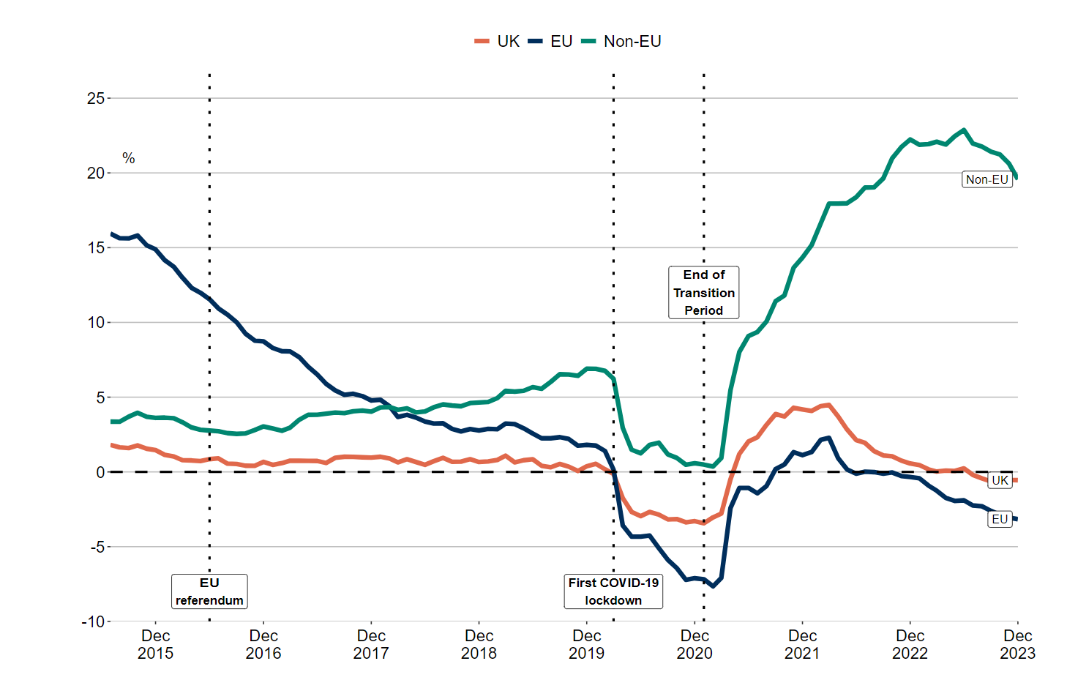
In the United Kingdom European Union membership referendum, commonly referred to as the Brexit or EU referendum that was held on 23 June 2016, the UK public voted to leave the European Union (EU), a decision that has since had profound implications for many sectors, including hospitality (Spital and Forster-van Aerssen, 2023). The HM Revenue and Customs (HMRC) (2024) statistic below (Figure 1) demonstrates the drastic decrease of 18 percentage points in payrolled employment of EU workers in the UK between 2015 (15%) and 2023 (-3%).

Figure 1 - Percentage change in payrolled employments on the same month in the previous year, by nationality, July 2015 to December 2023. (Source – HMRC, 2024)
The hospitality industry in the UK has historically faced challenges related to labour shortages and high employee turnover, challenges that have been exacerbated by Brexit. The sector's reliance on EU nationals is well-documented, with many hospitality businesses dependent on this workforce to meet operational demands. According to the British Hospitality Association (BHA) (2017), EU nationals comprised up to 23.7% of the hospitality workforce before Brexit, a figure that underscores the significant impact of changes to immigration policies on the industry. The termination of free movement has reduced the availability of EU workers, leading to a pronounced talent gap that businesses must now address (MAC, 2023).
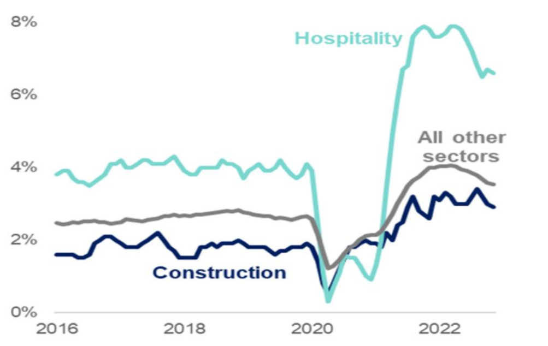
Statistics from the Migration Advisory Committee (MAC) (2023) as reflected below highlight a stark increase in vacancy rates from 4% in 2016 to 7% in 2023 within the hospitality sector post-Brexit, reflecting the industry's struggle to adapt to a reduced talent pool.

Figure 2 – Vacancy rates in construction and Hospitality, 2016-2022. (Source – MAC, 2023)
In addition, the Office for National Statistics (ONS) (2024) reported a notable decline in the number of EU nationals in the workforce, creating substantial recruitment challenges. The industry's need for skilled workers remains critical, and the inability to fill these roles threatens both service quality and the overall economic contribution of the sector.
The economic repercussions of Brexit extend beyond staffing shortages, with potential financial implications for both businesses and the broader economy. As noted by UKHospitality (2022), the industry's inability to operate at full capacity due to labour shortages could result in significant revenue losses, potentially affecting up to £21 billion in economic output. This situation presents a pressing concern for both industry leaders and policymakers, highlighting the need for strategic interventions to sustain the sector's growth and stability.
The post-Brexit landscape requires hospitality businesses to adopt innovative approaches to talent management, focusing not only on recruitment but also on retention strategies that ensure long-term workforce stability. Strategies that emphasise employee development, career progression, and engagement are crucial to reducing turnover and enhancing organisational resilience.
This dissertation addresses the need for a comprehensive understanding of the talent management strategies that are most effective in the Post-Brexit environment. By examining the role of training, development, and engagement in employee retention, the research aims to provide actionable recommendations for industry practitioners. This focus on talent recruitment and management as key drivers of success aligns with the evolving demands of the hospitality sector, offering insights into how businesses can navigate the challenges posed by Brexit and secure a skilled and committed workforce.
  - Aims and Objectives
The primary aim of this research is to investigate the effectiveness of talent management strategies in mitigating the impact of Brexit on the UK hospitality industry. The study will explore how these strategies contribute to workforce stability and identify best practices for enhancing employee retention. The research will be guided by the following specific objectives:
- To analyse changes in workforce composition within the hospitality industry pre- and post-Brexit.
- To identify the key recruitment challenges faced by hospitality businesses since Brexit.
- To evaluate the strategies employed by hospitality businesses to mitigate talent shortages.
- To assess the long-term impact of Brexit on the hospitality industry's talent pipeline.

  - Rationale for the Study
The researcher's background in the hospitality industry combined with an interest in workforce composition, talent recruitment and management challenges, has shaped the focus of this study. The sector's evolving landscape presents an opportunity to examine how businesses are adapting to external pressures and developing strategies to recruit and retain their workforce. By investigating the intersection of Brexit and talent management, this dissertation seeks to contribute valuable insights to both academia and industry practitioners. The findings aim to inform future policy and practice, supporting the hospitality sector's ongoing efforts to thrive in a post-Brexit environment.
This dissertation will encompass primary research via a literature review and secondary research using a quantitative survey, supplemented by qualitative insights, to achieve a comprehensive understanding of the industry's challenges and responses. This methodology facilitates an in-depth analysis, addressing the complexities of workforce composition and talent management during significant economic and political changes. The study aims to provide evidence-based recommendations that will support the industry's efforts to cultivate a resilient and sustainable workforce for the future.

- Literature review
2.1 Introduction
The hospitality industry is a vital component of the UK economy, contributing significantly to Gross Domestic Product (GDP) and employment. According to UKHospitality (2023a), the sector generates billions of pounds annually and supports millions of jobs. The industry's economic impact extends beyond direct revenue, influencing tourism, retail, and real estate markets. Based on the ONS (2024a) data, the hospitality industry is the third biggest employer in the UK, accounting for 3.5 million jobs through direct employment in 2022 and an additional 3 million indirectly. The industry generated over £93 billion of Gross Value Added (GVA) directly to the UK economy, and a further £121 billion indirectly. Pre-Brexit, the UK hospitality sector experienced steady growth, driven by increasing tourism and domestic demand. However, the economic landscape has been profoundly altered by Brexit, raising concerns about the future stability and growth of the sector. Despite proving resilient post-Brexit and post-COVID, the industry now faces cost pressures and labour supply shortages, with recent economic data showing lower levels of employment growth (UKHospitality, 2022).
Hospitality businesses have had to navigate a complex web of economic challenges since Brexit. Kaya et al. (2023) discuss the broader economic implications of Brexit, noting that sectors reliant on international trade and labour, such as hospitality, are particularly vulnerable. The depreciation of the pound following the Brexit referendum led to increased costs for imported goods, which are essential for the hospitality industry (Insight hospitality, 2023). These cost pressures have squeezed profit margins and forced businesses to reconsider pricing strategies and operational efficiencies. Additionally, the uncertainty surrounding future trade agreements has made it difficult for businesses to plan long-term investments, exacerbating financial instability (Kaya et al., 2023).
This literature review aims to explore the evolving workforce composition in the UK hospitality industry, with a specific focus on the periods before and after Brexit. By examining the pre-Brexit reliance on EU nationals and the post-Brexit adjustments in labour dynamics, this study provides an analysis of the sector's adaptation strategies and the broader implications for its future. The subsequent sections will examine the detailed workforce composition during these two distinct phases, highlighting key trends, challenges, and opportunities for the hospitality industry in a post-Brexit environment.
2.2 Workforce composition in the hospitality industry
Workforce composition in the hospitality industry is a critical factor influencing the sector's performance and service delivery. This industry is known for its diverse workforce, encompassing a wide range of skills, nationalities, and employment types (Barnes, 2023). The workforce dynamics in hospitality are significantly affected by socio-economic changes, regulatory frameworks, and migration policies. This section will explore the workforce composition in the hospitality sector, particularly focusing on the changes pre- and post-Brexit.
2.2.1 Pre-Brexit
Before Brexit, the UK hospitality sector heavily relied on EU nationals to meet its labour demands, with a significant proportion of its workforce comprised of EU migrants. Official sources reported that 12.3% of hospitality employees were EU nationals according to the Labour Force Survey (LFS) (ONS, 2016), while estimates from the British Hospitality Association (BHA) survey suggested that up to 23.7% of the workforce could be EU nationals (BHA, 2017). This discrepancy indicates that the true reliance on EU workers might be even higher, potentially underestimated by the LFS due to its methodological constraints. The sector's dependence was particularly pronounced in regions like London, where EU nationals made up between 25.7% and 38.0% of the hospitality workforce, and in specific sub-sectors such as hotels and restaurants, with EU nationals filling up to 75.3% of waiter and waitress roles, 24.6% of chef positions, and 37.1% of housekeeping roles (BHA, 2017).
The sector’s demand for EU migrant workers was driven by both the high turnover rate and the growth of the industry. Annually, the hospitality sector required approximately 62,000 new EU migrants to maintain its workforce levels and support its expansion (BHA, 2017). This high turnover rate, estimated at around 30% to 50%, necessitated a continuous inflow of workers to replace those leaving the sector and to meet new job creation due to sector growth (BHA, 2017). Additionally, the sector faced challenges in recruiting sufficient UK nationals, partly due to the nature of the jobs, which were often perceived as low-skilled and unattractive to local workers despite requiring specific skills such as customer service and language proficiency (BHA, 2017).
The reliance on EU nationals was not uniform across the sector. For instance, in Greater London, some businesses reported that up to 100% of their employees were EU nationals, with an average of 38.0% across surveyed businesses. This heavy dependence on EU workers was attributed to various factors, including the high cost of living in London, which discouraged UK workers from taking up hospitality jobs, and the seasonal nature of many positions, which were more readily filled by EU nationals (BHA, 2017). In contrast, the Labour Force Survey by ONS (2016) indicated that EU nationals represent an average of 6% of the workforce in the North East of the UK.
Overall, the pre-Brexit scenario highlighted a significant reliance on EU migrant labour in the UK hospitality sector. This dependence posed substantial risks to the sector’s sustainability and growth potential in the event of restricted access to EU labour post-Brexit. The projected shortfall, if EU migration were halted, was estimated to be upwards of 60,000 workers annually, leading to a cumulative recruitment gap of over one million workers by 2029 (BHA, 2017). This scenario underscored the critical role that EU nationals played in sustaining the UK hospitality industry and the profound impact that changes in migration policy could have on the sector.
2.2.2 Post Brexit
Post-Brexit refers to the period after January 31st, 2020, at 11 pm. Obtaining accurate data on workforce composition in the hospitality industry during this time has proven challenging, highlighting a gap in research.
Post-Brexit, the UK hospitality sector has faced significant challenges due to its previous reliance on EU nationals for its workforce. The end of free movement has drastically altered the composition of the workforce, leading to notable labour shortages. According to a report by Jonathan Portes and John Springford (2023), the new post-Brexit migration system, which came into effect in January 2021, introduced stringent requirements for EU nationals wishing to work in the UK. This has resulted in a marked decline in the availability of EU workers, which has not been fully compensated by non-EU workers.
Portes and Springford (2023) reported that the hospitality sector has experienced a shortfall of approximately 460,000 EU-origin workers, partly offset by an increase of about 130,000 non-EU workers. However, this increase is insufficient to meet the sector's demands, leading to significant operational challenges and restricted growth. The hospitality sector's reliance on EU nationals and the subsequent shortfall post-Brexit underscore the need for strategic adjustments in recruitment and retention practices within the sector.
The impact of these changes is most pronounced in lower-skilled roles within the sector. Many roles, such as waiters, waitresses, chefs, housekeepers, and kitchen assistants, which were predominantly filled by EU nationals, have seen significant shortages. This shift has created a substantial recruitment gap, which is challenging to fill with the domestic workforce due to the sector's historically high turnover rates and the low interest among UK workers in these roles (BHA, 2017)
According to Barnes (2023) the UK hospitality industry has experienced a substantial loss of nearly 200,000 overseas workers since Brexit, which has severely impacted its recovery post-pandemic. This workforce reduction, primarily comprising EU nationals, is linked to stricter immigration regulations and pandemic-related disruptions.
George, Limmer, and Halvorsrud (2020) provide a qualitative analysis of the impact of Brexit on migrant workers, noting significant changes in employment patterns. They argue that the reduced availability of EU workers has led to increased competition for labour, driving up wages and operational costs. Employers are now more reliant on domestic workers, who often require additional training to meet industry standards. This shift has placed a greater emphasis on workforce development and has highlighted the need for improved training programmes to upskill domestic workers.
The introduction of the Skilled Work Visa, which requires a job offer with a minimum yearly salary of £26,000 and skill level, has not fully mitigated the reduction in EU labour. Many roles in the hospitality sector do not meet the criteria for these visas, leading to difficulties in hiring sufficient staff. This has been exacerbated by the COVID-19 pandemic, which has further strained the labour market by reducing the overall labour supply (Hutton, 2022).
2.2.3 Analysis, comparison of pre/post Brexit
The comparison of workforce composition in the UK hospitality industry pre- and post-Brexit reveals significant shifts. Before Brexit, the sector relied heavily on EU nationals, who constituted up to 23.7% of the workforce, particularly in London and sub-sectors like hotels and restaurants (BHA, 2017). This reliance stemmed from high turnover rates and the difficulty in attracting UK nationals to roles perceived as low-skilled, despite requiring specific skills like customer service (BHA, 2017).
Post-Brexit, the end of free movement drastically reduced EU workers, causing notable labour shortages. The new migration system, introduced in 2021, imposed stricter requirements, leading to a shortfall of around 460,000 EU workers, partly offset by an increase of 130,000 non-EU workers (Portes and Springford, 2023). However, this increase remains insufficient to meet demand, particularly in lower-skilled roles like waiters and housekeepers (Barnes, 2023). The reduced EU workforce has driven up wages and operational costs, further straining the sector.
The introduction of the Skilled Work Visa, requiring a job offer with a minimum salary and skill level, has not alleviated the hiring difficulties, as many hospitality roles fall short of these criteria (Portes and Springford, 2023). The transition has highlighted the industry's reliance on EU migrant labour, forcing it to adjust recruitment and retention strategies to sustain workforce levels and growth potential (Barnes, 2023).

2.3 Recruitment challenges post Brexit
This section will explore two key challenges identified in the literature: the impact of stricter immigration policies and the reduced availability of skilled workers.
2.3.1 Immigration policies
Post-Brexit immigration policies have become more restrictive, with the points-based system favouring high-skilled workers, posing challenges for the hospitality sector, which largely relies on lower-skilled roles, up to 75% of employees according to National Careers Service (2024). For EU nationals to obtain a visa, their job must meet RQF3 skill level (A-level equivalent), and they must demonstrate English proficiency and meet the salary threshold of £26,000 or the job’s going rate, whichever is higher (Home Office and UK Visas and Immigration, 2023). This is problematic as many hospitality roles, such as experienced waiters earning around £22,000 annually, fall below the required salary for visa approval.
Portes (2019) argues that these policies exacerbate labour shortages and increase operational costs, prompting the hospitality industry to advocate for more inclusive immigration policies that accommodate its specific labour needs. CIPD (2023a) also emphasises the necessity for policy adjustments, recommending a flexible immigration approach to ease post-Brexit labour shortages. The sector has pushed for more roles to be included on the shortage occupation list, simplifying the recruitment of non-UK nationals for hard-to-fill positions.
These policy changes have increased operational costs, as businesses now face visa sponsorship fees and administrative burdens, compounding financial pressures from Brexit and COVID-19 (Hutton, 2022). The industry's ability to adapt to these challenges will be crucial, with Portes (2022) stressing the importance of continued engagement with policymakers to address the sector’s workforce needs.
Pre-Brexit, EU nationals could come to the UK, find work, and apply through standard recruitment processes. Now, they must secure employment from abroad, be sponsored, and meet salary thresholds, contributing to a decline in EU applicants and a shift toward other European countries. According to the Migration Observatory (2024), the post-Brexit uncertainty has made the UK less appealing to skilled workers, with many choosing destinations like Germany, the Netherlands, and Ireland due to their stable economies and favourable immigration policies (European Commission, 2024). This shift poses significant challenges for the UK’s ability to attract talent, particularly in sectors reliant on EU migrant labour.
2.3.2 Talent pool available
The hospitality industry relies on a diverse skill set, including customer service, culinary expertise, and management capabilities. Post-Brexit, the need for a skilled workforce has intensified due to labour market constraints. Rolfe (2017) and Davies (2021) emphasise the importance of substantial investments in training to enhance domestic skills as businesses adapt to this new landscape.
The industry's reliance on soft skills, such as customer interaction and service delivery, necessitates training programmes focusing on both technical competencies and interpersonal skills. Clarke, Serwicka, and Winters (2021), along with Jones and Brown (2023), stress the importance of these skills for maintaining the UK's competitive edge in the global hospitality market. They argue that soft skills are critical for customer satisfaction and business success. Front-of-house roles require strong communication and problem-solving abilities, while kitchen staff need efficiency and culinary expertise. Management roles demand leadership and financial acumen, necessitating tailored training for each role (CIPD, 2021).
Currently, 66 UK institutions offer 179 hospitality-related courses (Unistats, 2024), but the industry must recruit 200,000 new workers annually to meet demand, with Brexit adding an estimated 60,000 more (BHA, 2017). The reduction in EU workers has made it difficult to maintain a skilled workforce, forcing the industry to focus on upskilling its domestic workers while attracting new talent. Competitive wages, clear career progression, and ongoing training are essential strategies for filling these gaps (Jones and Brown, 2023).
The reduction in EU workers has increased competition for talent and put pressure on service quality, according to Sumption et al. (2022). High turnover rates, a longstanding issue in hospitality, have been exacerbated by Brexit. Retaining staff through improved working conditions, career development, and competitive pay is crucial for addressing these challenges (Ghani et al., 2022; Brown, 2024).
Recent ONS (2024c) data shows a significant decline in EU nationals applying for hospitality jobs in the UK, impacting operational capacity. Jones and Brown (2023) argue that firms face increased pressure to upskill new hires rapidly. Offering better wages and benefits has become essential for attracting the necessary workforce.
Many hospitality businesses are investing in training to improve both technical and soft skills, including customer service and teamwork. Programmes like Hilton's "Hilton University" enhance service quality (Smith, 2022), while partnerships with educational institutions bridge the skills gap (Clarke, Serwicka, and Winters, 2021; Jones and Brown, 2023).
Despite these efforts, high turnover rates, at approximately 30% annually (Ghani et al., 2022), coupled with Brexit’s impact, continue to make staff retention difficult, particularly in lower-paying roles. The perception of hospitality as a "stop-gap" rather than a long-term career adds to the challenge. A report by Hotel, Restaurant & Catering (HRC) (2023) shows that only 1-in-5 UK adults view hospitality as an appealing career, with only 10% considering it well-respected and 12% actively recommending it.
This negative perception, especially among older adults, presents a major obstacle for an industry that traditionally relied on EU workers. As these workers now seek more stable environments within the EU, the UK hospitality sector faces ongoing labour shortages.
2.3.3 Challenges Analysis
The post-Brexit hospitality industry in the UK faces significant recruitment challenges due to stringent immigration policies and a shrinking talent pool. The new points-based immigration system prioritises high-skilled workers, making it difficult for hospitality roles, often classified as low-skilled, to meet visa requirements. For instance, the required salary threshold of £26,000 is significantly higher than the average wage for roles like experienced waiters, who earn around £22,000 annually (Home Office and UK Visas and Immigration, 2023). This discrepancy has resulted in a marked decline in EU nationals applying for jobs in the UK, exacerbating labour shortages (Portes, 2019; CIPD, 2023a).
Research indicates that the reduction in EU workers has led to increased competition for talent, raising operational costs and pressuring existing staff. Recent data from the Office for National Statistics (2024) highlights a marked decrease in the number of EU nationals in the sector, necessitating rapid upskilling of new hires and better wages and benefits to attract necessary workforce (Sumption et al., 2022; Jones & Brown, 2023).
Additionally, the shift towards digitalisation in the industry requires new skills, further straining the talent pool. The hospitality sector's historical issues with high turnover and transient labour have been magnified post-Brexit, necessitating improved working conditions, career development opportunities, and competitive compensation packages to retain staff (Ghani et al., 2022).
Overall, the industry's future success depends on strategic adaptations, including advocating for more inclusive immigration policies and investing in comprehensive training programmes. The current environment underscores the urgent need for policy adjustments to support the hospitality sector's workforce requirements and sustain its operational capabilities (Portes, 2022; Brown, 2024).

2.4 Theories and strategies for talent attraction and retention
The hospitality industry has long been characterised by its reliance on a diverse workforce, particularly from the EU, to meet its labour demands. However, post-Brexit, the industry faces significant challenges in attracting and retaining talent due to the end of free movement and the introduction of stringent immigration policies (Portes & Springford, 2023). The importance of talent attraction and retention has therefore become more critical than ever for sustaining the industry's growth and maintaining service standards. This section will explore talent attraction and retention strategies within the hospitality sector post-Brexit, critically examining the Human Capital Theory and the Social Exchange Theory to determine the most effective approach.
2.4.1 Human Capital Theory
Human Capital Theory, developed by economists like Gary Becker, suggests that productivity and economic value can be enhanced through investments in education, training, and development (Becker, 1994). This theory views human capital similarly to physical capital, asserting that improving employees' skills and knowledge increases their productivity and output.
In the hospitality sector, this theory implies that businesses can enhance service quality and operational efficiency through staff training in areas like customer service, culinary skills, and management. For instance, companies such as Hilton and Marriott have established comprehensive programmes, like the Hilton Management Development and Marriott Voyage programmes, to continuously upskill their employees (Hilton, 2024; Marriott, 2024).
These investments help address the post-Brexit skills gap by upskilling the domestic workforce, allowing businesses to maintain high service standards despite labour shortages (Chapman et al., 2024). Moreover, offering clear career pathways can make hospitality roles more appealing to UK nationals, tackling the perception that these jobs are low-skilled and unattractive (Gable, 2022). This can lead to higher job satisfaction, loyalty, and reduced turnover (Ferdiana et al., 2023).
However, there are limitations. With a high annual turnover rate of around 30% (Ghani et al., 2022), training investments may not pay off if employees leave soon after. Additionally, the costs of training can be a financial burden, especially for smaller businesses already affected by Brexit and the pandemic (Hutton, 2022)
2.4.2 Social Exchange Theory
Social Exchange Theory, developed by George Homans and expanded by Peter Blau, focuses on reciprocal relationships, suggesting that employees are more likely to stay with an organisation if they experience supportive, positive exchanges (Blau, 1964). In the workplace, this theory highlights the importance of creating a supportive environment, recognising contributions, and maintaining open communication.
In hospitality, this theory can be applied through initiatives like employee recognition programmes, flexible working hours, and wellness support (Balata et al., 2023). For instance, Accor’s “Heartist” programme celebrates employees’ individuality and social skills, fostering a sense of purpose and enhancing engagement, job satisfaction, and retention (Accor, 2023). Such initiatives help employees balance work with personal life, reducing stress and improving overall well-being.
The strength of this approach is its focus on emotional and relational aspects of employment. A positive work culture can boost job satisfaction and loyalty, helping to reduce the hospitality sector's high turnover rates (CIPD, 2023c). However, while Social Exchange Theory supports employee retention, it does not fully address the skills gap left by the reduction of EU workers. It focuses on keeping existing staff satisfied but may not attract new talent to fill vacancies with necessary skills.
When comparing Human Capital Theory and Social Exchange Theory, both have advantages and limitations. Human Capital Theory provides a long-term solution by focusing on developing a skilled workforce, essential for maintaining high service standards, especially post-Brexit, where addressing the skills gap is urgent (Portes & Springford, 2023; UKHospitality, 2022). However, high turnover rates in hospitality challenge this approach, as training investments may not deliver returns if employees leave before applying their skills (Ghani et al., 2022; Hutton, 2022).
In contrast, Social Exchange Theory focuses on immediate retention by fostering a supportive work environment, reducing turnover and improving job satisfaction. However, it does not fully address the skills gap previously filled by EU workers (Blau, 1964; Balata et al., 2023; CIPD, 2023b). Therefore, a combined approach is likely the most effective post-Brexit strategy. Investing in employee development through training and clear career pathways can build a skilled workforce (Becker, 1994; Chapman et al., 2024). Simultaneously, creating a supportive work environment with flexible hours and recognition programmes can enhance satisfaction and loyalty, reducing turnover (Accor, 2023; UKHospitality, 2022).
For example, hospitality businesses could combine structured training with flexible conditions and recognition programmes to address immediate post-Brexit challenges while building a loyal workforce for the future (Centre for Ageing Better, 2021; ONS, 2023). This holistic approach will help the sector navigate Brexit’s challenges and thrive in the new economic landscape (Portes & Springford, 2023; UKHospitality, 2023b).
2.4.3 Strategies to attract UK workers Post-Brexit
This section will explore strategies highlighted in the literature that are aimed at attracting UK workers to fill the labour shortages in the hospitality industry post-Brexit. The focus will be on four key approaches: offering competitive wages and benefits, providing clear career progression pathways, investing in training and development opportunities, and recruiting workers over 50.
Competitive wages and benefits
Offering competitive wages is fundamental to attracting UK workers, especially in a sector often perceived as low-paying. According to the ONS (2024b), the average annual salary for roles such as waiters and waitresses falls below the general salary threshold for immigration, underscoring the need for wage adjustments. By aligning wages more closely with living costs and offering additional benefits such as health insurance, pensions, and performance bonuses, businesses can make these roles more financially attractive (UKHospitality, 2022).
In other EU countries like France, hospitality is seen as a viable and attractive career choice. This perception is partly due to a higher minimum wage specific to the industry, which exceeds the standard minimum wage. Similar to industries like construction, which are recognised for their physical demands and unsociable hours, the higher wages in French hospitality help enhance its appeal (JDN, 2024).
Brexit has also brought about changes in employment contracts and conditions (CIPD, 2023b). With the reduction in the availability of EU workers, some employers have moved towards offering more permanent contracts to retain their workforce. This shift marks a significant change from the pre-Brexit era, where zero-hour contracts and seasonal employment were more common. George, Limmer, and Halvorsrud (2020) note that these changes, while potentially beneficial for workers in terms of job security, also mean higher costs and commitments for employers.
Clear career progression pathways
Career progression opportunities are crucial in making hospitality roles appealing to domestic workers. Ferdiana et al., (2023) argue that clear pathways outlining potential career growth from entry-level positions to management roles can help shift the perception of hospitality jobs from temporary employment to long-term career options. For example, companies like Whitbread have implemented structured career development programmes that provide employees with a clear roadmap for advancement. Whitbread's "Step Up" programme is designed to identify and nurture talent within the company, offering training and mentoring to help employees progress from entry-level roles to senior management positions (Whitbread, 2022).
These structured career development programmes not only improve employee retention but also enhance job satisfaction by providing a clear vision of future opportunities. By investing in their employee’s growth, businesses can cultivate a more skilled and motivated workforce, ultimately benefiting the company as a whole (Balata et al., 2023). Moreover, career progression opportunities can make hospitality roles more attractive to a broader demographic, including younger workers who are often seeking clear development prospects and long-term career stability (Smith, 2023)

Training and development opportunities
Investing in training and development is essential for equipping domestic workers with the skills needed in the hospitality industry. Comprehensive training programmes that cover both technical skills such as culinary arts and customer service and soft skills such as communication and teamwork can enhance the overall competence of the workforce (Tracey and Swart, 2020).
Further and higher education institutions also play a crucial role in this ecosystem by providing foundational and advanced training tailored to the hospitality sector. Partnerships between businesses and educational institutions can create pathways for students to transition seamlessly into the workforce, with colleges and universities offering specialised hospitality management courses and vocational training centres providing certifications and short courses in areas such as culinary arts and hotel management (Institute of Hospitality, 2024). Educational institutions can collaborate with hospitality businesses to identify skills gaps and develop customised training solutions, ensuring that the curriculum is aligned with industry needs and that graduates are job-ready. Government support for apprenticeships and traineeships in hospitality can significantly enhance training and development opportunities by offering a blend of on-the-job training and classroom learning, allowing apprentices to earn while they learn (Institute of Hospitality, 2024).
A well-trained workforce is more capable, confident, and motivated, leading to improved service quality and customer satisfaction, while continuous learning opportunities help retain employees by showing a commitment to their professional growth and career advancement (Marriott, 2023)
Recruiting over-50s workers
Targeting older workers can play a crucial role in addressing the labour gap in the hospitality industry. According to UK hospitality's Workforce Strategy (2022), engaging older workers is vital for addressing staffing challenges and enhancing the sector's stability and service quality. The over-50s demographic often brings a wealth of experience and a strong work ethic (Dyball, 2023). Implementing flexible working arrangements, offering part-time roles, and providing continuous learning opportunities can make hospitality jobs more appealing to this age group (UKHospitality, 2023b).
Historically, older workers were not targeted due to several misconceptions and structural biases within the industry. Employers often assumed that older individuals might struggle with the physical demands of hospitality jobs or be less adaptable to new technologies and modern practices (UKHospitality, 2023b). Furthermore, the industry traditionally favoured younger workers for roles requiring high energy and long hours. However, these stereotypes are increasingly being challenged as the sector recognises the value that experienced, mature employees bring (Centre for Ageing Better, 2021).
Following the UK Government (2023) 'Back to Work Budget', there is a clear governmental effort to encourage people back to work, including the over-50s. The Centre for Ageing Better (2021) reports that by 2025 there will be an additional one million workers over the age of 50 in the UK. This demographic can help address the persistent 10% vacancy rate within the sector, with hospitality vacancies remaining approximately 50% higher than pre-Brexit levels (ONS, 2023).
To support businesses in employing this age group, UKHospitality (2022) has developed a tailored guide to debunk myths about employing older workers, suggesting recruitment process adaptations, and highlighting their unique strengths. The British Beer & Pub Association (BBPA) (2022) has also published a guide to recruiting older workers. Additionally, the Centre for Ageing Better (2021) offers resources such as the 'Good Recruitment for Older Workers' guide, and the Department for Work and Pensions (DWP) provides extensive support and guidance on its ‘help and support for older workers’ webpage (Centre for Ageing Better, 2021).
The strategies outlined in this section, including competitive wages, clear career progression pathways, training and development opportunities and recruiting older workers, offer practical solutions to the post-Brexit labour challenges in the UK hospitality industry. These approaches aim to make hospitality roles more appealing to UK workers, improve retention, and reduce the sector's reliance on EU labour. According to the reviewed literature, focusing on these strategies, could support businesses create a more sustainable and resilient workforce, capable of meeting the industry's evolving needs in a post-Brexit environment.
2.5 Conclusion
The literature review has provided a comprehensive analysis of the workforce composition in the UK hospitality industry, emphasising the significant changes brought about by Brexit. Pre-Brexit, the sector heavily relied on EU nationals, who comprised a substantial portion of the workforce, particularly in lower-skilled roles such as waiters, chefs, and housekeepers. This reliance was driven by the high turnover rates and the industry's difficulty in attracting UK nationals to roles perceived as low-skilled and unattractive (BHA, 2017).
Post-Brexit, the end of free movement and the introduction of a new migration system have drastically altered the workforce composition, leading to notable labour shortages (Portes & Springford, 2023). The sector has faced a significant shortfall of EU-origin workers, only partly offset by an increase in non-EU workers (Portes & Springford, 2023). This has resulted in substantial operational challenges and restricted growth, particularly in roles that do not meet the criteria for the Skilled Work Visa (Home Office and UK Visas and Immigration, 2023).
The analysis highlights the critical dependence of the UK hospitality sector on EU migrant labour and the profound impacts of migration policy changes on workforce composition. The sector now faces significant operational challenges, necessitating strategic adjustments in recruitment and retention practices (Barnes, 2023).
Key strategies identified include advocating for more inclusive immigration policies, investing in comprehensive training programmes, and fostering a supportive work environment to enhance job satisfaction and loyalty (CIPD, 2023b). The review suggests that a combined approach incorporating elements of both Human Capital Theory and Social Exchange Theory may be most effective in addressing the immediate challenges and building a sustainable workforce for the future (Becker, 1994; Blau, 1964).
Overall, the literature underscores the need for policy adjustments to support the hospitality sector's workforce requirements. The industry's future success will depend on its ability to adapt to the post-Brexit labour market, implement strategic recruitment and retention practices, and invest in the development and well-being of its domestic workforce (Portes & Springford, 2023; UKHospitality, 2023b).

3. Methodology
3.1 Introduction
This research investigated the talent challenges faced by the UK hospitality industry following Brexit. It aimed to analyse changes in workforce composition, identify key recruitment challenges, evaluate strategies used to mitigate talent shortages, and assess the long-term impacts on the industry’s talent pipeline. This chapter outlines the methodological approach, including both secondary and primary research methods, that were employed to achieve these objectives. The chapter also addresses the data collection methods, frameworks for analysis, and potential limitations encountered during the research process. Additionally, the study examined data collection and analysis methods, evaluating their reliability and validity, and addressed any necessary ethical considerations.
3.2 Secondary Research
Secondary research provided a foundational understanding of the UK hospitality industry's workforce dynamics before and after Brexit. This phase involved a comprehensive review of existing literature, government reports, industry publications, and academic studies to establish a solid background for assessing primary research findings.
An exploration of the historical composition of the hospitality workforce was conducted, examining data on demographics and employment patterns before Brexit. Key sources included the Office for National Statistics (ONS), UKHospitality (UKH), the Chartered Institute of Personnel and Development (CIPD), the Institute of Hospitality (IoH), and the British Hospitality Association (BHA), which offered valuable insights into changes in labour market trends over time. The significance of secondary research lay in its ability to contextualise primary research and guide the development of research questions and hypotheses (Saunders, Lewis, and Thornhill, 2023).
Post-Brexit changes in the workforce were a focal point, requiring an examination of shifts in workforce composition, such as changes in nationality, skill levels, and employment rates. Government reports and industry analyses were instrumental in identifying these changes. The recruitment challenges in the post-Brexit era had been widely documented, with numerous studies highlighting the difficulties faced by hospitality businesses in sourcing skilled labour.
Strategic responses to talent shortages, such as training programmes and international recruitment efforts, were explored through existing literature. The Human Capital Theory, as articulated by Becker (1994), offered a valuable lens for evaluating the effectiveness of these responses. This theory posits that investments in employee training and development enhance the skills and productivity of the workforce, thereby addressing talent shortages. Additionally, the Social Exchange Theory (Blau, 1964) was utilised to understand the reciprocal relationship between employers and employees, where employers invest in training and development, and employees reciprocate with loyalty and increased performance.
Secondary research not only provided a foundation for understanding the current state of the industry but also informed the design and direction of primary research (Snyder, 2019). By synthesising existing knowledge, this research aimed to contribute to a more comprehensive understanding of the post-Brexit talent challenges in the UK hospitality sector.
3.3 Primary Research
The process used for gathering, analysing, interpreting, and publishing the findings is referred to as the research design (Myers, 2019). Selecting the research design for this project presented challenges. The secondary research conducted underscored the importance of social and personal aspects affecting talent management in the post-Brexit UK hospitality industry, suggesting that the factors influencing business decisions are ultimately human and behavioural. When evaluating the preferred methods of research, the primary consideration was whether a quantitative, qualitative, or mixed-method (combining qualitative and quantitative approaches) would be most effective.
Research practice is generally divided into two paradigms. The 'positivist' paradigm required the researcher to be objective in analysing results, necessitating a level of interpretation to present the data as a 'tangible social reality' (Saunders, Lewis, and Thornhill, 2023). This paradigm is associated with greater accuracy because the information is typically factual and binary, collected via quantitative methods that aid measurement and interpretation (Collis & Hussey, 2021). However, it is noteworthy that positivist, quantitative methods can also gather less detailed qualitative data (Collis and Hussey, 2021).
Conversely, the 'phenomenological' paradigm focused on understanding human behaviour and its relation to the surrounding environment (Saunders, Lewis, and Thornhill, 2023). Instead of measuring statistics and numbers, this approach was attuned to exploring the interpretation of results and understanding why people act in certain ways, referred to as epistemological interpretivism (Saunders, Lewis, and Thornhill, 2023) or social constructivism (Savin-Baden and Howell, 2022). The phenomenological paradigm, primarily concerned with qualitative research methods, saw a trend of preference in research in the early 2000s (Frechette et al., 2020). However, there is now an increased emphasis on a mixed methodology and a 'pragmatic' approach to research design (Saunders, Lewis, and Thornhill, 2023), which combines the strengths of both paradigms to provide a 'best-fit' method for research projects. The mixed-methods approach, as advocated by Creswell and Guetterman (2024), enabled the triangulation of data, enhancing the validity and depth of the findings.
In relation to this research, qualitative (phenomenological) methods would have been suitable for gauging emotions and feelings, allowing for greater interpretation and authentic feedback (Creswell and Guetterman, 2024). Quantitative (positivist) methods, in contrast, are objective and statistically driven, focusing on data that highlights group trends rather than individual distinctions (Creswell and Guetterman, 2024). Since post-Brexit talent challenges involve complex human interactions, it could be argued that they would be best assessed using qualitative methods. However, collecting such data via interviews or focus groups could have compromised anonymity, which was crucial given the competitive nature of the hospitality industry and the desire to maintain confidentiality about strategic recruitment practices.
The critical issue with qualitative research on this topic was ensuring anonymity for respondents. While quantitative methods could easily ensure that no personal details were recorded, thus encouraging honest responses, the same could not be said for qualitative research (Frechette et al., 2020). To address this issue, a primarily quantitative approach was adopted to ensure the collection of truthful and accurate data. To bridge this gap and enhance the analysis, open-ended questions were included in the survey. These questions allowed respondents to select "Other (Specify)" to provide additional insights and concluded with an open-ended question: "Do you have any additional comments or insights regarding the impact of Brexit on the hospitality industry?" By incorporating these qualitative elements, the study aimed to deliver a more thorough analysis of the talent challenges confronting the hospitality industry post-Brexit. According to Rouder et al. (2021), open-ended responses yield authentic feedback and reveal diverse perspectives, capturing the "why" behind quantitative data and thus enriching the overall narrative.
The justification for using a quantitative research method was well-founded and offered numerous benefits, including reliability, precision, larger sample sizes, responsive data collection, low cost, protection from bias, and easy replication if needed (Malhotra & Birks, 2000; Myers, 2019; Collis & Hussey, 2021; Saunders, Lewis, and Thornhill, 2023). While the small amount of qualitative responses might suggest the research lacked the richness and depth usually associated with personal choice, hospitality business decisions are often made based on customer feedback, trends, and statistical analysis. By integrating quantitative data to provide clear evidence of trends and patterns affecting talent management decisions, along with some qualitative data through open-ended questions, this study aimed to provide a comprehensive analysis of the talent challenges faced by the hospitality industry post-Brexit.
    - Research Strategy
To examine the post-Brexit talent challenges in the UK hospitality industry, primary data was collected using an online survey (Appendix A) distributed through Microsoft Forms to a sample of hospitality businesses across the UK. The survey ran for three weeks and was designed to gather consistent data, as all respondents received identical closed-ended questions. This approach minimised irrelevant responses and simplified data interpretation. The survey aimed to assess the respondents’ business conditions, their views on Brexit’s impact on the industry, and opinions on the recruitment challenges highlighted in the literature review. Respondents ranked or rated factors based on their relevance to their business.
The survey was structured in four sections, each aligning with the key research objectives. The first section collected background information on the respondent and their company. The second section explored changes in workforce composition and recruitment challenges following Brexit. The third section focused on strategies businesses employed to address talent shortages. The fourth section assessed the long-term impact of Brexit on the talent pipeline and included an open-ended question for additional comments.
The first research objective, "To analyse changes in workforce composition pre- and post-Brexit," was addressed through the second section of the survey, which focused on workforce dynamics. The third section supported this by exploring talent management strategies. The second objective, "To identify key recruitment challenges post-Brexit," was covered in the third section, which directly addressed the challenges of attracting and retaining talent. The second section also provided insights into the importance of various factors influencing recruitment.
The third and fourth objectives, "To evaluate the strategies employed by hospitality businesses to mitigate talent shortages" and "To assess the long-term impact of Brexit on the talent pipeline," were covered in the final two sections. These sections focused on strategies to manage talent shortages and assessed their effectiveness, helping to determine how businesses were adapting their approaches based on perceived successes.
The research followed Saunders, Lewis, and Thornhill’s (2023) research onion model, beginning with a pragmatic research philosophy, which integrates both positivist and interpretivist approaches. This mixed-method approach allowed for practical solutions to complex research questions, combining quantitative survey data with qualitative insights.
A deductive research approach was adopted, using existing literature to develop hypotheses and research questions. This aligned with the study’s aim to test existing theories on talent management and recruitment challenges in the post-Brexit context.
For the research strategy, an online survey was chosen for its efficiency in reaching a broad audience across the UK. Microsoft Forms was selected for its user-friendly design and data analysis capabilities.
Data collection involved both primary data from the survey and secondary data from literature, government reports, and industry publications. The study used a cross-sectional time horizon, collecting data at a single point to capture the current challenges faced by the hospitality industry post-Brexit.
Data collection and analysis were conducted following best practices in survey methodology such as ensuring question clarity and simplicity (Dillman, Smyth, and Christian, 2014), ensuring the reliability and validity of the findings. Quantitative analysis involved using Microsoft Forms to summarise and interpret survey results, providing insights into workforce composition changes and recruitment challenges.
3.3.2 Data Collection
An online survey was chosen over face-to-face or paper-based questionnaires due to the time and resources available, as well as the efficiency provided by Microsoft Forms for distribution and data collection. Online surveys offered convenience for both the researcher and the respondents, though they presented challenges such as limited support for respondents who might have difficulty understanding the questions and the ease with which respondents could exit the survey at any point. These considerations informed the decision to limit the survey to twenty questions, balancing comprehensiveness with the need to maintain respondent engagement (Lambert, 2019).
According to Lambert (2019), there are numerous advantages to using the internet to distribute surveys and gather responses, including time efficiency, cost-effectiveness, and convenience. Modern survey tools like Microsoft Forms allowed researchers to structure, distribute, and analyse data with minimal effort and expertise, significantly reducing the time required to conduct the research. However, without prior warning, proper introduction, or existing connections with the target response group, the response rate could be disappointing (Dillman, Smyth, and Christian, 2014). Consequently, efforts to encourage participation and address non-response could become resource-intensive and time-consuming.
In this research, respondents were industry contacts, which facilitated easier motivation and persuasion to participate. A common issue in the digital age is that emails sent via survey platforms can be flagged as junk or spam, potentially missing the receiver's attention. Additionally, technical issues could arise at any stage, delaying the research process and presenting challenges to the researcher (Sakshaug, Vicari, and Couper, 2019).
Microsoft Forms, a widely used online tool, was chosen for generating and distributing the survey. This platform offered robust functionalities for survey design and data collection. Microsoft Forms provided powerful statistical and analytical tools, enhancing the visualisation of results and enabling the filtering and cross-tabulation of responses. While it had limitations, such as limited customisation, its ability to easily compare groups and analyse data based on varying factors was crucial for this study (Athow, 2023).
The survey was distributed to target groups via direct email and social media platforms such as LinkedIn, leveraging personal business connections to reach a diverse range of hospitality businesses across the UK.
3.3.3 Pilot Survey
A pilot survey was conducted before the main data collection to evaluate the survey’s effectiveness and improve both its validity and reliability (Malmqvist, 2019). The pilot was distributed to five trusted industry contacts and helped identify errors, refine problematic sections, and accurately estimate the time required for completion. Initially, 10 minutes were allocated for the survey, but feedback revealed that it took only 5 minutes to complete, prompting a revision of the estimated time. Additionally, feedback highlighted a need to disqualify participants with no hospitality industry experience. As a result, an option was added to the first question, which redirected participants with no relevant experience to the end of the questionnaire. This ensured that only qualified respondents contributed to the data. Aside from these adjustments, the rest of the feedback was positive, with participants noting that the survey was clear, easy to understand, and well-presented. The pilot was conducted online via Microsoft Forms, and results were analysed to ensure the platform’s analytical functions met the research objectives.
3.3.4 Framework for Data Analysis
The research focused on the post-Brexit talent challenges in the UK hospitality industry, encompassing a sample that included owners, managers, and employees from businesses of varying sizes. This diversity reflected the broad range of businesses within the hospitality sector, all of which have been impacted by Brexit. A sample size of 100 respondents was targeted for the survey, with Microsoft Forms used to efficiently manage and analyse the data. This number was selected to ensure a comprehensive representation of the sector, including hotels, restaurants, catering, and events services, each potentially experiencing unique challenges in the post-Brexit environment. A convenience sampling approach was utilised, described as a non-systematic method of recruiting respondents that often allows potential participants to self-select into the sample (Golzar, Noor, and Tajik, 2022). This qualitative research sampling strategy involved selecting participants based on their accessibility and availability to the researcher. Instead of being randomly selected from a larger population, participants were chosen because they were easily accessible. By emailing the survey link to a broad range of hospitality businesses, participation was voluntary and self-selected (Golzar, Noor, and Tajik, 2022), minimising potential bias and interference. This method was also advantageous in terms of efficiency, requiring less time, effort, and cost while still gathering valuable insights from industry professionals.
Data collection and analysis were conducted using Microsoft Forms, chosen for its comprehensive analysis tools, which allowed users to view individual responses, filter responses based on selected variables, cross-tabulate results, and illustrate findings in familiar graphs and tables. The data was analysed individually to identify clear trends, with bivariate analysis used to explore relationships between the various factors included in the survey (Lambert, 2019). One focus was detecting any correlation between the specific challenges faced by hospitality businesses and the strategies and outcomes deemed most important for addressing talent shortages. The overall outcomes of the survey and analysis were then used to address the research objectives both theoretically and statistically. By examining these relationships, the study aimed to provide a comprehensive understanding of how Brexit has influenced talent management within the hospitality sector and to identify effective strategies for overcoming the challenges posed by these changes.
3.3.5 Ethics, Reliability and Validity
This study on the post-Brexit talent challenges in the UK hospitality industry required voluntary participation from targeted groups, with no mandatory questions included to ensure ethical standards were maintained. Participants were assured of anonymity in both their participation and the survey results, providing the necessary consent to collect responses and proceed with the research. Confidentiality was safeguarded to encourage honesty in responses and to protect the professional standing and relationships of the respondents within the hospitality sector. The survey did not involve any known vulnerable individuals and did not require specific safeguarding measures beyond standard ethical protocols.
To ensure reliability, the survey was designed to yield consistent results when used in similar settings, as defined by Hammer (2017). Validity was also a critical concern, focusing on the accuracy of the data collection instrument in measuring what it was intended to measure (Hammer, 2017). To enhance validity, the survey questions were specifically designed to assess the challenges and strategies identified in the literature review related to post-Brexit talent management.
3.3.6 Limitations and potential challenges
The research identified several limitations and potential challenges that could have affected the validity and reliability of its findings. These included sampling bias, response rates, data validity, time constraints, and external factors.
Although the sample size may have limited the study on post-Brexit talent challenges in the UK hospitality industry, targeting up to 100 respondents was deemed appropriate for this context (Saunders, Lewis, and Thornhill, 2023), as further responses were unlikely to yield significantly different results. While the use of an online survey may have influenced responses, it was considered suitable given the prevalence of digital tools in modern business (Hammer, 2017).
A key limitation was the limited amount of qualitative data, due to resource and time constraints. The focus on quantitative methods helped minimise bias and allowed for the identification of key trends (Golzar, Noor, and Tajik, 2022). Techniques such as member checking and triangulation were used to enhance data validity and ensure reliability.
Time constraints also posed a challenge, requiring efficient project management to meet the research objectives. External factors like economic shifts or policy changes could have influenced the findings, but continuous monitoring of the external environment helped ensure relevance. With more time, the research could have delved into broader dimensions, such as post-COVID talent management.
Despite these limitations, the research methodology provided a thorough analysis of post-Brexit talent challenges in the UK hospitality sector. By combining secondary and primary research, focusing on quantitative methods with some qualitative elements, the study aimed to offer valuable insights for both academic and industry audiences.

4. Survey findings, discussion and synthesis
This chapter reveals the results of the survey as described in the previous chapter. It presents the findings from the primary research conducted, specifically focusing on the survey distributed to various hospitality businesses across the UK through personal contacts and connections using social media platforms such as LinkedIn.
The survey responses were collected over a three-week period from 07/08/2024 to 27/08/2024, yielding a total of 108 responses, which slightly exceeded the target sample size of 100. Among these, 9 respondents indicated that they had not worked in the hospitality industry within the past five years and were therefore excluded from answering the remainder of the questions. The remaining 99 respondents completed the survey in full, with no errors noted during the data collection process
As a reminder, the primary aim of this research is to investigate how Brexit has impacted talent management within the UK hospitality industry and to evaluate the effectiveness of strategies employed to mitigate these challenges. The specific objectives addressed by this research are:
- To analyse changes in workforce composition within the hospitality industry pre- and post-Brexit.
- To identify the key recruitment challenges faced by hospitality businesses since Brexit.
- To evaluate the strategies employed by hospitality businesses to mitigate talent shortages.
- To assess the long-term impact of Brexit on the hospitality industry's talent pipeline.
To summarise the responses, the questions were divided into four sections (Appendix 1). The first section consisted of questions related to the individual respondent to determine the demographic. The second section focused on workforce composition changes post-Brexit and identified recruitment challenges experienced since Brexit. The Third section addressed strategies implemented to manage talent shortages and explored the long-term impact of these strategies on talent acquisition and retention. The final section included an open-ended question to gather any additional comments or insights from the respondents regarding the impact of Brexit on the hospitality industry. The full results of the survey, which provide detailed insights into these areas, can be viewed in Appendix B.
The analysis of these survey results was approached systematically through a three-step process. Initially, each of the four sections provides a detailed account of the survey responses, including key statistics and trends observed. This descriptive section will serve as the foundation for the subsequent analysis. Following this, the descriptive data will be critically examined to identify underlying patterns and correlations. The analysis will focus on understanding how various factors have influenced the impact of Brexit on talent management within the hospitality industry. Finally, the descriptive data and analytical insights will be synthesised to draw broader conclusions linking to the literature review finding regarding the effectiveness of current talent management strategies. This synthesis will lead to a comprehensive evaluation of how the hospitality industry is adapting to the post-Brexit environment, identifying areas where further strategic adjustments may be necessary.
4.1 Demographic of respondents
The survey began with eight questions aimed at determining the demographic profile of the respondents. The full survey can be found in Appendix 1. According to Frederick (2021), including demographic questions in a survey is important as it provides insight into the target audience and their views. Furthermore, the results from demographic questions can influence long-term decision-making and may highlight shifts in behavioural trends (Ziegenfuss et al., 2021).
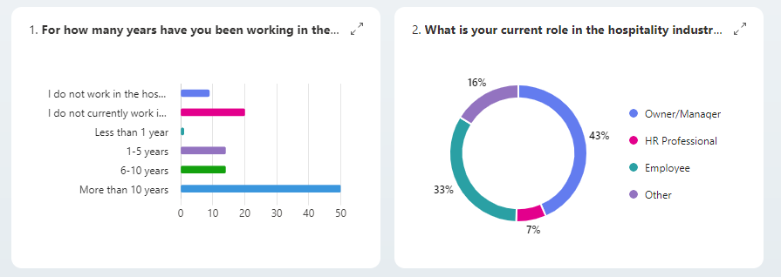

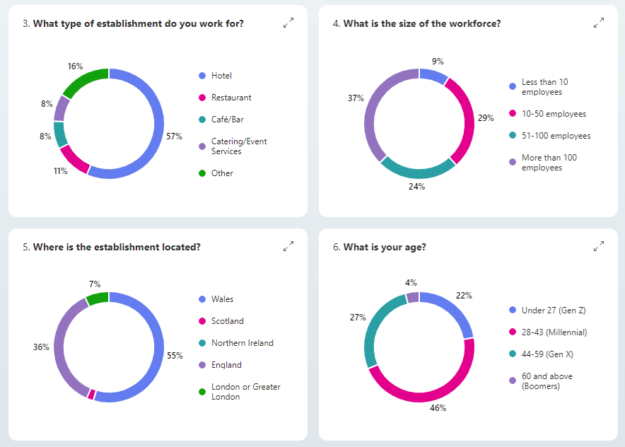

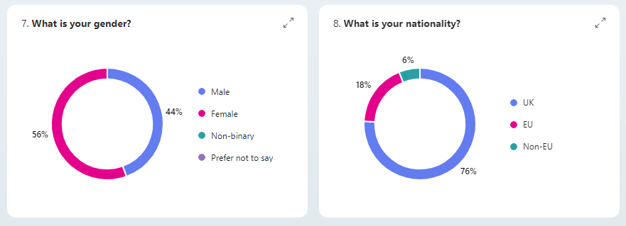
Figure 3 - Section 1 of survey: Demographic of respondents
Industry Experience
The largest group, 46%, have been working in the industry for more than 10 years, reflecting a high level of expertise among the participants. Those with 6-10 years of experience constitute 13% of the respondents, while another 13% have 1-5 years of experience in the industry. A small percentage, 1%, have been in the industry for less than a year, and 19% reported having worked in the industry within the past 5 years. As noted earlier, 9 respondents, representing 8%, who had not worked in the industry within the past 5 years, were excluded from completing the remainder of the survey.
Current Roles
A diverse array of roles within the hospitality industry is represented among the respondents. The largest group, 43%, are Owners or Managers, reflecting a strong presence of senior-level professionals. HR Professionals make up 7%, while employees at any other level account for 33% of respondents. The survey also includes respondents in other roles (16%), such as administrative positions. When combined with the broader employee category, this accounts for 49% of respondents.
Establishment Types
The respondents work across a variety of establishments, with 57% associated with hotels and 11% with restaurants. Catering and events services account for 8%, while cafes and bars also represent 8%. Additionally, 16% of respondents, likely those with experience in the past five years but not currently working in the industry, are involved in specialised settings such as universities, wine agencies, and the charity sector.
Workforce Size
The size of the workforce at these establishments varies, with 37% of respondents employed in organisations with more than 100 employees. Smaller establishments, with 51 to 100 employees, are represented by 24% of respondents, while 29% work in organisations with 10 to 50 employees. Additionally, 9% of respondents are employed in establishments with fewer than 10 employees.
Location
Geographically, 55% of respondents are based in Wales, followed by 43% in England, including those from the London area. A smaller percentage of respondents, 2%, are from Scotland, while Northern Ireland is not represented, with no respondents from that region.
Age and Gender Demographics
The age distribution shows that 46% of respondents fall within the 28-43 age group (Millennials), making it the largest demographic. The 44-59 age group (Gen X) represents 27% of respondents, while 22% are under 27 (Gen Z). A smaller portion, 4.0%, are aged 60 and above (Boomers). The gender demographics indicate a slight majority of female respondents, comprising 56%, while the remaining 44% are male.
Nationality of respondants
The nationality of respondents reveals a significant majority of UK nationals at 76%, with 18% representing the EU and 6% from non-EU countries.

The diverse demographics of the survey respondents provided a strong foundation for understanding various perspectives within the UK hospitality industry, particularly regarding Brexit's impact on talent management. Most respondents had over a decade of experience, suggesting that the insights gathered were based on substantial expertise, enhancing the credibility of the findings (Si, 2023). The inclusion of senior professionals like Owners and Managers, along with a broad range of roles, ensured that both strategic and operational viewpoints were captured. This diversity was essential for exploring how Brexit affected different facets of the industry, from leadership decisions to frontline challenges (Ziegenfuss et al., 2021).
The range of establishment types and workforce sizes among respondents highlighted the sector's complexity, enabling the identification of industry-specific challenges and opportunities. The regional focus, especially in Wales and England, underscored regional disparities in Brexit's impact, crucial for developing tailored strategies across the UK (Kaya et al., 2023). Additionally, the age, gender, and predominance of UK nationals provided context for interpreting results, as generational and national perspectives likely shaped attitudes towards Brexit and its effects (Hayes, 2024). Overall, the respondent demographics provided a well-rounded view of the UK hospitality industry's current state, with slightly higher representation from Wales compared to the rest of the UK. However, this slight overrepresentation is not expected to significantly impact the findings, ensuring the results still offer valuable insights for both academic analysis and practical application.

4.2 Post-Brexit workforce composition and recruitment challenges
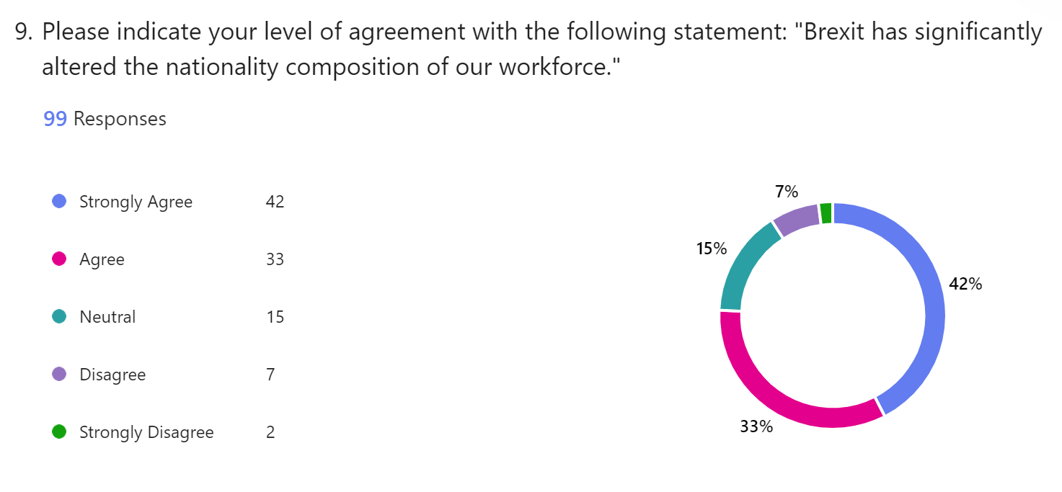
This section comprised six questions, with the first four asking respondents to indicate their level of agreement on a scale from "strongly agree" to "strongly disagree." The statements were: "Brexit has significantly altered the national composition of our workforce," "The diversity of our workforce has been negatively impacted by Brexit," "The number of UK applicants has increased since Brexit," and "Recruitment has become significantly more challenging since Brexit." Using statements allowed for a more nuanced understanding of respondents' views, aligning with the literature review, which highlighted these issues as key concerns within the industry. The final two questions were multiple-choice, asking respondents to identify "the most significant recruitment challenges" and "the hardest positions to fill post-Brexit."
Figure 4 – Section 2 of survey: Impact of Brexit on workforce composition
In response to the statement "Brexit has significantly altered the national composition of our workforce," 42% of respondents strongly agreed, and an additional 33% agreed, resulting in a total of 75% of respondents who concurred with this statement. Meanwhile, 15% of respondents remained neutral, 7% disagreed, and 2% strongly disagreed.
The strong agreement among respondents suggests that most have noticed a significant shift in their workforce composition post-Brexit, likely reflecting changes in the balance between UK nationals and workers from the EU and other regions. This indicates that Brexit has had a clear impact on workforce diversity within the hospitality sector. Such a shift could significantly affect operational dynamics, as workforce composition influences the availability of skills, cultural diversity, and adaptability. The small percentage of respondents who disagreed or remained neutral may reflect varying experiences across regions or differences in how Brexit has affected different types of establishments.
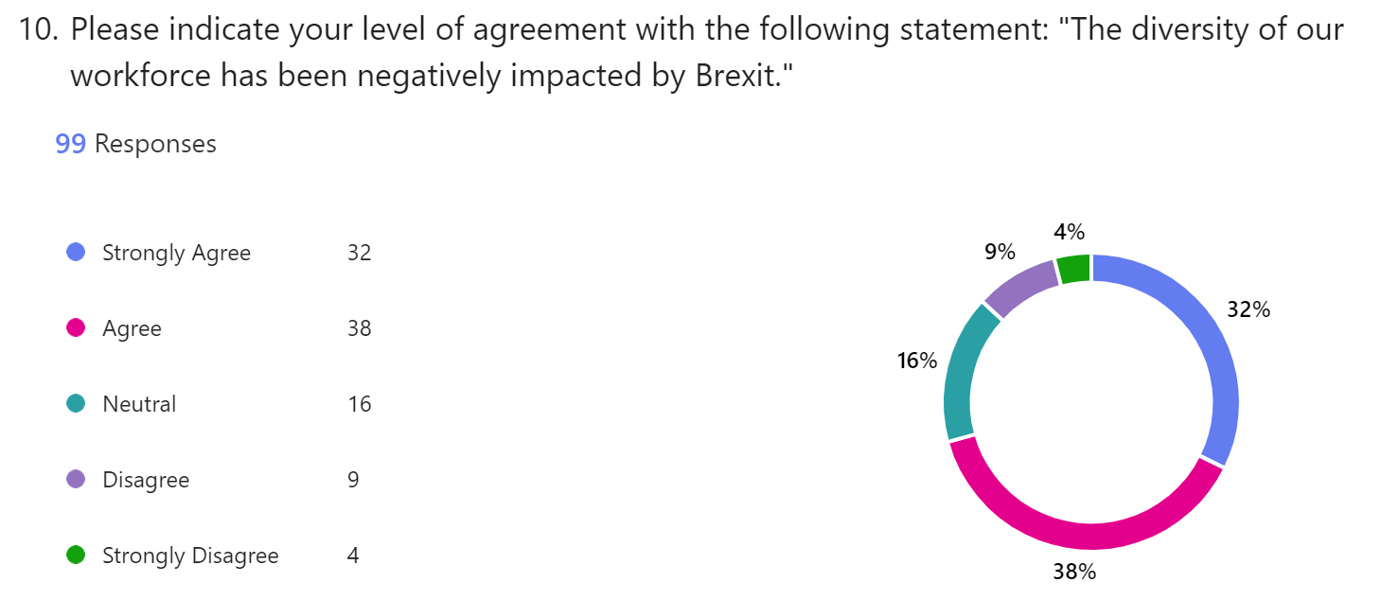
Figure 5 – Section 2 of survey: Impact of Brexit on workforce diversity
In response to the statement "The diversity of our workforce has been negatively impacted by Brexit," 32% of respondents strongly agreed, and an additional 38% agreed, resulting in a total of 70% of respondents expressing agreement with this sentiment. Meanwhile, 16% of respondents remained neutral, 9% disagreed, and 4% strongly disagreed.
The 70% agreement that workforce diversity has been negatively impacted by Brexit indicates significant challenges in maintaining a diverse workforce. This suggests difficulties in recruiting and retaining employees from various national backgrounds, particularly from the EU, which has historically provided much of the UK's hospitality workforce. Stricter immigration policies and reduced access to EU labour likely contribute to these issues. The fact that some respondents disagreed or remained neutral suggests that the impact may vary by region or context, with some establishments less affected or more able to mitigate these challenges. However, the overall trend indicates a reduced diversity, with potential implications for cultural dynamics, service quality, and operational flexibility.

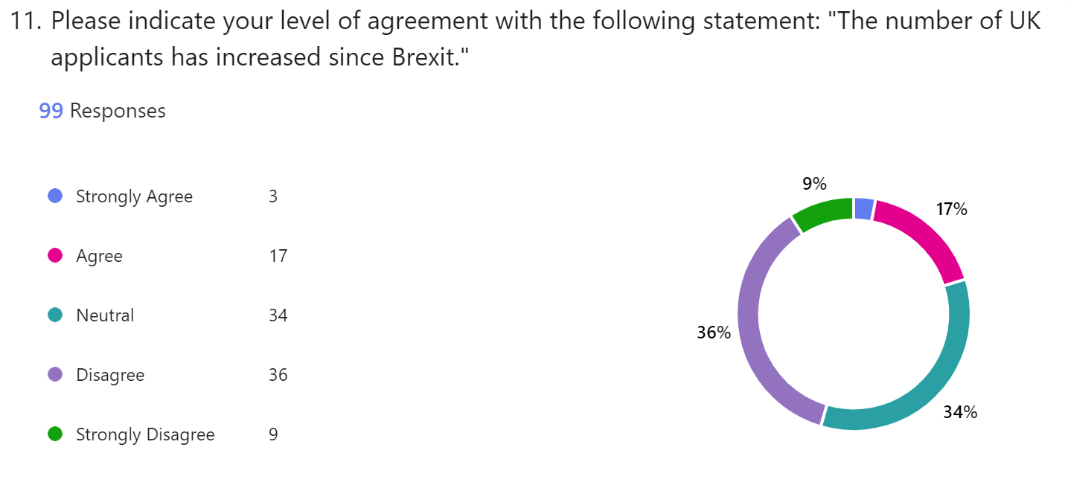
Figure 6 – Section 2 of survey: Change in number of UK applicants
In response to the statement "The number of UK applicants has increased since Brexit," 9% of respondents strongly disagreed, and another 36% disagreed, resulting in a total of 45% expressing disagreement. Additionally, 34% of respondents remained neutral, which could suggest that they either lack access to relevant data, are uncertain about the trend, or prefer not to make a judgment without further information. On the other hand, 17% agreed, and 3% strongly agreed, resulting in a total of 20% expressing agreement with the statement.
Further analysis shows that neutral responses were mainly from employees rather than managers or HR professionals, suggesting that their position may limit access to recruitment data or trends. In contrast, most managers and HR professionals, who likely have a clearer view of recruitment patterns, disagreed with the statement. This discrepancy highlights the importance of considering respondents' roles when interpreting survey data. The significant disagreement among managerial and HR respondents indicates ongoing challenges in attracting UK applicants post-Brexit, possibly due to factors like job insecurity, unattractive working conditions, or competition with other sectors.

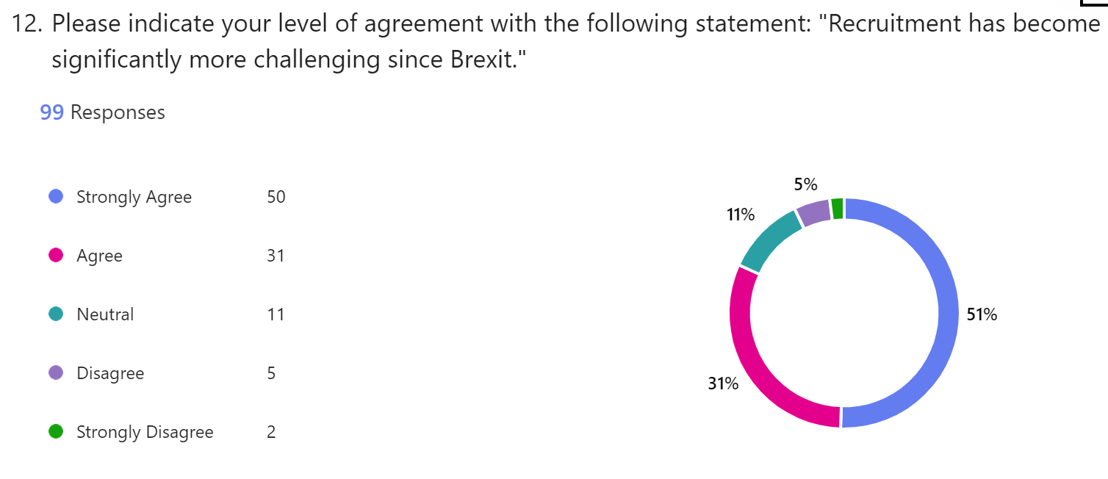
Figure 7 – Section 2 of survey: Impact of Brexit on recruitment challenges
In response to the statement "Recruitment has become significantly more challenging since Brexit," 51% of respondents strongly agreed, and 31% agreed, resulting in a high overall level of agreement at 81%. Meanwhile, 11% of respondents remained neutral, and only 7% expressed disagreement or strong disagreement.
The strong agreement suggests that most in the industry have faced significant recruitment difficulties since Brexit, reflecting reduced access to EU labour, stricter immigration policies, and increased competition for domestic talent. The few respondents who remained neutral or disagreed may represent contexts where recruitment challenges have been less severe, possibly due to location or effective mitigation strategies. The high level of agreement highlights the perception that Brexit has worsened recruitment issues, emphasising the need for innovative strategies to attract and retain talent in the evolving post-Brexit labour market.

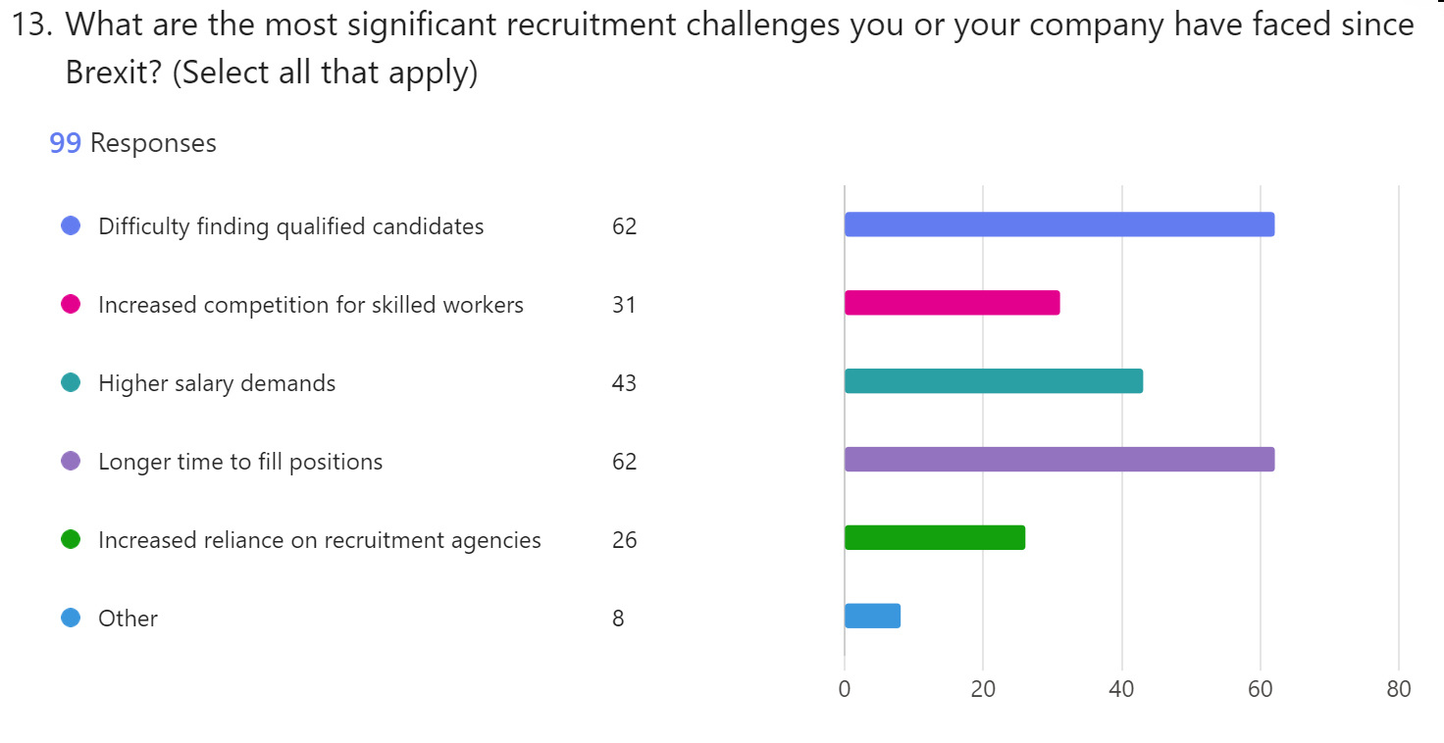
Figure 8 – Section 2 of survey: Key recruitment challenges
In response to the multiple-choice question, "What are the most significant recruitment challenges you or your company have faced since Brexit?" 62 respondents identified difficulty in finding qualified candidates, and an equal number cited a longer time to fill positions. The third most common challenge was higher salary demands, followed closely by increased competition for skilled workers. Notably, only 26 respondents mentioned an increased reliance on recruitment agencies. Additionally, 8 respondents selected "other" and highlighted challenges such as finding individuals who care about their work, a drop in overall recruitment numbers, difficulty attracting applicants interested in long-term careers, a lack of work ethic, and a lack of interest from UK applicants in filling junior positions.
This data shows that the main recruitment challenges since Brexit focus on candidate availability and quality, along with the time and costs required to fill positions. The frequent reports of difficulty in finding qualified candidates and extended hiring timelines highlight the strain Brexit has placed on the labour market, especially in sectors reliant on skilled workers. The reduced use of recruitment agencies may reflect companies' reluctance to incur additional costs, further complicating recruitment efforts.
Additional challenges, such as lack of interest from UK applicants and concerns about work ethic, point to deeper issues within the domestic labour pool, potentially worsened by Brexit. the findings suggest that the UK hospitality industry's recruitment landscape has become more complex, necessitating innovative approaches to attract and retain talent post-Brexit.
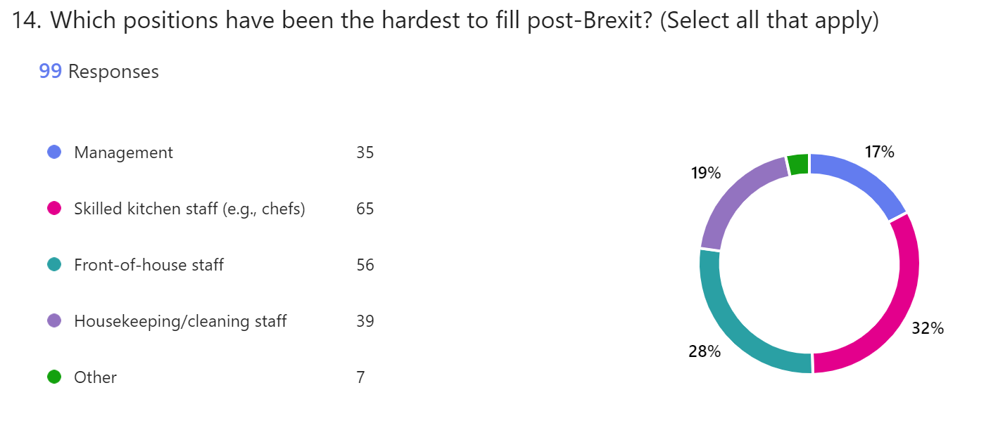
Figure 9 – Section 2 of survey: Post-Brexit: Most challenging positions to fill
In response to the question, "Which positions have been the hardest to fill post-Brexit?" 65 respondents identified skilled kitchen staff as the most challenging, followed by 56 respondents who indicated front of house staff. Housekeeping and back-of-house cleaning staff were selected by 39 respondents, while 35 pointed to management positions as the hardest to fill. Additionally, 7 respondents chose "other," highlighting difficulties in recruiting entry-level staff and night workers.
The difficulty in filling skilled kitchen and front-of-house roles highlights the severe talent shortage in critical areas of the hospitality industry. These positions are vital to daily operations, and the challenges in recruiting for them point to broader issues, such as skill shortages and the attractiveness of these roles to domestic workers, as well as challenges meeting the salary requirements for sponsoring EU workers. Recruitment difficulties for housekeeping and back-of-house staff further demonstrate that labour shortages affect various levels and functions across the sector. The struggle to fill management roles suggests that Brexit may also be limiting the availability of experienced leaders capable of handling the complexities of the current labour market. The inclusion of entry-level and night workers in the "other" category signals challenges even in positions requiring fewer specialised skills, showing a widespread problem in attracting workers across the board.
These findings indicate that the hospitality industry is grappling with recruitment challenges across a wide range of roles. Addressing these issues will likely require a mix of strategies, such as improved training and development programmes, enhanced recruitment practices, and reconsidering compensation and working conditions to attract a broader range of candidates.
4.3 Strategies to manage talent shortages
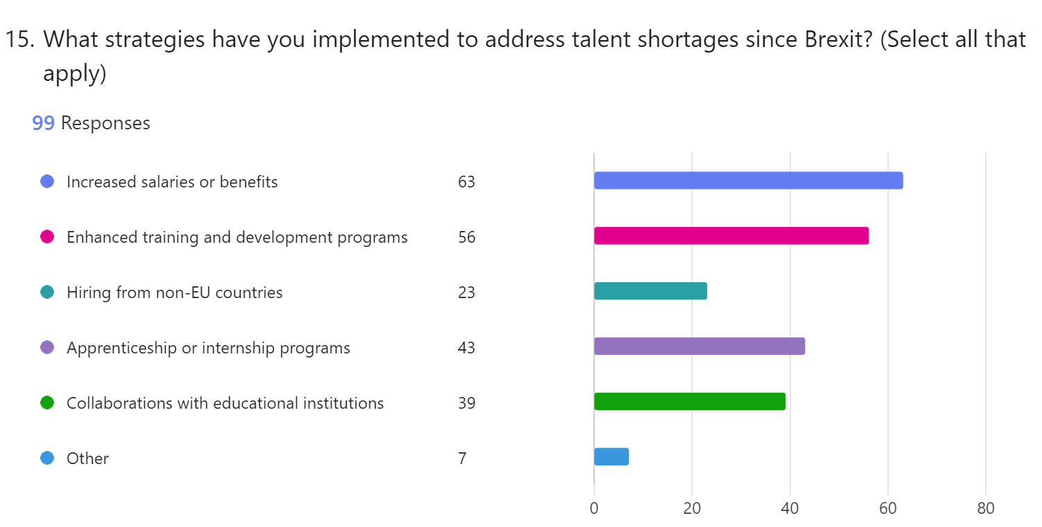
In this section, comprising three questions, respondents were asked to identify the strategies they have implemented to address talent shortages in their establishments since Brexit. Following this, they were required to express their level of agreement with two statements by selecting from options ranging from "strongly agree" to "strongly disagree." The statements included: "Our business has invested in technology or automation to offset workforce challenges" and "Targeting older workers can play a crucial role in addressing the labour gap in the hospitality industry."
Figure 10 – Section 3 of survey: Strategies implemented to address talent shortages
In response to the question "What strategies have you implemented to address talent shortages since Brexit?" 63 respondents indicated that they have increased salaries or benefits, while 56 respondents reported implementing enhanced training and development programmes. Additionally, 43 respondents selected the use of apprenticeship or internship programmes, and 39 mentioned collaborating with educational institutions. A smaller group, 23 respondents, highlighted hiring from non-European countries as a strategy. Among those who chose "other," seven respondents noted additional approaches, with three specifically mentioning closer collaboration with job centres, possibly indicating efforts to recruit more UK workers. Internal promotions were also mentioned as a strategy.
The range of strategies employed reflects a multi-faceted approach to addressing talent shortages worsened by Brexit. The focus on raising salaries and benefits shows that many businesses recognise the need for competitive compensation to attract and retain staff in a tighter labour market. Enhanced training and development programmes, along with apprenticeships and internships, demonstrate a long-term investment in building a skilled workforce from within, which is essential given the reduced availability of experienced EU workers.
Collaborations with educational institutions highlight efforts to create talent pipelines directly from the educational system, potentially bridging the gap between needed and available skills. Hiring from non-European countries shows a willingness to diversify the talent pool, though the lower uptake of this option suggests challenges related to immigration restrictions or complexities in international recruitment.
The focus on job centres and internal promotions signals a shift towards maximising domestic talent and leveraging existing resources. These strategies indicate that businesses are increasingly adopting a mix of short-term and long-term responses to the labour challenges posed by Brexit. The effectiveness of these approaches will likely vary by business context, but the overall trend suggests a proactive and adaptive response to the ongoing talent shortages in the UK hospitality industry.
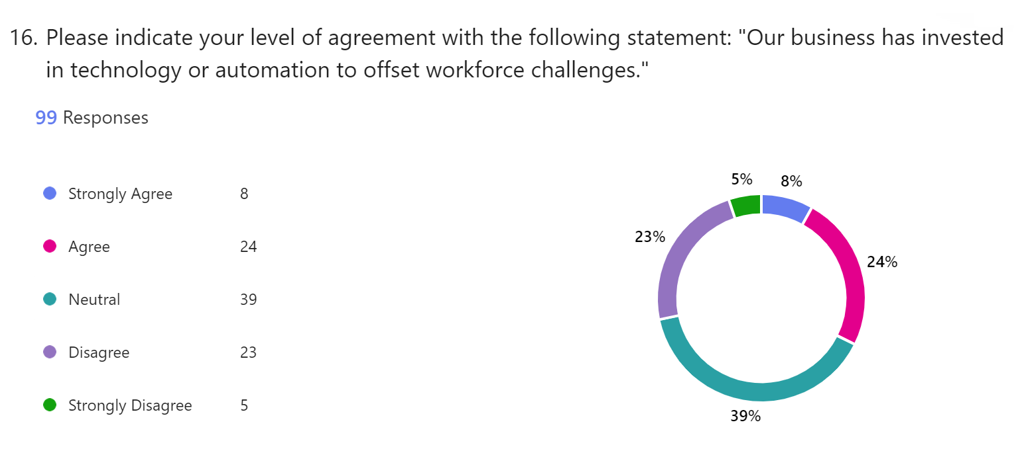
Figure 11 – Section 3 of survey: Technology investment to mitigate workforce challenges
In response to the statement "Our business has invested in technology or automation to offset workforce challenges", the majority of respondents selected a neutral stance, with 39%. Meanwhile, 32% either agreed or strongly agreed, and 28% either disagreed or strongly disagreed.
The balanced distribution of responses suggests that while some businesses have invested in technology or automation, these investments may not primarily target workforce challenges. This neutrality could indicate mixed experiences regarding their effectiveness in mitigating labour shortages. Additionally, the significant portion of respondents who disagreed or remained neutral highlights the reality that many hospitality roles, particularly customer-facing ones, cannot be fully replaced by technology. The varied responses suggest that the impact of technology and automation differs across businesses and roles, making these solutions more applicable in some areas than others.

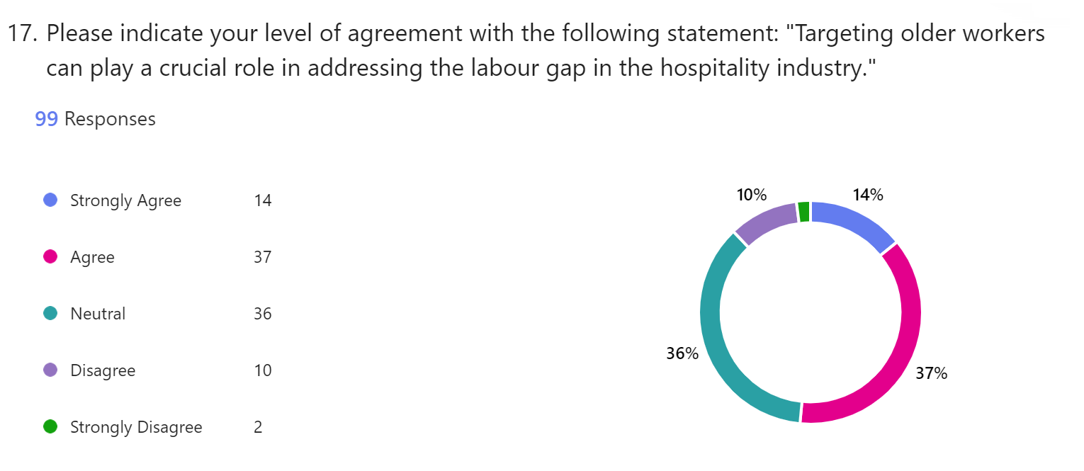
Figure 12 – Section 3 of survey: Role of targeting older workers
In response to the statement "Targeting older workers can play a crucial role in addressing the labour gap in the hospitality industry," 37% of respondents agreed, and an additional 14% strongly agreed, bringing the overall agreement to a majority of 51%. Meanwhile, 36% of respondents remained neutral, and 12% either disagreed or strongly disagreed with the statement.
The overall agreement indicates that many respondents see the potential value in targeting older workers to address labour shortages in the hospitality industry. The neutral responses, which account for over a third, may reflect uncertainty or limited experience with this strategy, possibly due to the industry's traditionally younger workforce, as highlighted in the literature. The relatively low disagreement rate suggests that integrating older workers is generally viewed positively, even if not universally accepted.
With the industry typically relying on a younger workforce (68% of survey respondents were under 43 years old) targeting older generations, such as Gen X and Boomers, could help bridge the skills gap. Older workers could bring valuable experience, reliability, and a strong work ethic, which are especially beneficial in customer service, management, and specialised roles. However, the neutral and negative responses imply challenges, such as the need for tailored training or addressing the physical demands of certain positions. Overall, the data suggests support for this strategy, but its success will depend on how well the industry adapts recruitment and retention efforts to the strengths and needs of an older workforce.
4.4 Long term implications
In this section, consisting of three questions, respondents were asked to provide their perspectives on the anticipated long-term impact of Brexit on the talent pipeline within the hospitality industry. Following this, they were invited to elaborate on their views through an open-text response. The final question was also open-ended, inviting respondents to share any additional comments or insights regarding the broader impact of Brexit on the hospitality sector.
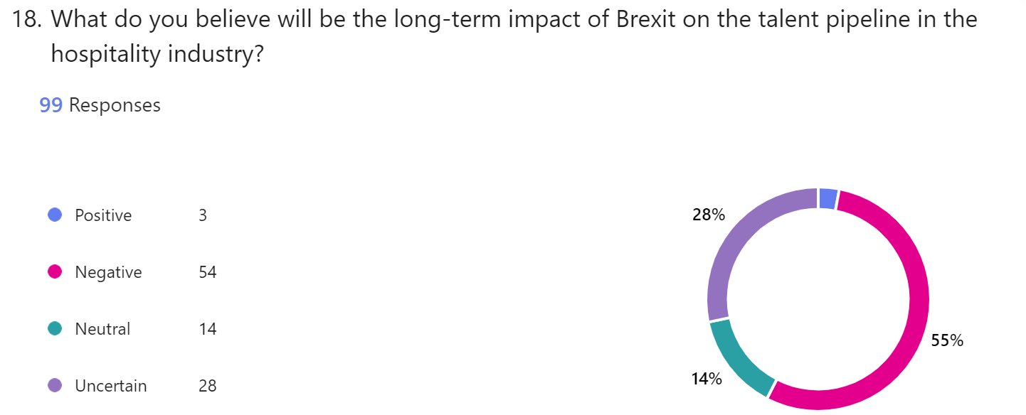
This section focused on the beliefs and opinions of individuals within the hospitality industry, drawing on their knowledge and experiences. While these perspectives were not grounded in empirical data, they provided valuable qualitative insights into the sentiments and perceptions prevalent within the industry. These viewpoints were crucial for understanding the industry's internal narrative regarding Brexit's impact and informed the recommendations presented in this thesis.

Figure 13 – Section 4 of survey: Perceived long-term impact of Brexit on talent pipeline
For the question "What do you believe will be the long-term impact of Brexit on the talent pipeline in the hospitality industry?" respondents were asked to select from the following options: positive, negative, neutral, or uncertain. A significant majority (55%) believed the long-term impact would be negative, while only 3% viewed it as positive. Additionally, 14% of respondents selected neutral, and 28% were uncertain about the future impact.
The overwhelming expectation of a negative impact reflects deep concerns within the industry about the future availability and quality of talent. The low percentage of positive responses suggests that few see potential benefits in the post-Brexit labour market, likely due to the challenges already faced in recruitment and retention. The substantial proportion of respondents who were uncertain underscores the unpredictability and ongoing uncertainty surrounding Brexit's long-term effects, which could further complicate strategic planning and decision-making for businesses in the hospitality sector. This distribution of responses highlights the need for proactive and adaptive strategies to mitigate potential risks and to navigate the evolving labour landscape in a post-Brexit environment.
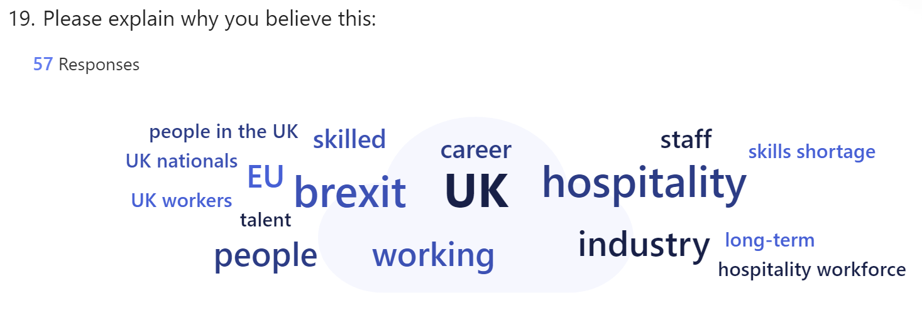

Figure 14 – Section 4 of survey: Expanded views on long-term impact
In response to the question regarding the long-term impact of Brexit on the talent pipeline in the hospitality industry, respondents were invited to elaborate on their views. A total of 57 respondents provided comments for this follow-up question, titled "Please explain why you believe this." These responses offered a wide range of insights, reflecting deep concerns about the future of the industry.
A recurring theme in the comments was the significant reliance on EU workers before Brexit, which has now led to substantial challenges in recruitment and workforce sustainability. Many respondents highlighted the increasing difficulty in attracting UK nationals to the industry, often due to the perception that hospitality is not a viable or attractive career option for British workers.
For instance, Respondent 1 noted, "Hiring from across the EU enabled hospitality to fill the existing skills shortage in the UK. UK youth tend to not want to be working in hospitality for a variety of reasons, which could include: as it is seen as being an unattractive industry to be in." This sentiment reflects a broader concern that the UK labour force lacks the interest or motivation to fill the gaps left by departing EU workers, a view supported by Respondent 9, who stated, "Hospitality is not seen as a career by British people. Shortage of staff is not a result of a shortage of workforce but of a shortage of people who are ready to commit to unsocial hours/minimum wage."
The impact of Brexit on the cost and complexity of recruitment was another critical issue raised by respondents. Many highlighted the increased operational costs associated with hiring from outside the EU due to visa requirements and the need to offer higher salaries to attract a shrinking pool of qualified candidates. As Respondent 5 observed, "The impact on limited applicants has resulted in an increase in skilled visa costs to hire outside the EU, further challenged by high salary requirements to obtain a visa." This sentiment was echoed by Respondent 30, who mentioned, "It gets worse and worse every month that we do not have qualified people. Staff turnover gets more and more, hospitality will struggle more in the near future as hospitality is not allowed to get people from non-EU countries under the skilled scheme."
The loss of skilled and experienced workers from the EU was frequently mentioned as a critical concern, with respondents fearing that this would lead to a decline in industry standards. Respondent 16 noted, "Brexit has meant a decrease in talent from the EU. The UK industry relied on this high-quality talent to not only run the industry but to teach and offer insight to UK nationals to increase their skills." Similarly, Respondent 4 stated, "Brexit's long-term impact on the hospitality industry's talent pipeline will likely result in significant labour shortages and increased operational costs due to reduced access to EU workers."
The overall decline in the attractiveness of the UK as a destination for skilled workers was another concern. Respondent 19 reflected on this shift by saying, "Before Brexit, I think the UK was seen as a land of opportunity—and would attract/keep talented individuals. I don’t feel that way post-Brexit." This view is indicative of a broader sentiment that the UK's hospitality industry may struggle to maintain its competitive edge in attracting global talent.
Lastly, the potential long-term consequences for the industry were starkly highlighted by Respondent 55, who warned, "There will not be the significant number of applicants to choose from as there once was, and UK youngsters do not regard hospitality as a career but only a stop gap to earn some money whilst they decide what career to pursue. Therefore, there will probably continue to be a significant decline in applicants, and the industry will struggle to operate on greatly reduced staffing levels to the detriment of the industry and the standard of service offered."
Overall, the responses underscore a deep concern that Brexit has not only reduced the availability of skilled labour but has also made it more challenging to maintain service standards and operational efficiency. Many participants expressed fears that the long-term effects of these changes could lead to a decline in the industry's overall quality and competitiveness. The insights provided suggest that without significant policy interventions or innovative strategies to attract and retain talent, the hospitality sector may continue to face severe challenges in the post-Brexit landscape.
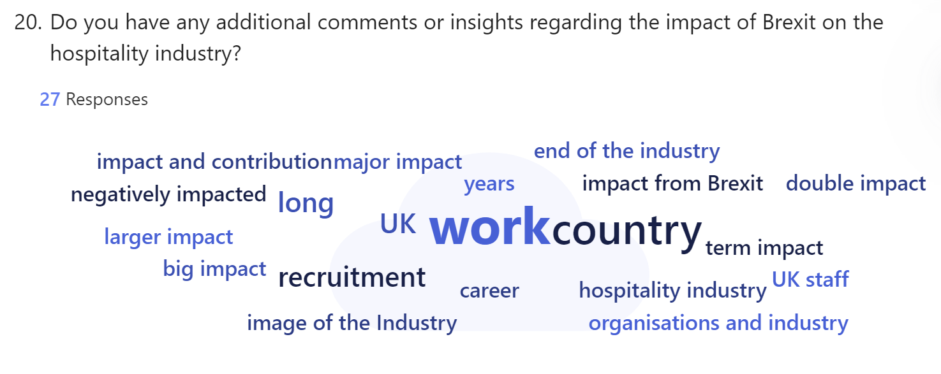
Figure 15 – Section 4 of survey: Additional comments and insights on Brexit's impact
In response to the question, "Do you have any additional comments or insights regarding the impact of Brexit on the Hospitality industry?" respondents expressed a wide range of concerns, with the overarching sentiment being predominantly negative. Many respondents highlighted the diminished attractiveness of the UK as a destination for work, particularly for young people from Europe. Respondent 1 remarked, "The UK was seen as a destination for many young people across Europe to learn English and also gain skills from a variety of international cultures. Brexit I believe is detrimental to UK staff as they are not exposed as much to international colleagues, who have differing experiences, knowledge and a different culture."
Others pointed to the broader economic challenges exacerbated by Brexit, particularly in terms of recruitment and operational costs. Respondent 2 noted, "Hospitality employees are underpaid and undervalued in Britain generally. The workforce needed from the EU will not come here due to all the red tape and poor wages." This sentiment was echoed by Respondent 8, who stated, "Brexit has made the UK an unattractive and unapproachable place to work, both because of the bureaucracy one needs to get through in order to get to the country legally and the decreased value of the pound."
Several respondents also emphasised the compounded difficulties caused by Brexit, particularly when coupled with the impact of the COVID-19 pandemic. Respondent 7 highlighted this dual challenge: "BREXIT followed by the pandemic has hit the industry hard in many ways, not just recruitment but service and guest experience. With BREXIT being completed during the pandemic, it has created a double impact and contribution to the shifts in the workforce and current skill shortages."
Moreover, some respondents called for significant changes within the industry and government policy to address these challenges. Respondent 11 commented, "There needs to be wholesale change in all these factors to enable the sector to grow sustainably. Costs (Rent, rates, VAT, taxation), wages, suppliers, and an attitude shift that enables a career in hospitality to be an attractive career, not something you do before getting a 'proper' job."
Overall, the responses paint a picture of an industry struggling to adapt to the post-Brexit environment, with concerns about the long-term sustainability of the workforce, the quality of service, and the economic viability of hospitality businesses in the UK.

4.5 Synthesis
The empirical findings from the survey responses closely align with concerns highlighted in the literature regarding post-Brexit challenges in the UK hospitality industry. The survey data showed that 75% of respondents acknowledged Brexit had significantly changed their workforce composition, reflecting the hospitality sector’s pre-Brexit reliance on EU nationals and the challenges arising from the end of free movement (Portes and Springford, 2023; Barnes, 2023). The reduction in EU workers not only impacted labour availability but also workforce diversity, as 70% of respondents noted a negative impact on diversity.
Literature corroborated these findings, emphasising how post-Brexit immigration policies limited access to EU labour, causing recruitment challenges. Portes and Springford (2023) highlighted that non-EU workers could not fully replace the shortfall of EU workers. Survey results supported this, with 81% agreeing recruitment had become more difficult since Brexit due to heightened competition and rising operational costs (George, Limmer, and Halvorsrud, 2020; Kaya et al., 2023). Both sources underscored the sector’s vulnerability in filling roles like skilled kitchen staff, front-of-house, and housekeeping (BHA, 2017; Portes and Springford, 2023).
The survey showed that technological investments had not alleviated workforce challenges significantly, as many respondents expressed uncertainty or disagreement, echoing the literature’s stance that technology could not replace human interaction in hospitality (Clarke, Serwicka, and Winters, 2021). The need for targeted human capital strategies remained evident.
Both the survey and literature highlighted recruitment difficulties and the importance of maintaining diversity in the workforce. They also pointed to the limited effectiveness of technological solutions. To sustain growth, the industry requires a multi-faceted approach, including more inclusive immigration policies, workforce training, and innovative recruitment strategies.
Survey responses about strategies to address talent shortages, such as increasing salaries, aligned with literature findings on the importance of competitive compensation post-Brexit (Portes and Springford, 2023; CIPD, 2023a). Enhanced training programmes and partnerships with educational institutions, cited by respondents, were also recommended in the literature for upskilling domestic workers (Rolfe, 2017; Jones and Brown, 2023). Despite these efforts, hiring from non-European countries remained challenging due to visa restrictions and salary thresholds, as only 23 respondents reported using this strategy (Portes and Springford, 2023).
Targeting older workers, supported by 51% of respondents, aligned with literature advocating for broadening the talent pool to include underrepresented demographics (UKHospitality, 2022). However, mixed responses indicated challenges such as training needs and the physical demands of certain roles (Centre for Ageing Better, 2021).
Overall, both the empirical findings and the literature suggest a comprehensive approach is needed to manage talent shortages, with a focus on higher wages, training, and tapping into older worker demographics. Immigration policies and the limitations of technological solutions remain key barriers. Further policy reforms and workforce development are necessary to fully address post-Brexit labour shortages (Portes and Springford, 2023).
The long-term impact of Brexit on the hospitality industry’s talent pipeline, cited by 55% of respondents as negative, echoed the literature’s prediction of severe labour shortfalls by 2029 (UKHospitality, 2023; Barnes, 2023). Both sources pointed to difficulties in attracting UK workers, compounded by low wages and tough working conditions (Jones & Brown, 2023). Economic impacts, including increased recruitment costs and visa challenges, were also highlighted by both respondents and literature.
Brexit and the COVID-19 pandemic have compounded these challenges, exacerbating labour shortages and operational difficulties. While digitalisation and automation offer partial solutions, they are insufficient to resolve the sector’s skills gap (Busulwa et al., 2021). Both the survey and literature concluded that without innovative strategies like workforce development and targeted immigration reforms, the long-term impact of Brexit on the hospitality industry will likely remain negative, threatening its sustainability

5. Summary of Findings and Conclusions
The overall aim of this research was to examine the impact of Brexit on talent management within the UK hospitality industry. Specifically, the study sought to identify and evaluate the strategies businesses have implemented to mitigate talent shortages, assess the long-term implications of Brexit on the talent pipeline, and understand the recruitment challenges that have emerged since the UK's withdrawal from the European Union.
Objective 1: To Analyse Changes in Workforce Composition Pre- and Post-Brexit
The empirical findings from the survey confirmed that Brexit has significantly altered the composition of the hospitality workforce. A substantial proportion of respondents (75%) noted changes in the national makeup of their staff, reflecting the sector's historical reliance on EU nationals. The post-Brexit end of free movement has made it challenging for businesses to replace these workers, leading to labour shortages and operational difficulties, particularly in low-skilled roles such as housekeeping and kitchen staff .
The literature reviewed supports this finding, with Portes and Springford (2023) emphasising that EU nationals comprised a substantial portion of the hospitality workforce pre-Brexit. Following Brexit restrictions on immigration have exacerbated the issue, reducing workforce diversity and limiting access to skilled labour. The sector has struggled to attract UK workers, and the recruitment of non-EU workers has not fully offset this shortfall (Barnes, 2023).
Brexit has significantly disrupted the workforce composition of the hospitality sector, particularly affecting roles traditionally filled by EU nationals. This has led to severe talent shortages, and the recruitment of non-EU workers has proven to be an insufficient solution.
Objective 2: To Identify the Key Recruitment Challenges Faced by Hospitality Businesses Since Brexit
Recruitment challenges emerged as a predominant theme in the survey. A total of 81% of respondents stated that recruitment has become increasingly difficult since Brexit. Difficulty in finding qualified candidates, longer time to fill positions, and increased competition for a shrinking talent pool were among the most significant issues identified. Additionally, respondents noted that the increased costs associated with visa applications and offering competitive salaries have placed further strain on businesses.
The literature corroborates these findings, with sources such as George, Limmer, and Halvorsrud (2020) explaining that Brexit has led to a labour shortfall that has not been fully mitigated by the influx of non-EU workers. Kaya et al. (2023) also highlight the growing competition for skilled workers and the financial burden on businesses in an already stretched market.
Recruitment challenges have intensified post-Brexit, with businesses facing increased competition for a reduced pool of skilled workers. This has led to longer hiring times, greater financial strain, and a struggle to maintain service standards.
Objective 3: To Evaluate the Strategies Employed by Hospitality Businesses to Mitigate Talent Shortages
The empirical data revealed that businesses are implementing a range of strategies to address talent shortages. The most frequently cited approaches include increasing salaries and benefits (63 respondents), investing in training and development (56 respondents), and collaborating with educational institutions to develop talent pipelines (39 respondents). A smaller proportion (23 respondents) reported hiring from non-European countries, although this strategy was hindered by visa challenges.
The literature supports these findings, highlighting that businesses must offer competitive compensation packages to attract workers in a shrinking labour market (Portes and Springford, 2023). Additionally, training and upskilling domestic workers have been identified as long-term solutions to mitigate skill gaps caused by the departure of EU workers (Rolfe, 2017).
Businesses are adopting a multi-faceted approach to managing talent shortages, including salary increases, enhanced training programmes, and collaborations with educational institutions. However, immigration restrictions and visa costs continue to present significant barriers to hiring from non-European countries.
Objective 4: To Assess the Long-Term Impact of Brexit on the Hospitality Industry's Talent Pipeline
Survey responses suggest that the long-term impact of Brexit on the talent pipeline is expected to be overwhelmingly negative, with 55% of respondents predicting adverse consequences for the availability and quality of labour. Only 3% of respondents viewed the long-term impact positively, while the remainder expressed uncertainty.
The literature echoes these concerns, predicting a shortfall of over 600,000 workers by 2029 (BHA, 2017). The reliance on EU nationals for both skilled and unskilled roles has left significant gaps that UK workers are reluctant to fill, particularly due to low wages and challenging working conditions (Barnes, 2023).
The long-term implications of Brexit on the hospitality industry’s talent pipeline are predominantly negative, with businesses anticipating severe labour shortages that could hinder their ability to operate efficiently and maintain service standards.

The findings of this research clearly illustrate the profound impact of Brexit on the UK hospitality industry's talent management practices. The sector has been forced to navigate a drastically altered labour landscape, with significant recruitment challenges and a disrupted workforce composition. Businesses have responded by adopting various strategies to mitigate talent shortages, but the effectiveness of these measures is constrained by ongoing immigration barriers, increased operational costs, and a reduced talent pool. The long-term outlook remains uncertain, with the majority of businesses predicting continued labour shortages and difficulties in maintaining service standards without significant policy changes and industry adaptations.
To ensure the sustainability of the hospitality sector in a post-Brexit environment, a combination of strategic human resource management, immigration policy reform, and investment in workforce development will be essential. Recommendations will be highlighted in the following section.

6. Recommendations and limitations
Based on the findings and conclusions drawn from this research, several recommendations are made to help the UK hospitality industry address the challenges posed by Brexit, particularly in talent management and workforce sustainability. These recommendations include both short-term and long-term strategies, with specific advice on their implementation.
Enhance Employee Compensation and Benefits
To tackle recruitment challenges and improve staff retention, hospitality businesses should enhance their compensation packages, offering competitive salaries and benefits to attract both domestic and international talent. Business owners, HR departments, and industry leaders should take the lead in implementing this strategy, recognising the importance of offering more competitive wages in light of Brexit. With fewer workers available due to the loss of EU staff, the sector must become more appealing to the smaller domestic workforce. This strategy should be implemented immediately to alleviate the current recruitment crisis and prevent further labour shortages. It should be applied across all levels of hospitality, focusing on the roles hardest to fill, such as skilled kitchen staff and housekeeping. A benchmarking exercise should be used to set competitive salary levels, along with bonuses, healthcare benefits, and flexible working arrangements to improve job satisfaction and employee retention.
Invest in Training and Development Programmes
Hospitality businesses should invest in comprehensive training and development programmes to upskill existing staff and prepare domestic workers to fill vacancies left by EU nationals. Business owners, HR departments, and training managers should oversee these initiatives, supported by industry bodies and educational institutions. Upskilling is essential to closing the skills gap created by Brexit and reducing dependency on external recruitment. While this is a long-term strategy, investment over the next two to three years will help address both immediate and future workforce needs. These programmes should focus on specific business needs and industry gaps, particularly at entry and mid-level management. Partnerships with local colleges and vocational institutions can help develop tailored training schemes, while apprenticeships and internships can provide practical experience for new entrants to the workforce.
Promote Hospitality as a Long-Term Career Option
The hospitality industry needs to enhance its public image by promoting itself as a viable and fulfilling long-term career option, particularly for UK residents. Industry bodies, marketing teams, and HR departments, in collaboration with educational institutions, should lead this effort. Changing the perception of hospitality as a low-skilled, temporary job is essential to attracting domestic workers who may otherwise avoid the industry due to its perceived lack of career progression. This strategy should be implemented over the next six to twelve months to address recruitment challenges in the medium term. Efforts should focus on schools, colleges, and career fairs, as well as online recruitment platforms. Campaigns showcasing success stories and potential career paths should be launched, while hospitality-focused workshops and apprenticeships can raise awareness of the opportunities available within the sector.
Lobby for Immigration Policy Reforms
The hospitality industry must advocate for immigration policy reforms to allow greater access to EU and non-EU workers, particularly for roles where domestic recruitment has proven difficult. Industry bodies such as UKHospitality and the British Hospitality Association, in collaboration with business owners and policymakers, should lead lobbying efforts to push for more flexible immigration policies. The post-Brexit immigration system has made it challenging to recruit EU non-EU workers for lower-skilled positions, so policy changes are necessary to ensure businesses can access a broader pool of international talent. Lobbying efforts should begin immediately, with the goal of influencing policy changes over the next twelve to eighteen months. Efforts should target government departments, particularly the Home Office, with proposals highlighting the economic contributions of the hospitality sector and the need for a more adaptable immigration system.
Engage Older Workers as Part of a Diversified Workforce Strategy
Targeting older workers, such as Gen X and Boomers, as part of a broader workforce strategy can help address talent shortages in the hospitality sector. HR departments and recruitment teams should focus on engaging this demographic through tailored recruitment campaigns and job offers. Older workers bring valuable experience, reliability, and a strong work ethic, which are particularly useful in customer service and management roles. Immediate implementation is recommended, with sustained efforts to build a more balanced and diverse workforce over the long term. Recruitment campaigns should target both urban and rural areas and focus on sectors experiencing the most severe labour shortages. Businesses should work with job centres and community organisations to recruit older workers, offering flexible working hours and retraining programmes that accommodate their skills and capabilities.
By following these recommendations, the UK hospitality industry could better navigate the ongoing challenges posed by Brexit and ensure workforce sustainability. The industry must adopt a comprehensive approach, combining competitive compensation, enhanced training, strategic recruitment, and targeted lobbying for immigration reforms. Diversifying the workforce by including older workers will further mitigate the impact of Brexit. These actions will not only address immediate labour shortages but also lay the foundation for long-term growth and stability in the UK hospitality sector.

Limitations
While the recommendations presented offer a multi-faceted approach to addressing the talent shortages caused by Brexit, several limitations must be acknowledged. First, the suggestion to increase salaries and benefits may not be feasible for all businesses, particularly smaller hospitality operations with limited financial resources. Many businesses, particularly those already struggling with the rising costs of goods and services post-Brexit, may find it difficult to offer competitive wages without significantly impacting their profit margins. This could make the implementation of enhanced compensation packages challenging for a portion of the industry, potentially exacerbating existing inequalities between larger and smaller enterprises.
Furthermore, the investment in training and development programmes, while beneficial in the long term, requires both time and financial commitment. Businesses may face immediate staffing shortages that make it difficult to allocate resources for training, especially in high-turnover roles. Additionally, it can take months or even years for the benefits of training programmes to materialise, meaning that such initiatives may not provide an immediate solution to current labour shortages.
The recommendation to target older workers also comes with challenges. While older workers can offer valuable experience and a strong work ethic, physical demands in some hospitality roles may limit their capacity to perform certain tasks. This strategy requires careful consideration of how to adapt roles and working conditions to suit an older workforce, which may incur additional costs and require changes to existing workplace infrastructure. Furthermore, attracting older workers may require specific recruitment campaigns and flexible working options that may not be practical for all businesses, particularly in smaller establishments with limited flexibility in shift patterns.
Lastly, lobbying for immigration policy reforms, while crucial, is beyond the direct control of individual businesses and depends on broader political and governmental shifts. The hospitality sector’s ability to influence such policy changes may be limited, and there is no guarantee that any lobbying efforts will result in meaningful reforms. Even if immigration policies were to change, the process would likely be slow, meaning businesses would need to continue managing labour shortages in the meantime.
In conclusion, while these recommendations offer potential solutions to the challenges posed by Brexit, they are not without limitations. Financial constraints, time lags in the effectiveness of training, the suitability of certain roles for older workers, and the uncertainty of political influence all present significant challenges that the industry will need to navigate carefully.

Reference List

Accor (2023) Hospitality ahead – Transforming how we welcome, engage and manage. London: Accor Group.
Athow, D. (2023) Microsoft Forms review: Tech Radar. Available at : https://www.techradar.com/pro/microsoft-forms (Accessed: 05 August 2024).
Balata, F., Chapman, A., Yunda, P. and Diski, R. (2023) Skills for a new economy: Investing in workers and closing the green skills gap. London: New Economics Foundation.
Baldwin, R.E. and Venables, A.J. (2020) Brexit: What Next? London: Oxford University Press.
Barnes, O. (2023) UK hospitality industry loses nearly 200,000 overseas workers. Available at: https://www.ft.com/content/027ea2e9-d6c3-4a18-a735-87f92ace95a4 (Accessed: 10 July 2024)
Baum, T. (2002) ‘Skills and training for the hospitality sector: a review of issues’, Journal of Vocational Education and Training. Available at: https://doi.org/10.1080/13636820200200204
Becker, G.S. (1994) Human Capital: A Theoretical and Empirical Analysis, with Special Reference to Education. 3rd edn. Chicago: University of Chicago Press.
Blau, P. (1964) Exchange and Power in Social Life. New York: Wiley.
British Beer and Pub Association (BBPA) (2024) Guidance For Recruiting Older Workers. Available at: https://beerandpub.com/ (Accessed: 19 July 2024)
British Hospitality Association (BHA) (2017) Labour migration in the hospitality sector. British Hospitality Association, prepared by KPMG. Available at: https://gla.moderngov.co.uk/documents/s67080/BHA (Accessed: 12 July 2024).
Brown P. (2024) Older workers can solve the hospitality sector’s employment crisis. Available at: https://modernhospitality.co.uk/older-workers-can-in-hospitality/ (Accessed: 10 July 2024)
Bryman, A., Bell, E., Reck, J. and Fields J. (2021) Social Research Methods. Oxford: Oxford University Press
Busulwa, R., Evans, N., Oh, A., and Kang, M. (2021) ‘Hospitality management and digital transformation’, Hospitality management and digital transformation. Available at: https://doi. org/10, 4324, 9780429325205
Centre for Ageing Better (2021) Good Recruitment for Older Workers (GROW). Available at: https://ageing-better.org.uk/ (Accessed: 19 July 2024)
Chapman, A., Kumar, C. and Yunda, P. (2024) Solving the UK’s skills shortage – How a national Skilling wage would future-proof our economy. London: New Economics Foundation
Chartered Institute of Personnel and Development (CIPD) (2021) Addressing Skills and Labour Shortages Post-Brexit: A Look at the UK’s Hospitality Sector. Available at: https://www.cipd.co.uk/knowledge/work/trends/skills-labour-shortages (Accessed: 10 July 2024)
Chartered Institute of Personnel and Development (CIPD) (2023a) Employment law: UK, EU and Brexit. Available at : https://www.cipd.org/uk/knowledge/factsheets/eu-impact-factsheet (Accessed: 10 July 2024)
Chartered Institute of Personnel and Development (CIPD) (2023b) Migrant workers and skills shortages in the UK: Role of immigration in tackling post-Brexit skills challenges. London: CIPD
Chartered Institute of Personnel and Development (CIPD) (2023c) Why staff turnover matters. Available at: https://community.cipd.co.uk/cipd-blogs/b/cipd_voice_on/posts/why-staff-turnover-data-matters (Accessed: 18 July 2024)
Clarke, G., Serwicka, I. and Winters, L. A. (2021) ‘The Impact of Brexit on the UK's Services Trade’, National Institute Economic Review, 242, pp 47-57.
Collis, J. and Hussey, R. (2021) Business research: A practical guide for students. 5th edn. London: Bloomsbury Publishing.
Creswell, J. W. and Guetterman T.C. (2024) Educational Research: Planning, Conducting, and Evaluating Quantitative and Qualitative Research. 7th edn. Upper Saddle River: Pearson.
Davies, G. (2021) Addressing skills and labour shortages post-Brexit. London: Chartered Institute of Personnel and Development.
Dillman, D. A., Smyth, J. D. and Christian, L. M. (2014) Internet, Phone, Mail and Mixed-Mode Surveys: The Tailored Design Method, 4th edn. New York: Wiley
Dyball, K. (2023) Hospitality is now the workplace of choice for over 50s with more than 165K joining the sector in 3 years Available at: https://www.caterer.com/recruiter-advice/hospitality-is-now-the-workplace-of-choice-for-over-50s-with-more-than-165k-joining-the-sector-in-3-years (Accessed: 19 July 2024)
European Commission (2023) Annual report on intra-EU labour mobility 2023 published - Employment, Social Affairs & Inclusion - European Commission. Available at: https://ec.europa.eu/social/main.jsp?langId=en&catId=559&furtherNews=yes&newsId=10788 (Accessed: 11 July 2024)
Ferdiana, S., Khoirunnisa, R., Khan, Z. and Ray, S. (2023) ‘Investigating the Impact of Career Development, Organizational Commitment, and Organizational Support on Employee Retention.’ Journal of Management Studies and Development. Available at : https://doi.org/10.56741/jmsd.v2i02.108
Frechette, J., Bitzas, V., Aubry, M., Kilpatrick, K., and Lavoie-Tremblay, M. (2020) ‘Capturing Lived Experience: Methodological Considerations for Interpretive Phenomenological Inquiry’, International Journal of Qualitative Methods. Available at: https://doi.org/10.1177/1609406920907254
Frederick, J. (2021) When to Ask (or Not Ask) Demographic Questions. Available at : https://sr.ithaka.org/blog/when-to-ask-or-not-ask-demographic-questions/ (Accessed: 28 August 2024)
Gable. O. (2022) Room to grow: Removing barriers to training for people on universal credit. London: Work Foundation. Available at : https://www.lancaster.ac.uk/work-foundation/publications/room-to-grow (Accessed: 18 July 2024)
George, A., Limmer, M. and Halvorsrud, K. (2020) ‘Impact of Brexit on Migrant Workers: A Qualitative Study of Hospitality Sector Employers in the UK’. Industrial Relations Journal, 51(5), pp. 410-426.
Ghani, B., Zada, M. ,Memon, K.R., Ullah, R., Khattak, A. ,Han, H., Ariza-Montes, A. and Araya-Castillo, L. (2022) ‘Challenges and Strategies for Employee Retention in the Hospitality Industry: A Review’. Available at: https://doi.org/10.3390/su14052885
Golzar, J., Noor, S. and Tajik, O. (2022) 'Convenience Sampling', International Journal of Education & Language Studies, 1(2), pp. 72-77. Available at: https://doi.org/10.22034/ijels.2022.162981
Hammer M. J. (2017) Ethical Considerations for Data Collection Using Surveys. Oncology nursing forum, 44(2), 157–159. Available at: https://doi.org/10.1188/17.ONF.157-159
Hayes, A. (2024) Demographics: How to Collect, Analyse, and Use Demographic Data. Available at: https://www.investopedia.com/terms/d/demographics.asp (Accessed: 29 August 2024)
Hilton (2024) Management Development Program. Available at: https://jobs.hilton.com/us/en/MDP (Accessed: 17 July 2024)
HM Revenue and Customs (HMRC) (2024) UK payrolled employments by nationality, region, industry, age and sex, from July 2014 to December 2023. Available at: https://www.gov.uk/government/statistics/uk-payrolled-employments-by-nationality-region-and-industry/uk-payrolled-employments-by-nationality-region-industry-age-and-sex-from-july-2014-to-december-2023 (Accessed: 11 July 2024)
Home Office and UK Visas and Immigration (2023) New immigration system: what you need to know. Available at: https://www.gov.uk/guidance/new-immigration-system-what-you-need-to-know (Accessed: 11 July 2024)
Hotel, Restaurant & Catering (HRC) (2023) Why is hospitality seen as an unattractive career choice? Available at: https://www.hrc.co.uk/news/hospitality-seen-unattractive-career-choice (Accessed: 15 July 2024)
Hutton, G. (2022) The Hospitality Industry and Covid-19. House of Commons Library: UK Parliament
Insight hospitality (2023) Effects of Brexit on the hospitality sector in the UK – from changes in workforce to economic impacts, and potential future challenges and opportunities. Available at: https://insighthospitality.net/news/news-article/effects-of-brexit-on-the-hospitality-sector-in-the-uk/ (Accessed: 09 July 2024)
Institute of Hospitality (2024) Future proofing the workforce - Education is at the heart. London: Institute of Hospitality
Jones, M. (2023) 'Bridging the skills gap through educational partnerships.' Hospitality and Tourism Management Journal, 20(3), pp. 112-129.
Jones, T. and Brown, S. (2023) ‘Strategies for Talent Management in the Hospitality Sector’, Hospitality Management Journal, 19(2), 87-102.
Jones, T. and Brown, S. (2023) ‘The Economic Impact of Brexit on the UK Hospitality Sector: A Review’, Journal of Business Research, 67(8), pp. 1254-1266.
Journal Du Net (JDN) (2024) Smic hôtelier : montant brut, grille des salaires. Available at : https://www.journaldunet.fr/management/guide-du-management/1201121-smic-hotelier/ (Accessed : 18 July 2024)
Kaya, A., Liadze, I., Low, H., Sanchezc P. and Millard S. (2023) National Institute of Economic and Social Research Topical Feature - Revisiting the effect of Brexit. London: NIESR
Lambert, M. (ed.) (2019) Practical research methods in education : an early researcher’s critical guide. 1st ed. Abingdon: Routledge.
Malmqvist, J., Hellberg, K., Möllås, G., Rose, R., and Shevlin, M. (2019) ‘Conducting the Pilot Study: A Neglected Part of the Research Process? Methodological Findings Supporting the Importance of Piloting in Qualitative Research Studies’. International Journal of Qualitative Methods. Available at: https://doi.org/10.1177/1609406919878341
Marriott (2023) Marriott International Launches New People Brand "Be" to Grow and Empower Global Workforce. Available at: https://news.marriott.com/news/2023/04/04/ marriott-international-launches-new-people-brand-be-to-grow-and-empower-global-workforce (Accessed : 19 July 2024)
Marriott (2024) My Marriott Voyage EMEA. Available at: https://mymarriottvoyage.com/ (Accessed: 17 July 2024)
Migration Advisory Committee (MAC) (2023) Construction and hospitality shortage review (accessible). Available at: https://www.gov.uk/government/publications/construction-and-hospitality-shortage-review/construction-and-hospitality-shortage-review-accessible (Accessed: 10 July 2024)
Migration Observatory (2023) Post-Brexit Migration Patterns and Their Impact on the UK Labor Market. Available at: https://migrationobservatory.ox.ac.uk/resources/briefings/ migrants-in-the-uk-labour-market-an-overview// (Accessed: 11 July 2024)
Myers, M. D. (2019) Qualitative research in business and management. 3rd edn. Auckland: Sage.
National Careers Service (NCS) (2024) Careers advice - job profiles, information and resources. Available at: https://nationalcareers.service.gov.uk/job-profiles/waiter (Accessed: 11 July 2024)
Office for National Statistics (ONS) (2016) Labour Force Survey (LFS) QMI. Available at: https://www.ons.gov.uk/employmentandlabourmarket/peopleinwork/employmentandemployeetypes/methodologies/labourforcesurveylfsqmi (Accessed: 12 July 2024).
Office for National Statistics (ONS) (2023) The Economic Impact of Brexit on UK Sectors. Available at: https://www.ons.gov.uk/economy/economicimpactofbrexit (Accessed: 10 July 2024)
Office for National Statistics (ONS) (2024a) Labour Market Overview, UK: June 2024. Available at: https://www.ons.gov.uk/employmentandlabourmarket/peopleinwork/employ mentandemployeetypes/bulletins/uklabourmarket/june2024 (Accessed: 15 July 2024)
Office for National Statistics (ONS) (2024b) Annual Survey of Hours and Earning (ASHE). Available at: https://www.ons.gov.uk/surveys/informationforbusinesses/businesssurveys /annualsurveyofhoursandearningsashe (Accessed: 18 July 2024)
Office for National Statistics (ONS) (2024c) EMP06: Employment by country of birth and nationality - Office for National Statistics. Available at: https://www.ons.gov.uk/employmentandlabourmarket/peopleinwork/employmentandemployeetypes/datasets/employmentbycountryofbirthandnationalityemp06 (Accessed: 11 July 2024)
Portes, J. (2019) What Do We Know and What Should We Do About Immigration? London: SAGE Publications.
Portes, J. (2022) ‘Immigration and the UK economy after Brexit’, Oxford Review of Economic Policy, 38, 1, pp 82–96. Available at: https://doi.org/10.1093/oxrep/grab045
Portes, J., and Springford, J. (2023) The Impact of the Post-Brexit Migration System on the UK Labour Market. London: IZA Institute of Labor Economics.
Riley, L. (2021) Recruitment and retention ‘huge’ concerns for hospitality. Available at: https://harpers.co.uk/news/fullstory.php/aid/28881/Recruitment_and_retention__91huge_92_concerns_for_hospitality.html (Accessed: 10 July 2024).
Rolfe, H. (2017) ‘It's all about the Flex: Preference, Flexibility and Power in the Employment of EU Migrants in Low-Skilled Sectors’. Social Policy and Society, 16, pp. 1-12. Available at: https://doi.org/10.1017/S1474746417000240.
Rolfe, H. and Hudson-Sharp, N. (2017) The impact of free movement on the labour market: case studies of hospitality, food processing and construction. London: National Institute of Economic and Social Research.
Rouder, J., Saucier, O., Kinder, R. and Jans, M. (2021) ‘What to Do With All Those Open-Ended Responses? Data Visualization Techniques for Survey Researchers’, Survey Practice, August. Available at: https://doi.org/10.29115/SP-2021-0008
Sakshaug, J. W., Vicari, B., and Couper, M. P. (2019) ‘Paper, E-mail, or Both? Effects of Contact Mode on Participation in a Web Survey of Establishments’, Social Science Computer Review, 37(6), pp. 750-765. Available at: https://doi.org/10.1177/0894439318805160
Saunders, M., Lewis, P. and Thornhill, A. (2023) Research Methods for Business Students. 9th edn. Harlow: Pearson.
Savin-Baden, M. and Howell, C.M. (2022) Qualitative research the essential guide to theory and practice. London: Routledge.
Si, A. (2023) The role of demographics in survey research. London: Academic Press
Simons, J. and Metcalf, H. (2021) Brexit and the British: Who Do We Think We Are? London: Biteback Publishing
Singh, A., Jones, C., and Brown, T. (2021) ‘Maintaining Service Quality in the UK Hospitality Sector’. Journal of Service Management, 18(4), 101-115.
Singh, K., P.J., S., Kokkranikal, J., Bharadwaj, R., Rai, S., & Antony, J. (2021) ‘Service Quality and Customer Satisfaction in Hospitality, Leisure, Sport and Tourism: An Assessment of Research in Web of Science’, Journal of Quality Assurance in Hospitality & Tourism, 24(1), pp. 24–50. Available at: https://doi.org/10.1080/1528008X.2021.2012735
Smith, A. (2022) 'Hilton University: A case study on enhancing service quality through training.' International Journal of Hotel Management, 34(1), pp. 56-72.
Snyder, H. (2019) ‘Literature review as a research methodology: An overview and guidelines’, Journal of Business Research, Vol 104, pp 333-339. Available at: https://doi.org/10.1016/j.jbusres.2019.07.039
Spital, T. and Forster-van Aerssen, K. (2023) The impact of Brexit on UK trade and labour markets. Available at: https://www.ecb.europa.eu/press/economic-bulletin/articles/2023/html/ecb.ebart202303_01~3af23c5f5a.en.html (Accessed 10: July 2024)
Springford, J. and Portes, J. (2023) The impact of Brexit on the UK labour market: an early assessment. Available at: https://ukandeu.ac.uk/the-impact-of-brexit-on-the-uk-labour-market-an-early-assessment/ (Accessed 10: July 2024)
Sumption, M., Forde, C., Alberti, G. and Walsh, P. W. (2022) How is the End of Free Movement Affecting the Low-wage Labour Force in the UK? London: ReWAGE and Migration Observatory report.
Tracey, B. and Swart, M. P. (2020) ‘Training and development research in tourism and hospitality: a perspective paper’. Tourism Review, 75(1), 256-259.
UK Government (2023) Employment support launched for over a million people. Available at: https://www.gov.uk/government/news/employment-support-launched-for-over-a-million-people (Accessed: 19 July 2024)
UK Hospitality (2022) The UK’s hospitality workforce strategy: Fixing the crisis. Available at: https://www.ukhospitality.org.uk/work/hospitality-workforce-strategy/ (Accessed: 11 July 2024).
UK Hospitality (2023a) Hospitality & Tourism Skills Board. Available at:
https://www.ukhospitality.org.uk/work/hospitality-tourism-skills-board/ (Accessed: 19 July 2024)
UK Hospitality (2023b) Hospitality Workforce Strategy – One year on. Available at: https://www.ukhospitality.org.uk/insight/hospitality-workforce-strategy-one-year-on/ (Accessed: 11 July 2024)
Whitbread (2022) Training & development. Available at: https://www.whitbread.co.uk/sustainability/opportunity/training-and-development/ (Accessed: 18 July 2024)
Wilson, A. (2024) Brexit has made the UK harder to invest in, and less productive too. Available at: https://goexporting.com/2024/03/17/brexit-has-made-the-uk-harder-to-invest-in-and-less-productive-too/ (Accessed: 10 July 2024)
Ziegenfuss, J.Y., Easterday, C.A., Dinh, J.M., Jaka, M.M. and Kottke, T.E. (2021) ‘Impact of Demographic Survey Questions on Response Rate and Measurement: A Randomised Experiment’. Survey Practice. 14 (1). Available at: https://doi.org/10.29115/SP-2021-0010
Appendices
Appendix 1: Microsoft Forms survey
https://forms.office.com/e/pnjJfJ17WS

Section 1
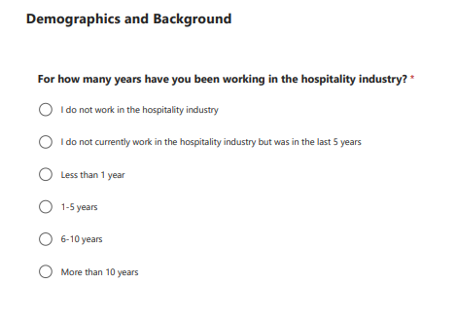

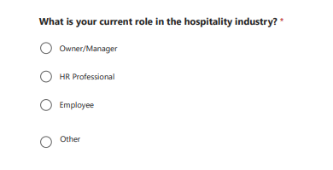

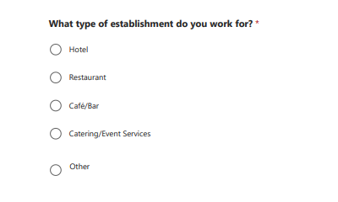
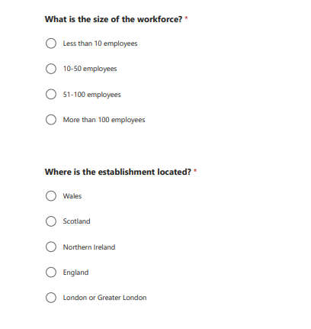

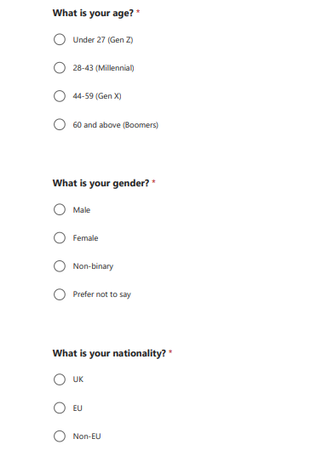

Section 2
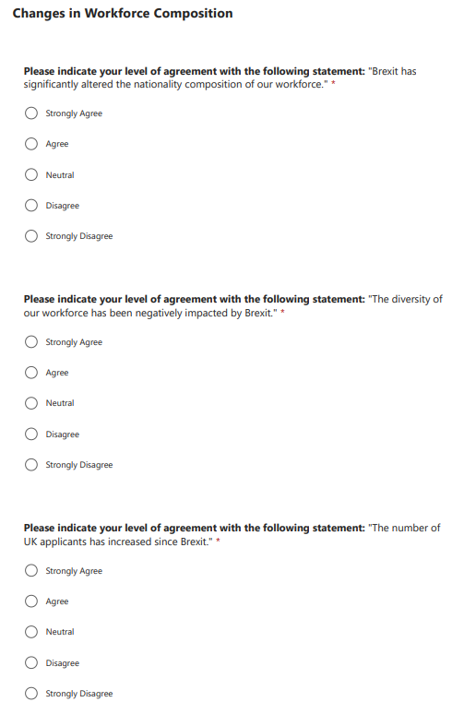

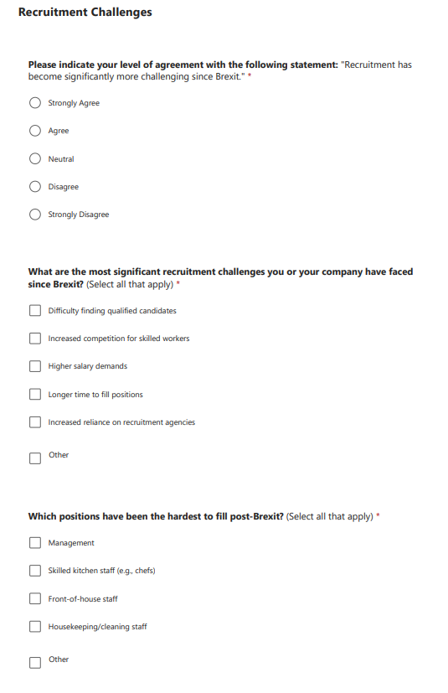

Section 3
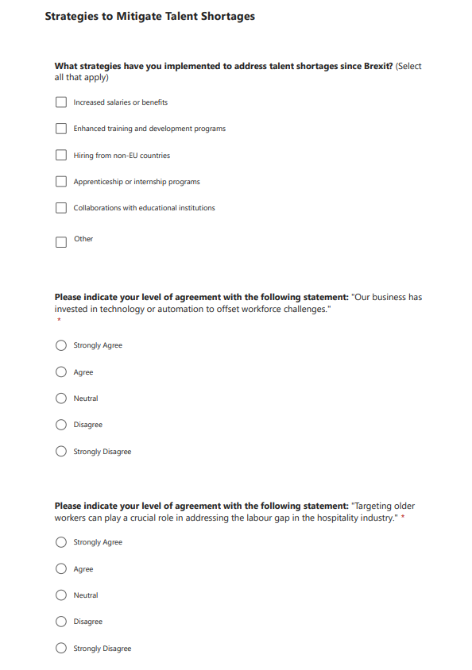

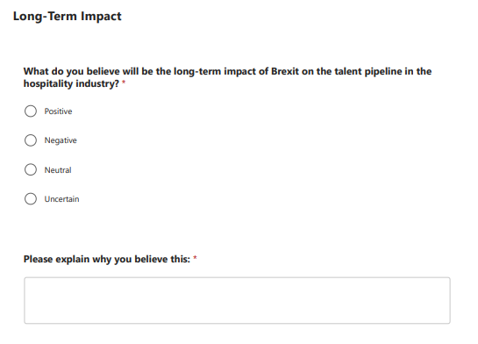

Section 4


