

PART 1: Upload your photo of your A3 in-class notes here:
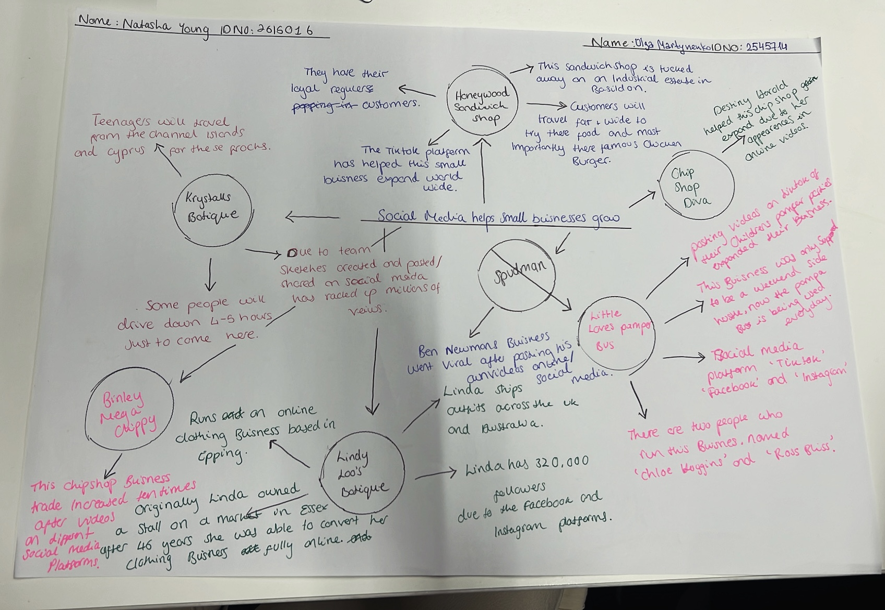

- What is the main idea of the whole text?
The main idea of the whole text is expressing and showing how social media can help expand small businesses.

- What is one key point that supports the main idea, and which specific example from the text shows this?
A key point from this text that supports this article would be the ‘Honeywood Sandwich Shop’. This Sandwich Shop is drawing customers far and wide, especially to try their famous chicken burger.

- What is a different key point that supports the main idea, and which specific example from the text shows this?

Another key point from this text that supports the main idea of this Article, the Honeywood Sandwich Shop already have their local regulars and thanks to their support and flooding posts on the TikTok social media platform, this has helped this small business expand massively.

- Which part of the text do you think is most important, and why?
Owner Murat Mutlu says, ‘customers started travelling long distances to try his food’. What I find most important about this text is that it shows us that from just one video shared to one social media platform, out of so many, what it can do when it comes to promoting a small business in the industry. A hidden sandwich shop, tucked in on an industrial state located in Basildon, from busy weekends of locals to new customers worldwide, flurrying in first thing on a regular Tuesday morning, to experience the Honeywood Sandwich Shop that’s so highly spoken about online by customers.

Reflection:
I did not find anything difficult in this task however, if there was anything that I possibly struggled on would be structuring my work in the correct form. To help me with this, I used and understood the mind map method that helped me remember the main key points and need important information for my assignment.

