An Early Years Practitioner Guidance Handbook to Successful Transition.


(Source: Friendship circle, no date)

Introduction

The purpose of this handbook is to guide and support early years practitioners to enable a smooth and effective transitional experience for younger children who are beginning in a school setting for the first time. The guidance in this handbook will enable practitioners to explore the holistic approach towards a successful transition with desirable outcomes.
Throughout this handbook there is a great emphasis on the importance on the role of the adult, the needs of a child and effective communication,
This handbook looks at the meaning of transitions, the needs of a child, the role of the adult, partnerships, interventions, proposed outcomes along with a large emphasis on the importance of effective communication and relationships throughout.
As emphasised by birthto5matters (no date) transitions which are managed sensitively within an early year’s setting may lay the foundations for positive transitions later on in life. In addition to this, birthto5matters (no date) state that transitions are not an event but a process and take time and careful planning.
What is the meaning of transition?
“Transitions are changes that take place in our life; changes that move us from one stage to another. Transitions are an essential part of growing up and the most important ones happen when we are babies and young children” (Milton- Keynes, no date).
Further to this, Milton- Keynes (no date) highlights the variety of transitions in which individuals may face, these include:
- Milk to solids,
- Crawling to walking,
- Nappies to trained,
- Nursery to school,
- A new baby,
- A new home,
- Parents divorcing.
O’Connor (2017) states that most children who are starting school will have already experienced around seven transitions in family life and educational settings and highlights that research shows that children find transitions just as stressful as adults and children's emotional well-being and academic outcomes can be impacted as a result of this. Moreover, O’connor (2017) argues that children who are supported correctly during transitions to be more emotionally intelligent and are able to make good attachments as well as able to embrace changes and new experiences in later life. Therefore, it is imperative that children know that they will be treated with respect and allowed to take control of what happens to them during these changes and early years practitioners ensures that these transitions are seamless.
Moreover, Milton Keynes (no date) emphasises the important of smooth transitions which have a positive effect on our emotional development and enable individuals to cope with life's changes.

The needs of a child

O’connor (2017) suggests that during a transition a child may feel a mixture of emotions such as anticipation, excitement, curiosity, anxiety, fear and uncertainty therefore it is crucial that every child is treated as an individual and that practitioners ensure they know the needs of the child.

Kline (no date) argues that Maslow’s Hierarchy of Needs is widely referred to within the educational sector, as for children to reach their full potential their needs must be met at their current level.
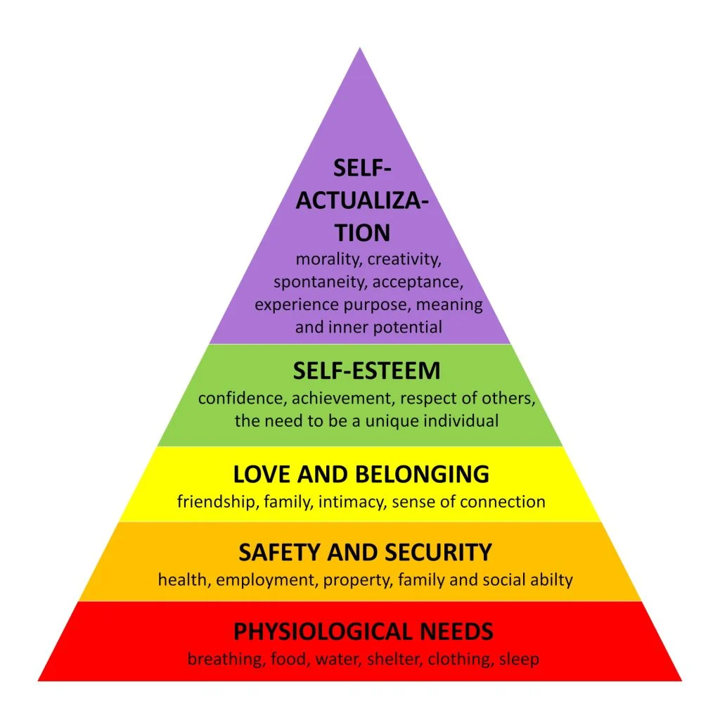
(Source: SimplyPsychology, 2023)
Maslow’s Hierarchy of Needs (1943) is made up of five sections all of which can be applied to policies and procedures within an early years setting, for example:
- Basic needs- all children have access to water and free school meals,
- Safety needs- all schools provide a safe space for children with adults who have a DBS,
- Belongingness- children are encouraged to make relationships and friendships with peers,
- steam needs- all children are encouraged to contribute to their own learning.

Conkbayir and Pascal (2014) highlight John Bowlby theory of attachment, stating children who have a positive, secure attachment with their main care giver usually the mother will be more likely to be happy and content due to their essential needs being met and in contrast children who fail to make this attachment tend to have poor emotional well-being and form insecure attachments in later life.
In addition to this, Conkbavir and Pascal (2014) point out Mary Ainsworth theory that children can form multiple attachments with adults who provide care and meet their individual needs and in turn these attachments give the child a sense of security.

Role of the adult
Lindon (2012) states that children who are well supported by knowledgeable and caring early years practitioners and parents tend to achieve more desirable outcomes.
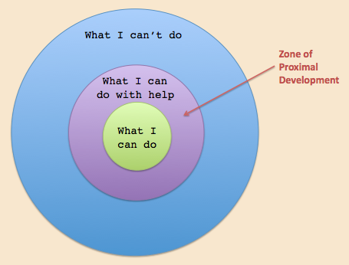
(Source: Instructionaldesign, no date)
Lev Vygotsky theory highlights the importance of interaction with peers and adults for a child's development.
Open Learn (no date) states that Vygotsky theory highlights the importance of a child being surrounded by individuals who have more life experience and are aware to their needs and abilities to further the child's cognitive development.
Likewise, Conkbayir and Pascal (2014) maintain Vygotsky theory that children learn from their interactions with others, this is because they imitate behaviours when completing tasks and in social situations.

Teachers
The environment in which the teacher creates for the children is also important, it needs to feel safe and inviting but also needs to encourage the children to be creative and feel the sense of freedom. Johnston and Nahmad-Williams (2018) back this argument and highlight Plowdens theory that children's curiosity tends to be stimulated by the environment the teacher provides and leads to questions and how to find the answers, furthering their independence and knowledge. Further to this, Johnston and Nahmad-Williams (2018) state that Plowdens findings have influenced education nationally with early years settings adapting a child-centred approach within their curriculum.
Likewise, Frobel supported this idea of the importance of an inviting environment and independent play. Early Education (2021) maintain this stating Froebel believed that play is fundamental for a child's development as it is the way in which they construct their understanding of the world.
Furthermore, Conkbayir and Pascal (2014) argue that Frobel believed that a practitioners support along with a good environment and a range of resources suited to individuals age and ability would encourage children to be creative and imaginative. This would likely lead to the children taking control of their own learning through exploring and motivate the child to learn about the world and their surroundings independently.
In addition to this, the UNCRC article 13 the freedom of expression and article 31 play and cultural and artistic activities highlight the child's right to play independently (Save the Children, no date).

Parent
Plowden (1987) argues the importance of parents involvement within their child's education, stating that children who read at home with their parents tend to develop their literature skills at a faster pace in comparison to those who only read at school with their teachers and peers.

Partnerships

Butler and Ostrosky (2018) highlight that when families and early years practitioner work together with the child's needs at the forefront everyone involved benefits and outcomes are more desirable.

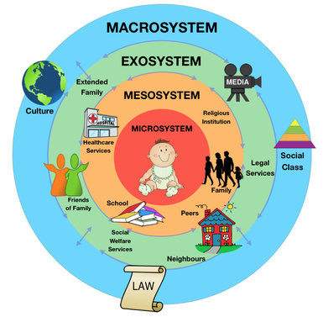
(Source: Study of the mind, 2015)
This illustration explains Bronfenbrenner’s ecological systems and highlights how a child's environment and relationships can affect not only their wellbeing but also their development.
According to Office for Multicultural Learning (no date) Bronfenbrenner’s theory suggests that the environment in which a child grows up in will affect every part of their life and the social factors will alter the way in which they think.
Conkbayir and Pascal (2014) argue that the microsystem tends to be most influential during a child's early life, this section includes family, nursery, school, teacher’s and health care professionals. Moreover, Conkbayir and Pascal (2014) highlight the importance of not only the relationship the child has with these individuals but the relationship the individuals within the mesosystem have with each other and how they interact as failing this it could potentially have a negative impact on the child's development.
Therefore, partnership working is crucial to ensure that a child's needs are met along with their development.
PACEY (no date) highlight four benefits of partnerships during transitions, these include:
- Children tend to appear more confident and settled,
- Families feel more reassured about their child transitioning,
- Parents participate more with the school curriculum and resources in their local community such as libraries and children centres,
- Schools and early years providers work together on how best to support the child during this time with both their confidence and wellbeing being at the forefront.

Interventions
Butler and Ostrosky (2018) argue that by understanding a young person's needs and abilities it enables early years practitioners and parents to plan accordingly and have more successful outcomes.
Welcome packs
Open days
Settling in sessions
One Page profiles

Proposed outcomes

