Cory Tyzack
1301015
Abstract
This report talks about the different smart home technologies currently available on the market along with the current advantages and disadvantages of setting up a smart home
Design and implementation of a smart home
Smart and Connected Devices I

Table of Contents
I. Introduction to A Smart Home 0
II. Smart Home Technologies 0
Smart Speakers 0
Smart Lighting 0
Smart Heating 1
Smart Appliances 1
Smart Security 1
IFTTT Technology 1
III. Advantages 2
Convenience 2
Accessibility 2
Other Advantages 2
IV. Disadvantages 2
Cost 2
Security Risks 2
Device Hijacking 2
DDoS (Distributed Denial of Service) 2
Privacy, Data and Identity Theft 2
V. Smart Home Design 0
VI. Conclusion 0
VII. Bibliography 1
VIII. Appendix 0
Appendix A – Table of Smart Devices 0

Introduction to A Smart Home
A “Smart Home” is becoming a more frequently used term in day to day life which involves controlling lighting, heating and other electronic devices at home remotely via a smart phone or computer. The idea is to control or automate day to day procedures with a click of a button, a voice command or detection from a sensor in order to complete tasks seamlessly.

This report looks at the key aspects of home automation and smart devices, analysing the current technologies available, the setup of routines, the advantages/disadvantages and the security risks and solutions.

These are some definitions of key phrases used throughout the report which will help gain a better understanding:
- Zigbee – Low data rate network using IEEE 802.15.4, designed for low power sensors so battery life is longer. [1]
- Z-Wave – Used in smart homes to provide communication between device and home control network[2]
- IoT- Internet of Things – A network of internet connected devices able to collect and exchange data[3]

Smart Home Technologies

Smart Speakers
Nowadays there are thousands of different products on the market to enable a person to create a smart home. One of the most common purchases to start off is a smart speaker. Amazon Echo, Google Play and Apple Home are just three of the products available that offer this type of smart technology.

The main feature advertised for these devices is its ability to understand voice commands and complete tasks.[4] The user starts speaking to the device using an unique keyword such as ‘Alexa’ for the Amazon Echo and the device comes to life and starts listening to the command. The user can get the device to set up alarms and reminders, play music through linked streaming sites and provide news or weather updates all from a simple sentence. These devices have the ability to speak back to the user with confirmation of what is commanded and completes the task. These devices also come with a app which allows the user to control the device.

These devices can be used in more advanced ways to create a smart home by linking up with other smart devices. The user can create routines through the app or voice commands which will start off a sequence of events involving the other devices. An example of this is in the Alexa app, the command “Alexa, start my day” will start a series of tasks.
- Turn the light on.
- Local weather.
- Appointments in calendar.
- Play music from Spotify.

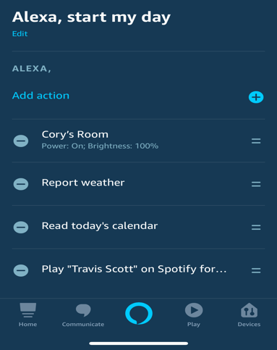
Figure 1.0 – Alexa Routine

Smart Lighting
Smart bulbs eliminates the need to control lighting manually via a switch on the wall. The technology used allows the bulb to be controlled through a mobile devices or a device such as a smart speaker instead and allows the user to control brightness and colour of the bulb without lifting anything more than a finger. [5]

There are 3 different methods to connect smart bulbs up to a network:
- Smart Hub – Uses Zigbee or Z-Wave technology to connect to bulbs.
- Directly to Router – Uses Wi-Fi technology to connect to bulbs.
- Bluetooth [5]

A Smart Hub is a useful gadget which is used as a central device connected to the router which is used to connect Internet of Things devices. The hub can use Zigbee or Z-wave to create a network which allows devices to communicate with each other and with the users smart phone. [6] The main advantages of using a hub is the ability to connect more devices than connecting to a router [7] and it also provides a more reliable performance than connecting to a router. [5]

Smart Heating
Implementing a smart heating thermostat improves efficiency of heating a home. The ability to control a heating system through a smart device enables the user to turn the heating on/off at the times when they’re not in the house. [8]

The biggest attraction to these sort of devices is its capability to reduce domestic bills, users can manually control the heating systems but these thermostats now have the ability to be programmed with routines. For Example – Turning the heating on 7am every weekday for an hour. The thermostat will remember these commands and automate the service.

Some thermostats even have the ability to memorise your routines and control themselves. They can also provide data of usage and analysis, all of these features are again promoted to help the buyer to save money on heating bills.[8]

Just like the majority of smart devices on the market today, the thermostat connects to the home Wi-Fi in order for its features to be made accessible on the go.

Smart Appliances
Smart appliances are another technology created to make day to day routines automated or more convenient. One example of a smart appliance would be the iKettle.[9] The iKettle is another device that can be activated through an app or by integration with smart speaker devices.

The smart kettle gives the user freedom to boil the kettle remotely, full temperature control and set routines. The iKettle has implemented technology to boil the kettle at different temperatures to make the perfect drink, some options are ‘Quick Boil 100oC’, ‘Coffee 95oC ’ and ‘Green Tea 8oC’. The iKettle also has the ability for families to set the temperature of the kettle through the app, to work around night time formula routines for new-born babies.[9]
Another appliance on the expensive side of smart homes are smart fridge freezers. An extremely innovative device which centralises all food management. Take the Samsung Smart Fridge Freezer for example. The features on this fridge are game changing, it has the ability to monitor and order groceries, cut food waste by tagging expiry dates and even discovers recipes to use up food that’s in the fridge which will be displayed on the fridges inbuilt screen. The screen even allows the user to listen to music or watch TV while cooking. [10]
The technology implemented makes everything food related so much more convenient and helps reduce food waste which can help save money and also help the planet by reducing methane emissions from food waste at landfills. [11]

There are loads of other smart appliances available but they all have the same aim, to improve convenience and potentially save money. Some other examples include:
- Ovens
- Dishwashers
- Coffee Makers
- Microwaves
- Toasters [12]

Smart Security
Smart Security is the idea of a network of integrated electronic devices working together to help protect a home from intruders and prevent criminal activity.[13] These devices can include cameras, sensors, alarms and locks, they work together to provide the home owner with information such as video footage or alert the user by sensors triggering alarms.

Home security systems work on a simple concept of connecting sensors to communicate to a central control panel.
The control panel is the main computer that arms and disarms the security systems, it obtains the data from the sensors which triggers the alarm if the criteria’s are met. [13]
The sensors can vary depending on the implementation on the systems.

IFTTT Technology
“If This Then That” technology is designed to connect all your devices together[14] It’s taken from the programming conditional statement and it allows automation by triggering actions by other actions.[15]

The idea is to get more devices and apps talking together so an example of this working would be:

If you add a new task to you Amazon Alexa to-dos, then it will also be added to your iOS reminders app as well[15]
It works via applets, which are like macros that connect multiple apps to achieve automated tasks. They can be set up using the IFTTT website[14] or the app on a smart phone.[15]

Advantages

Convenience
As mentioned throughout the report, the main advantage of setting up a smart home is the convenience of being able to control the smart devices through a click of a button, using your voice or even doing nothing at all with the automation routines that can be set up. The thought of getting up in the morning and the kettle is already boiled, Alexa has given a brief on what to expect today and advised what the weather is like give the user a good stead to start the day.

Accessibility
Creating a smart home helps to achieve accessibility. This is extremely helpful for people with disabilities. Smart speakers, smart locks, smart thermostat make their homes accessible and give them the opportunity to live life as they choose.[16]
It also makes devices more accessible for everyone else, if someone has limited time in the morning, they no longer need to choose between a shower and a coffee as they can set the coffee machine to go while they’re getting ready for work then take the coffee on the go.

Other Advantages
The ability to customise routines and tasks is another advantage of a smart home which links into both convenience and accessibility.
The last advantage as mentioned until Smart Heating is the ability to make everything more energy efficient, heating systems can be turned on only when required and anything that may have been left on can be turned off through an app on the users phone.

Disadvantages

Cost
Cost is one of the biggest factors to consider when creating a smart home. Appendix A shows a table of examples of devices and prices to what to expect when creating a smart home. Although there are some cheaper alternatives created by third party companies, sometimes these devices have security flaws so it is worth looking into the product thoroughly before purchasing. (Broadband speeds + Cost)

Security Risks
Security Risks are factor to consider with any form of technology, with criminals benefiting in many ways from using unlawful techniques to obtain personal/sensitive data or cause damage. Smart Devices are no different, in fact some devices are made so quickly for market that there are likely to be more security flaws to be exploited, in fact a recent study has found that
80% of people interviewed regarding disadvantages responded with privacy, security and hacking as a worry about implementing a smart home. [17]

Device Hijacking
This is where the perpetrator will use exploits to assume control of a device. It’s a technique which can be very difficult to detect. [17]

DDoS (Distributed Denial of Service)
DDos attacks are used a lot in the technology industry, it is the act of rendering a machine or network resource unavailable to disrupt services. [17]

Privacy, Data and Identity Theft
These attacks have been around for years and have evolved due to the shear amount of data stored on computers.[17]

Smart Home Design
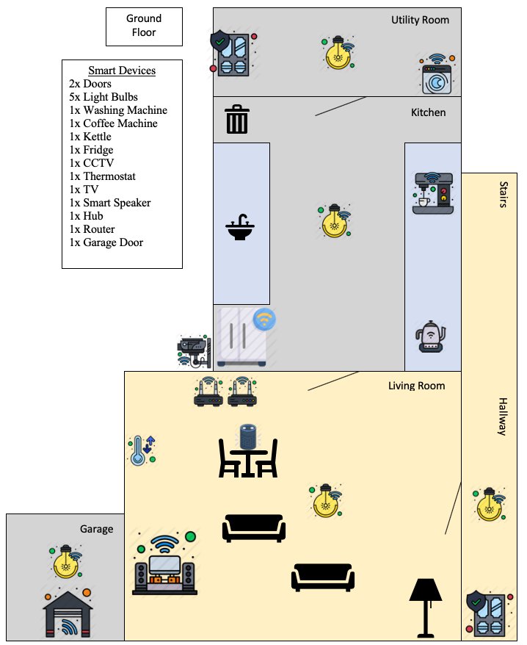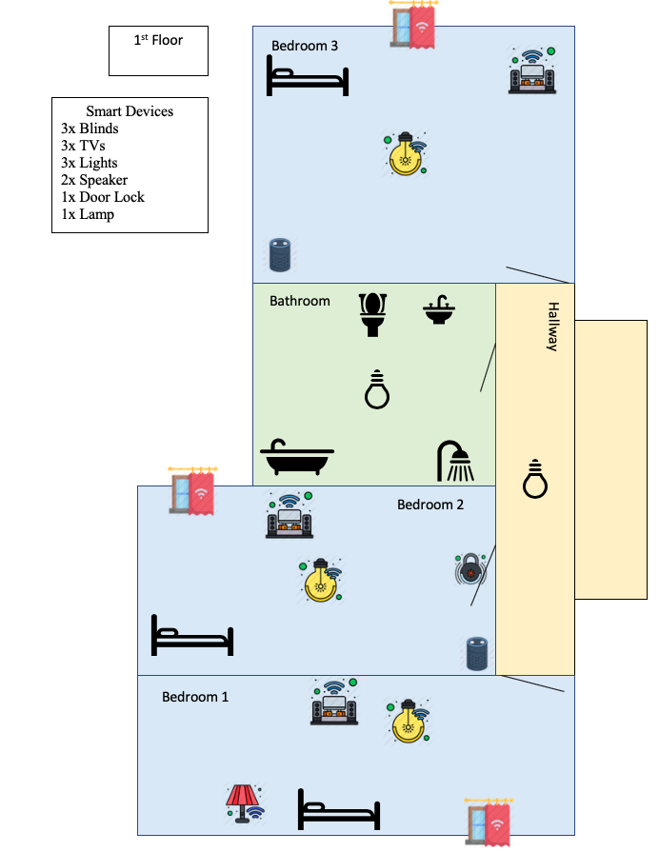[31]

Conclusion

Weighing up the benefits and vulnerabilities is vital for starting up a smart home. Although the cost can be high for some devices, there are plenty of entry level devices to get the consumer started. The start of automating day to day task can save a lot of time in all aspects of life, whether it be starting the day or deciding what to have to eat or feeling secure in your own home. In this day in ages, time is valued more precious than money so if the user is able to save time automating a task to spend with loved ones or in other area then it’s always going to be lucrative.

Smart home is also an ever expanding market so as time goes on more devices are created, with the addition to IFTTT it is possible to achieve automation in the majority of day to day tasks or tasks that are often forgotten about. After all, the aim of implementing a smart home is help provide a better quality of life. [18]

Bibliography
[1]"Definition of ZigBee", PCMAG. [Online]. Available: https://www.pcmag.com/encyclopedia/term/zigbee. [Accessed: 02- Jul- 2020].
[2]"What is Z-Wave? - Definition from Techopedia", Techopedia.com. [Online]. Available: https://www.techopedia.com/definition/27782/z-wave. [Accessed: 02- Jul- 2020].
[3]M. Burgess, "What is the Internet of Things? WIRED explains", Wired.co.uk, 2018. [Online]. Available: https://www.wired.co.uk/article/internet-of-things-what-is-explained-iot. [Accessed: 02- Jul- 2020].
[4]"Alexa Features @ Amazon.com", Amazon.com. [Online]. Available: https://www.amazon.com/b/ref=aeg_lp_features/ref=s9_acss_bw_cg_aeglp_md1_w?node=17934672011&pf_rd_m=ATVPDKIKX0DER&pf_rd_s=merchandised-search-4&pf_rd_r=JD0CZZM5A3SAN179071A&pf_rd_t=101&pf_rd_p=52f0169a-d394-40a7-85a8-d262af43323e&pf_rd_i=17934671011. [Accessed: 02- Jul- 2020].
[5]"Smart Bulbs Explained: How Do Smart Light Bulbs Work? - iDISRUPTED", iDISRUPTED, 2019. [Online]. Available: https://idisrupted.com/how-do-smart-bulbs-work/. [Accessed: 02- Jul- 2020].
[6]J. Foster-MarCom, "What Is a Smart Home Hub and Do You Need One?", Consolidated Communications, 2019. [Online]. Available: https://www.consolidated.com/blog/residential/artmid/7943/articleid/130/what-is-a-smart-home-hub-and-do-you-need-one. [Accessed: 02- Jul- 2020].
[7]"How Philips Hue smart lighting works | Philips Hue | Hue", Hue. [Online]. Available: https://www.philips-hue.com/en-gb/how-it-works. [Accessed: 05- Jul- 2020].
[8]"How to buy the best smart thermostat", Which.co.uk, 2020. [Online]. Available: https://www.which.co.uk/reviews/smart-thermostats/article/how-to-buy-the-best-smart-thermostat-a3sCE7E7z92w. [Accessed: 05- Jul- 2020].
[9]"iKettle - Smarter Kitchen Appliances", Smarter.am, 2019. [Online]. Available: https://www.smarter.am/ikettle. [Accessed: 05- Jul- 2020].
[10]"Samsung Family Hub Smart Fridges", Samsung uk. [Online]. Available: https://www.samsung.com/uk/refrigerators/family-hub-fridge-freezers/. [Accessed: 05- Jul- 2020].
[11]S. Clayton, "Why Save Food", Love Food Hate Waste. [Online]. Available: https://www.lovefoodhatewaste.com/why-save-food. [Accessed: 05- Jul- 2020].
[12]B. Morgan, "The Coolest Smart Kitchen Appliances You Can Buy Online", House Beautiful, 2020. [Online]. Available: https://www.housebeautiful.com/shopping/home-gadgets/g22826031/smart-kitchen-appliances/. [Accessed: 05- Jul- 2020].
[13]B. Sovacool, "Smart home technologies in Europe: A critical review of concepts, benefits, risks and policies", https://www.sciencedirect.com/science/article/pii/S1364032119308688, 2020. [Online]. Available: https://reader.elsevier.com/reader/sd/pii/S1364032119308688?token=6B0A392ACAAEC1777A2C5A67BB7851F84611CDC2A989CEC42AEBAA5EF1B12EB7C149F0C18FE7D0A078408DA1644FB48C. [Accessed: 05- Jul- 2020].
[14]"IFTTT / Incompatible Browser", Ifttt.com. [Online]. Available: https://ifttt.com. [Accessed: 06- Jul- 2020].
[15]J. Martin and M. Finnegan, "What is IFTTT? How to use If This, Then That services", Computerworld, 2020. [Online]. Available: https://www.computerworld.com/article/3239304/what-is-ifttt-how-to-use-if-this-then-that-services.html. [Accessed: 14- Jul- 2020].
[16]V. Patel and S. Khan, "7 Most Useful Smart Home Devices for People With Disabilities", Rolling Without Limits, 2017. [Online]. Available: https://www.rollingwithoutlimits.com/view-post/7-Most-Useful-Smart-Home-Device-for-Individuals-with-Disabilities. [Accessed: 15- Jul- 2020].
[17]"Smart Home: Threats and Countermeasures - Rambus", Rambus. [Online]. Available: https://www.rambus.com/iot/smart-home/. [Accessed: 06- Jul- 2020].
[18]G. MOKHTARI, A. ANVARI-MOGHADDAM and Q. ZHANG, "A New Layered Architecture for Future Big Data-Driven Smart Homes", Ieeexplore.ieee.org, 2019. [Online]. Available: https://ieeexplore.ieee.org/stamp/stamp.jsp?tp=&arnumber=8629861. [Accessed: 16- Jul- 2020].
[19]"Amazon Echo Dot", Amazon.co.uk. [Online]. Available: https://www.amazon.co.uk/dp/B07NQG1V13/ref=s9_acsd_al_bw_c2_x_1_t?pf_rd_m=A3P5ROKL5A1OLE&pf_rd_s=merchandised-search-3&pf_rd_r=7NV8A7NTVN14PP2NBQ18&pf_rd_t=101&pf_rd_p=3505fa53-3938-4926-b4c9-6a5b5b6a1373&pf_rd_i=14100223031. [Accessed: 08- Jul- 2020].
[20]"Google Store – Pixel, Chromecast and more", Store.google.com. [Online]. Available: https://store.google.com/gb/config/google_home. [Accessed: 08- Jul- 2020].
[21]"Buy HomePod", Apple (UK). [Online]. Available: https://www.apple.com/uk/shop/buy-homepod/homepod. [Accessed: 08- Jul- 2020].
[22]"Philips Hue White and Colour Ambiance Wireless Lighting LED Starter Kit with 3 GU10 Bulbs with Bluetooth & Bridge at John Lewis & Partners", Johnlewis.com. [Online]. Available: https://www.johnlewis.com/philips-hue-white-and-colour-ambiance-wireless-lighting-led-starter-kit-with-3-gu10-bulbs-with-bluetooth-bridge/p4841546?sku=238458351&s_ppc=2dx92700053300238455&tmad=c&tmcampid=2&gclid=EAIaIQobChMInpys89zJ6QIVhrTtCh0yqAPjEAQYAyABEgLvPfD_BwE&gclsrc=aw.ds. [Accessed: 09- Jul- 2020].
[23]"Hive Smart Lights Pack Bayonet (Hub and 2x Bulbs)", BT Shop. [Online]. Available: https://shop.bt.com/products/hive-smart-lights-pack-bayonet--hub-and-2x-bulbs--400014939-F5W8.html?utm_source=awin&utm_medium=affiliates&utm_content=ZA00&awaid=3043&utm_source=redbrain&utm_medium=shopping&utm_campaign=css&gclid=EAIaIQobChMIu6KI4t3J6QIVbIBQBh3YxAMIEAQYASABEgKgfvD_BwE00&utm_source=awin&utm_medium=affiliates&utm_content=ZA00&awc=3043_1590228286_57b844e40cf6808216c25cf5ad9336bd. [Accessed: 08- Jul- 2020].
[24]"Moko Smart Light Bulb", Amazon.co.uk. [Online]. Available: https://www.amazon.co.uk/gp/product/B07VK9CLDS/ref=ppx_yo_dt_b_asin_title_o03_s00?ie=UTF8&psc=1. [Accessed: 09- Jul- 2020].
[25]"HIVE Active Heating & Hot Water Thermostat", Currys. [Online]. Available: https://www.currys.co.uk/gbuk/smart-tech/smart-tech/smart-home/smart-heating/hive-active-heating-hot-water-thermostat-10151065-pdt.html?istCompanyId=bec25c7e-cbcd-460d-81d5-a25372d2e3d7&istFeedId=4d7eb93e-055f-499d-8ee5-1cdcc50d67d1&istItemId=xriqamppw&istBid=tztx&srcid=198&cmpid=ppc~gg~1051%20(PLA)%20SMART%20HOME%20CORONA%20PRIORITY%20CAMPAIGN~Amazing%20Deals%20Wk3%202020~Exact&mctag=gg_goog_7904&kwid=GOOGLE&device=c&ds_kids=92700053909760920&tgtid=1051%20(PLA)%20SMART%20HOME%20CORONA%20PRIORITY%20CAMPAIGN&&gclid=EAIaIQobChMI5crUj9_J6QIVgu3tCh1kiwTwEAQYAiABEgKGO_D_BwE&gclsrc=aw.ds. [Accessed: 08- Jul- 2020].
[26]"Google Nest Learning Thermostat 3rd Generation", Squizzas. [Online]. Available: https://www.squizzas.co.uk/products/nest-learning-thermostat-3rd-generation?variant=28797299097653&currency=GBP&utm_medium=product_sync&utm_source=google&utm_content=sag_organic&utm_campaign=sag_organic&gclid=EAIaIQobChMI5crUj9_J6QIVgu3tCh1kiwTwEAQYByABEgLlrfD_BwE. [Accessed: 09- Jul- 2020].
[27]"Samsung RS68N8941SL American Style Family Hub RS8000 Fridge Freezer With Ice & Water - STAINLESS STEEL - Appliance City", Appliance City, 2020. [Online]. Available: https://www.appliancecity.co.uk/refrigeration/american-style-fridge-freezers/samsung-rs68n8941sl-american-style-family-hub-fridge-freezer-ice-water/?gclid=EAIaIQobChMI16DRieDJ6QIVRrDtCh20XAnYEAQYASABEgJ0v_D_BwE. [Accessed: 09- Jul- 2020].
[28]"LG GSX961NSVZ American-Style Smart Fridge Freezer - Steel", currys. [Online]. Available: https://www.currys.co.uk/gbuk/household-appliances/refrigeration/fridge-freezers/lg-gsx961nsvz-american-style-smart-fridge-freezer-steel-10192365-pdt.html?istCompanyId=bec25c7e-cbcd-460d-81d5-a25372d2e3d7&istFeedId=4d7eb93e-055f-499d-8ee5-1cdcc50d67d1&istItemId=warmamlqp&istBid=tztx&srcid=198&cmpid=ppc~gg~0101_PLA_AO_BAU_Hoc3-MDA_Hoc1-REFRIGERATION_MA-FRIDGE+FREEZERS_All_G_None_Medium_~0101+Fridge+Freezers+Core+ad+group~Exact&mctag=gg_goog_7904&kwid=GOOGLE&device=c&ds_kids=92700021811720831&tgtid=0101_PLA_AO_BAU_Hoc3-MDA_Hoc1-REFRIGERATION_MA-FRIDGE+FREEZERS_All_G_None_Medium_&=--present--&gclid=EAIaIQobChMI2KL8gOHJ6QIVTbTtCh1M_wRIEAQYASABEgKtZPD_BwE&gclsrc=aw.ds. [Accessed: 10- Jul- 2020].
[29]"Yale Smart Alarm", Amazon.co.uk, 2020. [Online]. Available: https://www.amazon.co.uk/Yale-Smart-Alarm-Works-Amazon/dp/B07FR78X16?ref_=s9_apbd_otopr_hd_bw_b27G80F&pf_rd_r=SQ0F38PTS04QQYMXRG2V&pf_rd_p=d9ec20e6-23e4-5759-8bf9-fee91b936711&pf_rd_s=merchandised-search-10&pf_rd_t=BROWSE&pf_rd_i=1939544031. [Accessed: 10- Jul- 2020].
[30]"Ring Indoor Alarm Kit", Amazon.co.uk, 2020. [Online]. Available: https://www.amazon.co.uk/Ring-Alarm-Piece-Kit-Indoor/dp/B08523DJG1?ref_=s9_apbd_otopr_hd_bw_b27G80F&pf_rd_r=SQ0F38PTS04QQYMXRG2V&pf_rd_p=d9ec20e6-23e4-5759-8bf9-fee91b936711&pf_rd_s=merchandised-search-10&pf_rd_t=BROWSE&pf_rd_i=1939544031. [Accessed: 10- Jul- 2020].
[31]"Flaticon, the largest database of free vector icons", Flaticon, 2020. [Online]. Available: https://www.flaticon.com/home. [Accessed: 16- Jul- 2020].

Appendix

Appendix A – Table of Smart Devices
Name | What’s Included | Price
Amazon Echo Dot[19] | 1 Smart Speaker | £39.99
Google Home[20] | 1 Smart Speaker | £89
Apple Home[21] | 1 Smart Speaker | £279
Philips Hue Starter Kit[22] | 3 Light Bulbs + Bridge | £139.99
Hive[23] | 2 Light Bulbs + Hub | £54
Moko Smart Bulb[24] | 1 Bulb | £11.99
Hive Heating & Hot Water Thermostat [25] | 1 Smart Thermostat | £149.99
Google Nest Smart Thermostat [26] | 1 Smart Thermostat | £164.99
Original iKettle[9] | Smart Kettle | £99
Samsung Smart Fridge[27] | American Style Fridge Freezer w/ Ice and Water | £1975
LG Smart Fridge Freezer[28] | American Style Fridge Freezer | £1499
Yale IA-320 Sync Smart Home Alarm[29] | 1 Hub, 2 Motion Detectors, 1 Keypad, 1 Door Window Contact Sensor, 1 Siren | £260.64
Ring Alarm 5 Piece Kit with Ring Indoor Cam[30] | 1 Hub, 1 Keypad, 1 Motion Detector, 1 Contact Sensor, 1 Range Extender | £179.99

