

Management accounting
LCBB5002
Student name: Kostadin Dimitrov Kostov
Student id:2115193

Contents
Introduction 3
PART A 4
(i) Prepare The Monthly Control Report Showing Original Budget, Flexed Budget And Variances 4
(ii) Using the cost report prepared in (i) above, prepare a report on Amma’s performance during the year 2020: 7
(iii) Provide recommendations to Amma’s CEO on areas of improvement: 8
PART B 10
Report to Mr. Amana 10
Conclusion 12
Reference 13

Introduction
Giving management access to budgetary and administrative data so they may make well-informed choices about the firm is the practice of management accounting. This data consists of items like projections, achievement evaluations, and budgets. The emphasis on immediate judgments that management accounting places on is one of its fundamental features. Instead of focusing on making lengthy strategy choices, Management Accounting Information (MAI) is intended to assist executives in making smarter judgments on a daily basis. Data on expenses, sales, earnings, and other elements that are significant to organizational judgment are frequently included in MAI. The first element of this research shows how to create a monthly tracking report that summarizes Amana Ltd.'s results in the year 2020. The next paragraph offers suggestions on whether Mr. Amana should start his personal online business or purchase with Amazon.

PART A

(i) Prepare The Monthly Control Report Showing Original Budget, Flexed Budget And Variances
Monthly control report: A summary of the business's performance for the month is given in the monthly controlling statement. It contains information on the sale, costs, earnings, and expenditures as well as an analysis of selling by goods or services. The report also compares reality outcomes to projected statistics, emphasizing any instances when the results were different from what was anticipated. This makes it possible for management to spot any prospective problem or areas for development right away. It can be used, for starters, to monitor progress toward particular aims or ambitions. Additionally, it can be useful in identifying trends across time, which enables management to decide on long-term strategy with greater knowledge. The report can also be employed as a predictor of future productivity. Although it is a logical conclusion to the planning process, monthly reporting is not its ultimate objective. The cycle of planning, monitoring, and judgment is actually the cornerstone for maintaining a successful, expanding company because it aids in better preparing your subsequent actions. then the subsequent steps... then the subsequent steps. No matter how big or little your company is, there's a good chance it might advantage from improved, more efficient monitoring procedures, allowing you to confidently plan your future moves. You are supposed to use this document to assist them to do that (Christopher & Sarens, 2015).
The monthly control report is typically created by the top finance officers and approved by other executive management representatives before becoming decided to send to other divisions. It may be mailed out or made available online for staff members to access. It is simple to add the information to a protected section of the website because many businesses have sizable datasets that are available via worker private networks. Workers could then transfer a copy to their local disk for later use or discreetly browse it from any laptop with Internet connectivity. The monthly control report frequently comes with an executive version that highlights key points from the complete report. Because of this, managers may quickly and easily obtain the knowledge they require while being required to read the monthly control report in its entirety (Christopher & Sarens, 2015)
Flexible report: A management report called a budget variance achievement report contrasts the period started real earnings and expenses with those projected depending on the real sales volumes. To put it another way, it's a statement that compares the industry's true results to its planned success for the real volume sales. In essence, it contrasts the outcomes with the budget plan. In order to determine whether there any material differences here between actual ending figures and the projected budgetary expenses that were determined at the beginning of the quarter management prepares this analysis at the conclusion of a financial quarter. This is an important instrument because it enables managers to examine the company divisions that are accomplishing their budgetary objectives and the divisions or regions that require development. Flexible budgeting is the other primary method of setting a budgeting. Flexible budgeting provides for adjustments to the quantity of income and costs in the event that performance is higher or less than anticipated (Hamedinia & Asadi, 2021). For instance, if a company's monthly revenue is lower than anticipated, it can still stick to its budget by reducing part of its expenditure because they have an adaptable budget in place. . On the other hand, if the corporation has a spike in revenue one month, they could use the extra money to finance company growth. The use of flexible budgeting has two key advantages: it enables businesses to compare their real performances to their anticipated performances and it enables them to be more sensitive to changes in revenues and costs. Companies can pinpoint places where they are underestimated or outperforming and make the required modifications by tracking their real performance. Overall, because it accounts for both positive and unfavorable fluctuations in earnings and costs, a more precise method of planning is the adaptable method of setting a organization’s financial goals (Hamedinia & Asadi, 2021).

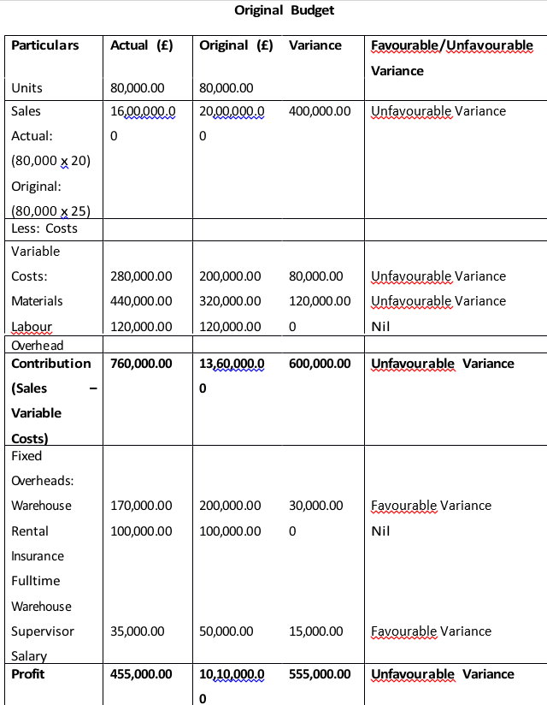

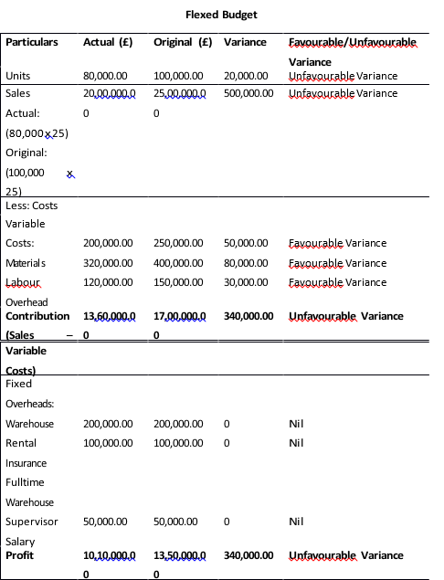

(ii) Using the cost report prepared in (i) above, prepare a report on Amma’s performance during the year 2020:

Performance Report
The year is not going well for Amana Ltd. Due to traveling and mobility limitations brought on by the Covid-19 outbreak, sales have decreased as a result. Amana Ltd. anticipates sales of £100,000; however, after taking into account various costs, its earnings is only £80,000. Despite a 20% spill in sales costs from £25 to £20 per unit, companies only have to contend with large increases in cost structure for materials (from £2.50 to £280,000) and labor (from £4 to £440,000). Costs are going up by 10%. This results in them losing 760 thousand pounds altogether as a result (budget vs actual). The only fixed expenses that have altered are the coverage, which went from £100,000 to £170,000, while the industry's warehousing leasing has remained constant. This results in them losing 760 thousand pounds overall as a result (budget vs actual). The only fixed expenses that have altered are the coverage, which went from £100,000 to £170,000, while the business's warehousing leasing has remained constant. The comprehensive warehousing manager's annual income is also being decreased by 20%, from £50,000 to £35,000. The company was able to sell souvenirs for less money while still preserving the same amount of units sold, therefore its stretched budgeting was more precise that their initial budget. The real results indicate that Amana performed poorly (Hamedinia & Asadi, 2021). Although the sales price per unit has increased, expenditures are still out of control. The expenses are in check. The economy as a whole has disappointed (Hamedinia & Asadi, 2021).
As a result of its lower profitability than in previous years, Amana Ltd. will have to reevaluate its future revenues and cost structures. Rather than placing themselves in accordance with a business, such as leisure, Amana Ltd. should place more emphasis on the market for their offerings.. The business has to inferior element expanse and appearance an alternative supplier of commodities and capital . If Amana Ltd. wants people to repose purchasing their souvenirs, they might need to reduce the pricing of all of their goods. Although it was predicted that mementos would sell for £25 a unit, Amana Ltd. is now selling them for £20 each. This causes a loss of £760,000 overall (budget vs actual). An growth in the price of materials and labor as well as an increase in overhead expenditures were the main causes of this deficit. Instead of establishing oneself in accordance with a business, like tourist, Amana Ltd. should concentrate on the market for its goods in order to offset these losses. They want to lower unit costs and search for alternative suppliers of elements and materials (i.e., local sourcing). Amana Ltd. Although it was predicted that mementos could sell for £25 a unit, Amana Ltd. is now offering them for £20 each. This causes a loss of £760,000 overall (budget vs actual). Growth in the price of materials and labor as well as an expansion in administrative expenditures were the main causes of this deficit. Instead of establishing oneself in accordance with a business, like a tourist, Amana Ltd. should concentrate on the market for its goods in order to offset these losses. They want to lower unit prices and look for alternative suppliers of components and supplies (i.e., local sourcing). Amana Ltd (Lyly-Yrjänäinen et al., 2017).

(iii) Provide recommendations to Amma’s CEO on areas of improvement:
Amana Ltd. is going through a hard patch, and the Director of the organization has to take certain particular actions to assist her organization in getting back on its feet. In this scenario, it is crucial to emphasize on maximizing profits by distributing more copies at a profit but minimizing unplanned costs (Lyly-Yrjänäinen et al., 2017).
There are several ways for Amana to boost its earnings:
- Without modifying the variable expenses, they can raise the sales price of each unit from £25 to £30, which will result in an additional contribution of £2 per unit and an overall improvement in revenue of £40,000. This choice might not be the best, though, as it might reduce sales volume and leave Amana with a lesser inventory of goods to sell. This choice is not advised (Smith et al., 2017).
- By raising the sales cost from £25 to £30 and lowering the changeable expanc from £20 per unit to £12, an additional contributions of £8 per unit will result, boosting revenue by a total of £80,000. This choice will lessen losses and increase Amana's contribution to fixed expenses. The suggested choice is this one (Patra, 2018).
- Selling at a reduced price of (£25-£5) for a brief time frame can be a successful marketing strategy that might boost sales and possibly bring in some previously untapped markets deterred from making purchases owing to high prices. However, if chosen, the business can end up with a sizable stock of unsold mementos after the promotional time, depleting its operating capital. Thus, it is not advised to choose this choice (Patra, 2018).

Amana's revenues will grow by £100,000 as a result of selling mementos online to clients who were unable to access real stores due to the shutdown, which will also help them save money on fixed expenses. As a result, this choice is advised (Smith et al., 2017).
There are many strategies to cut variable expenses, including:
- Lowering changeable input costs from £2.5 per unit to £2 per unit while maintaining other factors at their current levels. This will result in an increased contributions margin of £0.5 per unit, increasing revenue by a total of (£20,000). This could lead to subpar goods, which might reduce consumer happiness. This choice is not advised.
- Movable costs will decrease by £120,000 annually if there are more comprehensive warehousing workers employees are reduced from four to three. Other constants will remain the same. This choice is advised since it will lessen deficits and provide more for Amana's permanent expenses.
- Lowering overhead expenses from £1.50 per unit to £1 per unit will save the company £30,000 in annual unchanging expenses. However, since some of the administrative costs Charges have required the operation of the enterprise, these alternatives may not be workable (e.g., insurance. This strategy is not suggested.
- It is clear that the director of Amana require to concentrate on raising sales while bringing down changeable cost. The aforementioned Making decisions can help achieve these objectives and enhancing the corporation's economic condition.

PART B

Report to Mr. Amana
Mr. Amana made a wise choice to shift 50% of his company's revenues from the offline to the online channel. Only a small area/section of people could be served by his industry's offices in Liverpool, Wolverhampton, and Brighton. Although the presence of these locations could increase Amana Souvenirs' client loyalty base, the likelihood of reaching new consumer audiences would be modest and the costs connected with operating retail stores might be significant. Amana Souvenirs has the potential to significantly expand its market and consumer base by channeling half of its anticipated earnings using an internet strategy that focuses on the UK, and US. . In order to serve the national client bases and the devoted customers, it can plan to restructure or renovate its other offline outlets at the same time. Mr. Amana, the company director, must choose between starting his own internet store and selling on Amazon. The corporation weighed the costs associated with each option before determining which to pursue (Smith et al., 2017).
Amana has budgeted an additional £10,000 for start-up fees in order to open their own internet store, and they will also need an additional £100 each month to keep it operating. Additionally, the business's proprietors were thinking about paying a permanent coder £35,000 a year. As this employee would require ongoing guidance and oversight, it could only put further stress on the company as a whole. The cost of the distribution infrastructure must also be considered in addition to this. A delivery mechanism for consumers in the UK, Europe, and the US is expected to require £150,000 to set up. With all of these expenses taken into account, it is clear that Amana has to spend £295,000 in order to open their own internet shop, which might significantly enhance sales (Smith et al., 2017).
Alternately, Amana should have to keep in mind that it might need to pay £50,000 in Amazon transportation costs if they decide to sell on Amazon. Additionally, it is predicted that Amana might only reach the promised industry sales of 65,000 units as a result of to the intense rivalry among vendors on Amazon. This amount could, however, go up because it is heavily influenced by market demands.
Going back to the expenses, it is clear that Amana would have to pay £50,000 in order to sell their items on Amazon. If the business chooses to sell though Such e-commerce giant would expense a whole of £100,000 to build. Therefore, it can be observed that selling through Amazon would cost Amana less in start-up expenses. Their earnings and earnings, meanwhile, are probably going to be smaller than if they opened their individual internet shop. On the other hand, if the business chooses to launch its own online marketplace, it may see better revenue and profitability. This is due to the fact that they will have complete control over what they offer, however little they pay for it, and their straightforward profits. Therefore, Mr. Amana should carefully evaluate all pertinent factors before determining where to promote his goods. He may compare the benefits and drawbacks of running both an online marketplace and an Amazon shop to determine what is better for his brand (Prowle, 2020).
Given the abovementioned concerns, it might be best for Mr. Amana to delay choosing to sell on Amazon for at minimum one to two years. Although it is expected that it would then confront fierce competition in this industry, it will nonetheless provide Mr. Amana with constructive criticism feedback about the extent of the products' appropriateness the potential consumers and create advertising strategies in accordance with that knowledge to foster long-term customer acknowledgment and dedication. Mr. Amana could think about transferring to a specialized online retailer for Amana Knick knacks after considerably raising brand recognition for the business amongst the intended customers within the first 1-2 years. (Prowle, 2020).

Conclusion
This study came to the conclusion that management accounting is crucial to any firm. It enables companies to keep tabs on their economic performances and make wise choices that will increase their profit. Prior to making recommendations and observations to firm managers and team, accountant collect and examine financial data utilizing a range of instruments and techniques.

Reference
Christopher, J. and Sarens, G. 2015 “Risk management: Its adoption in Australian public universities within an environment of Change Management - A Management Perspective,” Australian Accounting Review, 25(1), pp. 2–12. Available at: https://doi.org/10.1111/auar.12057.
“Editorial. ‘The Management Accounting Report," The cost accountant (December 1950): 221-222” 2018 British Cost Accounting 1887-1952 (RLE Accounting), pp. 477–478. Available at: https://doi.org/10.4324/9781315886473-82.
“Experiencing change in German controlling – management accounting in a Globalized World” 2018 European Accounting Review, 20(4), pp. 767–771. Available at: https://doi.org/10.1080/09638180.2011.629794.
Hamedinia, H. and Asadi, B. 2021 “Computation of Financial Inclusion Composite Index in Iran,” Journal of Financial Managment Perspective, 11(33), pp. 193–215. Available at: https://doi.org/10.52547/jfmp.11.33.193.
“Introduction to management accounting” 2017 Managing Finance, pp. 94–116. Available at: https://doi.org/10.4324/9780080473307-10.
Lyly-Yrjänäinen, J. et al. 2017 “Improving societal impact of Management Accounting Research,” Interventionist Management Accounting Research, pp. 3–10. Available at: https://doi.org/10.4324/9781315316161-1.
Otley, D.T. 2018 “Management Accounting and Organization Theory: A review of their Interrelationship,” Management Accounting, Organizational Theory and Capital Budgeting, pp. 96–164. Available at: https://doi.org/10.1007/978-1-349-07096-1_3.
Patra, K. 2018 “Title: Modern cost and management accounting,” Review of Professional Management- A Journal of New Delhi Institute of Management, 11(2), p. 86. Available at: https://doi.org/10.20968/rpm/2013/v11/i2/88702.
Prowle, M.J. 2020 “The relevance of Management Accounting in Public Services,” Management Accounting in Public Service Decision Making, pp. 77–90. Available at: https://doi.org/10.4324/9780429430466-7.
Smith, J.A., Morris, J. and Ezzamel, M. 2017 “Organisational change, outsourcing and the impact on management accounting,” The British Accounting Review, 37(4), pp. 415–441. Available at: https://doi.org/10.1016/j.bar.2005.07.004.

