

BSc Cloud Computing L4 T1
INFORMATION ENGINEERING

Student Name: Todor Ivanov
Student ID: 1914970
Data: 07/05/2020

Table of Contents

1 Introductions……………………………………………………………………………..2
2 ERD Diagram……………………………………………………………………………..5
3 DFD Diagram………………………………………………..………………………..…..6
4 Conclusions……………………………………………………………………………….7

Introductions
So, when do we draw ERDs? While ER models are more often than not advanced for designing relational databases in terms of idea visualization and in terms of bodily database layout, there are nevertheless other situations whilst ER diagrams can assist. Here are some ordinary use cases.

Database design - Depending on the size of change, it could be volatile to modify a database shape directly in a DBMS. To avoid ruining the facts in a production database, it is critical to plot out the changes cautiously. ERD is a device that helps. By drawing ER diagrams to visualise database design ideas, you have got a chance to discover the mistakes and design flaws, and to make corrections before executing the adjustments in the database.

CASE STUDY

Creating a system for the “Pizza For U”

The owners of the ‘Pizza For U’, is a successful catering business located in central Harrow, supply catering service to local businesses and organisation in the Harrow and outlying areas. They have recently expanded and now have stores in Slough, Reading, Watford and Amersham. They wish to upgrade their entire data processing provision and they believe it could help them with the running of their catering services and finances.

They would like to use a system that would allow them to record customer details, record information of any catering services and events that the customer request, and then automatically print out customer invoices thus keeping a record of the income generated from catering. They also have a number of supplies where they order ingredients used for the day to day running of a catering business. To complete the accounting records they would like to be able to record purchases as well as sales thus they may at some future date be able to calculated quarterly and yearly profits.

They currently have a very basic customer invoicing system an example print out is a follows:

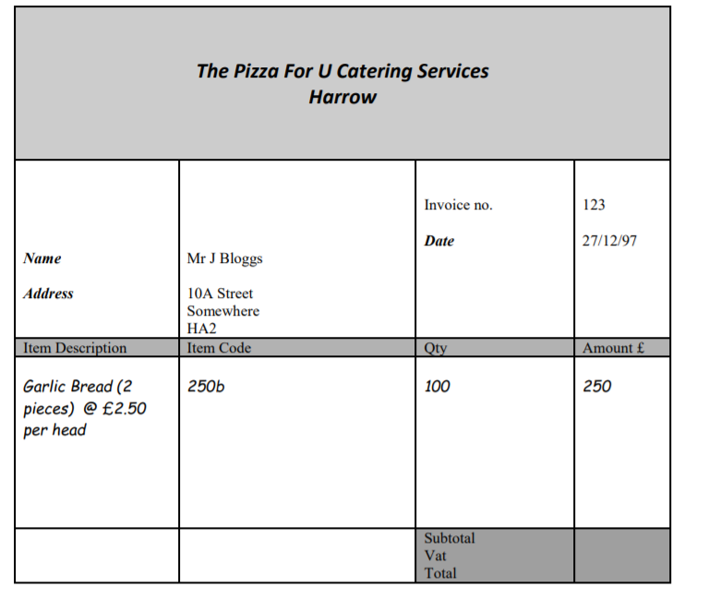

Fig. 1 ERD Diagram
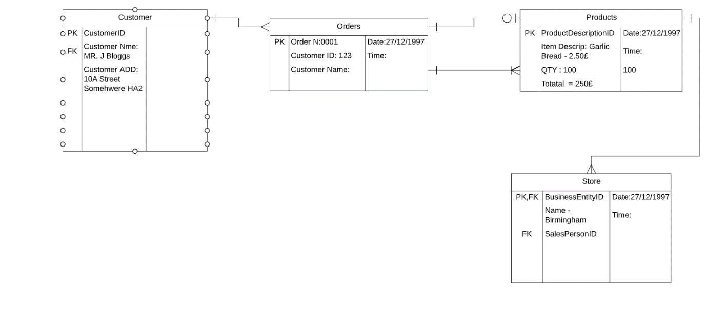

Tables | User requirements | Fields | Relationships
Customer | It holds the fields with employee’s personal information. | Customer ID  CustomerfirstName  CustomerlastName  Postcode ID somhwere | One to many
Orders | It holds the fields with employee’s personal information. | Order number,  Customer Id  Customer Name | One to one and one to many

Fig 2: DFD Level 1
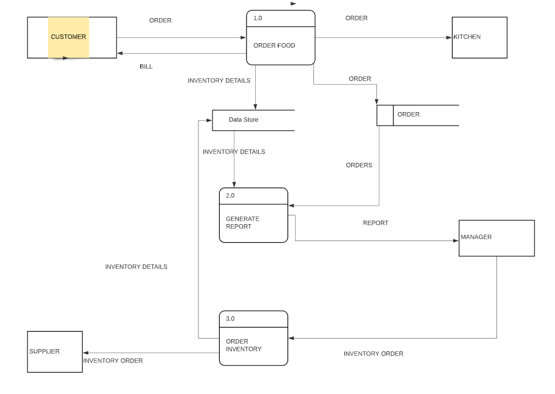

Conclusion

The Food Order System Data Flow Diagram instance incorporates 3 procedures, 4 outside entities, and information shops.

Based on the diagram, we recognize that a Customer can region an Order. The Order Food manner receives the Order, forwards it to the Kitchen, save it within the Order information shop, and save the up to date Inventory details within the Inventory statistics keep. The procedure additionally can provide a Bill to the Customer.

The Manager can receive Reports through the Generate Reports technique, which takes Inventory information and Orders as input from the Inventory and Order statistics keep respectively.

The Manager also can initiate the Order Inventory technique by means of imparting Inventory order. The process forwards the Inventory order to the Supplier and shops the up to date Inventory information in the Inventory data save.

