Title: Developing a project within an organization.
Project Name: Spread Joy, Donate Toys

Lecturer: Rebecca Francis-Davies
Student: Nicoleta Bichir
Student number: 2126694

Executive Summary:
It is all about bringing our community together. The project aims to foster community, increase awareness, and support underprivileged children by collecting toy donations. We aim to engage with the community, families, and friends to achieve this goal. This project uses several different tools to ensure smooth operation. To achieve positive outcomes, we used the following tools: quad charts, work breakdown structure, Gantt charts, risk analysis, and stakeholder analysis to help us plan, do our work, and keep things running smoothly.

We have worked closely with charitable organizations like Sense Charity and Cancer Research to complete our mission. Our engagement with stakeholders has been extensive, including personal visits to charities and regular communication through email and WhatsApp with student colleagues via the Student Union.

The project identifies potential risks, such as insufficient donations, storage limitations, and transportation issues. It implements mitigation strategies such as increased promotion, clear donation guidelines, and regular communication with charity partners. The WBS and Gantt Chart offer structured timelines and task management, guaranteeing a systematic approach to all steps.

Additionally, the project has limitations, including assumptions about resource availability and dynamic stakeholder interests that necessitate continuous monitoring and contingency planning.

Overall, Spread Joy, Donate Toy demonstrates a well-conceived project with strong stakeholder engagement and practical risk management focused on success with minor resource management and contingency planning improvements.

Contents
Executive Summary: 2
Introduction: 4
2.1.1 Aims of the tools and techniques used in project management within the workplace. 4
2.1.2 Quad Chart and iron Triangle in Project management. 5
2.1.3 Exploring the Iron Triangle tool? 5
2.1.4 Work Breakdown Structure (WBS). 6
2.1.5 Risk Analysis: 6
2.1.6 Stakeholder Analysis 7
2.1.7 Hard and Soft Evaluation 7
2.2.1 The quad chart for the project 8
2.2.2 The WBS for our Project Spread Joy, Donate toys 10
2.2.3 Stakeholder analysis for the Project 11
2.2.4 Risk analysis for the project. 13
2.2.5 Iron Triangle for Spread Joy, Donate Toys 15
2.2.6 Evaluation soft and hard for Spread Joy, Donate Toys 16
3. Stakeholders channels used for communication 17
4. Conclusion: 17
5. Appendices: 19
6. References: 23

Introduction:

This report, requested by Lecturer Rebecca Francis-Davies and compiled by student Nicoleta Bichir, is a comprehensive exploration of the development of a project within an organization. The 'Spread Joy, Donate Toys' project, which is the focus of this report, holds significant importance in skills development. The request was made on April 25, 2024, with a submission deadline set for June 28, 2024. The design of this report aims to critically evaluate the effectiveness of project management tools and techniques in managing a project within an organization. Additionally, it will plan the implementation of a project of appropriate complexity within a workplace and critically evaluate the ability to manage such a project. This report will provide a comprehensive analysis and practical application of project management principles to ensure the successful execution of the - Spread Joy, Donate Toys project completed by the ShareJoy team.

2.1.1 Aims of the tools and techniques used in project management within the workplace.

What is project management?
Project management, a crucial aspect of any project, applies knowledge, skills, tools, and techniques to project activities to meet requirements. The project manager, in particular, plays a pivotal role in this process. They must strive to meet specific project scope, time, cost, and quality requirements and facilitate the entire process to meet the needs and expectations of those involved in or affected by project activities.

Project management techniques and methods are theoretical concepts and practical tools that enhance project planning and management efficiency and effectiveness. When applied in real-world scenarios, any project can implement these principles, regardless of its field or sector. When used in conjunction with project management software, they help to save time and money, making them highly relevant and applicable in the context of our report (Schwalbe, 2009).
Their primary aims include:
- Enhancing Organization and Planning
- Improving communication and collaboration
- Strategic planning and evaluation
- Risk Management and Mitigation
- Efficiency and Productivity (Darling & Whitty, 2016)

2.1.2 Quad Chart and iron Triangle in Project management.

This technique provides a detailed explanation of the essence and purpose of a project. This process involves project scoping, identification of stakeholders, determination of intended objectives (key success factors), and establishing success measurements (secondary benefits). It is a concise and comprehensive project overview, combining visual elements with descriptive information. While useful for providing a concise overview, quad charts have several limitations that can obscure their effectiveness, particularly when used improperly, such as limited space for details, a lack of flexibility, and limited interactivity (Sanjuan & Froese, 2013).

2.1.3 Exploring the Iron Triangle tool?

Atkinson (1999) initially conceived the Iron Triangle as a framework to enable project managers to evaluate and balance the competing demands of cost, time, and quality within their projects. The team needs to position itself to meet these constraints (Morris & Sember, 2008), and the project manager needs to assess the impacts and create options when changes occur. The project manager must balance these constraints by understanding stakeholder priorities, facilitating productive discussions, and ensuring alignment and focus. However, the limitation is that it oversimplifies project complexities by focusing only on three constraints, potentially neglecting other critical factors like stakeholder satisfaction and risk management. (Ebbessen & Alex, 2013).

2.1.4 Work Breakdown Structure (WBS).
A work breakdown structure has the primary job to divide a project into smaller job components. It refers to the first phase of work organization, where complex details are carefully and systematically considered. A project manager can utilize a work breakdown structure to break a project into distinct stages, deliverables, activities, tasks, business units, and other components (Norman, 2008). However, like any tool, it has limitations. Individuals frequently regard the WBS as an inflexible framework. Once implemented, making modifications without impacting the entire project plan might be challenging. This inflexibility could be disadvantageous in dynamic project situations where changes occur frequently (Haugan, 2011).

2.1.5 Risk Analysis:
The main purpose of implementing risk analysis is to provide practical support for decision-making. A few of its strengths: Risk analysis allows project managers to identify potential issues before they occur, enabling proactive mitigation strategies. Early risk identification allows for more efficient resource allocation to address potential issues. A thorough risk analysis can increase stakeholder confidence by comprehensively understanding project challenges (Aven, 2015). While risk analysis is a powerful tool, it is crucial to maintain a balance in project management. Some risks, particularly those related to human factors or external events, can be difficult to quantify. Risk analysis typically provides a snapshot at a specific time, but risks can change dynamically throughout a project. By acknowledging this, stakeholders can feel reassured that their input and other project management aspects are equally valued and considered (Aven, 2015).

2.1.6 Stakeholder Analysis
Stakeholder analysis is a crucial concept in project management tools. It involves identifying, categorizing, and prioritizing stakeholders based on their level of interest and influence to focus on those with the biggest impact on the project's success (Landau, 2023). Therefore, the strength of this tool is that stakeholder analysis provides a holistic view of all parties involved in or affected by a project, ensuring that no key players are overlooked. It assists in developing targeted communication strategies for various stakeholder groups, improving overall project communication. However, the tools demonstrate significant strengths; they also highlight the limitations of this specific instrument. Stakeholder positions and influences are subject to change, necessitating ongoing changes to the analysis (Sinha, 2023).

2.1.7 Hard and Soft Evaluation
Project evaluation is crucial for learning from mistakes and reflecting on successful strategies, thus improving future project outcomes. It enables teams to acknowledge their achievements and reinforces the importance of evaluation as an integral part of the project rather than a supplementary task. Soft evaluation emphasizes people's experiences, processes, and attitude changes, providing insights into the less tangible aspects of project performance. Hard evaluation focuses on measurable outcomes, such as solid, visible results and quantitative data, providing concrete evidence of success. Balancing hard and soft evaluations ensures a comprehensive assessment, addresses objective metrics and qualitative feedback, and fosters continuous improvement and stakeholder satisfaction (Schneider, 2024)

To ensure the success of the Spread Joy, Donate Toys project, we employed several key project management tools, including the Quad Chart, Work Breakdown Structure (WBS), Iron Triangle, Risk Analysis, and Stakeholder Analysis.

2.2.1 The quad chart for the project
The Share Joy project used the Quad Chart technique because it provided a clear and structured overview of our initiative. It outlined the purpose and aims, such as raising awareness about toy donations and their positive impact on underprivileged children. The chart detailed specific objectives, like collecting toys and promoting a campaign at Haywood House from May 20–24. Additionally, engage the university community and collaborate with charity partners such as Sense Charity and Cancer Research. The tool ensured that all relevant parties were considered by identifying key stakeholders, including charity, the student body, the university, and the Student Union. The measurable and unmeasurable outcomes were clearly defined, helping us set realistic targets and track our progress. Overall, the Quad Chart facilitated effective communication, planning, and execution, significantly contributing to the project's success (Keenan, 2020).
Purpose  Aims  - Raise awareness about the importance of toy donation and its positive impact on underprivileged children  Objectives:  - Collect new or gently used toys for distribution to local charity shops  - Engage university students, staff, and local community members in a charitable cause  - Collaborate with charity partners to ensure the donated toys reach the intended beneficiaries  - Promote values of giving back and social responsibility | Stakeholders  - Students  - Charity Partners  - University  - Student Union  - Children
Desired end result  - Collection of at least 50 toys by the end of the project  - Increased awareness and positive feedback from participants and beneficiaries  - Measurable: The project was successful with 94 toys collected  - Unmeasurable: Enhanced community spirit and ongoing interest in future charitable activities | Measure of success  - The project was successful with 94 toys collected, surpassing the target  - Positive feedback from students, charity partner, and community

2.2.2 The WBS for our Project Spread Joy, Donate toys
The impact of the WBS tool for our Spread Joy, Donate Toys project offers a structured approach to guarantee the completion of all necessary steps, including defining the project scope, setting up collection boxes, and launching an awareness campaign. We included clear pinpointing collection locations, such as classrooms and university common areas for the other students. Moreover, I involved all my friends and family members to contribute to this mission. The project determines the collection period and identifies charity shops that accept donations. This organized method is crucial for successfully executing even small projects (Decision, 2008).

WBS for Spread Joy, Donate Toys


1.1. Define project scope and objectives
1.2. Identify stakeholders
1.3. Develop project timeline
1.4. Identify collection locations
1.4.1. Classrooms
1.4.2. University common areas
1.5. Determine collection period
1.6. Identify charity shops for donation

4. Closure and Evaluation
3. Processing and Donation
2. Collection
3.1. Sort collected toys
3.1.1. By age group
3.1.2. By type
3.2. Clean and sanitize toys
3.3. Perform quality checks
3.4. Package toys for donation
3.5. Contact selected charity shops
3.6. Schedule donation drop-offs
3.7. Arrange transportation
3.8. Deliver toys to charity shops
3.9. Obtain donation receipts
2.1. Set up collection boxes
2.1.1. In classrooms
2.1.2. In university common areas
2.2. Launch awareness campaign
2.2.1. Create posters and flyers
2.2.3. Send email notifications
2.3. Monitor and manage collection process
2.4. Regular collection box checks and emptying
4.1. Compile project metrics
4.1.1. Number of toys collected
4.1.2. Number of participants
4.2. Conduct post-project review
4.3. Prepare final project report
4.4. Share results with stakeholders
4.5. Celebrate project success

2.2.3 Stakeholder analysis for the Project
The next tool used by our project is stakeholder analysis, which is essential for identifying and understanding individuals or groups that have taken part in a project, assessing potential conflicts of interest, ensuring donation quality control, and building relationships for collaboration. In our case, it helps manage donors' preferences and organizational requirements for toy donations, facilitates logistical support and resources from the university administration, and provides students and faculty with practical experience (Mayers, 2005). However, it should be noted that it does face limitations, such as not fully meeting all stakeholders' needs. Furthermore, without the Student Union's advertising support, the project could not reach the student body effectively, resulting in lower participation and fewer toy donations (Sinha, 2023).



High | Project team(Share Joy) | Successful execution of the project, skill development, community impact, raise awareness | Regular meetings, clear role assignments, resource allocation. Engaging with the community.
Medium | Rebeca Francis-Davies (Lecturer) | Educational objectives met, successful project outcome | Regular progress reports, feedback sessions, adherence to project management principles
High | Student Union | Promoting student initiatives, community engagement, support for logistics | Advertising support.
Medium | Charity Partners | Receiving quality toy donations, supporting children and families. | Regular communication, clear donation guidelines, organized delivery
Medium | University Administration | Support for student activities, positive impact on university reputation | Formal proposals, regular updates, compliance with university policies (Freeman & Wicks, 2010).

2.2.4 Risk analysis for the project.
Implementing the risk analysis technique for the project is thorough and anticipatory, encompassing critical issues such as limited donations, storage limitations, transportation, hygiene aspects, damaged toys, and miscommunication. The plan gives us practical measures and suggestions such as expanded promotion, quality control inspections, and transparent communication channels, showcasing a comprehensive strategy. Moreover, the tool risk analysis provides a deeper plan to minimize potential problems, guaranteeing a smoother process, and we needed to extend our campaign for one week more and to change our donation to different stakeholder partners (Raftery, 2003)

Impact (H/M/L) Likelihood(H/M/L) Risk
H | M | Insufficient toy donations | - Increase promotion efforts on campus and social media  - Extend collection period
H | L | Damaged or unsafe toys | - Implement thorough inspection process  - Provide guidelines for acceptable donations
M | H | storage space limitations | - Coordinate with university for temporary storage  - Arrange frequent drop-offs to charity shops
M | M | Transportation issues | - Arrange for rental vans  - Coordinate with charity shops for pick-up options
H | M | Hygiene concerns | - Implement cleaning and sanitization protocols
M | M | Miscommunication with charity shops | - Establish clear communication channels  - Schedule regular check-ins with partners

2.2.5 Iron Triangle for Spread Joy, Donate Toys

The tool that has three angles is Iron Triangle, focusing on cost, time, and quality, providing a useful framework for our project by ensuring a structured approach to balancing these constraints. The cost management was effective because we utilized university resources and volunteer support, though unexpected expenses could arise. Time management is well-structured with clear milestones, but coordinating with stakeholders and extending collection periods results in challenges. Moreover, it is crucial to consider changing the donation to charity. In the beginning, we were supposed to donate to Sense charity, but the limitation of the communication channel led to a delayed response, resulting in misunderstanding. With thorough inspection processes, quality control is essential, but maintaining high standards requires additional time and resources. Furthermore, this tool's limitation is its narrow focus, potentially overlooking crucial factors like stakeholder satisfaction and risk management, which are vital for the project's overall success.

TIME: Planning, collection, and delivery timeline

The number and condition of toys collected, and the success of the delivery
COST: transportation
Spread Joy, Donate Toys
(Collect and donate safe toys)

2.2.6 Evaluation soft and hard for Spread Joy, Donate Toys
If critical analysis of the evaluation of the project is performed, we can say that our project demonstrated strong planning and potential risk management, with soft strengths including effective stakeholder engagement through increased promotion and clear communication channels, which foster collaboration and support. We knew how to address potential conflicts of interest and ensure donation quality control. Hard strengths involve practical logistics like securing storage space, arranging transportation, and implementing hygiene protocols. Furthermore, the project assumes resource availability, which may not always be guaranteed, posing a hard limitation. Additionally, the dynamic nature of stakeholder interests and potential miscommunication present soft limitations. Overall, the project is well-conceived, with strong practical measures and effective engagement strategies (Crowford, 2004).

3. Stakeholders channels used for communication
Our team used Share Joy’s multiple communication methods. Our team demonstrated proactive engagement and direct communication by visiting both a sense and a cancer charity. The face-to-face engagement likely facilitated a deeper understanding and stronger partnerships with these organizations. We also visit Haywood House, where the campaign has been ongoing for a week. Emailing the student union, lecturer, and students exemplifies a formal approach, ensuring project documentation and establishing a transparent communication trail. On the other hand, WhatsApp groups offer a more immediate and interactive platform for discussions, quick updates, and real-time feedback, fostering a sense of community and collaboration among student participants (Troise & Camilleri, 2021).

4. Conclusion:
Our project could not have positive outcomes without the techniques and tools we implemented. We successfully employed various project management tools, using the quad chart, iron triangle, risk analysis, stakeholder analysis and WBS, to ensure effective planning and execution.

To further enhance our communication, we propose incorporating more immediate and interactive methods, such as scheduled virtual meetings or dedicated project management platforms, to supplement WhatsApp and email. This will help reduce delays and miscommunication. We recommend to managing regular feedback or survey sessions with stakeholders to monitor their satisfaction and address concerns immediately.

Putting into practice the above recommendations will improve future project's operational effectiveness and stakeholder satisfaction and ensure a more resilient and successful initiative.

As we conclude, it is very important to recognize the significant contribution it has made to our team's development across various essential project management skills. This practical gain for future projects with a stronger, more versatile skill set is a confirmation to our team dedication and effort. Finally, adaptability and problem-solving were key as we addressed challenges and adjusted plans, fostering a mindset of continuous learning, practical and improvement, a quality that we can all be proud of.

Appendices:
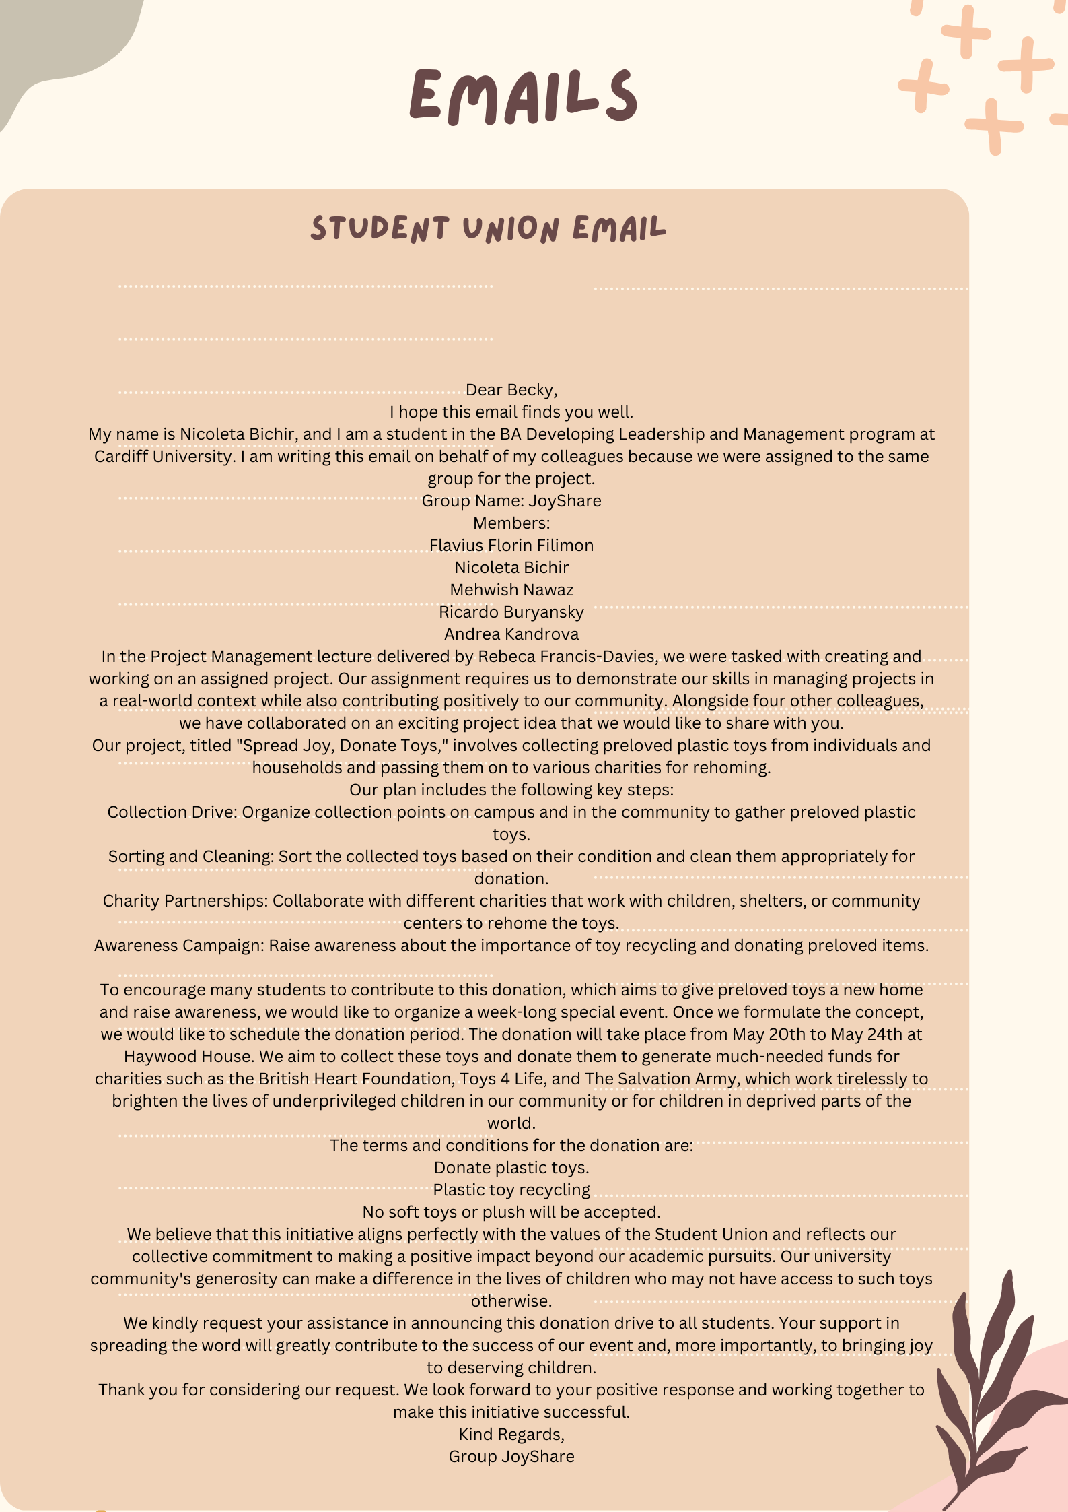

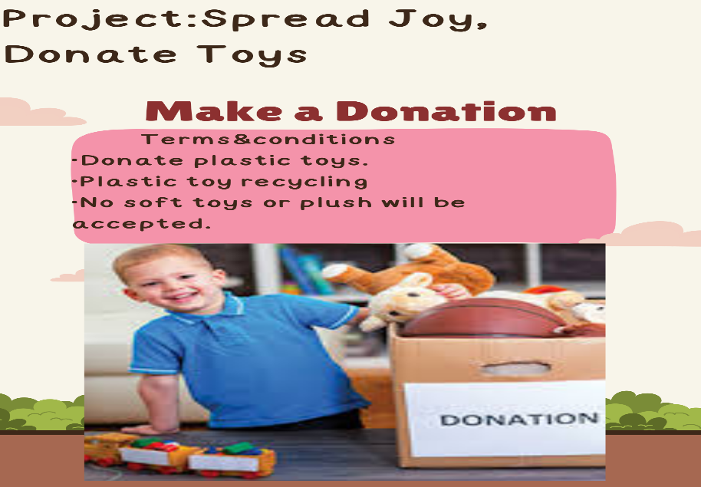

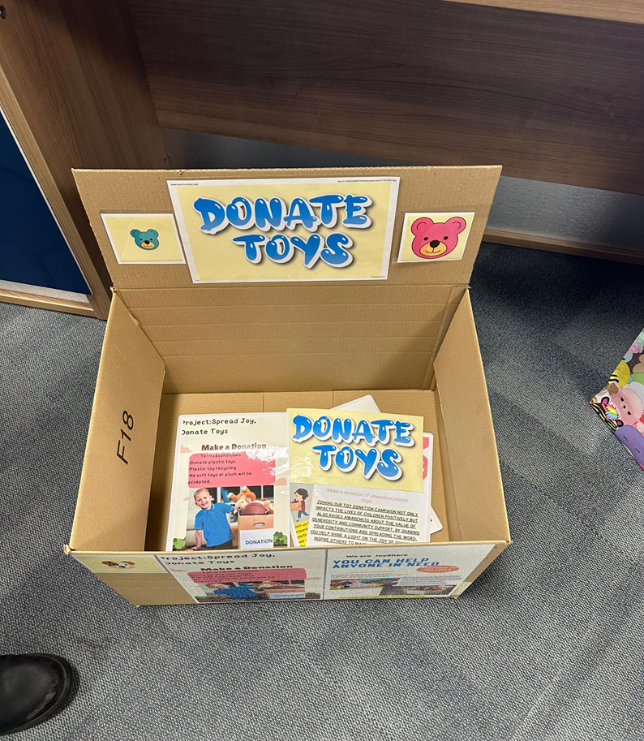

6. References:
Schwalbe, K. (2009). Introduction to project management. Boston: Course Technology Cengage Learning.
Accessed: [ 15 June 2024]

Darling, E.J. and Whitty, S.J. (2016), "The Project Management Office: it’s just not what it used to be", International Journal of Managing Projects in Business, Vol. 9 No. 2, pp. 282-308. https://doi.org/10.1108/IJMPB-08-2015-0083
Accessed at: [ 16 June 2024]

Sanjuan, A. G., & Froese, T. (2013). The application of project management standards and success factors to develop a project management assessment tool. Procedia-Social and Behavioral Sciences, 74, 91-100.
Accessed at: [24 June 2024]
Available at: https://www.sciencedirect.com/

Keenan, R. (2020). A brief intro to Quad(rant) charts. [Online]
Available at: https://positioninginsights.com.au/quad-charts/
Accessed: [23 June 2024]

Ebbesen, Jonas Balshoej and Hope, Alex (2013). Re-imagining the Iron Triangle: Embedding Sustainability into Project Constraints. PM World Journal, II (III). ISSN 2330-4480
Accessed at: [20 June 2024]
Available at: https://pmworldjournal.com/

Norman, E.S., Brotherton, S.A. and Fried, R.T., (2008). Work Breakdown Structures: The Foundation for Project Management Excellence. Hoboken, NJ: John Wiley & Sons.
Accessed at: [ 22 June 2024]
Available at: https://catedras.ugr.es/openpm2/sites/webugr/copenpm2/public/inline-files/PM2_Tools.pdf

According to Aven T. (2015), Risk analysis, Second edition, John Wiley & Sons. University of Stavanger, Norway.
Accessed at: [ 25 June 2024]
Available at: [ Online]

Crawford, L., & Pollack, J. (2004). Hard and soft projects: a framework for analysis. International Journal of Project Management, 22 (8), 645-653.
Accessed at: [ 25 June 2024]
Available at: https://doi.org/10.1016/j.ijproman.2004.04.004

Troise, C., & Camilleri, M. A. (2021). Digital media is used for marketing, CSR communication, and stakeholder engagement. In Strategic corporate communication in the digital age (pp. 161-174). Emerald Publishing Limited.
Accessed at: [ 27 June 2024]

Raftery, J. (2003). Risk analysis in project management. Routledge.
Accessed at: [25 June 2024]

Decisions, G. (2008). Effective Program, Project, and WBS.
Accessed at: [ 24 June 2024]

Haugan, G.T., (2011). Project Management Fundamentals: Key Concepts and Methodology. 2nd ed. Vienna, VA: Management Concepts.
Gürel, E. and Tat, M., 2017. SWOT ANALYSIS: A THEORETICAL REVIEW. Journal of International Social Research, 10(51), pp.994-1006.
Accesead at: [ 26 June 2024]
DOI:10.17719/jisr.2017.1832

Available at: https://catedras.ugr.es/openpm2/sites/webugr/copenpm2/public/inline-files/PM2_Tools.pdf
Accessed at: [ 23 June 2024]

Ganttchart.com, 2024. About Gantt Charts. [online] Available at: https://ganttchart.com
Accessed at: 24 [June 2024]

European Union, 2015, page: 33. Project Management Tools & Techniques, v.2. [online] Available at: https://catedras.ugr.es/openpm2/sites/webugr/copenpm2/public/inline-files/PM2_Tools.pdf
Accessed at: [24 June 2024]

Masarira, M., Rahbarimanesh, A., Papadopoulou, K. and Sinha, J. (2023). 'Stakeholder dynamics and their impact on value creation for industrial maintenance projects-a literature review', Research Gate. Available at: https://www.researchgate.net/publication/376993825_Stakeholder_dynamics_and_their_impact_on_value_creation_for_industrial_maintenance_projects-a_literature_review
Accessed: [13 June 2024]

Landau, P. (2023). Project Management Stakeholder Analysis 101 (Example and Template Included).
Available at: [Online] https://www.projectmanager.com/blog/stakeholder-analysis
Accessed: [11 June 2024].

Schneider, A., (2024). A complete guide to project monitoring, project evaluation, and project control.
[online] Available at: https://moodle.uwtsd.ac.uk/course/view.php?id=10964&section=6
Accessed at: [ 27 June 2024]

