An Exploration in Hans Bellmer’s erotic views of the female form and how this reflects on society’s view of women.

Lauren Tyler

Submitted in partial fulfilment of the requirements for the degree of BA (Hons) Photography in the Arts
University of Wales Trinity Saint David, Swansea
12th December 2018

List of Contents
List of Illustrations Page 3
Summary of Topic Page 6
Introduction Page 7
Bellmer’s Key Works Page 8
Inspiration and Influences Page 12
Social Influences of Bellmer’s works and its relevance to today’s society Page 20
Artists who discuss similar themes to Bellmer Page 26
Conclusion Page 31
Bibliography Page 33

Word Count:
5654

List of Illustrations
Figure 1: Bellmer, H. (1934). Die Puppe. [photograph]. Available at: https://theartsack.com/artists/hans-bellmer/la-poupee-berlin (Accessed: March 2018)
Page 8
Figure 2: Cochran Lambdin, G. (1882). Climbing Roses. [Giclee Print]. Available at: https://www.beverlyamitchell.com/climbing-roses-by-george-cochran-lambdin.html (Accessed: December 2018) Page 9
Figure 3: Bellmer, H. (1936). Die Puppe. [photograph]. Available at: https://el-gerund.livejournal.com/155334.html (Accessed: March 2018) Page 10
Figure 4: Sohl, M. (2017). Mark Schowalter as Spalanzani, Erin Moley as Olympia, and Christophe Mortagne as Cochenille in Offenbach’s Les Contes d’Hoffman. Available at: https://theepochtimes.com/vittorio-grigolo-stars-in-the-tales-of-hoffman-at-the-met_2338820.html (Accessed: November 2018) Page 12
Figure 5: Paul Rubens, P. (1632). The Judgement of Paris. [painting]. Available at: https://www.nationalgallery.org.uk/paintings/peter-rubens-the-judgement-of-paris (Accessed: December 2018) Page 13
Figure 6: Bellmer, H. (1934). Die Puppe. [photograph]. Available at: https://www.pinterest.co.uk/pin/475270566904545896 (Accessed: March 2018)
Page 14
Figure 7: Unknown. (2017). Founder and CEO of Realbotix Matt McMullen stands beside one of his female sex bot creations. Available at: https://www.dailiymail.co.uk/new/articles-524155/male-sex-robots-bionic-penises-coming-2018.html (Accessed: April 2018) Page 16
Figure 8: Bellmer, H. (1934). Rose Open at Night. [drawing]. Available at: https://avolona.com/bellmer-hans-1902-1975-rose-open-at-night.html (Accessed: October 2018) Page 20
Figure 9: Wiener Library Institute of Contemporary History. An idealised German family sheltered beneath the outstretched wings of the German eagle. [propaganda poster]. Available at: https://www.ushmm.org/propaganda/archive/poster-idealized-family (Accessed: December 2018) Page 21
Figure 10: Duncan, R. (1988). That’s an excellent suggestion, Miss Triggs. [cartoon drawing]. Available at: https://punch.photoshelter.com/image/1000eHEXGJ_wlmQ
Page 23
Figure 11: Bellmer, H. (1936). Die Puppe. [photograph]. Available at: https://el-gerund.livejournal.com/155334.html Page 24
Figure 12: Brener, A. (2017). Invisibler (breeze). [sculpture]. Available at: https://artspace.com/magazines/interviews_features/art-fairs/5-women-artist-redefining-feminist-body-art-at-nada-54642 (Accessed: November 2018)
Page 26
Figure 13: Sherman, C. (1992). Untitled #264. [photograph]. Available at: https://www.artnet.com/magazine/features/polsky/polsky10-10-7.asp (Accessed: November 2018) Page 28
Figure 14: Ray, C. Oh! Charley, Charley, Charley… [sculpture]. Available at: https://www.art-it.asia/u/admin_exPht/9qcilhtxkr4nigplijsx (Accessed: November 2018) Page 28

Figure 15: ORLAN. Available at: https://awarewomenartists.com/en/artiste/orlan (Accessed: November) Page 29
Figure 16: Bellmer, H. (1934). Die Puppe. [photograph]. Available at: https://www.artsy.net/artworld/hans-bellmer-la-poupee-the-doll-1 (Accessed: March 2018) Page 31

Summary of Topic

The aim of this dissertation is to explore the themes of Hans Bellmer’s work. I will focus mainly on his Die Puppe series and analyse how his images reflects society’s view of women at the time he was making this work and finding out if his work is relevant to today’s society. I will also be researching artists who present similar themes to Bellmer to see the change in the role women have in society since Bellmer made his work. To see if Bellmer’s work is relevant today, I will be studying various feminist texts and research the role of women today and compare it to the role of women during Bellmer’s time.

An Exploration into Hans Bellmer’s erotic views of the female form and how this reflects on society’s view of women.

Introduction

In this essay, I will be exploring the themes of Hans Bellmer’s work, his inspiration and influences and how women are represented, referencing artists who work with similar concepts, including Cindy Sherman and ORLAN. I will also be referencing feminist texts from books such as Mary Beard’s Women and Power and Natasha Walter’s Living Dolls: The Return of Sexism and reflecting on women in society today compared to women at the time Bellmer was creating his works.
I’m intrigued by Bellmer’s work as it relates to the themes that I’m researching for my current project. I want to construct my own doll to comment on society’s view of women today, how we are all obsessed with ageing and having the perfect look whilst also commenting on the recent news in the media about sexual misconduct in the entertainment industry and across many parts of society and how this is changing the position women have today.

Bellmer’s Key Works
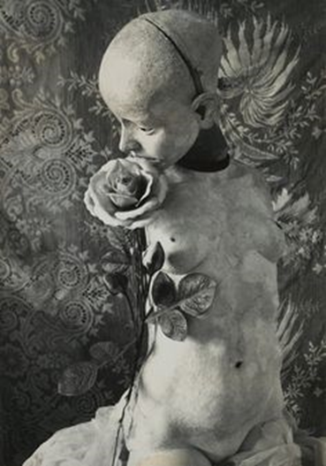
Figure 1 Die Puppe

The image in figure 1, one of Bellmer’s images from his Die Puppe series, fascinates me because of its beautiful yet disturbing nature. All of his images are disturbing, but this image stands out to me because I believe there’s more meaning behind it than the others. Bellmer has placed everything in this image in a certain way from the positioning of the doll to the way the rose leans against it. I was intrigued by the use of the rose so decided to research its symbolism. I found that the Romans would hang roses from ceilings at banquets, and then everyone would be aware that anything said at the banquet would remain confidential among the attendees. This is known as ‘sub rosa’, meaning secrecy and confidentiality. In the Middle Ages, roses were also hung from the ceilings of meeting rooms, then everyone understood that they were sworn to secrecy.
Commonly, roses are used in paintings to represent beauty and love. George Cochran Lambdin is considered to be one of the first artists to specialise in rose paintings. He was famous for the amount of detail in his rose paintings, as featured in figure 2. If Bellmer didn’t know the other symbolism of the rose, then it’s possible that, like other artists he’s using the rose to represent beauty and love. However, looking at the context of the work, it’s plausible that Bellmer has placed the rose next to the doll to symbolise confidentiality, that this doll is sworn to secrecy about what happens to her, sexually I assume, because she’s naked. It could also be to keep the doll silent in general, women’s voices weren’t taken seriously at the time Bellmer made these images, so it's plausible that the rose could symbolise keeping a woman’s voice silent. The doll is naked, showing that a woman ‘should be seen and not heard’. Her being naked could also present Bellmer’s erotic views of the female form and his views on the male power over women, how the female form can be manipulated to a man’s desire, in this case, Bellmer’s desire perhaps.

Figure 2 Climbing Roses

This particular doll seems more realistic because of the facial expression, which makes it more disturbing because the face could be passed as real. It doesn’t have hair, so a woman can look at this image and see herself because there’s no identifying features. The face is turned away from the camera to make the doll more submissive, making the viewer focus on the disturbing images of the body rather than giving it an identity and making it more real. This image is also the only image with a designed background from the Die Puppe series, all of his other images are either dolls on the floor, in beds or even hanging in trees, as seen in figure 3. I think the doll is presented to look appealing, almost like an advertisement, with the rose and the background. The face is slightly hidden, so it’s like a mannequin in a shop, focused on the clothes, only this doll isn’t wearing any, so if it isn’t selling clothes then perhaps it’s selling sex. This shows Bellmer’s view that a woman’s body is a commodity, and not something that is her own. This shows his manipulation of the female form and the male power over it, how a woman’s body doesn’t belong to herself.
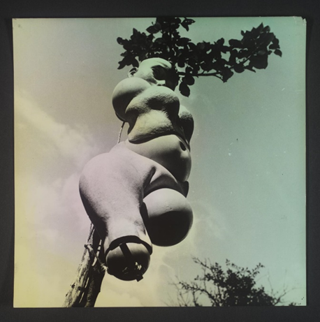
Figure 3 Die Puppe

Another way to look at the image in figure 1 is that it could represent grief or sadness, because it’s so decorative, but still quite dark. It has a melancholy feel to it, like it’s decorated for a purpose of celebrating life, like at a funeral a grave would be decorated with flowers. Giorgia Bottinelli, a critic for the Tate website, discusses Bellmer’s fascination with the loss of innocence in a critique on the Tate website.
With his Doll sculptures and photographs Bellmer appropriated and subverted the idea of the child’s toy. An erotic obsession, the Dolls incarnated his fascination for the corruption of innocence.
It’s plausible that Bellmer used the dolls to express his grief for the loss of innocence. This could be why he uses the doll, which was more commonly a child’s toy at the time Bellmer was making these works. He’s turned a child’s toy into a sexual object to express his grief.
The image in figure 3, also from his Die Puppe series, isn’t as much of an advertisement as in figure 1, but it’s similar because, like the first image, the face is hidden and there’s no defining features. I find this image disturbing in a different way to the first image, because the doll is strapped up in a tree and has no arms or legs, showing a woman’s powerlessness and her restrictions under the male regime. It’s not as decorative as figure 1, but I think it still has the same effect and is more erotic than the first. This shows his erotic views rather than being more melancholic like figure 1 could possibly be. It’s also another image that represents this idea of male power and how the female body wasn’t her own back when Bellmer was making these works, the tree could represent the restrictions that women were strapped into.

Inspiration and Influences
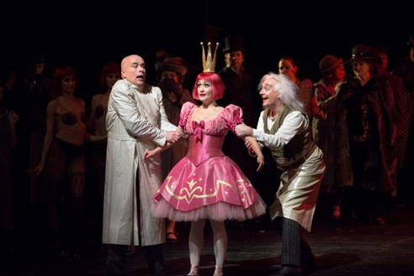
Figure 4 Les Contes d’Hoffman

Bellmer had two main influences for his work, the first being Jacques Offenbach’s opera, The Tales of Hoffman (Les Contes d’Hoffman, figure 4) which featured the hero, Hoffman, falling in love with a mechanical doll created by two scientists. I found this story very interesting, looking at who created the doll, Olympia, I believe that Hoffman didn’t fall in love with the doll but instead fell in love with the male idea of the perfect woman. Having been created by two men, she was made in the male image rather than representing an actual woman. This story made me think of classical paintings depicting the Judgement of Paris, such as the painting by Paul Rubens featured in figure 5. The painting depicts a contest between the three most beautiful Goddesses, Aphrodite, Hera and Athena. Olympia isn’t necessarily being judged by Hoffman but like Paris chose the most beautiful Goddess, Hoffman chose the most beautiful woman, even though she isn’t a woman but a constructed mechanical doll.

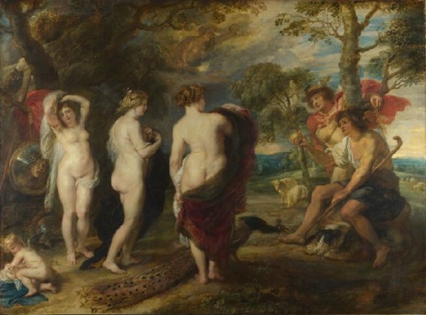
Figure 5 Judgement of Paris

Bellmer’s work also showed his fascination with the erotic writings of De Sade, who wrote stories that showed his sadistic sexual fantasies which included heavy violence and suffering whilst also showing blasphemy. We can see these themes in Bellmer’s work through the way he positions his dolls, they’re all very submissive and shown to only be used to live out sexual fantasies, possibly like the ones De Sade describes in his stories. Freelance writer, Douglas Hawk wrote about De Sade’s most famous story Justine for Pen and the Pad’s website,
After depicting Justine’s cruel treatment by brutal and corrupt people and portraying all sorts of horrific abuses headed upon her, De Sade rationalises the novel by informing readers that Justine’s fate was a moral lesson and that ‘true happiness is to be found nowhere but in Virtue’s womb, and that if, in keeping with the designs it is not for us to fathom, God permits that it be persecuted on Earth, it is so that Virtue may be compensated by Heaven’s most dazzling rewards’.
It’s almost as if it’s Justine’s fault that she had to go through all these horrible events, and that she was being judged so that when she died, she would be rewarded in Heaven. It’s possible that this is what Bellmer’s showing in his work, that these women are being put through these sexual abuses so that when they die, they will be rewarded in the Afterlife.
I think that De Sade is right that these women will be rewarded in the Afterlife after going through these ordeals, however I don’t agree with his view that it’s the only reason that they will be rewarded in the Afterlife. I believe that we are given other challenges in life other than being put through ordeals like the ones De Sade describes in his stories. I don’t think that women have to go through these ordeals to be rewarded like De Sade does, there are other ways to prove our worth to be rewarded.
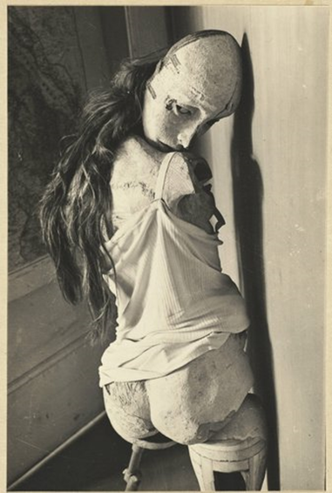
Figure 6 Die Puppe

It could also be said that Bellmer isn’t in fact inspired by these works but is actually criticising them, I think that Bellmer’s erotic views of the female form is more of a critique of De Sade and The Tales of Hoffman, rather than his actual beliefs. Perhaps he’s using the dolls to express his views against these erotic views rather than expressing his own fantasies. As I’ve mentioned before, perhaps his images are showing more grief and sadness than anything else.
Bellmer’s work not only consists of his images of dolls but he also drew disturbing images of children, which further shows his fascination for the corruption of innocence. Art historians such as Hal Foster and Rosalind Krauss discuss his erotic manipulation and how he uses his work to express his fears.
In his sadistic scenes Bellmer leaves behind masochistic traces; in his erotic manipulation of the doll he explores a sadistic impulse that is also self-destructive. In this way the doll may go inside sadistic mastery to the point where the subject confronts its greatest fear: its own fragmentation and disintegration.
Foster suggests that Bellmer fears the disintegration of the female form, and how it’s been manipulated so much by male power it’s become something so dismembered, which is why perhaps Bellmer has taken parts away from the dolls like their arms and legs.
Rosalind Krauss writes that Bellmer uses doll imagery as a tactic.
To produce the image of what one fears, in order to protect oneself from what one fears – this is the strategic achievement of anxiety, which arms the subject, in advance, against the onslaught of trauma, the blow that takes on by surprise.
Both historians agree that Bellmer uses the dolls to express his fears of the disintegration of the female form, perhaps he photographed the dolls in these positions because he fears that this will become a normality soon. I agree with Krauss and Foster that these photographs are used as a tactic. Bellmer built his first doll along with his wife so it could be possible that these dolls will one day be his wife. Perhaps he fears the future of women in society, that they will always be overpowered by men. At the time Bellmer was making these works, women weren’t their own person and didn’t have control over their lives, so I believe that Bellmer made these works to show the extreme power men have over women.
It could be said that Bellmer’s fears have been realised, there are still men who want to dominate women, even though women have more rights than before, our advancement in technology has given men new ways to dominate women. I watched a documentary on Channel 4 called The Sex Robots are coming which follows the company, Realbotix, as they develop the first ever sex robot with AI technology. The documentary shows the views of the developers, sex doll enthusiasts and those against the development of these sex robots.

Figure 7 Founder and CEO of Realbotix, Matt McMullen stands beside on of his female sex bots

The CEO of the company, Matt McMullen, pictured in figure 7, started creating hyper-realistic dolls as an art project but found that there was a market to sell them as sex dolls after being approached by multiple men asking if they could have sex with them. McMullen then took it further by making the dolls fully customisable, so men could decide how their doll looked from the colour of their hair to the size of their nipples. After the success of these dolls McMullen developed his new company, Realbotix and put together a team to start development on the first ever sex robot.
This is, I think, going to be a very big marketplace. 50 years from now, with the way technology is moving forward it would not surprise me one bit if sex robots were as commonplace as porn.
The documentary follows the company 4 years into their development, so we see that the robot is in the prototype stage. The documentary shows them inviting a sex doll enthusiast, James from Atlanta, to meet the sex robot so that they can test out her AI technology and the app that comes with the doll so that it can be communicated with. In James’ view, sexual relationships with sex dolls are only a small part, and that most doll owners find pleasure in looking after them and dressing them. When he meets the sex robot, named Harmony, he claims that it was like talking to a real person, It’s unusual and rather disturbing to watch someone communicating with a robot and then describing it as if they were talking to a real woman, it’s scary to think that this will become the norm, as McMullen believes, and that maybe men prefer speaking to these robots rather than an actual woman because they have complete control over them.
We also see the views of those against the development of these sex robots, one being Dr. Kathleen Richardson of De Monfort University, who has actually launched a campaign against them.
These sex robots, they’re modelled on pornographic representations of women. And they further keep reinforcing the idea that women are nothing but vaginas and breasts that can be removed and modified and explored. It’s kind of sending out messages of control and encouraging their misogyny against women.
I agree with Richardson’s view of the development of sex robots, they’re giving men the chance to have complete control over a female form and telling men that this is okay, and that if a real woman won’t bend to their ways, there’s an artificial woman that will
There is a definitive link between what is happening now with the development of these sex bots and The Tales of Hoffman, almost like the story predicted the future. These men are growing attachments to these dolls like Hoffman grew an attachment to Olympia. It’s also this idea of control over the female body, the fact that the bots will be customisable means that men will have complete control over how they look and will be able decide when they have sex with them and will be in charge of the conversation. It’s disturbing to think that men will now have the opportunity to be completely dominant over a female form.
It’s possible that this is what Foster and Krauss discuss, this idea of disintegration of the female form and therefore women become nothing but a man’s toy. Referring to the fears that they mention, it’s possible that this is what Bellmer feared and this is why he used mechanical dolls of his own in his work. He’s showing that one day actual women won’t be enough, and society will develop the ‘perfect’ woman like in The Tales of Hoffman, which this documentary shows is happening.
McMullen is currently developing a male version of his sex robot as well, but it hasn’t caused as much controversy as the female bot, perhaps because there isn’t as much of a demand for male sex bots as there are for the female bots. This shows again this male domination over women.
Natasha Walter discusses hyper-sexualisation in today’s culture in her book, Living Dolls: The Return of Sexism. She talks about how we have an illusion of equality, young women are told that pole-dancing is empowering, for example, because they choose to do it, but it’s still a pornographic act for men’s entertainment. Other examples include pornography and Playboy-branded commodities. Walter isn’t criticising these choices, but she points out in her book that these choices are dangerous because it gives women the illusion that they are equal to men because they have a choice. I agree with some of her points, I think that women have the right to choose the career path they want whether it’s sexual or not, but maybe she’s right that by choosing these careers they’re handing over power over their bodies to men.
Bellmer’s work reflects this idea of women’s bodies being made as commodities for sex, his sexual images show the same themes Walter discusses in her book and his work is also reflected in McMullen’s development of the sex bot. It’s plausible that Bellmer made his work to warn society of these scenarios, and yet they’ve happened. Our technology has developed a new kind of misogyny where men can choose a sex bot over an actual woman and even though women can use sex as their power over men, it could still be said that men still hold the power.
It could also be said that Bellmer and McMullen are very similar in that they’ve created their own versions of the female form. They create them for different reasons, but it could also be possible that they’ve created them for the same reasons if Bellmer has indeed created his doll to show his erotic views, they’ve created their dolls for the purpose of expressing their sexual desires.

Social influences of Bellmer’s work and its relevance to today’s society
Figure 8 Rose Open at Night
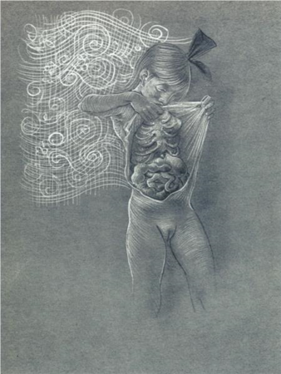

Bellmer’s work was highly influenced by the time and place he was making his work, during the rise of Nazism in Germany. He used the dolls to make judgement on the rise of the Nazi regime, he constructed the first doll before he left Berlin to join the surrealists in Paris in 1938. It is said that the first doll ‘emerges as a powerful tool for social critique, and a violent attack on stereotypes and the promotion of an idealised Aryan race’, meaning that Bellmer was using the dolls as a critique of Hitler’s idea for the perfect race. In Hitler’s view, men were supposed to be the providers for families and women were to stay at home and bare children and be housekeepers.
It’s not just his dolls that make these comments, his drawings of children could also present his views of the Nazis, as featured in figure 8. Children were made to follow the Nazi regime from a young age through camps such as the Hitler Youth (Hitler Jugend) which taught boys about being in the military, preparing them to fight in wars when they grew up, and teaching young girls how to look after their families and their husbands.

Figure 9 An idealised German family sheltered beneath to outstretched wings of the German eagle

Hitler’s views of women were very ‘traditional’, he said that he believed women were equal but different to men, but in fact he only said this to get votes. His actual beliefs were that women were inferior to men, in Hitler’s eyes women were only good for looking after the family and producing children to secure his dream future of the Aryan race. He took extreme measures to make sure women were inferior to men, introducing the Law for the Reduction of Employment, that gave women financial incentives to stay at home and putting pressure on single women to give up their jobs to unemployed men. They were to wear plain clothes, flat shoes and not to wear any makeup, dye their hair in any way and weren’t allowed to wear trousers or short skirts. So, imagine Hitler’s fury when Bellmer’s work was produced, presenting naked women in all these sexual positions, going against everything Hitler believed about women. Bellmer’s showing the Nazi oppression of women in his own way, by displaying them in these vulnerable positions. Nazi propaganda showed women in domestic positions in the ‘perfect’ family, like the poster in figure 9, whereas Bellmer’s images shows the sadism behind the scenes.
Bellmer’s images are still relevant today, but there’s a different kind of oppression happening. Women are under a lot of pressure to have the ‘perfect’ body and have ‘perfect’ makeup, encouraged by social media stars such as the Kardashians. Girls and even boys now feel pressure to reach these almost impossible standards, making the image in figure 1, relevant because it’s this idea of advertising the perfect body. Referencing back to the rose in figure 1, there are still secrets being held by women today, as can be seen in the Harvey Weinstein scandal and women talking about their sexual harassment stories in the #MeToo campaign. These stories coming out show the pressures women are under in the entertainment industry, hiding away these secrets because of their fear of being overpowered by these men and not wanting to risk their careers by releasing these stories.
In today’s society we are closer to equality than back when Bellmer was making these works, but we still have a long way to go, women are still stereotyped as housekeepers rather than working towards a career. Granted, not as often as before but there’s still that underlying judgement that women aren’t as capable of doing well in certain careers than men are. Sexism in work may be subtler now but it’s still there. Mary Beard discusses sexism in the workplace in her book, Women and Power, how the female voice is silenced, and any suggestions aren’t taken as seriously as when a man makes the same suggestion. An example comes from a Punch cartoon by Raina Duncan, featured in figure 10 with the caption, “That’s an excellent suggestion, Miss Triggs, perhaps one of the men here would like to make it.”
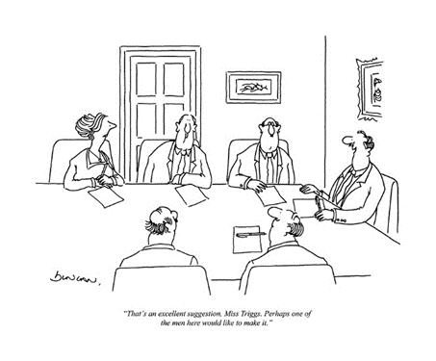
Figure 10 That’s an excellent suggestion Miss Triggs

Beard also points out that a lot of speech made by women are described as ‘barking’ and ‘yapping’ rather than giving them actual human speech.
There are only two main exceptions in the classical world to this abomination of women’s public speaking. First, women are allowed to speak out as victims and as martyrs, usually to preface their own death.
Even though Beard is discussing these issues about women’s voices in ancient times, it’s still relevant today. A perfect example is during the Presidential campaign between Donald Trump and Hilary Clinton. Trump was taken more seriously than Clinton simply because he was a man, even though his policies were more outrageous than hers were. Clinton was doubted as a leader simply because, as Beard points out, these attitudes against women are hard-wired into our culture. Society has taught us for centuries that women are inferior to men and this causes people to still undermine women today.
One of the biggest women’s rights issue today is the abortion issue, which comes up most often in political discussions and in the media. It’s become a very controversial topic but without the right to an abortion the government are essentially removing a woman’s right to choose what she wants to do with her own body. Personally, I believe that women should have the right to choose whether they want a family or not, a choice women didn’t have in Nazi Germany, as Hitler demanded that women have children so that his dreams of an Aryan race could be realised. Now they have the right to choose and there are still people who want to relinquish that right.
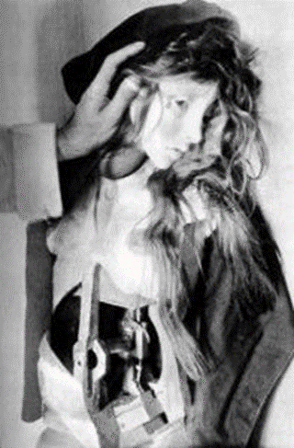
Figure 11 Die Puppe

We can see the difference in men and women in society in something as simple as sex, when a man has many sexual partners he is known as a ‘stud’ but when a woman has just as many, it’s more frowned upon and she’s called names such as ‘slag’ or ‘slapper’. Why are there different views for a man and a woman even when they’ve had the same number of sexual partners? It’s another reason women feel under pressure, to find and keep a man instead of ‘sleeping around’ and being looked down on, whereas a man is encouraged to ‘play the field’ before settling down. It’s another example of men’s power over women.

Artists who discuss similar themes to Bellmer
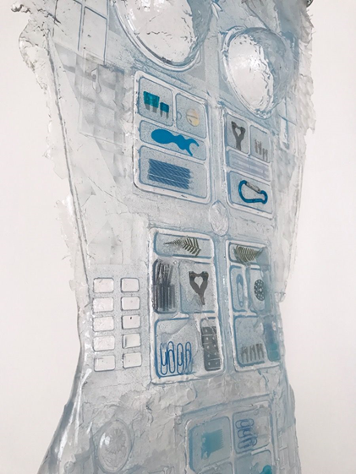
Figure 12 Invisibler (breeze)

Bellmer isn’t the only artist who uses the female form to make a social critique, over 80 years later artists are still sculpting in this way to criticise society’s view of women. One example is Amy Brener, who’s sculptures made of silicone represent this idea that a woman must always be presentable but is also invisible, which is why her sculptures are see-through.
Amy Brener reminds us how futile the ‘60s dream of ‘presentness’ is in our current virtual age. In her hanging sculpture, Invisibler, Brener renders the body not only literally ‘invisible’ in translucent silicone, but also compartmentalises it into small grid-like pockets filled with mundane objects like pills, paperclips and floss. In doing so she suggests the body is not simply an object of the male gaze today but merely an invisible container that no longer holds its form in the ‘breeze’ of digital space.
Amelia Ames, a writer for Artspace online, describes Brener’s work as a way of criticising society’s way of hiding away women and making them invisible, how their body is only for holding on to everyday objects. This is similar to Hitler’s view of women and how they were only housekeepers. In my opinion, Brener’s work is a modern way of discussing the same issues as Bellmer does in his, it’s subtler but still effective. Brener doesn’t sexualise the body but still criticises how the female body doesn’t belong to her and possibly discusses the male power over women, like Bellmer does.
Brener’s work may not be as sexualised as Bellmer’s, but there’s definitely some similarities in the way they use the female body to make social critiques during their times. Bellmer’s criticising the restrictions of women in his time whilst Brener is criticising how women are invisible. By comparing both artists, we can see a lot has changed for women in some ways but in other ways things haven’t changed. Brener basically highlights the same issues Bellmer does in his work but in a more contemporary way to represent the digital age.
Cindy Sherman is another artist who uses similar techniques to Bellmer to construct the body to photograph, in the book, Cindy Sherman, that accompanied her exhibition at the Museum of Modern Art, New York, Eva Respini wrote,
The relationship of sex pictures to Hans Bellmers experiments with dolls has been discussed numerous times in literature on Sherman. As a female author of her works, however, Sherman creates photographs that suggest a critique of the fetishes of male artists such as Bellmer and other surrealists who engaged in similar fantastical dismemberments of the female body.
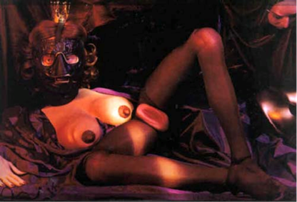
Figure 13 Untitled #264

Sherman uses her work with sculpting the female body to criticise Bellmer’s views, and maybe Bellmer’s fascination with sadism, that we can see in his inspiration from De Sade. Sherman’s work, unlike Brener’s goes against what Bellmer is saying by taking her sexual images to the extreme. Respini also suggests that Sherman was inspired by Charles Ray’s Oh! Charley, Charley, Charley…, pictured in figure 14. This shows further Sherman’s mocking of the male view of the female body. She dismembers the female body, perhaps to take back control of the female form.
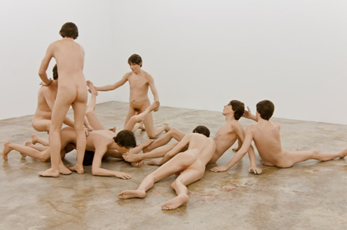
Figure 14 Oh! Charley, Charley, Charley…

Sherman’s interpretations are very dark and disturbing which makes them even more uncomfortable to look at, in my opinion, than Bellmer’s works. But it could also be suggested that Sherman’s work holds the same message as Bellmer’s. Her sexual images are very extreme, but them being extreme just brings up more similarities to Bellmer. So even though she’s criticising his work, she’s also making the same social comments he’s making.
ORLAN is another artist who uses similar techniques within her practice, but she takes it to a new extreme by having plastic surgery on herself and alters her body. In an interview for Artsy online, ORLAN said,
When I introduce myself, I say ‘I am ORLAN’, among others. And every letter of my name is written in capitals because I have no desire to step back into rank.
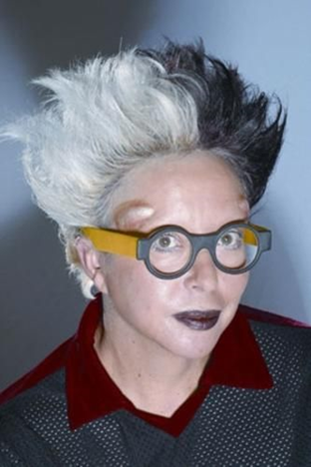
Figure 15 ORLAN

ORLAN discusses identity and goes beyond what’s the norm to make her point that everyone is individual. I feel like she also discusses similar issues to Bellmer as her work shows that a woman’s body is her own.
Women, as British film theorist Laura Mulvey once wrote, have historically been the bearers, rather than the creators, of meaning in visual culture. A woman’s body, at least as far as the male heterosexual gaze is concerned, is a series of codes. In art, she is often found nude, recumbent, and passive. Her body is heavy with culture and discourse. In making five decades’ worth of self-portraits, ORLAN has taken control of her own image and staked a claim to her body.
In comparison to Bellmer’s work, ORLAN is taking control of the female image by having surgeries done to herself and using her body to show that women should oversee their choices. This is an issue that is still raised today, as I’ve mentioned before with the abortion issue. Another issue raised frequently is that in some cultures there are practices involving genital mutilation to prepare a young woman for marriage, it’s brought up frequently as a violation of human rights as well as a violation of a woman’s right to choose what happens to her body. Whilst Bellmer is showing the oppression of women, ORLAN is representing the empowerment of women, and using her own body makes even more of an impact, showing she is willing to go to extremes to show her right to choose what happens to herself.
Like Sherman, it could be said that ORLAN is mocking the male view of the female body, yet how extreme her work is, her message is very similar to Bellmer’s, if Bellmer is showing criticism of the oppression of women rather than expressing his sexual fantasies.

Conclusion
Comparing these artists to Bellmer, I can see that his work is still relevant today because artists are still discussing these issues. I think Sherman’s work is more similar to Bellmer in terms of their erotic views of the female form and even though Sherman is mocking Bellmer’s work, they are still discussing the same themes. Their work discusses the male view of the female form, the oppression of women, and how the female body has become an object for sexual fantasies. It shows that not a lot has changed since the time Bellmer made his works, women aren’t as oppressed in the way Bellmer describes. But now there’s more sexual pressures for women, as Walter describes in her book. Women feel the need to use sex as a tool against them. Beard also discusses the oppression of women in her book, that even though women are more outspoken in today’s society, there’s still an underlying judgement that a woman’s voice isn’t as strong as a man’s voice.
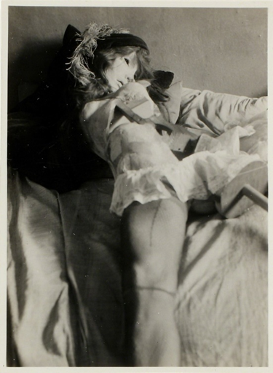
Figure 16 Die Puppe

Bellmer’s work reflects society’s view of women today by highlighting these issues, which goes to show this illusion of equality that Walter mentions in her work. Even though we have progressed in women’s rights, there is still a long way to go before women are fully equal to men.
I’ve learnt through my research of Bellmer’s work that there are loads more underlying themes in his work that I didn’t see before, and only after researching his inspiration for his work and finding links to other artists such as Sherman, I can see now that Bellmer’s work doesn’t just represent his erotic views but also criticises the Nazis belief of the role of women. They wanted to take away women’s rights to choose their own paths, which in some ways is still happening today, it’s not as obvious as Hitler made it, but we as a society have a habit of putting women in certain categories as Beard discusses.
In conclusion, regarding Bellmer’s work, I don’t think these erotic views are his own, but are in fact a criticism for the oppression of women but he expresses them using erotic imagery. It’s possible he uses images of women in submissive positions to criticise the work he was inspired by, Offenbach’s The Tales of Hoffman and De Sade’s stories. It has been written that Bellmer was inspired by these works and he shares the fascination, but another way of looking at it is that he disagrees with them, like Sherman uses erotic imagery to criticise his work. There is no way to find out which it is, whether he shares these erotic fantasies or is criticising them, because Bellmer isn’t here to tell us. Either way, as a society, there is still a long way to go for women’s rights if Bellmer’s work still has relevance today and if artists such as Brener and Sherman are still discussing these issues.

Bibliography
Ames, A. (2017). 5 Women Artists Redefining Feminist “Body Art” at NADA. Available at: https://artspace.com/magazines/interviews_features/art-fairs/5-women-artists-redefining-feminist-body-art-at-nada-54642 (Accessed: November 2018)
Artnet. Cindy Sherman. Available at: www.artnet.com/artists/cindy-sherman (Accessed: November 2018)
Basis, B. (2017). Vittorio Grigolo stars in The Tales of Hoffman at the Met. Available at: https://theepochtimes.com/vittorio-grigolo-stars-in-the-tales-of-hoffman-at-the-met_233820.html (Accessed: November 2018)
BBC. Life for Women and the Family in Nazi Germany. Available at: https://www.bbc.com/bitesize/guides/zxb8msg/revision/1 (Accessed: November 2018)
Beard, M. (2017). Women and Power. London. Profile LTD.
Bois, Y and Krauss, R. (1997). Formless: A Users Guide. New York
Bottinelli, G. (2004). Hans Bellmer, The Doll. Available at: https://www.tate.org/art/artworks/bellmer-the-doll-t11781 (Accessed: March 2018)
Foster, H. (2001). Surrealism: Desire Unbound. Tate Modern. London
FTD Fresh. (2016). Rose Flower Meaning and Symbolism. Available at: https://www.ftd.com/blog/share/rose-meaning-and-symbolism (Accessed: October 2018)
Hattenstone, S. (2011). Cindy Sherman: Me Myself and I. Available at: https://www.theguardian.com/artanddesign/2011/jan/15/cindy-sherman-interview (Accessed: November 2018)
Hawk, D. (2017). Synopsis of “Justine” by Marquis de Sade. Available at: https://penandthepad.com/synopsis-justine-marquis-de-sade-7463.html (Accessed: October 2018)
Jones, S. (2016). American Rose Artists: Perpetuating the Rose in Art – Part 4. Available at: https://scvrs.homestead.com/RoseArt4.html (Accessed: November 2018)
Leddy, S. (2017). At 70, Body Modification Artist ORLAN is still Reinventing herself. Available at: https://www.artsy.net/article/artsy-editorial-70-body-modification-artist-orlan-reinventing (Accessed: November 2018)
Morris, S. (2018). 8 Major issues facing women today. Available at: https://www.thoughtco.com/womens-issues-414020 (Accessed: November 2018)
Respini, E. (2012). Cindy Sherman. New York. The Museum of Modern Art.
Semff, M and Spira, A. (2006). Hans Bellmer. Art Books International.
Taylor, S. (2011). Hans Bellmer: The Anatomy of Anxiety. Cambridge, MA. MIT Press.
‘The Sex Robots are Coming’. (2017) Channel 4. 30 November.
Walter, N. (2011). Living Dolls: The Return of Sexism. Virago.
Webb, P and Short, R. (2006). Death, Desire and the Doll: The Life and Art of Hans Bellmer. London. New York.

Bottinelli, G. Hans Bellmer, The Doll (2004)
Marquis de Sade, 1740 – 1814
Hawk, D. Synopsis of “Justine” by Marquis de Sade (2017)
Foster, H. Surrealism: Desire Unbound (2001) p.208
Bois, Y and Krauss, R. Formless: A Users Guide (1997) p.196
McMullen, M. The Sex Robots are coming (2017)
Richardson, K. The Sex Robots are coming (2017)
Semff, M and Spira, A. Hans Bellmer (2006)
Duncan, R. That’s an excellent suggestion, Miss Triggs. (1988)
Beard, M. Women and Power (2017) p.13
Ames, A. 5 Women Redefining Feminist “Body Art” at NADA. (2017)
Respini, E. Cindy Sherman. (2012) p.38
ORLAN (2017)
Leddy, S. At 70, Body Modification Artist ORLAN is still Reinventing herself (2017)

