The Unhinged Narrative
By
Louis Burrows
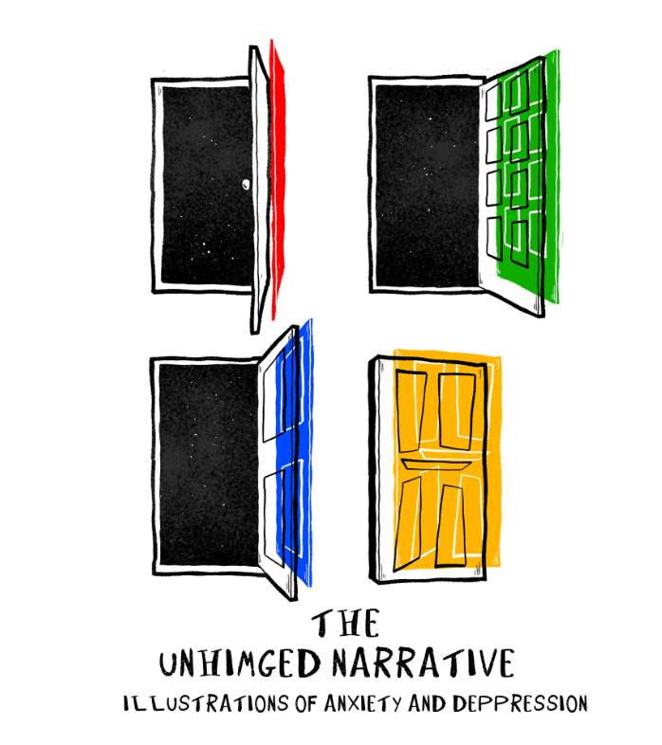
MA Contemporary Dialogues
Confirmative Praxis
Word count: 4841
Contents
Prologue Page 2
Introduction Page 3
Chapter 1 Page 4-11
Chapter 2 Page 12-16
Chapter 3 Page 17-20
Chapter 4 Page 21
Chapter 5 Page 22-24
List of Images page 25
Bibliography page 26
Prologue
Note to the reader: This prologue is to give an insight into why the topic of anxiety and depression has been chosen as the final part of my confirmative praxis.
This work began about a year ago in 2024, when I began to suffer with anxiety and a decline in my mental health. For a long time, I have wrestled with anxiety and depression and through my experiences, I took an interest in how to deal with it. In particular art therapy.
Like most people I would overthink have anxiety attacks and a constant what if? rolling through my mind. I locked myself away from the world and eventually sought help from family and medical professionals. During my time in counselling I was encouraged to keep a journal. I was encouraged to document my feelings and use an artistic outlet rather than a writing one. This ultimately led to the creation of this work. I used art as a therapy form. It was therapeutic and communicative and helped me visualise how I was feeling and how to process everything in a way that I better understood it.

Introduction
This report is an open and honest evaluation and discussion about the work that was produced for the final part of my MA. This report will be split into chapters and will give insight into anxiety, OCD and depression and how to deal with it through art therapy. The report aims at highlighting the importance of understanding mental health and to increase the knowledge about these conditions through art.
Anxiety and depression are two of the most common mental health conditions that affect many people in their everyday life and can be a silent struggle for many people, as one of those people I pose a question “what it is like to live with anxiety and depression?” and how illustrations can be used as a communicative act as well as therapeutic tool. This was one of the many aims of the MA confirmative praxis work titled, The Unhinged Narrative which focused on the topics of anxiety and depression and how it’s shown through the framework of a postmodern picture book. Through this medium it can highlight those everyday struggles with anxiety and depression in a fragment narrative, non-linear storytelling and symbolic imagery that can engage the viewer into to thinking about “what is like to live with anxiety and depression” but to also feel a personal connection. The viewer could connect with the storytelling narrative and see themselves in my experiences with mental health and feel connected by it and also supported in the knowledge that they’re not alone.
The second aim of this picture book was to encourage others to be more open about their mental health experiences as things like anxiety and depression can affect us all weather that be our own experiences or as well as of those we know in our own personal life. Ultimately this work demonstrates how postmodern illustrations can be used as a therapeutic and communicative act; it can also be used to transform personal struggle into a shared visual narrative that invites reflection and dialogue.

Chapter one
Why a picture book?
In creating this work I was asked once why I would choose to do a picture book rather than using the illustration themselves in a graphic novel. I considered this briefly, as this is usually my preference but then i remembered being shown a book by my lecturer called, The red tree by the author Shan Tan.
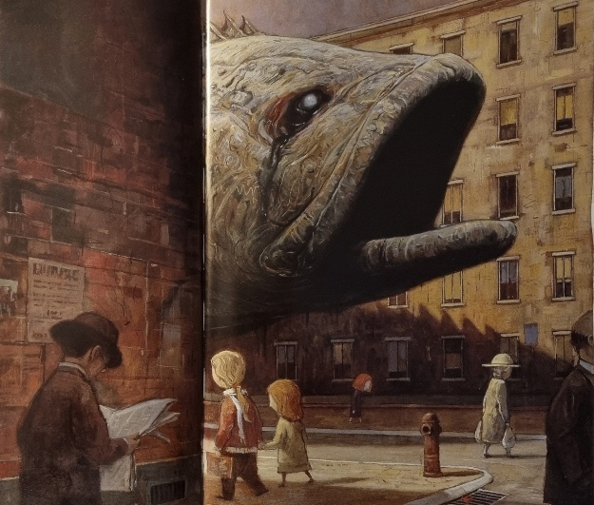
Fig. 1 The red tree 2003
When looking at this book I could not help but feel emotion. I saw myself in the main character and felt empathetic to the depression illustrated in the book. The book does not directly tell the reader that the little girl is depressed it uses imagery and subtle words and guides the reader into working it out for themselves. Look to figure 1 the illustration depicts an image of a rotten fish looming over the girl as she walks down the road with the words “darkness overcomes you” (Tan, 2001, pp 3). but nobody else sees this animal. This reinforces the idea that many people suffer in silence, and nobody can ever truly know what’s going on inside someone's head.

The Colour Monster
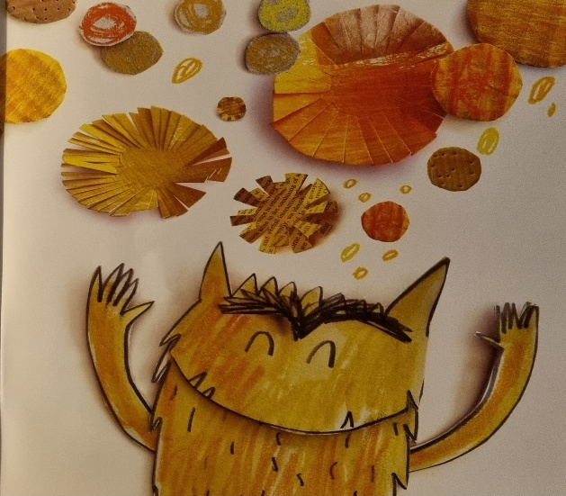
Fig. 2 The Colour Monster 2016
The Colour Monster by Anna Lleans, is picture book about a monster that is feeling all sorts of emotions. The characters of the book (a little girl and the monster) look more closely at what each colour means and the emotion that colour represents. This is interesting use of colour theory, for example fig 2 it shows the monster that the colour yellow means happiness, “This is Happiness it shines like the sun and twinkles like a star.” (Lleans, 2016, pp 12). The monster reacts with a facial expression of happiness in response.
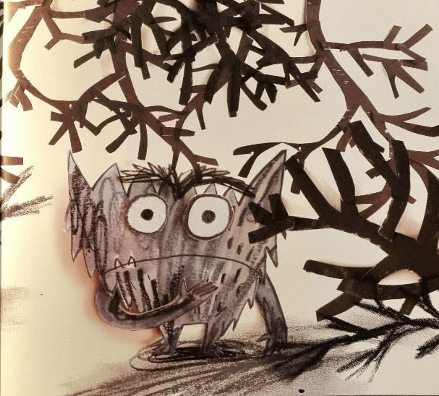
Fig. 3 The Colour Monster 2016
The page that I find most interesting and relevant to my work is fig 3 which shows what the colour black represents and why it is relevant. The colour black is shown to be the colour of fear (fig 3), “It hides and runs away like a mouse in the night” (Lleans, 2016, pp 23). Which in a fantastic way of describing fear and then representing it through the image. I took inspiration from this and decided to incorporate this in my work by using the theme of black and white. Black was a deliberate decision because I wanted it to represent how people with anxiety and depression hide their problems. And how the experience of depression can make it feel like there’s little light and colour in the world just like the way Anna Llenas used the monster to teach young people about emotions I wanted to convey that to the reader through my book.

The huge bag of worries By Virginia Ironside & Illustration by Frank Rodgers
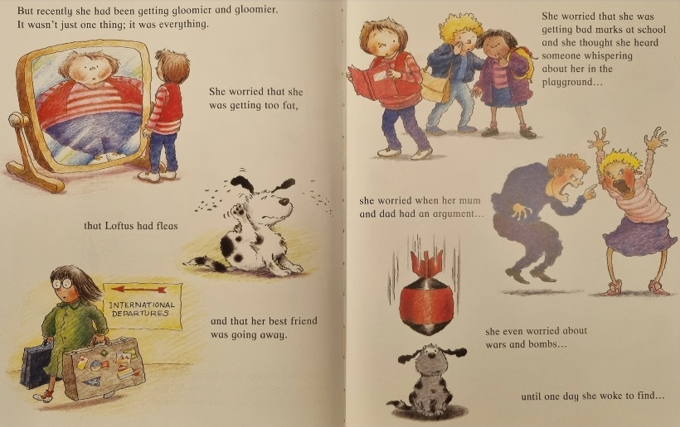
Figure 4 The huge bag of worries 2016
The huge bag of worries is a picture book about a girl called Jenny whose worries follow her in a big bag. This picture book is a great example of how worrying can play a big part in anxiety, fig 4 is example of how worries can play on our mind. At the top of fig 4 you can see that Jenny is worried about getting bad marks in school and if someone was whispering about her. This depicts how worries can play into out paranoia and exaggerate them.
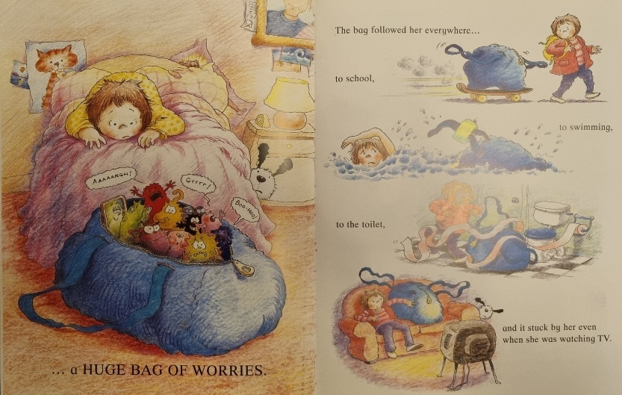
Figure 5 The huge bag of worries 2016
Figure 5 is great example of how our worries or problems can follow us around in our everyday lives even without us properly knowing them. The bag takes on a personality of its own almost like it was trying to physically interfere with Jennys life.
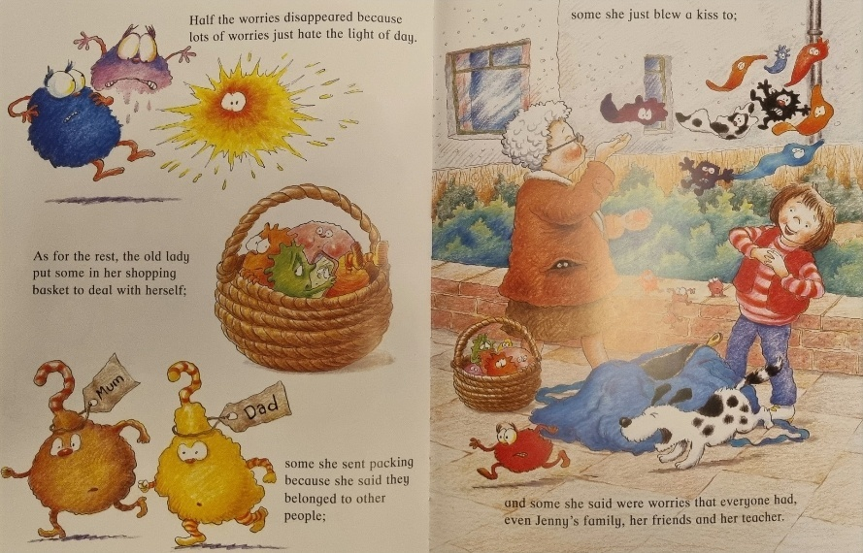
Figure 6 The huge bag of worries 2016
Towards the end of the book Jenny’s worries are taken out of the bag and what is interesting is the words that are used in the top left hand corner of figure 6 “worries just hate the light of day” (Ironside, 2016 pp. 20). This reminds me of my own personal experiences and how towards the end of my breakdown in felt like I’d I brought my worries to the light of day by asking for help. What this teaches young people is that it always better to talk about worries instead of repressing them or placing them in a huge bag.
Art therapy
At the beginning of the report I wrote that I used my illustrations as form of therapy to help understand and process what was happening. In this section of the report I will cover how illustrations can be used as a form of therapy.
Art Therapy is an adjunct to psychotherapy, facilitating the process through both image making and verbal exchange with the therapist. Others see art itself as the therapy; that is, the creative process involved in art making, whether it be drawing, painting, sculpting or some other art form, is what is life-enhancing and ultimately therapeutic.
(Malchiodi, 2011, pp 2.)
For myself the use of art therapy was very beneficial. It wasn’t about perfection anymore it felt more freeing. When I was drawing in my journal I tried not to care about things like style or weather it looked good. It was all about the emotion that went into it and when speaking to a counsellor about this they described some past experiences with other patients and how they found it helpful too. One patient would draw what makes her happy on days that she was happier and then bad things on the days she was not. It helped build her confidence and understand herself better. I liked the idea that art could physically improve your mind and mental health.
Social anxiety and obsessive compulsive disorder
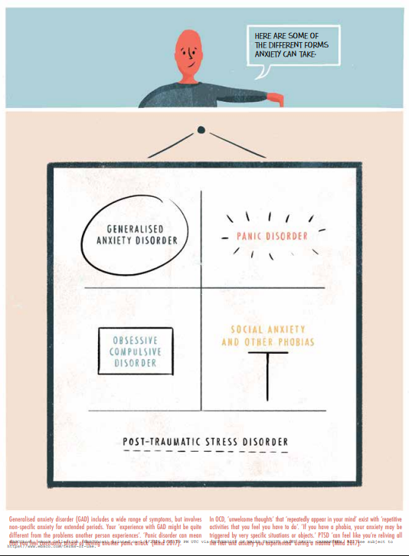
Figure 7 Anxiety is really strange 2018
My anxiety took the form of social anxiety and obsessive-compulsive disorder (OCD) although at the time I was unaware that I showed signs of OCD because my compulsions were internal as mentioned in chapter one. The relevance of four in this work is important. It's an example of my own OCD. As illustrated by Sophie Standing (fig7) in the book Anxiety is really strange, there are many different forms of anxiety and OCD such as, ‘unwelcome thoughts’ that ‘repeatedly appear in your mind’ exist with ‘repetitive activities that you feel you have to do’. (Haines, 2018, pp 8.).
Persons who have OCD have recurrent and persistent, intrusive and unwanted, unjustified, and anxiety- evoking thoughts or “obsessions.” They resist or reduce those obsessions by repeatedly performing some behaviour or “compulsion,” which can be mental or physical.
(Summers, 2019, pp 22.)

This is how my anxiety and OCD would appear. As a looping thought that would be in constant of what if and then heightened when I was in social situations. This part of the report delves into the pages of the picture book that I created to communicate what anxiety is like.
Social anxiety is an intense fear of being judged and scrutinised in social situations. It goes beyond shyness that some people may have and interferes with a person’s daily life, “Followed by situations such as meetings, social events (e.g. parties)” (Nutt, 2003, pp 95.) This can lead to a lot of symptoms such as avoidance and low self-esteem and in some cases physical symptoms sweating. shaking or even heart palpitations. I have struggled with social anxiety for all of my adult life in the past it has led me to avoiding social spaces parties an impacted relationships in social situations that I would almost find myself obsessing about. How would people see me? was I looking at people too long? should I look at the floor? question upon question would fill my mind and spiral. It reminded me of the book We’re all mad here by Claire Eastham she would write about her own experiences with social anxiety and in particular, there is a passage of the book where she wrote, “Lifts were another problem: I couldn’t bear the thought of a stilted conversation with a colleague. So, I ended up walking seven floors worth of stair every day” (Eastham, 2017, pp 10.).
Although I wouldn’t go as far as that I could feel the struggle of it. I found myself feeling with her descriptions because I would avoid also certain places or people just to avoid anxious feelings. I would think many other people would identify with Eastham and choose a longer way around longer routes and more difficult path instead of a shorter path just to avoid discomfort.

The relevance of Four
The picture book that I made takes place in four chapters with four illustrations on each page in acknowledgment to my OCD. I’d learn to recognise these compulsions in counselling and what it means to have it. I was made to realise that my kind of compulsion with the number four was a part of it. I had no idea OCD could be more than just being obsessed with hygiene. This led me to do my own researching into the subject and come across a book called The man who couldn’t stop the truth by David Adam. What is interesting about Adam’s book I think is that it’s meant to help people understand OCD.
It’s commonly seen as a behavioural quirk. In fact, OCD is server and crippling illness and one defined as much by the mental torment of recurring strange thoughts as physical actions.
(Adam, 2015, pp 7.)

It felt like someone had turned the light on whilst reading this book. I realised that my thoughts around the number four were repetitive and compulsive. Which is something I added in to the picture book and kept quiet because I wanted people to ask me why four? I wanted to explain it to people and ask them what they know about OCD too and what they know and intrusive thoughts like a communicative act.
The chimp Model
There is an interesting theory from the book The chimp paradox by Professor Steve Peters this book introduces a way of thinking about the human mind. It’s called the chimp management model the book writes “The three psychological brains in our model, the frontal, limbic and parietal, are called the Human, the Chimp and the Computer” (Peters, 2012, pp 3.). But I will focus on is the chimp. the chimp is described as “The Chimp is the emotional machine that we all possess. It thinks independently from us and can make decision.” (Peters, 2012, pp 4.) I took inspiration from this author by the way he uses animals to describe the subconscious for people to more easily understand complex problems.

Chapter two
Inky Sticky Squid
In one of my counselling sessions I was asked a few questions about my depression and what could be causing my depression at the time. When I remember the way I would talk about my depression I then think about a book by Shaun Tan titled the Little red tree. One section of the book that stuck was figure 1, depression was depicted as this huge rotten fish looming over the character which resonated more i pondered on it. I visualise my own rotten fish.
This is where Inky Sticky Squid came from. I described this creature that is able to wrap itself around me sticking to my mind and body and never leaving me. As time progresses the image of the creature slowly starts to come into shape. This is where we come to our first question of why an animal? For a long time in illustration animals were used a method of depicting things like emotions or feelings, and even people it serves as way for the viewer to have a better understanding of what the author or illustrator is trying to communicate to them.
Inky Sticky Squid was used as metaphor for my depression, a way not just for me to understand it but to also help the reader understand the shape that my depression takes as “Depression continues to be a common, complex, and detrimental mental health disorder with as significant impact on society and individual quality of life” (Durbano, 2024, pp 1.). Relating this back to chapter one about how art therapy can be used as tool for with mental health.
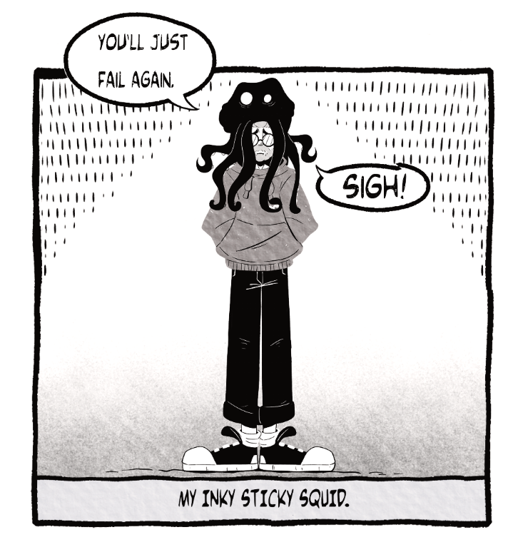
Figure 8 The unhinged narrative 2025
With this understanding the squid was meant to be a simple character with a simple design shape something that the reader could easily identify instead of something complex, as the book was for people of various ages but more towards a younger audience. This basic shape was created with the intent to suit younger readers, that they might easily understand as “We see shapes in context, and our reactions to them depend in large part on that context” (Bang, 2000 pp. 8). The example that is given in figure 6 from the work of Molly Bang that shape like this fig 8 can be easily seen as wolf or dog. Bang goes on to write about how adding different shapes to outline define it “What shapes make the wolf? Just three long black triangles. Why do these triangles feel so scary?” (Bang, 2000, pp 240). What can be taken from this is that by adding simple shapes to a design our minds start to fill in the gaps and this method of designing a character led into the creation on Inky Stick Squid.
Life with Inky Sticky Squid
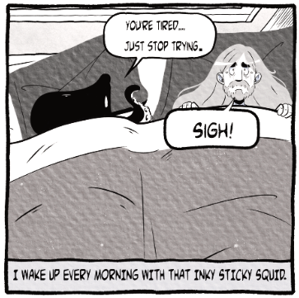
Figure 9 The unhinged narrative 2025
The first page shows Sticky Squid in everyday life waking up next to the character. It was illustrated in this way to represent how waking up every day was a struggle where my mind would be filled with thoughts of “why should I get out of bed?”. The reason why the page is illustrated this way as so that the reader can look down at the character and encourage connection for people that are suffering with depression. Everyone has moments of why? This page was meant to introduce the character of Inky Sticky Squid to the reader in a relatable scenario. Relating this back to The Chimp Paradox the idea of using an animal as the best way to describe something that is complex history behind things like mental health this was the right choice to give the reader a better understanding what this illustration was trying to show.
Secondly when it came drawing Inky Sticky Squid and the rest of the picture book I chose to keep a simple art style that was found in my journal but refine it for the picture book as I saw it, “The art style gives meaning to the subject matter” (Simon,1992, pp 17).
And as I wanted the reader to understand the subject matter of the book I decided simplicity would be better for the reader.
Reflection
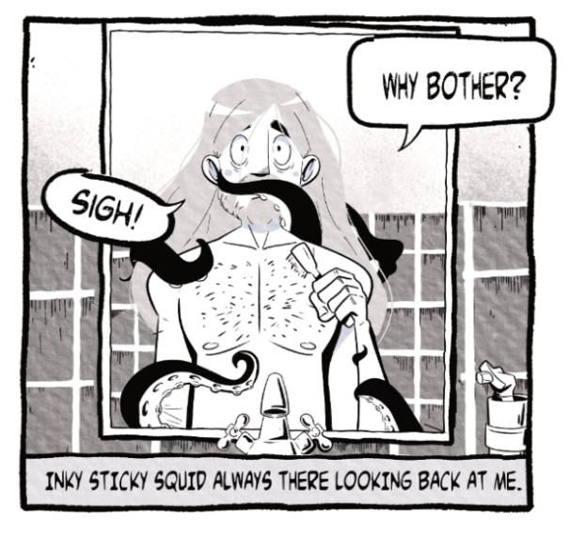
Figure 9 The unhinged narrative 2025
The third page of the book was done in the same way as the pervious page but in this illustration (fig 9) it shows the characters looking at themselves physical hygiene. With this page it was meant to show that depression does not just effect people mental health but also their physical health. I intentionally kept most of the Inky Sticky Squid out of the image, so that it not fully seen because of the inspiration from Shan Tan’s “Little Red Tree” as the rotten fish (figure 1) is only seen poking out from behind the corner. With this in mind the concept behind was to show that depression is not always seen it lurks behind us whether we acknowledge it or not and also can relate to the ideas from Molly Bang on how shapes can used to fill parts of the story for the reader. Looking to the centre of figure 9 Inky Sticky Squid has it tentacle across the character mouth preventing them from brushing their teeth even though the illustration does not have that written down, the shape of the tentacle and the placement of it can suggest to that to the reader.

Box
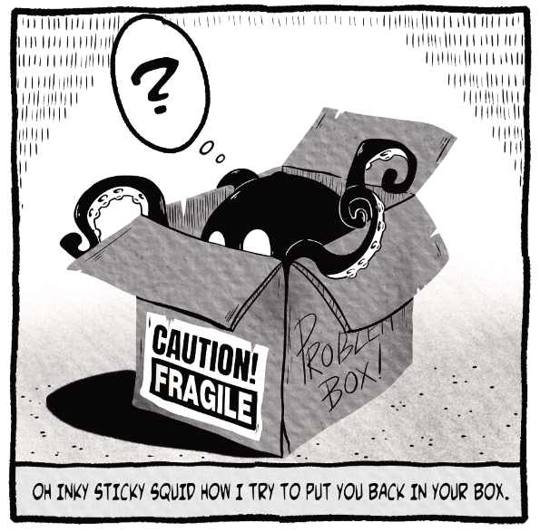
Figure 10 The unhinged narrative 2025
The final page of the picture book was on a memory unlike the rest. It’s based upon a therapeutic tool. In this illustration (figure 10) the question was how I hid my depression from so many years. In my mind's eye I used to imagine a box in my mind where I would stuff all my problems worries and fears away inside and eventually it became too much. It was too full I had no more room to fit my problems and eventually it would come pouring out. I used the Inky Sticky Squid to represent this by being inside a fragile box and popping out unable to be contained.
The illustration was meant to show the reader that no matter how hard you try hid things like depression it always finds a way to pop out of its box. The box is meant to signify the mind with the fragile sticker on the side showing how fragile humans mental health can be. How people look after their physical health should be important as looking after the mental. This fragile box also represents the mind and the Inky Sticky Squid in my book is the depression and anxiety.
Reflecting on this chapter I wonder if I was successful in my attempt to show how depression can manifest itself in everyday life and weather the reader would understand what the Inky Sticky Squid was meant to represent based on my own interpretations of depression. Based on the reactions I received from readers I do feel I achieved this and was able to encourage to talk about depression in the exhibition.
Chapter Three
The Never Ending Loop
The second chapter of the picture book is title The never-ending loop the premise of this chapter was to showcase my anxiety and unlike the previous chapter of the picture book the narrative in the following chapter is more of fragmented and takes place in various scenarios.
What if…What if
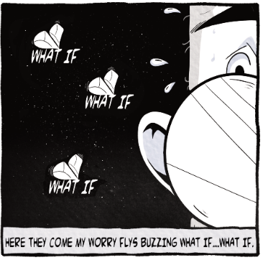
Figure 11 The unhinged narrative 2025
The first page of the second chapter of the picture book titled The never ending loop was based off a counselling session that I once had when we discussed how anxiety keeps your mind on edge with constant what if’s and fixations on problems which led to my obsession of counting to four. The continuous loop is a way of representing the ways we were discussing how to help my anxiety. I used the theme of creatures again using a wasp that flies in the room. You let it pass you by. The image of the wasp stayed in my mind because it felt an accurate way to describe anxiety. All that buzzing looping in the mind.
I sketched out what the wasp looked like because I felt the image of it buzzing around my mind. When it came time to placing the illustration in the picture book then I decided to redesign so the word what if (figure 11) would look like a buzzing wasp.
The illustration itself is to help the reader understand how anxiety can manifest and shows up in your brain. A wasp can seem louder if you focus on it just like anxiety.
Loop and Loop
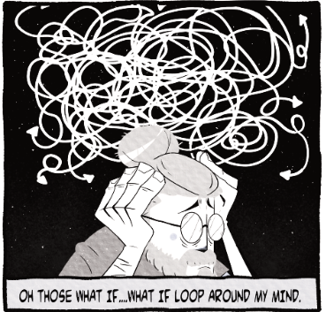
Figure 12 The unhinged narrative 2025
The second illustration (figure 12) follows along the same line as the previous illustration (figure 11) but in this case I wanted to give the reader an insight into how those looping thoughts work and how they can appear to be as tangled web of thought and how the thoughts can cause distress on the person. I remember speaking to someone in the exhibition about this scene and how they felt about this illustration to which “they said this is very much me, mind all scrambled about”. I was glad to see they took a small comfort in seeing themselves in the work and knowing they weren’t alone in the feeling. I wanted my work to encourage interactions like that and it did particularly this illustration.

Eyes, eyes and eyes
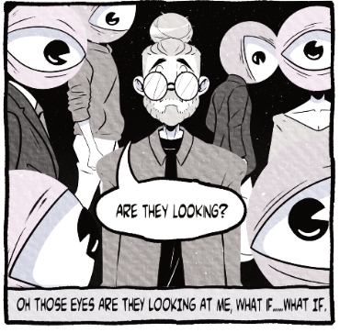
Figure 13 The unhinged narrative 2025
The third page of the picture book was more about social anxiety and how people often feel judged and paranoia in social situations. From my own research into OCD I saw that intrusive thoughts can make these feelings stronger. People with OCD can fixate on paranoia, worrying about weather people are looking at them or if they seem weird. What if’s can be a constant.
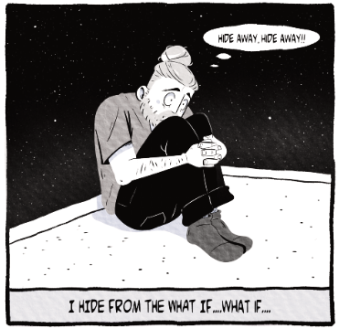
Hiding
Figure 14 The unhinged narrative 2025

This brings us to the last page of this chapter of the picture book where I wanted to use a more vulnerable image to depict the extent of depression and anxiety. That it can push a person into hiding away and sometimes even refusing to leave the house completely. To follow the story I’ve made the illustration represents an idea of the worst of it and hiding away completely from the what ifs.
This chapter of the book was the most difficult for me to illustrate as I was trying to illustrate on two different topics one being anxiety and the other OCD. In regard to illustrating about anxiety I believe this came through but the OCD it did not, as at the time I was still finding out more about it. I could have tried to give the reader more of an insight into OCD here but this can be taken into future work.

Chapter four
Sink
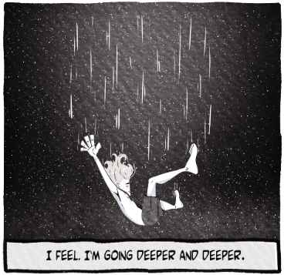
Figure 15 The unhinged narrative 2025
In this part of the report, I will cover the illustration that follows on from the last image where the worst turns into a mental breakdown. Through my research I chose to consider what that feels like, like as weight, heaviness and falling. I wanted my illustration to illustrate this by having them fall in that they were getting lost in their mind, deeper and deeper.
This is based on some of my own journalling and how I’ve felt in the past but also how others could feel when they’re depressed and feel like they can’t get back up or out of their depression.
Sink was the final illustration I created to illustrate breaking point. I feel, I’m going deeper and deeper would be an appropriate way of describing depression as a sinking feel, personally it was a slow decent into depression but can be different for others. When illustrating this page I wanted to keep that vague because I wanted the reader to think about depression not just a feeling of being sad but also a feeling of loss. You feel the loss of what makes you feel passionate, a hobby that once brought you joy now feels empty and hollow but even at our lowest there is always a way back but that starts with one word.

Chapter five
The word
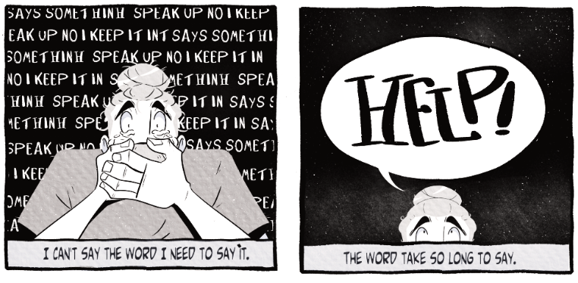
Figure 16 The unhinged narrative 2025

The last chapter of the picture book is about asking for help and how it can be the most difficult thing to do but also the most courageous thing to do. Each illustration going forward depicts this journey.
Figure 16 how difficult that journey can be in saying the word help. I wanted to show the reader that the first step in asking for help and the reassuring response for others once you do. The illustration to the left (Figure 16) you can see the word, “say the word” repeated in the background because before I ask for helped I personally felt it swirling in my mind as I struggled to say it out loud.
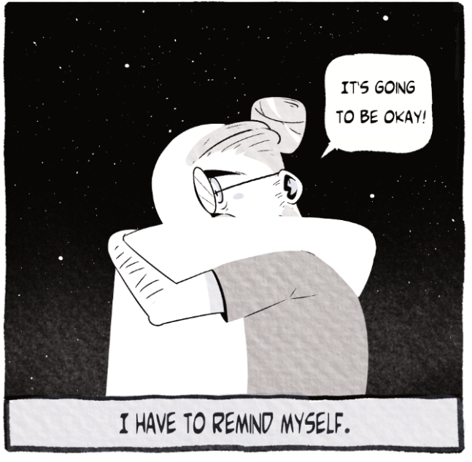
Acceptance
Figure 17 The unhinged narrative 2025

The next illustration (Figure 17) is meant to show that acceptance is also about self-assurance, and this illustration was meant to reassure the reader that asking for help to better your mental health is a good thing. It doesn’t have to be scary and can end up being the best thing you do. It leads to understanding and for me personally it allowed me to not just understand myself better but take an interest in how art therapy can really help a person organise their thoughts and move forward.
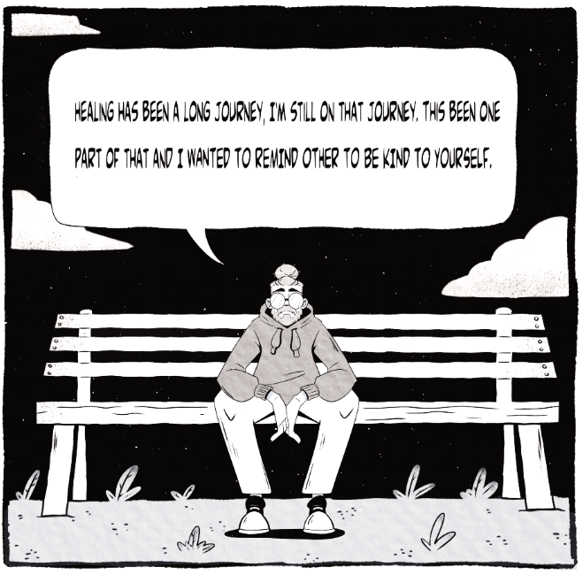
Figure 17 The unhinged narrative 2025
The last illustration was my attempt to talk to the reader to tell them that healing has been a long journey but also that healing is a long journey. It takes time and to be patient.

Epilogue
At the beginning of this report, I posed the question of “what it is like to live with anxiety and depression?” and how illustrations can be used a therapeutic tool. In short yes the illustrations that were used to make the picture book have shown how beneficial I think they can be for people and their journey. Through my own experiences I know they work. My work has only been seen by those attending the exhibition and the response was quite positive I had conversations about the book. After those kinds of conversations I felt inspired to maybe continued with this type of art in the future as I find it interesting.
Ultimately while doing this picture book and researching mental health I have come to a understand more about myself. Anxiety and depression are always going to be part of my life but I have found a healthier way to deal with these things now, as some who has come out the other side so to speak, and I wish now to help others. Others like me but also to help others understand mental health and maybe this will be a stepping stone into further work that includes art therapy.

List of images
Fig. 1 The red tree 2001
Fig. 2 The colour monster 2016
Fig. 3 The colour monster 2016
Fig. 4 The huge bag of worries 2016
Fig. 5 The huge bag of worries 2016
Fig. 6 The huge bag of worries 2016
Fig. 7 Anxiety is really strange 2018
Fig. 8 The unhinged narrative 2025
Fig. 9 The unhinged narrative 2025
Fig. 10 The unhinged narrative 2025
Fig. 11 The unhinged narrative 2025
Fig. 12 The unhinged narrative 2025
Fig. 13 The unhinged narrative 2025
Fig. 14 The unhinged narrative 2025
Fig. 15 The unhinged narrative 2025
Fig. 16 The unhinged narrative 2025
Fig. 17 The unhinged narrative 2025

Bibliography
Bang, M. (2000) Picture this: how pictures work. New York: SeaStar.
Durbano F, Irtelli F and Marchesi B (eds) (2024) Depression - What Is New and What Is Old in Human Existence. IntechOpen. Available at: http://dx.doi.org/10.5772/intechopen.1000384, (accessed 8 Jan. 2026).
Eastham, C. (2017) We’re all mad here: the no-nonsense guide to living with social anxiety. London, England; Jessica Kingsley Publishers. Available at: https://ebookcentral.proquest.com/lib/trinity/detail.action?docID=4715279 (Accessed:8 January 2006)
Llenas, A. (2016) The colour monster. London: Templar Publishing.
Nutt, D.J. and Ballenger, J.C. (2003) Anxiety disorders. Oxford: Blackwell Science.
Malchiodi, C.A. (2011) Handbook of art therapy. 2nd ed. New York: Guilford.
Simon, R.M. (1992) The symbolism of style: art as therapy. London: Routledge.
Steve Haines (2018) Anxiety Is Really Strange: Graphic Medicine. First edition. London: Singing Dragon. Available at: https://research-ebsco-com.uwtsd.idm.oclc.org/linkprocessor/plink?id=4ade02fb-53bc-35de-82bc-4faeafd39057 (Accessed: 8 January 2026).
Summers, Jesse S., and Walter Sinnott-Armstrong, Clean Hands: Philosophical Lessons from Scrupulosity (New York, 2019; online edn, Oxford Academic, 19 Sept. 2019), https://doi-org.uwtsd.idm.oclc.org/10.1093/oso/9780190058692.001.0001, accessed 8 Jan. 2026.
Tan, S. (2003) The red tree. Melbourne, Vic: Lothian.

