Management and Organisational Behaviour (BMIH5004)

Name - Maria Mihaela Hirs
Student ID - 2226556
Lecturer’s Name – Jessica Newport
Assessment 2 - Report

" I confirm that I have not used any AI tools in the research and creation of this assignment. I confirm that I have not presented any AI generated materials as my own work.
I confirm I have copies of my drafts, notes, and other resources I used, which I may be asked to provide in evidence."

Executive Summary
The report has been discussed over the management and organisational behaviour approach used by Hyatt, Matrix business organisation structure, business culture with inclusiveness and diversity management and also opting the acquisition business processes are the key success pillars of the business operations. Positive business culture development, developing the leadership intensity, concentrating more over the CSR approaches and others, best brand valuation development and making the brand sustainable in the market can be addressed.
Table of Contents
Introduction 4
Organisation Structure, Culture, and Goals 5
Recent Change Initiatives 6
Strategic Direction 8
Analysis of Key Theories 10
Recommendations 11
Conclusion 13
References 14

Introduction
Hyatt Hotels Corporation is a global hospitality company which is engaged in delivering the luxury experience to its targeted customers. This hotel brand started its business journey in 1957. Hyatt has expanded its business operations in more than 65 countries (Mullins & Dosser, 2013). The headquarter of the hotel is at States. Based on innovation and better product and service portfolio development, the business has developed its revenue margin for years.
Figure 1: Revenue of Hyatt Hotels Corporation worldwide from 2008 to 2023
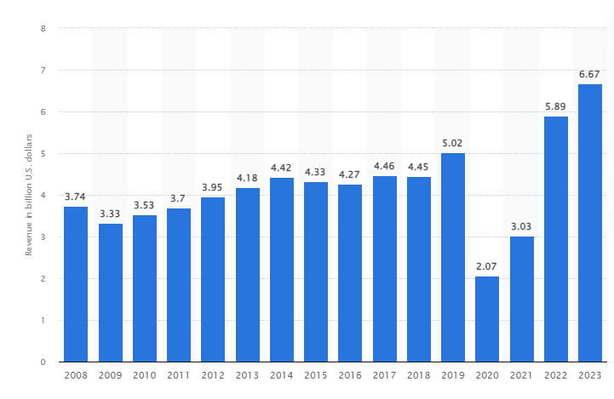
Source: (Statista, 2024)
Post pandemic development of the business since 2021 has observed. Based on this aspect, the structure, cultural perspectives, strategies, recent changes of Hyatt have been discussed in this report. The report also has discussed several recommendations for ensuring continued growth of the business and to develop the industry leadership image (Statista, 2024).
Based on the organisational situation of Hyatt hotel brand, matrix Organisation Structure, suitable Culture of the organisation supporting the business growth, and Goals along with the recent initiatives and innovations as well as suitable operational strategies taken by the organisation, suitable strategic direction opted by the organisation, and some theory analysis on the selected business organisation context have been analysed in this report. Some important recommendations for the hospitality brand also has discussed in this report. The aim of the report is to define the evaluation of the change initiatives and some recommendations to be followed by Hyatt’s management in their operational processes.

Organisation Structure, Culture, and Goals
Organisation structure
Matrix organisational structure is strongly followed by the business with a perfect blend of functional along with the divisional characteristics. Regional operational division-based structure is followed but the organisation as well. Local adaptation in the business operational process is strongly managed by the business (Mullins, 2019). This business structure can be linked with the decentralised approach of Hyatt offering tailored business services based on the regional customer expectations. But this structure also is subjected to result to the inefficiency like duplicated roles of the staff and slow-paced decision-making process. Some kind of business complexities also may get rise in this business structure of Hyatt. Communicational issues, and delay in decision making process in Hyatt also can be stated as the important structural limitations of Hyatt. In a contradicting discussion, it is also important to highlight the fact that Matrix structure has helped the staff of the organisation to share important information, knowledge and skill across the team to support overall organisation effectiveness development. Thus, based on critical analysis of both the advantages and disadvantages of the Matrix organisation structure, beneficial aspects have been focused by the Hyatt to be at the competitive position in the relevant hospitality industry.
Organisation culture
The corporate culture of Hyatt is based on the ‘care for people’ culture where both the customers and employees are offered with good treatment to make both of them retained with the business operations. The culture of inclusion is highly followed in the business culture of Hyatt. Employees are offered with empowerment to offer their new ideas to foster the innovation. Diversity management among the staff is well managed by the business. Women@Hyatt program is one of the examples where the female leaders are supported in the business as a best part of the talent management (Mullins, 2023). The perfect balance of Clan business culture fostering the people focused culture and the Adhocracy business culture fostering the innovation-focused business culture is strongly followed. These aspects have supported the business to support high level of employee morale. This kind of organisation culture ensures innovation to foster positivity in the organisation. But at the same time, critically it can be stated that lack of stability and less flexibility management influenced by the fast global expansion can be observed in Hyatt which is required to be handled by the management and leaders.
Organisation goals
Some of important organisation goals of Hyatt are:
- Expansion of the global footprint by expanding the business into new emerging markets.
- Increasing the shareholder value through sustainable business practices.
- Developing the footprint by using correct acquisitions and partnerships business operational process (Boddy, 2017).
- Development of operational excellence and developing overall customer satisfaction.
- Managing consistent service offering to the target customers and excellent product offering to the global customers to make them retained.

Recent Change Initiatives
In recent years, Hyatt has taken several initiatives based on the market changes and changes of the preferences of the targeted customers. Two important changes have been notices as discussed below:
Acquisition of Apple Leisure Group (ALG)
Acquisition is one of the important strategic directions which foster resource capability development and also performance development in the competitive world. Hyatt has acquired Apple Leisure Group in 2021 which is a famous resort operator so that overall offering of Hyatt to the customers can be developed by the help of enhanced resource ability. This acquisition has done for development of the leisure segment of travel of Hyatt. This has developed to make the business travel of Hyatt active in post-pandemic situation and has enabled to attract more target population towards their brand value offering. It also has ensured better accessing the ALG’s extensive loyalty programs by Hyatt and also has supported data analysis of ALG as well. Thus, overall customer engagement rate has developed by this acquisition (Adair, 2009). As during the acquisition, cultural differences may be faced by the business, it is required by Hyatt to ensure perfect blend of the Hyatt and ALG corporate culture to make it more successful.
Sustainability and Corporate Social Responsibility (CSR) Initiatives
Looking from the point of view of the CSR, Hyatt has launched World of Care platform in 2021. This program has aimed to minimise down the environmental footprint and also to look after community impact development on business operations. This program also is aimed to reduce down the carbon footprint and reach the Hyatt’s target of carbon emission reduction and water usage by 20% by the end of 2025. Developing this common platform and implementing this over the global market is challenging for Hyatt (Armstong, 2021). Important investment and effort delivery is very much important by Hyatt’s management to look after. But, it is required by the Hyatt management to make the staff aware and trained enough to accept these CSR initiatives to be implemented in a perfect manner to add competitive advantage in the organisation.
World of Hyatt
Hyatt is introducing new Milestones, new choices within the Milestone rewards. This is new way to share the awards of the customers. The Milestone chart is expanding beyond 100 nights. It has introduced earning at 110, 120, 130 and so on qualifying nights each year. The rewards start at 20 successful nights with Hyatt and earning 35,000 basic opts to be used in next staycation. It has been effective from 1st January, 2024 (Hyatt, 2024). Critically it can be stated that through added expenditure is calculated for the business, attracting more target population can be ensured in this strategy application for Hyatt.
Figure 2: EXCITING WORLD OF HYATT
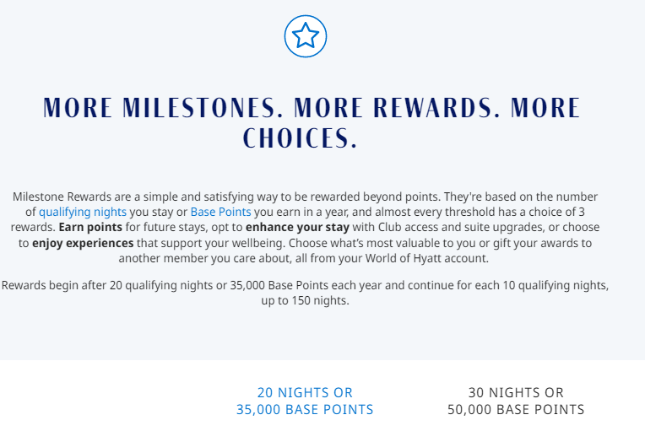
Source: (Hyatt, 2024)
The staff should be well versed with the new launch to better support the customers and to make them loyal to the business. Earn more, redeem more and achieve more are the important aspects looked after by the World of Hyatt program. This is different than the immediate competitor of the brand as Mariette’s Bonvoy. This loyalty program is available at more than 8000 properties in over 130 countries and territories. Compared to this loyalty program, Hyatt pales in comparison when it comes to the size which is offered over 1300 properties for 76 countries (Nerdwallet, 2024).

Strategic Direction
The strategic direction is Hyatt is towards making the brand leader in the hospitality industry. Excellent organisation growth plan, developed loyalty programs and advanced technology application for overall guest experience development are the important strategic direction to be followed by the business.
Growth strategy
Merger, acquisition and well-developed partnership development are the important growth strategies to be focused by the business. ALG acquisition is one of the good examples of acquisition business opted by Hyatt. Business operations expansion and also enhancement of the resource capability are the important aspects here (Armstrong, 2012). Rapid growth of the business in the Asia-Pacific seeks to develop the capitalisation investment. In this business context, Resource based view model is very much important which defines that full optimisation of the organisation resource enhances overall business capabilities and also adds the competitive advantage. Strong brand reputation can be enhanced by this approach but it should be within limited or else over dependency will become drawback. But, on the other hand, less consideration of correct resource alignment will not meet the desired performance outcome for the organisation which is required to be looked after by the management.
Loyalty program development
Hyatt focuses over the loyalty program positively. World of Hyatt is one of the examples here. This program has developed to make the customers retained with the business operations and services offered by the business. This program also offers excellent perks and other benefits to the customers. Thus, loyalty program offers better satisfaction to the customers and also develop their retention rate with the organisation (Arnold, 2020). Offering personalised services also is another important service offered by the business to its targeted customers. Long term business relationship is well managed with the help of the loyalty programs. Thus, it is required by the organisation to continuously look for the innovation application in loyalty program development to make the brand differentiated from others.
Technology advancement
Advanced technology has used by Hyatt in a positive manner. Digital transformation of the operational aspects for overall guest experience development has taken by the brand seriously. Using AI technologies, mobile check in and checkouts, room key app through mobile and other personalised services have developed by advanced technology application. Advanced technology also has helped the business to reply to the customer within short period developing the customers spending nature of the brand (Bloisi et al., 2017). As the hospitality industry is customer centric, it has become very much important by the management of the organisation to look after people-centric personalised evoke offering to make the target customers engaged with the business operations. Along with the benefits, there are also limitation of using AI technology in service development of the hotels as it become very much technology dependence where customers may prefer the human interaction to get the personalised service addressing the emotional aspects.

Analysis of Key Theories
Two key theories can be discussed in this business context.
Contingency theory application
This theory suggests the fact that there is not a single approach to effective management and leadership to control the talented staff in the organisation. Cortically, it can be stated that the management of the organisation is required to analyse the organisation situation and also need of the market to develop correct strategic step to be applied over the business operations. The approaches should be based on analysis of the situational factors. Following this contingency theory, management of Hyatt offer employee empowerment and better flexibility to the staff so perfect innovation-based business culture can be managed in the organisation. Meeting the local customer’s needs is addressed by hiring the local community those understand the local people needs and serve them as per their needs (Buchanan & Huczynski, 2007). Balanced service and profit offering approach also is managed by the Hyatt in the global market in a proper manner using this contingency theory application. The leadership style application in Asia differs than the leadership application in North America based on the local responsiveness development and to meet the needs and demands of the local population. Thus, to keep a perfect balance between the globalisation and the local responsiveness management, contingency theory application is very much important to be ensured. Without the contingency theory application, perfect balance between the global perspective and local operational perspective of Hyatt cannot be managed.
Transformational leadership application
Transformational leadership approach is all about making the staff valuable for the organisation and offering required guidance to them so they will be able to deliver their maximised effort towards the organisation target meeting ad also will be able to develop their skills as per the requirement.
Transformational leadership approach is very much suitable for the business operations of Hospitality industry and adds competitive advantage. The Transformational leadership approach is offered by the leaders of the organisation over the staff to effectively manage them and to make them retained with the business operations. Driving innovation, making the staff motivated and boosting up the morale value of the staff and delivering best effort towards organisation target achievement have supported by this transformational leadership application by the leaders (Robbins &Judge, 2017). Hyatt focuses over the employee development using various training programs and leadership programs. This also fosters continuous improvement of business culture positively.
Talent transformation strategy of Hyatt through leadership development model opted by the brand has targeted to raise the level of leadership. It has been highlighted by Rollinson et al (2008) that Transformational leadership is important in the hospitality sector as managing the satisfaction level of the customers and managing strong engagement of the staff with the organisation. Fostering the innovation-based business environment in Hyatt also has supported by this transformational leadership approach. This has added the competitive advantage in the organisation. Empathy, integrity, respect, inclusion, experimentation and wellbeing are the key success pillars of Hyatt which has been facilitated by the Transformational leadership approach. Caring the customers and also caring the employees is at the heart of the business operations of Hyatt strongly supported by the Transformational leadership approach. Well defined distinct guest experience has made Hyatt as the best hospitality brand in the global market. Corporate leadership training program is another important example here to develop skill base of the employees.

Recommendations
Developing the level of Acquisition business partnership
It is required by Hyatt to look after more acquisition-based collaboration with other businesses to develop resource capability and also to develop operational effectiveness. This will help the business to add competitive advantage in the business culture and also to develop distinguished brand name in the market by adding resources in their operational set up. Hyatt already acquired Apple’s leisure group to develop overall resource capability as well as economic status. After this acquisition, net revenue of the brand has been increased by 94.55% in 2022 from 2021 (Hyatt, 2024). Thus, more concentration over acquisition is recommended for the brand.
Concentration over technology equipped personalised service offering
Digital transformation has focused by Hyatt in a positive manner which is required to be improvised more to add value to overall business operations. Thus, further investment in AI development and developing the service profile of personalised service operations also is required to be concentrated by the management of Hyatt adding competitive advantage. Highly personalised services to the customers will add value to the brand name of Hyatt (Armstong, 2021).
Leadership program development
Global expansion of the business can be supported by the enhanced leadership support which can be developed by skilled leaders and supportive leaders. Thus, Hyatt is required to look after leadership program development session to be offered to the staff to develop overall competitive advantage of the organisation (Adair, 2009).Developing the transformational leadership pipeline is about developing overall operational aspects. Developing cross cultural leadership also is the important aspect to be looked after by the management of the hotel. With the help of these leadership development approaches, overall competitive advantage adding in the organisation can be ensured.
Developing CSR initiatives
CSR initiatives development of an organisation can be linked with the ethical image development of the organisation. Thus, it is required by the management of Hyatt to look after CSR initiatives development to develop overall brand valuation and to remain sustainable and competitive in the industry. More focus over the local community employment offering, education offering to the community children in need, offering support to the local business will develop overall CSR portfolio of the Hyatt. Training inadequacy of the staff about the business sustainability aspects as well as less awareness among the staff about the CSR importance can be stated as the important limitations to be looked after by the management by arranging required training and awareness programs.

Conclusion
Therefore, it can be addressed Hyatt is a well-positioned brand in the hospitality industry that prefers to opt for acquisition business to remain competitive in the hospitality market. It has also reflected suitable technological innovations in its business operations to develop a leading position of the brand in the Hospitality industry. It has continued its business operations to expand the market and also to develop a competitive advantage of the organisation. Developing the leadership programs sessions, developing the digital transformation of the business operations, looking after CSR initiative development, and others, overcall business brand differentiation can be continued by the business to remain challenging and sustainable in the hospitality industry. At the same time, need for operational efficiency development and also developing overall leadership capabilities also have been addressed in this report.

References
Adair, J. (2009) The Inspirational Leader (2nd Ed), London: Kogan Page
Armstong, M. (2021) Armstrong's handbook of performance management (7th Ed), London: Kogan Page
Armstrong, M. (2012) Armstrong’s Handbook of Management and Leadership (3rd Ed), London: Kogan Page.
Arnold, J. (2020) Work Psychology (7th edition) Harlow: Pearson Education Limited.
Bloisi, W. et al (2007) Management and Organisational Behaviour, (2nd edition) Maidenhead: McGraw-Hill.
Boddy, D. (2017) Management: An Introduction (7th Ed), Harlow, Pearson
Buchanan, D. And Huczynski, A. (2007) Organisational Behaviour: An Introductory Text (6th edition), Harlow: Prentice Hall.
Huczynski, A. & Buchanan, D. (2019) Organisational Behaviour (10th Ed), Harlow: Pearson
Hyatt ( 2024). Available at :https://investors.hyatt.com/news/investor-news/news-details/2024/Hyatt-Reports-Fourth-Quarter-and-Full-Year-2023-Results/default.aspx#:~:text=Comparable%20Net%20Package%20RevPAR%20for,the%20same%20period%20in%202022. Accessed on: 26th Oct, 2024.
Hyatt (2024). Available at: https://world.hyatt.com/content/gp/en/landing/world-of-hyatt-program-announcement.html#:~:text=World%20of%20Hyatt%20is%20introducing,150%20qualifying%20nights%20each%20year . Accessed on: 23rd October, 2024.
Mullins, L & Dosser, P. (2013) Hospitality Management and Organisational Behaviour (5th Ed) Harlow, Pearson.
Mullins, L (2019) Organisational Behaviour in the Workplace (12th edition) Harlow:Pearson
Mullins, L. (2023) Management and Organisational Behaviour (13th edition) Harlow: Pearson
Nerdwallet (2024). Available at : https://www.nerdwallet.com/article/travel/marriott-bonvoy-vs-world-of-hyatt#:~:text=How%20they%20differ,1%2C300%20hotels%20in%2076%20countries. Accessed on: 26th Oct, 2024.
Robbins, S. &Judge (2017) Organisational Behaviour (17th edition) Harlow: Pearson Education Limited.
Rollinson, D. et al (2008 ) Organisational Behaviour and Analysis (4 th edition) Harlow: Addison-Wesley Longman.
Statista (2024). Available at: https://www.statista.com/statistics/257362/revenue-of-the-hyatt-hotels-corporation/. Accessed on: 23rd Oct, 2024.

