Assignment title: Individual Report

Module name: Project Management

Module code: LCLM5003

Name: Burzo Marian Bogdan

Student ID: 2335150
Lectures name: Xavier Matieni

Table of Contents
Part A: Project proposal poster 4
Part B: Critical Feedback Reflection 5
Part C: Project Management Plan 7
1. Introduction 7
2. Project Description 7
2.1 Project Background 7
2.2 Project Justification 8
2.3 Objectives and Aim of the Project 8
3. Project Scope 9
4. Work Breakdown Structure (WBS) 10
5. Quad Chart 11
6. Gantt Chart 12
7. Stakeholders' Involvement 14
8. Allocation of Resources 16
9. Risk Assessment 18
10. Conclusion 19
References 20

List Of Figure
Figure 1. Poster 4
Figure 2. Work breakdown structure 11
Figure 3. Project Quad Chart 12
Figure 4. High Level Gantt Chart 13
Figure 5. Stakeholder Power Interest Matrix 15
Figure 6. RACI Matrix 16
Figure 7. Risk Heatmap 18

Last Of Tables
Table 1. Project Scope 10
Table 2. Stakeholder Register 14

Part A: Project proposal poster
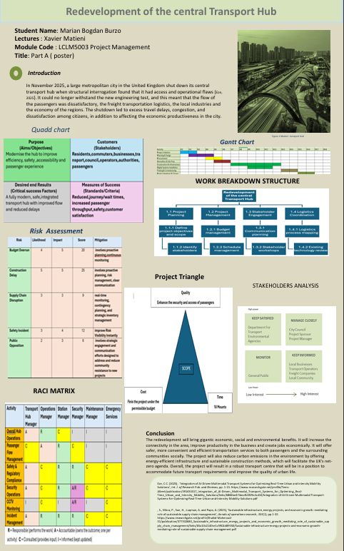
Figure 1. Poster

Part B: Critical Feedback Reflection
The redevelopment of the central transport hub was introduced in the project poster as a sustainable, integrated solution to the operational, accessibility, and infrastructure issues affecting the city's transport network. The poster was quite categorical on the necessity of redeveloping the transport hub by mentioning the impact of the poor infrastructure, traffic jams, and inefficient transport. It also revealed how effective project planning would lead towards the successful implementation of a modern transport facility through well-planned project management processes.
The good explanation as to why the redevelopment of the transport hub was needed was one of the strong aspects of the poster since it articulated the need. The poster was in a position to relate the project to improved passenger flow, economic viability, and a safer and environmentally friendly future. The project objectives were attainable, measurable and aligned with an overall objective of creating a multimodal modern transport hub. The poster was even designed in a logical and easy-to-follow fashion. The combination of project management tools, the Quad Chart, Work Breakdown Structure (WBS), Gantt Chart, Stakeholder Analysis, Risk Assessment, RACI Matrix and Project Triangle proved to be efficient in communicating the key points of the project and improving the presentation overall. Knowledge of stakeholder involvement in a large infrastructure project was evident through the stakeholders and key stakeholders identified, including the transport authorities, the project managers, the transport operators, businesses, passengers and emergency services.
Despite these strengths, there were a few areas that had to be improved. The project scope needed to be more specific in terms of project inclusions, project exclusions, assumptions and constraints to ensure that the chances of scope creep are minimised. The poster has indicated the major project risks; however, additional information was necessary in reinforcing the risk assessment by giving a more detailed discussion of the likelihood, impact and mitigation plans. The distribution of the resources, as well as the roles and the process of communication of the stakeholders, had to be further elaborated in order to demonstrate how the project was to be run during the lifecycle of the project. Although the Gantt chart gave a general outline of the implementation schedule, more activities, milestones and task dependencies on the project were necessary to enhance the project planning and monitoring.
The final project management plan thus incorporates a comprehensive scope statement that has well-defined deliverables, assumptions, constraints and project boundaries. An elaborated Work Breakdown Structure (WBS), Quad Chart and Gantt Chart have been added to give a better view of the project activities, milestones and scheduling. There has also been an inclusion of a stakeholder register, communication strategy, RACI Matrix and resource allocation plan to enhance stakeholder management and project governance. These extensions cement the overall project plan and make sure that the project management principles as identified are implemented throughout the project lifecycle.
On the whole, the project management plan enhancing the quality of the proposal was achieved through enhanced project planning, management of the stakeholders, the schedule, resource assignment and risk management. The final plan provides a logical and rational approach to redeveloping the Central Transport Hub effectively and achieving the strategic objectives of the project.
.

Part C: Project Management Plan

1. Introduction
The project management plan suggested targeting the redevelopment of the Central Transport Hub of a major city in the United Kingdom, which was shut down due to structural decay and shortcomings in its functions. The grave safety-related concerns, which were disclosed due to the structural checks, could not enable the plant to be sufficient in regard to modern engineering and accessibility needs. The closure not only stopped the flow of people movement and the transportation of freight, but also the local companies and other economic activities in the area and led to excessive traffic on other roads. The redevelopment is not an engineering project, but the report feels that redevelopment can only be finalised by applying the structured project management practice, which includes planning, stakeholder engagement, scheduling, resource management, and risk control in the lifecycle of this project (Iskandarani, 2023).

2. Project Description

2.1 Project Background
In November 2025, the terminal transport station of a major city in the United Kingdom was permanently closed following structural checks which showed severe engineering failures and operational deficiencies. The facility was the primary multimodal transport interchange in the city during the past four decades, integrating rail, bus and freight within the locality. The result of all these continuous depreciations of the infrastructure and the increasing number of passengers and varying engineering needs left the facility incapable of maintaining safe and efficient transport activity.
The lifestyle of a large population, which was daily commuting, was badly hit operations of logistics related to freight and the transport networks around it were delayed, and the transport networks were overcrowded. The business operations of local businesses, which depended on the number of people who moved, were affected negatively, and the sustenance of greater commute times had negative consequences on the productivity of the workforce and the competitiveness in the area. It is these implications that drive us to consider transport infrastructure as a critical national infrastructure whose functionality directly influences economic growth, national security, environmental sustainability, and welfare in society.
Simultaneously, the shutdown gives a possibility to modernise transport infrastructure by implementing new engineering strategies and using digital technologies. Instead of the existing facility being changed to a similar design, the intended redevelopment aims to change the transport hub into a smart, sustainable and fully integrated transport interchange that can accommodate the demands of transport in future. The project involves the implementation of digital ticketing systems and real-time information about passengers, smart technologies for traffic management, higher availability, sustainable construction materials, and energy-saving infrastructure. Consequently, the redevelopment will not just lead to the enhancement of the improvement of transport, but also facilitate wider urban regeneration and national sustainability objectives.

2.2 Project Justification
The redevelopment project is tactically grounded since it aims at closing the loopholes in the operations, which generate tremendous economic, environmental and social impacts (Devrath, Nag and Pareek, 2025). The modern transport network improves the efficiency of the area in the economic aspect by reducing travel time, increasing efficiency in freight transportation, and increasing accessibility to businesses. Improved transport systems facilitate business investment, increase employment and competitiveness of the region. Instead, the long-term economic benefits would extend beyond the construction process, as infrastructure would be developed.
The project brings about massive social returns, as well. Improved access also leads to equitable access for the aged, individuals with disabilities and other vulnerable populations and the enhanced network of safety also increases trust in the transportation system among passengers (Hook et al., 2025). More convenient transportation access leads to more convenient access to work, education, health services and commercial services; living in a metropolitan area is improved.

2.3 Objectives and Aim of the Project
The main objective of the redevelopment project is to turn the current central transport hub into a safe, accessible, digitally integrated and environmentally friendly transport node which will increase mobility of people, reinforce freight activities, and promote long-term economic growth (Bhadragoudar Shivanagouda, 2024).
To fulfil this, the project will work towards the following objectives:
- Fully redevelop in a period of eighteen months of implementation.
- Meet the business's necessary quality and complete the project within the approved capital budget.
- Strengthen the safety of passengers in keeping with the current engineering and transport standards.
- Introduce intelligent travel, including an e-ticket system and a live passenger information system.
- Reduce the impact of transport operations through the scheduling of construction.
- Lessen environmental effects by using sustainable building and energy-saving infrastructure.
- Assist the region in re-developing economically by restoring the transport capacity and improving the connectivity of the business.
These objectives serve as performance targets that are measurable and upon which a project is planned, done, monitored and evaluated.

3. Project Scope
One of the most notable parts of project management is proper scope management because it assists in delineating the scope of the project and keeping the expectations of the stakeholders in the project as the implementation process progresses (Ahmed, 2024). Unclear scope is one of the major factors of schedule slippage, cost overruns, low quality, failure and dissatisfaction with the stakeholders as a result of uncontrolled expansion of project activities. The resultant redevelopment of the central transport hub would entail the presence of a clear scope statement of the deliverables, assumptions, constraints, and a project boundary.
The project scope will include the removal of the unsafe transport infrastructure, the development of a modern multimodal transport terminal, rail, bus and freight infrastructure, smart ticketing and passenger information infrastructure, and CCTV and smarter security infrastructure, the improvement of accessibility, sustainable landscaping and energy-efficient buildings. All these deliverables assist in coming up with a transport hub that conforms to the current engineering requirements and a hub that will cater to the future transport demand.
The other activities which are not project related include airport development, residential development, commercial shopping centres, development of a new railway line, expansion of the metro and other non-project related development of regional infrastructure. Omitting these activities helps to avoid unwarranted scope creep and keep the project on track, and to make sure that the resources at its disposal are focused on fulfilling the strategic goals.
Table 1. Project Scope
In scope | Out of Scope
Demolition of structures | Airport Expansion
Construction of new Transport terminal | Residential developments
Rail and Freight integration | Commercial Developments
Smart ticketing system | Metro Expansion
Passengers’ information systems | New railway corridors
CCTV and Security systems | Highway infrastructure
Accessibility improvements | External development
Sustainable Landscaping | Underrated projects

4. Work Breakdown Structure (WBS)
The Work Breakdown Structure (WBS) offers the organisational structure of the delivery of the redevelopment project, which breaks down the complex activities into work packages that can be handled. The WBS, rather than being a scheduling tool, helps in cost estimation, allocation of responsibility, resource planning, quality management, and monitoring of the project. Hierarchy enables project managers to organise work in a methodical way and at the same time ensure that all the activities are directed towards the achievement of project objectives.

Figure 2. Work breakdown structure
(Source: Author, 2026)
As illustrated in Fig. 1, these five major stages of the redevelopment project can be separated as follows: Project Initiation, Planning and Design, Procurement, Construction, and Project Closure. All the stages will be further divided into smaller work packages like site preparation, demolition, civil engineering, technology installation, testing, commissioning and final handover. Such a structure will enable allocation of responsibilities without confusion and, at the same time, tracking the performance of the project against the established deliverables (Danilina, Korobeinikova and Teplova, 2024).

5. Quad Chart
The Quad Chart provides the senior stakeholders with a strategic snapshot of the redevelopment project by providing a summary of the purpose of the project, the end state that should be reached, the key stakeholders and an implementation timeline. The Quad Chart is to present high-level project information in a form that can be used to make decisions and governance by the executives (not detailed planning documents).
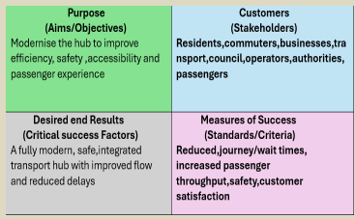
Figure 3. Project Quad Chart
(Source: Author, 2026)
The Project Purpose acknowledges the regeneration of the ageing transport hub to a modern, secure, digitally incorporated and eco-friendly transport facility. The desired result outlines a fully functioning multimodal transport hub that enhances the mobility of passengers, freight, accessibility, and environmental performance. The Customers (Stakeholders) quadrant includes the City Council, Project Sponsor, Project Manager, contractors, transport operators, environmental agencies, local businesses, commuters and surrounding communities. Finally, the project's measure of success will establish the implementation at eighteen months, which will be after the initiation, planning, procurement, construction, testing and project handover.

6. Gantt Chart
Project scheduling is quite a significant part of project management as it stipulates the manner in which activities are planned, coordinated and monitored in the project lifecycle. The delays most commonly encountered in large-scale infrastructure projects are caused by poor planning, lack of coordination and even procurement or even unforeseen external circumstances. These delays would increase the project cost, reduce the confidence of project stakeholders and the project gains expected. As a result, a systematic timing strategy must be used to make sure that project activities are done within the stipulated eighteen months of implementation.
Many engineering, procurement, construction and commissioning activities in the Central Transport Hub redevelopment project must be very tightly coordinated. In order to facilitate efficient scheduling management, a Gantt Chart has been embraced as the main scheduling tool since it offers a visual layout of project operations, milestones, dependencies of activities and implementation schedules. A Gantt Chart assists project managers to regularly update on the progress, allocate resources efficiently and identify potential schedule slips before it provokes significant alterations in the project performance.
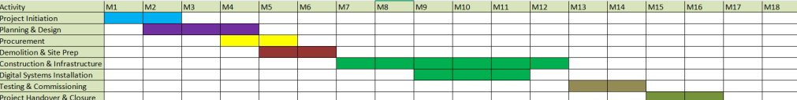
Figure 4. High Level Gantt Chart
(Source: Author, 2026)
The implementation schedule is given in Figure 3, which is broken down into six major stages, which include: Project Initiation, Planning and Design, Procurement, Construction, Testing and Commissioning, and Project Handover. Project Initiation is the setting up of governance, acceptance by the stakeholders, firming of funding and the project management team. This stage determines the organisational hierarchy that is needed to make project delivery successful (Anton, Šmit, and Gašparović, 2025).
Planning and Design phase focuses on the engineering design, environmental studies, procurement planning, regulatory approvals and stakeholder consultation. Comprehensive planning minimises the unpredictability at the subsequent stages of implementation and enables proper budgeting and a realistic timetable (Manurung and Kurniawan, 2022).
Following the planning processes, the procurement phase involves vendor selection, involving suppliers, Procurement of materials, contract negotiation and mobilisation of construction resources. Good procurement management is especially essential since the time lag in delivering materials or mobilisation of contractors may cause a great impact on the general project schedule.
The Construction stage is the most prolonged part of the project that constitutes demolition of the existing buildings, foundation, building of structures, transport facilities, smart ticketing technologies, security tools, as well as accessibility, landscaping and environmental enhancement. Continuous observation of the advancement in the stage assists the project managers to identify delays and implement corrective actions before they can impact the activities that follow (Özkan and Salepçioǧlu, 2022).
Testing and Commissioning are the last stages, with the Project Handover as the last process. Engineering systems, transport technologies, digital infrastructure, safety equipment and operational procedures are stress-tested to achieve the regulatory requirements and project specifications. Under formal closure of the project, the process of operation of the transport hub is handed over to the relevant transport authority in case of successful test runs.

7. Stakeholders' Involvement
Infrastructure redevelopment projects include various stakeholder groups, which vary with respect to interest, responsibility and level of influence. Good management of the stakeholders in the project lifecycle, therefore, is essential to ensure effective project delivery. The following are some government agencies, engineering consultants, contractors, transport operators, regulatory agencies, businesses, freight organisations and local communities who are impacted by the redevelopment of the Central Transport Hub. Each of the stakeholder groups comes with a specialisation of knowledge and, simultaneously, influences the type of decisions made within the project, the way the project is perceived and the results of the project activities.
The prescriptions of the Project Management Institute (PMI) stipulate the necessity of not just consulting the stakeholders but actually involving them in the project planning and decision-making, communications, and monitoring the project performance. The inability to deal with stakeholder expectations has often been a source of project conflict, opposition by the populace, schedule overruns and cost overruns. Therefore, the stakeholder management process is considered a strategic project management process and not an administrative process.
Table 2. Stakeholder Register
Stakeholder | Role | Influence | Interest
City Council | Funding and Governance | High | High
Project Sponsor | Strategic Oversight | High | High
Project Manager | Project Leadership | High | High
Engineering Consultants | Technical Design | High | High
Construction Contractors | Infrastructure Delivery | High | High
Transport Operators | Operational Integration | Medium | High
Environmental Agencies | Regulatory compliance | High | Medium
Local Business | Economic beneficiaries | Medium | High
Local Community | Primary users | Low | High
Freights Operators | Logistics operations | Medium | Medium

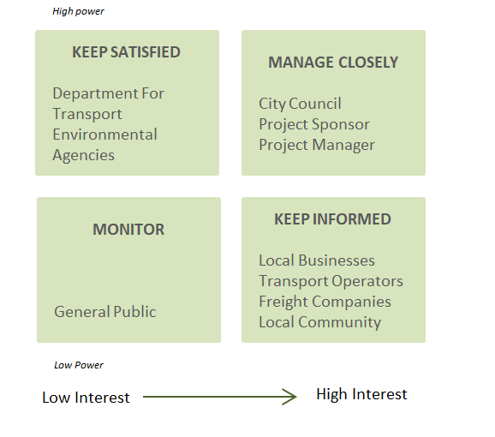
Figure 5. Stakeholder Power Interest Matrix
(Source: Author, 2026)
Stakeholders are categorised in terms of power and interest in Figure 4. Close management of the City Council, Project Sponsor and Project Manager is needed as they hold a lot of power regarding funding and governance, as well as making decisions on the project. To maintain a happy environmental regulator, constant compliance reporting is needed, and there should be frequent communication between transport operators, local businesses and the surrounding communities as the operations of such organisations are clearly affected by the project implementation. Weaker stakeholders should also be kept informed on the project to ensure that they have confidence and transparency among the people (Dolgui and Ivanov, 2023).

8. Allocation of Resources
The allocation of resources plays a critical role in ensuring that project activities are successfully done and at the same time keeping proper standards of quality, safety and financial control. Infrastructures are re-developed with the combination of human resources, construction machinery, materials, information technology, finances and professional expertise. Productivity loss, conflict with the contractor, cost increment and delay are some of the common consequences of ineffective resource planning. Consequently, effective management of resources should be equivalent to the priority of resources that the project can have in the implementation process.
Physical resources are also related to the project, i.e., the demolition equipment, cranes, construction machinery, structural materials, smart ticketing equipment, surveillance, passenger information display, landscaping material, and testing equipment. Early procurement planning is able not only to reduce uncertainty within the supply chain but also to increase the reliability of the schedule.
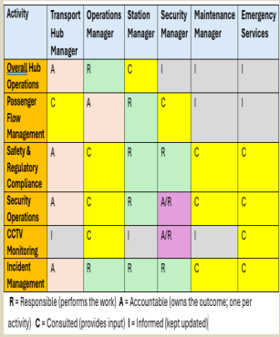
Figure 6. RACI Matrix
(Source: Author, 2026)
Table 3 identifies the responsibility allocation amongst some of the major project activities through distinction of those that will be Responsible, Accountable, Consulted and Informed. The advantage of the RACI Matrix is that they increase accountability, reduces duplication of effort, made as well as improving communication within the project members (Quiroz Villanueva et al., 2025).

9. Risk Assessment
Risk management plays a crucial role in successful project delivery, as uncertainty is an issue in all stages of infrastructure redevelopment. Project management should thus be undertaken in an orderly manner that identifies, evaluates, mitigates and monitors risks before it affects project goals. Rather than attempting to eliminate uncertainty, current project management focuses on reducing the likelihood and effect of any adverse occurrences, and putting in place contingency plans for the eventuality of risks that cannot be avoided by any means.
The redevelopment around the Central Transport Hub is susceptible to the financial risks, operational risks, environmental risks, technical risks, regulatory risks and stakeholder risks. Inflation, a lack of materials, availability of labour, regulatory delays, contractor performance, and opposition by people all have the ability to affect the cost, schedule and quality of the project. Risk management should thus be a proactive process that cannot be considered a one-time planning process and should be incorporated in the entire project lifecycle.
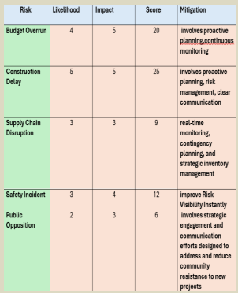
Figure 7. Risk Heatmap
(Source: Author, 2026)
Figure 5 is graphical and clusters project risks in terms of their probability and impact, enabling the project managers to prioritise mitigation. The most important risks are associated with budget overruns and construction delays due to their direct impact on the performance of the project delivery and stakeholder trust (Iskandarani, 2023). The risk with lower priority still requires monitoring but does not require as many resources to pay attention to at the moment.
Effective risk management ultimately leads to project resilience through improvement in decision-making, minimising uncertainties and delivering successfully within acceptable cost, quality and schedule.

10. Conclusion
The redevelopment of the Central Transport Hub is one of the strategically important infrastructure projects that may introduce significant economic, social and environmental impacts. Delivery is much more than what engineering skills provide; it relies on applying well-known project management processes through the project life-cycle. The project management plan has demonstrated that scope definition, work breakdown structure, scheduling, stakeholder management, resource allocation and well-organised risk management can all culminate towards good project governance.
Overall, the proposed redevelopment provides a long-term sustainable solution, which not only restores transport capacity but also improves passenger experience, strengthens connectivity of the region and supports the overall economic and environmental objectives of the United Kingdom. Considering the tight project management plan and regular communication with the stakeholders, the project can be completed in the planned timeframe of eighteen months and make an inevitable impression on the city, its business and the community at large.

References
Ahmed, B.A. (2024), ‘Optimizing project management methodologies to enhance efficiency and success in new product development (Doctoral dissertation, Politecnico di Torino)’, pp.1-99. https://webthesis.biblio.polito.it/32047/1/tesi.pdf
Anton, L., Šmit, K. and Gašparović, S., (2025) ‘The Concentration of Urban Functions Within Transformed City Areas Due to the Deployment of a Multimodal Transit Hub—A Case Study: Barcelona, Berlin, and London’, Urban science, 9(8), p.327, https://www.mdpi.com/2413-8851/9/8/327
Bhadragoudar Shivanagouda, L. (2024), ‘Stakeholder Perspectives on Mobility Hub Planning for Sustainable Cities: Navigating their interests for accessible, inclusive, and eco-friendly transportation solution’, pp. 1-45. https://www.diva-portal.org/smash/get/diva2:1894907/FULLTEXT02
Danilina, N., Korobeinikova, A. and Teplova, I., (2024) ‘Decision-Making Approach for Land Use in Urban Industrial Area Redevelopment Projects’, Sustainability, 16(22), p.9827, https://www.mdpi.com/2071-1050/16/22/9827
Devrath, S.C., Nag, A. and Pareek, S. (2025), ‘Transforming Mining Regions through Sustainable Redevelopment with Urban Voids and Underground Housing’, Journal of Mining and Environment, 16(4), pp.1-24. https://www.researchgate.net/profile/Aditi-Nag-5/publication/390546068_Transforming_Mining_Regions_Sustainable_Redevelopment_Through_Urban_Voids_and_Underground_Housing/links/68fcde36f3032e2b4bebe36e/Transforming-Mining-Regions-Sustainable-Redevelopment-Through-Urban-Voids-and-Underground-Housing.pdf
Dolgui, A. and Ivanov, D. (2023), ‘Metaverse supply chain and operations management’, International Journal of Production Research, 61(23), pp.8179-8191. https://www.tandfonline.com/doi/abs/10.1080/00207543.2023.2240900
Hook, H., Durán-Rodas, D., Jamal, S. and Schwanen, T. (2025), ‘Evaluating initiatives to improve transport justice’, Transportation Research Part D: Transport and Environment, 142, pp. 1-13. https://ora.ox.ac.uk/objects/uuid:34f41bb7-3271-46ae-903d-30c0a156537a/files/rw9505231t
Iskandarani, H. (2023), ‘Improving Post-Conflict Housing Reconstruction Projects by Strengthening Stakeholder Engagement During the Project Planning Stage’. https://www.open-access.bcu.ac.uk/14709/
Iskandarani, H.(2023), ‘Improving Post-Conflict Housing Reconstruction Projects by Strengthening Stakeholder Engagement During the Project Planning Stage’, pp. 1-296. https://www.open-access.bcu.ac.uk/14709/1/Heba%20Iskandarani%20PhD%20Thesis%20published_Final%20version_Submitted%20Feb%202023_Final%20Award%20Aug%202023.pdf
Manurung, A.H. and Kurniawan, R. (2022), ‘Organizational agility: do agile project management and networking capability require market orientation?’, International Journal of Managing Projects in Business, 15(1), pp.1-35. https://www.emerald.com/ijmpb/article/15/1/1/148278
Özkan, H. and Salepçioǧlu, M.A. (2022), ‘Does organizational agility affect sustainable quality perception? The mediating role of innovation orientation’, International Journal of Business, 27(4), pp.1-20. https://www.researchgate.net/profile/Hasan-Oezkan-6/publication/365027636_Does_Organizational_Agility_Affect_Sustainable_Quality_Perception_The_Mediating_Role_of_Innovation_Orientation/links/63636f06431b1f5300670df6/Does-Organizational-Agility-Affect-Sustainable-Quality-Perception-The-Mediating-Role-of-Innovation-Orientation.pdf
Quiroz Villanueva, M.J., Guglielmi, F., De Fabiis, F. and Coppola, P., (2025) ‘Social and Economic Impacts of Transportation Multi-Modal and Multi-Service Hub Development’, Sustainability, 17(4), p.1767, https://www.mdpi.com/2071-1050/17/4/1767

