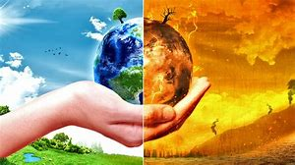
How Climate Change Impacts Businesses

By Jasmine Thomas

What s Climate Change?
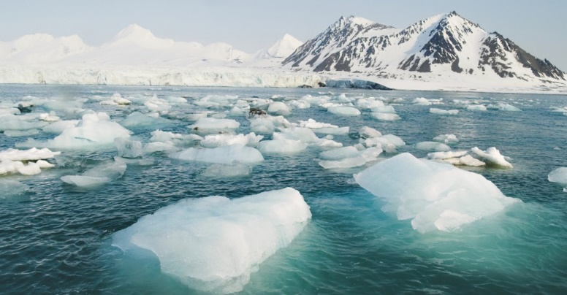
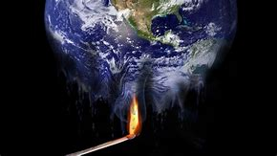
Climate Change is a change in weather and temperature, it's about how weather can behave differently in some areas of the world. For example, how much sun or rain a country usually have in a year. Climate Change also means a change in the Earths climate meaning there can be an unusual change into the Earth's temperature, currently, the Earth's temperature has risen meaning the earth is warmer. The warm climate of the Earth has caused ice in the Atlantic to melt, a rise in sea levels, and changes to the time some plants grow. All these impacts of climate change can not only impact the environment but also businesses across the globe. (Nasa,2017)
Are there any advantages of climate change?
Believe it or not, there are a few advantages from climate change. The first advantage of climate change is that places that have very low temperatures like the Arctic or Atlantic have warmer temperatures which makes it difficult to grow any plants, although with climate change rising these cold places will get warmer and ice will start to melt allowing plants to grow. (Brainshare,2019) This meaning businesses like farms will have a new area to start their business.
You could say that climate change advantages agricultural businesses mostly, for example, climate change has changed the length of seasons this meaning that in some places the winter season has shortened and moved on to the summer season. Also, there are some places where the growing season of plants produce has prolonged all because of climate change, this gives agricultural a greater advantage as they have more time and more agricultural products such as vegetables to sell. (Brainshare,2019)
Although there are some advantages to climate change there are also many disadvantages to climate change which may seem obvious to most people. One disadvantage from climate change which I had mentioned previously is that the Atlantic ice is currently melting which will lead to a rise in the sea levels, this can cause many floods to happen in low-lying areas of the world. (Brainshare,2019) This gives a threat to businesses that are located in these areas as their shops and production factories will be damaged which will cost businesses a large amount of money to get it back running and that is if the flood clears. If the flood does not clear businesses will have to relocate their shops and factories somewhere that is less likely to be disrupted by climate change, which would be difficult because climate change is starting to take over the world.
Another disadvantage that climate change brings to us is that it can affect the growth rate of plants. Plants require a certain temperature and a certain amount of rainfall for them to grow but recently rainfall and weather have been unpredictable which is leading certain plants to extinction. (Brainshare,2019) This mainly impacts agricultural businesses as there will be no crops for them to sell and make a profit from. From learning about the disadvantages of climate change it is becoming apparent how much climate change is impacting businesses.
How will climate change impact businesses?
Climate change won't only disrupt the environment we live in but it will also have a large impact on businesses. The first impact would be that due to unpredictable and extreme weather there will be a change in cost and the availability of resources. (Renewable energy, 2018) The reason following this is simply that the extreme weather has the potential to disturb supply chains, this leading business to difficulty as supply chains distributes businesses resources and materials. With the government trying to set laws on businesses to help prevent climate change from getting any worse, electricity and transportation may cost businesses more as the cost of moving goods are being increased. Also, products that contribute to climate change such as plastic have regulatory restrictions which also has an increased cost. The reasons why the costs of electricity, transportation, and regulatory restrictions are being increased by the government is to convince businesses to use alternative materials and recycle more waste to help contribute to saving the environment. (Renewable energy, 2018)
The second impact that climate change has on businesses is the change in demand. The meaning of change in demand is when the market changes its preferences in products or service. With temperatures rising at the moment there's going to be less demand for oil and gas to heat our homes, we now have customers prioritizing a sustainable lifestyle and buying more sustainable products which are shifting the demand towards more environmentally friendly products. (Renewable energy, 2018)
Another impact climate change has on businesses is that working conditions will be harsher on employees. This impact is mainly directed to agricultural businesses that rely on the weather to make profits. With temperatures increasing and weather patterns changing, working conditions for employees can become difficult. Farmers that do physical labour outdoors will have more health and safety risks, meaning agricultural businesses will have to pay employees a higher wage to cover their health costs. (Renewable energy, 2018)
The last impact climate change has especially on energy businesses is the changing regulations, regulations are like rules businesses have to follow to be fair and, in this case, to prevent air pollution. If energy businesses don't follow energy regulations, they will have to purchase extra credits. Businesses must invest to upgrade their facilities to get rid of the high level of emissions. This will help make energy businesses to go towards a cleaner resource, which will have a higher cost. (Renewable energy, 2018)
Businesses have to find a way to adapt to the conditions they are in so they can be successful in the future.
“The first step a business needs to take is to analyze to define how it impacts the environment, as well as the potential risks it faces due to climate change. In addition to risks, businesses should identify opportunities to improve their environmental performance. Companies should examine whether they can source alternative materials and evaluate the feasibility of using renewable energy such as solar, wind and biomass.”
-Renewable energy, 9/11/2018
Businesses can measure their carbon footprint to evaluate how much greenhouse gas emissions they generate annually. Once knowing how much greenhouse gas emission is being generated businesses can start working on reducing their carbon footprint. A business will have to make a plan, set emissions reduction targets, monitor their progress, and support climate change policies set by the government to overcome climate change.

Businesses role in climate change
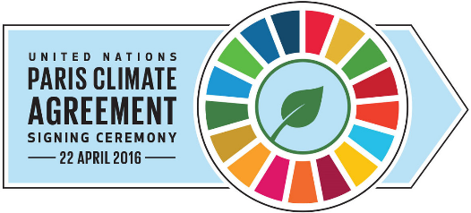
In 2015 all nations were brought together to undertake the crisis of climate change, so we can live in a safe sustainable environment. The nations made the Paris Agreement whose goal is to mark the threat of climate change in everybody’s thought. The nations want to keep temperatures below 2 degrees Celsius above preindustrial levels.
“To reach these ambitious goals, appropriate financial flows, a new technology framework and an enhanced capacity-building framework will be put in place, thus supporting action by developing countries and the most vulnerable countries, in line with their national objectives.”
-United Nations,2019
Since the mention of the Paris Agreement businesses has begun using renewable energy, situate low-carbon technology and working on more innovative solutions. With businesses being the economic most powerful forces, it is the businesses role to address the problems with climate change and persuading consumers to live a more sustainable lifestyle.
Businesses are showing motivation in wanting to tackle climate change, with more than 150 companies and 70 non-governmental organizations, government bodies, and cities from around the world collaborating to come up with solutions to tackle climate change. There are eight different areas that this team covers including low-carbon transport fuels, forests, energy efficiency in buildings, renewable energy, low carbon freight, chemicals, cement, and climate-smart agricultural. One of the largest outcomes to come of low Carbon technology partnerships initiative (LCTPi) is the global collaboration below50. The collaboration brings the valve chain for sustainable fuels, which is fuels that make at least 50% less CO2 emissions than the usual fossil fuel. This shows how important it is for businesses to collaborate because one business could not do this by themselves.
Governments across the nation must play their role in the Paris Agreement to succeed and prevent climate change from getting any worse than it is. Governments will also have to work together to advertise the negative impacts that we are promoting on to the environment, and what we need to do to stop this crisis from getting any worse.

How can businesses adapt to climate change?
We already know that the answer for businesses to adapt to climate change is to begin looking at ways to be more sustainable, but for the time being, it can be difficult for businesses to just stop and reanalyze everything in their company just with a click from their fingers. It takes time, money, and planning to make businesses sustainable straight away, which is why its best to take small steps into becoming environmentally friendly. (Nibusinessinfo.co.uk,2019)
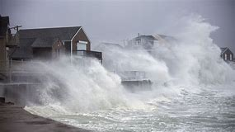
The first aspect to look at is extreme weather. The weather can destroy or damage a business in a second including flooding, strong wind, and thunderstorms. If a company is built on a low grounded area near water, then evidently the company is more likely to be affected by floods. The company needs to have a flood plan, the plan should include what the company is going to do in an event of a flood and think of plans for the stock to prevent them from being damaged if a flood occurs, for example, storing the stock above floor level if it’s possible.
The second aspect all businesses should consider is their employees. Managers should understand and consider what actions to use if their employees are absent from work due to disruptive weather, managers can start a work at home system if employees are unable to attend work they can work from home. This solution saves the business from losing a whole day of work. Managers can also ensure employees are comfortable in the workplace by providing clothing and natural ventilation or insulation in the workplace. The more comfortable employees are, the more work will be done, and the business will run effectively. (Nibusinessinfo.co.uk,2019)
It's important that businesses also have a strategic plan, which includes longer-term objectives and the steps for reaching that objective. With climate change being the focus of businesses today or it should be, the longer-term objective for most businesses is to be more carbon-free. To reach this objective there are a few steps businesses must take, which I will be explaining in the following.
Businesses should include climate change into their business strategy, by thinking about the impact climate change can have on the business. There will also be negative impacts including rising costs and a change in what customer buys. Businesses should make sure to think about how climate change will affect the supply chain and customers.
Another step a business should take is changing its priorities to respond to climate change. There’s going to be sustainable businesses that will be giving their best efforts to prevent climate breakdown from reducing emissions and energy use. The direction businesses should be going is consumer demand, farm diversification, changes for tourism businesses and construction standards. (Nibusinessinfo.co.uk,2019)
Are their companies in the UK trying their best effort to be more sustainable?
Fortunately for us, many companies in the UK are coming up with solutions to be more sustainable and helping the economy from climate change.

BBC Earth
BBC Earth is a well-known British documentary that’s so successful nearly everyone across the globe has watched it. BBC Earth has aired Blue planet where they show how climate change and humans’ negative behaviour has impacted the worlds ocean. Other than airing blue planet BBC Earth has also launched a sustainable fashion brand that’s made from organic silk. (Businessleader,2019)

Bio-Bean
Another company in the UK that is known for being very sustainable is Bio-Bean. Bio-Bean is a company that collects coffee ground waste from coffee companies across the UK and turns them into coffee logs. The coffee logs generate 80% less emission than if the grounds were to go to landfill. Bio-Bean believes there is no such thing as waste, only resources in the wrong place. (Businessleader. 2019)
Lush

Lush is a British company that creates and sell fresh handmade cosmetics made from natural ingredients, and they are also against animal testing. Lush is now in the process of eliminating palm oil from its products. Lush is also releasing a vegan range where they are offering limited-edition vegan products so they can raise money for charities to save the environment. (Businessleader,2019)
The Travelling Bee Company

The Travelling Bee Company is a company that’s the main priority is to save the bees, they do this by collecting a bunch of bees into a bee-mobile and release them into hives across the UK. Bees are important as they pollinate plants which creates the food that we eat, the travelling bee company’s main mission is to save the bees. The company also sells the bees honey to make a profit to open up more bee mobiles. (Businessleader, 2019)
Wyatt & Jack

Wyatt and Jack have smartly created bags and accessories from upcycled beach deckchair canvas and old bouncy castles vinyl. Usually, handbags are made from animal leather but Wyatt and Jack have made their bags that don’t only raise awareness towards using products made from animal skin, but they are also raising awareness to re-use old, and worn-out materials instead of throwing them away to landfills and the ocean. (Businessleader,2019)
Green Tomato Cars
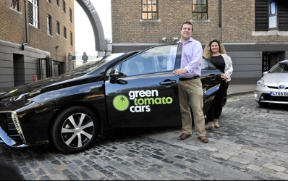
The last sustainable company to know about is Green Tomato Cars. Green Tomato Car is a taxi service in London that is eco-friendly by using the UK’s hydrogen fuel cell EVs. The company has 600 hybrid vehicles altogether and all are fuel-efficient. And if the company doesn’t already do enough to save the planet with their eco-friendly cars they also plant 200 trees a year. (Businessleader,2019)
Conclusion
I believe it’s evident that climate change has had a tremendous amount of impact on businesses. Climate change is surrounding us today, where ever we go all we hear about on the news is how much climate change is destroying our environment and that we need to put an end to the crisis. Even though businesses are being impacted by climate change, they are still the ones to make a stand against it by advertising the harm we are currently doing to the environment. With businesses showing the way to an eco-friendly lifestyle, everyone is now following the same footsteps as these businesses so in a few years we can overcome the climate change crisis.

References

https://www.advantages-disadvantages.co/climate-change/
https://www.nasa.gov/audience/forstudents/k-4/stories/nasa-knows/what-is-climate-change-k4.html
https://www.renewableenergymagazine.com/emily-folk/how-climate-change-will-affect-businesses-20181109/
https://unfccc.int/process-and-meetings/the-paris-agreement/the-paris-agreement
https://www.wbcsd.org/Overview/News-Insights/Insights-from-the-President/The-role-of-business-in-climate-change
https://www.nibusinessinfo.co.uk/content/generate-your-own-renewable-energy
https://www.businessleader.co.uk/25-sustainable-uk-companies-that-are-out-to-save-the-planet/66208/
Made in Office 2007 for office2007.com

