A report on the research surrounding the effectiveness of elective fertility treatment available to women in comparison to fertility ritual, and concerns surrounding women.

Introduction:
The report aims to act as a steppingstone towards an essay on issues surrounding women’s fertility in both a medical and ritualistic setting; how a woman’s fertility journey is often subject to the individuals background and culture. The attributions of worth and stigma of infertility in modern society both now and historically are explored. This report gathers data on issues, contentions, and strategies towards social change on the topic of women’s femininity and fertility and how these are related. The subject matter is the advantages and disadvantages of fertility treatment faced by those with female reproductive organs, and whether women are subject to symbolic and structural violence due to the socially constructed definition of what a woman is. The starting point is a research proposal from the University of Sheffield on evaluating ways to improve women’s chances of a successful pregnancy and increase live birth rates in those undergoing treatments for infertility and recurrent miscarriages. It presents statistics surrounding fertility treatment in the Uk (Human fertilisation and embryology authority, 2017, Ferguson, 2021). Cross cultural attitudes to fertility are considered in an evaluation of A historical and modern scientific perspective on Infertility and assisted reproduction cross culturally, (Singh and Shyam Sharma, 2018). Concepts of maternal as an assumed innate and primitive drive are explored, as an arguably defining element of a woman's nature in wider society, (Blaffer Hardy, 2000). There is discussion on how fertility is viewed differently across the world, and how women have found alternative ritual and treatment for infertility (Nutt, 2017, Bajekal, 2019). This data is collected in an attempt to to offer an overview of concerns surrounding women both medically and socially in reference to fertility, culutral variation and potential issues with both medical and ritualistic treatment. This topic is particularly relevant in a time of great social upheaval surrounding the safety and position of women within society (Charsley, 2021).
Background History:
Fertility rites are arranged to occur in calendric cycles, as rites of passage within the life cycle, commonly embedded within larger-order religions or other social institutions. Historically they often rely upon acts of worship to nature and gods. In Ancient Greece, Demeter Olympian goddess of the harvest and agriculture, presided over grains and the fertility of the earth and was often associated with the cycle of life and death (Finley and Hornblower, 2002). Thesmophoria, dating back to the 11th century, is a fertility festival to ensure fertile land and good harvest, and in conjunction the fertility of its participants. It is an example of early fertility ritual (Thesmophoria, 2021). According to the Southern California Reproductive Centre, early medical solutions for female infertility were mainly surgical, but by the late 1850s, artificial insemination was being attempted. As a first major development towards assisted reproductive technologies. The first IVF baby was born 25 July 1978, at Oldham and District Hospital in Greater Manchester (Contributor, 2021). Previously infertility was considered as divine judgement. Most medical fertility treatments target women specifically. The term ‘barren’ meaning (of land) too poor to produce, is used about any women without children rather than just the medically infertile.

Data Sources:
Fertility treatment 2017: trends and figures - Human fertilisation and embryology authority.
The study shows statistical changes in fertility treatment in the Uk between 1991 and 2017. The report shows changing social trends towards female fertility, more women taking the steps towards single parenthood and at a climbing age range. Delivery of treatment is underfunded as issues such as debt and mental health problems occur as by-products.
- 35.5 is the average patient age has increased for both IVF and DI treatments from 33.5 and 32 in 1991 to 35.5 and 34.5 in 2017.
- 65% of patients aged under 37 make up 65% of people having IVF treatment cycles and 73% of those undergoing DI treatment cycles.
- 90.7% of treatment cycles were undertaken by patients with male partners. The remaining patients were listed with a female
- partner (5.9%), no partner (3%) or as a surrogate (0.4%).
- 12% Treatment cycles for patients in same-sex partnerships have increased by 12% from 2016 to 2017 and 4% and 22% for patients with no partner or surrogates, respectively.
- The Adoption and Children Act 2002 gave unmarried couples, including same sex couples, the right to adopt, and this became law in December 2005.
- There were 69,822 IVF treatment cycles and 5,603 DI treatment cycles undergone in 2017, increases of 2.5% and 3% respectively since 2016.
- The fastest growing fertility treatment type is egg preservation (freeze cycles).
- 91 clinics were actively providing fertility treatment in the UK in 2017: 78 in England, six in Scotland, four in Wales and three in Northern Ireland.

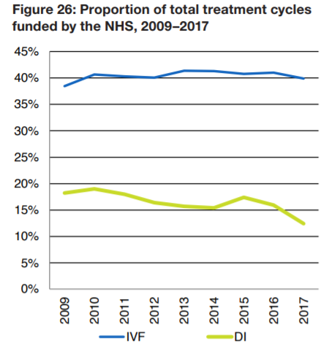
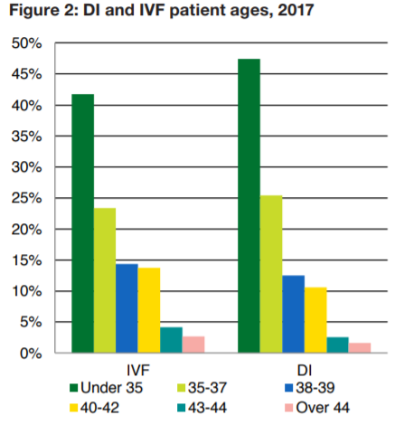
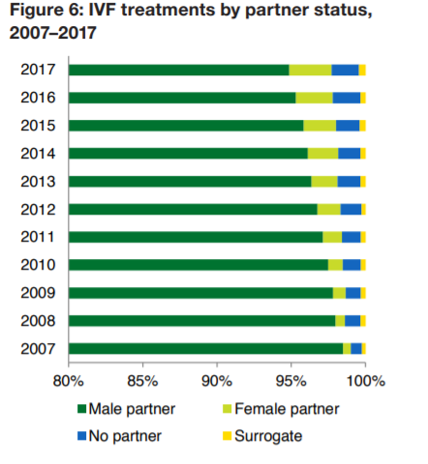

Pioneering study will investigate ways to improve women’s chances of having a baby - University of Sheffield press release
This study follows the proposed research from University of Sheffield’s Clinical Trials Research Unit to support the trial with Sheffield Teaching Hospitals NHS Foundation Trust. Funded by the National Institute for Health Research, it attempts to assess if removing small fibroids and endometrial polyps is an effective way to improve fertility in women and increase live birth rates in those undergoing treatments for infertility and recurrent miscarriages.
- 20 to 40 percent of women with unexplained infertility are found to have fibroids and around 15 to 20 percent have endometrial polyps.
- The 1.8 million grant, is the third successive multi-million-pound grant obtained by the team of gynaecologists and researchers based at the University of Sheffield’s Clinical Research Trials Unit
- 1,120 women are set to take part in the study, across 30 gynaecology and fertility centres in the UK.
- Hysteroscopy is an optional additional treatment offered to women with smaller fibroids and endometrial polyps as part of their fertility treatment.
- Treatment is due to commence on 1 April 2021.
- The study is expected to take around two and a half years, with initial findings due to be published in summer 2025.

What you look at, you make: menstruation and fertility in Italian renaissance art - Racheal Nutt
Nutt’s undergraduate thesis follows how menstruation was not viewed as a normal function of the body, but as a marker of feminine incompetence during 12th century Italy. Gender equality and reproductive rights have made strides in Western cultures, but natural, bodily functions typically associated with womanhood and fertility carry negative connotations.
- Michele Savonarola, who penned a popular advice book for the people of Ferrara in the fifteenth century, wrote that menstrual blood was the true main ingredient--just as necessary as dough in the creation of bread.
- The Church had quite vitriolic views of menstrual blood, as menstruating women were technically barred from entering churches by rules laid out in Leviticus, as menstruating women were seen as unclean and therefore unfit to receive the Eucharist; similarly, Mary Douglas and Judith Okely wrote about cultural divide on the ‘purity’ of women due to menstruation (Vodou women).
- Art was used to help mothers conceive, birth, and raise their children.
- Jacqueline Musacchio wrote about sympathetic magic, or the belief that what one sees influences one’s body and wellbeing.
- Gazing at pictures of the ‘valorous men’ while having sex, was believed to promote conception. Ideology transferred through art and décor.
- Coral was worn and gifted as a protective element.
- Florence’s population dropped about 72 percent between 1347 and 1480. The low infant survival 27 rates during this period inference fertility ritual.
- Bridal jewellery served as a reminder of the bride’s physical duty: acting as a vessel for her husband’s seed – due to the ‘protective’ qualities of gemstones.

Conclusion:
In conclusion, the trend of growing fertility treatment within all areas of social identification suggests there is a slow movement towards social change and justice for women. However, women are still facing inequality and discrimination due their natural bodily functions and fertility. Law and legislation may protect the modern woman from previous historic prejudice however structural and systematic violence towards women is still prevalent. Using the data collected I hope to expand on the ritual aspects of fertility as an alternative or coexisting treatment for women; and how different strategic measures such as the adaptation of gendered education materials (Women and girls are about to be portrayed in textbooks a lot differently, 2020) can help bridge the gap of (fertility-based) gender inequality/bias.

References:
- Bajekal, N., 2019. Why So Many Women Travel to Denmark for Fertility Treatments. [online] Time. Available at: <https://time.com/5491636/denmark-ivf-storkklinik-fertility/> [Accessed 20 April 2021].
- Blaffer Hrdy, S., 2000. Mother Nature Maternal Instincts and how They Shape the Human Species. 2nd ed. New york: Ballantine Books, pp.1-723.
- Bohn, W., 1991. Apollinaire and the faceless man. Rutherford, N.J.: Fairleigh Dickinson University Press, p.66.
- Charsley, M., 2021. Reclaim Sutton's Streets: new group launches to improve safety for women. [online] Your Local Guardian. Available at: <https://www.yourlocalguardian.co.uk/news/19242871.reclaim-streets-women-launch-sutton-campaign-group/> [Accessed 20 April 2021].
- City Full of Gods. 2021. Thesmophoria. [online] Available at: <http://cityfullofgods.weebly.com/thesmophoria.html#:~:text=The%20Thesmophoria%20were%20a%20religious,fertile%20land%20and%20good%20harvest.> [Accessed 20 April 2021].
- Contributor, S., 2021. The Evolution of Fertility Treatments and Development of IVF. [online] Blog.scrcivf.com. Available at: <https://blog.scrcivf.com/ivf-the-history-and-evolution-of-fertility-treatments> [Accessed 20 April 2021].
- Ferguson, R., 2021. Pioneering study will investigate ways to improve women’s chances of having a baby. [online] The University of Sheffield. Available at: <https://www.sheffield.ac.uk/news/pioneering-study-will-investigate ways-improve-womens-chances-having-baby> [Accessed 19 April 2021].
- Finley, M. and Hornblower, S., 2002. The world of Odysseus. London: Folio Society, pp.1-92.
- Hfea.gov.uk. 2017. [online] Available at: <https://www.hfea.gov.uk/media/2894/fertility-treatment-2017-trends-and-figures-may-2019.pdf> [Accessed 20 April 2021].
- Larbi, M., 2021. Women are reclaiming the word 'barren' to talk about their fertility issues. [online] Metro. Available at: <https://metro.co.uk/2019/07/31/women-reclaiming-word-barren-talk-fertility-issues-10284278/> [Accessed 20 April 2021].
- Sky News. 2020. Women And Girls Are About To Be Portrayed In Textbooks A Lot Differently. [online] Available at: <https://news.sky.com/story/exam-board-owner-pearson-to-flip-gender-stereotypes-in-childrens-learning-materials-12140397> [Accessed 18 December 2020].
- Nutt, R., 2017. What You Look A ou Look At, You Make: Menstruation and F e: Menstruation and Fertility in Italian tility in Italian Renaissance Art. UVM College of Art and Science Honors Theses, [online] pp.1-70. Available at: <https://scholarworks.uvm.edu/cgi/viewcontent.cgi?article=1045&context=castheses> [Accessed 20 April 2021].
- Singh, R. and Shyam Sharma, R., 2018. Infertility & assisted reproduction: A historical & modern scientific perspective. [online] PubMed Central (PMC). Available at: <https://www.ncbi.nlm.nih.gov/pmc/articles/PMC6469376/> [Accessed 19 April 2021].

