operating hotel facilities

Health & Wellbeing – the emerging trend within hotels.

Date:27-10-2022
Mohammad Shahidul Islam Chowdhury
Student Id: 2026960
Module Lecturer: Tristan Hawkins

The emerging trend in hotels is health & well-being:
Physical fitness and mental stability are both essential to health and well-being. In response to this awareness, the hospitality industry has put its customer's well-being concerns at the heart of its products and services. Despite the busyness of life, physical activity, healthy eating, holistic treatments, regularly taking steps, resting, exercising, and enrolling in fitness and spa classes are all part of lifestyle wellness. Having a happy and healthy mental environment and surrounding yourself with the right people is equally essential for your health and well-being. Many hotels are developing comprehensive plans to provide their guests with better health and wellness amenities.
Wellness: The goal of health is to cultivate healthy habits daily so that we don't just survive but thrive in our physical and mental well-being. Understanding the link between wellness and health is essential to understanding its significance.

Light or Soft wellness- Self-care offerings include apps for mental health or relaxation, yoga maps with online tutorials, and yoga classes. It also includes environmental considerations, such as air quality and natural light.

Heavy or Hard wellness- The spa includes hydrotherapy pools, experience showers, hammams, and cutting-edge spa facilities.
Wellness tourism- The concept of wellness tourism refers to travel that promotes physical and psychological well-being. In 2017, the global wellness market was valued at €4,040 billion, according to the Global Wellness Institute, with its value increasing by +6.4% annually. More than 609 billion euros are generated annually by the wellness tourism industry.
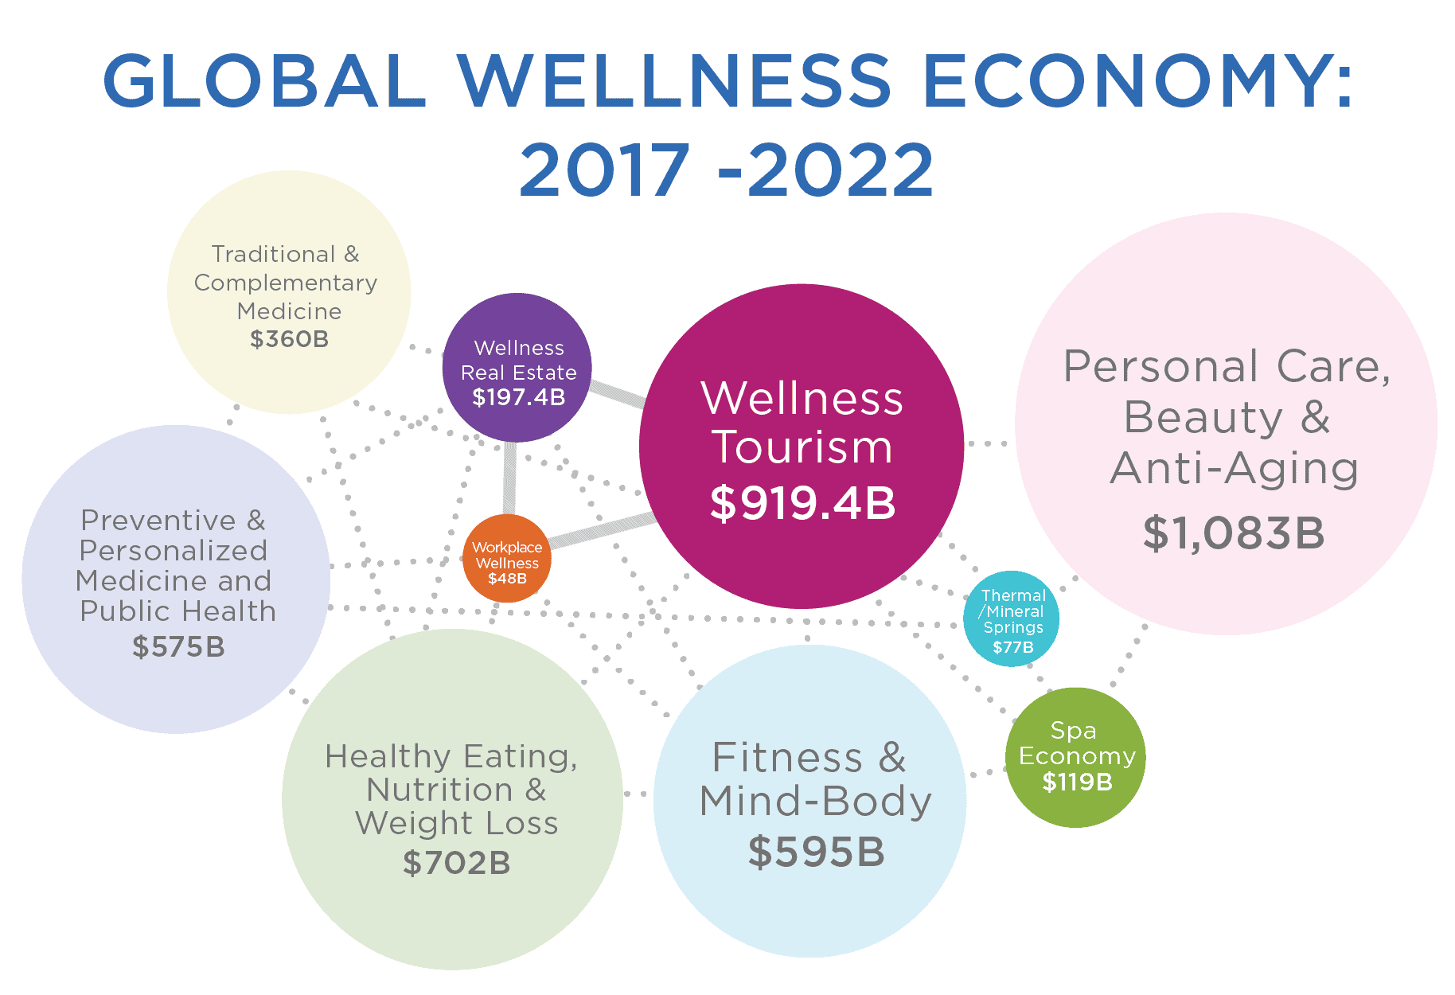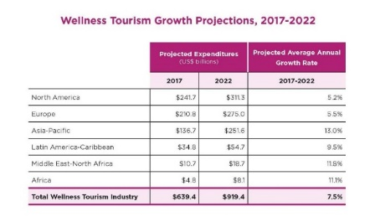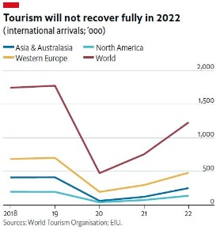
The growth of wellness tourism is expected to average 7.5% each year through 2022, significantly higher than the growth of 6.4% expected for total tourism. Yearly wellness trips will reach 1.2 billion by 2022, with $919 billion in spending. Asia-Pacific, Latin America-Caribbean, Middle East-North Africa, and Sub-Saharan Africa will account for nearly half of the total wellness expenses (and three-quarters of full wellness trips) through 2022.
Primary wellness tourism- An individual who tourism exclusively for wellness reasons. Among the examples of activities are Fitness, Life Coaching, Seminars, Retreats, Skiing, Trekking, and Spa Resort packages.
Secondary wellness tourism- Wellness tourism or tourism participating in wellness experiences while on vacation. Among the examples of spa days and massages are yoga classes, hair and beauty treatments, gastronomy, fitness, and spa treatments.
Health and well-being in hotels: how do they maintain them?
The hospitality industry is highly competitive, and industry trends can be volatile; Staying competitive in the health and wellness industry requires keeping up to date with current trends. The demand for well-being experiences is on the rise. Health and tourism destinations have become prime facilitators for participating in well-being experiences—accommodations such as hotels, spas, active living facilities, and retirement communities. These wellness-focused hotels and health retreats are ideal for those looking to unwind when on vacation, whether occupied, practicing meditation, eating organic, or trying new spa treatments.
Trends in Health and Wellness in 2022-
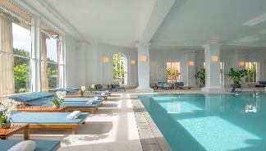
Breathing exercises- Stress-related health problems can be diverted through breathing exercises, which reduce acute stress responses.
Keeping your skin healthy is simple - Maintaining a healthy and attractive complexion by doing and using these things.
Keeping fit virtually- An unrestricted timeframe and a fitness goal are required for a virtual fitness challenge. I was walking a set distance at a set time, running, cycling, or cycling a certain distance.
Relax in a touchless spa- The Massages & Spa Services treatment allows you to restore healthy cells and boost your energy through mitochondrial healing.
Maintain a healthy immune system- Stay healthy by boosting your immune system. Avoid smoking. Having a healthy diet includes fruits and vegetables. Stay active. Maintain a healthy weight.
Maintaining good sleep hygiene - excellent hygiene helps people sleep better, stay asleep longer, and feel refreshed.
Food upcycling- Food waste can be prevented by buying upcycled products.
Foods with functional properties- Processed foods that provide health benefits and reduce disease risk can be categorized as functional foods.
Maintaining mental fitness- Stress less, sleep better, and enjoy life more to be happier. Every day, practice mindfulness with Headspace to give your mind kindness.
From my experience, I have learned that hotel guests are now more focused on their health than anything else. The hospitality industry should provide these facilities: physical activity, nutritious food, regular walking, exercise, sleep, and fitness programs. Hotel wellness programs can help them stand out from their competitors and profit from the competitive side. In today's hotel industry, guests expect the latest facilities, and guests are used to these features.
Reference:
https://www.hse.gov.uk
https://hospitality-on.com
https://globalwellnessinstitute.org
https://www.simpleviewinc.com/blog
https://www.weforum.org
https://www.starhealth.in
https://www.laingbuissonnews.com
https://occa-design.com
https://blog.fr-one.com
https://www.goodhousekeeping.com
https://blog.guestrevu.com
https://www.healthline.com
https://www.pfizer.com
https://www.laingbuissonnews.com

