Module : BMSS5007
Developing your Professional Profile

Modiwl : BMSS5007C
Datblygu eich Proffil Proffesiynol



Asesiad / Assessment :
E-portfolio prep for CPD / Work

Gan / By: ………………………

Arweinydd Modiwl / Module lead : Heddwen Davies

CV :
Josh Harvey
28a Bridge Street, Burry Port, SA160NR | 07468 468402 | 2405385@student.uwtsd.ac.uk

PROFILE
Enthusiastic Sport and Exercise Science undergraduate with strong customer service experience and a proven ability to design and deliver training programmes. Motivated to gain hands-on experience in weightlifting coaching and athlete development alongside academic studies, working towards industry-recognised qualifications such as UKSCA accreditation (UKSCA, 2024).

EDUCATION
BSc Sport and Exercise Science, University of Wales Trinity Saint David (Sep 2024 – Present)
Peter Symonds College – 2 BTECs and 1 A-Level (Sep 2021 – Jul 2023)
Kings’ School, Winchester – 9 GCSEs (Sep 2019 – May 2021)
Jebel Ali School, Dubai – Reception to Year 9 (2009 – 2019)

EXPERIENCE
Personal Trainer Experience, UWTSD (Jan 2025 – May 2025)
- Conducted consultations, designed 5-month resistance programmes, and delivered gym inductions to build client confidence.
- Developed skills in client communication, training design, and performance monitoring.
Barista, Costa Coffee, Winchester Moto Services (Oct 2022 – Present)
- Delivered excellent customer service in a high-pressure environment.
- Led coffee and brand standard training for new staff.
- Handled cash, stock management, and night-shift responsibilities.

SKILLS
• Client Communication – Consultations, interviews, and inductions.
• Programme Design – Multi-month resistance/weightlifting programmes.
• Instruction & Coaching – Technique correction, motivation, and safety.
• Leadership & Teamwork – Peer-led training and group coordination.
• Problem Solving – Applied exercise science knowledge to client needs.
• Organisation & Time Management – Balanced work, study, and training.
• IT – Proficient in Microsoft Office and social media for client progress.
• Professional Development - Pursuing UKSCA S&C Coach accreditation pathway (IUSCA, 2024; UKSCA,2024).

ACHIEVEMENTS
• YMCA Level 3 Personal Trainer & YMCA Level 2 Gym Instructor, June 2025
• RAF Air Cadets – Cross Country Gold Award & Regionals Representation January, 2020
• Completed the Nijmegen Road March August, 2021

INTERESTS
Fitness & Exercise, Golf, Swimming

REFERENCES
Available on request (e.g. Dylan Blain, d.blain@uwtsd.ac.uk | Heddwen Davies, heddwen.davies@uwtsd.ac.uk)

Llythyr / Letter for a post

28a Bridge Street
Burry Port, SA160NR
07468 468402
2405385@student.uwtsd.ac.uk
20 October 2025

Joe Alford
Southern Academy of Sport Ltd
Chippenham, Wiltshire

Dear Mr Alford,

I am writing to apply for the Strength and Conditioning/Athletic Development Coach position at the Southern Academy of Sport, as advertised on UK Sport. I am undertaking BSc in Sport and Exercise Science at the University of Wales Trinity Saint David and am deeply passionate about athlete development. I am eager to contribute my hands-on coaching experience and commitment to high standards to your team.

During my studies and experience as a Personal Trainer, I have designed and delivered resistance training programmes, conducted client consultations, and led gym inductions. These experiences have strengthened my communication skills with clients effectively, tailoring training to individual needs, and monitoring performance progress. I am particularly motivated by the opportunity to work with athletes across various sports, including those in collision sports, and contribute to both gym and field-based programming.
I am enthusiastic about collaborating with physiotherapists on injury rehabilitation, contributing to athlete education in recovery and nutrition, and supporting the delivery of world-class results. My background in customer service at Costa Coffee has also developed my teamwork, leadership, organisational and communication skills, which are essential for the collaborative and high-performance environment at the Southern Academy of Sport.

I hold a YMCA Level 3 Personal Trainer qualification and a Level 2 Gym Instructor certificate, and I am deeply committed to ongoing professional development in line with industry standards (UKSCA,2024). I am confident in contributing energy, focus, and a growth mindset to your team. This letter demonstrates a clear alignment between my qualifications and your persons specification for this role (Harvard University, n.d.; Indeed Career Guide, 2025). I am excited by the prospect of helping athletes fulfil their sporting and personal potential.

Thank you for considering my application. I am genuinely excited about contributing to the Southern Academy of Sport and am eager to discuss how my skills and experiences align with your goals.

Yours sincerely,
Josh Harvey

Focus Statement
Opening
I am determined to become a qualified Strength and Conditioning Coach, dedicated to helping athletes across various sports reach their full potential on and off the field. I am passionate about collision sports and thrive in high-performance environments that demand world-class results. Currently, I am pursuing a degree in Sport and Exercise Science at the University of Wales Trinity Saint David(UWSTD), where I am not only focusing on my studies but also actively gaining invaluable coaching experience and refining the practical skills essential for success in strength and conditioning environments (IUSCA, 2024). The opportunity at the Southern Academy of Sport is the ideal next step in my journey; it will allow me to learn from accomplished coaches, work with a diverse range of athletes, and be part of a team that prioritises delivering outstanding strength and conditioning support. Working with athletes from various sports to help them achieve their fullest potential on and off the field is one aspect of training I aspire to learn. My interest lies in collision sports and the unique challenges in high-performance environments, striving for world-class results. Alongside my studies, I am dedicated to gaining practical coaching experience and honing the skills necessary for success in this field. The opportunity at the Southern Academy of Sport aligns perfectly with my goals; it offers a chance to learn from experienced coaches, engage with diverse athletes, and contribute to a team committed to providing exceptional strength and conditioning support.

SWOT Analysis and Strengths
After evaluating my SWOT analysis, I confidently recognise that my strengths align seamlessly with the essential strength and conditioning coaching requirements. My degree has equipped me with a robust understanding of biomechanics, physiology, and training principles, enabling me to design evidence-based programs rather than relying on guesswork. My practical experience as a Personal Trainer at UWTSD has sharpened my abilities in client consultation, tailored program design, and progress tracking—skills that are directly transferable to working with athletes.
Additionally, my time at Costa Coffee has instilled in me the capacity to communicate effectively under pressure, lead training for new staff, and collaborate within a team—all critical skills when coaching athletes or partnering with physiotherapists and other professionals. With my YMCA Level 3 Personal Trainer and Level 2 Gym Instructor qualifications, I demonstrate a strong commitment to maintaining professional standards, and I am poised to pursue advanced certifications, such as those offered by the UKSCA (UKSCA, 2024). When applying for professional positions, it is essential to provide references that can verify skills and qualifications (University of Colorado, 2017). I am eager and fully prepared to contribute to the Southern Academy of Sport while continuously evolving as a coach.

Training Needs and Career Progression
My Training Needs Analysis has clearly identified the areas I must focus on to advance in this field. While my current qualifications lay a solid foundation, obtaining the NSCA CSCS professional accreditation is essential for reaching higher levels and working with elite athletes (UKSCA, 2024). I've also pinpointed key gaps in my experience, particularly in performance testing, collaborating on injury rehabilitation, and delivering athlete education programs. To address these areas effectively, I will shadow seasoned coaches during testing sessions, participate in workshops on sports science methodologies, and gain insights from physiotherapists on rehabilitation practices. Additionally, I will secure my first aid certification and stay committed to continuous professional development (CPD) courses, ensuring that I meet industry standards and remain at the forefront of best practices. Addressing these needs will enhance my employability and empower me to provide safe and impactful coaching that truly benefits athletes.

SMART Targets
Based on what came out of my SWOT and Training Needs Analysis, I've set myself some clear targets using the SMART framework, which research shows significantly enhances goal achievement and performance (Locke and Latham, 2002). Within the next year, I'll complete my NSCA certification by spending at least 5 hours a week studying from textbooks and online materials. Goal setting theory emphasises that specific challenging goals lead to higher performance than vague objectives (Locke and Latham, 1990). Over the next 6 months, I want to shadow qualified coaches during at least 10 athlete testing sessions to get comfortable collecting and interpreting data. I'll book myself onto an HSE-approved First Aid at Work course within the next 2 months to meet the health and safety side of things. I'm also committing to attending at least 3 CPD workshops or webinars on injury rehab and nutrition over the next 9 months. Finally, I'll ask supervising coaches for feedback on my session delivery at least once a month – regular input is the best way to improve. Research demonstrates that SMART goals provide a practical framework for rehabilitation and professional development (Bovend’Eerdt et al., 2009; Moeller et al., 2012). These targets give me a roadmap to follow and keep me accountable as I work towards becoming a well-rounded S&C coach.

Conclusion
This process has allowed me to define my path, highlight my strengths, and pinpoint the areas where I will enhance my skills. By systematically addressing my training needs through these targets, I am confident in developing the skills and qualifications required for success in high-performance environments and significantly impact development (Latham and Locke, 2007). I am enthusiastic about the journey ahead and committed to continuous learning as I strive to become a respected strength and conditioning coach.

References
- Bovend'Eerdt, T.J.H., Botell, R.E. and Wade, D.T. (2009) 'Writing SMART rehabilitation goals and achieving goal attainment scaling: A practical guide', Clinical Rehabilitation, 23(4), pp.352-361.
- Harvard University (n.d.) CVs and Cover Letters. Available at: https://hwpi.harvard.edu/files/ocs/files/gsas-cvs-and-cover-letters.pdf (Accessed: 26 October 2025).
- Indeed Career Guide (2025) Writing a Reference Letter: Template and Example. Available at: https://www.indeed.com/career-advice/resumes-cover-letters/references-letter-template (Accessed: 26 October 2025).
- International Universities Strength and Conditioning Association (IUSCA) (2024) How to Become a Strength and Conditioning Coach. Available at: https://www.iusca.org/how-to-become-a-strength-and-conditioning-coach (Accessed: 26 October 2025).
- Latham, G.P. and Locke, E.A. (2007) 'New developments in and directions for goal-setting research', European Psychologist, 12(4), pp.290-300.
- Locke, E.A. and Latham, G.P. (1990) A Theory of Goal Setting and Task Performance. Englewood Cliffs, NJ: Prentice Hall.
- Locke, E.A. and Latham, G.P. (2002) 'Building a practically useful theory of goal setting and task motivation: A 35-year odyssey', American Psychologist, 57(9), pp.705-717.
- Moeller, A.J., Theiler, J.M. and Wu, C. (2012) 'Goal setting and student achievement: A longitudinal study', The Modern Language Journal, 96(2), pp.153-169.
- UK Strength and Conditioning Association (UKSCA) (2024) Accredited S&C Coach. Available at: https://www.uksca.org.uk/assessments (Accessed: 26 October 2025).
- University of Colorado Graduate School (2017) Guide to Job References. Available at: https://www.colorado.edu/graduateschool/services-resources/career-resources/guide-job-references (Accessed: 26 October 2025).

Appendices
- Tutor / Student log of meeting/meetings
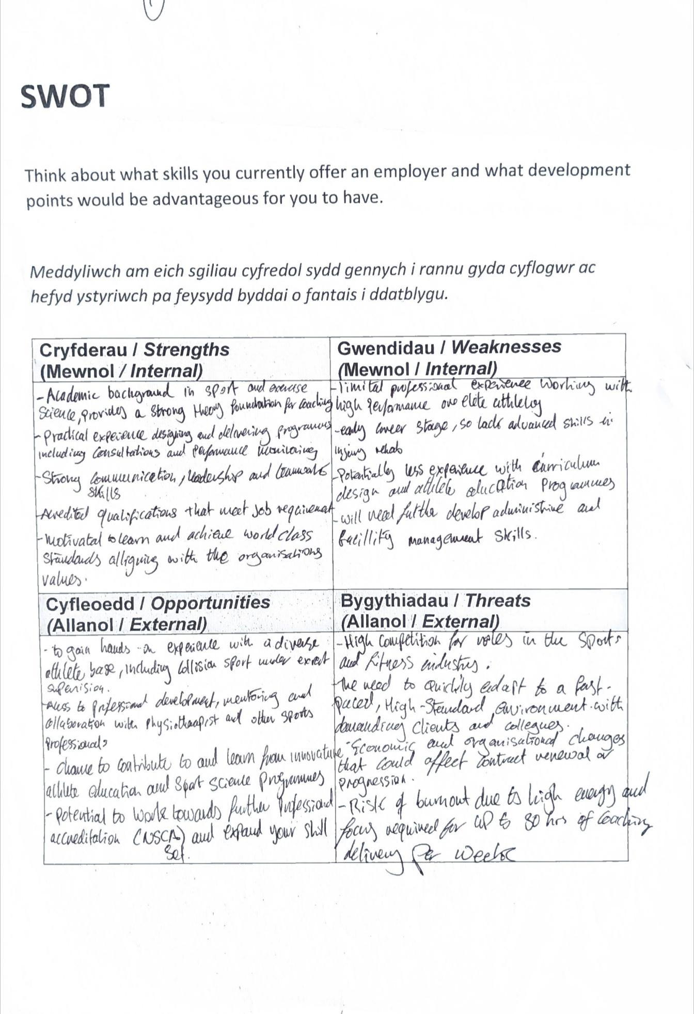
SWOT Analysis
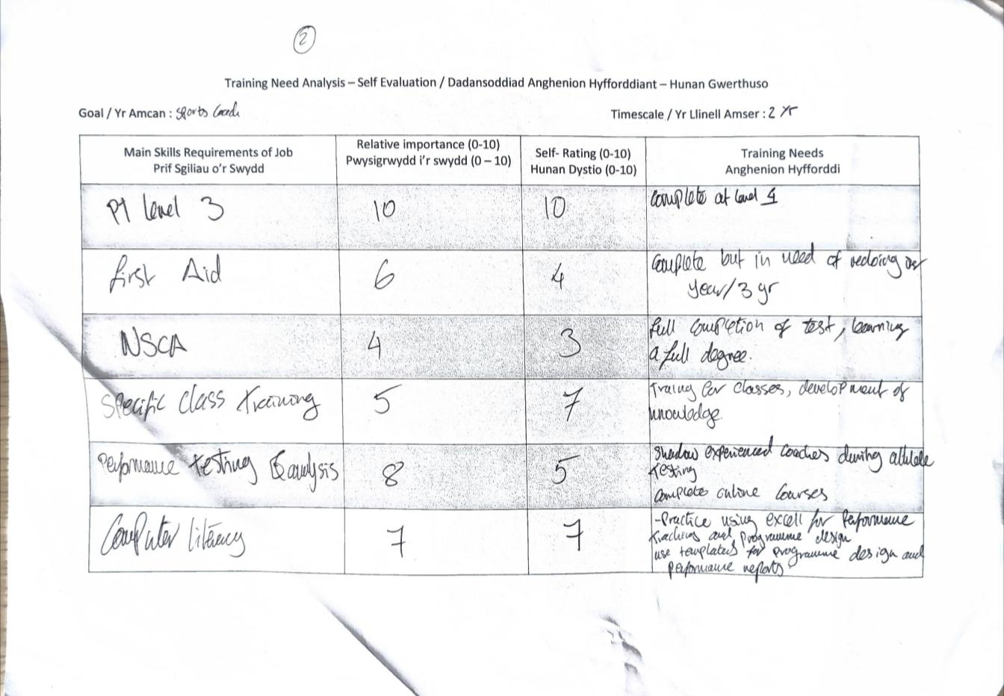
- Training Needs Analysis

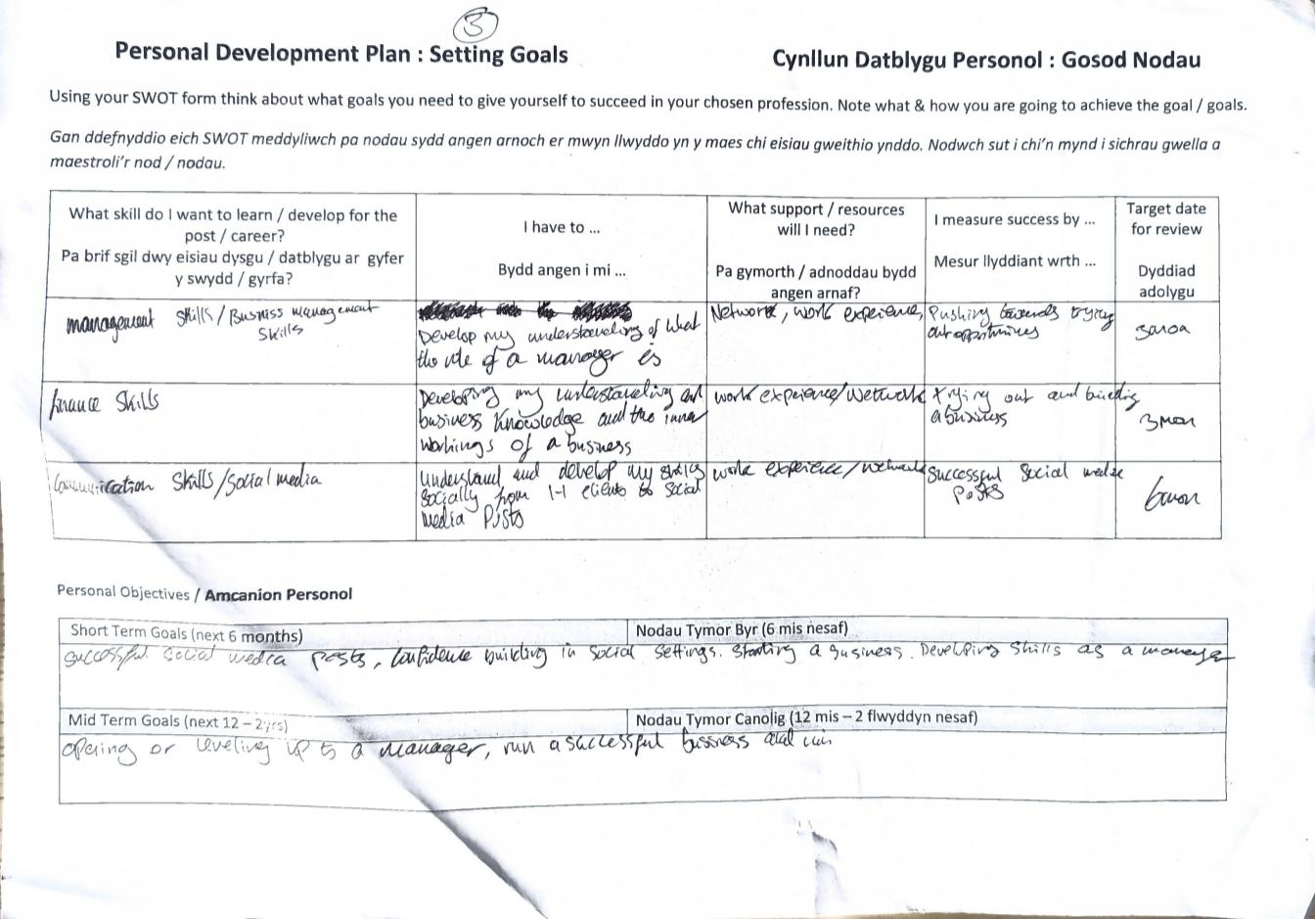
- Personal Development Plan – create SMART targets

