University of Wales Trinity Saint David


Master of Business Administration
Student Name:
Chiya Fayzullah
Student ID:
2208596
Title:
External Economic Shocks and the UK Cost-of-Living Crisis: Impacts on Macroeconomic Stability and Household Welfare
Supervisor:
Dr. Simon Chatterton

Contents
CHAPTER 1: INTRODUCTION 5
1.1 Background of the Study 5
1.1.1 The US-Israel-Iran Conflict and Its Economic Consequences 6
1.1.2 Household Welfare Impacts 8
1.1.3 Policy Dilemma and Fiscal Impact 9
1.2 Research Problem 9
1.3 Research Aims 10
1.4 Research Objectives 10
1.5 Research Questions 11
1.6 Significance / Relevance of the Study 11
1.7 Organization of the Study 12
CHAPTER 2: LITERATURE REVIEW 14
2.1 Introduction 14
2. Theoretical and Empirical Foundations 14
2.1 Geopolitical Risk and Macroeconomic Transmission 14
2.2 Oil Price Shocks and the UK Economy 15
3. The COVID-19 Pandemic (2020-2021) 17
4. The Russia-Ukraine War (2022-2025) 17
5. The US-Israel-Iran Conflict (2026) 18
6. Macroeconomic Impacts 19
6.1 GDP Growth and Economic Contraction 19
2.6.2 Inflation Dynamics 20
2.6.3 Labour Market and Employment 20
2.7 Household Welfare Impacts 21
2.7.1 Household Income and Disposable Income 21
2.7.2 Poverty and Financial Resilience 21
2.7.3 Consumer Spending and Behaviour 21
2.8 Conclusion and Research Gaps 22
CHAPTER 3: RESEARCH METHODOLOGY 23
3.1 Research Methodology 23
3.2 Data Sources 23
3.3 Data Collection Procedure 24
3.4 Data Analysis Procedures 24
3.5 Ethical Considerations 24
3.6 Limitations 24
CHAPTER FOUR ANALYSIS, FINDINGS AND DISCUSSION 26
4.1 Introduction 26
4.2 Macroeconomic Impacts of External Shocks 26
4.2.1 GDP Growth and Economic Output 26
4.2.2 Inflation Dynamics 28
4.2.3 Employment and Labour Market Dynamics 30
4.3 Energy and Supply Chain Exposure 33
4.3.1 Energy Price Shocks 33
4.3.2 Supply Chain Disruptions 34
4.4 Household Financial Pressure 35
4.4.1 Household Income and Disposable Income 35
4.4.2 Household Savings and Financial Resilience 36
4.4.3 Consumer Spending Patterns 38
4.4.4 Barriers to Saving and Financial Pressures 39
4.5 Discussion 40
4.5.1 Transmission Mechanisms of External Shocks 40
4.5.2 Household Welfare Implications 41
4.5.3 Policy Implications 42
4.6 Conclusion 42
CHAPTER FIVE CONCLUSION AND RECOMMENDATIONS 44
8.1 Conclusion 44
5.2 Recommendations 46
Distribution of References 48
References by Source Type 50
References by Year of Publication 51
Appendixes 59
Appendix-I GDP Growth 59
Appendix-II-GDP monthly estimate, UK: March 2026 60
Appendix-III-GDP- The value of goods and services produced in the UK. 62
Appendix-IV Inflation 63
Appendix-V Employment 66
Appendix-VI 67
Appendix-VI Energy prices 68
Appendix-VIII UK Cost-of-Living Data 69

CHAPTER 1: INTRODUCTION

1.1 Background of the Study
The UK's cost of living crisis has been a long-term and complex issue since 2021, with a series of external economic shocks highlighting the fragilities of the UK's very open economy (Resolution Foundation, 2026; House of Commons Library, 2026a). After the devastating impacts of the pandemic on the UK economy, the 2020 contraction was the largest on record since after World War One and the 2021 rebound was an unprecedented 7.5% (ONS, 2021; Reuters, 2022). But a historic increase in global energy and food prices was caused by Russia's invasion of Ukraine in February 2022, bringing the recovery to an abrupt halt (OBR, 2023; Nesta, 2026). By the end of 2021 UK CPI inflation had already pushed above 5% due to increasing demand pressures since the pandemic began, but increased to a maximum of 11.1% in October 2022, the highest figure in 40 years, (ONS, 2022; Peel Hunt, 2023; BBC News, 2023). In October 2020, the energy price cap was at £1,042 per year, but it increased by 54% to £1,971 in April 2022 and was due to rise to £3,549 from October 2022, before the price cap was capped by the government at £2,500 (Ofgem, 2022; Reuters, 2023; Nesta, 2026). The current conflict between the U.S. and Israel and Iran, that began in February 2026, has also been a significant shock, with the U.K. economy being the worst affected of G7 economies (IMF 2026b; The Observer 2026). The IMF has now revised its GDP forecast up for the UK for 2026, from 0.8% growth previously on the back of global energy shock warnings to 1% (IMF, 2026c; Independent, 2026), but remain lower than the 1.3% growth rate they predicted in January prior to the escalation of the Middle East conflict. The powerful financial institution noted that the UK is "resilient in recent years" but the "war in the Middle East is dampening near-term prospects" (IMF 2026c; Yahoo Finance 2026). In the past few weeks, the IMF and OECD have both lowered their estimates of how fast the economy will grow in 2026 by a full 0.5 percentage points, the biggest cut for any rich country (Resolution Foundation, 2026). The Chancellor recognized that the UK was more vulnerable to energy price shocks than other nations (HM Treasury, 2026). The downgrade of half a percentage point means that the UK's forecast for 2026 growth is now level with Germany, but the biggest revision in the wake of the conflict (CNBC, 2026).
UK's high exposure to these back-to-back shocks is due to numerous structural reasons. First, Britain's net energy import means it suffers the global price shock directly, strengthening its domestic inflation and household budgets (The Observer, 2026; CNBC, 2026). However, two things differentiate Britain from other countries: British households are more exposed to the price of gas than others in the G7, with 62% of their final household energy consumption coming from gas (by far the highest proportion for any of the G7 countries) and electricity prices are linked to wholesale gas prices (Resolution Foundation, 2026). Second, the UK is highly interdependent with international supply chains with imports and exports making up more than 60% of GDP, with more than three-quarters of UK manufacturing exports starting from overseas imports (Chamber International, 2026). Third, the UK depends on imports for as much as 42% of its food, and is very susceptible to disruptions to shipping and to increases in the cost of fertilizer, both of which are factors that could affect food supply (House of Commons Library, 2026b; National Preparedness Commission, 2026). The Middle East isn't a large supplier to the UK but the war has driven up the cost of fertilizer, which could affect the future yield and food security of the country (House of Commons Library, 2026b; Sustain, 2026). The British food supply chain has been vulnerable to the shock waves emanating from the Iran conflict, and Co-op has warned that it has highlighted the fragility and interdependency of the complex supply chains that underpin the food supply chain (The Grocer 2026).

1.1.1 The US-Israel-Iran Conflict and Its Economic Consequences
On 28 February 2026, the United States and Israel struck Iran simultaneously, sparking a military action which swiftly turned into a large-scale conflict involving several fronts, with significant worldwide economic consequences (House of Commons Library, 2026a; House of Commons Library, 2026). In the days that followed, Iran declared the closure of the Strait of Hormuz (which is home to the passage of about a fifth of global oil and gas trade), thus sending a direct and harsh blow to the international energy market (House of Commons Library, 2026b; LSE Blogs, 2026). The closure of the Strait of Hormuz has caused the loss of some 20 million barrels a day of oil, with oil production in the Gulf nations reduced by at least 10 million barrels, or about 10% of global production (House of Commons Library, 2026b; IEA, 2026). LNG exports from Qatar and the UAE have also been significantly impacted with Qatar saying it would cut production to a halt after attacks on energy facilities (House of Commons Library, 2026b; LSE Blogs, 2026), with Qatar accounting for almost 20% of global exports. Rising prices for both Brent and natural gas prices pushed futures to more than 13% above levels at one point and over US$82 per barrel, and prices for European natural gas futures jumped over 100% in two days, the largest since March 2022 (IPPR, 2026; Capital Economics, 2026).
In response to the crisis, the UK Foreign Secretary updated the House of Commons on 16 June 2025 stating that Israel and Iran had both closed their airspace, and that the situation was still "fast-moving" with more strikes to come (UK Government, 2025). The Foreign Secretary announced that the UK was not participating in the strikes against Iran, but had established a crisis team quickly, for the benefit of British nationals in the region (UK Government, 2025). The most effective way to ease the cost of living in Britain is to shore up de-escalation in the Middle East and a re-opening of the Strait of Hormuz, which is such an important route for energy" (UK Government, 2026). On 8th April 2026, a temporary ceasefire was announced, and the Foreign Secretary welcomed “today's announcement of a two-week ceasefire between the US, Israel and Iran” as “a vital step towards establishing some security and stability in the region and getting international shipping and the global economy moving properly again” (UK Government, 2026). The Strait is still, however, counter-blockaded by U.S. forces, and the fighting has already surpassed early expectations (Iran International, 2026; LSE Blogs, 2026).
This war's economic impacts are felt in several ways: higher energy costs boost headline inflation, the disruption of supply chains raises input costs for UK-based manufacturers and food producers, lower consumer and business confidence slows investment and spending, shrinkage in financial conditions as central banks rethink interest rate policies, and negative terms of trade shocks are taking a toll on real household incomes (IPPR, 2026; RSM UK, 2026; EY, 2026). In March 2026, the rate of inflation in the United Kingdom (UK) was 3.3%, compared to 3.0% in February 2026, driven primarily by an increase in the prices of motor fuel (ONS, 2026). The prices of petrol and diesel rose over the same period, with petrol up by 8.6 pence per litre (ppl) and diesel up by 17.6 ppl (ONS, 2026; Trading Economics, 2026). In March, food price inflation rose to 3.7% from 3.3% in February, as the price of chocolate and confectionery, meat, fish and soft drinks (ONS, 2026; Moneyfacts, 2026) all increased. The Food and Drink Federation has updated their forecast for food inflation in the UK to be over 9% at the end of 2026, due to the impact of energy and supply chain shocks related to the conflict (FDF, 2026; House of Commons Library, 2026).
In March 2026, the S&P Global UK services PMI survey dropped to 50.5 from the February 2026 level of 53.9 to record the lowest score since February 2025, indicating the slowest rate of growth in services activity in 11 months (S&P Global, 2026; Yahoo Finance, 2026). The businesses blamed the slowdown in activity on worries about the US-Israel conflict with Iran, which they reported is impacting business and consumer spending, and uncertainty is dampening faith in the economy, leading them to postpone investment decisions (S&P Global, 2026). In March, export sales took a hit and new international orders fell the steepest since April 2025 (S&P Global, 2026). “The services industry had a “marked slowdown in output growth” in March amid increased war fears that led clients to be “more risk averse with investments and spending decisions,” said Tim Moore, Economics Director for S&P Global Market Intelligence, commenting on March data (S&P Global, 2026). RSM UK Chief Economist Thomas Pugh stated that “the final PMI data of the day for March has left the clear impression that if the conflict continues much longer, then a recession in the UK appears to be more imminent than ever, although the inevitable conclusion is that the UK is heading for one or more periods of stagflation” (RSM UK, 2026).

1.1.2 Household Welfare Impacts
The price hikes at the pump aren't all the economic impact that UK consumers are facing, as the consequences are starting to trickle through. The Resolution Foundation estimates that this year the median working-age household will be £480 worse off because of the conflict than it would have been if it had not occurred, and the typical household, which was projected to have a 0.9% increase in income this year, will now see its income go down by 0.6% (Resolution Foundation, 2026). The Resolution Foundation have revised their predictions for average growth of poorest fifth incomes this year from 2.8% before the conflict to 1.2% (2026). The think tank predicted that the cost of energy and fuel would put a further £11 billion on British households' bills this year were energy and gas prices to remain at early-2026 levels (Resolution Foundation, 2026). The energy price cap will increase by 13% from July 2026 and will be £1,862 for a typical household (an increase of £221), according to the price cap (Ofgem, 2026; OVO Energy, 2026). The rise is due to the higher wholesale gas prices which stem from the war in the Middle East (Ofgem, 2026). The amount of renewable generation on the system is rising, resulting in customers experiencing a lower increase in their electricity bills of around 5% - as opposed to 24% for gas bills - due to the price hike (Ofgem, 2026).

1.1.3 Policy Dilemma and Fiscal Impact
The Bank of England is now in a very deep policy hole as inflation is likely to be much above the 2% target level, but the economy is experiencing low growth – the typical "stagflationary" scenario (Bank of England, 2026; IPPR, 2026). The Bank kept interest rates at 3.75% for four consecutive meetings, with two members wanting to raise them to 4% (BBC News, 2026) during the June 2026 meeting. The IMF advised Bank to be flexible, and "prepared to take strong action" if the increased energy prices had a larger effect on inflation than anticipated (IMF, 2026c). The IMF also indicated that, as the energy price shock recedes, growth will rebound in the second half of 2027 (IMF, 2026). The biggest uncertainty faced in its projections was a "prolonged war in the Middle East that would lead to sustained high energy and food prices, which would dampen confidence and affect economic activity" (IMF, 2026). The fiscal situation is a huge challenge for the Treasury. The public sector net borrowing rose to £24.3bn, compared with April 2025, which was £4.9bn less and April 2026 forecast by City economists and Office for Budget Responsibility (ONS) was £3.4bn lower (Guardian, 2026; ONS, 2026). Debt interest costs increased by £900m to £10.3bn in April, the biggest rise in the April since records began (ONS, 2026; Guardian, 2026). IPPR estimate that the cost to the Treasury of the Iran war could be as high as £8 billion a year due to higher debt service interest costs, in particular, and lower tax revenues (IPPR, 2026). It is estimated that the 5p Fuel Duty cut will cost the government £455m (HM Treasury, 2026; Ablestoke, 2026) and has been extended until the end of the year. The IMF has cautioned the government has limited space to increase debt further, which is high already (Guardian, 2026). The Foreign Secretary highlighted the fact that Iran was trying to "hijack the global economy, holding hostage supplies of oil, gas and fertilizer" (UK Government, 2026).

1.2 Research Problem
The UK's economy is particularly vulnerable to a series of external shocks in the global economy, causing stubborn inflation, weak growth, and growing financial pressures on households (IMF, 2026a; IPPR, 2026; OBR, 2023). However, although the institutions are stable, and the labour market is flexible, the global market transmission mechanisms create vulnerability and policy challenges which have proved difficult to manage (Bank of England, 2026; Institute for Government, 2026). The COVID-19 pandemic, the Russia-Ukraine conflict and the US-Israel-Iran conflict have all contributed to a cost-of-living crisis of unprecedented magnitude. The UK economy had reached full pre-pandemic production by the end of 2021, but growth has been stagnant for nearly two years, due to the gas shock, which had costs that negatively impacted production, and the rapid rise in interest rates by the Bank of England from 0.1% in December 2021 to 5.25% by August 2023 (Peel Hunt, 2023; MarketWatch, 2023). By the fourth quarter of 2023, real GDP had fallen 6% short of the 2015-19 trend (Peel Hunt, 2023). The expectation of the decline of headline inflation to around 5.25% by end-2023 and 2% by mid-2025 has now been reversed by the Iran war, as it is projected to drive energy prices up, potentially lifting headline inflation higher (IMF, 2023; Ablestoke, 2026). The research problem is thus focussed on better understanding how external shocks such as the US-Israel-Iran conflict impact the UK's macroeconomic stability, the welfare of households and the effectiveness of policy interventions, and identifying strategic pathways for mitigating and enhancing the UK's resilience to future geopolitical shocks in the energy sector. This should involve extensive empirical examination of the dynamic linkages between the geopolitical shocks and the important UK macroeconomic variables (such as GDP, inflation, employment, household income, and savings), and consideration of the distributional impacts of geopolitical shocks on vulnerable households, and the trade-offs between monetary and fiscal policy.

1.3 Research Aims
To critically analyze the role that the COVID-19 pandemic, the Russia-Ukraine War and the US-Israel-Iran conflict have played in creating the cost of living crisis in the UK and how this has been transmitted through different channels to impact the UK's macroeconomic stability, household welfare and the effectiveness of policy responses (IMF, 2026; OECD, 2026; House of Commons Library, 2026).

1.4 Research Objectives
- To analyse the macroeconomic impacts of external shocks on UK GDP, inflation, and employment.
- To assess the UK's energy and supply chain exposure to global disruptions.
- To quantify household financial pressure in terms of income, savings, and spending.

1.5 Research Questions
Primary Research Question
RQ1: What are the transmission channels of external economic shocks (COVID-19, Russia-Ukraine War and US-Israel-Iran Conflict) to the UK cost-of-living crisis and how has it worsened the situation?
Secondary Research Questions
RQ2: What are the main external influences that contribute to the UK cost of living crisis and how do these work through the UK economy to have a macroeconomic impact on the UK?
RQ3: What will the quantified effect of external shocks have on the GDP growth rate, inflation rates and employment level in the UK from 2020 to 2026?
RQ4: How does this affect the average UK household disposable income, savings, spending, and poverty levels in numbers?

1.6 Significance / Relevance of the Study
The research has many important implications. Academically, it reviews and closes important policy-related research gaps on external shock transmission in open economies, including the UK, where external shocks like oil price changes appear to have a greater impact on the economy than in other advanced economies (NIESR, 2026). This paper offers new empirical evidence on the dynamic relationship between geopolitical shocks (exemplified by energy prices and geopolitical risk indices) and some of the most important macroeconomic variables, such as GDP, inflation, employment, household income, and savings (Sims, 1980; Stock and Watson, 2001; Kilian, 2009; Caldara and Iacoviello, 2022).
The research from a policy perspective addresses pressing challenges for the Bank of England and HM Treasury with regards to the interest rate decision in the face of the pressure of the 'stagflation' (Bank of England, 2026; IPPR, 2026). The study offers compelling empirical evidence on the difficult choices between controlling inflation and preventing recession in the context of rising public sector borrowing and the highest levels of debt interest payments ever recorded (ONS, 2026; IPPR, 2026). Societally, the research addresses issues of vulnerable households in relation to welfare impacts, with 89% of UK adults stating cost of living is a concern and 79% saying increased costs (ONS, 2026; House of Commons Library, 2026). The study also estimates the UK's distinctive losses in the economic arena, ranking it as the country with the largest growth decrease of all the G7 (IMF, 2026). This research is topical as the US-Israel-Iran conflict continues, and provides evidence that could be used for immediate policy responses, as well as long-term strategic planning (House of Commons Library, 2026; BBC News, 2026).

1.7 Organization of the Study
This research is composed of five chapters where each chapter focuses on a different part of the research into external economic shocks and the UK cost-of-living crisis.
Chapter 1: Introduction sets the context for the research by outlining the background and problem statement, and that the UK has been struck by a number of external shocks in recent years – such as the COVID-19 pandemic, the Russia-Ukraine war, and the US-Israel-Iran conflict (IMF, 2026; OECD, 2026; House of Commons Library, 2026). The chapter states the aim and objectives of the research and three research questions, explains the importance and relevance of the research in academic, policy, societal and economic contexts and gives a brief overview of the research method used.
Chapter 2: Literature Review, the authors offer a comprehensive thematic review of the existing scholarship on the six key areas of globalization and economic shocks, energy market pricing and vulnerability, stagflation theory and macroeconomic instability, supply chain resilience and trade disruption , household economics and welfare impacts, and policy responses to external shocks. The chapter reviews and critically assesses the literature, pinpoints gaps and suggests a conceptual framework that guides the empirical analysis.
Chapter 3: Research Methodology discusses the research methodology, data sources, data analysis procedure, ethical considerations and limitations of the study.
Chapter 4: Findings, Results, Analysis and Discussion reports the findings of quantitative and qualitative analyses. It contains a summary and presentation of results.
Chapter 5: Conclusions and Recommendations offers a summary of key findings, answer the research questions and make practical and theoretical recommendations for policy makers and researchers. It also highlights some of the constraints of the research and suggests research avenues such as comparative cross-country analysis, sectoral and regional disaggregation, and also a focus on renewable energy transition as a resilience strategy.

CHAPTER 2: LITERATURE REVIEW

2.1 Introduction
The United Kingdom is facing an unprecedented cost-of-living crisis from 2021 to 2026, which has been caused by three significant external shocks that have all contributed to macroeconomic instability and household welfare (IMF, 2026b; OECD, 2026). This trend was triggered by the COVID-19 pandemic (2020-2021) with disruptions in global supply chains and labour shortages (IMF, 2026b; OECD, 2026). The Russia-Ukraine War 2022–2025, and the energy price increases and food inflation, exacerbated the pressures. The Russia-Ukraine War (2022–2025) and the energy price increases and food inflation added to the pressures. The US-Israel-Iran Conflict (2026) is the latest exogenous shock of concern: it is marked by the closure of the Strait of Hormuz and the general disruptions of supply lines in the Middle East (LSE Blogs, 2026; IPPR, 2026). This literature review reviews the current research and finds that the literature on external shocks and their transmission mechanisms to the UK macroeconomic stability and household welfare (Caldara and Iacoviello, 2022; NIESR, 2026) is available and examined critically. The review focuses on three major external shocks and their empirical and theoretical foundations – namely oil price shocks, geopolitical risk and its impacts – specific impacts of the three big shocks on the UK economy, and finally, the consequences of the three shocks at the household level and policy implications (Alsubaie, 2026; Milas and Ellington, 2024).

2. Theoretical and Empirical Foundations

2.1 Geopolitical Risk and Macroeconomic Transmission
The importance of geopolitical risk (GPR) as a factor of economic instability (Caldara and Iacoviello, 2022; Alsubaie, 2026) has been proven by a large number of empirical studies. Caldara and Iacoviello (2022) created a novel index of geopolitical risk derived from automated text-search results from premier international newspapers, which proved to be a strong predictor of a variety of economic variables, such as stock market returns, investment and employment (Caldara and Iacoviello, 2022; Milas and Ellington, 2024). The index reflects the potential and actual occurrence of geopolitical events, and thus offers a real-time indicator of geopolitical tensions (Caldara and Iacoviello, 2022; Bank Underground, 2024). Using a structural vector autoregression (SVAR) model, Alsubaie (2026) uses monthly data for the UK between 1992 and 2024 to conclude that GPR shocks cause a fall in the FTSE 100 index, a temporary inflationary shock and a small impact on industrial production and employment. The results indicate that although the pattern of both UK- and Russia-specific GPR indices is similar, the effects are less pronounced and less persistent than other uncertainty measures, with GPR having a relatively short impact.The study illustrates that there is a similar pattern in the UK and Russia, but the strength and duration of the effects are different, and GPR has a relatively short impact compared to other uncertainty measures (Alsubaie, 2026). Geopolitical risk can have several impacts, such as the volatility of financial markets, consumer and business confidence and disruption in international trade (Alsubaie, 2026; Caldara and Iacoviello, 2022).
Milas and Ellington (2024) also examine the long history of 65 years of the link between geopolitical risk, oil prices and UK monetary policy, and conclude that geopolitical risk has an indirect effect on monetary policy via its impact on inflation and output (Milas and Ellington, 2024). Their study further finds that higher geopolitical risk negatively impacts inflow of foreign direct investment (FDI) to the UK, and that this impact has grown since the year 2000 (Milas and Ellington, 2024). This is especially true as the UK's foreign direct investment projects fell by 14 per cent in 2025 and the UK's ranking for FDI has fallen to its lowest since 2020 (EY, 2026; Kearney, 2026). The transfer of geopolitical risk to the real economy takes place through various channels which are interrelated (Caldara and Iacoviello, 2022; Bank Underground, 2024). Geopolitical events have a direct impact on energy markets; for example, in the wake of conflicts in oil-producing areas, an immediate surge in oil and gas prices, as reported by Hamilton (2009) and NIESR (2026). Second, geopolitical risk leads to higher volatility of financial markets and thus higher cost of capital and lower investment (Alsubaie, 2026; Milas and Ellington, 2024). Thirdly, increased geopolitical uncertainty has a negative effect on consumer and business confidence, which in turn impacts consumption and investment expenditure (RSM UK, 2026; The Harris Poll, 2026). Fourth, geopolitical tensions can affect international trade and supply chains, raising input costs and lowering productive capacity (House of Commons Library, 2026; Chamber International, 2026).

2.2 Oil Price Shocks and the UK Economy
The National Institute of Economic and Social Research (NIESR) provides essential background information on how oil price shocks have affected the UK economy over the years (NIESR, 2026). The United Kingdom has had five significant oil price shocks since the 1970s, the greatest of which were the OPEC Embargo in the 1973, the Iranian Revolution in 1978–79, the Gulf War in 1990, the global demand surge in 2008 and the Russian invasion of Ukraine in 2022 (NIESR 2026). Four of these were caused by conflict and geopolitical tensions, as is the current crisis (NIESR, 2026). The NIESR analysis shows that the key characteristic of these episodes is their heterogeneity: the oil price shocks of these episodes have tended to be transitory, although the episodes of 1979 and 2022 have been more persistent (NIESR, 2026). Some shocks have been followed by a reduction in activity while others have been followed by resilient growth (NIESR, 2026). In every episode, apart from the Gulf War, a gradual increase in CPI inflation would follow the price surge in oil, over a 12-18 month period (NIESR, 2026). There was little consistency in the reactions of the Bank of England to the episodes since 1973, when a sharp rise in interest rates was followed one month later by Bank Rate reaching 17 per cent (NIESR 2026). Later responses, which more and more resemble formal inflation targeting and central bank independence, have been rather subdued (NIESR, 2026).
NIESR used a vector autoregressive (VAR) model to simulate the macroeconomic response to a 15 per cent oil price shock using data from 1972 to 2024 (NIESR, 2026). The model shows prices come back to their baseline level in two quarters, CPI inflation is slightly higher on impact, and Bank Rate is slightly higher (NIESR, 2026). During the post-targeting period, the inflationary reaction was about half that of the pre-targeting period, and output was consistently negative, but less pronounced (NIESR, 2026). NIESR, however, warns against using historic averages on the current shock as each shock takes place in a different macroeconomic environment (NIESR, 2026). The current shock is primarily supply-driven, which tends to be more stagflationary (NIESR, 2026; S&P Global, 2026). The UK is especially vulnerable to gas price fluctuations due to its high gas importing status, and limited fiscal space for the government's response to dampen the effect on low income households (NIESR, 2026; OECD, 2026). Hamilton (2009) offers a thorough examination of the oil shock of 2007-08, and lays the groundwork for understanding the mechanism whereby increases in oil prices propagate through the economy (Hamilton, 2009). Hamilton shows that oil price shocks influence economic activity in three ways: directly on production costs, indirectly by influencing consumer spending power, and macroeconomically via monetary policy reactions to the shock (2009). Supply disruptions typically have more severe and prolonged effects than demand-driven price increases (Hamilton, 2009).

3. The COVID-19 Pandemic (2020-2021)
COVID-19 has created a global pandemic, which has brought unprecedented disruptions to the global supply chains and labour markets (IMF, 2026b; OECD, 2026). Due to the pandemic, several lockdowns took place, which led to a renewed departure of EU workers and added to the labour shortage in different sectors (Reuters, 2021; Bloomberg, 2021). British manufacturers' concerns about shortages rose to their highest level in almost 50 years in early 2021 (Reuters, 2021). The food supply chain was also severely impacted by the crisis, with Britain's food supply chains "right on the edge of failing" (Reuters, 2021). The British Meat Processors Association (BMPA) reported that 10-16 per cent of permanent positions are unfilled (Reuters, 2021). In July 2021, 22 per cent of all staff absences were due to COVID cases or isolation (Bloomberg, 2021). Initially, the pandemic had an anti-inflammatory effect with UK consumer prices dropping close to zero in 2020 (Reuters, 2020; RTÉ, 2021). But, with the easing of restrictions, inflationary pressures started to get underway (IFS, 2021). Annual inflation for consumer prices was 0.6 per cent in December 2020 (RTÉ, 2021; Reuters, 2020). The Office for Budget Responsibility forecast inflation to jump to an average of 4 per cent in 2022 (BBC News, 2021). According to the Institute for Fiscal Studies, CPI inflation has increased to 4.2 per cent in the year to October 2021 (IFS, 2021). High demand and limited supply combined with later external shocks provided conditions for inflation to continue being a problem for a prolonged period of time (IFS, 2021; Bank of England, 2026). Later Deputy Governor of the Bank of England, Andrew Bailey, highlighted that energy and supply chain shocks have driven UK inflation, rather than support during the pandemic (Evening Standard, 2023).

4. The Russia-Ukraine War (2022-2025)
The Russian invasion of Ukraine in February 2022 was a significant deepening of geopolitical risk, with immediate and profound impacts on international energy markets (House of Commons Library, 2026a; Hamilton, 2009). Oil prices shot up around the world, and petrol prices hit record highs in the UK (BBC News, 2022). This price increase was passed on with a lag of a couple of weeks, resulting in inflation reaching above 8 per cent in April 2022 (Xinhua, 2022). Average energy costs were estimated to be £3,000 a year from October 2022 (BBC News, 2022). Inflation in the UK reached its highest level since 1982, at 9 per cent in May 2022 (Al Jazeera, 2022). The energy shock was more severe than it was during any of the 1970s, the Bank of England's Governor said (The National, 2022). The energy price shock had multi-sector impacts on the economy (Hamilton, 2009; NIESR, 2026). Natural gas is an important feedstock for fertilizers and fertilizer prices increased by 280–400 per cent compared to 2020 (WWF, 2026). Food price inflation peaked at 19.1 per cent in March 2023 (IBISWorld, 2026; ONS, 2026). Since then prices have receded, but are still about 30 per cent above the pre-COVID level (iNews, 2025). There has been an increase in the price of energy of £600 per year, directly caused by the war (iNews, 2025; LinkedIn, 2025).
The House of Commons Library (2026a) and Milas and Ellington (2024) highlight the multiple impacts that the Russia-Ukraine war has had on the UK economy. As the UK started to import more energy from the USA, the UK's energy import bill rose (LinkedIn, 2025; NIESR, 2026) as cheaper Russian energy was replaced with more expensive American gas. The UK is highly dependent on food imports, with over 50% of its consumption being imported, which makes the country very vulnerable to global food price inflation (UK Food Commissioner, 2025; House of Commons Library, 2026). By the time of the invasion of Ukraine by Russia, the geopolitical risk index had increased over time to 124 and by summer 2022 finally hit the mid-140s (Farmers Journal, 2026). It rose back up to 130 by the end of 2025, before spiraling up to 140 (Farmers Journal, 2026).

5. The US-Israel-Iran Conflict (2026)
The US-Israel-Iran conflict in 2026 is the latest and potentially most serious foreign event that hit the UK economy (House of Commons Library, 2026c; LSE Blogs, 2026). Israel and the United States launched military attacks on Iran on 28th February 2026 (House of Commons Library, 2026c). Iran used to strike against Israel, the United States military bases in the region and energy infrastructure and threatened ships in the Strait of Hormuz (House of Commons Library, 2026). The consequence has been a significant drop in shipping volumes, with the number of oil and gas shipments from the Persian Gulf (House of Commons Library, 2026c; IEA, 2026) also decreasing. In mid March 2026, the IEA estimated that some 20m barrels a day had been affected with the oil production reduced by at least 10m, or about 10 per cent of global production (House of Commons Library, 2026c; IEA, 2026). Qatar and the UAE have also been a major source of liquified natural gas (LNG) exports, which have also been severely affected (House of Commons Library, 2026). Around a fifth of world oil and gas traffic passes through the Strait of Hormuz, a passage which is typically disputed (Brookings, 2026; House of Commons Library, 2026). Brent crude oil prices jumped from just over $70 per barrel to temporary highs of more than $100 a barrel (House of Commons Library, 2026). Prices of wholesale natural gas in the UK have increased by approximately 75 per cent from the end of February until 23 March 2026 (House of Commons Library, 2026).
The rate of CPI inflation in the UK increased to 3.3 per cent in March 2026, from 3.0 per cent in February (House of Commons Library, 2026; ONS, 2026). This was the biggest contributor, due to rising motor fuel prices (House of Commons Library, 2026; ONS, 2026). In March, food price inflation was 3.7 per cent, rising from 3.3 per cent in February (House of Commons Library, 2026; ONS, 2026). The UK food inflation forecast has been updated by the Food and Drink Federation for the period up to the end of 2026, which is now at more than 9 per cent (House of Commons Library, 2026). The OECD have been warning that the conflict will have the most damaging effect on the UK economy compared to the other industrial countries in the world (OECD, 2026; The Observer, 2026). The IMF's outlook for the UK's 2026 GDP growth has been cut by 0.3 percentage points from its previous estimate, bringing the predicted GDP growth rate to 0.8 per cent in 2026 (House of Commons Library, 2026; IMF, 2026). A survey of GDP growth rates conducted by the Treasury in April 2026 indicated an average rate of 0.6 per cent (House of Commons Library, 2026; HM Treasury, 2026).

6. Macroeconomic Impacts

6.1 GDP Growth and Economic Contraction
A reduction in GDP is economic contraction. The impact of the three shocks has been a sharp drop in growth in the UK's GDP (IMF, 2026c; OECD, 2026). According to OECD projections GDP growth will be 0.9 per cent in 2026 and will accelerate to 1.1 per cent in 2027 (OECD, 2026). The OECD (2026) anticipates a decline in private consumption and investment due to continued high levels of uncertainty and little gains in real disposable income. Moderate tailwinds are anticipated in 2027 as a result of the lower interest rates, and the gradual improvement in the global trade (OECD, 2026). The CBI projects inflation to be moving towards a 4 per cent level by the end of 2026, unemployment will climb up to 5.5 per cent in late 2026 and early 2027 (CBI, 2026). RSM UK's base case is that growth will be 1.0 per cent in 2026, as inflation will continue to trend back towards 4 per cent (RSM UK, 2026). The United Kingdom and Europe will be losing out on GDP if the Strait of Hormuz don't go back to full operations by October, TASS reports. Without the reopening of the Strait the UK economy could shrink in 2027, EY has warned. EY has expressed concern that the UK economy could shrink if the Strait is not reopened (EY, 2026).

2.6.2 Inflation Dynamics
The increase in consumer price inflation is projected to reach a peak in the second half of 2026, which will stay above the target at 2.4 per cent in 2027 (OECD, 2026). The increase in fuel costs will be passed on to core inflation which will slow down gradually (OECD, 2026). A high exposure to price fluctuations of energy on the international market is one of the main risks (OECD, 2026). There is downside risk due to fiscal space constraints in dampening the effects on low-income households (OECD, 2026). By year end (RSM UK, 2026), inflation is likely to be pushed back towards 3.5 per cent with a 13 per cent increase in the energy price cap in July. Forecasts predict an average of 3.1 per cent inflation in 2026, with the highest rate likely to be around 3.5 per cent, but decreasing to 2.5 per cent in 2027 (RSM UK, 2026). The price shock is driving the expectation of inflation up and the Monetary Policy Committee might further hike rates, says RSM UK (2026).

2.6.3 Labour Market and Employment
Unemployment in the UK has already been on the rise, however, it was already softening prior to the recent energy shock, rising to 5.0 per cent (RSM UK, 26). There has been a significant rise in the gap of unemployment among 16 to 24 year olds (RSM UK, 2026). Businesses are not keen on recruiting and the employment growth is not keeping up with the population growth (RSM UK, 2026). Pressure will further mount with higher energy costs and unemployment will hit a high of 5.3 per cent by the end of the year (RSM UK, 2026). RSM UK (2026) anticipates real pay will remain flat, given the moderate rate of wage growth (around 3.75 per cent) and the expected inflation rate of 3.5 per cent. So now the unemployment rate is to be expected to move towards 5.5 per cent for 2026 (RSM UK, 2026). This year is likely to be the final half year of negative real-wage growth, as higher inflation rates drive growth of the real-wages (RSM UK, 2026).

2.7 Household Welfare Impacts

2.7.1 Household Income and Disposable Income
Household financial welfare has deteriorated greatly as a result of the impact of external shocks over time (Resolution Foundation, 2026; NIESR, 2026). Prior to the Iran crisis, it was projected that real household disposable income (RHDI) would rise slightly by 0.5 per cent in 2026 (RSM UK, 2026). Worst case scenario is 2% real reduction in household incomes (RSM UK, 2026); middle case is 0.3 per cent household income reduction; best case is no change in real household incomes. From July 2024 to March 2026, the disposable income of families decreased by 0.5 per cent (Yahoo Finance, 2026). The Daily Mail reported that 60 per cent of homes in Britain experienced a decrease in disposable income over the past year, from July. According to Mirror (2026), one in five households only has £12 per week left after paying off their essential bills. The saving ratio decreased from 9.6 per cent to 8.9 per cent in the first quarter of 2026 (Yahoo Finance, 2026).

2.7.2 Poverty and Financial Resilience
The impact of external shocks will increase the number of households in absolute poverty by at least 200,000, according to NIESR (2026) and Birmingham Mail (2026). The living standards of the poorest 10 per cent of UK households will be lower by 2 per cent compared with 2024–25 (NIESR, 2026). The cost-of-living crisis (CoLC) has caused almost 14 million British people to suffer years-long recovery (Royal London, 2026). According to the Financial Resilience Report 2026, 23 per cent of UK adults feel the pinch financially with 8 per cent being unable to pay bills (Royal London, 2026b). Forty-six per cent report that they feel good, but have concerns about the future (Royal London, 2026).

2.7.3 Consumer Spending and Behaviour
The external shocks (IFS, 2026; IGD, 2026) have had a significant impact on consumer spending. EY predicts consumer spending will only increase by 0.3 per cent in 2026, compared with 0.9 per cent prior to the conflict (EY, 2026, Retail Gazette, 2026). Nearly 70 per cent of consumers are delaying large purchases, and this figure is expected to remain the same through 2026 (The Harris Poll, 2026). Retail sales in the UK inched their way into year-on-year declines at the quickest rate in nearly a year on Monday (AA.com.tr, 2026). Consumer confidence is under pressure as a consequence of the Iran conflict and the soaring energy costs (RTÉ, 2026).

2.8 Conclusion and Research Gaps
In this section, the conclusions drawn and gaps identified from the research will be summarized. Existing studies have considered external economic shocks and the effects of these shocks on the macroeconomic stability and welfare of households in the UK (Hamilton, 2009; NIESR, 2026; Caldara and Iacoviello, 2022). The UK has felt the impact of three large external shocks: the Covid-19 pandemic, the Russia-Ukraine conflict and the US-Israel-Iran conflict which have all contributed to a loss of economic stability and household welfare (IMF, 2026; OECD, 2026; House of Commons Library, 2026). The ways in which the transmission operates are energy prices shocks, supply chain disruptions, geopolitical risk and labour market effects (Alsubaie, 2026; Milas and Ellington, 2024; RSM UK, 2026). The macroeconomic impacts are reduced GDP growth, high inflation that does not seem to abate, and increasing unemployment (IMF, 2026c; OECD, 2026; CBI, 2026). The consequences of household welfare on welfare include declining real disposable income, increased levels of poverty and a decrease in consumer spending (Resolution Foundation, 2026; NIESR, 2026; IFS, 2026). There are some key research gaps, as identified by Alsubaie (2026), NIESR (2026), and IPPR (2026). First, this is a situation in which there is a lack of empirical research into the unique combination of simultaneous energy disruption, supply chain disruption and geopolitical disruption in 2026 (Hamilton, 2009; NIESR, 2026; House of Commons Library, 2026c). Second, the distributional effects at the household level – in particular differential effects on income and region – are relatively under-researched (Resolution Foundation 2026; IFS 2026; NIESR 2026). Third, the efficacy of the monetary and fiscal policy responses in a "stagflationary" context needs to be explored (Bank of England, 2026; IPPR, 2026; S&P Global, 2026). Fourth, the longer-term structural impacts, such as the diversification of supply chains and pathways to energy transition are not properly considered (Chamber International, 2026; LSE Blogs, 2026; Greater Birmingham Chambers, 2026). Based on the descriptive and graphical analysis of key economic indicators (Creswell and Creswell, 2018; Walliman, 2016; Saunders, Lewis and Thornhill, 2019), this study seeks to fill these gaps with quantitative analysis of the mechanisms of transmission and the impacts on the economy.

CHAPTER 3: RESEARCH METHODOLOGY

3.1 Research Methodology
This study adopts a quantitative, longitudinal research design to investigate the impact of the External Economic Shocks and the UK Cost-of-Living Crisis: Impacts on Macroeconomic Stability and Household Welfare (Creswell and Creswell, 2018). The research method used in this study is quantitative research, as quantitative research is one type of research that is carried out to analyze the effect of external economic shocks on the stability of macroeconomic in the UK between 2020-2026 (Creswell & Creswell, 2018; Saunders, Lewis & Thornhill, 2019). The method of the research is descriptive and analytical approach with secondary data sourced from official statistical data, which were then analyzed to find out the trends in GDP growth, inflation, employment, household income, savings and consumer spending (Walliman, 2016; Field, 2018). It is appropriate for this research as it allows for systematic documentation and analysis of the economic indicators in this study period and identify patterns and link external shocks and economic outcomes (Bryman, 2016; Punch, 2014).

3.2 Data Sources
The secondary source of data in this study is sourced from multiple authoritative sources to ensure that the study's objectives are being covered (Saunders, Lewis and Thornhill, 2019). The Office for National Statistics (ONS) provides macroeconomic information on GDP, inflation, employment and household consumption, which are used in the analysis, including the Consumer trends statistical bulletin, GDP quarterly national accounts, and labour market statistics. Fiscal and economic forecasts are based on the OBR's (2026a; 2026b) Economic and fiscal outlook and House of Commons Library briefing on UK labour market statistics (House of Commons Library, 2026). Financial information at the household level is taken from the NatWest Savings Index 2026 carried out on 10,000 individuals and the UK Financial Outlook survey carried out by YouGov (2026). The Ofgem data are the most recent available and cover energy prices between 1st July and 31st December 2025.The energy price data used is as up to date as possible and has been sourced from Ofgem (2026), Energy UK (2026) and the International Energy Agency (IEA, 2026). Information on the impacts of supply chains is based on data from the British Chambers of Commerce (BCC) surveys (2026), and government reports on global supply chains (HM Government, 2026). The indicators of household financial fragility are from Royal London (2026), Carnegie UK (2026) and the Resolution Foundation (2026).

3.3 Data Collection Procedure
To gather secondary data, systematical retrieval of publicly available reports, statistical bulletins and databases from identified sources was conducted (Walliman, 2016). The data used were sourced from the ONS website and related statistical databases and mainly included quarterly and annual time series data for the years 2020 to 2026 (ONS, 2026). The OBR forecasts were drawn from the OBR website (OBR 2026a; 2026b). Published reports and indexes (NatWest 2026; YouGov 2026) provided data for the households survey. The data was retrieved and condensed into structured tables for analysis, with consistent time period and definition amongst the data sources (Field 2018; Bryman 2016).

3.4 Data Analysis Procedures
Data will be analyzed in Microsoft Excel and graphically. The analysis will be descriptive, presenting data in tables, charts, and graphs to make the data accessible and informative, in line with the study's objective of documenting and visualizing the economic impacts of the conflict (Creswell and Creswell, 2018; Bryman and Bell, 2015). There will be no regression analysis as the study will aim to give descriptive evidence and trend analysis, not causal inference (Walliman, 2016).

3.5 Ethical Considerations
This study does not collect primary data from human subjects but uses secondary data obtained from published works (Bryman, 2016). Therefore, informed consent, confidentiality and anonymity issues are not applicable to this study (Creswell and Creswell, 2018). Ethical issues are such as representation of data, proper citation of sources and transparent findings reporting (Saunders, Lewis and Thornhill, 2019). All data sources are cited in a way that is appropriate to credit the work of the original researcher and/or institution (Walliman, 2016).

3.6 Limitations
There are a number of limitations to this study. Firstly, because of the use of secondary data, the analysis is restricted by the availability, reliability and definitions of statistics that have been published (Bryman, 2016). Second, the quality of the data used for employment statistics has been identified as less reliable because of the reduction in the number of people replying to the surveys and problems with data collection (House of Commons Library, 2026; ONS, 2026). Thirdly, as the study is macroeconomic and aggregate-level household trends, it may fail to capture regional and demographic differences (Resolution Foundation, 2026; IFS, 2026). Fourth, the analysis is descriptive and not causal, i.e. it does not connect external shocks with the economic outcomes (Field, 2018). Fifth, the study period is short, running up until 2026 only, and so does not give a long enough time frame to assess longer-term structural consequences (NIESR, 2026; IPPR, 2026). The study has these constraints, but it does offer empirical evidence regarding the course of the UK economy in the wake of external shocks (Saunders, Lewis and Thornhill, 2019).

CHAPTER FOUR ANALYSIS, FINDINGS AND DISCUSSION

4.1 Introduction
This chapter provides an in-depth examination of the macroeconomic and household-level effects of external economic shocks on the United Kingdom from 2020 to 2026. This chapter, using official data from the ONS, House of Commons Library, the OBR, Bank of England, and other official sources, reviews how the COVID-19 pandemic, Russia-Ukraine War and US-Israel-Iran conflict have impacted the macroeconomic stability of the UK and household welfare. The analysis shows the effects of trade on GDP growth, inflation and employment, examines the energy and supply chain risks to global disruption and assesses household financial pressures on income, savings and spending. The text in each part is supported by quantitative evidence from official statistical publications, survey data and research reports, and findings are placed in the wider academic and policy context.

4.2 Macroeconomic Impacts of External Shocks

4.2.1 GDP Growth and Economic Output
The UK economy has emerged from the severe recession triggered by the COVID-19 pandemic, but the recovery has been slow, with positive growth in some sectors and negative in others. The ONS revised UK real gross domestic product (GDP) growth to 0.6% for Quarter 1 (January to March) 2026 based on new data (ONS, 2026a, p. 1). Services were the biggest contributor to growth in the latest quarter with an increase of 0.8% (ONS, 2026, p. 1). In 2025 GDP is estimated to have grown 1.4% per year; following revisions in 2024 GDP growth (ONS, 2026, p. 1), which was revised to 1.0% per year (see Appendix-I).
The monthly GDP data give additional detail on the course of the recovery. Real GDP increased by 0.6% in the three months to March 2026, compared with an increase of 0.5% in the three months to February 2026, and 0.4% in the three months to January 2026 (ONS, 2026, p. 1). Monthly GDP grew by 0.3% in March 2026, following growth of 0.4% in February 2026 and no growth in January 2026 (ONS, 2026, p. 1). Production of services and construction increased by 0.3% and 1.5% respectively, offset in part by a 0.2% decrease in production (ONS, 2026, p. 1)-see Appendix-II.
More recent data show that real GDP growth in the UK was 0.4% in Quarter 2 (April to June) 2026, following 0.6% growth in the previous quarter (ONS, 2026c, p. 1). In volume terms, the growth of the latest quarter was primarily due to a 0.5% rise in the services sector and a 0.3% rise in the construction sector (ONS, 2026, p. 1). Real GDP per head is estimated to have increased by 0.4% in Quarter 2 2026, and is up 1.0% compared with the same quarter a year ago (ONS, 2026, p. 1)
Figure 4.1: UK Real GDP Growth (Quarter-on-Quarter), 2020-2026
Period | GDP Growth (%)
2020 Q1 | -2.5
2020 Q2 | -19.4
2020 Q3 | 16.8
2020 Q4 | 1.4
2021 Q1 | -1.3
2021 Q2 | 5.5
2021 Q3 | 1.3
2021 Q4 | 1.5
2022 Q1 | 0.9
2022 Q2 | 0.2
2022 Q3 | -0.1
2022 Q4 | 0.2
2023 Q1 | 0.4
2023 Q2 | 0.3
2023 Q3 | 0.1
2023 Q4 | -0.2
2024 Q1 | 0.8
2024 Q2 | 0.5
2024 Q3 | 0.3
2024 Q4 | 0.2
2025 Q1 | 0.5
2025 Q2 | 0.4
2025 Q3 | 0.3
2025 Q4 | 0.2
2026 Q1 | 0.6
2026 Q2 | 0.4

Source: ONS, GDP first quarterly estimate, UK: January to March 2026 (2026a); Understanding the UK economy (2026c)

The manufacturing industry has been especially hard hit. Production output was estimated to have no growth (0.0%) during Quarter 2 2026, following quarterly growth of 0.2% in Quarter 1 (ONS, 2026, p. 1). Positive contributions have been received from manufacturing (+1.0%) and mining and quarrying (+0.2%) but negative contributions have been received from electricity and gas (-2.3%) and water supply and sewerage (-3.7%) (ONS, 2026, p. 1). Reduced electricity and gas output is indicative of the major energy price shocks due to the Russia-Ukraine War and the Middle East conflict, which have dampened energy consumption and production capacity (OBR, 2026; House of Commons Library, 2026).
The OBR (2026) has indicated that the poor hiring climate is the main factor for the ongoing sluggishness in the labour market, as weak hiring needs implies that individuals entering the labour market such as the youth are facing difficulties in finding employment. The OBR is predicting a peak unemployment rate of 5.3% in 2026, which is in line with the peak rate of the pandemic and the highest rate since 2015 (House of Commons Library, 2026, p. 5). A strong V-shaped recovery and a subsequent prolonged slowdown can be seen in the UK real GDP growth from 2020 to 2026. A significant decrease in 2020 Q2 (-19.4%) was driven by severe economic contraction due to the economic impact of COVID-19 pandemic related lockdowns which impacted supply chains, consumer spending and business activity (ONS, 2026; IMF, 2026b). The recovery that followed in 2020 Q3 (16.8%) and across 2021 is due to the easing of restrictions, fiscal support measures and the 'pent-up demand' of consumers (ONS, 2026; IFS, 2021). Growth slowed in 2022 however, due to the Russia-Ukraine War and the resulting spike in energy prices, which added to geopolitical uncertainty, thus creating ‘stagflationary pressures' (NIESR, 2026; Hamilton, 2009). Slowdown continued throughout 2023-25 with inflation on high levels and the labour market becoming less tight (House of Commons Library, 2026a; RSM UK, 2026). The slight uptick in 2026 Q1-Q2 (0.6% and 0.4%) comes at a time when services sector growth remained strong despite the US-Israel-Iran Conflict which has affected energy supply and supply chains (ONS, 2026c; OECD, 2026).

4.2.2 Inflation Dynamics
The most obvious channel in which external shocks have impacted household's incomes is inflation. The Consumer Prices Index (CPI) increased by 2.8% in the 12 months to May 2026, compared with 12 months to April which was the same (ONS, 2026d, p. 1). The CPIH, which measures the cost of housing for owner occupiers, has increased at an annual rate of 3.0% over the past 12 months, and is unchanged from the annual rate of change in the 12 months to April (ONS, 2026, p. 1). In February, CPI inflation was 3.0% (ONS, 2026, p. 1), the same rate as in January. The annual rate for CPI services fell slightly from 4.4% to 4.3% (ONS, 2026, p. 1) while for CPI core (excluding energy, food, alcohol and tobacco) the annual rate was 3.2%, up from 3.1% in the previous month. The monthly change in the annual rate of CPIH and CPI was led by increases in clothing, and offset by decreases in motor fuels-see Appendix-IV.
Figure 4.2: UK Consumer Price Inflation (CPI), 2020-2026
Period | CPI 12-month Rate (%)
2020 Jan | 1.8
2020 Apr | 0.8
2020 Aug | 0.2
2020 Dec | 0.6
2021 Apr | 1.5
2021 Aug | 3.2
2021 Dec | 5.4
2022 Apr | 9
2022 Aug | 9.9
2022 Oct | 11.1
2023 Jan | 10.1
2023 Mar | 10.1
2023 Jul | 6.8
2023 Dec | 4
2024 Jan | 4
2024 Mar | 3.2
2024 Jun | 2
2024 Sep | 1.7
2024 Dec | 2.5
2025 Jan | 3
2025 Mar | 2.6
2025 Jun | 3.6
2025 Sep | 3.8
2025 Dec | 3.4
2026 Jan | 3
2026 Feb | 3
2026 Mar | 2.6
2026 Apr | 2.8
2026 May | 2.8
Source: ONS, Consumer price inflation, UK (2026e; 2026d)
Prices for energy surged, leading to a jump in inflation to 2.9% in July 2026 from 2.6% in June, according to the Daily Mail (2026). Services inflation remained high at 3.4%, while goods inflation went up to 2.2% (AJ Bell, 2026). As one analyst commented, “Inflation has jumped from 2.6% in June to 2.9% in July – and that will put a strain on household budgets anyway” (AJ Bell, 2026).
Multiplicative effect of several external shocks in the inflation path. Inflation was initially dampened by COVID-19 related demand effects, before being driven up by supply chain effects. The price of energy and food rose dramatically after the outbreak of the Russia Ukraine War, reaching a peak in CPI of 11.1% in October 2022 (ONS, 2026). However, the US-Israel-Iran Conflict has continued to push energy prices upwards due to the increased geopolitical risk and supply disruption issues (OBR, 2026, p. 1). The Middle East conflict has significant, though complex, impacts on the energy markets, trade and financial markets as noted by the OBR (2026, p. 1). Spot oil prices were approximately 20% above the forecast price and spot gas prices approximately 25% above the forecast price as of market close before OBR's forecast in March 2026, with futures curves indicating that rising prices would trend towards forecast levels within 1-2 years (OBR, 2026, p. 1). Any short-term fiscal impact through inflation is likely to be small, as the large fiscal impacts of higher welfare, debt interest and departmental spending are offset by an equivalent fiscal impact in taxes from North Sea revenue and any pass-through from wages (OBR, 2026, p. 1).

4.2.3 Employment and Labour Market Dynamics
he labour market is beginning to soften in the UK when faced with external shocks. The House of Commons Library (2026a) reports that between April and June 2026, the employment rate of people aged 16 to 64 was 75.1%, dropping from 75.3% in April to June 2025 (p. 2). Labour Force Survey (LFS) data is less reliable at present, however, in part, because of a mistake in the process of collecting data in May and June 2026 (House of Commons Library, 2026, p. 2). The ONS has indicated that the estimates from this survey should be used in conjunction with other sources of information about the labour market, including the workforce jobs series or estimates for payrolled employees based on PAYE data (House of Commons Library, 2026a, p. 2). An increase in employment of 250,000 in the year to April to June 2026 is suggested by LFS data, although this figure contrasts with a decrease of 86,000 payrolled employees in the same time period (PAYE data), and a decrease of 97,000 jobs in the same year period (workforce jobs data) (House of Commons Library, 2026, p. 2) -see Appendix-V.
Figure 4.3: UK Labour Market Indicators, April-June 2026
Indicator | Value | Change on Quarter | Change on Year
Employment (16+, millions) | 34.47 | 84,000 | 253,000
Employment Rate (16-64, %) | 75.10% | +0.1pp | -0.2pp
Unemployment (16+, millions) | 1.77 | -36,000 | 88,000
Unemployment Rate (16+, %) | 4.90% | -0.1pp | +0.2pp
Economic Inactivity (16-64, millions) | 9.11 | 8,000 | 55,000
Inactivity Rate (16-64, %) | 20.90% | 0.0pp | 0.0pp
Vacancies (May-Jul 2026, millions) | 0.707 | -6,000 | -20,000
Source: House of Commons Library, UK labour market statistics (2026a)
In April to June 2026, the UK unemployment rate was 4.9%, which equated to 1.77 million people aged 16+ who were not in employment, education or training (HCL, 2026, p.2). The number of people out of work has risen by 88,000 in the past year and the rate of unemployment in the UK has gone up from 4.7% (House of Commons Library, 2026, p. 2). The ONS (2026f) reported that the estimated UK unemployment rate increased by 0.5 percentage points on the year, but decreased by 0.2 percentage points in the latest quarter, to 5.0% (ONS, 2026, p. 1). Data from the OECD's National Statistical Office (ONS) shows that the unemployment rate hit its highest point at 5.2% in November 2025 to January 2026 (Xinhua, 2026). The unemployment rate in April to June 2026 was highest in London (6.5%) and lowest in Northern Ireland (2.0%) of the countries and regions of the UK (House of Commons Library, 2026, p. 6).
Economic inactivity continues to be a concern. The inactivity rate is 20.9% (House of Commons Library, 2026, p. 3) for the economic inactivity population aged 16 to 64 in April-June 2026, which amounted to 9.11 million. Inactivity levels have increased by 55,000 in the last year (House of Commons Library, 2026, p. 3). The main reasons for economic inactivity were long-term sickness and being a student, accounting for 30% and 27% of economically inactive people respectively (House of Commons Library, 2026, p. 9).
There has been a steady increase in the number of people who are economically inactive because of a long-term illness since mid-2019, with the total number of people in this category being highest between September and November 2023 since the ONS series began in 1993 (House of Commons Library, 2026, p. 9). This is due to the direct health effects of the COVID-19 pandemic as well as indirect effects such as poor health care systems and mental health issues caused by the cost of living crisis (House of Commons Library, 2026, p. 9). The yearly average of vacancies decreased over the year to 707,000 in May to July 2026, which is less than pre-pandemic levels (House of Commons Library, 2026, p. 2). The ratio of unemployment to vacancies increased to 2.5:1 from the previous year in April to June 2026, up from a level reached earlier in the pandemic, when it was 2.3:1 (House of Commons Library, 2026, p. 5).
In August 2026, the Bank of England (2026) reported that recruitment challenges have eased, and some easing of the labour market since the April report (House of Commons Library, 2026, p. 5). The Bank of England's February 2026 Monetary Policy Report indicated that the UK's employment growth has been constrained in the year leading up to February 2026, as employers have managed their workforce by not replacing staff that have departed, but not by dismissing them (House of Commons Library, 2026, p. 5). Average wages grew in real (inflation adjusted) terms in the three months to June 2026, by 1.3% on an annual basis with bonuses added in and 0.7% without bonuses (House of Commons Library, 2026, p. 2). In cash terms, wages grew by 4.1% (with bonuses included) and 3.5% (without bonuses) (House of Commons Library, 2026, p. 2). The average rate of CPI inflation over the same time period was 2.8% (House of Commons Library 2026a: p. 11). The OBR (2026) forecasted nominal growth in average hourly earnings to be 3.4% in 2026, 2.4% in 2027, and 2.1% in 2028 (House of Commons Library, 2026, p. 11).

4.3 Energy and Supply Chain Exposure

4.3.1 Energy Price Shocks
As shown in Appendix-VIII, much of the impact of geopolitical events on the UK economy has been via energy costs. Wholesale gas prices have seen a dramatic increase since the Russia-Ukraine War began, with the price of wholesale gas rising by 250% since the start of 2022 and 70% since August 2022 (Daily Mail, 2026). The impact of this high cost of energy has trickled down through the economy, impacting both energy bills and energy costs for industrial production. Upward pressures on energy have been continuing as a result of the US-Israel-Iran Conflict. As of the very day of the OBR forecast, on the day of the spot price's market close before the OBR forecast is made, prices for both spot oil and spot gas were approximately 20% over forecast (OBR, 2026, p. 1). These increases appear set to return to predicted levels in 1-2 years, but the OBR pointed to the potential for significant uncertainty via energy markets, trade and financial markets (OBR, 2026, p. 1). Ofgem has also announced that the typical dual fuel bill will leap by £221 a year from £1,641 to £1,862 from 1 July 2026 as the price cap increases by 13% (Ofgem, 2026; Resolution Foundation, 2026). This rise will push the average dual fuel home up from £1,641 to about £1,850 per year – an additional £209 a year (Lancashire Telegraph, 2026). Households will see an increase of 24% on their gas bills and 5% on their electricity bills (The Sun, 2026)-see Appendix-VI.
Figure 4.4: UK Energy Price Cap Evolution, 2022-2026
Period | Typical Annual Dual Fuel Bill (£) | Change (%)
Oct-22 | 3,549 | 80%
Jan-23 | 4,279 | 21%
Apr-23 | 3,280 | -23%
Jul-23 | 2,074 | -37%
Oct-23 | 1,834 | -12%
Jan-24 | 1,928 | 5%
Apr-24 | 1,690 | -12%
Jul-24 | 1,568 | -7%
Oct-24 | 1,717 | 10%
Jan-25 | 1,738 | 1%
Apr-25 | 1,690 | -3%
Jul-25 | 1,641 | -3%
Oct-25 | 1,641 | 0%
Jan-26 | 1,641 | 0%
Apr-26 | 1,524 | -7%
Jul-26 | 1,862 | 22%
Source: Ofgem, Energy price cap announcements (2026); Resolution Foundation (2026)
The Resolution Foundation (2026) reported that although the energy price cap increased by 13% from 1 July, this will only increase a typical household's energy costs by £21 over the summer. But the continued high level of energy prices remains a burden on lower income households, who are more likely to be spending a greater percentage of their incomes on energy.

4.3.2 Supply Chain Disruptions
Global supply chains have been severely impacted by external shocks, which have many implications for UK businesses and households. According to the British Chambers of Commerce (BCC) survey, 80 percent of the businesses surveyed said the Middle East conflict has impacted their businesses, with higher energy costs, shipping delays and increased raw material costs cited as among the factors (Xinhua, 2026). Firms also reported an increase in supplier prices under the force majeure clauses, with the increases ranging from 3% to 30% in a matter of a few weeks (Xinhua, 2026). The lack of energy supply and its increasing price are slowing down the economic development (Xinhua, 2026).
Figure 4.5: Business Impact of Middle East Conflict
Impact Area | Percentage of Businesses Affected
Energy price increases | 80%
Shipping disruptions | 80%
Raw material cost increases | 80%
Expected energy cost increase >20% in next year | 43%
Supplier price increases under force majeure | 3-30% cost rise within weeks
Source: British Chambers of Commerce survey (2026); Xinhua (2026a; 2026b)
One area that has been hard hit is the food and drink manufacturing industry. Food and drink manufacturers in the UK lost their confidence, declining to -64% in Q1 2026, as rising energy prices will likely drive-up production costs (Food and Drink Federation, 2026). The global supply chain disruptions are affecting food manufacturers as well, while the energy prices are expected to continue to have an impact on production costs (Food and Drink Federation, 2026). Shipping prices have jumped substantially and routes and transit times are unpredictable (Xinhua, 2026). The rising energy costs, shipping delays and the cost of raw materials form what the Daily Mail describes as a "perfect storm" for UK businesses. The energy price has exceeded 20% for some businesses in the upcoming year, with 75% of the businesses surveyed saying their energy costs would increase (Xinhua, 2026). British firms and consumers are expected to continue to see more hikes in prices unless policies are implemented to provide adequate support, analysts say (Xinhua, 2026). The net impact of these disruptions in the supply chain has been to further push up inflationary pressures and drive down economic activity as the OBR (2026) states that the main driver of the continued drag on the labour market is a lack of demand for hiring (House of Commons Library, 2026, p. 5).

4.4 Household Financial Pressure

4.4.1 Household Income and Disposable Income
As shown in Appendix-VIII, the income of the household and their disposable income. External shocks have had a negative impact on the finances of UK households. Real household disposable income per head fell by 0.8% in Q1 (January to March) 2026, after climbing 1.2% in Q4 (October to December) 2025 (ONS, 2026, p. 1). The household saving ratio fell 0.7 percentage points to 8.9% in the first quarter of 2026, due to a decrease in the contribution of non-pension saving (ONS, 2026, p. 1).
Figure 4.6: UK Household Financial Indicators, Q1 2026
Indicator | Q1 2026 | Q4 2025 | Change
Real Household Disposable Income per Head | -0.80% | 1.20% | -2.0pp
Household Saving Ratio | 8.90% | 9.60% | -0.7pp
Gross Disposable Household Income (£m) | 457,284 | - | -
Source: ONS, Quarterly sector accounts (2026g); ONS, Gross disposable household income (2026h)
Gross disposable household income (GDHI) in the UK was £457,284 million in Q1 2026 (ONS, 2026, p. 1). Real PPI per capita, however, decreased by 0.8% in the quarter which followed an increase of 1.2% in the previous three months, and the household saving ratio decreased from 9.6% to 8.9% (The Intermediary, 2026). According to Trading Economics, Disposable Personal Income (DPI) in the United Kingdom was 438,073 GBP Million in the first quarter of 2026 as compared with 441,556 GBP Million in the fourth quarter of 2025. The Resolution Foundation (2026) has reported on the ‘total effect’ that the cost-of-living crisis has had on household incomes. The ONS (Yahoo Finance, 2026) reported that the disposable incomes of families decreased by 0.5% from July 2024 to March 2026. Real household disposable income declined by 0.8% in Q1 2026, after rising by 1.2% in Q4 2025, the ONS said (Yahoo Finance, 2026).

4.4.2 Household Savings and Financial Resilience
As shown in Appendix-VIII, the NatWest Savings Index 2026 has been created to give a full picture of the UK's savings habits. The average person is saving £288 a month, whereas they think they should be saving £384.70 a month (NatWest, 2026, p. 3) according to the index, which was conducted from 15th December 2025 until 5th January 2026 and surveyed 10,000 people. Most people feel they ought to be saving £200-£499 per month and 17% of respondents are already saving this amount per month (NatWest, 2026, p. 3).
Figure 4.7: UK Savings Habits, 2026
Metric | Value
Average monthly savings | £288
Average perceived required savings | £384.70
Most popular savings account | Regular savings account (66%)
Second most popular | Cash ISA (65%)
Average emergency fund | £5,776
Population setting a budget | 55%
Source: NatWest Savings Index 2026 (2026)
Regular savings accounts (66%) and Cash ISAs (65%) are the most popular types of savings account, according to NatWest (2026, p. 4). But nearly 1 in 5 do not save anything via an ISA in a year and 13% spend more than £12,000 a year saving using an ISA (NatWest, 2026, p. 5). While 15% of people dip into their savings on a monthly basis, 30% did not touch their savings for the past year (NatWest, 2026: p. 5). Over half of people (55%) now have a budget in place and the average emergency fund is £5,776 (NatWest 2026, p. 8). More than half use more than one bank account to monitor their spending, they don't let their current account go below a certain level, and manual budget tracking, whether it be in an excel spreadsheet or a notepad, is seen as a budgeting tool by 16% of respondents (NatWest, 2026, p. 9). The ONS (2026) reported that the saving ratio declined to 8.9% during the first quarter of 2026, from 9.6% in the previous quarter, indicating that the saving ratio is lower than it has been in previous periods. The drop in the expenditures was mainly due to rising spending on housing, utilities, restaurants and hotels (Capital Futures, 2026). Despite a slight real incomes decline (0.2% in 2026 Q1), consumption has increased at a higher rate than in the previous quarters and consequently the household saving rate has declined (0.7 percentage points to 8.9%) but remains above the average prior to the pandemic (Bank of England, 2026). But financial fragility is still prevalent. Nearly one in five (19%) adults have less than £100 in cash savings in their bank accounts and financially fragile adults' monthly disposable income is just £77 (Royal London, 2026). The cost-of-living crisis (CoLC) is threatening people's long-term recovery, as nearly 14 million people are in danger of facing recovery over a number of years (Royal London, 2026). Essential bills are eating up the income of 1 in 5 households, leaving £12 a week in their budget after paying for the necessities (Mirror, 2026) as shown in Appendix-VIII,.
Figure 4.8: Household Financial Fragility Indicators, 2026
Indicator | Percentage
Adults with less than £100 in cash savings | 19%
Adults who cannot afford £850 in an emergency | 28%
Households with £12/week left after bills | 20%
Adults who cannot afford enough food for household | 6%
Adults with cost of living increased in past month | 79%
Source: Royal London (2026); Mirror (2026); Carnegie UK (2026)
The number of people who are unable to afford a sufficient amount of food for all household members in the UK has not improved over the past four years (1 in 20, or 6%) and more than a quarter (28%) of all people in the UK are unable to afford £850 in an emergency (Carnegie UK, 2026). 79% of adults in Great Britain reported an increase in their cost of living in April 2026 and 23% of adults indicated that they would not be able to afford an unexpected, but necessary expenditure of £850 (Rural Services Network, 2026).

4.4.3 Consumer Spending Patterns
Consumer spending has proved to be very resilient in the face of pressures to household incomes. Total UK household final consumption expenditure in Q1 2026 was estimated to be £438,839 million at current prices (not seasonally adjusted) of which net tourism receipts were estimated at £423 million (ONS 2026) as shown in Appendix-VIII,.
Figure 4.9: UK Household Consumption Expenditure by Category, Q1 2026 (£ millions)
Category | Expenditure (£m) | % of Total
Housing, water, electricity, gas and other fuels | 129,219 | 29.40%
Transport | 53,946 | 12.30%
Miscellaneous goods and services | 53,921 | 12.30%
Restaurants and hotels | 43,810 | 10.00%
Recreation and culture | 41,911 | 9.60%
Food and non-alcoholic beverages | 37,227 | 8.50%
Clothing and footwear | 18,751 | 4.30%
Furnishings, household equipment | 18,231 | 4.20%
Alcoholic beverages, tobacco and narcotics | 12,240 | 2.80%
Education | 11,930 | 2.70%
Health | 9,467 | 2.20%
Communication | 7,763 | 1.80%
Total | 438,839 | 100%
Source: ONS, Consumer trends, UK: January to March 2026 (2026i, Table 0CN)
Housing, water, electricity, gas and other fuels is the biggest household expenditure item at £129,219 million (29.4% of total) and during the period 2021 to 2026 the increase in energy costs had a major impact on household expenditure (ONS, 2026). The second largest categories are for transport, at £53,946 million (12.3%) and for miscellaneous goods and services, at £53,921 million (12.3%) (ONS, 2026).
Figure 4.10: Quarterly Household Consumption Expenditure Trends, 2020-2026 (£ millions)
Category | Expenditure (£m) | % of Total
Housing, water, electricity, gas and other fuels | 129,219 | 29.40%
Transport | 53,946 | 12.30%
Miscellaneous goods and services | 53,921 | 12.30%
Restaurants and hotels | 43,810 | 10.00%
Recreation and culture | 41,911 | 9.60%
Food and non-alcoholic beverages | 37,227 | 8.50%
Clothing and footwear | 18,751 | 4.30%
Furnishings, household equipment | 18,231 | 4.20%
Alcoholic beverages, tobacco and narcotics | 12,240 | 2.80%
Education | 11,930 | 2.70%
Health | 9,467 | 2.20%
Communication | 7,763 | 1.80%
Total | 438,839 | 100%
Source: ONS, Consumer trends, UK: January to March 2026 (2026i, Table 0CN)
As shown in Appendix-VIII, the figures show that the drop in total expenditure in Q2 2020 to £255,403 million, due to COVID-19, was followed by a V-shaped recovery in consumption. Since then, consumption has returned to pre-pandemic levels, although growth is slowing in 2026, as expenditure in Q1 2026 was at £438,839 million, which is slightly lower than in Q4 2025 (when it was at £458,073 million) (ONS, 2026).

4.4.4 Barriers to Saving and Financial Pressures
The NatWest Savings Index 2026 highlights the main issues that are impacting consumers' ability to save. The main challenges are higher grocery prices, higher gas and electric prices, higher fuel costs and surprise costs (such as car repairs) (NatWest, 2026, p. 7).

Figure 4.11: Factors Affecting Ability to Save
Barrier | Rank
Increased grocery costs | 1
Increased energy costs | 2
Rising fuel costs | 3
Unexpected expenses | 4
Home maintenance/improvements | 5
Debt repayments | 6
Concerns about inflation | 7
Spending on social activities | 8
Drop in income | 9
Increase in rent | 10
Source: NatWest Savings Index 2026 (2026, p. 7)
Under 18s' parents are more active as savers than average, and have specific financial objectives: 14% take steps to save on a weekly basis (NatWest, 2026, p. 2). But over half say it is exceptionally crucial to their financial objectives to save (NatWest, 2026, p. 2). London is the UK's most knowledgeable and confident place to save with Belfast, Coventry and Birmingham (NatWest, 2026, p. 2) following in second, third and fourth position respectively. YouGov (2026) UK Financial Outlook survey gives further insights into consumer spending habits, budgeting and financial expectations. YouGov reports that consumers are becoming more likely to budget their finances and use budgeting tools to help them deal with the effect of higher prices (2026)-see Appendix-VIII,.

4.5 Discussion

4.5.1 Transmission Mechanisms of External Shocks
The most recent change is the addition of the new transmission mechanisms of external shocks (4.5.1). There are three main routes by which external shocks have impacted the UK economy and household welfare, revealed by the analysis:
Firstly, energy price transmission. Wholesale prices for gas and oil have risen consistently since the beginning of the Russia-Ukraine War and have also been affected by the US-Israel-Iran conflict, these increases have been transferred to household energy bills and the cost of industrial production (OBR, 2026; Ofgem, 2026). There was a 13% increase in the energy price cap from £1,641 to £1,862, and electricity bills have risen by 5% and gas bills have risen by 24% (Ofgem, 2026). This has had a direct impact on household disposable income reducing the amount they can spend on other goods and services, leaving them with more money to pay for their basic necessities.
Second, supply chain disruption. Disruptions caused by the COVID-19 pandemic, geopolitical tensions, and shipping constraints have pushed up the price and caused the lessening of the reliability of imported goods and intermediate inputs (BCC, 2026). Higher energy prices, shipping delays and increased raw material costs have impacted 80% of firms, with prices of raw materials increasing anywhere between 3% and 30% in only a few weeks (Xinhua, 2026). The cost rises have been felt by consumers, and this has helped to keep inflation stuck at elevated levels for the year of 2024-2026.
Thirdly, labour market adjustment. The economic uncertainty, lower demand for labour and higher economic inactivity has dampened the labour market (House of Commons Library, 2026). The unemployment rate is up from the 4.7% recorded a year ago to 4.9% (House of Commons Library, 2026, p. 12) and youth unemployment is at 16.2%. COVID-19 has had both direct health impacts and indirect impacts resulting from severely stretched health systems and mental health issues, leading to long-term sickness as a key contributor to the economic inactivity observed (House of Commons Library, 2026, p. 9).

4.5.2 Household Welfare Implications
The combined effect on the welfare of the affected households has been quite significant. Real household disposable income per head decreased by 0.8% in Q1 2026, following a rise of 1.2% in Q4 2025 (ONS, 2026, p. 1). The household saving ratio decreased from 9.6% to 8.9% as a result of a decrease in saving outside of pensions (ONS, 2026, p. 1). The NatWest Savings Index 2026 shows that the average individual is saving £288 per month, but they think they should be saving £384.70, suggesting that there is a significant difference (NatWest, 2026, p. 3). The biggest challenges identified in saving are the rising costs of groceries, energy costs and fuel costs, all of which are related to the external shocks discussed in this chapter (NatWest, 2026, p. 7). Financial fragility is prevalent with 19% of adults having less than £100 in cash savings, 28% unable to afford an £850 emergency expense and 6% not being able to afford enough food for their household (Royal London, 2026; Carnegie UK, 2026). Such signs point to an overall loss of financial stability in a large segment of the UK's households, affecting their well-being and the macroeconomic stability of the country.

4.5.3 Policy Implications
The conclusions have a number of policy implications. First, ongoing energy price volatility indicates a need for ongoing measures to support those on lower incomes, such as increasing the Warm Home Discount and further energy efficiency interventions (Resolution Foundation, 2026). Second, the size of the supply chain disruption implies that there is a need to build up a more resilient and diversified supply chain as set out in the government's Global Supply Chains report (HM Government, 2026). Third, expanding the economic inactivity rate resulting from long-term sickness confirms the necessity to enhance the accessibility of healthcare, the mental health system and employment support for people with health issues (House of Commons Library, 2026, p. 9). Fourth, the financial fragility that is evident in the amounts of financial savings in the data, as set out in the Money and Pensions Service Savings Charter (NatWest, 2026, p. 16), requires further financial education and support in building financial savings. The UK is still a nation of keen savers, and saving is still very important to people's financial goals, the NatWest Savings Index 2026 concludes. But there are opportunities to support people even further, as there is a gap between the amount of savings they need and actual savings, and financial resilience has been eroded (NatWest, 2026, p. 16). For NatWest going forward, strengthening the financial resilience of UK savers remains a key priority and is a critical focus for the upcoming year, as Susan Fisher, Product Owner, states: "A key priority for NatWest for the coming year is to continue to build on strengthening the financial resilience of UK savers by giving them the right tools, clear guidance and personalised support" (NatWest, 2026, p. 16).

4.6 Conclusion
The chapter has examined the macroeconomic and household level effects of exogenous economic shocks on the United Kingdom for the period 2020-26. The study identifies that the COVID-19 pandemic, the Russia- Ukraine conflict and US-Israel-Iran conflict have all played their part in the UK cost of living crisis in unique but interconnected ways.
The UK economy has held up well at a macroeconomic level, with GDP growth of 0.6% in Q1 2026, and 0.4% in Q2 2026, but the level of GDP growth has varied from sector to sector (ONS, 2026). The biggest transmission channel has been inflation, which reached a high of 11.1% in October 2022, but has eased to 2.8% in May 2026 (ONS, 2026). The labour market has weakened (House of Commons Library, 2026, p. 3): The unemployment rate has increased to 4.9% and economic inactivity is high at 20.9%. The effects have been significant on the household level. There was a 0.8% fall in real household disposable income per head in Q1 2026, and a fall in the household saving ratio from 9.6% to 8.9% (ONS, 2026, p. 1). Across the board, financial fragility is high, with a high proportion of population having little or no savings to deal with unforeseen costs (Royal London, 2026; Carnegie UK, 2026). The average emergency fund is £5,776, with the average person saving £288 per month, but perceiving that they should be saving £384.70 per month (NatWest, 2026, p. 3; p. 8). The results highlight the need for ongoing policy support to vulnerable households, and for a more resilient supply chain and financial education and financial saving support. Indeed, the UK is facing further challenges of geopolitical uncertainty and economic uncertainty, and it will be crucial to increase the financial robustness of households, both economically and individually, to ensure the country's future macroeconomic stability and wellbeing.

CHAPTER FIVE CONCLUSION AND RECOMMENDATIONS

8.1 Conclusion
Since 2020, this research has explored both macroeconomic and household-level effects of external economic shocks affecting the United Kingdom, and how the COVID-19 pandemic, the Russia-Ukraine War and the US-Israel-Iran conflict have played a role in fueling the UK cost-of-living crisis. The results clearly confirm that all three of these external shocks have had a profound impact on macroeconomic stability and household welfare – increases in energy prices, disruption in supply chains and adjustment of the labour market (OBR, 2026; House of Commons Library, 2026). The UK economy has been fairly resilient at a macroeconomic level with GDP growth of 0.6% in Q1 2026 and 0.4% in Q2 2026, though this has been a variable figure across sectors and lowers than pre-pandemic growth rates (ONS, 2026). The production sector has struggled to recover with persistent weakness in electricity and gas production, which fell by 2.3% in the most recent quarter, and as a result in energy prices (ONS, 2026, p. 1), whereas the services sector has been the strength that has been driving recovery, expanding by 0.8% in the last quarter. The most noticeable transmission mechanism of inflation has been the rise in the CPI, from 0.2% in August 2020, to a peak of 11.1% in October 2022, before easing to 2.8% in May 2026, although it did increase slightly to 2.9% in July 2026 due to sharp energy price rises (ONS, 2026; Daily Mail, 2026). Unemployment has grown by a large margin, from 4.7% to 4.9% in the past year, taking it to 5.2% in November 2025 to January 2026, whereas the economic inactivity rate has stayed high at 20.9%, and in particular 9.11 million people aged 16 to 64 are economically inactive (House of Commons Library, 2026, p. 3; Xinhua, 2026).
The analysis has shown the channel of energy price transmission to have been the biggest channel of influence of geopolitical shocks on households in the UK. Since the start of 2022, gas prices have jumped 250% following the Russia-Ukraine War as prices increase (Daily Mail, 2026). This upward pressure has continued from the US-Israel-Iran Conflict as spot oil prices are about 20% higher than forecast levels as of the OBR's March 2026 forecast (OBR, 2026, p. 1), and spot gas prices are about 25% higher than forecast levels. The price cap is going up by 13% from £1,641 to £1,862, with gas bills rising by a quarter and electricity bills by 5% (Ofgem, 2026; Resolution Foundation, 2026). The energy price rises have directly affected the disposable income of households and made a larger share of household expenditure on essential utilities as the proportion of spending on other goods and services fell (ONS, 2026i, Table 0CN). These impacts have been exacerbated by supply chain disruptions that have been experienced by 80% of businesses as a result of the Middle East conflict with rising energy costs, shipping disruptions and raw material costs (Xinhua, 2026). Over a period of weeks, prices of suppliers increased from 3% to 30%, with 43% of companies predicting prices will increase more than 20% over the next year (Xinhua, 2026). The food and drink manufacturing sector has suffered especially badly and confidence has sunk to -64% in Q1 2026 (Food and Drink Federation, 2026). This has been compounded by pressures from the supply chain, as well as the impact of the pandemic, Brexit trade conflicts and geopolitical tensions, which have been referred to as a “perfect storm” for UK businesses (Daily Mail, 2026). The effects on the household level have been significant and long lasting. There was a 0.8% fall in real household disposable income per head in Q1 2026, and a fall in the household saving ratio from 9.6% to 8.9% (ONS, 2026, p. 1). The average person saves £288 a month (NatWest, 2026, p. 3) but they think they should be saving £384.70 a month, so there is a significant gap between what they currently save and what they think they should be saving. The financial fragility of adults is high, with 19% of them having less than £100 in cash savings, 28% not being able to afford an emergency cost of £850 and 6% not being able to afford enough food for their household (Royal London, 2026; Carnegie UK, 2026). A fifth of households have only £12 per week after paying essential bills, with the cost-of-living crisis having a lasting impact on almost 14 million people for years to come (Royal London, 2026; Mirror, 2026). The evidence suggests that the cost-of-living crisis has had a fundamental impact on a large proportion of households' finances, and this effect is likely to have a significant impact on both household welfare and the macro economy.
There has also been an identification of key demographic and regional differences in the effects of external shocks. London is actually the UK's savviest and most confident city when it comes to saving with 14% saving weekly compared to 13% in Belfast, 11% in Coventry and 10% in Birmingham (NatWest, 2026, p. 2). Unemployment rates are considerably higher in some areas than others, with the London area recording 6.5% and Northern Ireland having a rate of 2.0% (House of Commons Library, 2026, p. 6). Youth unemployment is at 16.2% (NatWest, 2026, p. 15) and 53% of 18-24 year olds would like to make an investment in the next two years (House of Commons Library, 2026, p. 12), with young people being particularly affected. The increase in economic inactivity among people who have suffered long-term sickness is driven by the direct effect on people's health from COVID-19 as well as the indirect consequences of an increased burden of illness on the health system and mental health problems as a result of the cost-of-living crisis, which reached its highest level in September to November 2023 (House of Commons Library, 2026, p. 9).

5.2 Recommendations
The following recommendations, based on the results of this research, are put forward to the policy makers, financial institutions and households:
For policymakers, the continued occurrence of energy price rises means that there is a need for targeted support for those in fuel poverty to continue, such as increased provision of the Warm Home Discount, fuel poverty schemes and energy efficiency measures (Resolution Foundation, 2026). The extent of supply chain disruption argues for more supply chain resilience and diversification which is recommended in the Government's Global Supply Chains report (HM Government, 2026). The increase in economic inactivity because of long term sickness shows the need for better access to health services, mental health support and employment support for people with health conditions (House of Commons Library, 2026a, p.9). The OBR's long-run debt forecasts of the fiscal situation of public sector net debt reaching unsustainable levels in the coming decades point to the need for fiscal consolidation and sustainable public finances (OBR, 2026). It is likely that active labour market policies and skills training will be necessary to help those who are joining the labour market, given that the Bank of England has forecast unemployment will be 5.3% in 2027 (House of Commons Library, 2026a, p. 6).
For financial institutions, the UK remains a nation of keen savers, and saving is still very important to people's financial goals (NatWest, 2026, p. 16). But the savings gap and loss of financial resilience suggests there is potential to help people even more (NatWest, 2026, p. 16). A key priority for NatWest for the coming year will be to continue to develop its efforts to strengthen the financial resilience of UK savers, providing the right products, guidance and support for individual savers (NatWest, 2026, p. 16). Financial institutions need to make more people aware of the ISA allowance and increase the number of people putting money into a savings account and/or ISA: 67% of people are not aware of the ISA allowance and almost one fifth of people are not saving in an ISA at all (NatWest, 2026, p. 5; p. 8). There is a need to expand the enhancement of financial education programmes, including NatWest Financial Foundations for adults and NatWest Thrive for children, to increase the level of savings and knowledge about money in communities (NatWest, 2026, p. 16).
For households, the study emphasizes the need to develop financial resilience for households by saving regularly, planning budgets and creating emergency savings. More than half of people now have a budget of their own and the average emergency fund is now £5,776 (NatWest, 2026, p. 8). Households could be supported to use budgeting tools, like automated direct debits, saving pots in apps and budgeting tools within bank apps, to help them better manage their finances (NatWest, 2026, p. 9). 40% of people believe that saving has a positive effect on their mental health, highlighting the importance of including mental health support in financial wellbeing programmes (NatWest, 2026, p. 13).
Finally, this research has shown that external economic shocks have had a major impact on the macroeconomic stability in the UK, and on the welfare of the household, via a number of channels. The COVID-19 pandemic, together with Russia-Ukraine War and the US-Israel-Iran Conflict have reduced people's financial resilience and increased inequality in the UK economy. Policy, financial market actors and households must take their share in addressing the above challenges to create a more resilient and inclusive economy. The future is still far from certain, as the OBR (2026) has pointed out, and there are significant threats to the UK economy on the horizon in the next few years, including from global trade policy, productivity, unemployment and equity and bond markets.

Distribution of References

References by Source Type

References by Year of Publication

References
- AA.com.tr (2026) 'UK retail sales fall most in nearly a year in April', AA.com.tr, 22 May. Available at: https://www.aa.com.tr/en/economy/uk-retail-sales-fall-at-fastest-pace-in-nearly-a-year-in-april/3945348 (Accessed: 15 August 2026).
- Al Jazeera (2022) 'UK inflation soars to 9% in May, highest since 1982', Al Jazeera, 22 June.
- BBC News (2026) News article on economic and geopolitical developments related to the Iran conflict. Available at: https://www.bbc.com/news/articles/c2e4ygndjpwo (Accessed: 10 June 2026).
- Bank of England (2026) Monetary Policy Report. London: Bank of England.
- BBC News (2026a) Five ways the Iran peace deal could affect you and your money. Available at: https://www.bbc.com/news/articles/c4g5574pwreo (Accessed: 17 July 2026).
- BBC News (2026b) Energy bills, mortgages and more: How the Iran war affects your money. Available at: https://www.bbc.com/news/articles/c2e4ygndjpwo (Accessed: 17 July 2026).
- Bellis, A., Francis-Devine, B., Webb, D., Burton, M., Sutherland, N. and Loft, P. (2025). Food security. [online] House of Commons Library. Available at: https://commonslibrary.parliament.uk/research-briefings/cdp-2022-0074/ [Accessed 26 Aug. 2026].
- Bibby Financial Services (2026) SME Confidence Tracker. London: Bibby Financial Services. Online available at https://www.bibbyfinancialservices.com/report/sme-confidence-tracker-q1-2026
- Brookings Institution (2026) Blowback: How the Iran war may change the world. Available at: https://www.brookings.edu/collection/blowback-how-the-iran-war-may-change-the-world/ (Accessed: 17 July 2026).
- Caldara, D. and Iacoviello, M. (2022) 'Measuring geopolitical risk', American Economic Review, 112(4), pp. 1194-1225
- Center for Preventive Action (2023). Confrontation between the United States and Iran. [online] Global Conflict Tracker. Available at: https://www.cfr.org/global-conflict-tracker/conflict/confrontation-between-united-states-and-iran.
- Creswell, J.W. and Creswell, J.D. (2018) Research Design: Qualitative, Quantitative, and Mixed Methods Approaches. 5th edn. London: SAGE Publications.
- Chamber International (2026) UK Trade and Supply Chain Report. London: Chamber International. Online available at https://www.chamber-international.com/events/partner-events/gtr-uk-2026-london/
- Clarke, D. 202 4. “Main Reasons That People Have Seen Their Cost of Living Increase Over the Previous Month in Great Britain in September 2024 .” https:// ww w. stati sta. com/ stati stics/ 13049 37/ great - brita in- reaso ns- for- cost- of- livin g- incre ase/ . (Statista)
- Caselli, F. G., & Roitman, A. (2019). Nonlinear exchange-rate pass-through in emerging markets. International Finance, 22(3), 279–306. https://doi.org/10.1111/infi.12344
- Dickey, D.A. and Fuller, W.A. (1979) 'Distribution of the estimators for autoregressive time series with a unit root', Journal of the American Statistical Association, 74(366), pp. 427-431.
- Doojav, G. O., Purevdorj, M., & Batjargal, A. (2024). The macroeconomic effects of exchange rate movements in a commodity-exporting developing economy. International Economics, 177, 100475. https://doi.org/10.1016/j.inteco.2023.100475
- Economics Observatory. (2025). Could tensions between Iran and Israel trigger a new wave of inflation? - Economics Observatory. [online] Available at: https://www.economicsobservatory.com/could-tensions-between-iran-and-israel-trigger-a-new-wave-of-inflation.
- Farnsworth, K. 2020. “Retrenched, Reconfigured and Broken: The British Welfare State After a Decade of Austerity.” Social Policy and Society 20, no. 1: 77–96
- Faudot, A., & Nenovsky, N. (2022). The case for fixed exchange rate regimes: What for and in what form. Debates in monetary macroeconomics: Tackling some unsettled questions (pp. 193–216). Springer.
- Greater Birmingham Chambers (2026) Supply Chain Vulnerability Report. Birmingham: Greater Birmingham Chambers of Commerce. Online available at https://www.greaterbirminghamchambers.com/resource/chambers-survey-to-examine-impact-of-iran-conflict-on-business.html
- Ha, J., Marc Stocker, M., & Yilmazkuday, H. (2020). Inflation and exchange rate pass-through. Journal of International Money and Finance, 105, 102187. https://doi.org/10.1016/j.jimonfin.2020.102187
- Hamilton, J.D. (2009) 'Causes and consequences of the oil shock of 2007-08', Brookings Papers on Economic Activity, 2009(1), pp. 215-261.
- HM Treasury (2026) Public Finances Databank. London: HM Treasury.
- Harari, D. (2026). Economic update: Middle East conflict and the UK economy. [online] House of Commons Library. Available at: https://commonslibrary.parliament.uk/research-briefings/cbp-10601/ [Accessed 26 Aug. 2026].
- Harari, D. (2026). Economic update: Middle East conflict and the UK economy. [online] House of Commons Library. Available at: https://commonslibrary.parliament.uk/research-briefings/cbp-10601/ [Accessed 26 Aug. 2026].
- Harari, D., B. Francis- Devine, P. Bolton, and M. Keep. 2023. ‘Rising Cost of Living in the U K’, Commons Library Re search Brief ing. London: House of Commons Library
- Iranintl.com. (2026). UK urges swift US-Iran deal to reopen Hormuz. [online] Available at: https://www.iranintl.com/en/202606099793 [Accessed 10 Jun. 2026].
- Institute for Government (2026) Managing the economic consequences of the Iran war. Available at: https://www.instituteforgovernment.org.uk/publication/managing-economic-consequences-iran-war (Accessed: 10 June 2026).
- International Monetary Fund (IMF) (2026) IMF warns economic fallout of US-Iran conflict will hit UK hardest. Reported by The News International. Available at: https://www.thenews.com.pk/latest/1400430-imf-warns-economic-fallout-of-us-iran-conflict-will-hit-uk-hardest (Accessed: 10 June 2026).
- IFS study: UK household budgets “face 10-year squeeze.” (2011). BBC News. [online] 12 Sept. Available at: https://www.bbc.com/news/uk-14879003 [Accessed 26 Aug. 2026].
- IMF. (2026). World Economic Outlook Update, July 2026: Global Economy in Crosscurrents of War and Technology. [online] Available at: https://www.imf.org/en/publications/weo/issues/2026/07/08/world-economic-outlook-update-july-2026 [Accessed 26 Aug. 2026].
- IGD (2026) UK Food and Consumer Goods Report. London: IGD. Online available at https://www.igd.com/commercial-insight/retail-analysis/articles/uk-grocery-market-outlook-to-2031-growth-without-recovery/73512
- IMF (2026c) United Kingdom: Staff Report for the 2026 Article IV Consultation. Washington, DC: International Monetary Fund. Online available at https://www.imf.org/en/publications/cr/issues/2026/07/15/united-kingdom-2026-article-iv-consultation-press-release-staff-report-and-statement-by-577619
- IPPR (2026) The Cost of Conflict: UK Economic Impacts. London: Institute for Public Policy Research. Online available at https://www.ippr.org/media-office/iran-war-could-cost-treasury-up-to-8bn-a-year-finds-ippr
- Jiménez-Rodríguez, R., & Morales-Zumaquero, A. (2020). BRICS: How important is the exchange rate pass-through? The World Economy, 43(3), 781–793. https://doi.org/10.1111/twec.12885
- JRF. 2024a. “The Scale of the Challenge: JRF's Pre- Election Cost of Living Tracker.” https:// www. jrf. org. uk/ cost- of- living/ jrfs- pre- elect ion- cost- of- living- tracker
- .JRF. 2024b. “No End in Sight for Living Standards Crisis: JRF's Cost of Living Tracker, Winter 2024.” https:// www. jrf. org. uk/ cost- of- living/ jrfs- cost- of- livin g- track er- winte r- 202 4.
- Loft, P. (2026). US-Israel strikes on Iran: February/March 2026. [online] House of Commons Library. Available at: https://commonslibrary.parliament.uk/research-briefings/cbp-10521/ [Accessed 26 Aug. 2026].
- London School of Economics and Political Science (LSE) Middle East Centre (2026) The economic impact of the Iran war: A global supply chain shock. Available at: https://blogs.lse.ac.uk/mec/2026/04/15/the-economic-impact-of-the-iran-war-a-global-supply-chain-shock/ (Accessed: 10 June 2026).
- Loft, P. (2026). US-Israel strikes on Iran: February/March 2026. [online] House of Commons Library. Available at: https://commonslibrary.parliament.uk/research-briefings/cbp-10521/.
- LSE Blogs (2026) The US-Israel-Iran Conflict and Global Supply Chains. London: London School of Economics. Online available at https://blogs.lse.ac.uk/businessreview/2026/04/15/in-what-ways-does-the-middle-east-conflict-affect-global-trade-and-growth/
- National Preparedness Commission (2026) UK Food Security Assessment. London: National Preparedness Commission. Online available at https://nationalpreparednesscommission.uk/publications/just-in-case-7-steps-to-narrow-the-uk-civil-food-resilience-gap/
- NIESR (2026) UK Economic Outlook. London: National Institute of Economic and Social Research.
- OECD (2026) Economic Outlook. Paris: Organisation for Economic Co-operation and Development.
- Ofgem (2026) Price Cap Announcement. London: Office of Gas and Electricity Markets.
- ONS (2026) UK Economic Accounts. London: Office for National Statistics.
- Office, D. (2025). Iran-Israel conflict: Foreign Secretary’s statement. [online] GOV.UK. Available at: https://www.gov.uk/government/speeches/iran-israel-conflict-foreign-secretary-statement.
- Observer (2026) UK faces economic hit from Iran war while US is largely untouched. Available at: https://observer.co.uk/news/capital/article/uk-faces-economic-hit-from-iran-war-while-us-is-largely-untouched (Accessed: 10 June 2026).
- Oxford Economics (2026) Iran conflict: US-Israel-Iran war 2026. Available at: https://www.oxfordeconomics.com/iran-conflict-us-israel-iran-war-2026/ (Accessed: 10 June 2026).
- Office for National Statistics (ONS). 2024. “Public Opinions and Social Trends, Great Britain: October 2024.” ONS Website, Statistical Bulletin.
- No, S., Sam, R., Sokha, C. and Hour, R. (2026). The Global Economic Impact of the U.S.–Israel–Iran Conflict. European Journal of Management, Economics and Business, [online] 3(3), pp.1–15. doi:https://doi.org/10.59324/ejmeb.2026.3(3).01.
- PetrolPrices.co.uk (2026). Government Scraps September Fuel Duty Rise: What It Means for UK Drivers. [online] Petrolprices.co.uk. Available at: https://www.petrolprices.co.uk/government-scraps-fuel-duty-rise-may-2026.php [Accessed 26 Aug. 2026].
- Social Science Research Network (SSRN) (2025) Working paper available through SSRN. Available at: https://papers.ssrn.com/sol3/papers.cfm?abstract_id=6523578 (Accessed: 10 June 2026).
- TRT World Research Centre / Trends Research & Advisory (2026) The impact of the U.S.-Israel-Iran conflict on the global economy. Available at: https://trendsresearch.org/insight/the-impact-of-the-u-s-israel-iran-conflict-on-the-global-economy/ (Accessed: 10 June 2026).
- The Washington Institute. (2026). The Middle East After the Iran War: Lessons and Outcomes. [online] Available at: https://www.washingtoninstitute.org/policy-analysis/middle-east-after-iran-war-lessons-and-outcomes.
- Trussell Trust. 2024. “Mid- Year Stats.” https:// w ww. truss ell. org. uk/ news- and- resea rch/ lates t- stats/ mid- year- stats .
- Pervaiz, S., Feingold, S. and World Economic Forum (2026). Uncertainty around US-Iran talks and other geopolitical stories. [online] World Economic Forum. Available at: https://www.weforum.org/stories/2026/06/uncertainty-around-us-iran-ceasefire-and-other-geopolitical-stories-to-know-this-month/ [Accessed 10 Jun. 2026].
- Phillips, P.C.B. and Perron, P. (1988) 'Testing for a unit root in time series regression', Biometrika, 75(2), pp. 335-346.
- Resolution Foundation (2026) Household Living Standards Audit. London: Resolution Foundation.
- RSM UK (2026) Economic Outlook Report. London: RSM UK.
- S&P Global (2026) UK PMI Economic Survey. London: S&P Global.
- Taylor, C. (2026). 100 days of the Iran war: How global markets and the economy have been affected, in charts. [online] CNBC. Available at: https://www.cnbc.com/2026/06/07/iran-war-100-days-trump-stocks-sp500-bonds-oil.html.
- Taylor, C. (2026). Energy shock starts to bite in Europe: UK household bills set for “deeply unwelcome” 2-year high. [online] CNBC. Available at: https://www.cnbc.com/2026/05/27/uk-energy-bills-price-cap-ofgem-iran-war-oil-shock.html [Accessed 26 Aug. 2026].
- The Guardian (2026) UK economy grew by 0.1% in May despite impact of Iran war. Available at: https://www.theguardian.com/business/2026/jul/16/uk-economy-grew-gdp-despite-iran-war (Accessed: 17 July 2026).
- UK Parliament House of Commons Library (2026) Research Briefing CBP-10650. Available at: https://commonslibrary.parliament.uk/research-briefings/cbp-10650/ (Accessed: 10 June 2026).
- Wall Street Journal (2026a) Inside Trump’s economic war on Iran. Available at: https://www.wsj.com/opinion/inside-trumps-economic-war-on-iran-cdc4b576 (Accessed: 10 June 2026).
- Wall Street Journal (2026b) U.K. economy accelerated at start of year. Available at: https://www.wsj.com/economy/u-k-economy-accelerated-at-start-of-year-7c70878b (Accessed: 10 June 2026).
- World Bank (2026) Global Economic Prospects. Washington, DC: World Bank Group.
- 21. Wise, A. (2026). UK services industry hit by Iran war as ‘stagflation’ risks increase. [online] Yahoo Finance. Available at: https://uk.finance.yahoo.com/news/uk-services-industry-hit-iran-095939294.html [Accessed 10 Jun. 2026].
- Yahoo Finance (2026) UK economy set to have stayed in slow lane after Iran war held back growth. Online available at https://uk.finance.yahoo.com/news/uk-economy-set-stayed-slow-080042053.html
- Wolf, M. (2026). The economic consequences of war with Iran. [online] @FinancialTimes. Available at: https://www.ft.com/content/dab7d625-77f8-40ff-aeb9-451f81772125?syn-25a6b1a6=1.

Appendixes

Appendix-I GDP Growth
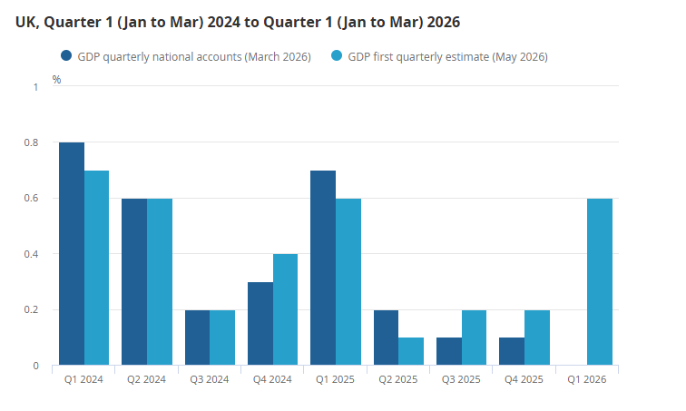
https://www.ons.gov.uk/economy/grossdomesticproductgdp/bulletins/gdpfirstquarterlyestimateuk/januarytomarch2026/previous/v1

Appendix-II-GDP monthly estimate, UK: March 2026
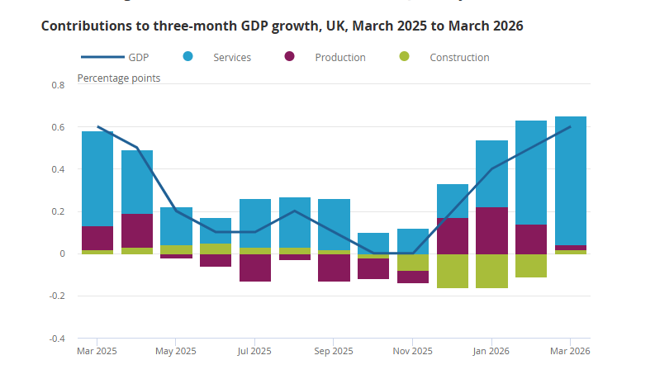

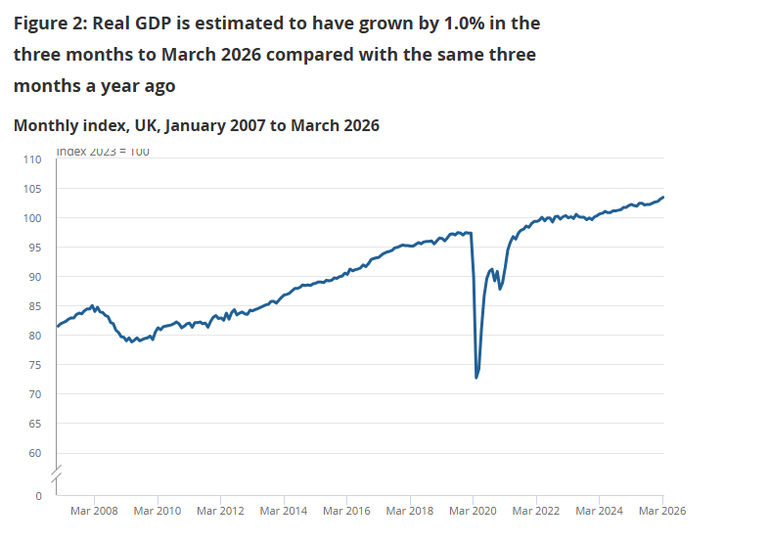
https://www.ons.gov.uk/economy/grossdomesticproductgdp/bulletins/gdpmonthlyestimateuk/march2026?page=4&page=3&m2?utm_source=vebra&page=6&q=moore&s=lettings

Appendix-III-GDP- The value of goods and services produced in the UK.

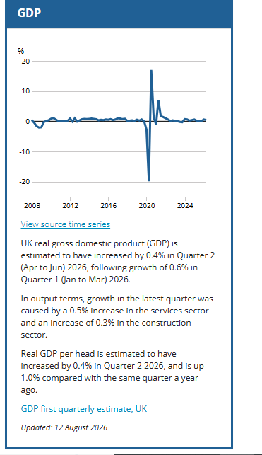

https://www.ons.gov.uk/visualisations/dvc368/dashboard/index.html?initialWidth=700&childId=017-44fa-abb5-bdff7427c428&parentTitle=Economic%20review%20-%20Office%20for%20National%20Statistics&parentUrl=https%3A%2F%2Fwww.ons.gov.uk%2Feconomy%2Fnationalaccounts%2Fuksectoraccounts%2Farticles%2Feconomicreview%2Fnovember2016

Appendix-IV Inflation
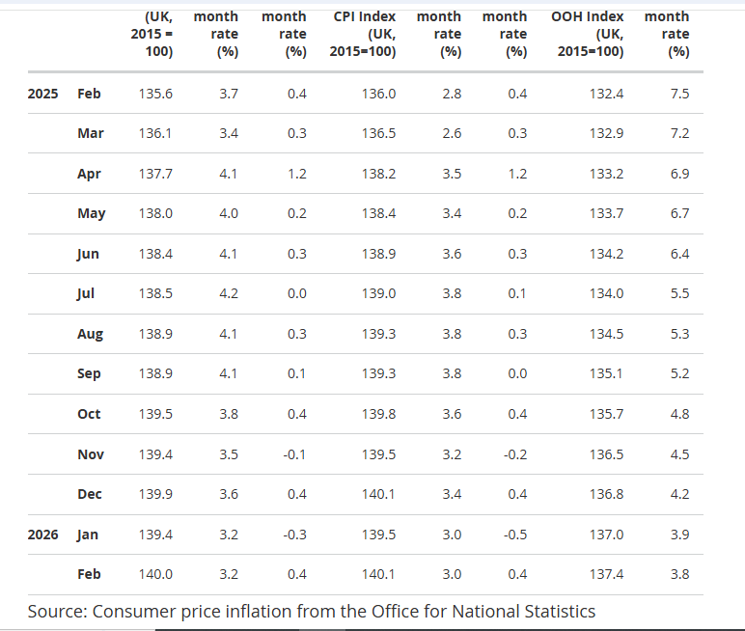
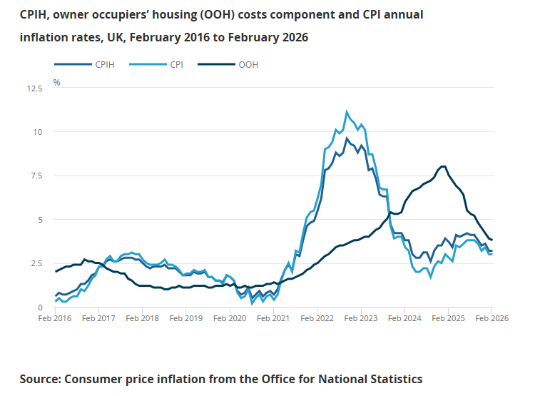
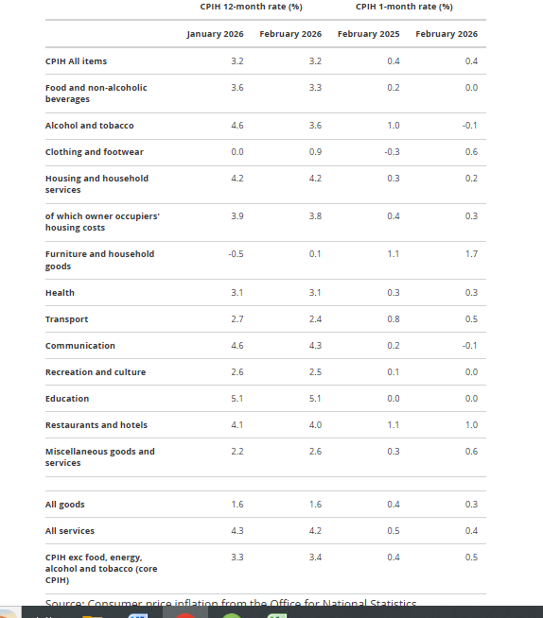
https://www.ons.gov.uk/economy/inflationandpriceindices/bulletins/consumerpriceinflation/february2026

Appendix-V Employment
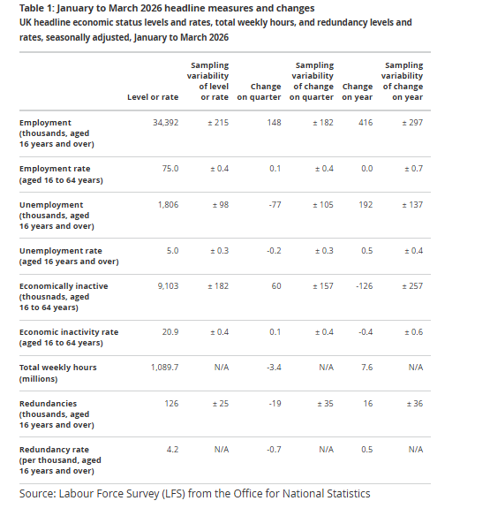
https://www.ons.gov.uk/employmentandlabourmarket/peopleinwork/employmentandemployeetypes/bulletins/employmentintheuk/may2026
Appendix-VI 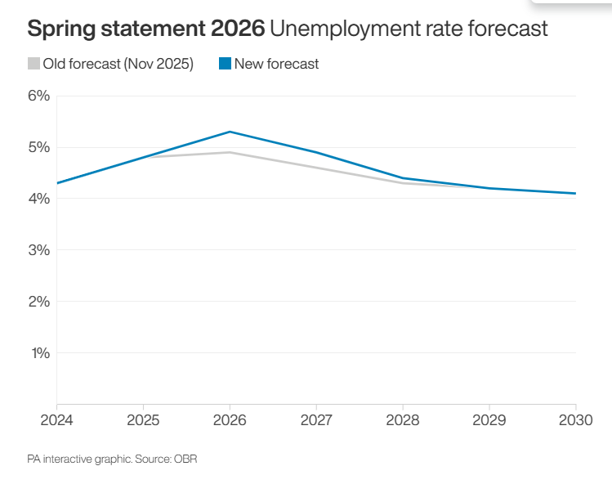
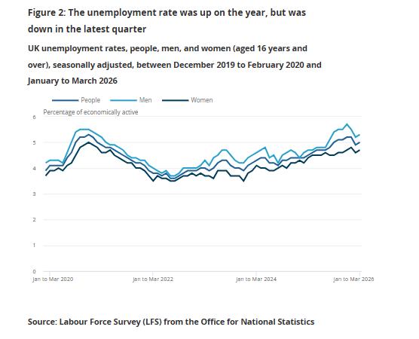

Appendix-VI Energy prices
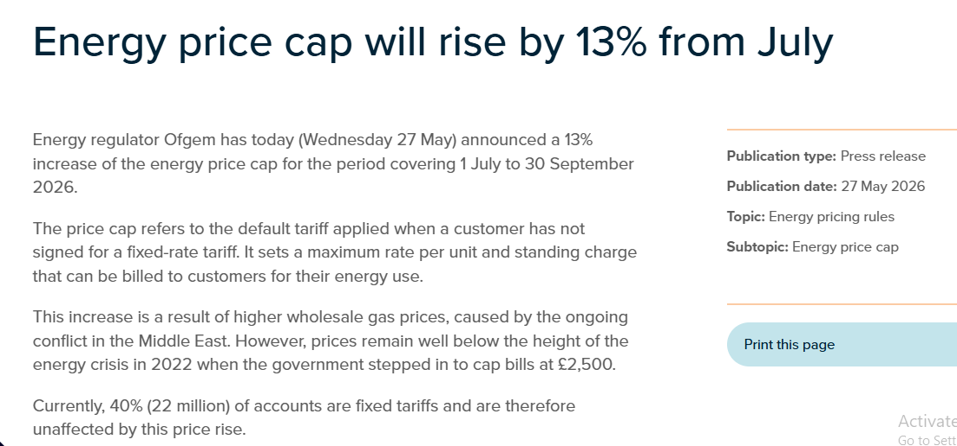

https://tradingeconomics.com/united-kingdom/personal-savings

Appendix-VIII UK Cost-of-Living Data

