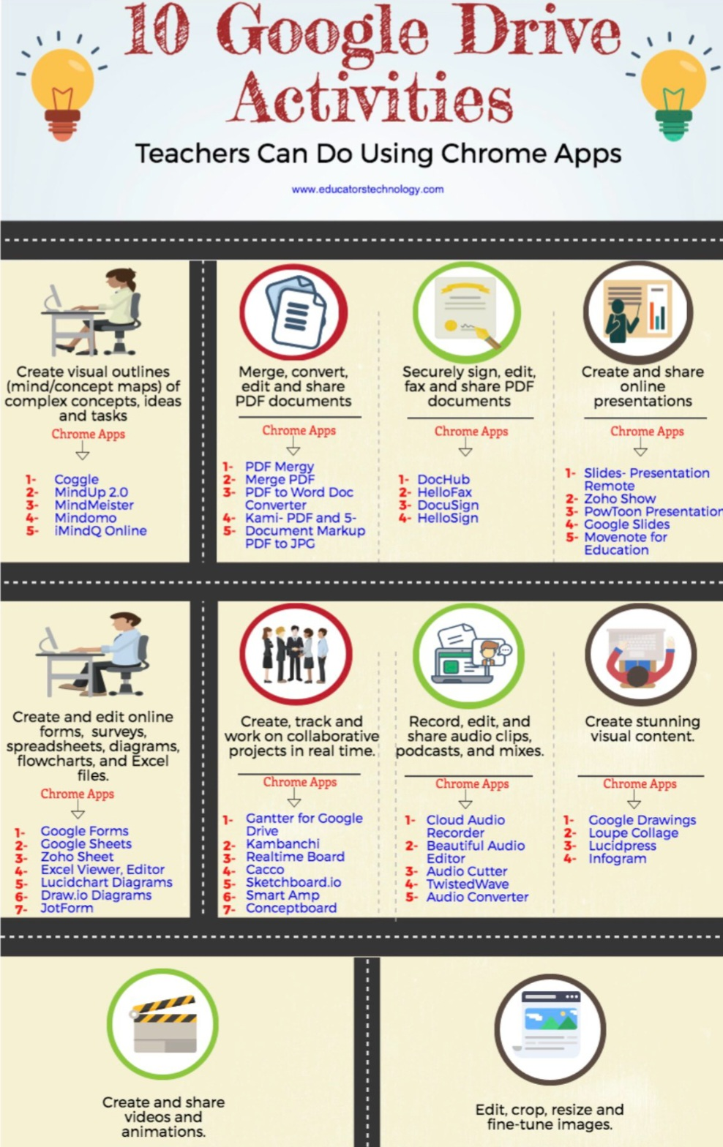
CERT HE_ BUSINESS SKILLS FOR THE WORKPLACE_FEBRUARY 25_DIG_TASK 2_TERM 1 GROUP_WEEKEND

