

Software Solution for Business
Module name: ACCA4026

18 July 2026
Lecturer: osman elgawi, mohd syafiq bin zolkepl
assignment title: componet 1-coursework: portfolio
sulvanus godoga
id: 2537881
university of wales birmingham campus

Contents
Task 1. e-Commerce Website builders/software solutions 2
WooCommerce 2
Shopify 2
Task 2. Mind-map of contemporary software applications 3
Task 2a: Mind Mapping and its benefits in business operation 3
Task 2b: Creation of Mind map 4
Task 3. Office Applications for creating, storing, presenting, and analyzing information/data: 6
Task 3a: MS Suite 6
Microsoft Word 6
Microsoft Excel 7
Microsoft PowerPoint 7
Microsoft Access: 8
Task 3b: Practical Application 8
IF Function: 8
Goal Seek Function: 10
Task 4. Communication and Collaboration applications 11
Task 4a. Communication Application-Microsoft Outlook 11
Collaboration Application-Zoom 12
Task 4b: Feature Testing 13

Task 1. e-Commerce Website builders/software solutions

Introduction
Software platforms known as e-commerce website builders enable individuals and organisations build, run, and operate online shopfronts without having a high level of programming expertise. They offer solutions for tracking customer orders, managing merchandise, receiving payments, and creating websites. WooCommerce and Shopify are two of the most popular e-commerce platforms available today.

WooCommerce
For WordPress websites, WooCommerce is an open-source e-commerce plugin. Because WooCommerce is independent, it gives users total control over their online store, unlike Shopify. With thousands of WordPress themes and plugins, users can customise any function of the website. Product administration, safe payment gateways, inventory control, shipping management, tax computations, and customer account management are all made possible by WooCommerce.
The versatility of WooCommerce is a big benefit. Companies are not required to pay monthly platform costs to develop completely customised online shopfronts, but they nevertheless need to buy a domain name and web hosting separately. The vast WordPress community, which offers a wealth of documentation, tutorials, and third-party extensions, also supports WooCommerce.
The main disadvantage is that users oversee program upgrades, backups, hosting performance, and website security. In comparison with hosted platforms like Shopify, beginners might also need greater technical expertise [1].

Shopify
A cloud-based e-commerce platform called Shopify is designed specifically for companies of all sizes. With its straightforward drag-and-drop interface and adjustable templates, clients can build a luxurious online store. Because Shopify is hosted in the cloud, users don't have to install software or maintain web servers. Secure payment processing, inventory control, shipping choices, order tracking, marketing tools, and customer analytics are among the built-in capabilities of the platform.
The simplicity of Shopify's use is one of its main features. Professionally created themes enable business owners with little technological expertise to rapidly launch an online store. Additionally, Shopify has a huge App Store with hundreds of thousands of apps that improve the features of online stores, like social media integration, email marketing, customer assistance, and accounting. Shopify handles software maintenance, security updates, and backups automatically, relieving the business owner of some of their technical obligations.
Nevertheless, Shopify uses a monthly membership model, and using third-party payment processors may result in additional transaction fees. Additionally, businesses may have to pay more for third-party apps or premium themes [2].
Shopify, WooCommerce, and other website builders provide reliable e-commerce solutions suitable for a range of business requirements. Shopify is ideal for people seeking a user-friendly, fully hosted platform with minimal technical maintenance. WooCommerce is more appropriate for companies who require greater autonomy, control, and customisation but possess the technical expertise to manage hosting and website maintenance.
The choice between these platforms is determined by several variables, including financial constraints, technological know-how, scalability, and business needs. Because of these systems' many features, safe payment methods, and robust support networks, businesses all over the world continue to use them extensively.

Task 2. Mind-map of contemporary software applications

Task 2a: Mind Mapping and its benefits in business operation

Mind mapping is a visualisation technique that organises information around a primary theme by connecting similar concepts via branches and sub-branches. It aids users in organising data that is complex, understanding conceptual linkages, and coming up with fresh notions. Because mind maps provide information in an organised and understandable manner, they are widely utilised in both business and education. They are particularly useful for organising tasks, coming up with concepts, solving problems, and making decisions [3].
Mind mapping improves communication and collaboration in businesses by helping teams to visualise activities, objectives, and workflows. Employees can better arrange their ideas, pinpoint priorities, and learn how different business tasks are related. Mind maps also assist managers analyse problems, assess solutions, and allocate resources more efficiently. Employees can more quickly remember essential information and swiftly recognise important connections since information is presented graphically rather than as lengthy text blocks [4].
In meetings, organisations also use mind maps to capture ideas, delegate tasks, and track project advancement. To plan project phases, identify hazards, set deadlines, and organise team activities, project managers frequently make mind maps. Mind maps are used by marketing teams to plan promotional plans, assess consumers, and create campaigns. They are utilised by HR departments for performance management, employee training, and recruitment planning. In general, mind mapping enhances creativity, productivity, organization, and decision-making in a variety of business-related tasks [3], [4].

Task 2b: Creation of Mind map
Figure 1 below shows the mind map I made of contemporary Software Applications.
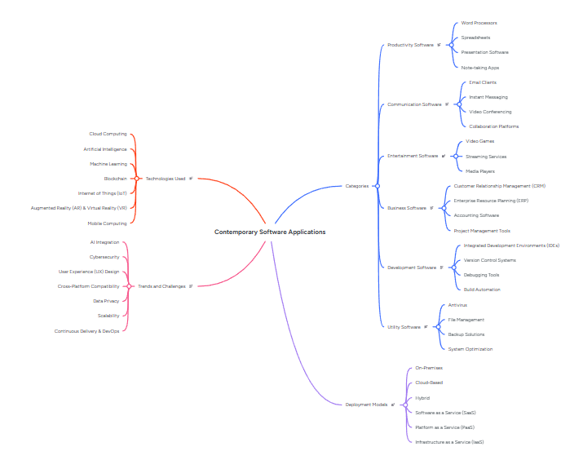
Figure 1 mind map of software applications

Contemporary Software Applications:
Trends and Challenges: Integration, Cyber Security, Continuous Delivery & DevOps, User Experience (UX) Design, Cross-Platform Compatibility, Data Privacy, Scalability.
Technologies Used: Mobile Computing, Augmented Reality (AR) & Virtual Reality (VR), Internet of Things (IoT), Blockchain, Machine Learning, Artificial Intelligence, Cloud Computing.
Deployment Models: Infrastructure as a Service (IaaS), Platform as a Service (PaaS), Software as a Service (SaaS), Hybrid, Cloud-Based, On-Premises.
Categories:
- Productivity Software: Word Processors, Spreadsheets, Presentation Software, Note-taking Apps

- Communication Software: Email Clients, Instant Messaging, Video Conferencing, Collaboration Platforms.

- Entertainment Software: Video Games, Streaming Services, Media Players.

- Business Software: Customer Relationship Management (CRM), Enterprise Resource Planning (ERP), Accounting Software, Project Management Tools.

- Development Software: Integrated Development Environments (IDEs), Version Control Systems, Debugging Tools, Build Automation.

- Utility Software: Antivirus, File Management, Backup Solutions,

Deployment Models: On-Premises, Cloud-Based, Hybrid, Software as a Service (SaaS), Platform as a Service (PaaS), Infrastructure as a Service (IaaS).

Task 3. Office Applications for creating, storing, presenting, and analysing information/data:

Introduction
Corporations can generate documents, analyze data, manage databases, and make polished presentations with Microsoft Office (Microsoft 365). To help improve communication, improve efficiency, and help with well-informed decision-making, organizations in the domains of education, healthcare, finance, retail, manufacturing, and government rely on these applications. Microsoft Word, Microsoft Excel, Microsoft PowerPoint, and Microsoft Access are four of the most popular office programs. Each application offers distinct capabilities that assist various business tasks while easily interacting with one another to enhance organizational effectiveness [5].

Task 3a: MS 365 Suite

Microsoft Word
Microsoft Word is a word processing program used for professional document creation, editing, formatting, and sharing. Businesses use Word to write reports, letters, contracts, proposals, manuals, meeting minutes, invoicing, and business paperwork.
Important elements:
PDF exporting, cloud collaboration via Microsoft OneDrive, commenting and tracking changes, mail merging, tables, charts, and SmartArt, styles, themes, and formatting tools Spell and grammar checkers, expert templates, and the production and modification of documents
Benefits:
Professional documents may be drafted fast and efficiently with Microsoft Word. Multiple users can examine and update files at the same time because of their collaboration features and formatting tools, which ensure documents have a consistent appearance. Track Changes makes it easier to examine changes, improving teamwork and document accuracy. Employees can work remotely and access data from many devices thanks to OneDrive integration [6].
Limitations: Large papers can be challenging to handle, sophisticated formatting calls for expertise, and it is less appropriate for numerical data analysis.

Microsoft Excel
A spreadsheet program called Microsoft Excel is used to store, arrange, analyse, and display numerical data. Businesses use Excel for budgeting, financial reporting, payroll, forecasting, inventory management, sales analysis, and performance monitoring.
Important elements: Worksheets and workbooks, Formulas and functions, PivotTables, Charts and graphs, Conditional formatting, Data validation, What-if analysis, Macros and automation and Power Query.
Benefits:
Excel allows businesses to analyze enormous amounts of information quickly and accurately. PivotTables summarize complex datasets, while formulas reduce human error by automating calculations. Charts give visual representations that enhance business decision-making. Automation with macros saves time while conducting repetitive operations [7].
Limitations: Large spreadsheets may become slow, Errors in formulas might cause inaccurate results and multi-user cooperation can become impossible without cloud storage.

Microsoft PowerPoint
Presentation software like Microsoft PowerPoint is made to convey information visually. PowerPoint is used by businesses for executive meetings, project presentations, sales pitches, company proposals, and staff training.
Important elements: Features for collaboration, the ability to record presentations, Presenter View, charts and diagrams, animations and transitions, SmartArt visuals, images, audio and video, themes and layouts, and presentation templates.
Benefits:
PowerPoint allows presenters to clarify difficult material using visual aids, making presentations more interesting and easier to follow. Multimedia features boost audience engagement, while templates assure a professional image. Cloud collaboration allows teams to produce presentations collaboratively from different places [5].
Limitations: Excessive animations may cause users to become distracted, making it unsuitable for creating complex documents.

Microsoft Access:
A relational database management system (RDBMS) called Microsoft Access is used to store, arrange, retrieve, and handle organized business data. It is often used by small and medium-sized enterprises for inventory systems, customer databases, staff records, and order administration.
Important elements: Tables, Forms, Queries, Reports, Relationships, Macros, QL support, Import and export data and Database templates

Benefits:
Businesses can effectively store massive volumes of structured data with Microsoft Access. Forms make data entry easier, queries enable users to easily get specific information, and reports offer expert summaries. Relationships enhance data integrity and minimise redundant information [8].
Limitations: Less suitable for very large businesses, needs database knowledge, Limited scalability compared with enterprise database solutions such as Microsoft SQL Server or Oracle Database.
Conclusion
Microsoft Word, Excel, PowerPoint, and Access all play critical roles in modern company operations. PowerPoint facilitates effective communication through presentations, Word gives professional document creation, Excel offers robust data analysis tools, and Access effectively organises structured business information. These tools work together to boost productivity, facilitate collaboration, improve decision-making, and help businesses handle information more effectively. For students who want to work in business or information technology, mastering these apps is a crucial employability skill.

Task 3b: Practical Application

IF Function:
Microsoft Excel's IF function is a logical function that determines if a condition is true or false. If the condition is TRUE, it returns one value; if the condition is FALSE, it returns a different value [9].
Regarding the table below, revenue was categorised as "High" or "Low" using the IF Function based on a threshold of £1,080.
=IF(H3>=1080, "High", "Low") was the formular used.
If Total Revenue (H3) is 1080 or higher, the cell displays "High", else it shows "Low".
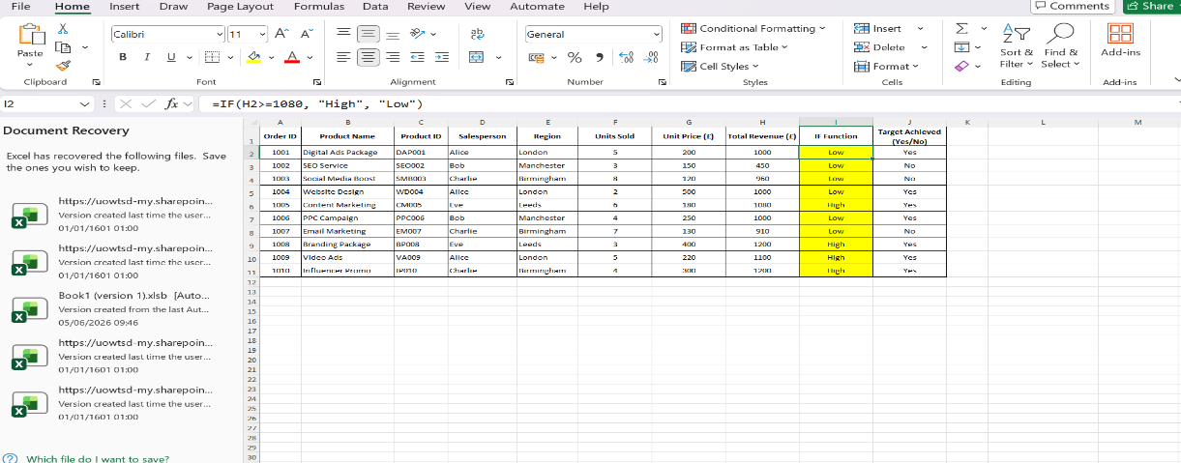
Figure 2

Goal Seek Function:
With Microsoft Excel's built-in What-If Analysis feature, Goal Seek, users can find the input value needed to get a particular outcome in a formula. Goal Seek automatically modifies one input cell until the formula yields the desired result, eliminating the need to manually test several values. In business, finance, forecasting, budgeting, and
decision-making, this feature is especially helpful for determining the value required to achieve a goal or target [10].
Cell formular: Units sold * Units price(=G2*F2).
The input values of image figure 3 below was adjusted to achieve targeted results and I wanted to know how many units I can sell to reached £2,000.

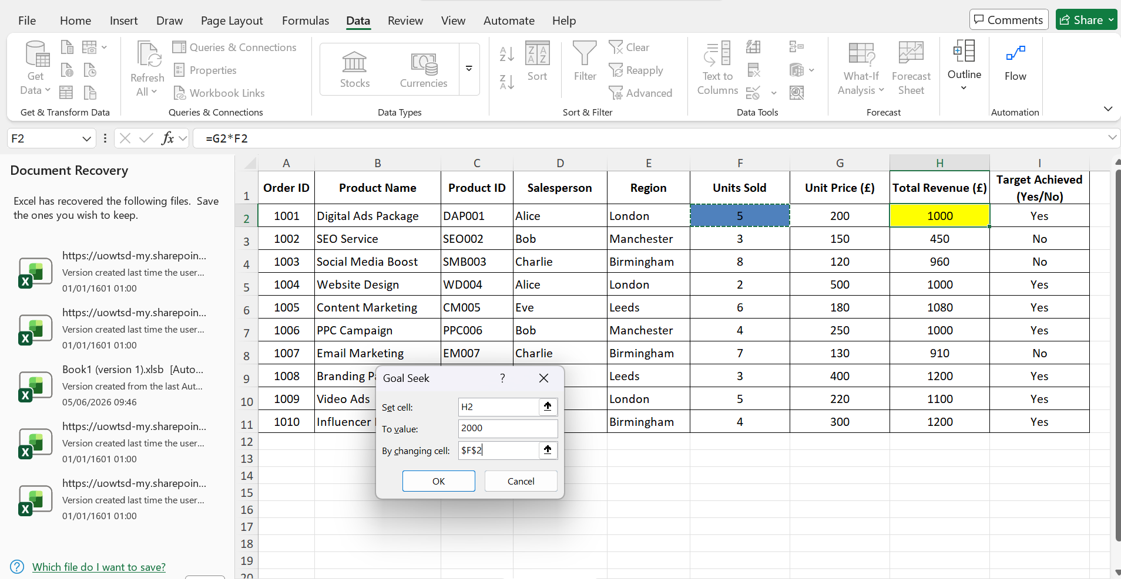
Figure 3
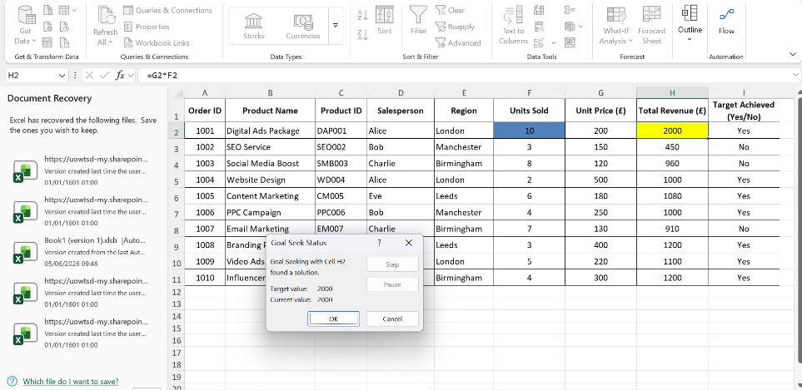
The Goal Seek Function was used to determine that 10 units must be sold to reach the desired value of £2,000 in the image figure 4 below.
Figure 4

Task 4. Communication and Collaboration applications
Introduction:
To boost productivity, foster remote and hybrid working, and enhance teamwork, modern enterprises rely on online collaboration and communication tools. Employees can work together on projects, exchange information safely, and interact in real time thanks to these tools, regardless of where they are. This section examines Zoom as an online collaboration tool and Microsoft Outlook as a communication tool.

Task 4a: Communication Application-Microsoft Outlook
Microsoft Outlook is a popular tool for managing personal information and communicating. Emails can be sent and received, calendars can be managed, meetings can be scheduled, contacts can be arranged, and tasks can be tracked. Outlook is a crucial communication tool for companies, academic organisations, and governmental organisations since it is frequently connected with Microsoft 365 [11].
Important features
Email Management: Allows users to send, receive, organise, and search emails efficiently using folders, categories, and rules.
Calendar and Scheduling: Users can schedule meetings, set reminders, and share calendars with colleagues to improve time management.
Contacts Management: Stores contact information and allows users to organise business and personal contacts.
Task Management: Enables users to create task lists, set deadlines, and monitor progress.
Microsoft 365 Integration: Works seamlessly with Microsoft Teams, Word, Excel, PowerPoint, OneDrive, and SharePoint, supporting collaboration and productivity.
Security Features: Includes spam filtering, phishing protection, email encryption, and multi-factor authentication to enhance data security [11].
Benefits
Microsoft Outlook facilitates better workplace collaboration by offering a common platform for task management, scheduling, and email. Teams can plan meetings and deadlines with the aid of shared calendars, and users can view and share files straight from Outlook thanks to Microsoft 365 integration. Its security features lessen the possibility of cyberattacks and safeguard private company data [12].
Limitations
Outlook has many drawbacks despite its great benefits. For cloud-based functions and syncing, an internet connection is necessary. A Microsoft 365 subscription is required to access certain advanced features. To properly utilise its sophisticated email management and scheduling features, new users might also need training.

Task 4a: Collaboration Application-Zoom
One of the most widely used online collaboration tools in the world, Zoom allows companies to hold webinars, virtual meetings, online training, and remote collaboration. Its high-quality video conferencing, convenience of use, and interoperability with both desktop and mobile devices have led to its widespread adoption [13].
Important Features: Breakout rooms for group discussions, high-definition video and audio meetings, screen sharing and remote presentation tools, meeting recording and transcription, virtual whiteboards for group brainstorming, chat messaging during meetings, and integration with business apps like Slack, Google Workspace, and Microsoft Teams.
Benefits
By facilitating communication from any location, Zoom helps business partners, clients, and employees collaborate effectively. While meeting records enable participants to evaluate discussions and conclusions later, features like screen sharing, meeting rooms, and whiteboards foster teamwork. Zoom is especially useful for companies with distant or dispersed workers [13].
Limitations
For bigger group meetings, the free version sets a time limit. Organisations must also adhere to the proper security settings to safeguard private meetings and corporate information.

Task 4b: Feature Testing

The below images are the various steps taken to add a signature in Microsoft outlook mail.
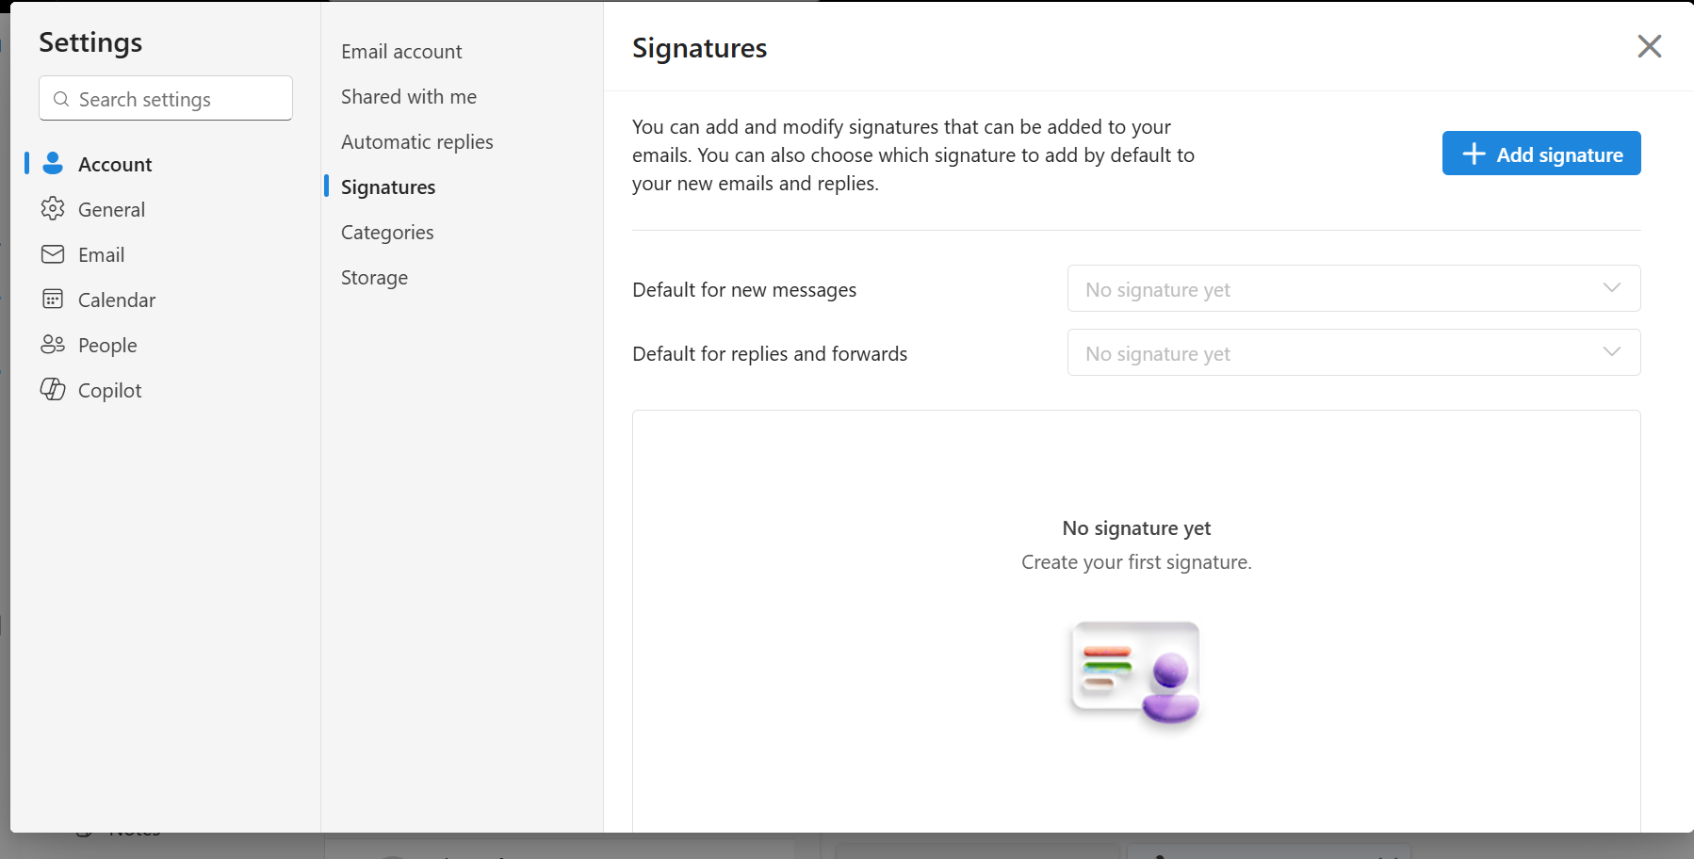
Figure 5 step 1 a search for the word signature in settings.

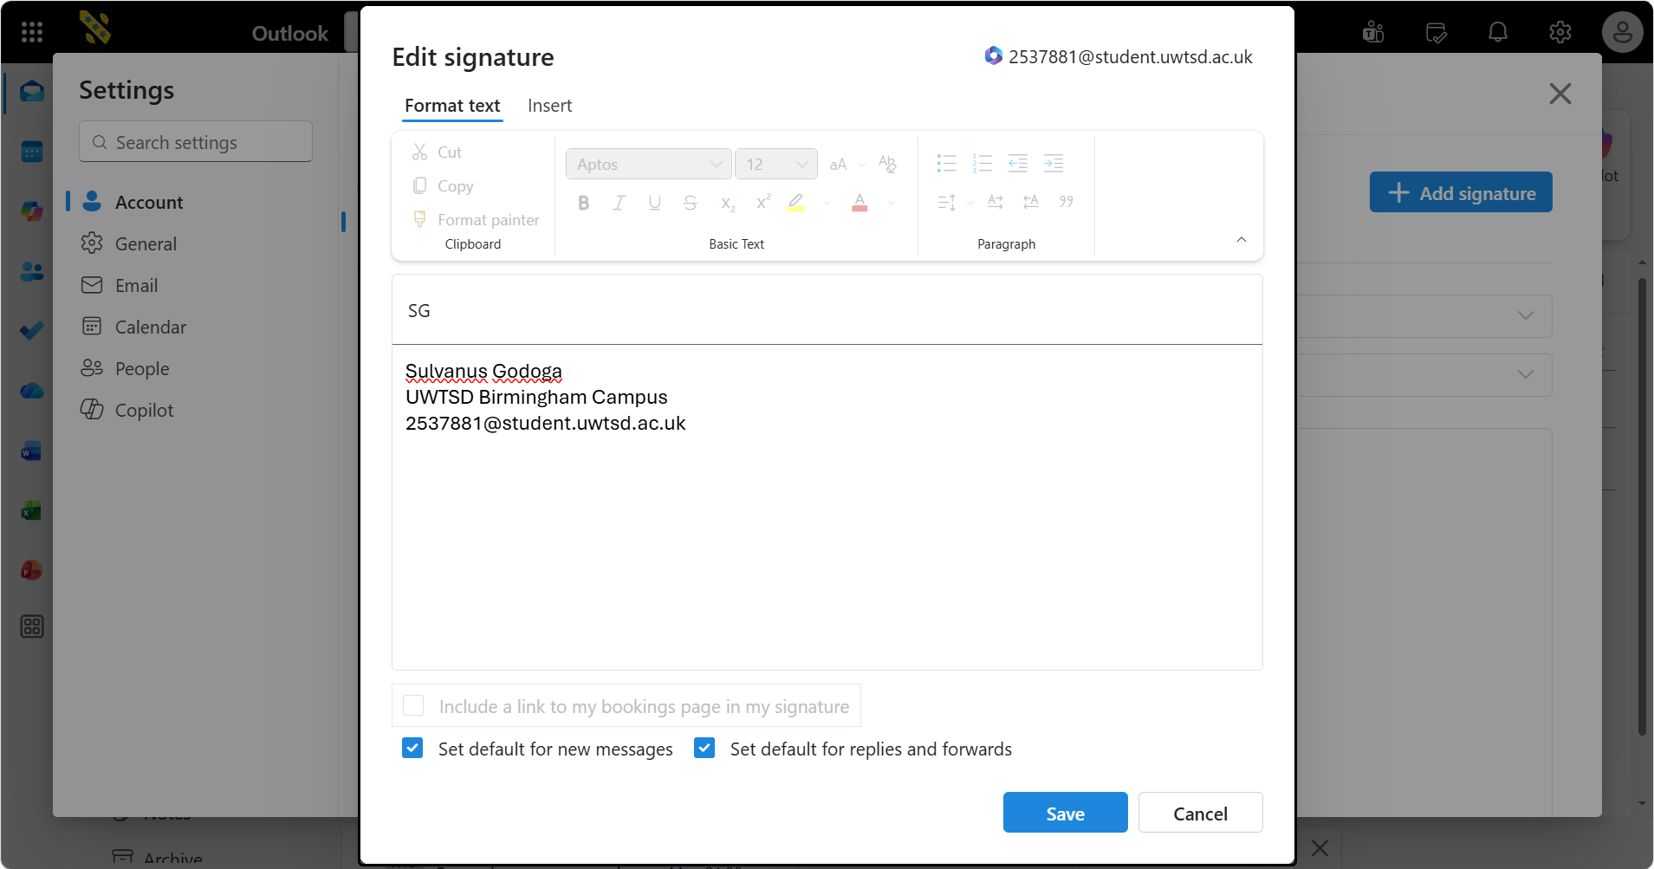
Figure 6 step 2 adding a signature.

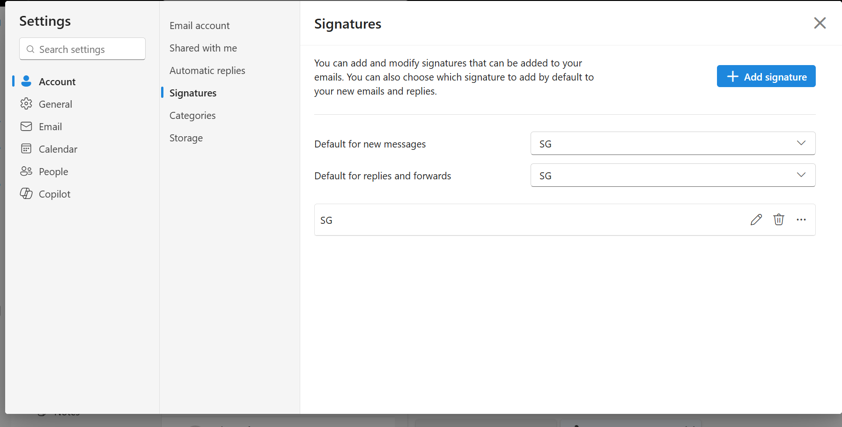
Figure 7 Signature was added.

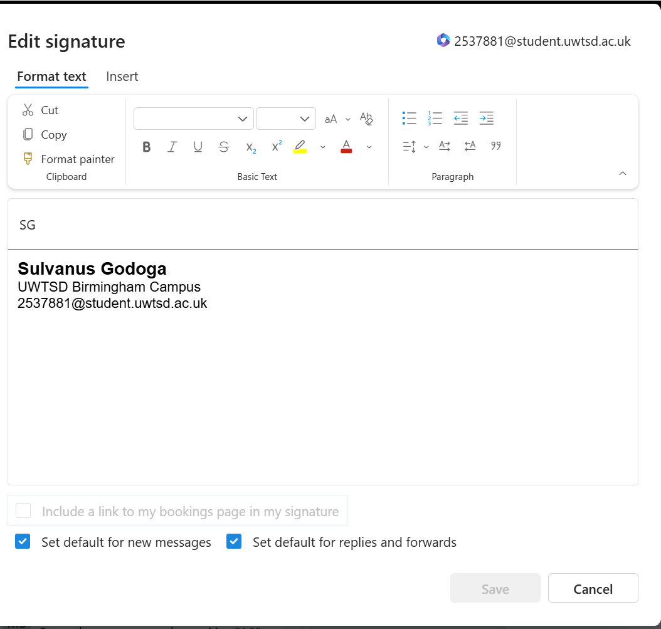
Figure 8 Final step showing the signature of my name, the School and ID number.

The images below demonstrate the many steps necessary to set up a meeting and how Zoom was utilised as a collaboration tool.

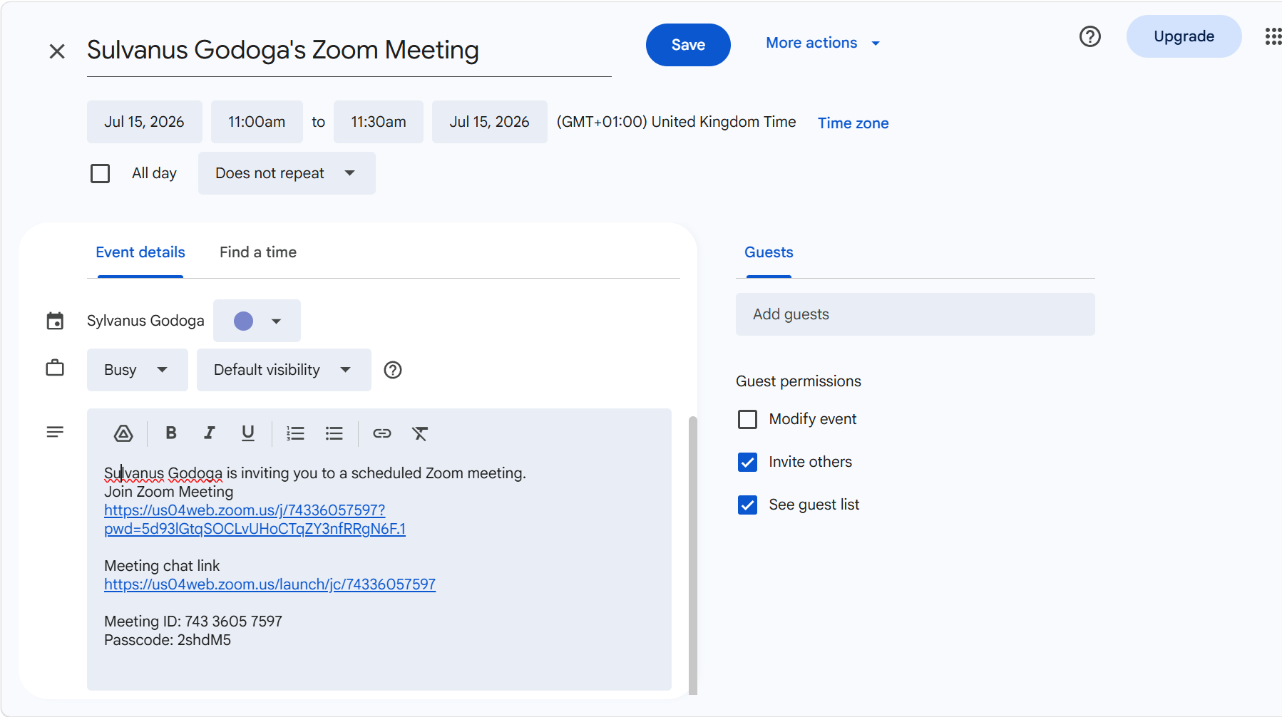
Figure 9 The image shows the meeting links, ID and password for the meeting.


Figure 10 The image shows when the meeting was going on.

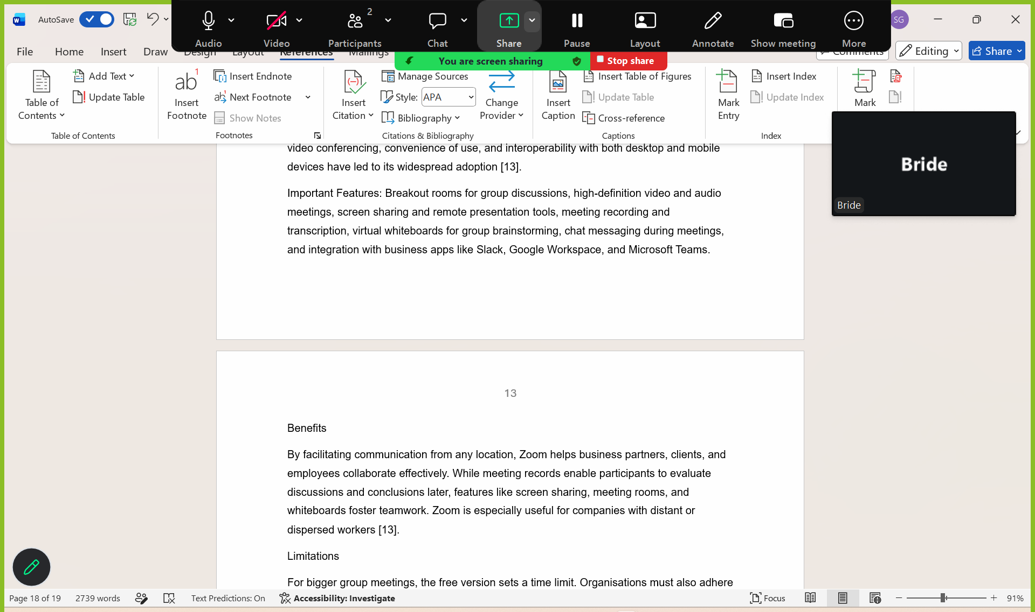
Figure 11 The image shows when the host was shearing his screen with the participant in the zoom meeting.

Inconclusion
Microsoft Outlook and Zoom are two popular applications that help businesses communicate and collaborate. Because of its smooth interaction with productivity tools, Microsoft Outlook is especially appropriate for businesses that utilise Microsoft 365. For meetings, webinars, and online training, Zoom excels at providing dependable video conferencing and virtual collaboration. These applications are crucial tools for contemporary firms since they enhance teamwork, organisational communication, and operational efficiency.

References
[1] WooCommerce, WooCommerce Documentation. Available: https://woocommerce.com/documentation/. Accessed: Jun. 23, 2026.
[2] Shopify, Shopify Features. Available: https://www.shopify.com/features. Accessed: Jun. 23, 2026.
[3] M. MacDonald, Creating a Website: The Missing Manual, 5th ed. Sebastopol, CA, USA: O'Reilly Media, 2022.
[4] T. Buzan and B. Buzan, The Mind Map Book: Unlock Your Creativity, Boost Your Memory, Change Your Life, updated ed. London, U.K.: BBC Active, 2022.
[5] Mind Meister, "Why Mind Mapping Improves Team Collaboration." Available: https://www.mindmeister.com/blog/. Accessed: Jun. 24, 2026.
[6] A. Müller and S. Klein, "Digital Mind Mapping as a Collaborative Learning and Business Planning Tool," International Journal of Information Management, vol. 69, 2023.
[7] Microsoft, Microsoft 365 Documentation. Available: https://learn.microsoft.com/microsoft-365/. Accessed: Jun. 28, 2026.
[8] J. Lambert, Microsoft Word Step by Step (Office 2021 and Microsoft 365). Redmond, WA, USA: Microsoft Press, 2022.
[9] C. Frye, Microsoft Excel Step by Step (Office 2021 and Microsoft 365). Redmond, WA, USA: Microsoft Press, 2022.
[10] J. Walkenbach, Microsoft Excel 365 Bible. Hoboken, NJ, USA: Wiley, 2021.
[11] Microsoft Corporation, Microsoft Outlook, 2024. Available: https://www.microsoft.com/en-gb/microsoft-365/outlook/email-and-calendar-software-microsoft-outlook. Accessed: Jul. 10, 2026.
[12] S. P. Robbins and T. A. Judge, Organizational Behavior, 19th ed. Harlow, U.K.: Pearson, 2023.
[13] Zoom Communications Inc., Zoom Workplace Features, 2024. Available: https://www.zoom.com. Accessed: Jul. 10, 2026.

