
Student Name: Muhammad Imran
Student Number: 2311530
Programme: BA (Hons) Leadership and Management Skills for the Workplace
Assignment Title: Component 1 – Business Research Proposal
Module: Research Methods for Business
Module Code: LCLM6004
Lecturer: Dr Olu Adegbite
Table of Contents
Title Page ………………………………………………………………………………1
Table of Contents …………………………………………………………………………2
Business Research Title: Analysis of Contextualising the Strategic Importance of Last-Mile Decarbonisation ………………………………………………………………….3
1. Introduction ………………………………………………………………………………….3.4
2. Strategic Importance of Last-Mile Decarbonisation for Business Performance…4
3. Organisational Context and Key Strategic Challenges …………………………… 5
4. Research Aim, Objectives, and Questions ………………………………………….5.6
4.1. How do regulatory, economic, and competitive pressures shape UPS UK’s last-mile performance ………………………………………………………………………….6
5. Critical Literature Review …………………………………………………………………7
5.1 Review and critically analyse key academic and professional sources related to your topic ……………………………………………………………………………………….7
5.2 Research Gap and Study Contribution ……………………………………………….7
5.3 Theoretical Frameworks…………………………………………………8.9
6.Research Methodology and Designs ……………………………………………………10
6.1 Justification for the Research Approach …………………………………………….10
6.2 Data Collection and Data Analysis Methods ………………………………………. 11
  - Sampling Strategy, Ethical Considerations, and Research Quality ………. 12
7. Organisational Impact and Practical Contributions …………………………….13
7.1 Strategic Value of the Research for Organisational Decision-Making …….13
  - Potential Strategic Recommendations and Operational Innovations ……14

  - Reflection on the Contribution to Applied Business Research ………………15
12. References …………………………………………………………………………………16.17

Business Research Title: Analysis of Contextualising the Strategic Importance of Last-Mile Decarbonisation

Introduction
Last-mile delivery represents a critical component of UPS UK’s operational and financial performance. Research suggests that the last mile can account for approximately 53% of total shipping cost due to congestion, low drop density, and delivery failures (DHL, 2026). Simultaneously, regulatory developments including the UK Zero Emission Vehicle mandate and London’s Ultra Low Emission Zone intensify decarbonisation pressure (Department for Transport, 2024; Greater London Authority, 2025). UPS has committed to achieving carbon neutrality by 2050. This section establishes the strategic importance of transforming urban delivery system.
United Parcel Service (UPS) Ltd. is one of the world’s largest logistics and parcel delivery organisations, operating an extensive global network that connects businesses and consumers across more than 200 countries and territories. In the United Kingdom, UPS plays a significant role in supporting e-commerce, international trade, and time-sensitive logistics services. The rapid expansion of online retail has increased parcel volumes, placing greater operational pressure on last-mile delivery networks, particularly in dense urban areas.
The last mile represents the final stage of the delivery process and is widely recognised as the most complex and cost-intensive component of the logistics chain. It is characterised by traffic congestion, fragmented delivery points, failed delivery attempts, and rising customer expectations for faster and more reliable delivery services (Gevaers, Van de Voorde and Vanelslander, 2014; Mangiaracina, Perego and Seghezzi, 2022). Studies indicate that last-mile delivery can account for a significant proportion of total logistics costs due to inefficient routing, urban congestion, and the high density of individual delivery locations (McKinnon, 2018; Rai, Verlinde, and Macharis, 2021). At the same time, growing environmental awareness and regulatory developments, including emissions standards and urban clean air zones, are reshaping the operating environment for logistics providers and encouraging firms to adopt low-carbon delivery solutions (World Economic Forum, 2024; International Transport Forum, 2025). These interconnected operational and environmental pressures create both strategic challenges and opportunities for organisations such as UPS UK,
requiring companies to balance efficiency, sustainability, and service quality within increasingly complex urban logistics networks.
Rather than viewing these issues in isolation, it is necessary to adopt a systems perspective. Operational efficiency, environmental sustainability, competitive positioning, and technological capability are closely interlinked. For UPS Ltd., long-term success will depend on its ability to integrate these elements within a coherent strategic framework. This Research proposal therefore examines a key business challenge facing UPS UK and evaluates how the organisation can respond effectively while maintaining profitability, service quality, and competitive advantage.

2. Strategic Importance of Last-Mile Decarbonisation for Business Performance
The decarbonisation and optimisation of last-mile delivery operations represent a significant strategic challenge for UPS Ltd. in the United Kingdom. The last mile—defined as the final stage of parcel delivery from distribution hubs to end customers—is widely recognised as the most complex and costly segment of the logistics chain. It is characterised by traffic congestion, fragmented delivery locations, failed delivery attempts, and growing customer expectations for fast and reliable delivery services (Gevaers, Van de Voorde and Vanelslander, 2014; Mangiaracina, Perego and Seghezzi, 2022). Research suggests that last-mile delivery can account for a substantial proportion of total logistics costs, in some cases exceeding 50% of overall distribution expenditure due to operational inefficiencies and urban congestion (McKinnon, 2018; World Economic Forum, 2024). For UPS UK, operating in dense urban centres with high traffic volumes, these inefficiencies directly influence cost structures, delivery performance, and customer satisfaction.
The significance of this issue extends beyond operational challenges; it fundamentally affects business performance and competitive strategy. Rising fuel prices, vehicle maintenance costs, and labour expenses continue to place pressure on logistics providers’
operating margins, particularly within high-volume parcel delivery markets (Christopher, 2022; McKinsey & Company, 2025). At the same time, regulatory developments aimed at reducing transport emissions are reshaping the logistics sector. In the UK, policies such as the Zero Emission Vehicle (ZEV) mandate and the expansion of urban low-emission zones require logistics providers to progressively transition towards electric or low-emission
delivery fleets (Department for Transport, 2024; International Transport Forum, 2025). This transition requires substantial investment in electric vehicles, charging infrastructure, and redesigned delivery networks. Without careful strategic planning, these investments may increase short-term operational costs and create financial pressure for logistics firms.

3. Organisational Context and Key Strategic Challenges

UPS Ltd. operates as part of a global logistics network serving over 200 countries and territories. In the UK, UPS plays a critical role in supporting e-commerce growth, international trade, and time-sensitive deliveries. The rapid expansion of online retail has increased parcel volumes, placing greater strain on urban distribution systems. High population density, road congestion, and limited urban infrastructure present structural challenges for efficient delivery operations.
Organisationally, UPS possesses strong internal capabilities, including advanced route optimisation technology and established distribution networks. For example, investment in data-driven optimisation systems demonstrates the company’s commitment to improving operational efficiency and reducing mileage (BSR, 2016). These capabilities provide a foundation for strategic transformation. However, transitioning to a lower-carbon delivery model requires more than technological investment. It demands coordination across fleet management, infrastructure planning, financial strategy, and regulatory compliance.

4. Research Aim, Objectives, and Questions.

Research Aim
The aim of this research is to analyse the strategic importance of last-mile decarbonisation for UPS UK and evaluate how sustainable delivery solutions can improve operational efficiency, regulatory compliance, and long-term business performance.

Research Objectives

- To examine regulatory, economic, and competitive pressures shape UPS UK’s last-mile performance.

- To analyse the integration of strategic approaches that enable UPS to balance sustainability with competitive performance.

- To examine how can UPS’s internal capabilities can create sustained competitive advantage during decarbonisation.

Research Questions

- How do regulatory, economic, and competitive pressures shape UPS UK’s last-mile performance.

- To analyse the integration of strategic approaches that enable UPS to balance sustainability with competitive performance.

- How can UPS’s internal capabilities create sustained competitive advantage during decarbonisation?

4.1. How do regulatory, economic, and competitive pressures shape UPS UK’s last-mile performance.
UPS UK operates within a highly regulated and intensely competitive environment. The UK Zero Emission Vehicle (ZEV) mandate and expansion of urban clean air zones impose structural pressure to transition towards electric fleets (Department for Transport, 2024). These regulatory drivers intersect with the economic realities of last-mile delivery, which can account for over 50% of total logistics costs due to congestion, fragmented delivery patterns,
and failed drop attempts (DHL, 2026). From a strategic perspective, these pressures are not independent; they create systemic constraints affecting cost structure, capital allocation, and operational design. Furthermore, in a high-rivalry industry characterised by strong buyer power, firms cannot simply pass increased costs onto customers (Porter, 1980). Therefore, regulatory compliance directly influences strategic positioning and margin sustainability.

5. Critical Literature Review.

5.1 Review and critically analyse key academic and professional sources related to your topic.
Sustainable supply chain theory emphasises that environmental and economic objectives should be integrated rather than treated as trade-offs (Seuring and Müller, 2008). Although last-mile delivery is widely recognised as the most expensive stage of logistics operations due to congestion, failed deliveries, and inefficient routing, it remains critically important because it directly affects customer satisfaction, delivery speed, and overall service quality (DHL, 2026). As e-commerce continues to expand, efficient last-mile delivery has become a key competitive factor for logistics providers. Therefore, despite the high operational costs, improving last-mile delivery efficiency is essential for organisations seeking to maintain competitiveness, reduce environmental impact, and enhance customer experience (Seuring and Müller, 2008; DHL, 2026).
However, much of the existing research examines operational or technological solutions independently rather than adopting a strategic systems perspective. Recent research increasingly emphasises the importance of combining multiple strategies such as electric fleets, digital logistics systems, and alternative delivery models to achieve both environmental and operational improvements. This integrated perspective provides a useful foundation for analysing sustainable logistics transformation within organisations such as UPS.

5.2 Research Gap and Study Contribution
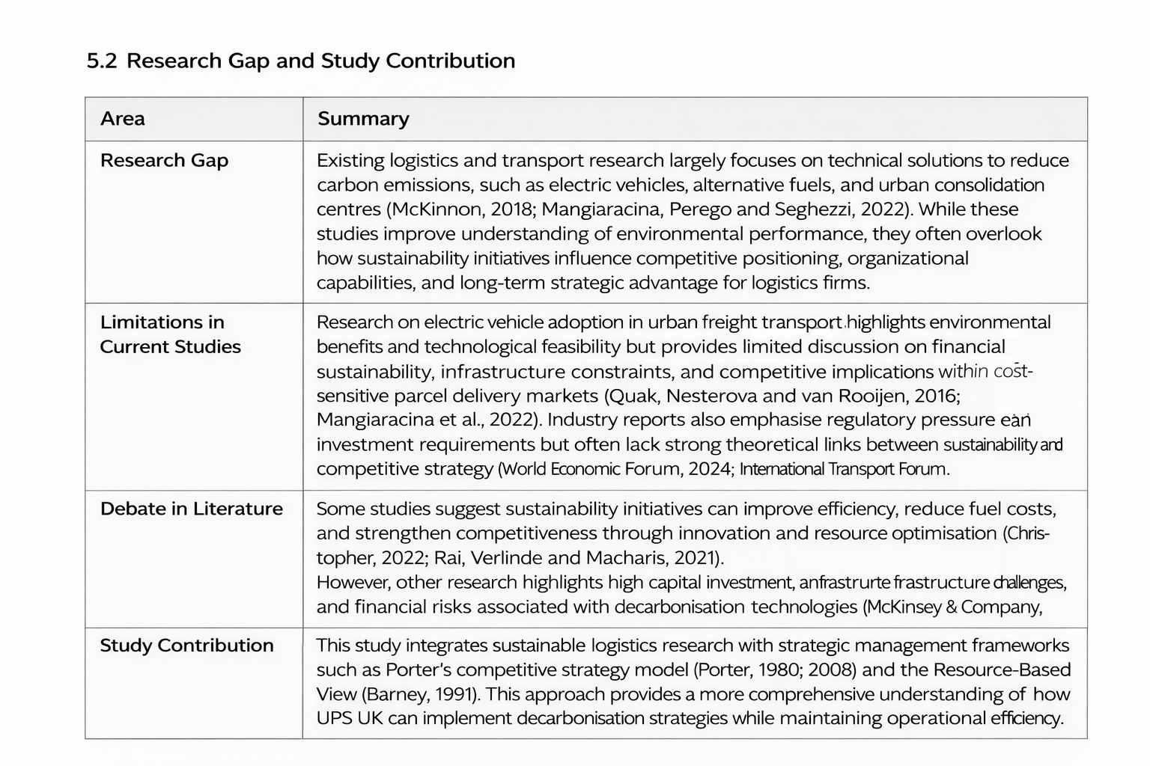
A significant gap in the current literature concerns the limited integration between strategic management theory and sustainable urban logistics research. Much of the existing research within logistics and transport management focuses primarily on technical and operational solutions for reducing carbon emissions, including the adoption of electric vehicles, alternative fuels, and urban consolidation centres (McKinnon, 2018; Mangiaracina, Perego and Seghezzi, 2022). While these studies provide valuable insights into environmental performance and emissions reduction strategies, they often place less emphasis on how sustainability initiatives influence competitive positioning, organisational capabilities, and long-term strategic advantage for logistics firms.

5.3 Theoretical Frameworks
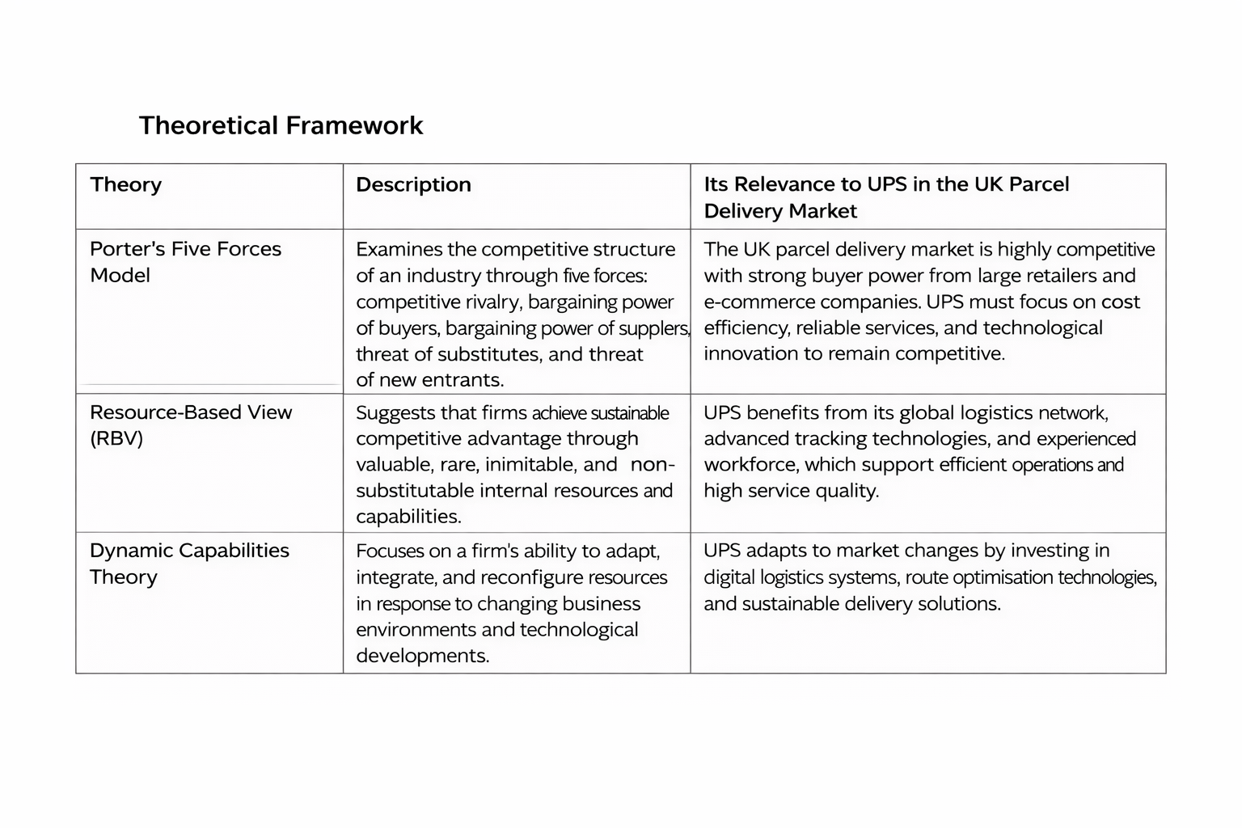
This study is supported by several theoretical frameworks that help explain the competitive dynamics, strategic resources, and adaptive capabilities of organisations operating within the UK parcel delivery market. The analysis draws on Porter’s Five Forces Model, the Resource-Based View (RBV), and Dynamic Capabilities Theory. These frameworks collectively provide a strong analytical foundation for understanding how firms achieve competitive advantage through operational efficiency, strategic resource management, and continuous innovation (Porter, 1980; Barney, 1991; Teece, Pisano and Shuen, 1997).
6. Research Methodology and Designs.

6.1 Justification for the Research Approach
This study adopts a qualitative case study approach, as the research problem is strategic, contextual, and exploratory rather than purely statistical. The objective is not to measure emissions numerically, but to understand how UPS UK can align regulatory compliance, operational efficiency, and competitive positioning within a coherent strategic framework. Qualitative research is particularly suitable when investigating complex organisational phenomena that require interpretation of managerial decisions, structural constraints, and environmental pressures (Saunders, Lewis, and Thornhill, 2019). In addition, qualitative research enables the researcher to explore relationships between organisational strategy, environmental sustainability, and operational performance in greater depth. This is particularly relevant when analysing strategic transformation within logistics organisations operating in complex and dynamic market environments.

Given that last-mile decarbonisation involves regulatory dynamics, competitive forces and internal capabilities, a qualitative design enables in-depth analysis of interconnected variables rather than isolated quantification. This approach supports systems-level understanding and strategic interpretation. It also allows deeper contextual insights into organisational strategy. Such insights support more comprehensive interpretation of complex business environments. Furthermore, the case study method allows the researcher to analyse real-world organisational practices and strategic responses within their operational context. By focusing on UPS UK as a single case study, the research can generate detailed insights into how large logistics firms respond to regulatory pressures and sustainability challenges while maintaining operational efficiency and competitive advantage.

6.2 Data Collection and Data Analysis Methods
This research adopts a qualitative approach using secondary data
within a single case study design, focusing, specifically on UPS UK. A case study methodology is appropriate when examining complex organisational and strategic

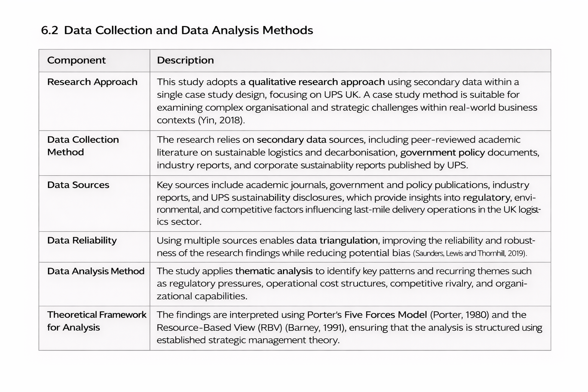
challenges within real-world contexts, allowing researchers to gain in-depth insights into contemporary business issues (Yin, 2018).

6.3 Sampling Strategy, Ethical Considerations, and Research Quality
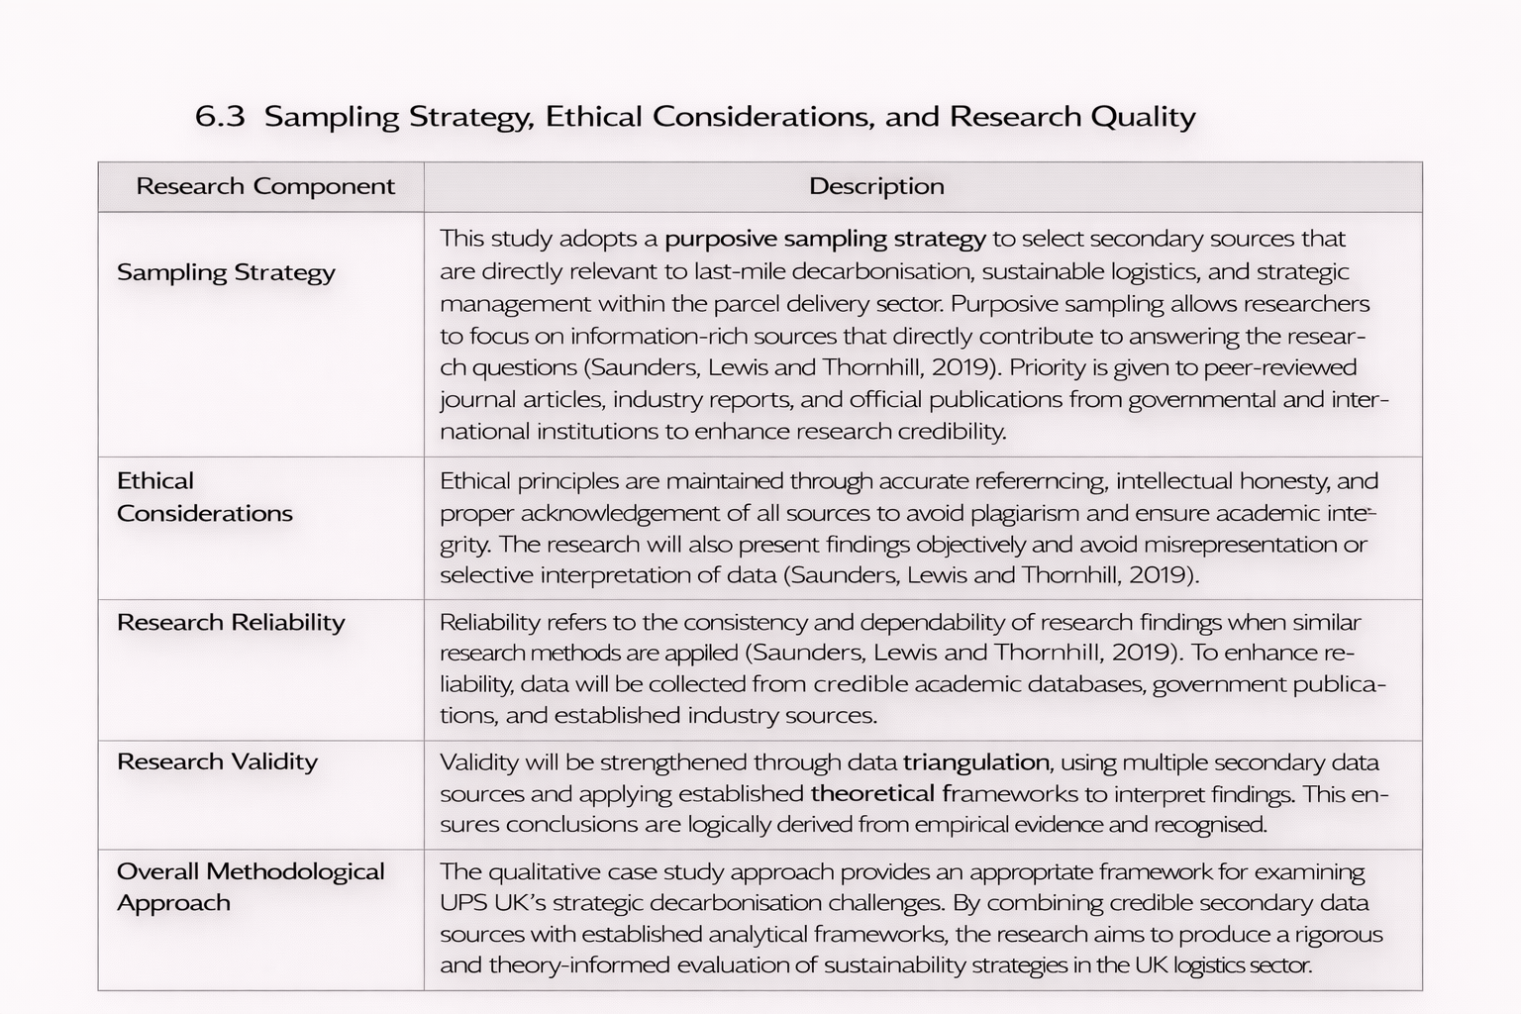
A purposive sampling strategy will be used to select secondary sources that are directly relevant to the research topic, particularly those addressing last-mile decarbonisation, sustainable logistics, and strategic management within the parcel delivery sector. Purposive sampling allows researchers to focus on information-rich sources that contribute directly to answering the research questions (Saunders, Lewis, and Thornhill, 2019).

7. Organisational Impact and Practical Contributions

7.1 Strategic Value of the Research for Organisational Decision-Making
This research has the potential to support more informed strategic decision-making within UPS UK by providing a structured analysis of how environmental regulation, operational efficiency, and competitive pressures interact within the last-mile delivery sector. As governments increasingly introduce stricter carbon reduction policies and urban emission regulations, logistics firms must balance environmental compliance with operational cost efficiency and service reliability. By integrating sustainability concepts with established strategic management frameworks, the study enables decision-makers to evaluate not only regulatory compliance but also the long-term strategic implications of decarbonisation initiatives.
For example, applying Porter’s Five Forces framework enables the analysis of how sustainability investments may influence competitive rivalry, operational costs, and service differentiation within the UK parcel delivery market (Porter, 2008). In addition, linking operational capabilities to the Resource-Based View allows the organisation to assess whether its internal technological assets, logistics infrastructure, and optimisation systems can be leveraged to support fleet electrification and sustainable delivery practices while maintaining competitive advantage (Barney, 1991).
Furthermore, the research aligns with recent logistics management literature which emphasises that data-driven sustainability strategies can simultaneously improve operational performance and environmental outcomes (Christopher, 2022; McKinnon, 2018). As a result, the study intends to promote evidence-based strategic planning rather than reactive responses to regulatory pressure, supporting UPS UK in identifying sustainable practices that also strengthen operational efficiency and market positioning.

7.2 Potential Strategic Recommendations and Operational Innovations
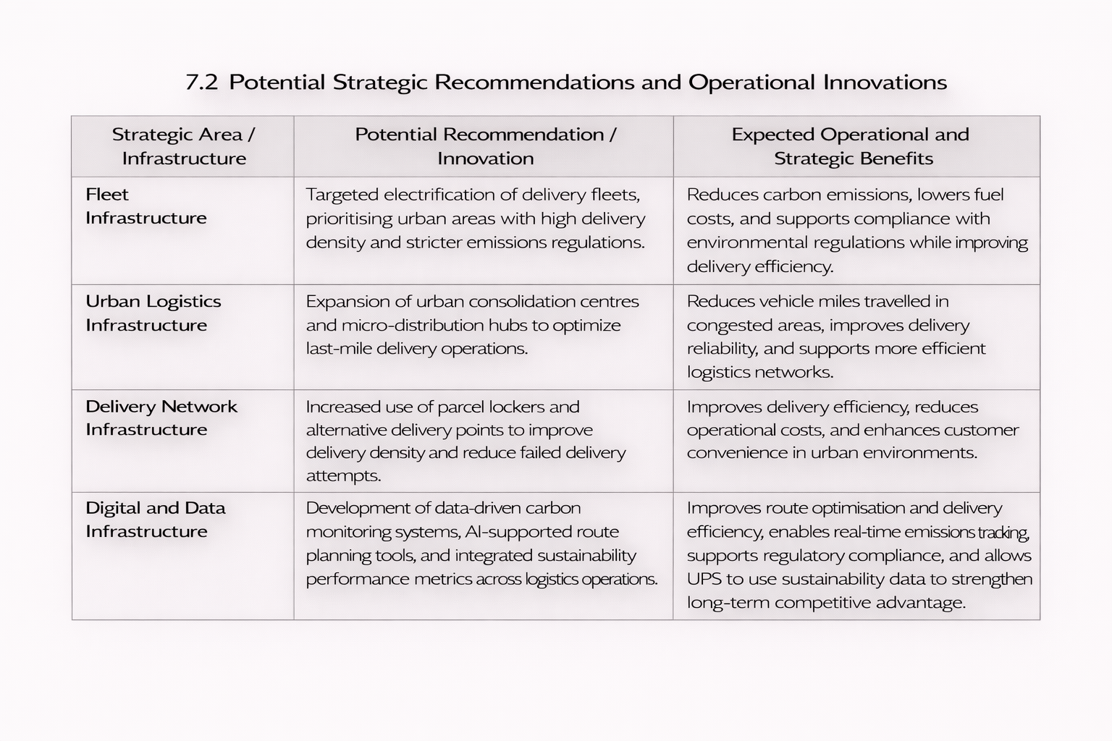
The findings of this research could generate several practical strategic recommendations and operational innovations that could support UPS UK’s transition towards lower-carbon last-mile delivery systems. Rather than implementing isolated sustainability initiatives, the research emphasises the importance of integrated operational transformation across logistics networks.

7.3 Reflection on the Contribution to Applied Business Research
This project contributes to a deeper understanding of applied business research by demonstrating how academic theory can inform practical organisational decision-making. The research highlights the importance of linking theoretical frameworks with real-world business challenges to develop meaningful and actionable insights for organisations.
Through the use of a case study research design, the project illustrates how complex business problems require contextual analysis and interpretation rather than relying solely on quantitative measurement techniques (Yin, 2018). The case study approach allows the research to explore how environmental regulation, logistics operations, and competitive strategy interact within a specific organisational context.
Additionally, the research process reinforces the importance of integrating strategic management theory, empirical evidence, and industry analysis when developing practical business recommendations. This experience strengthens the understanding that applied business research plays a critical role in bridging the gap between academic knowledge and managerial practice (Saunders, Lewis, and Thornhill, 2019).
Overall, the project demonstrates how structured academic research can generate insightful, evidence-based solutions to contemporary business challenges, particularly in areas such as sustainable logistics and strategic operational transformation.

12. References
Allen, J., Browne, M. and Cherrett, T. (2012) ‘Investigating relationships between road freight transport, facility location, logistics management and urban form’, Journal of Transport Geography, 24, pp. 45–57.
Barney, J. (1991) ‘Firm resources and sustained competitive advantage’, Journal of Management, 17(1), pp. 99–120.
BSR (2016) ORION: Technology Adoption at UPS. Available at: https://www.bsr.org (Accessed: 25 February 2026).
Browne, M., Allen, J. and Leonardi, J. (2011) ‘Evaluating the use of urban consolidation centres’, International Journal of Logistics Research and Applications, 14(1), pp. 1–16.
Christopher, M. (2016) Logistics and Supply Chain Management. 5th edn. Harlow: Pearson.
Department for Transport (2024) Pathway for zero emission vehicle transition by 2035 becomes law. Available at: https://www.gov.uk (Accessed: 25 February 2026).
DHL (2026) The Last Mile: The moment that defines brand perception. Available at: https://www.dhl.com (Accessed: 25 February 2026).
Financial Times (2025) ‘Royal Mail installs parcel lockers in Sainsbury’s supermarkets’, Financial Times. Available at: https://www.ft.com (Accessed: 25 February 2026).
Greater London Authority (2025) London-wide Ultra Low Emission Zone One Year Report. Available at: https://www.london.gov.uk (Accessed: 25 February 2026).
Johnson, G., Scholes, K. and Whittington, R. (2017) Exploring Strategy. 11th edn. Harlow: Pearson.
Kotter, J.P. (1996) Leading Change. Boston: Harvard Business School Press.
McKinnon, A. (2018) Decarbonizing Logistics: Distributing Goods in a Low Carbon World. London: Kogan Page.
Porter, M.E. (1980) Competitive Strategy: Techniques for Analyzing Industries and Competitors. New York: Free Press.
Quak, H., Nesterova, N. and van Rooijen, T. (2016) ‘Possibilities and barriers for electric-powered freight vehicles’, European Transport Research Review, 8(4), pp. 1–12.
Reuters (2024) ‘UPS, FedEx transition to electric vans slowed by battery shortages’, Reuters. Available at: https://www.reuters.com (Accessed: 25 February 2026).
Saunders, M., Lewis, P. and Thornhill, A. (2019) Research Methods for Business Students. 8th edn. Harlow: Pearson.
Seuring, S. and Müller, M. (2008) ‘From a literature review to a conceptual framework for sustainable supply chain management’, Journal of Cleaner Production, 16(15), pp. 1699–1710.
Teece, D.J., Pisano, G. and Shuen, A. (1997) ‘Dynamic capabilities and strategic management’, Strategic Management Journal, 18(7), pp. 509–533.
Yin, R.K. (2018) Case Study Research and Applications: Design and Methods. 6th edn. Thousand Oaks: Sage.

