

Chris Atkinson – 1603207

Level 6. BSc (Hons) Construction Management

Module: Building Conservation Asset and Facilities Management
Assignment Title: Analysis of built assets

Table of Content

Task One.

Ref No. | Content | Page No.
1. | Proposed Work | 3.
2. | Objective | 3.
3. | Significance | 3-7
4. | Proposed Changes | 7-8
5. | Impact of the Proposal | 8.
6. | Best Solution | 9
7. | Offsetting | 9.

Task Two

Ref No. | Content | Page No.
1. | Conservation | 9-10
1.1. | Risk to the Building’s Exterior walls | 9-10
1.2. | Maintaining the Building’s exterior walls | 10
1.3. | Maintenance. | 10
2. | Retrofitting | 10-12
3. | Asset Management | 12-13
3.1. | Analog Approach. | 12
3.2. | Spreadsheets. | 12-13
3.3. | The Workaround Solution | 13
3.4. | Asset Management Software. | 13
4. | Survey of the Central Library. | 13-21

Table of Figures

Fig No. | Content | Page No.
1. | Alexandra Road Conservation Area | 3
2. | Image of Alexandra Road, Historic | 5
3. | Location of Old Central Library | 5
4. | Image of Alexandra Road, Historic | 6
5. | Image of Alexandra Road, Historic | 6
6. | CGI Proposal of the Alex Project | 7
7. | CGI Proposal of the Alex Project | 8
8-23. | Visual Survey of Central Library | 13-21

Task One – Heritage Impact Statement
- Proposed Work.
Project Alex (School of Industrial Design)
Project Alex would see the complete re-development of the Grade II listed former Central Library on Alexandra Rd, Swansea. It would also see a development of a contemporary new extension to create a new international academic centre.

- Objective.
The objective is to create a more usable space for the University of Wales Trinity St David, Alexandra Campus of Art, Design and Media. To make the building more suitable for the future and the twenty first century and creating more usable living and utility space. The objective is to not only convert the former school into a more usable, working and living space, it is also to extend onto bringing the historic building into the twenty first century with minimal effect to its original characters. As the building currently stands the Alexandra building is not large enough to hold all the desired students and courses of art, design and media department. The aim is to design a more usable and practical space for the university without taking away the original building’s features which can accommodate the Art School with the option to expand and grow the institute.
- Significance.
Alexandra Road – Conservation Area.
National Grid Reference – SS6545093400
Conservation Area N0. – CA:022
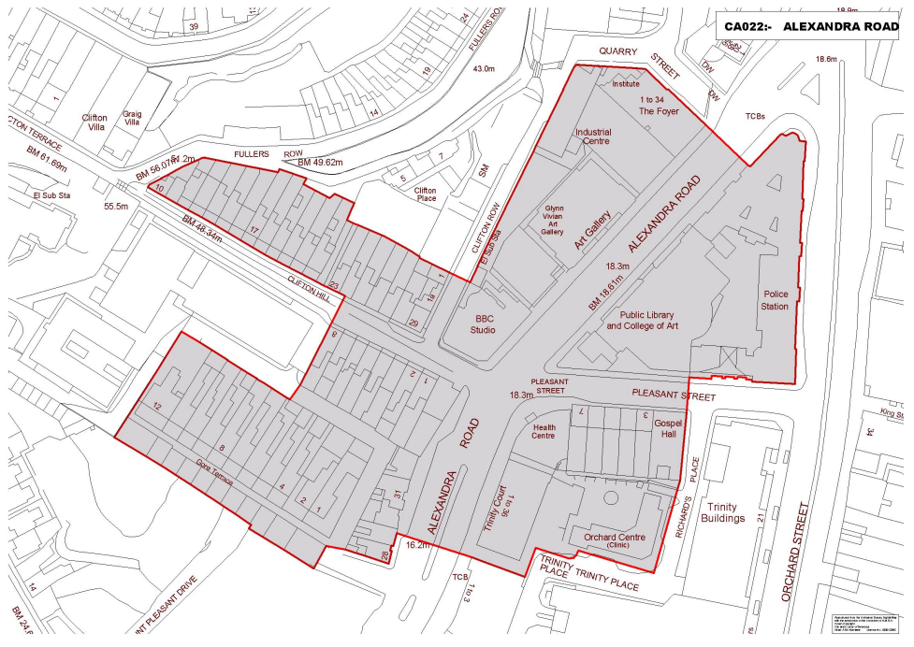
Fig 1 – Alexandra Road Conservation Area

Alexandra Road consists of historic group of buildings on both sides of Alexandra Road and 19th Century houses along Gore Terrance, Clifton Hill and Pleasant Steet. In the area next to High Street AStation and the ‘middleclass’ houses of Dynevor Place lay an area of Poor Housing. These are described as ‘back street. The area was built around 1803 and 1823 when the town responded the its initial rise in population.
The houses were built in local sandstone with a good amount of brickwork used in the chimney’s and around doors and window openings. These materials would be the most common combination of materials used for walls in the 19th century for Swansea Houses. The openings for the ground windows and front doors had arched heads and the arch would be filled with a recessed panel of brickwork. This characteristics feature was of many small houses built in the Swansea area in the first three decades of the 19th Century.
The group of houses in Pleasant Street which were built in 1813-23 and the houses continuing up Clifton Hill are the only part of the houses standing today and these examples still retain the arched recesses above the front doors.
In 1876, the Swansea Town Council had an order under the ‘Artisans and Labourers Dwelling Improvement Act of 1875 to remove the run-down areas also known as the slums. The clearance of the Back Street area was carried out from 1876 and 1880 and gave a new layout of Alexandra Road which was constructed in 1879. The Alexandra Road was originally called Yeo Street after Frank Ash Yeo who was a Councillor who was mainly responsible for the clearance of the area. The area had a name change in October 1881 after a visit to Swansea from the Prince of Wales and Princess Alexandra.
Alexandra Road originally designed as a ‘Grand Boulevard’ which would sweep visitors into the town centre from the Great Western Railway Station. The Scheme certainly demonstrated and enhanced Swansea’s tourist reputation.
Between 1887 and the First World War a number of significant public buildings were constructed on both sides of the Alexandra Road. This led to the construction of the Working Men’s Club and Institute in 1885, The Central Library in 1887, the BBC Building in 1899, the Glynn Vivian Art Gallery between 1909 – 1911 and the Central Police Station in 1913.
These buildings were designed rich classical style and were just part of the impressive curve of buildings along the ‘Grand Boulevard’ which formed the picturesque streetscape and attractive urban space.
Due the First and Second World War, there has seen destruction and reconstruction and in particular road construction. Much of the original character of Alexandra Road is gone only leaving a group of historic public buildings. ‘Swansea – Conservation areas index, 2022.
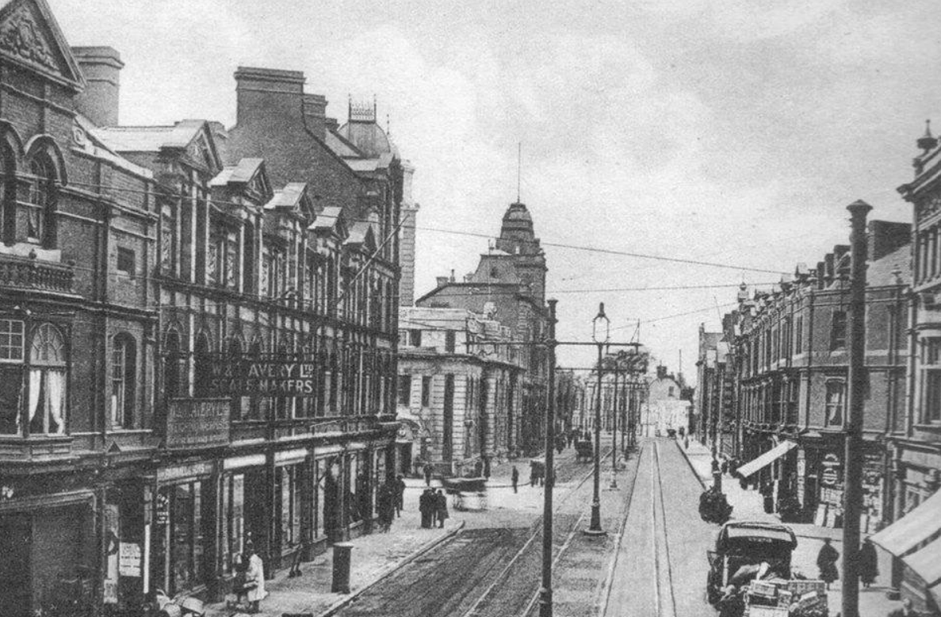
Fig 2 – Image of Alexandra Road, Historic. Alexandra Road Estate, 2022
The Old Swansea Central Library which is located in Alexandra Road which is situated in a group of public buildings at the North end of the city centre. The Old Library is a Grade II listed building and originally opened in 1887. There is a circular reference library 86 feet in diameter and has a domed top which is 25 feet high in the centre. The collections provided a vast of source material for research on Swansea and of Wales in general.
The building was designated as grade II listed on the 30th of March 1987. It was built in 1886-87 and designed by Henry Holtom, Dewsbury with an approximate cost of £20,000.
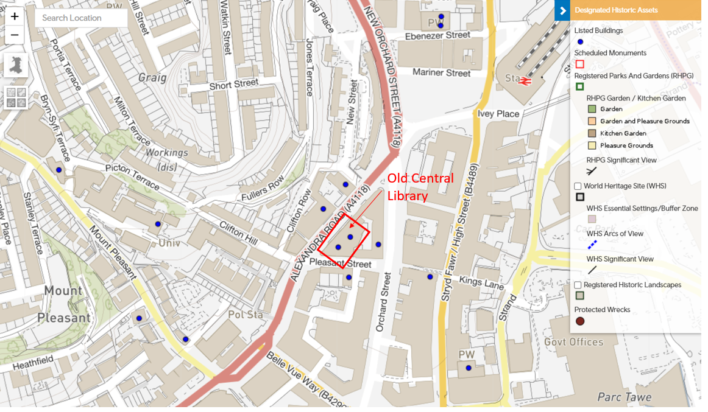
Fig 3, Location of Old Central Library, Swansea. Cadw, 2022.
The building is of a monumental, symmetrical classic design with pale freestone dressing and red face bricks. The building is two-storey with an attic and basement. The advanced centre and end bays have slate pavilion roofs – the centre roof was destroyed in the Second World War bombings but has since been re-built. The tower to the centre has tripartite arched windows. There are banded quoins to the upper floor and angle and fluted pilasters below. There are arched ground floor windows with linked impost band and panelled aprons. Glazing – majority T-Frame. On the far right of the building there is a set-back bay with similar style with glazed top storey and two-bay return elevation. The porch to the street has a segmental pedimented doorcase, panelled pilasters and carved tympanum. The main arched and pilastered doorcase has foliage carving to spandrels and keyblock. There is a smaller doorcase to the far left with a guilloche surround, inscribed over under glazed lunette.
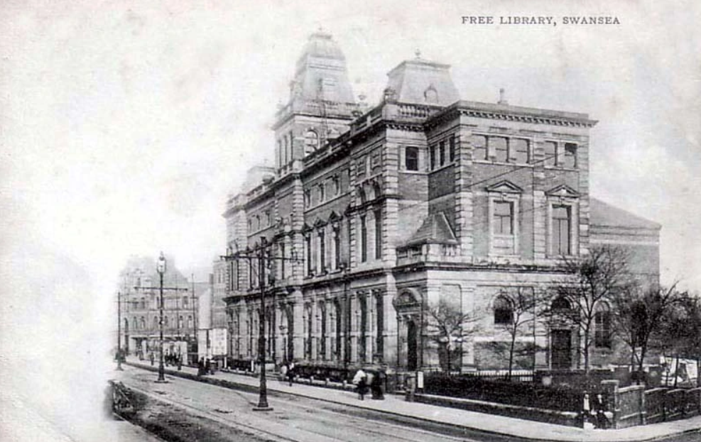
Fig 4 – Image of Alexandra Road, Historic. Alexandra Road Estate, 2022 (Picture from 1890)

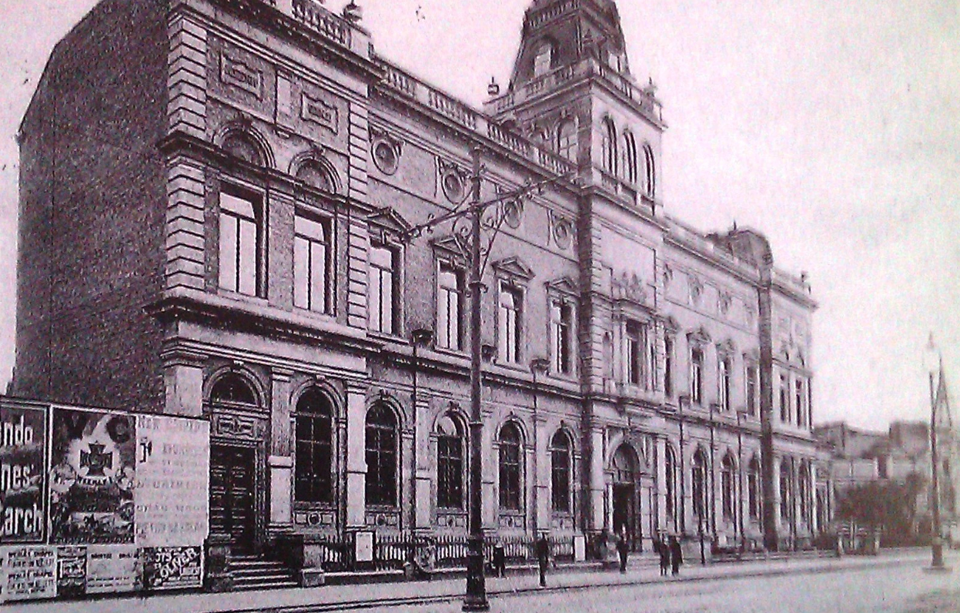
Fig 5 – Image of Alexandra Road, Historic. Alexandra Road Estate, 2022 (Picture from 1980)
The interior of the building and entrance hall has paired doorway up steps, there is an arched coffered ceiling to vestibule and timber pedimented doorcases with lunettes over. The lateral corridors are of an arched and pilastered treatment. The circular rear reading room is of classical detailing, cast iron columns with timber bookcases with ironwork balconies support. Listed Buildings, Full Report, 2022.
There is signs of great architecture and design within the exterior and interior of the existing building therefore it is important to withhold these and withhold the heritage and character of the building when assessing the proposals to enhance the reconstruction and extensions.
- Proposed Changes.
This Project, if approved would result in the removal of the gardens to the right of the Central Library of Swansea and the construction of a new extension in replace of the gardens. The Extension’s design would be seamless and to not distract or to harm the original features and history of the original building. The loss of the gardens would be offset by the new extension and the restoration of the building as part of the Swansea City regeneration and Urban Renewal. The addition of the proposed extension would bring a new purpose to the listed building and give the University of Wales Trinity St David the additional space much needed to carry out their courses in the future with room to grow. The addition has little significance to the existing building and would not have a negative effect on the heritage character of the heritage conservation area of Alexandra Road.
This Project’s proposed main feature would be an impressive double façade achieved with a curtain walling solution with the concept of adding more space to original building. The new, modern looking extension would provide an approximately 660m2 additional space with a new entrance, teaching spaces, workshops and design studios.
The proposed façade would compromise would consist of a curtain wall system forming the internal wall and a structurally bonded toughened laminated glass which would form the outer skin wall with a space between them.
This proposal and solution would bring transparency that the listed building deserves whilst also introducing many possibilities for climate control. As the new proposed extension would be south facing, it would offer long exposition to the sun for solar energy and to keep the building warm during the winter months. It would also help to reduce the energy consumption with a number of louvers at the bottom of the façade to reduce the noise pollution from the potentially busy road outside. Aluk, 2022.
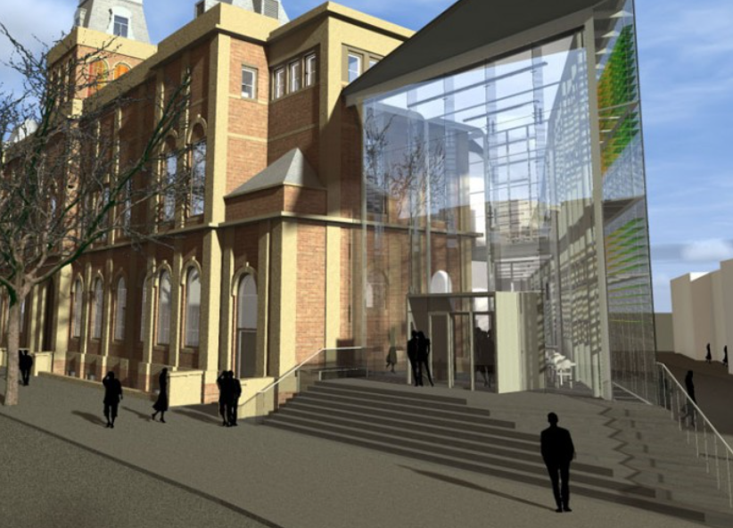
Fig 6 – CGI Proposal of the Alex Project. Structural and Civil Engineering Design, 2022
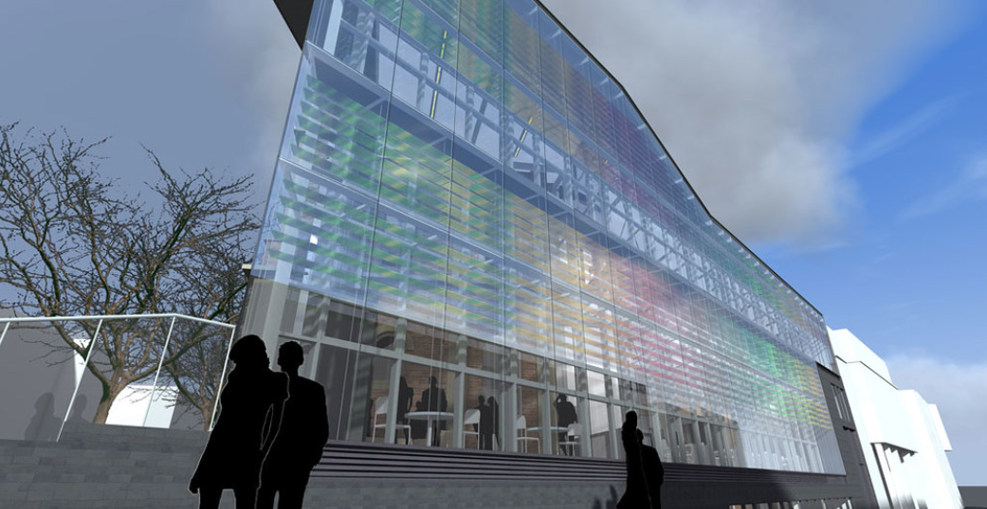
Fig 7 – CGI Proposal of the Alex Project. Structural and Civil Engineering Design, 2022

- Impact of the Proposal.
First and foremost, the future of the former Central Library would be secured through the proposed project. At present, it’s future is in question. No other party has expressed any desire to intervene in any way to become steward of the property.
The proposal and design of the project is believed to taken into account of the existing Listed Building. It is imperative that the new proposed extension is as transparent as possible to express and to not hide the original scale and the features of the historic fabric of the Central Library. In which the design submitted does not hide any historic values and characteristics and will only conserve them. The Client is also looking for a truly sustainable solution in both the reduction of energy consumption and to create an inspiring place to work and learn. Aluk, 2022
The Client’s intention is to return the building to its original glory with a modern context. The building’s original façade is to be retained ensuring the new design extension is only complimenting the original design.
Internally of the Central Library the iconic round reading room, the proposal would be to reinvigorate but without removing any original features, making use of this historic room for public meetings, events and other activities. Further to the internal layout of the existing building, the intention is to not change the layout and to only protect and maintain its historic detailing.
This project would also see care taken to the existing building fabric, ensuring all originally features remain intact or repairs where needed, giving attention to roof, window details ensuring watertightness, including the repair and maintenance of any damaged fabric.
This project would be part of the City of Swansea’s vision to create a Cultural Quarter in the heart of Swansea and regenerate and bring life back to this iconic building and the community making it easier to access to historic building.
The project does however call for the removal of the gardens to the right of the building to make way for the new glazed structure extension.

- Best Solution
In early design stage there were proposals to construct an extension to mirror and look like the existing Library. It is believed that this approach would harm and distract away from the character of the Grade II listed building.
The new design of glazed structural walls will not only retain the original building, it will bring transparency also. With the design being glazed and South Facing it will also bring with its climate control. The design would offer long exposition to the sun for solar energy and to keep the building warm during the winter months.
The proposed use of the Old Central Library, although will not be interpreted as a Library facility, its history and former use will be part of its historical presentation in the iconic central round reading room.

- Offsetting
The project takes into account the removal of the gardens to the right of the building to make way for the proposed extension. The client is suggesting and willing to plant a new replica garden with the agreement of the Town and City of Swansea’s Council in a location of their choice to protect the history and to allow access for the community to visit.

Task Two.
- Conservation

  - Risk to the Building’s Exterior walls
Stones and Bricks are commonly known to be a very strong building material. These materials are known to be used across most historic buildings. But, without special care there is risk that these materials could and would deteriorate over time. The Central Library’s main construction is of Stones and Bricks therefore special attention will need to be made to preserve and maintain these materials from the weather. A big challenge in in caring for historic buildings is the damage caused by rain water. As well as contributing to erosion decay if the water penetrates the joints or any cracks that may be in the structure it could weaken or wash out the mortar which then could increase the risk of structural failure. In the winter months if there were cracks in the mortar and water was to penetrate, the trapped water could freeze and fracture the stone/bricks. Also, any defects to the exterior face as generally older buildings have solid exterior walls the historic interiors and collections are also at risk of decay and damage if water enter the building.
Other issues for older buildings are plant growth on the façade. Some plants can spread from the ground and grow into the stonework and take root. The more harmful of these plants grown deep roots into the building which will harden grow bigger over time. If this plant growth is not kept maintained, the roots can grow into the mortar joints and gaps between the stones, which in time will wear and dislodge the material allowing the water to enter the core of the wall.
Plants and Moisture on buildings are becoming are larger issue as climate brings more rainfall, frequent storms, rising sea levels and wetter winters that promote increased plant growth. English Heritage, 2022
  - Maintaining the Building’s exterior walls
Regular maintenance to the building is necessary to mitigate any serious damage before it occurs. This would include the removal of harmful plants and protecting the exposed stone and brickwork. Even with the regular maintenance and mitigation measures, there is occasions where damage and deterioration can occur to the stone and brickwork which will require repair. Repointing is the most common repair that will usually be undertaken. Pointing is where filling of any open joints in the face of the wall. If there any loose or dislodged stones, these are re-bedded in their original position. The use of lime mortar would generally be used as this would reflect the character and performance of the historic building. Lime mortar is weaker than the modern cements but more porous. This allows the stonework to breath and helping to release any moisture that may have entered the wall. If stones are cracked, they can often be repaired by pinning and grouting. In some cases, the original stone may be damaged beyond repair and careful research will need to be carried out to source the best matching stone material. A crafted stonemason will cut the sourced stone to shape and dress the visible faces of the new stone to ensure that the texture matches that of the original.

  - Maintenance.
Much like all buildings, historic buildings require regular maintenance in order to restore any damage. This is generally caused by wear and tear and to protect and the regular maintenance is to protect the building for years to come. The challenges with the upkeep that historic buildings like the Central Library of Swansea will face are;
- Water damage, this will often be caused by damaged roofs or poor drainage on the exterior of the building – which in effect will promote mould growth and poor air quality. (Please see appendix A of findings of damp caused by these issues)
- Light damage, this can deteriorate collections within the building and degrade the paintwork. – no signs of light damage but regular maintenance of the décor is required.
- Old infrastructure – such as heating and poor wiring, these are both not energy efficient and can become dangerous if left unaddressed.
Necessary interventions may include the items mentioned above, repairs to the roof, improving drainage, timber repairs to windows, re-wiring and repairs to stonework. All repairs that have to be undertaken would need to be carefully considered to ensure the integrity and history of the building is maintained while also creating a safe environment for any end user, visitors and staff inside the building.

- Retrofitting
Retrofitting is a way to help to improve a buildings energy efficiency through the addition of new technology of features. Retrofitting can also help on saving money on the long-term energy bills.
There are different way to retrofit a building, this can vary from a single room improvement or to a whole building retrofit. Each process will be ultimately designed to increase the energy efficiency. The focus on the efficiency is why retrofitting is different to renovating a building or making building improvements designed to make a building more aesthetic.
There are several industry groups that believe retrofitting in the UK is essential, especially if the UK’s target is to reach net zero by 2050. This is why many industry groups are campaigning for a National Retrofit Strategy to be introduced to help the nation provide a roadmap. Retrofitting a home, 2022.
Retrofitting requires a more substantial change to the original building into something much more energy efficient. Retrofitting typically involves a significant improvement in the thermal performance of the building and also by doing so improving the fabric of the building. Typically, in this case, the Central Library of Swansea is a Grade II listed building therefore improving the exterior fabric of the building will prove difficult and all parties would not desire to remove the character and the history of the building. Therefore, other options would need to be considered here an option of improving the thermal performance of the building from the inside.
Retrofitting can be filtered in many ways and options that can be adopted include,
- The insulation of roofs, walls and floors.
- Replacement Windows, in the case of the Central Library as the building is Grade II listed the replacement of windows can cause difficulties and may not pass planning therefore internal secondary glazing may be an option here.
- Improved ventilation designs – Mechanical Heat Recovery Systems (MVHR) can be used to extract stale, moisture laden air from the building and re supply fresh, filtered air back in – resulting in a comfortable and condensation free environment. What is MVHR, 2022.
- Airtightness – special attention and advise would be needed here as this may not be possible in a historic building as generally the exterior walls and rooms are designed to ‘breath’ and if the building were to become airtight, dampness and condensation may occur.
- Heating and Hot Water Systems – A common change, changing the heating systems and boiler to a newer and up to date, will provide a better output of heat and will be more energy efficient.
There are many benefits that come from retrofitting a building, for the person using the building as well as the environment. Retrofitting can help improve the energy efficiency of buildings, reduce fuel bills and also create comfortable, even temperatures all year round. Well retrofitted buildings are likely to be healthier environments and will drastically reduce the risk of poor internal air quality of a building. They will use less energy and put less pressure on the power grid.
Retrofits could involve making changes to the fabric of the building. The Central Library being a Grade II listed building, making excessive changes may prove difficult but these would include;
- Insulation – this is a key part of a retrofit; it tends to involve external insulation (which as a Grade II listed building will be not possible) internal wall insulation as well as roof and floor insulation. The attention to detail is important to avoid cold bridges. Cold bridges are where gaps meet such as when the floors meet the walls.
- Airtightness – this would entail minimising any gaps in the insulation which could lead to heat loss from the building and also attention around openings, windows and doors to ensure airtightness and no air leakage are at these points.
Once the fabric of the building is improved, the addition to low carbon heating and hot water systems can be made such as; Solar Thermal, Biomass boilers and Heat Pumps.
Although the Alex building is a well-designed modern building, it has good aspects of being energy efficient. The Central Library could benefit from several ways such as;
- insulation to parts of the fabric albeit a Grade II listed not all areas the are required could be insulated.
- Air Tightness – attention around openings to ensure no air leakage,
- New Heating and Hot Water System – this would have a better output of heat and will be more energy efficient.
- Electrical re wire.

- Asset Management.
Assets are the centrepiece of an organisation. Maintenance teams are recognised for their ability to keep assets/buildings running.
There are many parts of an asset’s lifecycle, asset management will involve a contribution form multiple departments, such as planning, engineering, production, maintenance and accounting. These departments will work together to assess and manage the assets from cost, value, risk and performance.
Knowing the condition of an asset is important for the maintenance and decommission planning. Condition information is mainly and usually obtained through visual inspections and reports. Any asset failure that requires attention will then be reported to the maintenance team of the building.
An important component of managing an asset is understanding the design of the building and its specification. The design and nature of a building will provide the boundary for operating the asset and its maximum efficiency. The specification of the building will also lead the maintenance procedures and ensure the correct repair and replacement of any material/component.
  - Analog Approach.
The Analog approach is keeping track of limited assets in a notebook or whiteboard. Tracking this by hand gives the flexibility to build the systems and organize notes the way that works on a small scale. By using this approach, there is opportunity to take notes quickly without inputting the data onto a computer etc. On another positive side there is no additional or low education required with an analog management system.
On the negative side that with pen and paper, there is not a reliance as digital features that come with software or web-based systems. For example, it is not possible to run reports automatically, and not having real time overview of the inventory over multiple locations.
  - Spreadsheets.
Spreadsheets can be seen as the step up from the Analog Approach. With Spreadsheets there would still be the need to enter the inventory data by hand, but the solution is a bit more customizable and flexible than an analog approach.
With Spreadsheets, you are able to input formulas with the allowance to filter the inventory and rank it by certain criteria’s such as value, date and quantity. There will be the need to accurately input formulas, the formulas are limited but this approach is more functional than the analog system.
Spreadsheets are a low-cost option and many businesses generally use spreadsheets for other aspects of their day-to-day business needs.
The negative of using a spreadsheet to manage assets is that they can become unruly to manage when you have multiple people who have access to and are able to edit. It also can be slow to update and load if the document has many assets in one spreadsheet.
  - The Workaround Solution
The Workaround solution is a good option if the assets require more than a spreadsheet to manage the data.
The Solution offers different ways to handle repetitive tasks in the workflows, so the solution can be used for more than inventory tracking. With this system you can connect all of the work apps through the platform.
  - Asset Management Software.
This Solution removes the manual tracking out of Asset Management – which includes both physical and software assets. The Software is an integrated platform that lets you track important asset data including the health and maintenance costs in real time. There is an ease to scan, tag and search for assets, prioritize maintenance and IT service tickets, perform routine audits and quickly assess the lifetime costs of assets in one central location. The software can also provide deeper insight and reporting that can’t be generated through any spreadsheet alone. Approaches to Asset Management, 2022.
- Survey of the Central Library.
When visiting the Central Library and the Alex Building, we carried out a survey of the property with recommendations on maintenance and potential changes that could be made to make to asset more sustainable.
  - Central Heating.
Radiators are old cast iron type – these could be upgraded to a more recent more energy efficient radiator which would give a greater output.
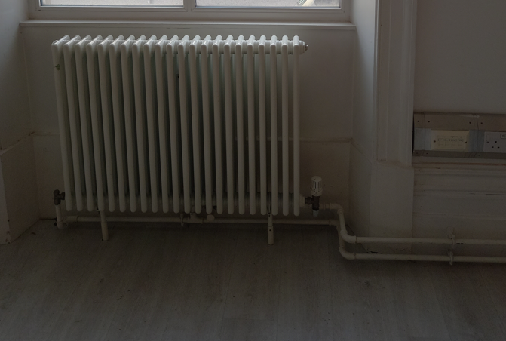
Fig 8.
  - Glazing
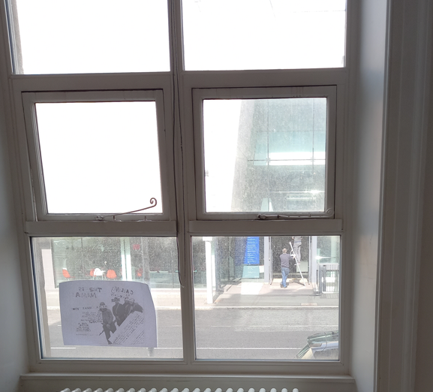
Glazing in the majority of the building is single glazed. Changing this glazing would prove difficult being Grade II listed – there secondary glazing may be introduced internally to prevent heat loss and air tightness betterment.

Fig 9

  - Lighting
Lighting in the Entrance Hall looks dated and a number not working. To improv efficiency, change bulbs to ‘energy efficient type’
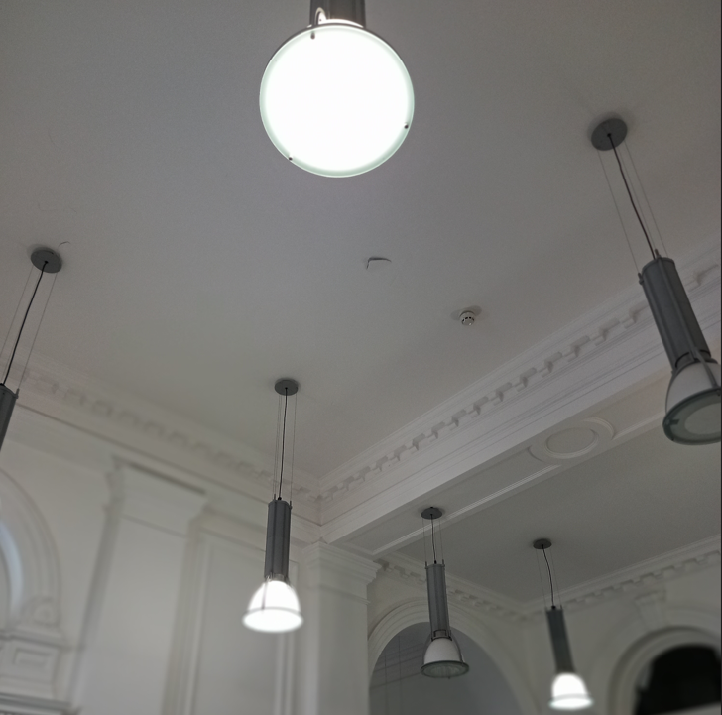
Fig 10
  - External Doors
External doors will need regular maintenance to ensure durability. Attention to detail could be made to ensure air tightness.
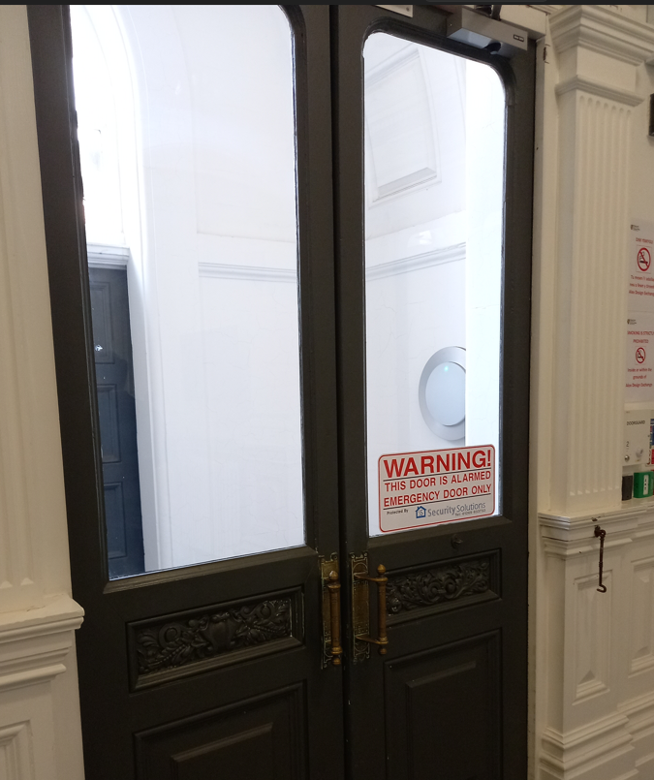
Fig 11
  - Internal Décor.
Attention to detail at a high level to the historic wall panelling. Great importance needed for the upkeep and maintenance of this detail.
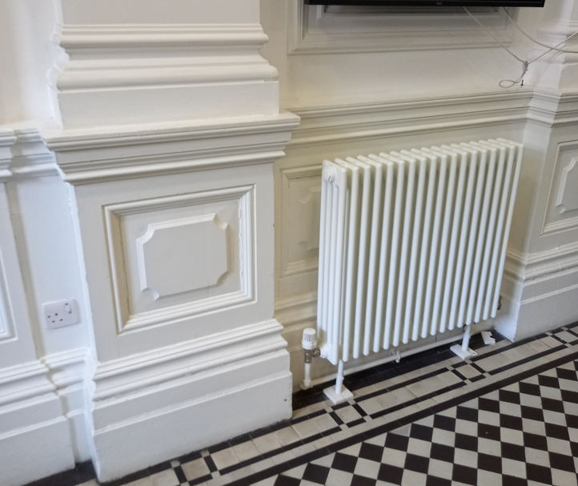
Fig 12
Attention to detail to arches in the entrance halls – sign of damp in the top corner at ceiling height. Further investigation required to locate source.
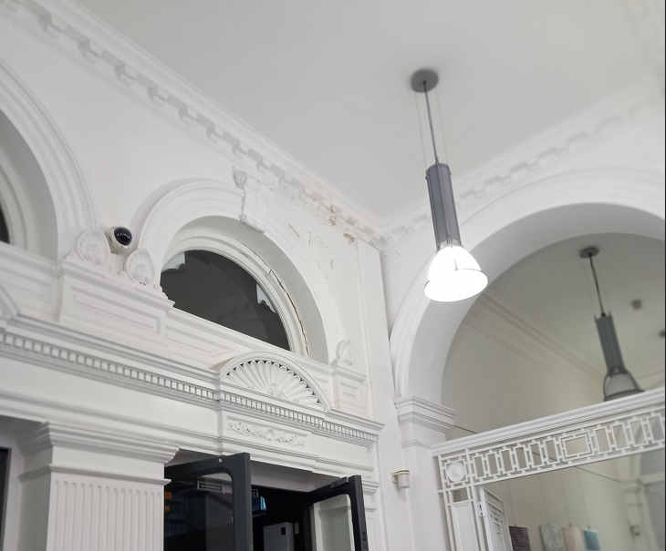
Fig 13
  - Circular Reading Room.
Original stained wall panelling preserved throughout - sign of damp in the top corner at ceiling height. Further investigation required to locate source.
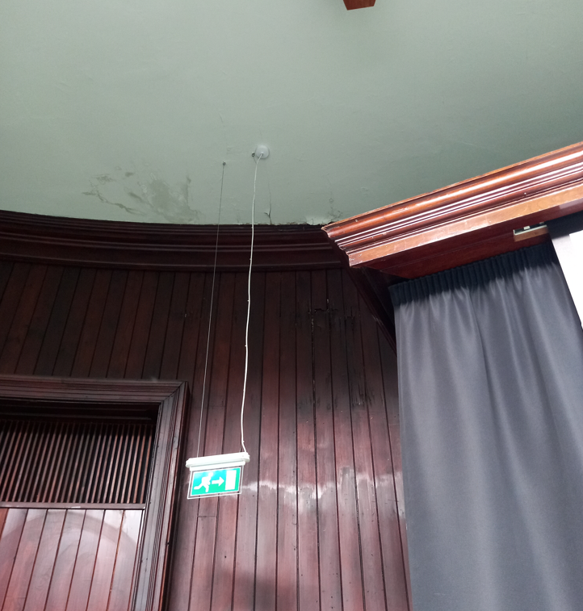
Fig 14
High end attention to detail to the balustrading, pillars and domed roof and surround. Preservation and maintenance throughout this room to keep the history.

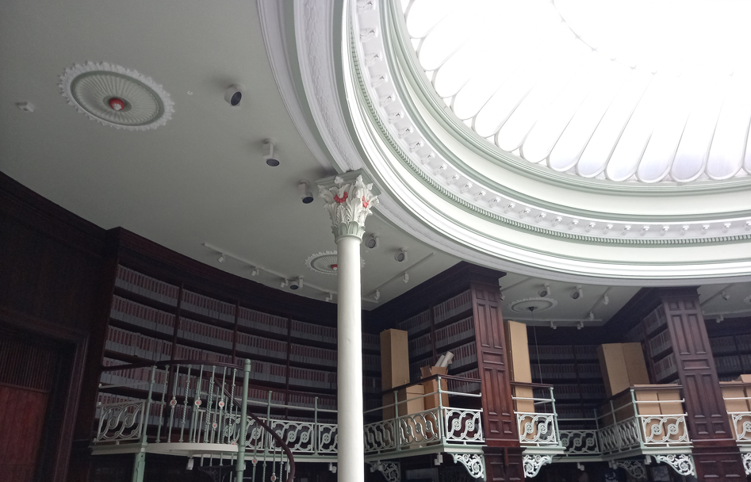
Fig 15
  - Rainwater Goods (RWG)
Signs of plant growth in some areas of rainwater goods i.e. gutters and downpipes. To ensure RWG’s are working efficiently and to prevent damp from entering the building, maintenance required to clear out and clean pipework.
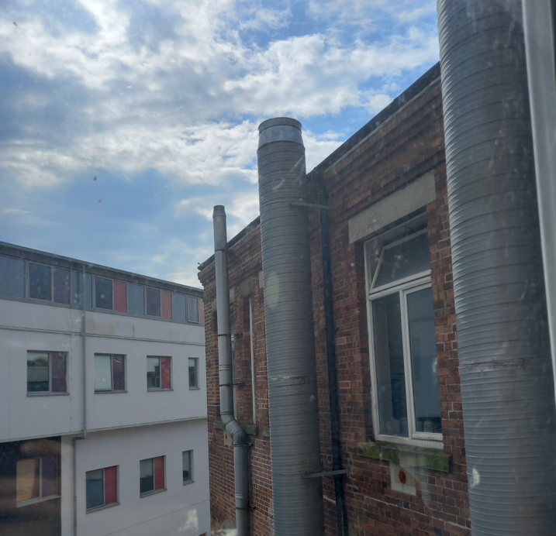
Fig 16
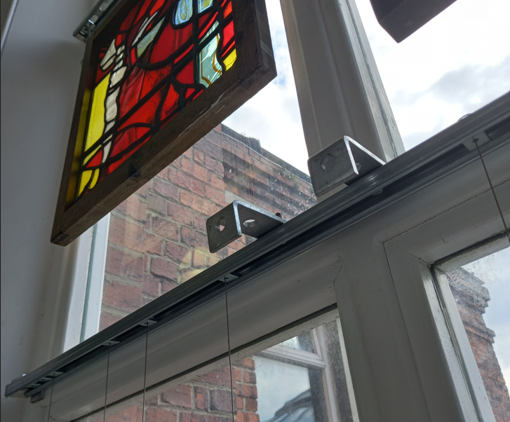
Fig 17

  - Roofing Works
Cracked tiles to domed roof to circular reading roof – possible point of entry of rainwater causing damp.
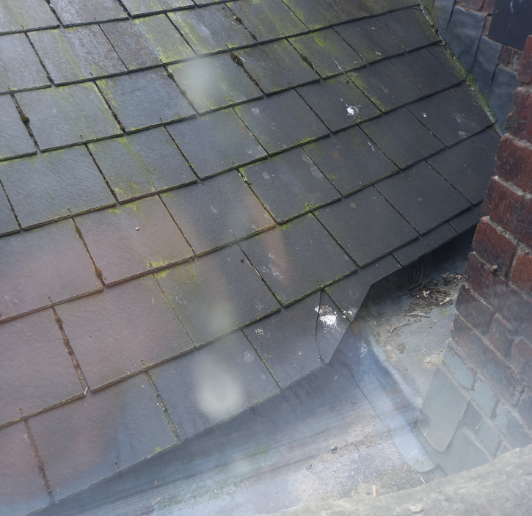
Fig 18
  - Windows
Water damage to window frames to first floor windows. Remedial and Repair works required to preserve with regular maintenance.
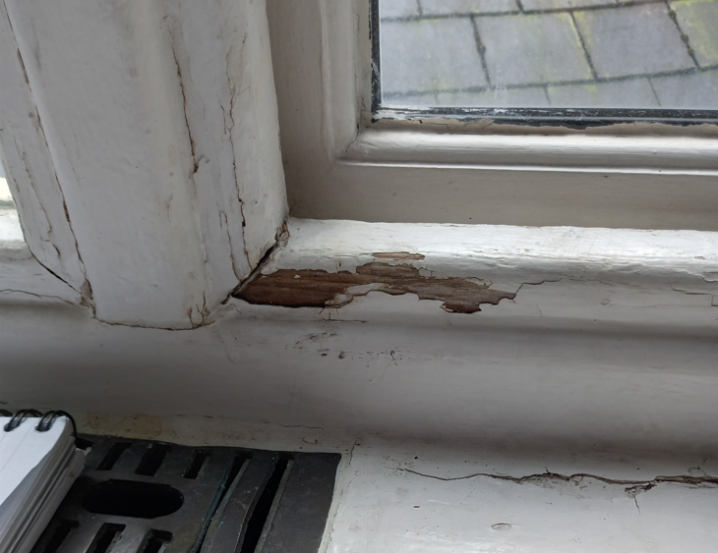
Fig 19
  - Water Ingress.
Several signs of water ingress throughout the building which would require further investigation, remedial, repair and maintenance.
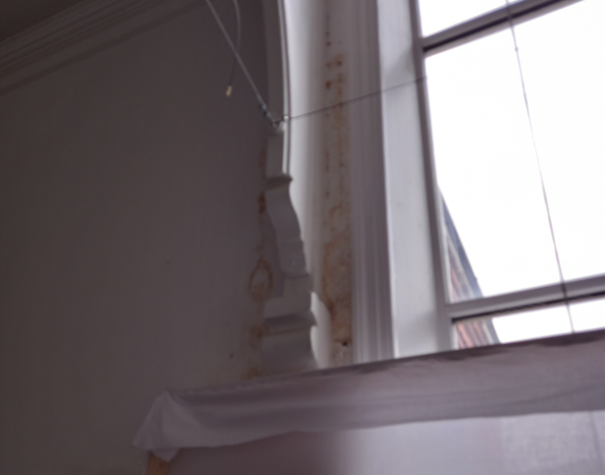
Fig 20
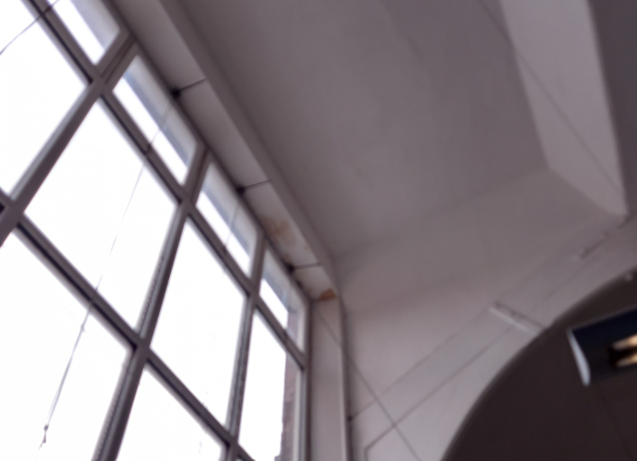
Fig 21

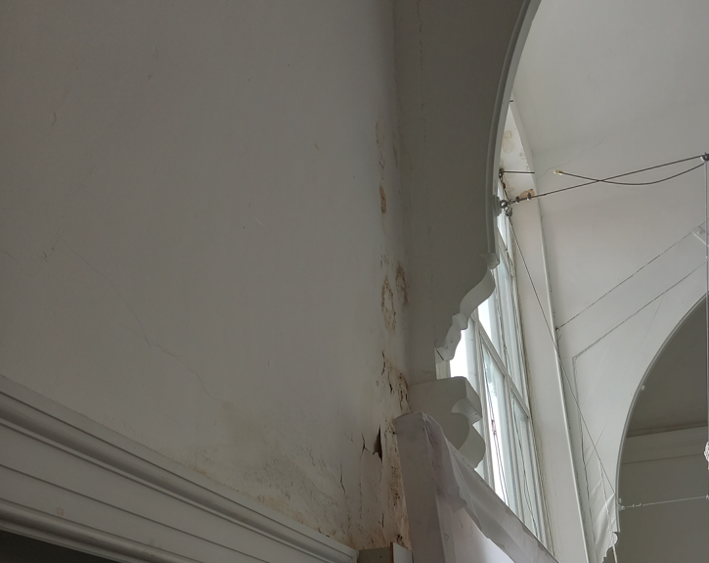
Fig 22
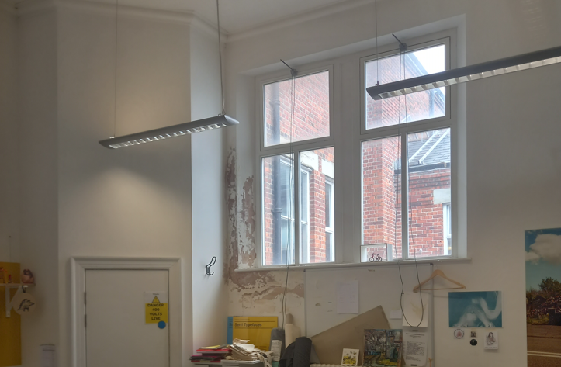
Fig 23

Referencing

- Swansea – Conservation area index, Archive, Swansea.Gov, 2022, https://archive.swansea.gov.uk/conservationareasindex (Access date 24/05/2022)
- Alexandra Road Estate, London x London, 2022, https://www.londonxlondon.com/alexandra-road-estate/ (Access date 24/05/2022)
- Cadw, Cadw.service.gov.wales, 2022, https://www.cadwmembership.service.gov.wales/ (Access date 24/05/2022)
- Listed Buildings – Full Report – HeritageBill Cadw Assets. Cadwpublic-api-azurewebsites.net, 2022, https://cadwpublic-api.azurewebsites.net/reports/listedbuilding/FullReport?id=87858 (Access date 23/05/2022
- Aluk, 2022, https://www.aluk.com/en/projects/alex-house (Access date 24/05/2022)
- Introduction – CB3 Consult – Structural and Civil Engineering Design. http://www.cb3consult.co.uk/ (Access date 24/05/2022)
- English Heritage, 2022, https://www.english-heritage.org.uk/ (Access date 24/05/2022)
- Retrofitting a home: the definitive guide. Homebuilding and Renovating, 2022. https://www.homebuilding.co.uk/advice/retrofitting (Access date 24/05/2022)
- What is MVHR? Xpelair.co.uk. 2022. https://www.xpelair.co.uk/what-is-mvhr (Access Date 24/05/2022)
- Approaches to Asset Management, Reftab, 2022. https://www.reftab.com/blog/2022/01/the-5-different-approaches-to-asset-management-solutions/ (Access Date, 2022)

