Session 15 booklet – Quo Vadis (MGM 1951)
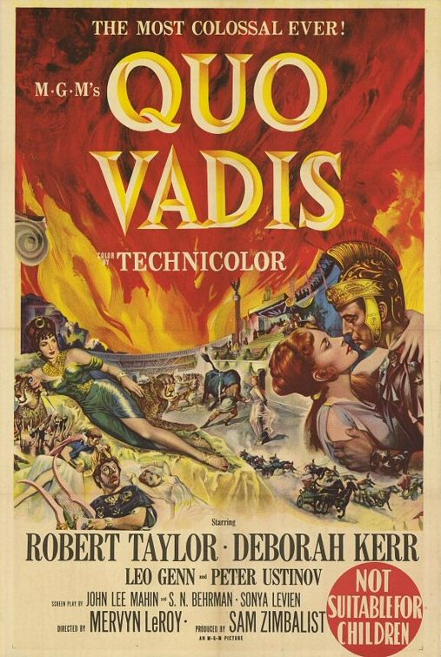

In this workshop we will watch the 1951 M.G.M. film adaptation of the book Quo Vadis (a novel written by Henryk Sienkiewicz in 1895). While watching the film you should consider the following issues:

1) How close or loose are the characterisations of Nero and Poppaea to their presentation in the Classical literary sources?

2) What historical liberties have been taken?

3) What more contemporary concerns can you pick out from the film (consider the recent world war / fascism / communism / totalitarianism)?

There is no set reading. However, you may find it of use to have a look at: Winkler, M. M. 1997-1998. ‘The Roman Empire in American Cinema after 1945’, The Classical Journal 93 (2): 167-196. – See Moodle.

