

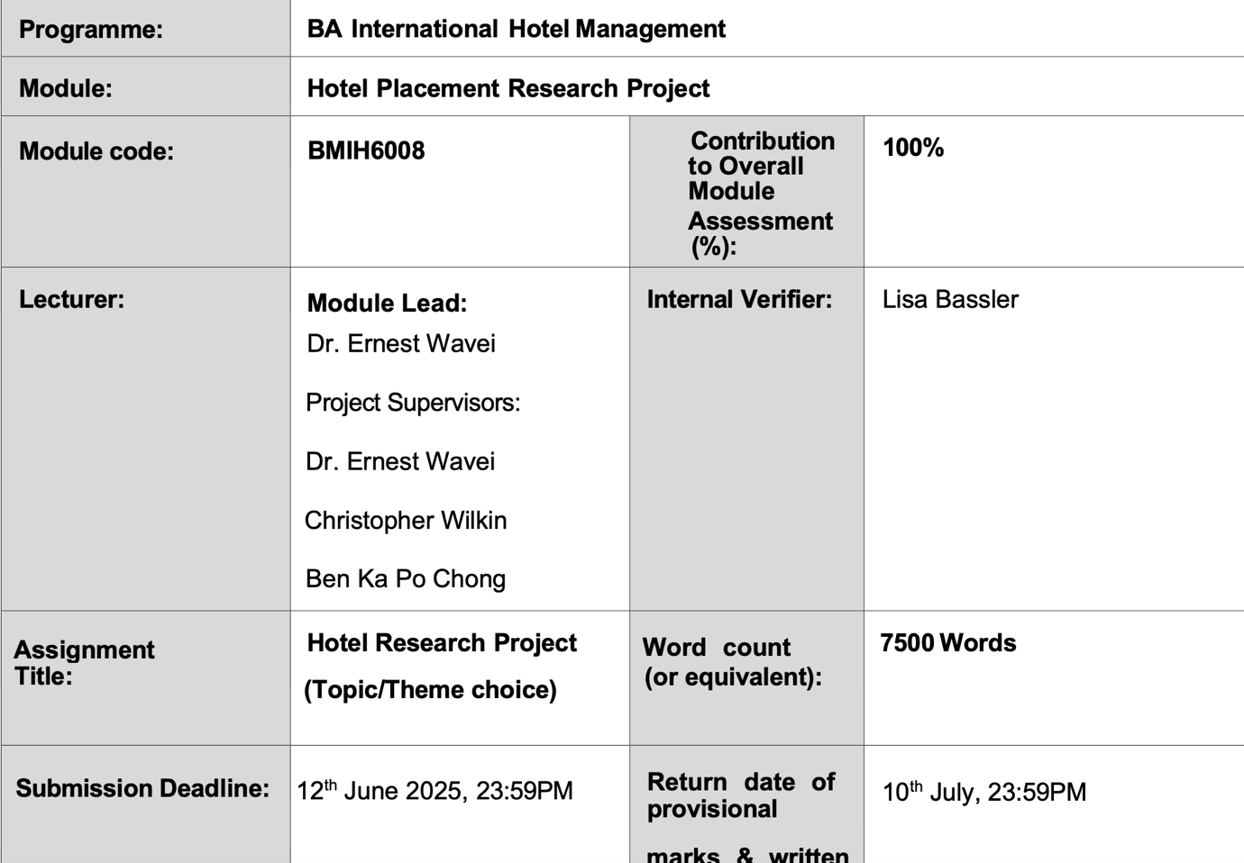

Title: Placement Research Project Topic
An Analysis of Staff Management Dynamics in Event Management: A Case Study of Mercure Birmingham West

Declaration
I confirm that this submission is my own work and that I have not used Artificial Intelligence (AI) tools such as ChatGPT, Grammarly GO, or similar platforms to generate or rewrite content for this assignment. Any support received is appropriately acknowledged, and all sources have been cited according to academic standards.
Signed: Jahanara begum
Date: 11.06.2025

Abstract
Using Mercure Birmingham West as a case study, this research project investigates the important part staff management plays in the effective running of events within the hotel sector. The main goal is to see how professional behaviour, staff coordination, and training affect visitor pleasure and event results. The event operations of the hotel provide a perfect environment to closely review the logistical and human sides of service delivery in real time.
Direct observation became the principal technique of data collecting under a qualitative study design. During events like weddings and business meetings, the interpretivist method let the researcher better understand staff activities, team dynamics, and guest and outside vendor interactions. Review of internal records and casual talks added to observational data.
Three main themes emerged from the results: the value of staff training; degrees of professionalism under duress; and procedures for handling outside suppliers. Staff members with good training showed efficiency, open communication, and adaptability—all of which helped to ensure a better running of events. Client satisfaction and the event environment improved by professionalism in appearance, attitude, and visitor engagement. Furthermore, discovered to be crucial for providing coherent and timely services is smooth collaboration with outside providers.
This research emphasises the need of ongoing staff development, good leadership, and organised vendor management, therefore adding useful information to hotel management. The results are pertinent for both academic audiences and industry professionals as the insights acquired provide useful suggestions for optimising visitor experiences and event management

Table of Contents
Title: Placement Research Project Topic 1
Abstract 3
Chapter 1: Introduction 5
Chapter 2: Literature Review 10
2.1. Introduction to Literature Review 10
2.2 Event Management in Hotels 10
2.3. Theories of Staff Management in Event Context 11
2.4. Staff Professionalism and Training in Events 13
2.5. Vendor and Outsourcing Management in Events 15
2.6 Gaps in Existing Literature 17
2.7. Conclusion of Literature Review 18
Chapter 3: Methodology 18
3.1 Research Philosophy 19
3.2 Research Approach 19
3.3 Research Strategy 19
3.4 Data Collection Methods 20
3.5 Ethical Considerations 24
3.6 Limitations 25
3.7 Summary 26
Chapter 4: Findings and Discussion 27
4.1 Introduction 27
4.2 Theme 1: Staff Training Effectiveness 28
4.2 Theme 2: Maintaining Professionalism 31
4.3 Theme 3: Vendor Acquisition and Coordination 34
Conclusion for Chapter 4 40
Chapter 5: Conclusions and Recommendations 41
5.1 Conclusion 41
5.2 Recommendations 43
5.3 Limitations 45
5.4 Recommendation for Future Research 45
Table: Recommendations for Future Research (self-created) 46
References 48
Appendix 55
Appendix A: Observation Notes Table 55
Appendix B: Sample Event Planning Document (Anonymised) 56
Appendix C: Ethics Form (Summary) 56
Appendix D: Supervisor Meeting Log 57

8081 words

Chapter 1: Introduction
Focussing especially on the staff management during event operations, this placement report offers a thorough assessment and analysis of my experience at Mercure Birmingham West Hotel. This paper aims to investigate how well staff training, professionalism, and coordination with outside suppliers help events to be successfully executed and general visitor satisfaction. Using a qualitative method based on observation, the study looks at real-time procedures and points out both areas of strength and development in event delivery. The results seek to link scholarly theory with pragmatic knowledge acquired throughout the placement, therefore providing insightful advice for improving hotel event management. This paper also shows how placement learning may be combined with pertinent hospitality research.
Background
Dynamic and multifarious, the hotel business depends on visitor pleasure, operational efficiency, and service quality. In this regard, events including conferences, weddings, and private gatherings provide a major source of income and a main component of hotel operations (Veal, 2006). Particularly with an focus towards staff duties, coordination, and real-time service delivery, my employment at Mercure Birmingham West presented a unique chance to see the inner workings of hotel event operations. The location provided a useful prism through which one could see hotel management of live events, handling of unforeseen difficulties, and guarantee of customers leaving with good impressions.
Events at hotels need flawless coordination across many departments, including food and beverage, cleaning, front desk, and outside suppliers; they are labour-intensive. The intricacy rises with the size and modification of the occurrences. This raises strategic as well as operational importance of personnel management. Whether an event is a success, or a reputational risk depends mostly on staff members' capacity for training, direction, and leadership. Future hotel managers (Cottrell, 2014) must grasp this dynamic.
Value of Event Management for Hospitality
Crucially a sub-sector of the hotel economy, event management calls for flexibility, accuracy, and preparation. Collis and Hussey (2014) contend that the synergy between human resources and logistical systems determines how well an event is delivered. Hotels depend on properly planned events to improve their brand image, attract business and private guests, and foster long-term customer loyalty. In a saturated market, a competitive advantage is the capacity to plan extraordinary events (Kashef, 2015).
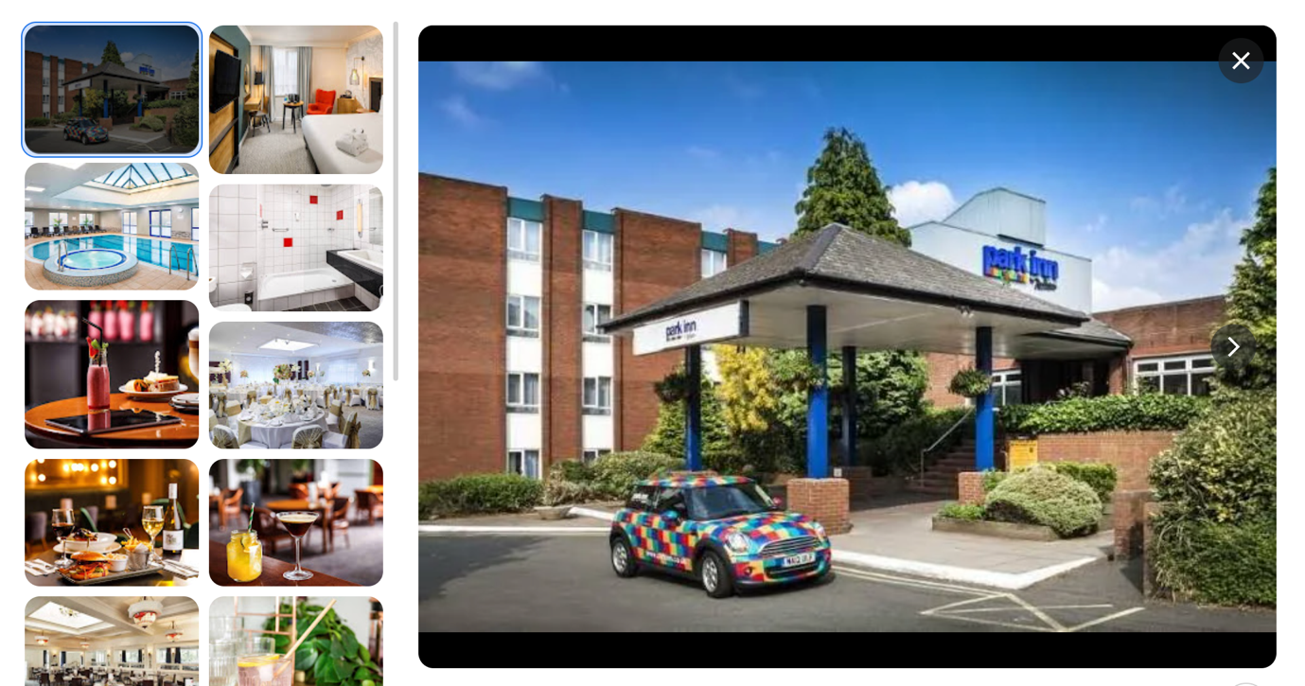
Figure 1: Mercure Birmingham West Hotel. Image source https://all.accor.com/hotel/B538/index.en.shtml
Operating in an experience economy, the hotel business values tailored service and emotional gratification (Pine & Gilmore, 1998). Events therefore provide a chance to create unforgettable experiences, but they also run the danger of public scrutiny and discontent should they be badly managed. Given this, the human element—more especially, staff management—emerges as the pillar of effective event performance (Kolb, 2021)
Problem Statement
Even while well-planned events are rather important, many hotels find it difficult to properly staff such events. Events are time-sensitive, often high-stress settings where one mistake or delay may affect the whole visitor experience. Inadequate training, poor staff coordination, and lack of professionalism may cause logistical problems, visitor complaints, and harm of reputation (Liudmyla, et al 2024). Including outside vendors—decorators, performers, caterers—adds even another level of complication to staff management.
Usually depending on how effectively the team was ready and managed, I saw both well-executed and poorly organised events throughout my employment. This mismatch begged the issue: What are the main components of good staff management for hotel events? By means of research, this discrepancy may be closed and useful suggestions for raising operational performance and visitor happiness can result.
Aim: Focussing on the efficacy of staff training, professionalism in service, and integration of external vendors, this study aims primarily to monitor and assess staff management dynamics in hotel event delivery.
Objectives
- To support the aim, this study is guided by the following objectives:
Evaluate the effectiveness of staff training during events.
- Assess the level of professionalism demonstrated by staff in real-time event execution.
- Explore how external vendors are selected and integrated into the hotel’s event operations.
Rationale
Academic curiosity as well as a need to link theory with reality drive this research. Direct participation in hotel operations throughout the placement let me see personally how operational policies affect client happiness. By doing this study, I want to further knowledge of event planning from an operational and human resources standpoint.
The location provided a learning environment, balancing pragmatic experience with classroom knowledge. By means of this study, I want to show how theoretical models—such as HR policies and service quality models—manifest in practical settings. For instance, the SERVQUAL model stresses dependability and responsiveness, two characteristics clearly impacted by staff training and professionalism (Parasuraman, Zeithaml & Berry, 1988).
Moreover, this study fits the academic objectives of this module especially in terms of developing analytical abilities, using research methods, and synthesising data to get important findings (Saunders, Lewis & Thornhill, 2012). Grounding this research in a real-world environment helps the study to provide useful, pragmatic findings that can help hotel management, event planners, and hospitality students.
The results could also help hotels create better vendor management plans and training courses. Increased consistent service quality and finally improved client experiences might follow from this. Students in hospitality management have to realise as future hotel managers how operational decisions—especially those involving staff—translate into customer pleasure and financial success (Bryman, 2008).
All things considered, the introduction prepares the ground for a study effort anchored in both scholarly theory and actual observation. The research seeks to provide insightful analysis of the operational dynamics driving event performance by investigating staff training, management, and coordination during events as well as how outside suppliers are included into the hotel's service delivery model. Given the growing need in the competitive hotel industry for well-run, premium events, this study is topical and pertinent.

Chapter 2: Literature Review

2.1. Introduction to Literature Review

Emphasising staff training, professionalism, and vendor coordination, this chapter critically reviews the body of current research on event management within the hotel sector. Guest happiness and hotel profitability depend on effective event implementation; this is especially true in mid-range hotels where resources could be few. Knowing these dynamics helps one to evaluate operational effectiveness and real-time personnel performance. To fit the goals of the research, the evaluation links corporate practices with academic ideas. It also highlights attention to a disparity in present research—that is, the dearth of observational studies in live hotel event settings.
While Lashley (2008) contends that staff professionalism greatly affects visitor impressions during events, Cottrell (2014) stresses the need of connecting theory with practical uses.

2.2 Event Management in Hotels

In the hotel sector, event management is the thorough planning, organisation, and execution of many purposes including conferences, business meetings, weddings, and private parties. These activities are important income sources and help to greatly strengthen the brand reputation and visitor loyalty of a hotel (Getz, 2007). Events typically account for 20–30% of total income in many mid-sized to large-scale hotels, therefore greatly influencing overall profitability (Yeoman, 2011).
Goldblatt (2013) claims that to provide memorable experiences, good event management calls for combining innovation with efficient logistics and flawless service delivery. Given the complicated operating environment hotels have, where many departments and outside suppliers must collaborate well, this integration becomes more difficult. Tum, Norton, and Wright (2006) underline how hotels use events as strategic instruments for branding and client retention, but only careful planning and execution can help gain these advantages.
According to Jones and Robinson (2012), urban hotels serving business and leisure guests—like the Mercure Birmingham West Hotel—have particular difficulties running events. Among these difficulties include controlling changing demand, distributing resources, and coordinating staff schedules with vendor events. Inadequate management of these factors could cause service failures, therefore compromising client pleasure and compromising the hotel's image.

Furthermore, the research emphasises the crucial need of adaptive leadership and cooperation during occasions where service personnel have to act under pressure to satisfy high guest expectations (Getz, 2012). Smooth event delivery depends on hotel personnel working across several departments in concert with outside vendors. This research intends to investigate these dynamics in more detail by means of real-time personnel management and event coordination within a mid-scale hotel setting.

2.3. Theories of Staff Management in Event Context

In event settings, where partnership, motivation, and leadership directly affect event performance and customer happiness, good staff management is very vital. By separating between hygienic elements and motivators, Herzberg's Two- Factor Theory (1968) offers a helpful perspective to grasp staff motivation. While motivators like recognition, accomplishment, and responsibility drive staff involvement and performance, hygiene elements like working environment and salary avoid discontent but do not increase motivation. In event management, where jobs may be fast-paced and demanding, worker morale and commitment are often maintained by intrinsic motivators (Robbins & Judge, 2019). Identifying and addressing these motivators helps to guarantee that event staff members stay engaged going beyond just work satisfaction.
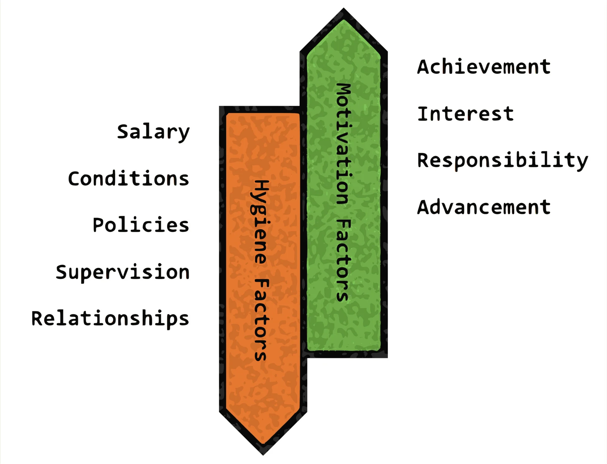
Herzberg's Two- Factor Theory (1968 image source https://www.simplypsychology.org/herzbergs-two-factor-theory.html

Effective event delivery also depends fundamentally on the relationships between teammates. Belbin's Team Roles (2010) theory shows how effective teams call for a mix of complimentary roles—coordinators, implementers, and resource investigators. This balance guarantees that chores like planning, problem-solving, and communication are fairly assigned among team members in event settings, therefore lowering conflict and raising general performance (West, 2012). Different responsibilities in event teams help to provide flexibility and adaptation, which are vital for managing unanticipated problems during live events.

Staff actions and event results are highly influenced by leadership style. Particularly successful in high-stress events is transformational leadership, which is defined as inspiring and encouraging staff to surpass expectations (Bass & Riggio, 2006). Transformational leaders inspire creativity, create a shared vision, and provide customised support—all of which may strengthen team cohesiveness and resilience during challenging event activities (Northouse, 2018). By contrast, servant leadership emphasises worker and visitor need, fosters empathy, ethical conduct, and a service-oriented attitude (Greenleaf, 1977). This kind of leadership fits very well with hotel principles and improves visitor experiences by means of sympathetic staff actions (Spears, 2010).
Combining these approaches emphasises the many aspects related to personnel management in event environments. Effective leadership, balanced team responsibilities, and motivating methods all help to create operational excellence and visitor happiness, thereby highlighting the need of customised management techniques for the proper operation of hotel events.

2.4. Staff Professionalism and Training in Events

The good running of events in the hotel sector depends mostly on professionalism and effective personnel training. From setup to guest services and logistical coordination, training offers the basis for staff members to acquire the technical abilities required to effectively execute event-related duties. Often performed in classrooms or via e-learning modules, formal training courses provide staff members expertise on hotel regulations, safety precautions, and event-specific procedures (Pizam & Ellis, 1999). On-the-job training, however, is equally vital as it enables employees to get hands-on experience in real-time situations, therefore developing flexibility and fast decision-making—skills vital for controlling the dynamic environment of hotel events.

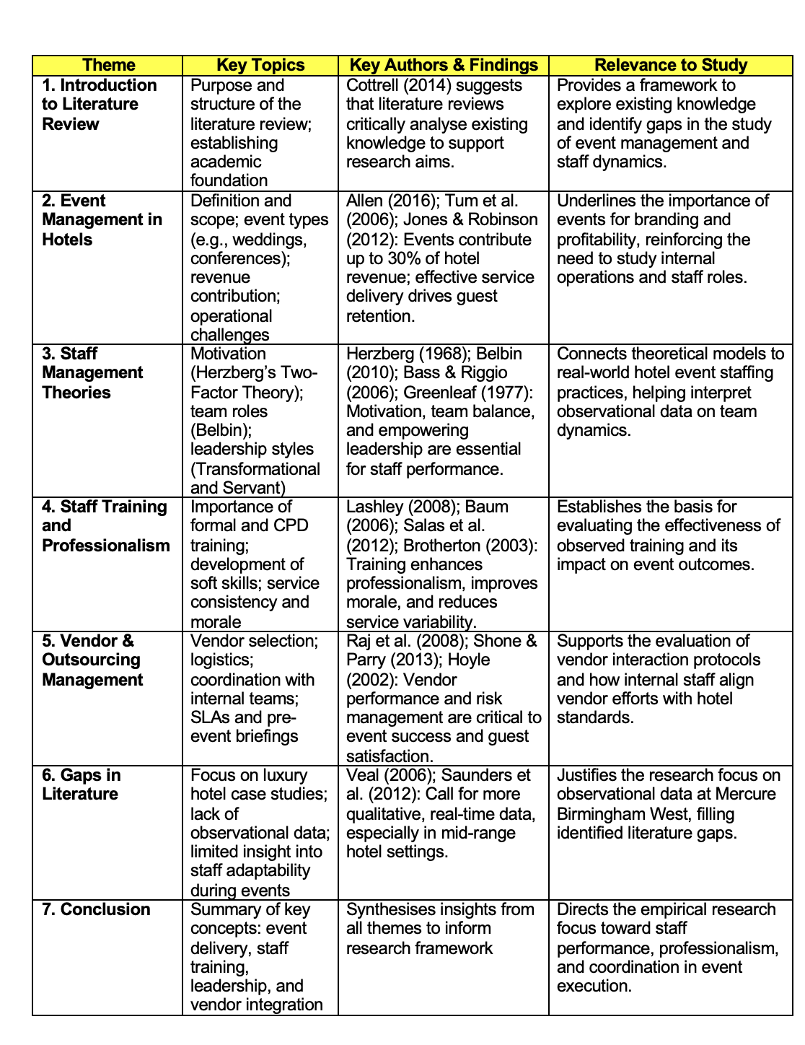
Literature Review Summary Table Self-created)
Professionalism in the hotel personnel goes beyond simply technical skill; it also includes the capacity to provide service with morality, empathy, and good communication. Managing guest contacts at events—often fast-paced and stressful events—requires soft skills that are very essential (Gursoy et al., 2017). Emphasising emotional intelligence, training courses enable employees to better meet visitor demands, resolve problems peacefully, and provide individualised service. Developing unforgettable events that improve client satisfaction and inspire repeat business depends on this human-centric approach (Mattila & Enz, 2002). The reputation of the hotel depends directly on staff professionalism, which also is rather important for distinguishing service quality in a highly competitive marketplace.

Maintaining high standards in event performance also depends critically on Continuous Professional Development (CPD). Especially when hospitality changes with new technology and customer standards, CPD guarantees that staff members' abilities stay current (Baum, 2006). By stressing best practices and bringing ideas, regular conferences, refresher courses, and certification programs help to minimise variations in service. Moreover, by offering clear paths for personal development and professional advancement, CPD helps staff motivation and morale (Woods, 2013). Well-trained and motivated employees are more involved and dedicated, which enhances collaboration and results of the whole event.

Therefore, two key tactics for hotels to improve operational efficiency and client experiences during events are funding staff training and encouraging professionalism. Excellent training helps control unanticipated difficulties, lowers service variance, and strengthens a strong service culture in line with the brand values of the hotel. As such, this expenditure not only enhances the success of the event right now but also supports long-term profitability and client loyalty.

Continuous Professional Development
Maintaining high levels of service depends also on ongoing professional development (CPD). Workshops, refresher courses, and certification programs among CPD activities guarantee staff members remain current with the most recent industry practices and technology developments (Salas et al., 2012). Furthermore, CPD helps employees to be motivated and to advance their careers, thereby improving work satisfaction and lowering turnover rates. Staff members who feel appreciated and competent participate better, which enhances team performance and results of events.
To ensure constant, high-quality service during events, hotels must therefore make investments in thorough training and support professionalism. These initiatives help to lower variation in service quality and equip employees to properly handle problems, hence raising visitor happiness and company performance.

2.5. Vendor and Outsourcing Management in Events

Successful event planning relies mostly on efficient vendor and outsourcing management, especially in the hotel sector where visitor pleasure depends much on flawless coordination and excellent service delivery(Ogden, and McCorriston, 2007). The choice of suppliers according on clearly defined criteria including quality, dependability, and cost-effectiveness is one of the main features of this approach. Quality insures that the finished service or product satisfies hotel standards; dependability provides timely delivery and regular performance; and cost concerns help events remain below budget (Raj et al., 2008). Vendors that fall short of these criteria run the risk of harming the visitor experience, therefore affecting the reputation of a hotel and maybe influencing repeat business.
Coordinating internal hotel teams with suppliers is another basic feature. Ensuring that vendor services—such as food, décor, or audiovisual equipment—fit the logistical requirements and schedules of the event depends on this teamwork. Walk-throughs and pre-event briefings are great instruments to help all the stakeholders to have common understanding. Emphasising the value of this kind of cooperative efforts, Shone and Parry (2013) contend that outsourcing should be seen as a strategic alliance instead of a transactional arrangement.

Vendor involvement also depends much on risk management, especially for big or well-known events. Delays in delivery, poor performance, or team misunderstanding might all pose potential risks. Clearly defined Service Level Agreements (SLAs) that specify the extent of service, expectations, consequences for non-compliance, and lines of contact help to reduce them. Hoyle (2002) emphasises that for managing responsibility and matching outside contributions with the goals of the event, thorough contracts and SLAs are very necessary.

Strategic outsourcing improves event efficiency ultimately only when it is backed by close vendor relationships, regular communication, and strict risk management. This guarantees that every component of the event—from logistics to food—works together to provide a flawless experience for attendees as well as planners.

2.6 Gaps in Existing Literature
The collection of current research on event management in the hotel sector reveals a clear inclination towards luxury, or high-end, hotel case studies. Many research centre on well-known sites with plenty of resources, therefore restricting the generalisability of results to mid-scale or cheap hotels (Getz, 2012). This results in a knowledge vacuum on how mid-range hotels, which account for a significant share of the hotel market, control staff dynamics and event operations under more limited circumstances.
The absence of real-time observational studies on event management strategies in these mid-scale hotels adds even another important disparity. Most studies mostly rely on surveys or retrospectives, which could not adequately depict the immediacy and intricacy of actual event planning (Mair & Jago, 2010). Direct observation helps one to better understand staff coordination, challenge adaptation, and vendor interaction during events. This leads to little understanding of the pragmatic reality frontline employees experience throughout event execution.
Moreover, in current research there is little integration of event operational data with actual personnel management systems. Although theoretical models exist on team dynamics and leadership, few research provide empirical data connecting these ideas to real-world staff conduct during events (Fried & Tregaskis, 2013). Furthermore, the research seldom addresses how front-line employees handle unanticipated difficulties such last-minute modifications, technological problems, or guest complaints—common in event environments and thus significantly affect general success.
With qualitative observational techniques used at a mid-range hotel—the Mercure Birmingham West Hotel—this study seeks to close these gaps. Focussing on live events, staff interactions, and vendor coordination will let the research provide novel, useful findings that could guide industry practice as well as academic theory.

2.7. Conclusion of Literature Review
All things considered, the literature validates that hotel event management is a complex process including strategic planning, competent personnel, and consistent vendor relationships. Useful perspectives to evaluate staff performance during events come from theories of motivation, leadership, and team dynamics.
Guest happiness depends on professionalism and training; operational success of events depends on vendor cooperation. A research vacuum exists, too, in mid-range hotel settings without observational data.
By means of real-time observation, this research adds to the field by investigating how staff management and vendor integration impact event performance, therefore providing useful information for hotel managers and staff members.

Chapter 3: Methodology
The research approach used in this study to probe event management strategies, staff dynamics, and vendor collaboration within a mid-scale hotel setting is described in this chapter. Emphasising a thorough qualitative investigation of live event situations, the approach reflects the research aims and questions. It addresses the study philosophy, methodology, strategy, data collecting methods, sample procedures, ethical issues, and constraints.

3.1 Research Philosophy
This study uses an interpretivist research philosophy, which is suitable for investigating the intricate, socially created reality of hotel event management. Recognising that reality is subjective and multifarious, interpretivism focusses on comprehending human conduct and interactions within their natural surroundings (Creswell, 2013). Interpretivism recognises the value of context, meaning, and participant viewpoints (Saunders, Lewis, & Thornhill, 2019) unlike positivist paradigms, which strive to measure events by objectivity and generalisability. An interpretivist perspective helps one to examine lived experiences in event management, where staff conduct, team dynamics, and spontaneous decision-making affect results.

3.2 Research Approach
Underlying this work is a qualitative method that gives rich, descriptive data first priority above numerical measurement. Examining difficult to measure processes, behaviours, and social interactions calls for qualitative approaches best suited for this (Denzin & Lincoln, 2018). This study uses real-time event setting observation to record real-time staff contacts, vendor collaboration, and reactions to operational difficulties. This method offers understanding of how event teams operate under duress, beyond of what polls or interviews by themselves may reveal (Silverman, 2016).

3.3 Research Strategy

Using a case study approach, the research mostly centres on the Mercure Birmingham West Hotel. Particularly in cases where the borders between the phenomenon and context are not well defined, case studies allow in-depth research of events within their natural setting (Yin, 2018). Choosing the mid-scale Mercure Birmingham West with a varied event schedule lets one investigate common issues with event management experienced by like hotels. To allow thorough observation of staff responsibilities, cooperation, and vendor coordination during active operations, the study focusses on one or two particular events.

3.4 Data Collection Methods

The study uses many data collecting techniques in order to get a thorough knowledge:
Participant and Non-Participant Observation: The main data collecting method is observation, which lets the researcher see interactions and behaviours in situ (Angrosino, 2007). Participant and non-participant observations While non-participant observation allows a more detached, objective view of the events, participation observation entails interacting with personnel throughout event planning and delivery to get insider views. Recording staff communication, collaboration, and problem-solving techniques, field notes help to preserve these records.
Event Documentation Review: Reviewing pertinent material such staff rotas, event schedules, vendor checklists, and briefing notes helps triangulation by verifying observational results and knowledge of organisational procedures (Robson & McCartan, 2016).
Existing database: Gathering secondary materials meant a methodical and orderly process to guarantee for the study relevance, trustworthiness, and comprehensiveness. At first, the main areas of inquiry were clearly event management, personnel dynamics, training, and hotel vendor coordination. This emphasis directed the choice of keywords such "hotel event management,," "staff training in hotel,," "vendor coordination in events,," and "hospitality operations."
Searching academic databases like Google Scholar, JSTOR, ScienceDirect, and university library portals turned up peer-reviewed journal articles, conference papers, and authoritative books released throughout the last ten to fifteen years. Sources providing empirical results, theoretical frameworks, or thorough reviews relevant to the study goals took first priority.
Furthermore, examined were industry papers from reputable companies such the International Hospitality Association, Event Industry Council, and hotel consulting companies to identify present trends, issues, and best practices in event management.
Before inclusion, every possible source was carefully evaluated in terms of relevancy, approach, and academic rigidity. Methodologies, arguments, results, and gaps pertinent to the study topics were highlighted as notes were methodically gathered.
To provide contextual information on the economic and operational environment of the hotel sector, lastly secondary data from government publications and statistics sources was also included. This multi-source method guaranteed a well-rounded secondary research basis free from imbalance.

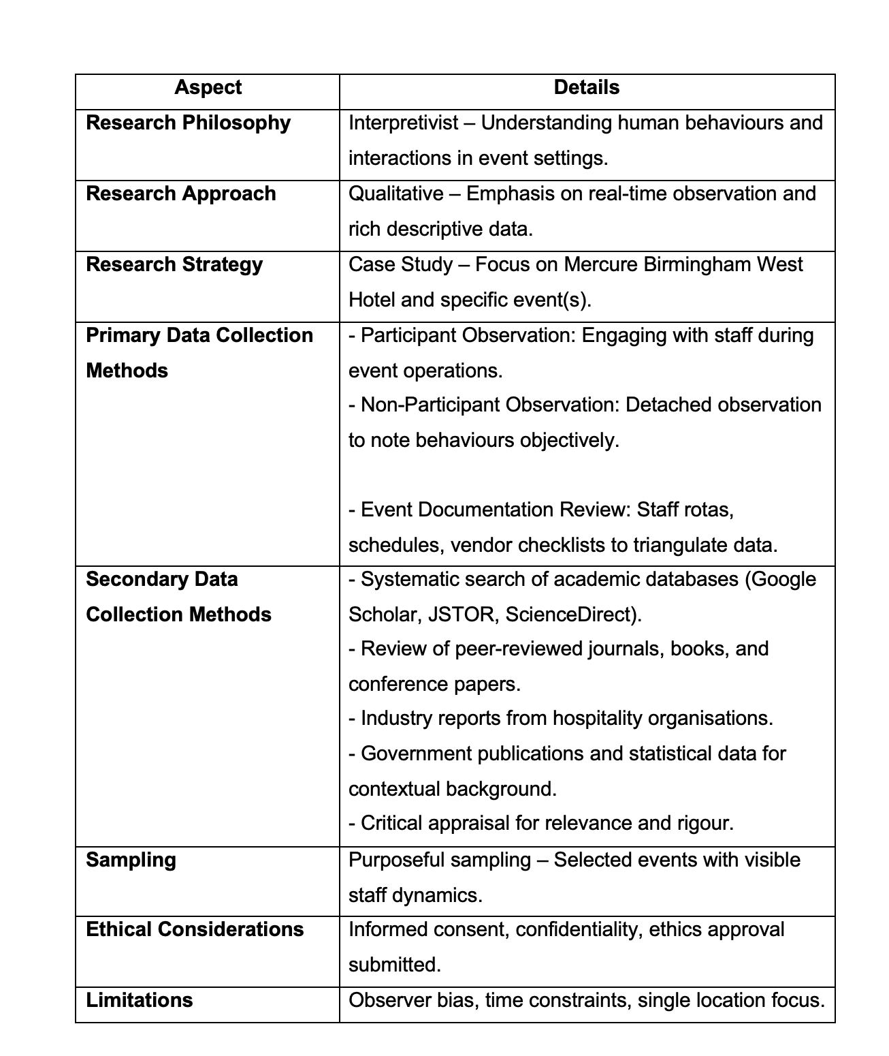
summary table incorporating both primary (observation, conversations, documentation) and secondary data collection methods

Sampling
The research chooses events where staff dynamics and vendor interactions are very obvious and vital for event success using deliberate sampling (Palinkas et al., 2015). Emphasising on complicated situations rather than generalisable samples, this non-probability sampling method guarantees rich and useful data collection. The selected activities enable investigation of many operating settings within the same hotel as they reflect diverse kinds of business meetings and private festivities.

3.5 Ethical Considerations

Maintaining ethical standards became crucial given the observational character of this study. Without doing any official interviews, the research consisted on non-intrusive, real-time observations of hotel workers during event operations. Informed permission was sought from hotel management before data collecting, therefore guaranteeing openness on the nature of the observations and the study goal. Direct staff interviews were not done, no personal information was asked for, and interactions consisted only of passive observation.

All observational notes were anonymised in order to preserve anonymity and no identifying information about the hotel personnel or event attendees was noted. With the observer keeping a polite distance and avoiding intervention in daily chores, the study was intended to be least disruptive. The study followed ethical standards for observational research, including those set by the British Sociological Association (BSA, 2017), therefore guaranteeing respect for every person seen in the natural surroundings.

3.6 Limitations

This research admits some constraints. First, observer bias might affect data collecting and interpretation as the presence of the researcher could change staff conduct or subjective interpretations might distort results (Maxwell, 2013). Reflexivity and triangulation using documentation were used to help to offset this. Second, time constraints restricted observation to a few chosen occurrences, hence maybe not fully reflecting the variety of event management techniques. Third, depending only on one hotel limits the generalisability of results beyond comparable mid-scale hotel environments (Flyvbjerg, 2006). Still, the breadth and contextual richness this targeted case study provides give insightful analysis relevant to like-minded hospitality settings.
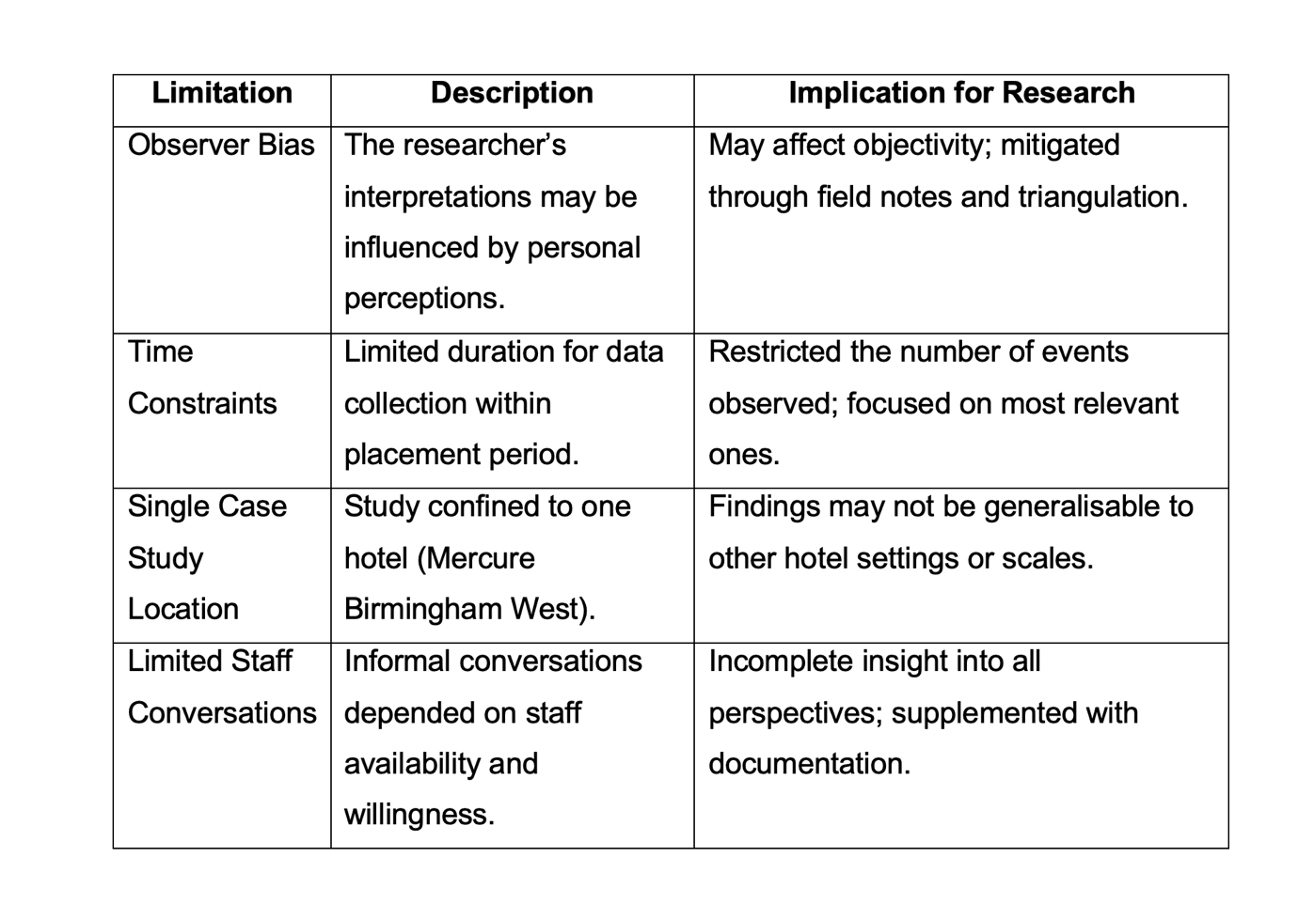Table 2: Research Limitations, Self-created

3.7 Summary
In essence, this chapter on summary gives a clear framework in line with the interpretivist philosophy, qualitative technique, and case study strategy to investigate event management at a mid-scale hotel. The study gathers comprehensive, contextual data on staff and vendor cooperation during live events using participant and non-participant observation, casual interactions, and document analysis. Tight ethical practices and deliberate sampling guarantee data quality and relevance. Though constrained by observer bias and breadth, this method offers a thorough awareness of the operational reality influencing event success in hotel environments.

Chapter 4: Findings and Discussion

4.1 Introduction

This research aims to investigate how staff training, professionalism, and vendor coordination affect the efficacy of event management within a mid-range hospitality environment—more especially, at the Mercure Birmingham West Hotel. With a focus on frontline staff performance and coordination especially, the study intends to provide pragmatic insights into the daily dynamics of event operations utilising a qualitative, observational research technique.

The main findings in connection to the aims of the research in this chapter are presented and discussed. Three basic topic areas define the study: staff training effectiveness, professionalism in service delivery, and vendor acquisition and coordination. Real-time data of many events held at the hotel naturally revealed these themes. The qualitative character of the data provided for a comprehensive, in-depth knowledge of staff interactions, behaviours, and procedures throughout event implementation.
Observations were methodically recorded as field notes and supplemented by quick informal staff feedback and evaluations of event records. This method enables a complete knowledge of how theoretical frameworks of training and service standards operate in a real hospitality setting (Veal, 2011; Yin, 2018). Each topic will be covered in detail in the next sections, which will integrate observational data with pertinent literature and assess how they affect general event success.

4.2 Theme 1: Staff Training Effectiveness

Training Practices Observed

Structured observation at the Mercure Birmingham West Hotel produced research showing a mix of formal and informal training techniques. Official training took mostly the form of pre-event briefings. Usually delivered by event managers or supervisors, these workshops included thorough health and safety guidelines, particular duty assignments, and consumer engagement techniques. Clear expectations and matching staff goals with the event objectives were made possible in great part by such briefings (Baum, 2008).

Apart from official methods, informal on-the-job training proved rather important, particularly for new or temporary employees. For instance, more seasoned colleagues regularly mentored new staff members in real time on table arrangement or guest engagement. This method connects with the idea of contextual learning, in which information is acquired by means of active involvement in work environments (Lave and Wenger, 1991).
Though there was diversity in the training delivery, irregularities were noted throughout many divisions and shifts. While some teams had little training, others had extensive briefings. This discrepancy emphasises the necessity of more consistent training methods for all hotel operations. Standardised training is essential, as Ladkin (2002) argues, in ensuring hotel industry service consistency.

In-Event Performance Indicators
Staff members' in-event performance offers tangible indicators of how well training turned into actual service delivery. Among the most obvious aspects was operational effectiveness. Teams that had attended thorough briefings and rehearsals showed exceptional precision and rapidity of event setup. For example, banquet arrangements requiring many layout adjustments were carried out quickly and with open communication, therefore reducing customer disruption. This supports Lashley's (2000) claim that operational excellence in hospitality results from good training.
Another important sign is communication. Staff members who received clear communication training—that is, those who used hand signals, radios, or brief spoken cues—were better at organising their work, therefore lowering delays and overlaps. Real-time information sent between the kitchen and front-of-house employees during one event stopped a service delay brought on by last-minute dietary adjustments. Such events show how training improves communication effectiveness, which is very vital in stressful hotel settings (Enz, 2004).
Furthermore, highlighted the need of training was the management of unanticipated problems, like guest complaints or rearranging of the seats. Employees who had participated in scenario-based training or role-playing activities during onboarding were seen answering with confidence and grace. Training that mimics real-world issues may greatly increase workers' problem-solving abilities and lower their stress reaction during busy times, claims Hinkin and Tracey (2010).

Good training also helped to raise visitor satisfaction. Guests clearly appreciated staff members who kept eye contact, spoke politely, and followed service procedures. This validates the results of Hemdi and Nasurdin (2006), who relate organisational reputation and customer happiness directly to training quality.

Gaps and Challenges in Training
Though the results were good, some issues connected to training were noted. One of the main gaps was the different onboarding procedures for casual or new employees. Many times, these people lacked clarity about their jobs and responsibilities, which caused delays and more reliance on top personnel. One incident that caught notice was the new employee not knowing how to manage wine service, therefore compromising the dining experience. This reflects the criticism of Nolan et al. (2010) that ad hoc training programs in hospitality may lack the tools needed to satisfy service requirements.
The survey also found a lack of ongoing professional development (CPD). Rarely did long-term workers get updates courses or updates on new technology and service standards. This stagnation might lower adaptation in busy event settings. As suggested by Airey and Tribe (2005), CPD is essential for preserving service quality in a sector defined by regular changes in customer expectations and operational processes.
Department-specific differences were also noted. Although front-of- house employees generally underwent customer service training, back-of- house teams lacked such possibilities. This mismatch could cause conflict and impede cross-functional cooperation. As Guerrier and Lockwood (2002) emphasise, effective event planning relies on the synergy among all operational departments; so, training should include these departments as well.
At last, a recurrent problem was the lack of post-event feedback sessions, which would have been a teaching tool. These debriefings support effective practices and point out areas needing work (Walsh and Taylor, 2007). Particularly for young or temporary personnel, their absence might lead to repeated mistakes and missed learning possibilities.

4.2 Theme 2: Maintaining Professionalism

Observed Professional Conduct
The impressions left by guests and the perceived quality of service delivery are much shaped by professional conduct. Observations at the Mercure Birmingham West Hotel repeatedly showed staff members following grooming standards and uniform requirements. A majority of employees showed consistent brand standards in their grooming and were seen wearing neat, well-ironed uniforms with obvious name badges. This focus on appearance helps to corroborate Lashley's (2008) perspective on how frequently visual and behavioural criteria define professionalism in hospitality.
Most staff members arrived on time for their shifts and pre-event briefings, so overall their timeliness was really good. Being on time improved team readiness by allowing better transitions between stages of planning and execution. Interactions with vendors as well as visitors revealed professional manners; staff members greeted guests politely, made eye contact, and demonstrated attention to guest requirements. These actions fit the standards of service culture, in which emotional labour is expected of the employees (Hochschild, 1983).
Moreover, employees shown professionalism by being calm and helpful regardless of busy periods. Their capacity to maintain polite conversations under operational demands supports the perspective that professionalism is about behaviour and dependability rather than just appearance (Worsfold, 1999). The results show that particularly in a high-contact service sector like hospitality, observable professionalism boosts brand reputation and visitor happiness.

Communication Styles and Challenges
Effective event management depends mostly on communication within the hotel staff and with external stakeholders like suppliers and visitors. Most team members, according to observations, communicated politely and directly—especially in relation to pre-event planning. Usually short, instructions were straightforward and critical information like food preferences or room arrangement modifications was communicated in real time. This effectiveness shows strong use of soft skills—especially clarity and attentive listening (Spowart, 2011).
Still, there were clearly differences in communication approaches. While some younger staff members struggled hesitation or abruptness in their interactions, senior staff members usually showed calm, controlled tones and inclusive words. One temporary staff member, for example, was seen answering tersely to a visitor inquiry because of lack of confidence, which clearly caused the guest great discomfort. This highlights Goleman's (1998) emotional intelligence theory, according to proper management of interpersonal dynamics in hotel environments depends on self-awareness and empathy.
In team interactions, sometimes there were communication failures especially in cases with unclear roles. For instance, two employees crossed duties because of a misunderstanding on vendor arrival management. These events highlight the need of tailored communication training and feedback systems (Nickson, 2013). Although communication was usually polite and deliberate, the weaknesses pointed out indicate a need for ongoing growth in soft skills.

Behaviour Under Pressure
The high-stress environment of event planning exposed important fresh perspectives on staff professionalism, especially in terms of adaptation, stress management, and cooperation. Last-minute changes in guest seating, time delays, and vendor arrival misalignments defined many events at the hotel. Staff conduct in such times varied depending on their teamwork and experience.
Experienced team members typically stepped up in high-stress situations to mentor others and cool things down gently. For example, one senior staff member allocated tasks to guarantee guest refreshments were delivered quickly, therefore deflecting attention from the technological error postponing the presentation start. This showed a useful implementation of transformational leadership, wherein leaders inspire and assist their staff to adjust to changes (Bass and Riggio, 2006).
On the other hand, younger or less experienced employees clearly showed fear under trying circumstances. In one instance, misunderstanding about procedure caused a young staff member to mishandle a guest complaint about food allergies, which escalated things. This aligns with Belbin's (2010) team role theory, which holds that, particularly under pressure, different people work better in various roles—such as coordinators, implementers, or completer-finishers.
One important quality seen in employees who kept their composure even when plans fell apart was resilience. Their ability to react fast and reassure suppliers and attendees was really crucial. Resilience in hospitality is connected, as Baum (2015) argues, to constant exposure to uncertain situations and reflective learning from prior events.
Through simulations and scenario-based training, hotels may help employees to acquire emotional preparation therefore supporting good reactions to pressure (Lucas and Deery, 2004). Furthermore fostering adaptable attitudes is encouraging a feedback culture and supporting leadership. In the end, under pressure staff professionalism not only protects visitor happiness but also helps to guarantee perfect event execution and team morale.

4.3 Theme 3: Vendor Acquisition and Coordination

Vendor Arrival and Preparation Process
Smooth event delivery in hotel environments depends on effective vendor integration. Observations at Mercure Birmingham West Hotel showed a generally ordered but sometimes unstable approach to vendor check-ins and preparation. Usually arriving through assigned service entrances, vendors were met by front-line workers or duty supervisors. Before pointing vendor credentials and event information to the suitable event venue, staff will verify them.
In general, vendors had quick access to setup sites and unloading bays. But several suppliers indicated gaps in early communication when they first voiced uncertainty about room arrangement or event time. As Allen et al. (2011) stress pre-arrival briefings in their event management system, this reflects the need of pre-event cooperation to minimise operational problems.
Staff contacts with vendors were mostly professional; specific staff members helped with setup or spoke with the event planner for clarification. Mostly completed within the allocated prep time, was equipment placement—such as AV systems or food trays. The minor delays reported were from overlapping vendor setup brought on by uncertain time management . Particularly in multi-vendor events, this underscores the requirement of better logistical planning and resource allocation to guarantee efficient delivery and lower last-minute strain on event workers.

Role of Staff in Vendor Management
At the hotel, vendor management combined front-of-house personnel with event planners and shift managers. Usually acting as vendor liaisons, event planners provided direction and clarification of objectives. These employees were very important in making certain suppliers followed hotel policies, including those related to safety standards and keeping service times. Their participation meets Tum et al. 2006, emphasis on the main channel between internal teams and external teams.
Staff members actively informed vendor access times directed them to staging spaces, and made sure they had all required tools—such as serving carts or power points—in well-executed events. These group events highlighted the advantages of close ties and common goals. For a wedding, for instance, personnel made sure the florist had additional room for big arrangements and provided trolleys for mobility, thereby stressing anticipatory service conduct.
Not every interaction, however, was smooth. Sometimes lack of real-time coordination or absence of assigned personnel kept vendors waiting for access. These delays caused little disturbances and rush preparations. Such gaps reflect what Ladkin (2011) describes as "informal vendor management," in which uneven interaction with suppliers causes operational inefficiencies.
Furthermore, the employees' understanding of vendor duties and readiness varied. Senior staff members successfully controlled expectations, but sometimes younger team members lacked clarity, which resulted in communication overlays. This difference emphasises the need of focused training in third-party involvement and service-level alignment (Robinson et al., 2012). The findings imply that enabling employees with vendor-specific procedures will help to provide a more consistent experience for both sides.

Communication and Standards Alignment
A key element of effective vendor cooperation is making sure beyond service providers follow operating guidelines of the hotel. Notes taken at the Mercure Birmingham West Hotel revealed that throughout event preparation and implementation, this alignment often rested on good communication. Vendors at high-performance events knew hotel restrictions like setup times, dress requirements, and safety compliance. These events supported Bowdin et al. (2012) paradigm for integrated event logistics by proving great upstream communication and shared responsibility.
When expectations were not precisely stated ahead of time, however, suppliers worked with presumptions that led to non-compliance or variations from intended quality. For example, one caterer showed up with inappropriate equipment sizes because he was unclear about area limitations. These events draw attention to the effects of mismatched goals and inadequate communication loops as Shone and Parry (2013) have explored in their study of event breakdown risks.
Moreover, worker experience and degree of motivation affected the way hotel staff members spoke with suppliers. Herzberg's Two- Factor Theory (1959) offers a helpful prism here: employees who were more driven and involved tended to help to create better vendor experiences. Staff members who proactively addressed problems or helped without being asked clearly displayed motivators like praise and accomplishment.
On the other hand, employees without motivate or unclear positions showed little effort, which frustrated merchants. This result supports Getz's (2012) dispute that team excitement and stakeholder alignment equally contribute to the quality of services provided at events than merely preparation. Thus, by means of feedback and responsibility, strengthening team commitment will help to greatly enhance vendor coordination results.

Discussion and Critical Evaluation
The observational results of this research provide a complex perspective on how theoretical frameworks show themselves in real hotel event operations. Although many of the procedures used at Mercure Birmingham West Hotel expressed accepted concepts in training, professionalism, and coordination, numerous differences between theory and reality surfaced, therefore stressing important areas for development.
Practices in staff training fit only partly the body of knowledge on Continuing Professional Development (CPD). As advised by Garavan et al. (2000), CPD requires systematic, continuous learning opportunities catered to changing responsibilities of workers. On observations, nevertheless, it was clear that formal instruction focused only on initial orientations or pre-event briefings and was limited in terms of ongoing upskill development. While some senior staff members showed confidence and skill—probably from informal learning or past experience—newer staff members were unsure of their roles. This difference supports Kolb's (1984) experiential learning theory, which holds that while learning by doing is valuable, it must be accompanied with reflection and reinforcement for best impact.

Especially among top team members, the professionalism shown under demanding circumstances reflected many aspects of transformative leadership. The Bass and Riggio (2006) model emphasises the need of inspiring motivate and individualized consideration in improving team performance. Leaders who remained calm and gave clear direction were very helpful in preserving morale and ensuring smooth operations in difficult circumstances such vendor delays or last-minute event adjustments. But inconsistent leadership styles among middle-tier employees revealed a discrepancy in the consistent implementation of these values, implying the need of leadership development programs.

One of the most important variables determining event success turned out to be communication. Effective, timely communication guaranteed staff and vendor alignment, reduced confusion, and helped to enable real-time problem-solving. This aligns with Argenti's (2007) perspective that operational excellence and stakeholder satisfaction depend on efficient internal communication as fundamental basis. On the other hand, poor coordination mechanisms underlined the need of great significance when communication broke down as it resulted in inefficiencies, repeated tasks, and delayed installations.

Another key element was vendor agreement with hotel standards. Although the literature generally assumes standard operating procedures (SOPs) are consistently understood (Tum et al., 2006), investigations revealed diversity in how they were perceived and implemented. While some suppliers were left unsure, others got thorough direction. This discrepancy implies that pre-event cooperation along with standardising of vendor interaction procedures is very essential.
Subsequently, feedback on staff morale and service culture underlined the unstated importance of peer learning and inspiration. Teams that were involved and encouraging had quite different results. As Huczynski and Buchanan (2013) contend, team dynamics and informal norms significantly affect organisational behavior—qualities that need more management focus in hotel environments.

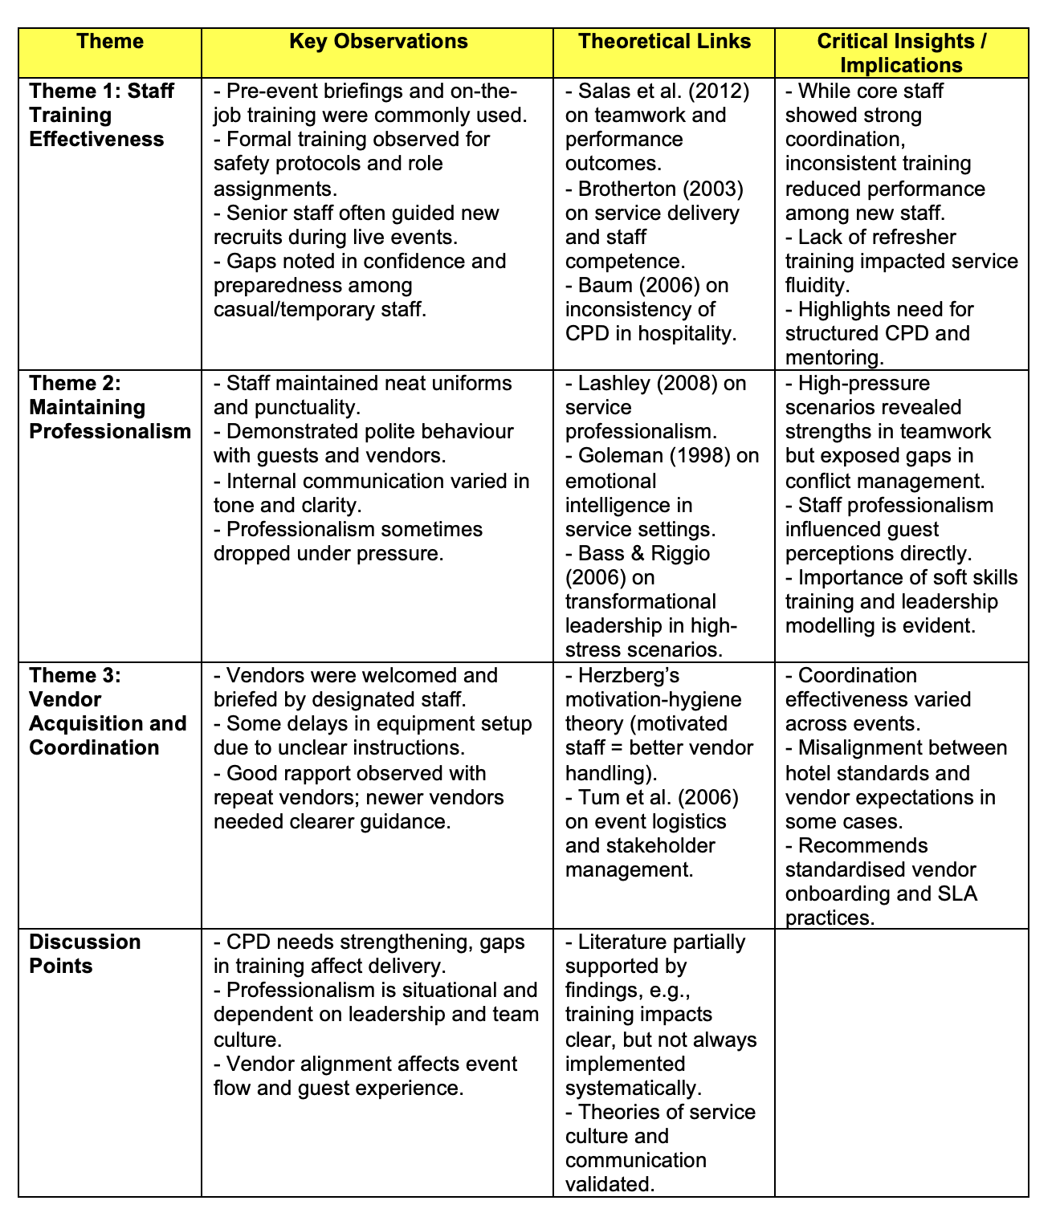
Summary table for Findings and Discussion (self-created )

Conclusion for Chapter 4

Three important themes—staff training effectiveness, preserving professionalism, and vendor procurement and coordination—have been discussed in this chapter. Observations showed that while pre-event briefings and formal training help staff members be ready, there are still gaps especially for new or temporary staff members. Though stressful conditions exposed variety in leadership and adaptation, professionalism was often maintained through punctuality, grooming, and efficient communication. Vendor coordination had uneven outcomes; some suppliers were clearly incorporated into hotel operations while others received inconsistent direction and communication. These results together cover the goals of the research by showing how staff performance is affected by training; how professionalism effects guest and vendor relations; and how coordination determines the success of events. The revelations highlight the need of constant growth, good leadership, and effective communication. Based on these results, Chapter 5 will provide thorough conclusions and practical suggestions for improving operational effectiveness and event staff management at the Mercure Birmingham West Hotel.

Chapter 5: Conclusions and Recommendations

5.1 Conclusion

The dynamics of staff management within the framework of event operations at the Mercure Birmingham West Hotel have been under close inspection in this study. The research concentrated especially on three main objectives: assessing vendor acquisition and coordination, maintaining professionalism, and staff training effectiveness. Document analysis and qualitative observational techniques revealed some really important results.

The findings on staff training effectiveness exposed a mix of formal and on-the-job training approaches that supported operational preparedness and service delivery. Pre-event briefings and job allocations improved team cooperation; yet, new and temporary workers clearly showed uncertainty in their duties. This is consistent with other studies pointing up difficulties in hotel training uniformity (Baum, 2006; Nickson, 2013). There seemed to be little Continuous Professional Development (CPD) chances, which might affect long-term skill development and confidence (Salas et al., 2012). The study emphasises the important role organised training programs play in maintaining staff morale and service quality.
Staff members typically maintained professionalism, shown by respect of dress standards, timeliness, and respectful guest interactions, therefore validating Lashley's (2008) argument that professionalism is very essential for brand reputation in hospitality. Stress-inducing situations, however, exposed different degrees of emotional intelligence and resilience, which fit Goleman's (1998) view on the use of soft skills in service professions. Traits of transformational leadership surfaced in challenging situations, inspiring team members and solving problems (Bass & Riggio, 2006). Still, some poor communication and inconsistent behaviour point to opportunity for improvement in interpersonal skills.
Coordination and acquisition of vendors made good communication and defined responsibilities even more important. Although occasional misunderstanding caused operational friction, staff appointed as vendor liaisons were very important in matching vendor activity with hotel standards. Emphasising the need of staff motivation to assist external stakeholders and maintain service quality, Herzberg's (1968) motivation-hygiene theory is reflected in this result The study supports Tum, Norton, and Wright's (2006) approach, which emphasises that smooth event logistics need coordinated staff-vendor cooperation.
These results taken together show the complicated interaction of personnel competencies, professionalism, and vendor management in determining event performance. The research adds to the body of knowledge by offering an advanced understanding of staff dynamics in a mid-scale hotel environment—an area often disregarded in favour of large-scale or luxury settings (Veal, 2006; Saunders, Lewis, & Thornhill, 2012). To maximise event delivery and guest pleasure, practical insights underline the need of constant growth, flexible leadership, and strong lines of communication.

5.2 Recommendations

The results provide numerous practical suggestions to improve staff management and event operations at Mercure Birmingham West Hotel and comparable mid-scale hospitality environments.

1. Formalised and Ongoing Staff Training
Create and start a thorough training program combining on-the-job learning with formal classroom education. Orienting new and temporary employees through organised induction programs should take front stage in terms of addressing event procedures, position clarity, guest service requirements, Integration of Continuous Professional Development (CPD) opportunities—which include refresher courses and skill development seminars—allows one to maintain high service standards and increase confidence by means of skill enhancement workshops (Salas et al., 2012; Nickson, 2013). Furthermore, enabling flexible training access is the use of blended learning strategies incorporating e-learning modules.

2. Clear Protocols for Vendor Integration
Create standard operating procedures (SOPs) especially for coordination and procurement of vendors. To help to reduce misconceptions, they should include staff roles for vendor contact, check-in procedures, and communication channels. Frequent vendor meetings before events help to match expectations and support hotel standards (Tum et al., 2006; Getz, 2012). Vendor management techniques should be included into staff training to support group projects.

3. Mentoring and Performance Reviews to Maintain Professionalism
Establish a mentoring system wherein more recent recruits are matched with experienced staff members to develop emotional intelligence and professionalism. This social support may improve adaptation under pressure and inspire persistent commitment to behavioural standards (Lashley, 2008; Goleman, 1998). Periodic performance evaluations emphasising communication, appearance, timeliness, and customer service may also serve to highlight areas for development and recognise success, therefore strengthening a good service culture (Baum, 2006).

4. Enhance Communication Skills Training
Combine focused courses on conflict resolution, active listening, and successful communication. Under time restrictions, these soft skills are essential for controlling visitor contacts and organising internal teams and suppliers (Goleman, 1998; Brotherton, 2003). Staff may be ready for real-world difficulties by means of role-playing activities and scenario-based learning.

5.3 Limitations

This research acknowledges various limits that restrict the generalisability of results even with the insightful analysis obtained.
First, there were only one mid-scale hotel, Mercure Birmingham West, and few event venues for data collecting. This limits the relevance of results for different kinds of hotels or different geographical areas. Though rich in detail, the qualitative, observational approach is subject to observer bias and lacks the quantitative accuracy that may be gained by bigger-scale surveys or experimental designs (Veal, 2006; Saunders, Lewis, & Thornhill, 2012).

Furthermore, lacking in the research were formal interviews and thorough vendor viewpoints, which would have enhanced knowledge of coordination difficulties and motives. At last, time frame limits prevented longitudinal monitoring, therefore restricting evaluation of training effect over extended periods.

5.4 Recommendation for Future Research

By using a larger and more varied study approach, future studies might overcome these constraints.

1. Cross-Hotel Comparative Studies
Comparative studies that extend many hotels in several sectors (cheap, mid-scale, luxury) and geographical areas will provide more generalisable results on staff management techniques and event operations. Such research might point to contextual elements affecting effectiveness as well as optimal practices (Baum, 2006; Nickson, 2013).

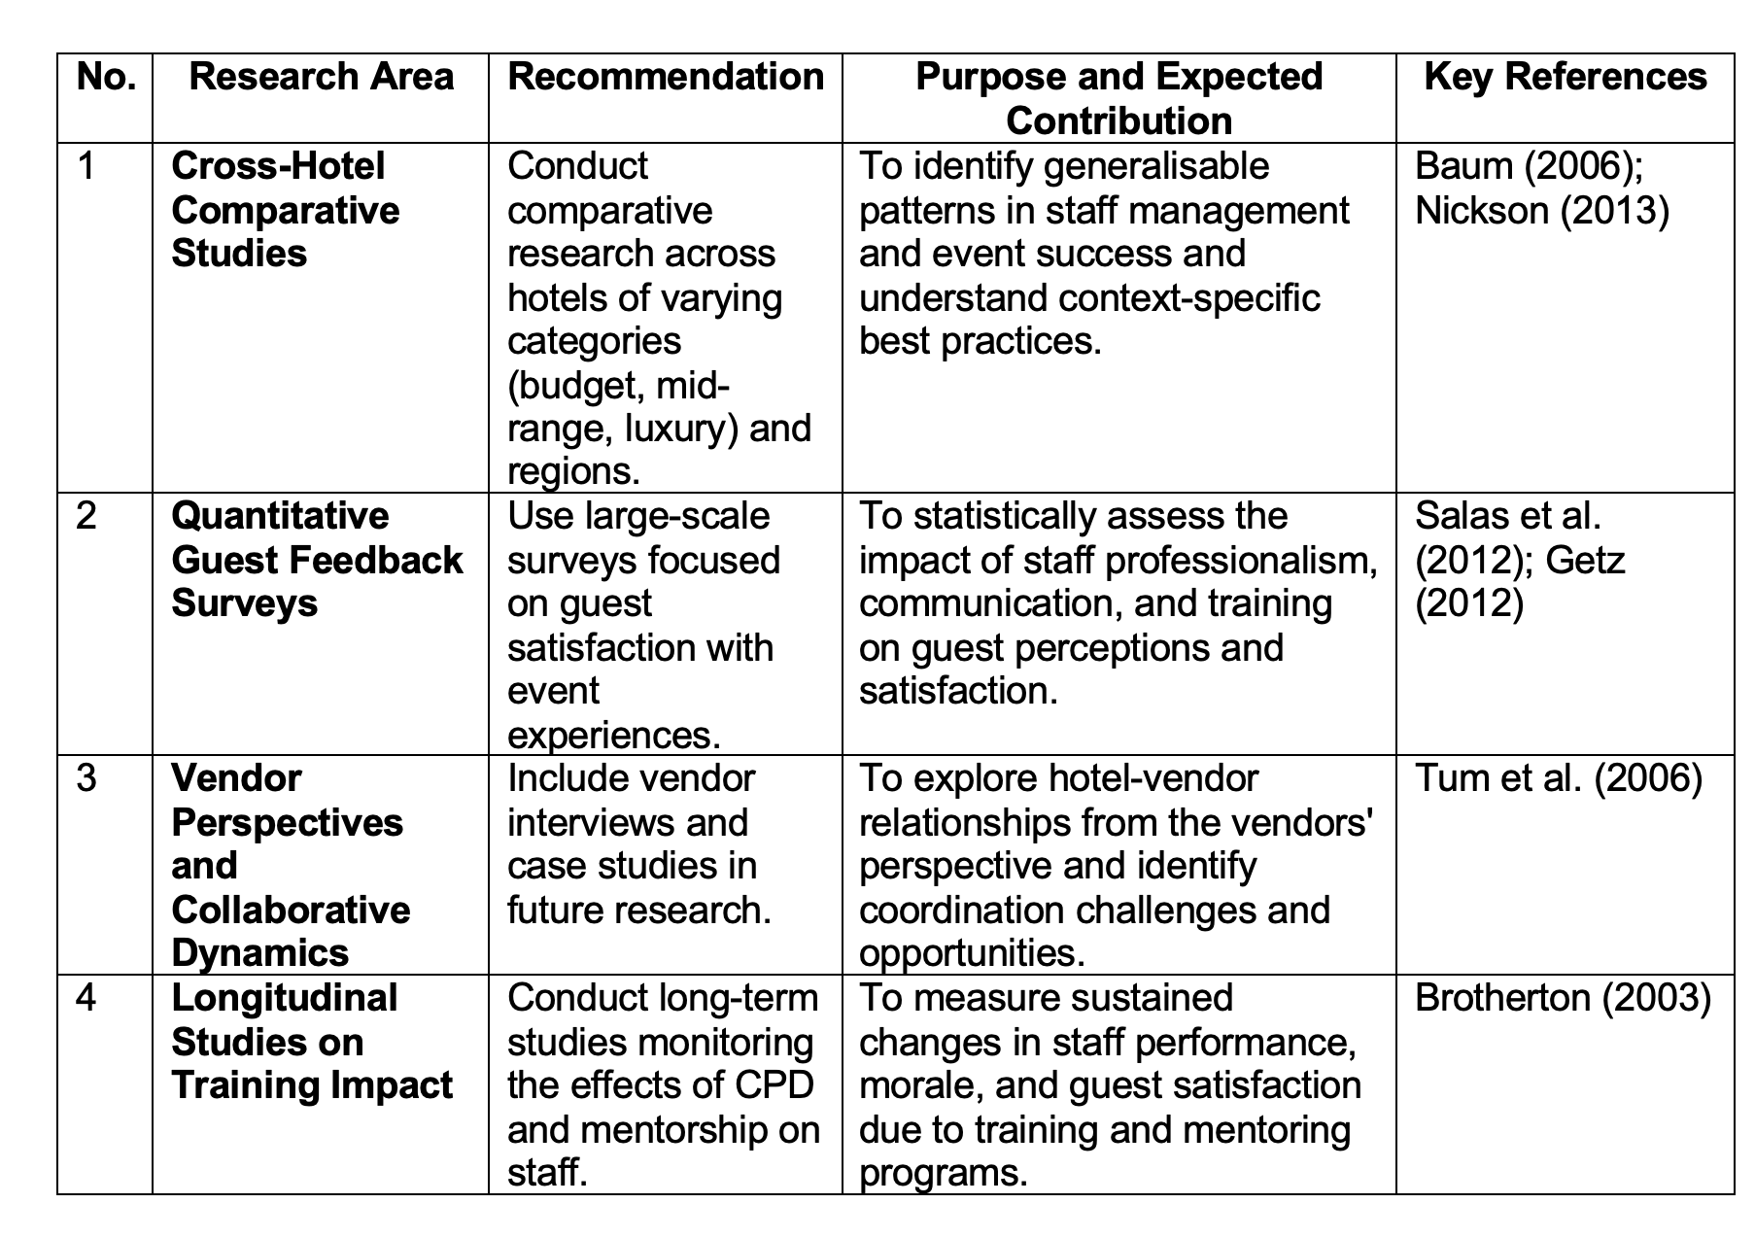

Table: Recommendations for Future Research (self-created)
2. Quantitative Surveys on Guest Feedback Related to Event Experiences
Large-scale visitor satisfaction surveys centred on event experiences allow one to measure how staff professionalism and performance affect client impressions. This method would provide statistical support for training and management initiatives as well as qualitative insights (Salas et al., 2012; Getz, 2012).
3. Vendor Perspectives and Collaborative Dynamics
Case studies and vendor interviews might be included into future studies to investigate the success of hotel-vendor relationships from both sides. Knowing vendor motives, difficulties, and satisfaction can help to guide more cohesive coordination systems (Tum et al., 2006).

4. Longitudinal Studies on Training Impact
Deeper understanding of sustainable staff development techniques would come from long-term research monitoring the impact of CPD and mentorship programs on staff competency, morale, and visitor satisfaction over time (Brotherton, 2003).

References

- Allen, J., 2010. The business of event planning: behind-the-scenes secrets of successful special events. John Wiley & Sons.
- Angrosino, M.V. (2007). Doing Ethnographic and Observational Research. Sage. Available via https://books.google.co.uk/books?hl=en&lr=&id=XEDKGQencScC&oi=fnd&pg=PR3&dq=1.%09Angrosino,+M.V.+(2007).+Doing+Ethnographic+and+Observational+Research.+Sage.&ots=yM3eS65G6C&sig=a_k5sVCaUouaMmb-wjFwcPXbcDo&redir_esc=y#v=onepage&q=1.%09Angrosino%2C%20M.V.%20(2007).%20Doing%20Ethnographic%20and%20Observational%20Research.%20Sage.&f=falsev (Accessed on 21 May 2025).
- Argenti, P.A. (2007) Corporate Communication. 4th edn. New York: McGraw-Hill.
- Bass, B. M., & Riggio, R. E. (2006). Transformational Leadership. Psychology Press.
- Bass, B.M. and Riggio, R.E. (2006) Transformational Leadership. 2nd edn. Mahwah, NJ: Lawrence Erlbaum Associates.
- Baum, T. (2006). Human Resource Management for Tourism, Hospitality and Leisure: An International Perspective. Thomson Learning.
- Baum, T. (2015) Human Resource Management for Tourism, Hospitality and Leisure: An International Perspective. London: Thomson Learning.
- Belbin, R.M. (2010) Team Roles at Work. 2nd edn. Oxford: Butterworth-Heinemann.
- British Sociological Association (BSA) (2017). Statement of Ethical Practice. BSA.
- Brotherton, B. (2003). The International Hospitality Industry: Structure, Characteristics and Issues. Butterworth-Heinemann.
- Brunt, P., Semley, N. and Horner, S., 2017. Research methods in tourism, hospitality and events management.
- Bryman, A. (2008) Social Research Methods. 2nd ed. Oxford: Oxford University Press.
- Bryman, A. (2008). Social Research Methods. Oxford: Oxford University Press.
- Collis, J. and Hussey, R. (2014) Business Research: A Practical Guide for Undergraduate and Post Graduate Students. London: Palgrave.
- Cottrell, S. (2011) Critical Thinking Skills: Developing Effective Analysis and Argument. Palgrave Study Guides. Basingstoke: Palgrave Macmillan.
- Cottrell, S. (2014) Dissertations and Project Reports: A Step-by-Step Guide. Palgrave Macmillan.
- Creswell, J.W. (2013). Qualitative Inquiry and Research Design: Choosing Among Five Approaches. Sage.
- Denscombe, M. (2010) Ground Rules for Social Research: Guidelines for Good Practice. 2nd ed. Maidenhead: Open University Press.
- Denzin, N.K., & Lincoln, Y.S. (2018). The Sage Handbook of Qualitative Research. Sage.
- Diamantopoulos, A. and Schlegelmilch, B. B. (2002) Taking the Fear Out of Data Analysis. London: Dryden.
- Evans, N.G., 2024. Strategic management for tourism, hospitality and events. Routledge.
- Flyvbjerg, B. (2006). Five Misunderstandings About Case-Study Research. Qualitative Inquiry, 12(2), pp.219-245.
- Fried, J., & Tregaskis, O. (2013). Event Management: A Professional and Developmental Approach. Routledge.
- Garavan, T.N., Morley, M., Gunnigle, P. and Collins, E. (2000) ‘Human capital accumulation: the role of human resource development’, Journal of European Industrial Training, 24(2/3/4), pp. 48–68.
- Getz, D. (2007). Event Studies: Theory, Research and Policy for Planned Events. Butterworth-Heinemann.
- Getz, D. (2012). Event Studies: Theory, Research and Policy for Planned Events. Routledge.
- Goldblatt, J. (2013). Special Events: A New Generation and the Next Frontier. Wiley.
- Goleman, D. (1998) Working with Emotional Intelligence. New York: Bantam Books.
- Grbich, C. (2006) Qualitative Data Analysis. London: Sage Publications Ltd.
- Greetham, B. (2014) How to Write Your Undergraduate Dissertation. Basingstoke: Palgrave Macmillan.
- Gursoy, D., Chi, C.G., Lu, L. & Nunkoo, R. (2017). Theories in hospitality and tourism. In: P. Robinson et al. (eds.) The Routledge Handbook of Tourism and Hospitality Education. Routledge.
- Herzberg, F. (1968). One more time: How do you motivate employees? Harvard Business Review.
- Hochschild, A.R. (1983) The Managed Heart: Commercialization of Human Feeling. Berkeley, CA: University of California Press.
- Huczynski, A. and Buchanan, D. (2013) Organizational Behaviour. 8th edn. Harlow: Pearson Education.
- Kashef, T.E., 2015. What is the value of event management education? The views of six industry practitioners. Event Management, 19(1), pp.1-13. Available via https://www.ingentaconnect.com/content/cog/em/2015/00000019/00000001/art00001 (Accessed on 1 June 2025).
- Kilkenny, S., 2011. The complete guide to successful event planning. Atlantic Publishing Company.
- Kolb, B.M., 2021. Event management for the tourism and hospitality industries. Routledge. Available via https://www.taylorfrancis.com/books/mono/10.4324/9781003127321/event-management-tourism-hospitality-industries-bonita-kolb (Accessed on 1 June 2025)
- Kolb, D.A. (1984) Experiential Learning: Experience as the Source of Learning and Development. Englewood Cliffs, NJ: Prentice Hall.
- Kvale, S., & Brinkmann, S. (2015). InterViews: Learning the Craft of Qualitative Research Interviewing. Sage.
- Lam, T. and Han, M.X., 2005. A study of outsourcing strategy: a case involving the hotel industry in Shanghai, China. International Journal of Hospitality Management, 24(1), pp.41-56.
- Lashley, C. (2008) ‘Studying hospitality: Insights from social sciences’, Scandinavian Journal of Hospitality and Tourism, 8(1), pp. 69–84.
- Lashley, C. (2008) Hospitality Retail Management: A Unit Manager's Guide. Routledge.
- Lashley, C. (2008). Hospitality Retail Management: A Unit Manager's Guide. Routledge.
- Liudmyla, B.A., Mouloudj, K., Rasulova, A.M. and Tkachuk, T.M., 2024. Viral Content in Event Management of Hospitality and Socio-Cultural Activities. In New Technologies in Virtual and Hybrid Events (pp. 228-257). IGI Global. Available via https://www.igi-global.com/chapter/viral-content-in-event-management-of-hospitality-and-socio-cultural-activities/353857 (Accessed on 6 June 2025).
- Lucas, R. and Deery, M. (2004) ‘Signalling the Hill: Graduate employment and hospitality management’, International Journal of Contemporary Hospitality Management, 16(4), pp. 207–212.
- Mair, J., & Jago, L. (2010). The Development of a Conceptual Model of Greening in the Business Events Tourism Sector. Journal of Sustainable Tourism, 18(1), pp.77-94.
- Marshall, C. (2015) Designing Qualitative Research. 6th ed. London: Sage.
- Mattila, A.S. & Enz, C.A. (2002). The role of emotions in service encounters. Journal of Service Research, 4(4), pp.268-277.
- Maxwell, J.A. (2013). Qualitative Research Design: An Interactive Approach. Sage.
- McGiven, Y. (2006) The Practice of Market and Social Research: An Introduction. Harlow: Prentice Hall.
- Nickson, D. (2013) Human Resource Management for the Hospitality and Tourism Industries. 2nd ed. London: Routledge.
- Northouse, P.G. (2018). Leadership: Theory and Practice. Sage Publications.
- Ogden, S.M. and McCorriston, E., 2007. How do supplier relationships contribute to success in conference and events management?. International Journal of Contemporary Hospitality Management, 19(4), pp.319-327.
- Orb, A., Eisenhauer, L., & Wynaden, D. (2001). Ethics in Qualitative Research. Journal of Nursing Scholarship, 33(1), pp.93-96.
- Palinkas, L.A., Horwitz, S.M., Green, C.A., Wisdom, J.P., Duan, N., & Hoagwood, K. (2015). Purposeful Sampling for Qualitative Data Collection and Analysis in Mixed Method Implementation Research. Administration and Policy in Mental Health and Mental Health Services Research, 42(5), pp.533-544.
- Pallant, J. (2010) SPSS Survival Manual. Buckingham: Oxford University Press.
- Parasuraman, A., Zeithaml, V.A. & Berry, L.L. (1988). SERVQUAL: A Multiple-Item Scale for Measuring Consumer Perceptions of Service Quality. Journal of Retailing, 64(1), pp.12–40.
- Pine, B.J. & Gilmore, J.H. (1998). The Experience Economy: Work is Theatre & Every Business a Stage. Harvard Business Review Press.
- Pizam, A. & Ellis, T. (1999). Managing Hospitality Human Resources. Wiley.
- Robbins, S.P. & Judge, T.A. (2019). Organizational Behavior. 18th ed. Pearson Education.
- Robson, C. (2016) Real World Research. 2nd ed. Oxford: Blackwell.
- Robson, C., & McCartan, K. (2016). Real World Research. Wiley.
- Salas, E., Tannenbaum, S. I., Kraiger, K., & Smith-Jentsch, K. A. (2012). The science of training and development in organizations: What matters in practice. Psychological Science in the Public Interest, 13(2), 74-101.
- Saunders, M., Lewis, P. & Thornhill, A. (2012). Research Methods for Business Students. Harlow: Pearson Education.
- Silverman, D. (2011) Qualitative Research Methods. 2nd ed. London: Sage.
- Silverman, D. (2016). Qualitative Research. Sage.
- Singh, A.J. and Kasavana, M.L., 2005. The impact of information technology on future management of lodging operations: A Delphi study to predict key technological events in 2007 and 2027. Tourism and Hospitality Research, 6(1), pp.24-37.
- Spears, L.C. (2010). Servant Leadership and Robert K. Greenleaf’s Legacy. In: D. van Dierendonck & K. Patterson, eds., Servant Leadership: Developments in Theory and Research. Palgrave Macmillan.
- Spowart, J. (2011) ‘Hospitality students’ competencies: Are they work ready?’, Journal of Human Resources in Hospitality & Tourism, 10(2), pp. 169–181.
- Tews, M.J., Michel, J.W. and Ellingson, J.E. (2013) ‘The impact of coworker support on training transfer’, Personnel Psychology, 66(3), pp. 723–755.
- Tum, J., Norton, P. and Wright, J.N. (2006) Management of Event Operations. Oxford: Butterworth-Heinemann.
- Veal, A. J. (2006) Research Methods for Leisure and Tourism. 3rd ed. Harlow: Financial Times/Prentice Hall.
- Veal, A. J. (2006). Research Methods for Leisure and Tourism: A Practical Guide. FT/Prentice Hall.
- West, M.A. (2012). Effective Teamwork: Practical Lessons from Organizational Research. 3rd ed. BPS Blackwell.
- Woods, R.H. (2013). Managing Hospitality Human Resources. 6th ed. Wiley.
- Yeoman, I. (2011). Festival and Event Management. Routledge.
- Yin, R. K. (2003) Case Study Research. 4th ed. London: Sage.
- Yin, R.K. (2018). Case Study Research and Applications: Design and Methods. Sage.

Appendix

Appendix A: Observation Notes Table

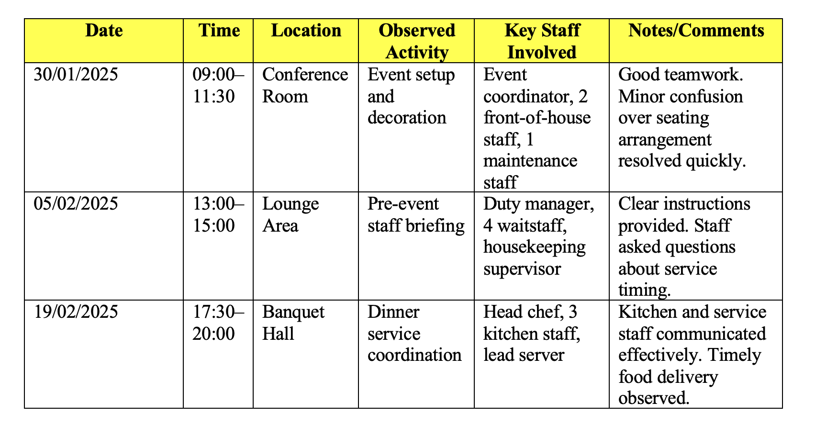

Appendix B: Sample Event Planning Document (Anonymised)

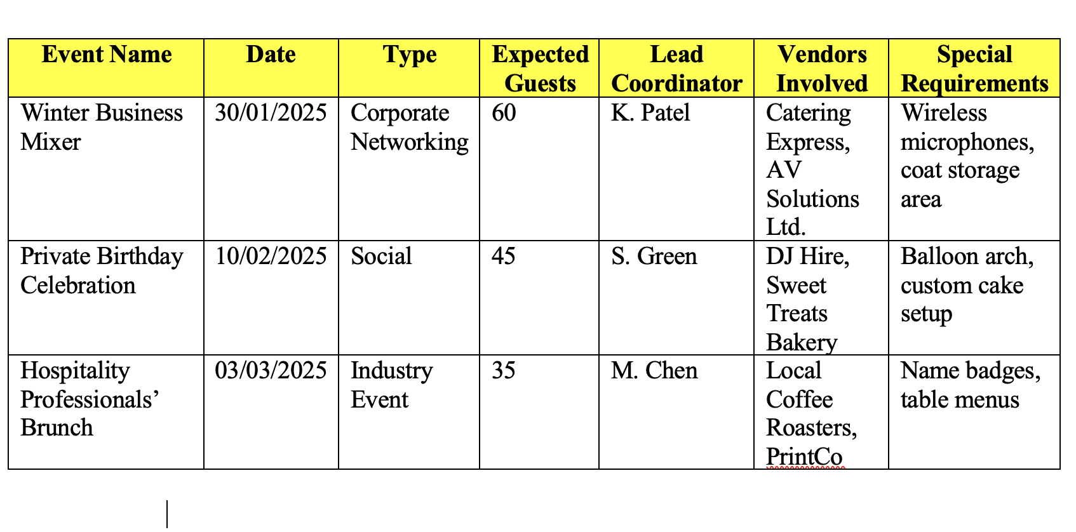

Appendix C: Ethics Form (Summary)

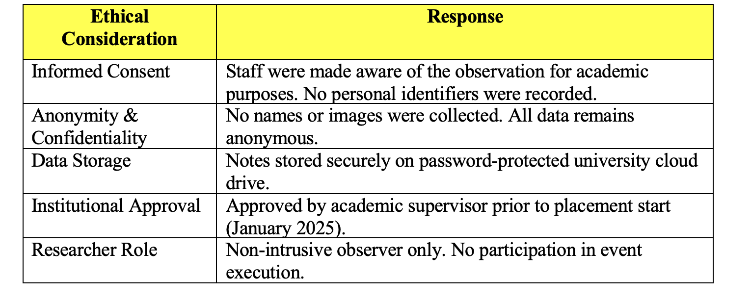

Appendix D: Supervisor Meeting Log



