
GSK Carbon Neutral laboratory analasys
Assignment 1

December 30, 2022
Liam evans
2110014
December 30, 2022
Liam evans
2110014

Contents
Introduction 2
Foundations 2
Excavation 3
Superstructure 3
Cladding 3
Structural Timber 4
Roof 5
Conclusion 6
References 7

Introduction
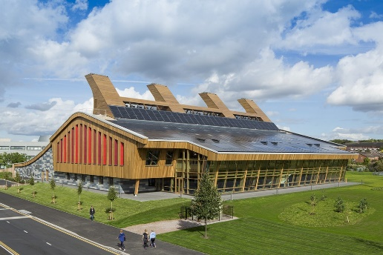
The GSK Carbon Neutral Laboratory is a modern building situated in Nottingham. It is no secret that the design and aesthetics of this building is very easy on the eye, but my aim in this document is to analyse the finer details of the building such as the foundation detail and analyse the choice of materials of the superstructure. Some of these being structural requirements but also looking at them from a sustainability and aesthetics standpoint.
Fig.1 GSK Carbon Neutral Laboratory (e-architect, 2017)

Foundations
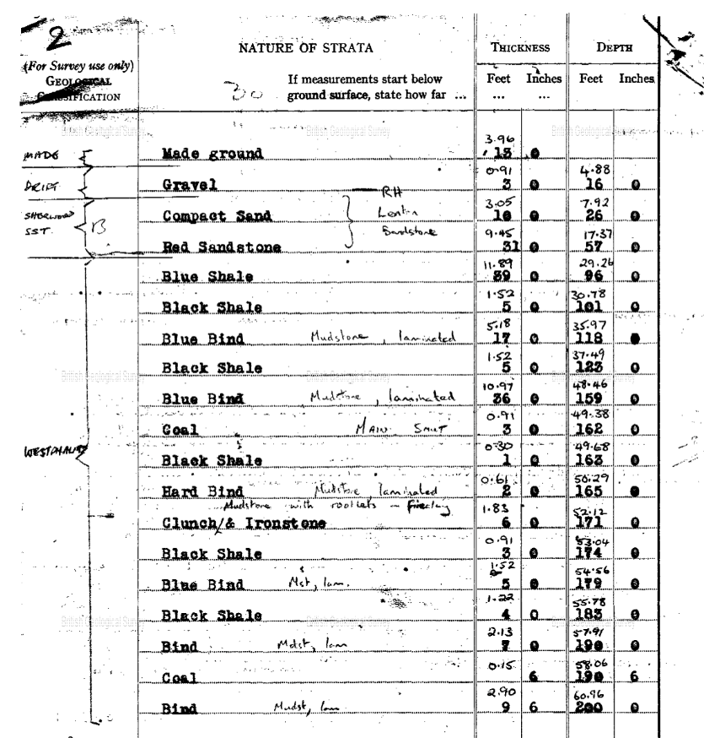
Getting the foundation detail correct is key to any building let alone a building on the scale of the GSK laboratory. There are many different factors that can affect the design of a foundation. This can be the ground condition or the load imposed on the foundation. By researching online, I was able to find information on the ground conditions in the local area to the laboratory. This information was available from a borehole log on BGS website (Britishgeologicalsurvey, 2022). The below table is a bore hole log just a few meters away from the site in question. In order to build a building such as the GSK laboratory you will need to form the foundation on solid strata. Judging by the table, solid ground is not found until 7.92 meters below ground. Having a solid base is key for the foundation to function correctly. With this information there are 2 possible foundation types available. Piled foundations or raft foundation. These are two very different types of foundation. Piling is effective in situations like this, where solid strata is not found until meters below ground level. Where long piles of concrete are driven into the ground, often with steel reinforcement in order for the load of the building to be transferred effectively to solid ground. These piles would be located around the perimeter and on load bearing walls internally, then with pile caps on top taking the load of the superstructure. The second foundation type is also effective in these scenarios. ‘Raft foundations are formed by reinforced concrete slabs of a uniform thickness (typically 150 mm to 300 mm) that cover a wide area, often the entire footprint of a building’ (designbuildings, 2015). In my opinion piled would be the better of the 2 methods. My reasoning for this is due to the size of the building the load may be too great for a raft foundation. The type of pile I would recommend would be bored piles with steel reinforcement. One of the main advantages of these piles is ‘piles of variable lengths can be extended through soft, compressible or swelling soils into suitable bearing materials’ (centrumpile, 2021). The space for the pile would be excavated by the chosen rig and then concrete would be poured to the desired depth.
Fig.2 Borehole log of area near where GSK Lab is built. (BGS.ac.uk, n.d)

Excavation
When on site ground specific ground investigation and for this, a borehole will need to be excavated across different parts of the site in order to determine how deep the piles will need to be. Finding solid ground for the bottom of the pile to lay is crucial to the structure of the building. As the site prior to commencement of works would not be flat hard standing the contour of the ground should be considered for the type of rig. An off road rig type would be best suited for this job. Assuming the building was built on a greenfield site the terrain may not be suitable for a highway rig. By considering the borehole log shown above, the depth of excavation will require to be at least 8 meters deep in order to perform this, an excavation rig will be necessary.

Superstructure
Taking a look at the envelope of the GSK Carbon Neutral Laboratory on the surface, it is clear that environmental and sustainability aspects have been considered greatly. ‘The laboratory is built from natural materials and energy required to run the laboratory is met by renewable sources such as solar power and sustainable biomass’ (Nottingham.ac.uk, 2017). Sustainability has become more and more important to all in the construction industry. There is a push in making building more self sufficient and using materials that are recyclable. ‘According to the Supply Chain Sustainability School, building and construction works in countries which are part of the Organisation for Economic Co-operation and Development (OECD) use: 25-40% of total energy, 30% of raw materials, 30-40% of global greenhouse gas emissions, 30-40% of solid waste generation (goconstruct.org, 2020). These statistics are good reason for using a sustainable material such as timber. Timber is widely known as a sustainable material due to the fact that is very renewable. Our ability to re plant trees we cut down for timber makes it a great material that we are able to use over and over.

Cladding
The cladding to a building is often the first thing you see and notice. In modern construction there are many different types of cladding ranging from bricks, concrete, plastic, timber and many more. Some of these materials are more suited to projects such as the GSK laboratory due to the sustainability of it and the aesthetic appeal it has. Materials such as bricks or concrete are far less sustainable than timber or UPVC and therefor would not have suited this project. These materials would also have been more intrusive to the surrounding areas than the chosen ones. The materials used to clad the external walls is timber and UPVC. The purpose of cladding to any building is to protect the internal parts of the building from the outside. The main threat being the weather. Plastic claddings are often preferred to timber due to the low maintenance required. Timber has the disadvantage of possibly rotting if not treated and maintained correctly. ‘PVC is 100% recyclable. Our panels can be taken to any plastic recycling facility (dumaplast, 2022). This ties in with the carbon neutral approach taken in constructing the building. ‘The building is designed to offset the carbon emissions from construction within 25 years of operation’ (ukgbc, n.d). The design and placements of the cladding is not intrusive, and shows willing of in keeping with its surroundings. With regards to the timber cladding, this is less commonly used in construction. Timber always carries a fire risk when used but this can be treated with a fire resistant paint or treatment. Timber of course is the most sustainable option and all ‘timber used for construction was either PEFC or FSC-certified’ (ukgbc, n.d). This means the timber used is sourced from ethical forests which promote ‘sustainable forest management’ (PEFC, 2023).
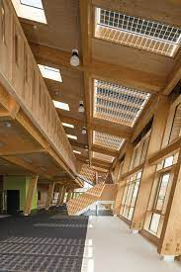
Internally the Glaxo Smith Kline laboratory is a very open plan building with large dramatic timbers. These timbers being exposed pushes the importance of sustainability to all to see inside the building. This design will have been intentional by the architect in order to encourage collaborative working and communication. This approach is becoming more and more common across working stations. ‘This can create buzz and enable better collaboration and create and environment which people can easily communicate’ (mindtools, 2019).

Structural Timber
As seen in the photo the external walls are comprised of large structural timbers. In order for a timber to be structurally safe, it often relies on thickness. This can be achieved by using thick single pieces of timber or with engineered timbers. In order to get the strength required for a building of this size they would require to be of great thickness. It is possible to achieve this strength with an engineered timber such as glulam beams. Glulam is seen as a natural alternative to structural steels or concrete. With the qualities it has it is often used when sustainability is a priority for the client. ‘Glulam is made by gluing together – under pressure and heat – laminates of timber that have been accurately planed. The resulting product is strong, stable and corrosion-proof with significant advantages over structural steel and concrete’ (glulambeams, n.d). The lengths of timber used for glulam are glued and pressed together with the grains running parallel to each other. Running numerous lengths of timber lengthwise until reached the desired thickness to take the load required. One of the main negatives with using single pieces of timber for this purpose is that it warps and gets misshaped by moisture. These timbers can often twist and this can be detrimental to its strength profile. Where glulam is superior is ‘its high strength and dimensional stability’ (ecohousemart, n.d). These beams are all pre fabricated off site and then are delivered to site ready for install. They are very easily adaptable and able to cater to any size that the client desires.
Fig.3 Photo of the GSK Lab internally. (building.com, n.d)
One of the main concerns with using timber in any form of construction is often it’s fire safety capabilities. A direct comparison of using glulam beams for such purpose would be to use steel beams instead. Without coating steel in a paint or treatment it does not tend to perform well when high heats are introduced. As surprising as it sounds, glulam does perform well in restraining fire compared to steel. This is due to steel tends to ‘distort and buckle in high temperatures’ (bucklandtimber, 2022). When designing the glulam beams for a project you are able to adjust the thickness to give the structure a certain time of fire resistance. This is possible as glulam has a standard char rate. ‘For glulam components, the char rate generally used for calculations in the United States and Canada is nominally 0.635 mm/min’ (timberlab, 2020). Due to the building analysed being a laboratory, it is worth looking how timber performs when exposed to chemicals and moisture. ‘In moisture and chemical-filled environments steel corrodes more quickly, whereas glulam lasts longer and is lower maintenance’ (bucklandtimber, 2022). By taking the characteristics that glulam possesses over steel beams it is clear that it was chosen for these reasons as well as it’s aesthetics and sustainability. To put into perspective the difference between using steel or timber from sustainability standpoint ‘in general 1 tonne of softwood substituted for concrete/steel leads to a CO2 reduction of 1.5 tonnes of CO2. (Gary Ramsay, 2022).

Roof
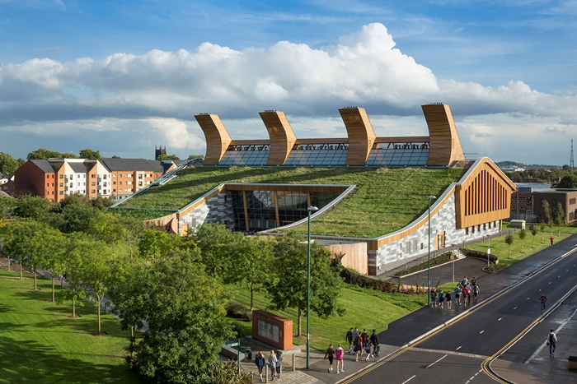
Traditional styled roofs usually consist of materials such as slates, concrete tiles or clay tiles. A method that has come to surface over recent times is a green roof, this is what is being displayed in fig.4. ‘Green roofs are roofs that are purposely fitted or cultivated with vegetation’ (designbuildings, 2013). This is not a method that is usually used on most residential type buildings, whereas they are more commonly seen on commercial buildings like the GSK Laboratory. With a clear message being conveyed by this building of sustainability, this type of roof is perfect for the cause. There are a lot of benefits to incorporating a roof design like this, some of these are ‘decreased surface water runoff, increased durability and increased local biodiversity’ (designbuildings, 2019). The way in which they reduce water runoff is the vegetation consumes the water which deters water away from the local water drainage systems, thus making it beneficial to the environment. Green roofs also have the ability to ‘reduce both heating and cooling loads in buildings’ (designbuildings, 2019). This would have been a big reason this type of roof was chosen. With the building promised to ‘offset the carbon emissions from construction within 25 years of operation’ (ukgbc, n.d) benefits like the green roof offers are hard to ignore. Alongside these benefits, it also makes the building blend in with its surroundings excellently. There are some modern buildings which are not in keeping with the surrounding area whereas this building is the opposite.
Fig.4 Photo of the laboratory’s roof (Architecture.com, 2018)
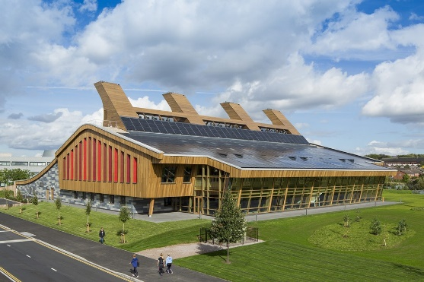
The south facing side of the roof is covered almost completely in photovoltaic cells. These cells fit seamlessly with the build and of course offer a big hand in ensuring the building is to be carbon neutral in its 25 year period. These are producing ‘An excess 40MWh of energy should be created by the building the first 25 years’ (ukgbc, n.d).

Conclusion
The Glaxo Smith Kline carbon neutral laboratory is brilliant piece of architecture and design. It stands out enough to notice the brilliance of it, but seamlessly marries in with its surroundings. The materials used for the build are a large reason for this. Using materials which are not in keeping with the area can ruin the façade of a project completely. It just so happens that these materials whilst are pleasing on the eye, also serve a big purpose in the message the laboratory is trying to convey of sustainability. With the build being the ‘first carbon neutral chemical research laboratory in the world’ (building.com, 2016) it certainly achieved this message.

References

Welch, A. (2017). GlaxoSmithKline Carbon Neutral Laboratory. [online] e-architect. Available at: https://www.e-architect.com/birmingham/glaxosmithkline-carbon-neutral-laboratories-for-sustainablechemistry. [Accessed 28 December 2022]
scans.bgs.ac.uk. (n.d.). Page 2 | Borehole SK53NW25 | Borehole Logs. [online] Available at: http://scans.bgs.ac.uk/sobi_scans/boreholes/225495/images/10429301.html. [Accessed 28 December 2022]
Designing Buildings Wiki (2015). Raft foundation - Designing Buildings Wiki. [online] Designingbuildings.co.uk. Available at: https://www.designingbuildings.co.uk/wiki/Raft_foundation. [Accessed 2 Jan 2023]
‌Centrum Pile Ltd. (2021). What are the differences between Bored Piles and Driven Piles? [online] Available at: https://www.centrumpile.co.uk/what-are-the-differences-between-bored-piles-and-driven-piles/#:~:text=The%20main%20advantages%20of%20bored [Accessed 9 Jan. 2023].
Ijeh2016-11-16T06:00:00+00:00, I. (n.d.). Carbon Neutral Laboratory: Out of the ashes. [online] Building. Available at: https://www.building.co.uk/focus/carbon-neutral-laboratory-out-of-the-ashes/5084942.article. [Accessed 4 Jan 2023]

‌Nottingham.ac.uk. (2017). The Carbon Neutral Laboratory - The University of Nottingham. [online] Available at: https://www.nottingham.ac.uk/chemistry/research/centre-for-sustainable-chemistry/the-carbon-neutral-laboratory.aspx. [Accessed 4 Jan 2023]
Go Construct Team (2020). Sustainability in construction. [online] Go Construct. Available at: https://www.goconstruct.org/why-choose-construction/whats-happening-in-construction/sustainability-in-construction-1/. [Accessed 5 Jan 2023]
UKGBC - UK Green Building Council. (n.d.). CASE STUDY: GSK Centre for Sustainable Chemistry. [online] Available at: https://www.ukgbc.org/solutions/case-study-gsk-centre-for-sustainable-chemistry/. [Accessed 5 Jan 2023]
‌Glulam Beams. (n.d.). Glulam Ltd | The UK Largest Supplier of Glulam Beams. [online] Available at: https://glulambeams.co.uk/. [Accessed 8 Jan 2023]
Anon, (n.d.). GLUE-LAMINATED TIMBER (GLT) BEAMS ARE STRONGER THAN STEEL | EcoHouseMart. [online] Available at: https://ecohousemart.com/glulam-beams-are-stronger-than-steel/ [Accessed 9 Jan. 2023]
‌Buckland Timber. (2022). Which is better, steel or glulam? [online] Available at: https://www.bucklandtimber.co.uk/blog/which-is-better-steel-or-glulam/. [Accessed 9 Jan 2023]
Hasburgh, L., Bourne, K. and Barber, D. (2020). DETERMINATION OF CHAR RATES FOR GLULAM COLUMNS EXPOSED TO A STANDARD FIRE FOR THREE HOURS. [online] Available at: https://timberlab.com/uploads/resources/TE0206-DETERMINATION-OF-CHAR-RATES-FOR-GLULAM-COLUMNS-EXPOSED-TO-A-STANDARD-FIRE-FOR-THREE-HOURS.pdf [Accessed 9 Jan 2023].
Designingbuildings.co.uk. (2013). Green roofs. [online] Available at: https://www.designingbuildings.co.uk/wiki/Green_roofs. [Accessed 9 Jan 2023]
Gary Ramsay(Summer 2022) ‘Timber The Optimum Solution’, Structural Timber [Accessed 9 Jan 2023]

