University of Wales Trinity Saint David

Course | Doctor of Business Administration
Module Name | Strategic Change and Organization
QAA Level | 8
Schedule Term | Two
Student Number | 1812265
Assignment Title | Morrison collaborated with Amazon for its supply arrangement
Date of Submission | 20th September, 2019

Abstract
Currently, many companies are going for collaboration in order to sustain and for long-term growth. This report has examined the collaboration between Morrison which is the UK’s fourth largest supermarket and US based online giant Amazon in 2016. This report found out that Morrisons entered into a supply agreement with logistic expert Amazon to expand and strengthen market position, secondly as it was experiencing decline like-for-like sales so to improve, and to achieve e-commerce opportunities as may costumers switch to do grocery shopping from stores to online platforms.

Table of Contents
Introduction 1
Morrisons collaboration with Amazon 2
Morrisons supply agreement with Ocado 2
Morrisons supply agreement with Amazon 3
Collaboration’s motives 4
To improve like-for-like sales 4
To gain market share 5
E-commerce Opportunities 6
Synergy 7
Analysis the change 7
Strategic fit/ alliances 7
Value chain Analysis 8
Porter’s five forces model 10
Conclusion 12
Reference 14
Appendices 17

Introduction
Rhodes et al (2003) suggested that to achieve the critical mass and expand business collaboration is becoming the main route. Many companies are adopting this strategy to bring change to the company and strengthen the position of the company in the market. Collaboration is driven by various factors, such as innovation, change, expansion. Prominently, identify the right partner gives a rational strategic plan to enhance the likelihood of successful collaboration. This report will examine the collaboration between Morrisons, UK’s fourth large supermarket and online giant Amazon in 2016.
Wm Morrisons Supermarket plc, which trading name is Morrisons, established in 1899, headquartered in Bradford, West Yorkshire. William Morrisons commenced business by selling eggs and butter, now It has become UK’s 4th largest supermarket chain. According to the report, Morrisons has 491 superstores across Scotland, Wales, and England. It employs 110,000 employees, serves approximately 11 million customers every week (Morrisons,2019).

The objectives of this report are:
- To assess supply, arrange with Ocado (Morrisons’ delivery partner), and why Morrisons changed delivery partner?
- To evaluate why Morrisons entered the supply agreement with Amazon?
- To demonstrate whether that change has been fruitful or not, and future perspective?

Information gathering
This report is based on secondary sources such as online articles, annual reports of Morrisons, textbooks, different accredited resources such as science direct, google scholars and news released to demonstrate though Morrisons has 25 years delivery contract with Ocado, online supermarket, why It has collaborated with Amazon.

Morrisons collaboration with Amazon
In 2016, Morrisons entered supply agreement with online giant Amazon. In the agreement Morrisons products such as ambient, fresh and frozen would be available to Amazon Prime Now and Amazon Pantry customers, so a customer could enjoy a extensive range of products of Morrisons (Morrisons,2019). Amazon introduced Amazon Pantry in 2015 but it didn’t offer fresh food, deal with Morrisons Amazon fill the gap to expand Amazon’ business in the grocery retail industry in the UK (BBC News, 2016).
In order to build a border business, strong position in the market and for consistent capital-light growth, wholesale capabilities need to volumize and leverage said David Potts CEO of Morrisons (Sillitoe, 2019). In addition, he said combining fresh food expertise Morrisons with logistic expert Amazon would help Morrisons to gain market share in a competitive market. Additionally, he added Amazon is the best digital operators and partnership, so it can provide greater opportunity for future growth (Sillitoe, 2019).
Amazon introduced grocery business in the US in 2017 after-acquired US grocer Whole Foods Market,10 years ago it had launched food delivery service, Fresh in the US. Hence, this is the first time Amazon has moved into the grocery business in the UK after signed a deal with Morrisons (Butler and Wood, 2017).

Morrisons supply agreement with Ocado

Ocado is a British online supermarket, which also provides online delivery services to Morrisons and serves web orders come from Morrisons.com (Morrisons,2019). Morrisons and Ocado entered into a supply agreement in May 2013 It provides service of logistic and distributions, operates Morrison’s online retail business, and the deal between them is for 25-years contract. (Ocado Solutions,2019). However, in 2016, Morrisons and Ocado recached in the new agreement, as per the report, initial deal with Ocado was too costly and restrictive, hence, Morrisons and Ocado would be no longer exclusive digital delivery partner (Vandevelde, 2016). Secondly, the deal with Ocado’s network doesn’t serve Morrisons’ heartland North and Scotland, as a result, David Potts CEO of Morrisons entered the agreement with Amazon (BBC News, 2016).
Source: (Ocado Solutions, 2019).
Hence, in 2016 Morrisons entered into a supply arrangement with Amazon, and Morrisons believes this deal is an ideal combination. As Morison has conveniently located local supermarkets and Amazon is well recognised platform for online services, however, Morrisons could not expand further, because of, arrangement it had with Ocado. However, in February 2019, Ocado had to loosen its agreement with Morrisons as its warehouse was caught on fire, as a result, Morrisons got the freedom to access other online platforms for its deliveries (McCormick, 2019).

Morrisons supply agreement with Amazon

In 2016 Morrisons entered in agreement with online giant Amazon to supply a wide range of products from Morrisons. This service was offered for Amazon prime service customers and Amazon Pantry. The report revealed that more than 50% of prime customers shop compare to regular shop, therefore Amazon prime is a priority (Amazon, 2019). Potts CEO of Morrisons said that over the three years period Amazon has been a valued partner, hence they have expanded their partnership, as currently, they offer service in Manchester, Leeds, Birmingham and selected parts of the London now they are extending to Glasgow, Newcastle, Sheffield, Liverpool, and Portsmouth (Munbodh, 2019).
According to Neil Wilson ETX capital analyst, this agreement is a game changer for Morrisons. In addition, he added this deal would provide Morrisons enormous edge over Sainsbury and Tesco in the market of home delivery (Rodionova, 2016). Furthermore, from this deal, Morrisons attempts to push itself further into the market of wholesale. Reportedly, shares in Morrisons has gone up from 7.3p to 201.3p, and analyst reacted positively and stated that it is a sign of recovery in the grocery market (Appendix 1).

Morrisons at Amazon
Source: Amazon,2019
Initially, when the partnership started through the Amazon prime app, prime customers from selected postcodes in Hertfordshire and London could have their shopping baskets delivered with an hour for £6.99 (Rodionova, 2016), now they have changed for £7.99 in 2019 (BBC, 2019). This scheme provided joint opportunities for both Morrisons and Amazon and build a new broader for both companies and customers. Morrisons at Amazon facilitates to become a retailer on Amazon.

Ultra-fast same day grocery deliveries
Amazon Prime customers can enjoy same day delivery service for their groceries shopping from Amazon. Butler (2019) reported same-day delivery has been extended to five new cities in the year 2019, Liverpool, Sheffield, Newcastle, Glasgow and Portsmouth and they are planning to extend this service more cities across the UK. In addition, the report revealed that this agreement put pressure on the traditional food retailers of the UK. As per Amazon’s UK country manager Doug Gurr said, agreement with Morrisons is long-term growth strategy for both companies, Morrisons store on Amazon Prime Now, so prime members can do their grocery shopping with ultra-fast same day delivery. In addition, he added, this strategy facilitates to capture the space in the growing online grocery market in the UK (Butler,2019).

Collaboration’s motives

To improve like-for-like sales
According to the report, Morrisons’ like-for-like sales have been continuously declined over the period (figure 1) therefore Morrisons had entered into the agreement with Amazon to improve. Figure 1 right-side shows that group like-for-like sales have been declined to 5.9% in 2014/15. David Potts, CEO of Morrisons stated consumer confidence has been dragged down due to Brexit uncertainty which has been directly hit their sales (Butler, 2019). However, like-for-like sales have been improving from the year 2016 and has increased + 2.8% in the year 2018. Which evident that strategy Morrisons introduced online expansion with Amazon has impact on like-for-like sales. According to the report, soon it strengthens ties with Amazon grocer posts its first jump in profit for six year. Reportedly, a 5.3% rise in pre-tax profit and o.4% revenue increase to £8.83 billion (Morrisons,2019).
Furthermore, David Potts was inherited by agreement with Ocado by his predecessor Philips, however, he managed to do renegotiate arrangement with Ocado and entered a wholesale deal with Amazon helped to improve revenue figures of the company (Armstrong, 2017).
The retail analyst for Global data Thomas Brereton stated that approximately 48.9% online food market expected to be increased over the next five years, therefore, the strategy Morrisons has taken to bolster revenues figures by online expansion is pretty much understandable (Butler, 2019).

Figure 1: Group Like for Like sales performance
Source: (Morrisons ,2015 & 2018)

To gain market share
Reportedly, four largest supermarkets of the UK Tesco, Asda, Sainsbury and Morrisons gradually losing their dominance in the market, as discounters shop Lidl and Aldi approach with lower cost strategy and slowly growing their market share, consequently big supermarket has to cut down their price (BBC News ,2019). Additionally, according to report Lidl planning to open 40 new stores in the South East of London, which will put more pressure on big supermarkets to retain their market share.
Figure 2 reveals that the market share of Morrisons has been constant over the period however because of Brexit uncertainty and growing discounter supermarkets can cause lose market share. Shore Capital analysts described that Morrisons deal with Amazon is an innovative deal and it would boost the revenue and would help to gain market share (BBC News, 2017).

Figure 2: Market share of grocery Stores

Source: (Statista, 2019)

E-commerce Opportunities
Internet shopping is rapidly growing which forces retailers to increase investment in their online and delivery operations (Armstrong, 2017). The popularity of online grocery shopping is growing rapidly as it is fast, quick and convenient for most of the people, prominently, customers can track spending. Despite having a deal with Ocado which is popular for online supermarkets, Morrisons could not a make a strong online presence in the online grocery market, therefore Morrisons opt in the deal with online giant Amazon to uplift the presence of Morrisons’ products in the market (Armstrong, 2017). Additionally, among the online grocery sites, Amazon Pantry has been ranked first and second, Amazon fresh appraised by The Telegraph based on the best online food shopping services offered, which indicates that deal between Amazon and Morrisons can be game changer in the grocery retail industry (Russell, 2019).

Synergy
Latash (2008) described synergy as work together is always better rather do work alone. So, Morrisons wants border business where the grocery market of the UK is heading from store to online, Amazon has excellent customer pool, so collaboration effectively giving them to broaden their business to the next level. This deal is a revenue synergy for both parties, as Morrisons and Amazon can boost their revenues.

Analysis the change
This section of the report examines the Morrisons’ supply agreement with Amazon from different business models such as Strategic fit, Value chain analysis, and Porter’s five forces model. To analyse the rationale between the supermarket and digital partner collaboration.

Strategic fit/ alliances
Garlichs (2011) explained that strategic fit refers degree to which organisation’s core competencies and resources are matched with the external environment. In other words, how the combination of resources and capabilities of two entities can gain a competitive advantage. Mainly, successful firms achieve a strategic fit by supporting their appropriate structures and processes, on the other hand, the less successful firm reveals poorer fit. According to research conducted by Wagner et al (2012) discovered that firms who have higher supply chain fit, have a higher return on assets, similarly if the firms have negative misfits then they have lower performance compared to positive misfit. Rhodes et al (2003) advised that success and failure of collaboration depends on how companies are fit in the deal. Many collaborations remain unsuccessful due to fail to deliver the value which promised initially.
Choosing alliance partners:
In the case of the Morrisons, Morrisons has 25 years contract with Ocado for its online delivery services, however, Morrisons collaborate with Amazon in 2016 and it further extending its partnership to expand in more cities across the UK. The drivers behind this collaboration are, its sales were declining (figure 1), so they were looking for the third party to expand their customer base through online digital partner, therefore they chose Amazon for their delivery partner. On the other hand, Amazon also looking for ambition to expand the food retailer sector in the UK, thus, deal become a perfect match, and both strategically merit according to analysts at Shore Capital (BBC News, 2016). Additionally, Amazon introduced in 2015 Amazon Pantry which is the first step it moved into the food retail market, having a deal with Morrisons indicates that it is heading to destination for online grocery shopping in the UK.

Value chain Analysis
Value chain analysis facilitates to analyse the firm’s key activities that add value to the customers and firms’ process (Chaffey,2009). It also helps to recognise the most valuable activities of the firm, which help to provide a competitive advantage.

Figure 3: Value chain
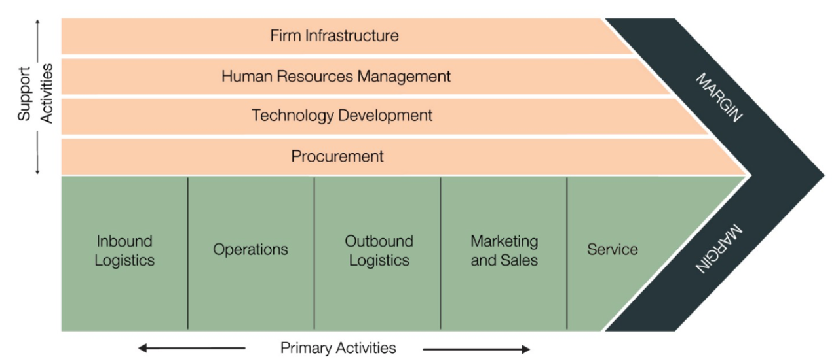
Source: (Chaffey,2009)

A firm needs to identify both primary and secondary activities and need to structure all the processes to add value. In the case of Morrisons, particularly Outbound logistics will be analysed as they have adopted new delivery partner Amazon to add value to their company and customers. For every company, outbound logistics is a backbone of the company, so the firm should be structured all primary and secondary activities appropriately.
When like-for-like sales figures of the Morrisons were declining (figure 1), then Morrison’s reviewed outbound logistics then discovered that the arrangement with Ocado was too costly and restrictive (Vandevelde, 2016). Secondly, changing behaviour of customers, who prefer to do online grocery shopping rather than doing shopping in physical stores.

Figure 4: share of grocery retail channels based on value in the UK
Source: (Statista, 2019)

Statics reveals that online grocery growing rapidly with a growth of 3.2%, in contrast, supermarket retail is expected to fall by 4.1 % by 2021 (Statista, 2019). Therefore, the deal Morrisons with the Amazon will definitely add value to those customers to move to online shopping and company for its long-term growth. Furthermore, as deal provides ultra-fast same day delivery and delivery within one hour give facilities to customers, consequently, it has a positive impact on Morrison’s like-for-like sale, which had increased by +2.8% in 2017/18. Moreover, David Potts CEO of the company has seen greater potentiality of growth of Morrisons by collaborating with Amazon, as Ocado is running the online delivery service from Morrisons.com and additionally from the deal with Amazon gives expand its customer base, thus from both sides it is in win-win arrangement and adding value to company (Butler, 2019).
Figure 5 reveals the expansion of the customer base of Morrisons, as it used to serve customers through Morrisons.com now it has expanded its distribution by collaborating Amazon (Butler,2019). So initially the demand of online shoppers was serving from morrisons.com now they have been serving from Amazon prime now and Morrisons considering getting into other emerging other online platforms such as Deliveroo and Uber eat to border the business (Butler, 2019).

Figure 5: Change in structure in supply arrangement of Morrisons
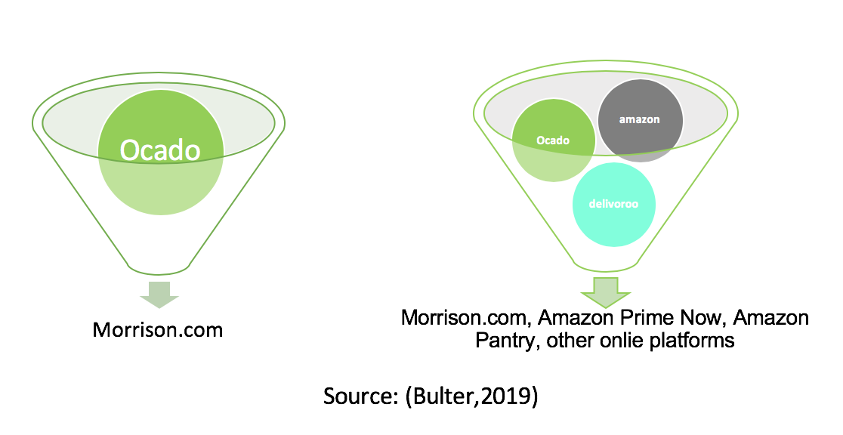

Porter’s five forces model
Porter’s five forces model is a business analysis model which facilitates to analyse the competitive environment of the company in the industry. Additionally, this model helps to identify and analyse the five competitive forces to determine the industry’s weaknesses and strengths (Porter, 2008). With the help of this model, this report will analyse the competitive environment of Morrisons, and its position in the grocery retail industry of the UK, and how change arrangement has been a rationale for the company.
Figure 6: Porter five forces Model
Source: (Porter, 2008).

Threat of entry:
The threat of new entrants in the grocery retail sector of the UK is very high, a number of supermarket chains, convivence stores, and discounted stores are growing rapidly (Appendix 2). In this stiff competitive market to retain and sustain, a company needs to have a competitive advantage. Similarly, figure 2 reveals that the market share of Morrisons constant over the periods, additionally it predicted that shares of discounter likely to increase and the supermarket’s share expected to fall (figure 4). In these circumstances collaborating with Amazon will provide the new platforms to grow.

Bargaining power of buyers
The bargaining power of customers are very high, due to growing discounter stores customers can easily switch to the retailers who offer the best price and services. David Potts CEO of the Morrisons said, to bring back customers from discounter shops they had adopted aggressive price strategy (Armstrong,2017), they have slashed prices on poultry and meat by 12% and prices of more than 4000 lines have been reduced. Therefore, attractive prices and collaboration with Amazon will provide a pool of customers to Morrisons.

Industry rivalry:
Despite being the fourth largest supermarket in the UK, still Morrisons can gain market share, figure 2 reveals that the market share of Morrisons has been constant over the periods. Therefore, deal with Amazon expecting game changer in the retail sector industry. Firstly, changing behaviour of customers from stores to online platforms, secondly, Amazon has a very strong position in online platforms which will be strategically fit to compete with industry rivalry.

Threat of substitute
The threat of substitutes is very high in the case of the Morrisons as numbers of supermarkets, convivence stores and discounter stores are emerging in the market (Appendix 2).

Bargaining power of Suppliers
The Independent (2017) reported that over half the food consumed in the UK is obtained from British framers. As customers of Morrisons said they would prefer to see more products from British framers, as a demand of the consumers of Morrisons they intended to recruit more than 200 British suppliers. Additionally, two-thirds of Morrisons products are produces and buys in the UK (Morrisons,2019). Though the supplier force moderate for Morrisons, other forces can make a position of Morrisons in the market weaker.
From this analysis it’s clear that the grocery retail sector has stiff competition, as Tesco has covered nearly 30% of grocery market (figure 2) and discounter stores gaining more attention due to their low-cost strategy. Therefore, move Morrisons has taken with a revised deal with Ocado and collaborating with Amazon will give opportunities to strengthen its position in the market.

Future Perspective
As per record from both sides, Morrisons and Amazon were looking forward to expanding their business, as a result they had entered into the agreement. The deal was signed in 2016, however, they could do better progress, but as Morrisons had a deal with Ocado previously which restricted to expand. Hence, CEO of Morrisons has reviewed and changed the exclusive supply arrangement with Ocado. Therefore, it has been expecting that this deal is an innovative deal and game changer in the grocery retail industry in the UK. Now they have expanded business five more new cities in the UK and CEO of Morrisons and said he is looking forward to expanding more in the near future (Bultler,2019).

Conclusion

After analysing the motives behind the collaboration between Morrisons and Amazon and analysis from different business models, it seems that the deal signed in 2016 by both has a positive impact on Morrisons’ performance. Firstly, this report discovered that the reason behind the changing delivery partner by Morrisons, as David Potts found out that the deal with Ocado is not gearing the sales of the company, and it was too costly and restrictive, then he decided to change third party to arrange their supply arrangement. Secondly, report also found out the change they made choosing online platforms to boost their performance, as emerging e-commerce opportunities, changing customer behaviour drive them to enter into the agreement. Additionally, as like-for-like sales have improved, and the profit figure has improved soon they arrange the new agreement and expecting to achieve more in the future, so the deal has been fruitful to the company so far.

Reference

- Armstrong, A. (2017). Morrisons recovery gains momentum with profits jump and looming Amazon deal. [online] The Telegraph. Available at: https://www.telegraph.co.uk/business/2017/03/04/Morrisons-recovery-gains-momentum-profits-jump-looming-amazon/ [Accessed 18 Sep. 2019].
- BBC News. (2017). Amazon expands Morrisons delivery deal. [online] Available at: https://www.bbc.co.uk/news/business-37997510 [Accessed 17 Sep. 2019].
- BBC News. (2019). Morrisons and Amazon expand fast deliveries. [online] Available at: https://www.bbc.co.uk/news/business-48619785 [Accessed 17 Sep. 2019].
- Butler, S. (2019). Amazon and Morrisons expand same-day grocery deliveries. [online] the Guardian. Available at: https://www.theguardian.com/business/2019/jun/13/amazon-and-Morrisons-expand-same-day-grocery-delivery-service [Accessed 17 Sep. 2019].
- Butler, S. (2019). Morrisons free to use Amazon and Deliveroo in looser Ocado deal. [online] the Guardian. Available at: https://www.theguardian.com/business/2019/may/09/Morrisons-free-to-use-amazon-and-deliveroo-in-looser-ocado-deal [Accessed 17 Sep. 2019].
- Butler, S. and Wood, Z. (2017). Amazon to buy Whole Foods Market in $13.7bn deal. [online] the Guardian. Available at: https://www.theguardian.com/business/2017/jun/16/amazon-buy-whole-foods-market-organic-food-fresh [Accessed 17 Sep. 2019].
- Chaffey, D., 2009. E-Business and E-Commerce Management, Strategy, Implementation & Practice, Prentice Hall, 2009: E-Business and E-Commerce Management, Strategy, Implementation & Practice (Vol. 1). Bukupedia.
- Garlichs, M. (2011). The Concept of Strategic Fit. Hamburg: Diplomica Verlag.
- Igd.com. (2019). [online] Available at: https://www.igd.com/Portals/0/Downloads/Research/UK-grocery-stores-table.pdf [Accessed 19 Sep. 2019].
- Latash, M. (2008). Synergy. Oxford University Press.
- McCormick, M. (2019). Morrisons and Amazon to expand UK delivery partnership | Financial Times. [online] Ft.com. Available at: https://www.ft.com/content/a76bce40-8da1-11e9-a24d-b42f641eca37 [Accessed 17 Sep. 2019].
- Morrisons. (2015). [online] Available at: https://www.Morrisonscorporate.com/globalassets/corporatesite/investorcentre/financialreports/documents/2014-15/Morrisons_ar_2014_full.pdf [Accessed 17 Sep. 2019].
- Morrisons. (2019). About Us - Morrisons Corporate. [online] Available at: https://www.Morrisons-corporate.com/about-us/ [Accessed 17 Sep. 2019].
- Munbodh, E. (2019). Morrisons and Amazon to expand same-day food delivery service to more UK cities. [online] mirror. Available at: https://www.mirror.co.uk/money/Morrisons-amazon-expand-same-day-16511014 [Accessed 18 Sep. 2019].
- Ocado Solutions. (2019). Morrisons. [online] Available at: https://www.ocadosolutions.com/Morrisons/index.html [Accessed 18 Sep. 2019].
- Porter, M (2008), The five competitive forces that shape strategy, Harvard Business Review, Watertown
- Rhodes, I., Nelson, C. and Berman, G., 2003. The key to successful collaborations: Rigorous and independent due diligence. Journal of commercial biotechnology, 9(4), pp.297-304.
- Rodionova, Z. (2016). Amazon customers will be able to order a full Morrisons shop via their smartphone from today. [online] The Independent. Available at: https://www.independent.co.uk/news/business/news/amazon-Morrisons-same-day-delivery-service-a7420356.html [Accessed 17 Sep. 2019].
- Russell, K. (2019). The best online grocery shopping sites – which one delivers the goods?. [online] The Telegraph. Available at: https://www.telegraph.co.uk/food-and-drink/features/best-online-grocery-shopping-sites-one-delivers-goods/ [Accessed 18 Sep. 2019].
- Sillitoe, B. (2019). Morrisons makes distribution changes as Amazon partnership expands. [online] Essential Retail. Available at: https://www.essentialretail.com/news/Morrisons-distribution-changes/ [Accessed 18 Sep. 2019].
- Statista. (2019). Great Britain: Grocery market share 2015-2019 | Statista. [online] Available at: https://www.statista.com/statistics/280208/grocery-market-share-in-the-united-kingdom-uk/ [Accessed 17 Sep. 2019].
- The Independent. (2017). Morrisons says only half the food eaten in the UK comes from local sources. They want to change that. [online] Available at: https://www.independent.co.uk/news/business/news/Morrisons-hires-uk-suppliers-local-produce-warning-a7585216.html [Accessed 19 Sep. 2019].
- Vandevelde, M. (2016). Ocado agrees more flexible deal with Morrisons | Financial Times. [online] Ft.com. Available at: https://www.ft.com/content/9a5bbf0c-5e25-11e6-a72a-bd4bf1198c63 [Accessed 18 Sep. 2019].
- Wagner, S.M., Grosse-Ruyken, P.T. and Erhun, F., 2012. The link between supply chain fit and financial performance of the firm. Journal of Operations Management, 30(4), pp.340-353.

Appendices

Appendix 1: share price of Morrisons
Source: (Morrisons,2019)
Kjhkhuhuiiu

Appendix 2: Number of grocery retail stores in the UK

Source: Igd.com. (2019)

