

Nike RE: LOOP - A Sustainable Brand Extension: Poster, STDP Analysis,

Marketing Mix and Reflection

Student Name: Tarjan Bhandari

Student ID: 2542504
Programme: Master of Business Administration

Module Name: Marketing Management

Module Code: LCMB7024

Lecturer’s Name: Sinan He

Assignment Title Portfolio: Presentation • Report • Reflection

Word count: 2500

Date: 08/14/2026

Table of Contents
1. Element 1: Sustainable Brand Extension Poster Presentation 1
2. Element 2: Segmentation, Targeting, Differentiation and Positioning (STDP) Analysis 2
2.1 Segmentation 2
2.2 Targeting 3
2.3 Differentiation 4
2.4 Positioning 6
Element 3: Marketing Mix (7Ps) 8
3.1 Product 8
3.2 Price 9
3.3 Place 9
3.4 Promotion 10
3.5 People 10
3.6 Process 11
3.7 Physical Evidence 11
Element 4: Reflection 12
4.1 Description 12
4.2 Feelings 12
4.3 Evaluation 13
4.4 Analysis 13
4.5 Conclusion 13
4.6 Action Plan 14
References: 15

Table of Figure
Figure 1: adidas recycled-polyester share vs. global apparel industry average, 2018–2024 4
Figure 2: Global fibre production (million tonnes) and recycled fibre share, 2020–2024. 5
Figure 3: Perceptual positioning map: Performance credibility vs. Sustainability credibility. 6
Figure 4: The 7Ps Marketing Mix framework 8
Figure 5: Gibbs' Reflective Cycle. 12

1. Element 1: Sustainable Brand Extension Poster Presentation
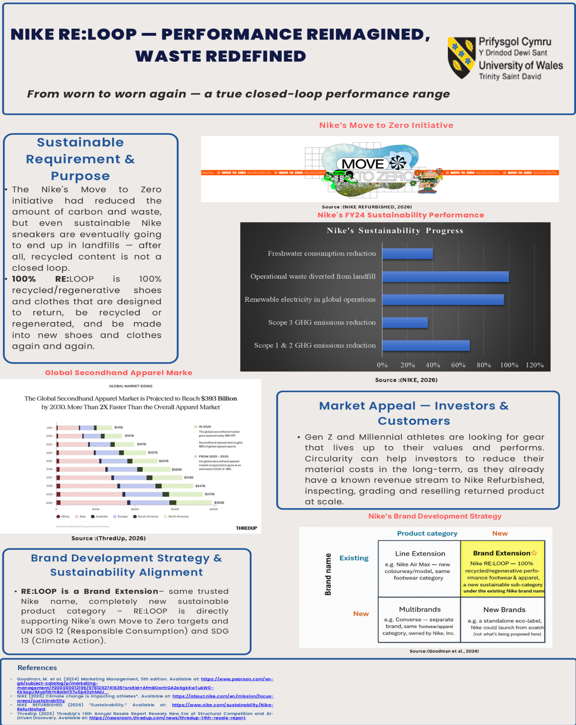

2. Element 2: Segmentation, Targeting, Differentiation and Positioning (STDP) Analysis

2.1 Segmentation
Geographically
Sustainability-wise, the biggest potential markets for Nike RE: LOOP are urban markets in North America, Western Europe and East Asia where the circular-economy and resale segments are best established. ThredUp (2026) forecasts that the global secondhand apparel market will grow at about 9% CAGR to reach $393 billion by 2030, and North America and Europe will witness the maximum growth in the secondhand apparel market.
Demographically
The segment is demographically defined as an economically active age group (18–40) having enough money to afford top-quality performance sportswear.
Psychographically
Psychographically, the variable distinguishing consumers is values-driven identity; consumers who believe sustainability is an integral part of their identity, vs. those for whom sustainable considerations are more an afterthought or are not a priority at all, in keeping with the framework outlined by Albrecht, Green and Hoffman (Albrecht, Green and Hoffman, 2023).
Behaviourally
The segment is defined behaviourally: as existing Nike loyalists who are using Nike Refurbished and take-back schemes, as well as consumers who are frequent buyers of athletic gear.
But, dividing by values alone is not a good idea. Ronda (2024) provides five barriers for the link between positive attitude and actual purchase behaviour: high price, low visibility of the product, low availability, low awareness of the negative impacts of fast fashion and, crucially for RE: LOOP, low trust in sustainability claims. In a large sample, Pires et al. Pires et al. (2024) also obtained a non-linear price–WTP relationship using the PLS-SEM method, which indicates that price segmentation alone will not necessarily be a valid predictor of purchase behaviour. The segmentation process has to be viewed as a supposition to be tested and validated against the evidence and not as a promise of conversion.

2.2 Targeting
A differentiated (concentrated-lead) targeting strategy needs to be followed by RE: LOOP as it focuses on Gen Z and Millennial performance athletes who have a strong sustainability outlook. According to Liu et al. (2024), Gen Z and Millennials are responsible for 68% of the revenue in green apparel, and by 2027, they are expected to make up more than a third of the sustainable fashion market alone.
In addition, this segment is the most competitive segment. In 2018, adidas' recycled-polyester share was 27%, compared to an average of 12-15% for the apparel industry as a whole, which did not change significantly in the same timeframe Adidas Group, 2025). In 2023, Allbirds made a 22% reduction in per-product carbon footprint and was the first to develop carbon-labelled products (Allbirds, 2025). The key to targeting this segment is for RE: LOOP to not just compete on recycled-content percentage, but rather on true closed-loop circularity, which competitors in the recycled-content market are just starting to become a factor.
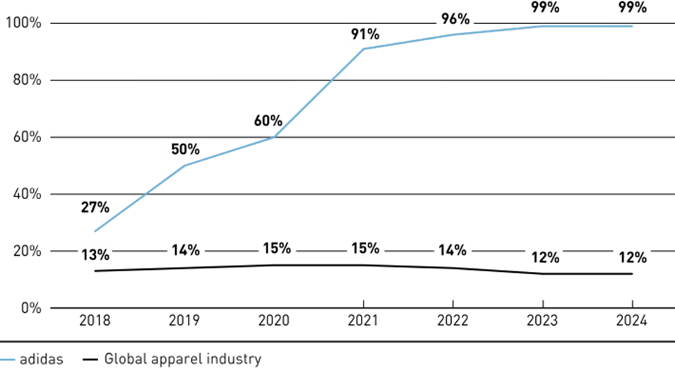
Figure 1: adidas recycled-polyester share vs. global apparel industry average, 2018–2024
Source: (Adidas Group, 2025a)

2.3 Differentiation
RE: LOOP distinguishes itself from other circular streams mainly in product design and technology integration, based on the circular management themes that they developed as a result of interviews with industry decision-makers, which are presented in Abdelmeguid, Afy-Shararah and Salonitis (2024) framework. There is a good amount of evidence for this. The overall amount of recycled fibre produced, as shown in Figure 3, actually decreased slightly from 2020 to 2024, from 109 million tonnes to 132 million tonnes, even though these figures are still higher than in the past, with 8.1% of all fibre produced being recycled in 2020, and 7.6% in 2024 (Textileexchange, 2025). This is a key takeaway: as the number of recycled content claims increases across the entire industry, the movement of recycled materials in and out of textiles is in fact not growing, but instead being overwhelmed by the growth in output.
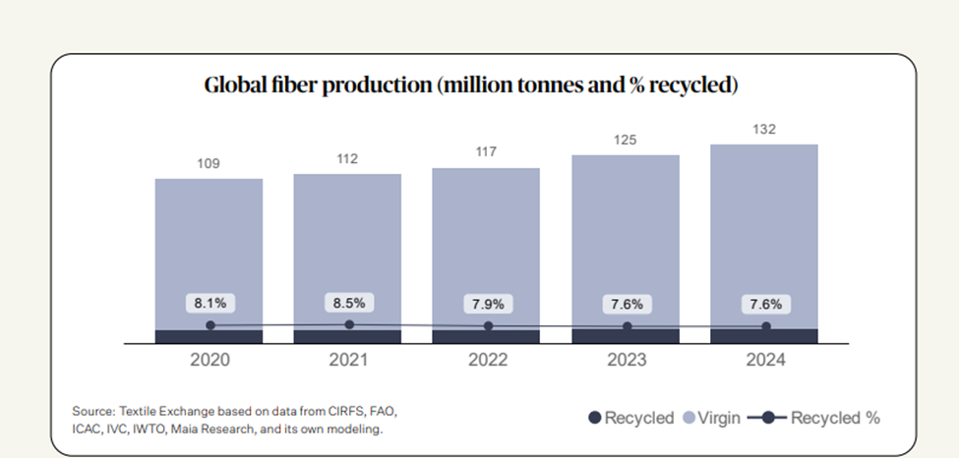
Figure 2: Global fibre production (million tonnes) and recycled fibre share, 2020–2024.
Source:(Textileexchange, 2025)
So, a 99% recycled polyester figure, as Adidas claims, or a carbon-labelled product, as Allbirds claims, does not count as a closed loop, as both still use a lot of recycled inputs from bottles but don't return and remake polyester. This industry-wide gap is directly tackled in RE: LOOP’s return-reprocess-remake model.
The second one is traceability. According to the study by Legardeur & Ospital EPRS, 2024) for the EU Parliamentary study, the details of the traceability information available in-store are very limited (only country of manufacture for 93% of brands, and very few linking supply chain information with individual products). RE: LOOP’s proposed take-back and traceability system is one of the unique selling points that has the potential to actually make a difference, and is ahead of the EU's upcoming Digital Product Passport guidelines.

2.4 Positioning
Positioning statement: To Nike-loyal performance athletes who want sustainable choice without compromise, RE: LOOP is the only Nike range built on true closed-loop circularity, delivering elite performance and full material accountability.
This positioning is plotted in Figure 4, on two dimensions: Performance Credibility and Sustainability Credibility. The Nike standard lines (in-between) perform at a high level and have medium sustainability. Allbirds has a relatively good score in both areas of sustainability communication and performance credibility, while adidas Primeblue/Primegreen does not perform as well in those two areas. RE: LOOP is in the high performance, high genuine sustainability credibility quadrant in white space no direct competitor is in.
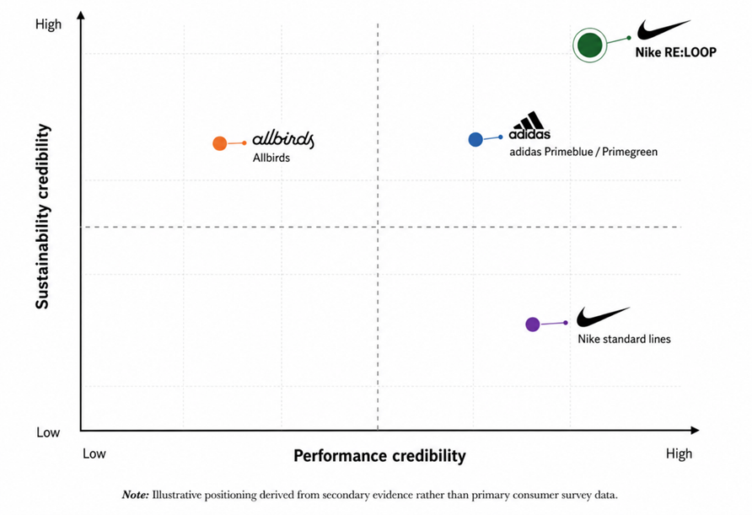
Figure 3: Perceptual positioning map: Performance credibility vs. Sustainability credibility.
Source: self-made
There is a risk of positioning this. UNEP (2023) emphasizes that it is not only a matter of brand marketing, but also a matter of system collaboration throughout the value chain for credible claims to circularity; otherwise, RE: LOOP’s positioning could be undermined by greenwashing skepticism and authenticity perception, as both factors were found to significantly influence green purchase decisions by (Fang, 2024).

Element 3: Marketing Mix (7Ps)
The 7Ps framework has been used throughout this section (Figure 5).
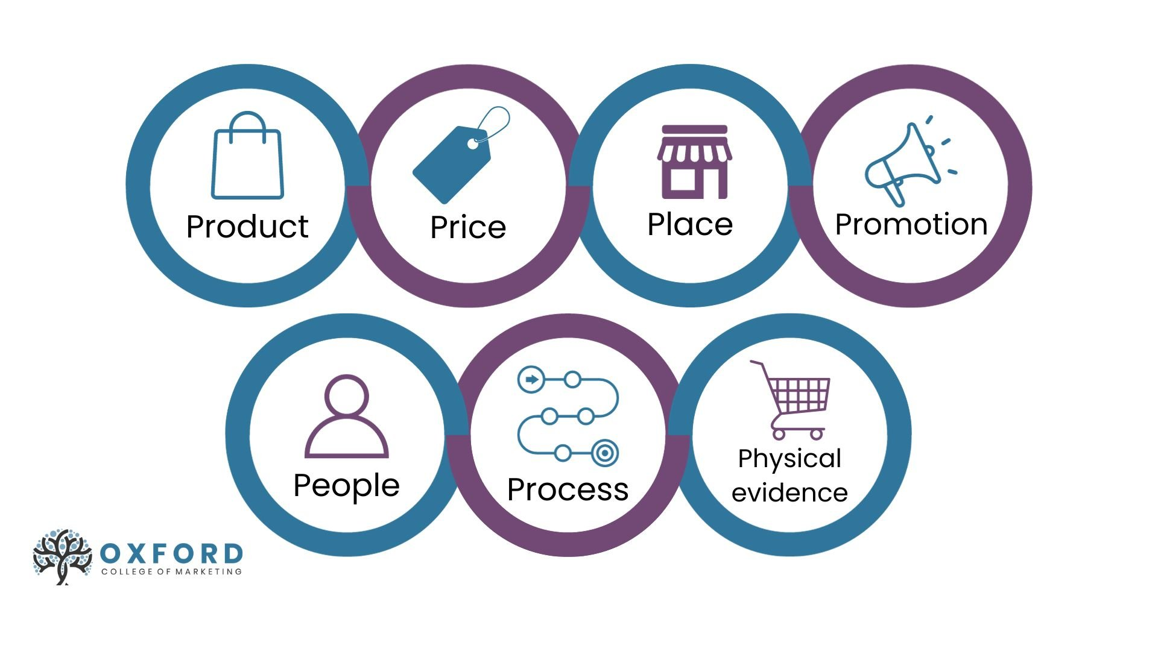
Figure 4: The 7Ps Marketing Mix framework
Source: (Oxford College of Marketing, 2020)

3.1 Product
The product range of RE: LOOP features footwear and clothing that are made from reclaimed and reprocessed materials, from the beginning made for the end-use. Each unit is fitted with a material-tracking identifier, which comes with the recognition of the lack of product-level traceability across the industry, as highlighted by Legardeur and Ospital (2024 ), where 93% of brands are unable to provide any more detail than the country of manufacture in the store. A sustainable marketing mix is not just a design choice, but also a structural one, with a sustainable product choice being an integral component of a sustainable supply chain, as opined by Garg et al. (2024) in their systematic review of 972 studies. No amount of promotional or pricing strategy can fit the circularity onto the product if it isn't really designed for it. This makes Product the core of RE: LOOP’s differentiation claims, which was built in Element 2.

3.2 Price
A (PWC, 2024) global survey of 20,000+ consumers across 31 countries showed that, on average, consumers will pay a 9.7% premium for sustainably produced goods, with an average rating for production methods that focus on waste reduction and recycling given as the single most influential sustainability incentive at 40%. This lends a defensible basis to RE: LOOP’s prices, as opposed to an assumed one. Pires et al. (2024), however, found the link between price and WTP to be non-linear, not linear, meaning that consumers do not always increase their WTP as the price increases, but instead thresholds and even decreases past. This is echoed by Ronda (2024), who found that high price is one of the five main structural barriers for establishing a connection between positive sustainability attitudes and actual purchase behaviour. Combined, this evidence implies that the pricing of RE: LOOP should be close to, but not above, the empirically determined premium ceiling and that it should be coupled with clear value justification (traceability, proven return rates) and not sustainability messaging, as price sensitivity is a significant constraint even within a values-driven target market.

3.3 Place
It is distributed via Nike.com, Nike stores, and the current Nike Refurbished program with dedicated take-back locations also in stores. These existing channel assets and their "known revenue stream" argument were identified on the poster, meaning that it's easier to go to market than to build a new channel from scratch, thereby maintaining low go-to-market costs. This channel decision is also strategic, in that the take-back points are located within existing retail and e-commerce channels, and therefore keeps the reverse-logistics loop within sight and easy for the consumer, so that it becomes a true closed loop, and not just a gesture. In this model, Distribution and Process are therefore interdependent, and this is less the case in Nike's traditional linear product lines.

3.4 Promotion
Promotion should be digital-first, based upon athlete partnerships and content that is transparent instead of generic sustainability messaging. In two related studies (n=441 and n=448 respectively), Ries and Rese (2025) determined that attitude-behaviour gaps can only be closed if content is adapted to specific age group preferences, as younger consumers react differently to older ones, depending on the specific channel and type of information. Fang, (2024) investigated green social media influence and the perception of green authenticity on green purchase intentions for 413 fashion consumers in Guangzhou, China, and found that both measures had a significant impact on green purchase intentions, and the greenwashing perception did not significantly mediate between the two; this finding indicates that perceived green authenticity, not the absence of greenwashing accusations, is the driver of green purchase conversion. In practice, this translates to the promotion of RE: LOOP's content on concrete proof points (supply chain footage, real return rate data, third-party audit results) rather than sweeping statements of sustainability, as these might be interpreted as aspirational rather than convincing, and thus defeat the positioning developed in Element 2.

3.5 People
All staff members, both in retail and take-back logistics, need specific training for the circularity messaging as well as on how to actually handle the returned product, both in the customer-facing element of the take-back process and in the back-of-house sorting and condition-grading process. If the People element doesn't reinforce, but instead is inconsistent or poorly informed about how the take-back scheme works, then the customer is directly challenged between RE: LOOP’s promotional positioning and its day-to-day reality — a contradiction that can be both disastrous and a significant deviation from the perception of authenticity that can be hard to overcome in a purchase.

3.6 Process
The reverse-logistics process (collection, sorting, reprocessing and remanufacture) is the differentiator of RE: LOOP’s operations and needs to be audited independently, not only brand communicated. Abdelmeguid, Afy-Shararah and Salonitis (2024b), based on 10 semi-structured interviews conducted with senior industry decision makers, highlight “integration of technology” and “collaborations” as two of eight key themes that distinguish true circular practice from just putting it on the agenda. This is a relevant difference when considering RE: LOOP as a take-back system – one that lacks third-party evidence of actual return and remanufacture rates – because it could easily be deemed to be the type of unsubstantiated claim that RE: LOOP recommends avoiding altogether as a way to build consumer trust in propositions for the circular economy industry.

3.7 Physical Evidence
Physical evidence consists of minimal, fully recycled packaging, in-store circularity signage with information on the take-back process, and a digital "impact tracker" on each product, displaying the individual material journey that the product takes from being returned to being remanufactured. This directly responds to the near-universal lack of traceability identified by Legardeur and Ospital (2024) at the product level, and RE: LOOP has a product-level proof point that facilitates the Promotion strategy, which focuses on verifiable evidence rather than aspirational claims.

Element 4: Reflection
This reflection is organized using Gibbs' (1988) Reflective Cycle as illustrated in Figure 6.
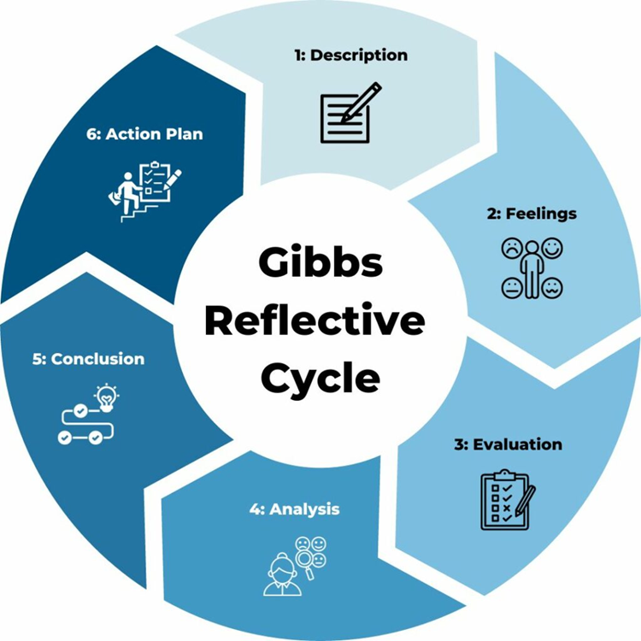
Figure 5: Gibbs' Reflective Cycle.
Source:(TSW, 2025)

4.1 Description
I went through four phases to create the Nike RE: LOOP sustainable brand extension: concept development, STDP analysis, marketing mix design, and, in the last phase, I presented the poster to both "investors" and "consumers" in a format of 3–5 minutes.

4.2 Feelings
I was confident with the creative concept but not so sure about making the sustainability claims credible through the process rather than aspirational. The uncertainty was even greater when conducting competitor research, and I thought that the problem of circularity had already been "solved" by both adidas and Allbirds.

4.3 Evaluation
What was successful was basing decisions on primary industry information as opposed to assumptions — for instance, finding out from Textile Exchange (2025) that the world's share of recycled fibre is in fact down a little since 2020 despite the increased output. This made a Sustainable development pitch into a differentiation argument based on evidence. It was less successful with my initial segmentation, which based on income level would predict likelihood of purchase, which Pires et al. (2024) later showed to be non-linear, forcing me to change my rationale for targeting.

4.4 Analysis
The biggest takeaway was the understanding that the 'recycled' claims from the leading competitors are almost exclusively bottle-to-bottle recycling, and not textile-to-textile recycling (Textile Exchange, 2025). Reframing my understanding of differentiation, as I saw it in previous posts, which has been a viable sustainability claim, must have specific, falsifiable evidence and not be aspirational language, as Fang (2024) determined, that direct reduction in consumer trust occurs by perceived greenwashing. Presenting the poster also revealed a disconnect between my written analytical skills and my spoken, audience-oriented communication — that a skill set for writing an evidence-rich argument was required for talking through a presentation that lasts 3-5 minutes in which I needed to present a persuasive argument.

4.5 Conclusion
Overall, I was able to support this project with primary consumer research of the target group instead of secondary research like Liu et al. (2024), which describes the broader Gen Z/ Millennial market and not the target market of Nike. UNEP (2023b) rightly points out that a collaborative effort across the value chain is essential to credible circularity; and this is something that no single brand extension proposal can fully demonstrate, something I now see more clearly than I did when I began the project and something I would, in a real-world consultancy version, explicitly make clear.

4.6 Action Plan
For the future, I will practice and develop: (1) skills in condensing complex arguments with evidence into shorter, more persuasive forms for presentation situations, which I still have not mastered, particularly because I have not yet developed this skill through this module; (2) taking marketing assumptions and testing them with primary data, rather than only secondary data, before determining a strategic direction, which I have not done in depth yet, as the Process element of the marketing mix identified a need for further study beyond that covered in this module; (3) developing my technical understanding of the processes of circular supply chains, which I found is an area that still needs further development beyond what has been covered in this module.

References:
Abdelmeguid, A., Afy-Shararah, M. and Salonitis, K. (2024a) “Towards circular fashion: Management strategies promoting circular behaviour along the value chain,” Sustainable Production and Consumption, 48, pp. 143–156. Available at: https://www.researchgate.net/publication/380880811_Towards_circular_fashion_Management_strategies_promoting_circular_behaviour_along_the_value_chain.
Abdelmeguid, A., Afy-Shararah, M. and Salonitis, K. (2024b) “Towards circular fashion: Management strategies promoting circular behaviour along the value chain,” Sustainable Production and Consumption, 48, pp. 143–156. Available at: https://www.sciencedirect.com/science/article/pii/S2352550924001398.
Adidas Group (2025a) Metrics and Targets. Available at: https://report.adidas-group.com/2024/en/group-management-report-sustainability-statement/esrs-e5-resource-use-and-circular-economy/metrics-and-targets.html.
Adidas Group (2025b) Resource Use and Circular Economy. Available at: https://report.adidas-group.com/2024/en/group-management-report-sustainability-statement/esrs-e5-resource-use-and-circular-economy/overview.html.
Albrecht, M.G., Green, M. and Hoffman, L. (2023) “Principles of Marketing,” in. Available at: https://books.google.com.np/books/about/Principles_of_Marketing.html?id=ZwjMzwEACAAJ&redir_esc=y.
Allbirds (2025) Allbirds announces 22% reduction to per product carbon footprint in annual sustainability report. Available at: https://report.adidas-group.com/2024/en/group-management-report-sustainability-statement/esrs-e5-resource-use-and-circular-economy/overview.html.
EPRS (2024) Digital product passport for the textile sector | Think Tank | European Parliament. Available at: https://www.europarl.europa.eu/RegData/etudes/STUD/2024/757808/EPRS_STU(2024)757808_EN.pdf.
Fang, Z. (2024) “Greenwashing Versus Green Authenticity: How Green Social Media Influences Consumer Perceptions and Green Purchase Decisions,” Sustainability, 16(23), p. 10723. Available at: https://www.mdpi.com/2071-1050/16/23/10723.
Garg, R. et al. (2024) “Sustainable marketing mix and supply chain integration: A systematic review and research agenda,” Sustainable Futures, 8, p. 100269. Available at: https://www.sciencedirect.com/science/article/pii/S2666188824001187.
Legardeur, J. and Ospital, P. (2024) “Digital product passport for the textile sector, Study for European Parliamentary Research Service, Panel for the Future of Science and Technology, Scientific Foresight Unit (STOA).” Available at: https://www.researchgate.net/publication/382463943_Digital_product_passport_for_the_textile_sector_Study_for_European_Parliamentary_Research_Service_Panel_for_the_Future_of_Science_and_Technology_Scientific_Foresight_Unit_STOA.
Liu, L. et al. (2024) “The impact of environmental accidents on the green apparel purchase behavior of Generation Z,” Frontiers in Psychology, 15. Available at: https://www.frontiersin.org/journals/psychology/articles/10.3389/fpsyg.2024.1338702/full.
Oxford College of Marketing (2020) Understanding The 7Ps of The Marketing Mix. Available at: https://blog.oxfordcollegeofmarketing.com/2020/10/08/understanding-the-7ps-of-the-marketing-mix/.
Pires, P.B. et al. (2024) “Sustainable Fashion: Conceptualization, Purchase Determinants, and Willingness to Pay More,” Administrative Sciences, 14(7), p. 143. Available at: https://www.mdpi.com/2076-3387/14/7/143.
PWC (2024) “Shrinking the consumer trust deficit.” Available at: https://www.pwc.com/gx/en/issues/c-suite-insights/voice-of-the-consumer-survey/2024.html.
Ries, T. and Rese, A. (2025) “Can information help bridge the attitude–behavior gap in sustainable clothing consumption?,” Cleaner and Responsible Consumption, 17, p. 100278. Available at: https://www.sciencedirect.com/science/article/pii/S2666784325000294.
Ronda, L. (2024) “Overcoming barriers for sustainable fashion: bridging attitude-behaviour gap in retail,” International Journal of Retail & Distribution Management, 52(1), pp. 44–61. Available at: https://www.emerald.com/ijrdm/article-abstract/52/1/44/1232569/Overcoming-barriers-for-sustainable-fashion?redirectedFrom=fulltext.
Textile Exchange (2025) “Materials Market Report 2025.” Available at: https://textileexchange.org/knowledge-center/reports/materials-market-report-2025/.
Textileexchange (2025) “Materials Market Report.” Available at: https://textileexchange.org/app/uploads/2025/09/Materials-Market-Report-2025.pdf.
ThredUp (2026) ThredUp’s 14th Annual Resale Report Reveals New Era of Structural Competition and AI-Driven Discovery. Available at: https://newsroom.thredup.com/news/thredup-14th-resale-report.
TSW (2025) “Gibbs Reflective Cycle – A Practical Guide.” Available at: https://www.tsw.co.uk/insights/gibbs-reflective-cycle/.
UNEP (2023a) Sustainability and Circularity in the Textile Value Chain - A Global Roadmap. Available at: https://www.unep.org/resources/publication/sustainability-and-circularity-textile-value-chain-global-roadmap.
UNEP (2023b) “Sustainability and Circularity in the Textile Value Chain - A Global Roadmap.” Available at: https://www.unep.org/resources/publication/sustainability-and-circularity-textile-value-chain-global-roadmap.

