DS 1 Template

My Screenshots/Photos
- Please add 4–6 screenshots or photos of your digital life.
- You can use your phone or laptop.
- For each screenshot, write one or two sentences explaining what it shows.

Screenshot/Photo 1
[Insert Photo/Screenshot below]
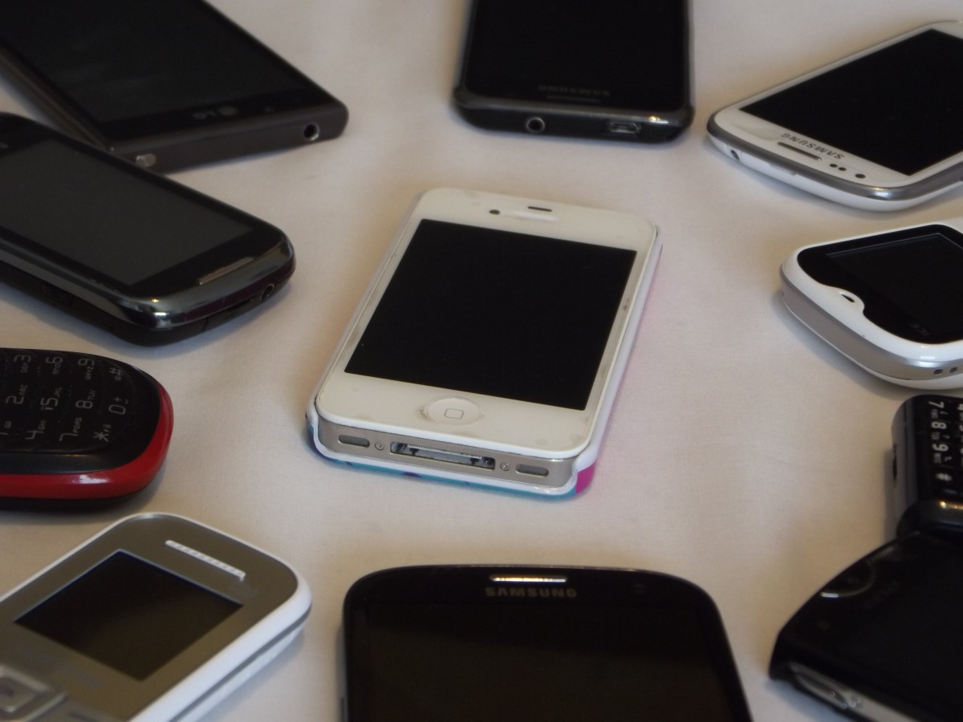
[I used my mobile as apart of communication for my work and home life and also school life.
Mobile is very important to use in every aspect of our life to communication due to how accessible is to carry around with you.
The challenges that you can faces is;
last of signal when travelling in different area
Also, data update, outdated software and memory storage will caused your mobile to malfunction so therefore you will experience a lot of challenges with your mobile devices.

Screenshot/Photo 2
[Insert Photo/Screenshot below]
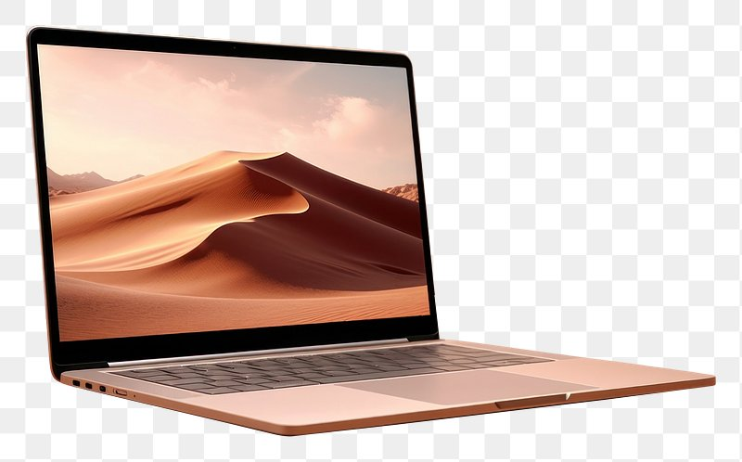
We used a laptop to do assignment and for work purpose and to learn how to use updated technology
The risk of using laptop is that you must understand the device
Using the right plug, it cannot use with an overloaded socket
You must protect it from spillage that can damage the software
And you must used a laptop that have good memory space for new update for the device to function effectively

Screenshot/Photo 3
I use bbc to see new updates

Screenshot/Photo 4
[Insert Photo/Screenshot below]
I use one drive to save files

Screenshot/Photo 5
[Insert Photo/Screenshot below]
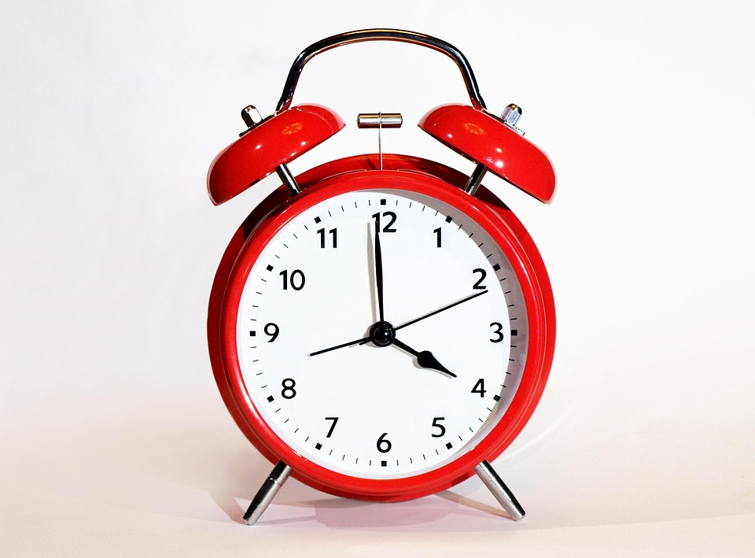
This clock helps me to be on time
It helps me set my day
This clock helps me to be on top of my time keeping
I face challenges if I don’t set my alarm especially when am busy and tired and causes a lot of stress due to be late.

Screenshot/Photo 6
[Insert Photo/Screenshot below]
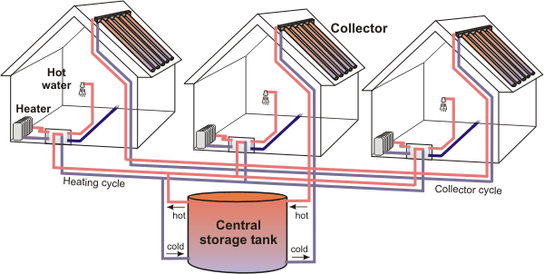
The heating is used to regulate the cold temperate at home
When the heating is on set timer it functions ok and I don’t have to worry
When the system is not service it need update for it work effectively

My Short Reflection
- Write 5–8 simple sentences about your digital life.
- You can use the sentence starters below if helpful.
I used digital tools to help me to no the different tool that is needed to function and be included in the new digital era
I am confident when I am train to used them
I would like to improve more and using the different tools that is needed for specific areas
I often use tools that I am train to used
I sometimes feel nervous when I can used some of the tool effectively
I hope the module will help me to the different tools that are available for me to do my work in every area of my study that I can pass and be confident
Hope this module will help to get all that I needed to know
Digital s important to me learned for everything is digital era

Sentence starters
- I use digital tools to …
- I feel confident when I …
- I want to improve …
- I often use these tools: …
- I sometimes feel nervous about …
- I hope this module will help me …
- Digital skills are important for me because …
You can write more if you want.

Submission Checklist
Before you submit, please check:
​​​ ☒ I added 4–6 screenshots
☒ I wrote short sentences for each screenshot
☒ I wrote my short reflection
☒ My work is my own
☒ My file opens correctly
​​☒ My file opens correctly

