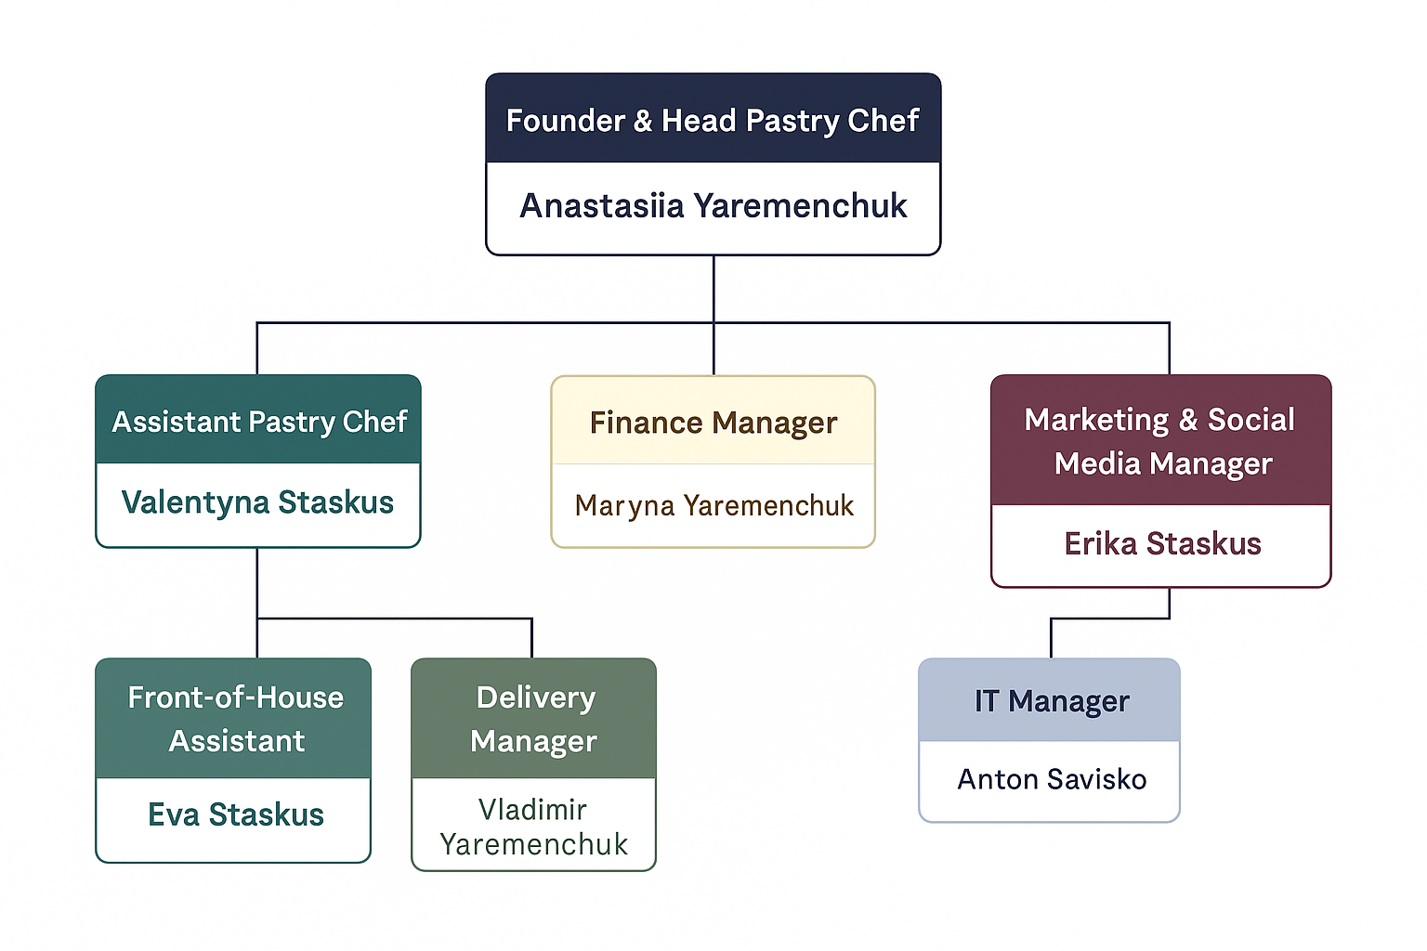
Business idea:
A small bakery producing healthy, gluten-free and sugar-free cakes and desserts.
1. Founder & Head Pastry Chef – Anastasiia Yaremenchuk
She is responsible for managing the overall operations and business strategy of the bakery. She also develops and tests new gluten-free and sugar-free recipes to ensure product quality and innovation.
2. Assistant Pastry Chef – Valentyna Staskus
She assists in preparing, baking, and decorating cakes under the supervision of the Head Pastry Chef. Valentyna ensures cleanliness, follows recipes accurately, and maintains consistency in product quality.
3. Finance Manager – Maryna Yaremenchuk
She oversees the bakery’s financial planning, budgeting, and reporting. Maryna manages expenses, payments, and ensures financial stability and profitability.
4.Marketing & Social Media Manager – Erika Staskus
She promotes the bakery through social media and digital campaigns to increase brand awareness. Erika creates content, analyses engagement, and develops strategies to attract more customers.
5. Delivery Manager – Vladimir Yaremenchuk
He is responsible for delivering orders safely and on time to customers and partners. Vladimir maintains the delivery vehicle and ensures excellent customer service during deliveries.
6.IT Manager – Anton Savisko
He manages and maintains the bakery’s website, online orders, and digital systems. Anton also ensures data security and supports the team with technical solutions.
7.Front-of-House Assistant – Eva Staskus
She greets customers, takes orders, and provides information about the bakery’s products. Eva ensures a friendly atmosphere, maintains the display area, and handles payments efficiently.

