Applied PLC Control Systems

Jack Solomon

1503512

Dr. Gary L Jones

24/01/20

Contents
Introduction / Specification 3
Block Diagram 4
Discussion into Potential Problems 6
Breakdown of Errors 6
Breakdown of Warnings 7
Timing Diagrams 8
HMI Home Screen Design 40
HMI Error and Warning Screen Design 41
Demonstration of the Error Procedure 42
Demonstration of the Warning Procedure 43
Operator Check Procedure 44
HMI Final Designs 44
Audit Document 46
Suggested Improvements 47
Bibliography 48

Introduction / Specification
The aim of this assignment is to design a PLC control system which can determine the diameter and height of a selection of aluminium pucks when they pass along the PLC trainer. These pucks come in two different heights and three different diameters. The pucks must be sorted into the five assortment bins defined in the assignment brief using the three cylinders and a reverse mechanism.
Figure 1 states the storage location of each puck, as well as identifying each component on the PLC trainer.
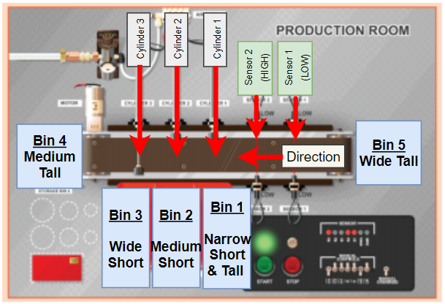
Figure-1. [1]
This report will also outline an error and warning system which meets the brief, along with an HMI system which will work in tandem with the program. The HMI system will consist of: -
- An emergency stop button.
- The ability to navigate screens.
- An error and warning system.
- The number of pucks sorted into each bin.
- The speed of the conveyor.
- An indication of when the system is running.

Block Diagram
Figure-2 shows a block diagram of how the components of the system powered and how they are connected.
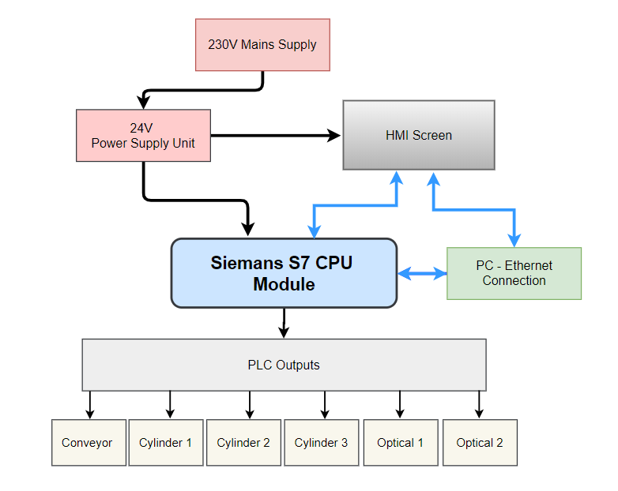
Figure-2.
Flow Chart
Figure-3 shows an operational flow chart of the proposed system.
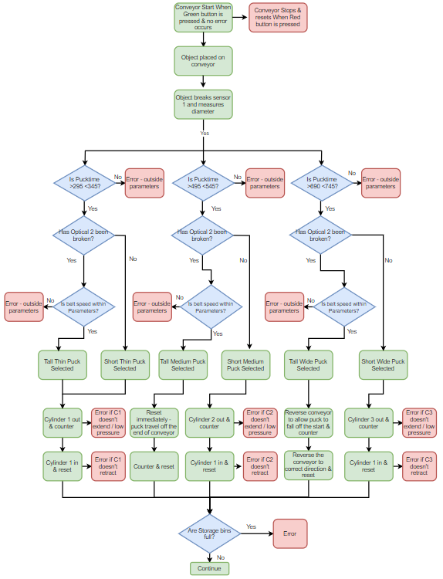
Figure-3.

Discussion into Potential Problems
It is important to prevent potential problems and to maintain maximum efficiency in the system. Potential problems which may harm the system are flagged up as ‘errors’ which will be displayed on the HMI. Within the program, errors are defined as major problems which will cause the conveyor to stop.
Minor problems within the system are classed as warnings. If a warning is flagged, it is not designed to stop the conveyor like an error. The purpose of warnings is to notify the user by being clearly displayed on the HMI screen.
If an error occurs, the conveyor can only be started again when the master reset is pressed. This is possible by connecting an error flag button to the master error tag. The process of this mechanism will be analysed later in this report.

Breakdown of Errors
Table-1 gives a detailed description of why each warning is required within in the program. It also explains how each error is going to be created within the system.
Error Description | Error Flag Creation
Conveyor Speed too fast & slow (two errors).
Reasons the errors are required.  - If the speed is too quick, then the objects may fall off the conveyor.  - If the speed is too slow then this may cause a bottleneck in the system.  Timing functions will be needed to extend the cylinders at the correct time to be able to store the pucks in the bins accurately and efficiently.  - An increase or decrease in conveyor speed will tamper with the cylinder timers and the cylinders will not extend at the correct time.  - As a result, the pucks will not be stored in the correct bins. | - The speed of the conveyor must be calculated first by measuring the distance between the two sensors, then recording the time taken for a tall puck to break both sensors.  - After the speed is calculated, a function can be used to set high and low conveyor speed limits, if the conveyor breaches the limits then this will set an error.
Cylinder fails to extend.
Reasons the errors are required.  - If a cylinder fails to extend, the pucks will not be stored in the correct bins.  - For example, cylinder 2 is meant to extend and store the medium short pucks into bin 2. If cylinder 2 fails to extend, the medium short pucks will travel the length and fall into bin 4. This is a problem because the medium tall pucks are to be stored in bin 4. | - A function could be written to flag an error after a set time if the cylinder fails to extend.
Cylinder extends but does not retract.
Reasons the errors are required.  - If a cylinder extends but fails to retract and the conveyor is still on this will cause the pucks to crash into the extended cylinder causing a bottleneck.  - A bottleneck may cause the pucks to fall into an incorrect bin or on the floor. | - After each cylinder extends, a function must be written to retract the cylinder after a specified time.  - A function could be used to set an error flag if the cylinder does not retract within a specified time after extending.
Boxes Full.  - The purpose of this error is to stop the storage bins from over-flowing. | - A counter will be installed to set an error flag when the pucks in the storage bins reach a certain number.
Emergency Stop Button.
- An emergency stop button is a requirement in the brief and must be displayed on the HMI.

Table-1.

Breakdown of Warnings
Table-2 explains why each warning is required along with an explanation of how the warnings are going to be incorporated into the system.
Warning Description | Warning Flag Creation
Conveyor Speed slightly too high & low (two warnings).  - If the conveyor speed is marginally too high/low but the system is still able to function correctly then a warning will be in place to notify the user.  - This is important because the user can see that there is a problem occurring to plan a stoppage. | - Identical to the conveyor speed error in figure 1 above - but with lower upper and lower speed limits.
Conveyor running but no activity.  - This warning is used to alert the user to prevent the conveyor running unnecessarily.  - This will make the system more efficient by saving money on wasted power costs. | - A function will be made to flag a warning if the conveyor is running but nothing passes through after a set time.
Boxes Full warning  - The purpose of this warning is to notify the user to prevent the ‘Boxes Full Error’ occurring. | - A counter will be installed to set a warning flag when the pucks in the storage bins reach a certain number.
Cylinder Pressure Too High & Low (two warnings).  - This warning is to notify the user that the there is too much/little air pressure in each cylinder. | This warning is not eligible to be written into the program at this time. However, the warning light will be in place for potential future advancements.
Table-2.

Timing Diagrams
This section will give a brief description of each network along with an analysis of the timing diagrams for each network.

Network 1
The conveyor is locked off when the green button is pressed. When the conveyor starts it starts a 1.7s timer. This timer is used to cause a delay in the program for more accurate sensor readings. If the red button is pressed or MasterError is flagged the conveyor will stop.
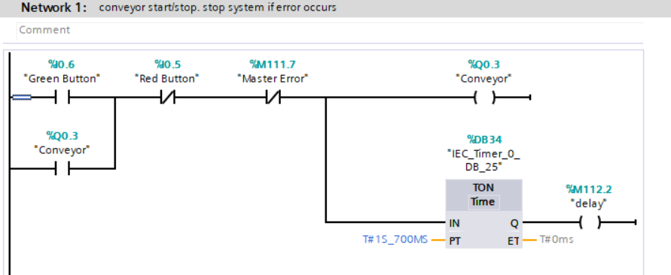
Figure-4.
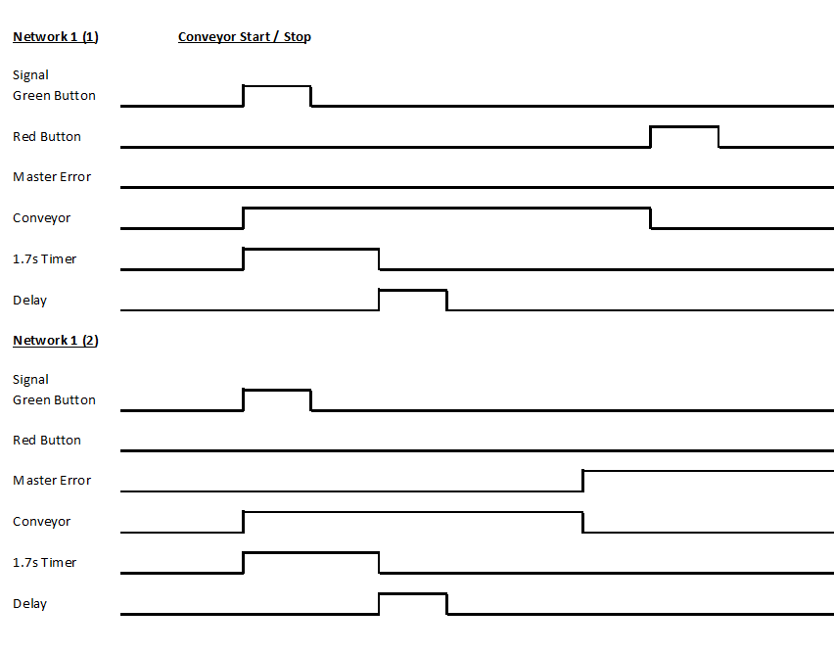
Figure-5.

Network 2
Green light is on when conveyor is on. Red light is on when conveyor is off.
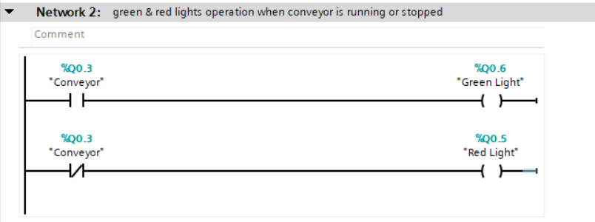
Figure-6.

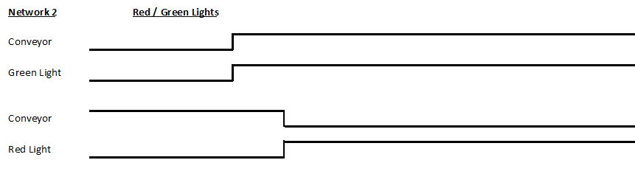
Figure-7.

Network 3
When optical1 breaks it is locked off by mode1. If reset and MasterError activate, this will deactivate mode1.
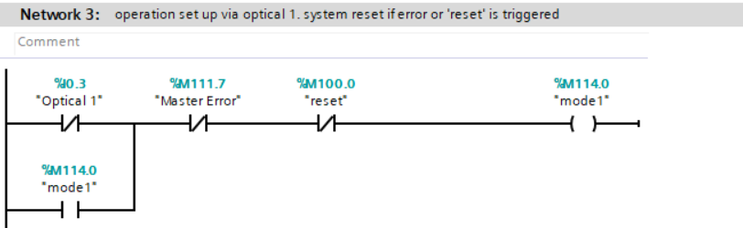
Figure-8.

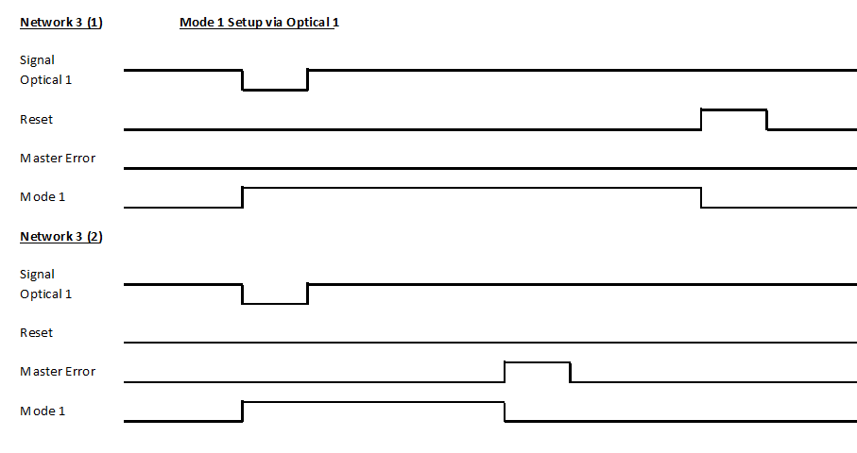
Figure-9.
Network 4
Mode1 must be set and when optical2 is activated, it is required to be locked off for speed measuring purposes. It is also required to identify tall pucks as the sensor is higher than sensor 1. Opt2_lock is 0 if its short and 1 if its tall. Optical 2 is locked off by opt2_lock. Reset will deactivate opt2_lock.
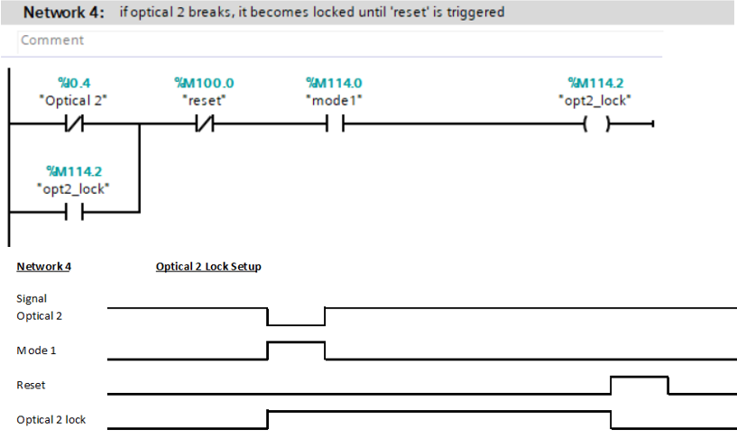
Figure-10.

Network 5
The time taken to travel from optical1 to optical2 is required to measure conv_time so a TONR is required.
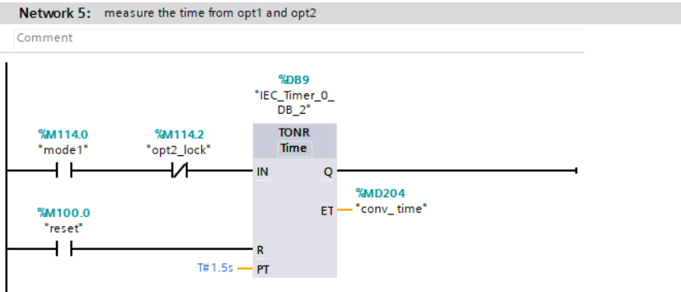
Figure-11.

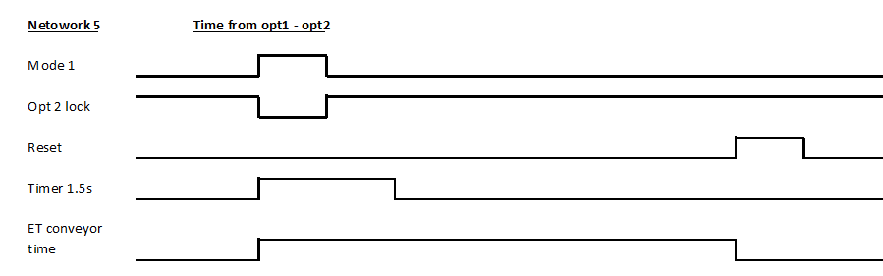
Figure-12.

Network 6
If mode1 and opt2_lock is set, then conv_time can be converted into a double integer. The distance between the 2 sensors is 50mm so 50,000 is divided by integer c_count to calculate the conveyor speed.
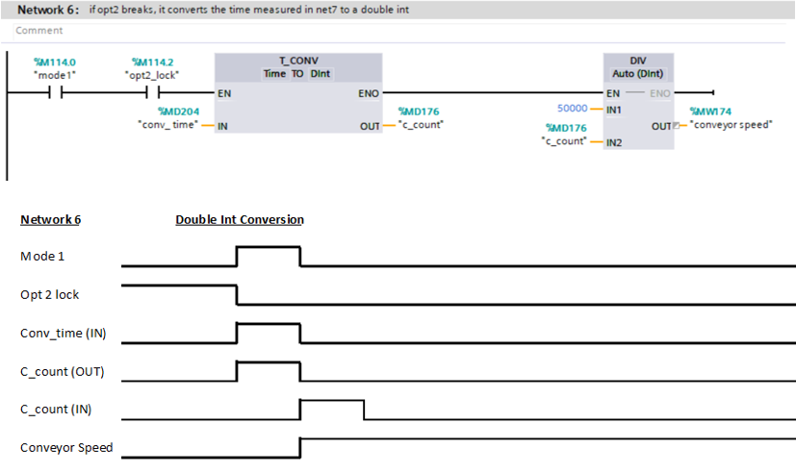
Figure-13.

Network 7
When optical1 is broken, a timer is started to measure the puck widths which is used for assortment (pucktime). The reset tag is used to reset the timer.
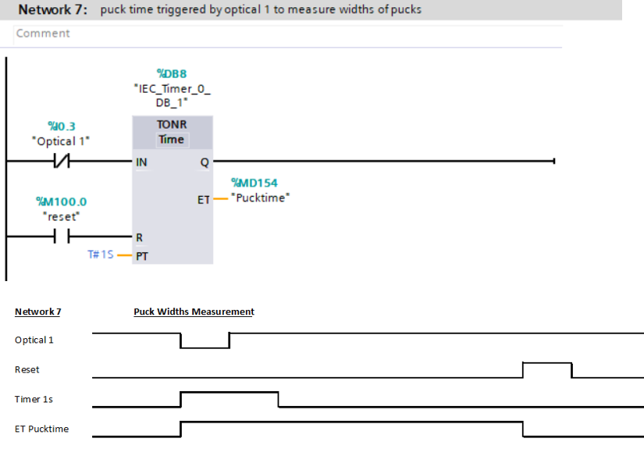
Figure-14.

Network 8
This network is used to tag each of the 6 puck sizes. For example, if mode1, delay and opt2_lock is set and the pucktime is within 295ms and 345ms then the output tag will be a tall_thin.
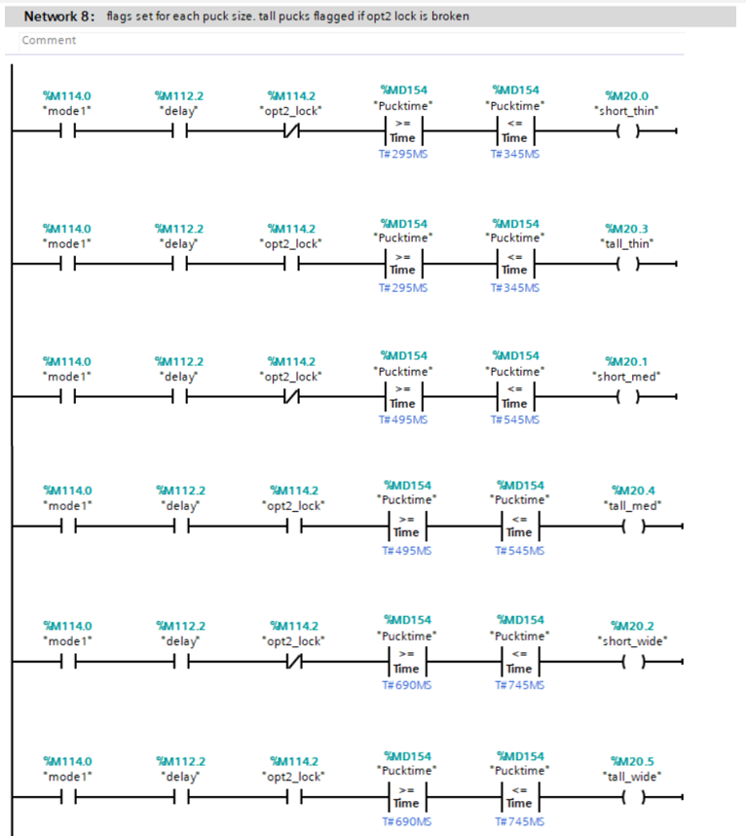
Figure-15.

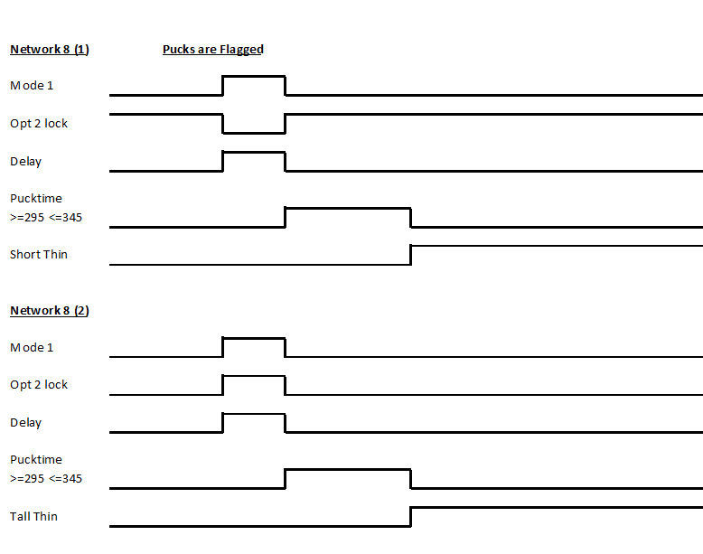
Figure-16.

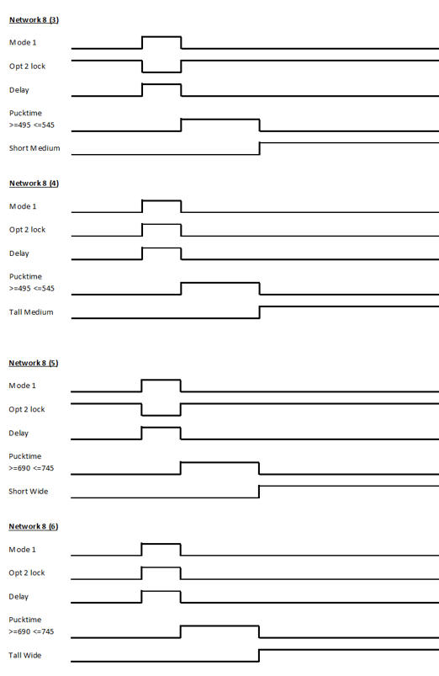
Figure-17.

Network 9, 10, 11.
These networks are used to extend the cylinders. For example, if mode1 is set a 2.5s timer will start. If either short_thin or tall_thin are set after timer finishes, cylinder 1 extends.
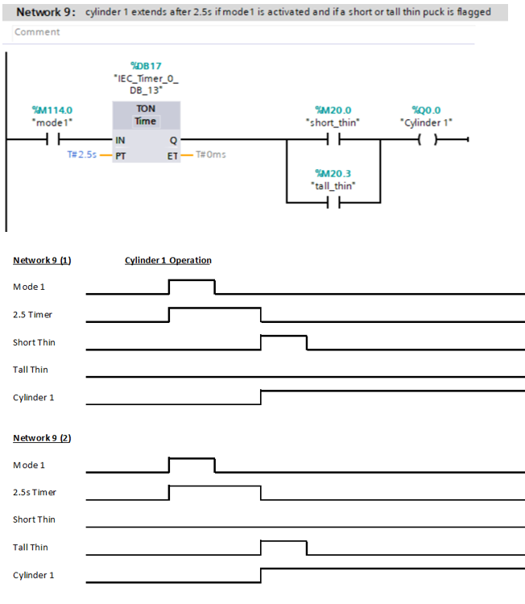
Figure-18.

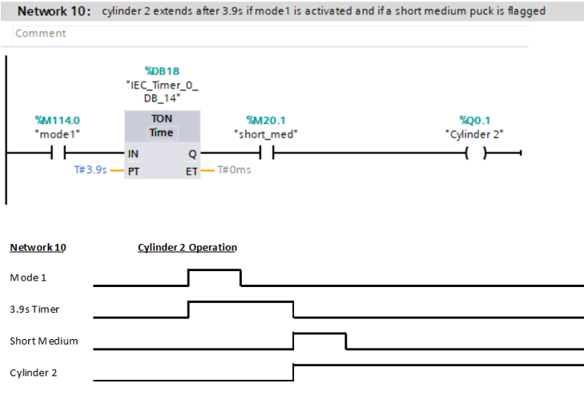
Figure-19.

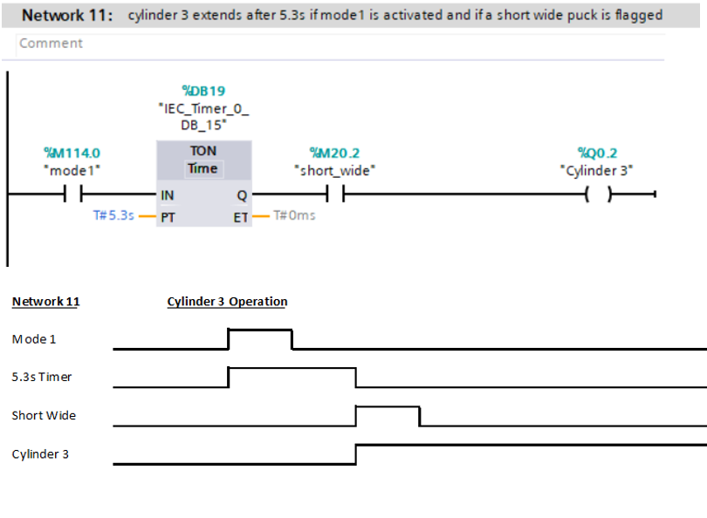
Figure-20.
Network 12
If tall_med is set, a 1s timer starts. When the timer finishes, reset2 is activated to allow the puck to be stored in bin 4.
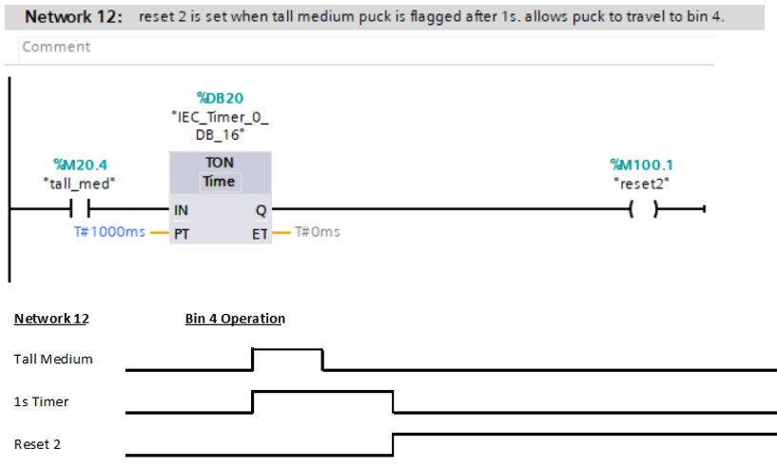
Figure-21.

Network 13
If mode1 and tall_wide are set 2.51s timer will be set, when the timer finishes the conveyor will reverse and another timer will be set. After the second timer finishes the conveyor will reverse again and reset3 will be set.
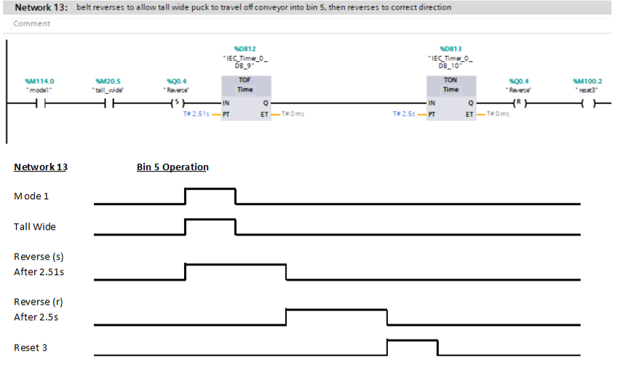
Figure-22.
Network 14
This network is broken down into 4: -
- If either cylinder 1, 2 or 3 retract this will start a 0.5 second timer then reset is activated.
- If reset2 is set then reset is set.
- Mode1 sets a 6.5s timer. When the timer finishes reset is activated. This is to reset the system if nothing passes after 6.5s after mode1 is set.
- If reset3 is set the reset is activated.

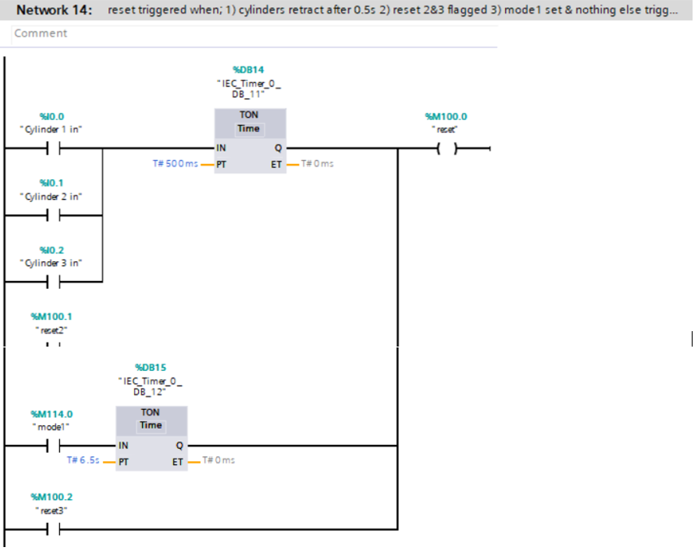
Figure-23.

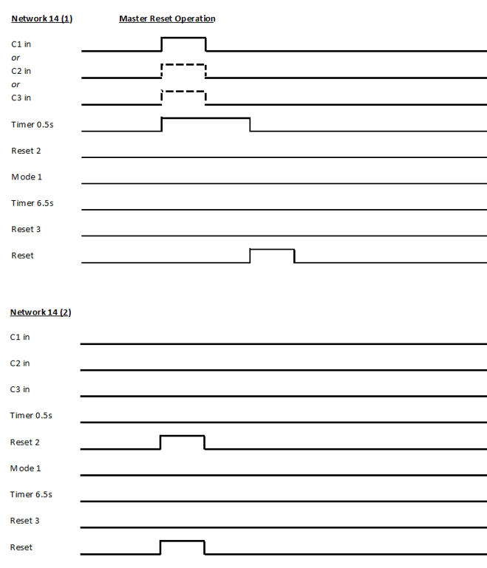
Figure-24.

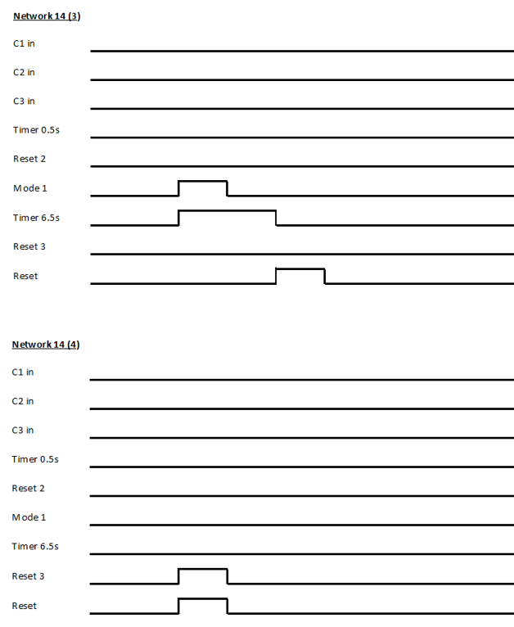
Figure-25.

Network 15
If an error is set to 1 then this activates the master error tag.
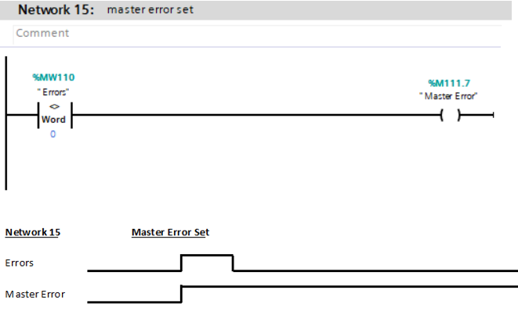
Figure-26.

Network 16
If master error is set, then ErrorFlag is set. This creates an error lock off. If an error occurs, then the conveyor cannot be started until the error is cleared.
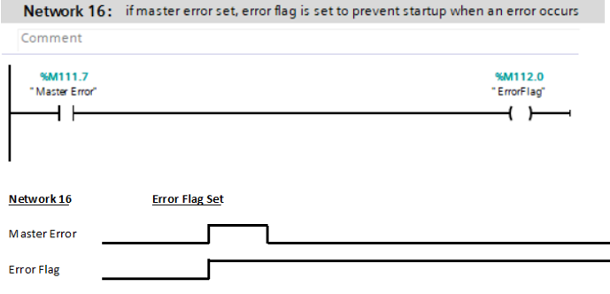
Figure-27.

Network 17
If a warning is set to 1 then this activates WarningFlag.
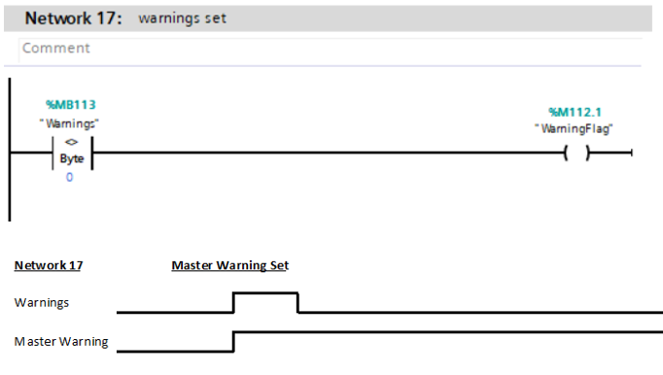
Figure-28.

Network 18
For example, if cylinder 1 extends and short_thin is set, this sets a trigger to an incrementing counter.
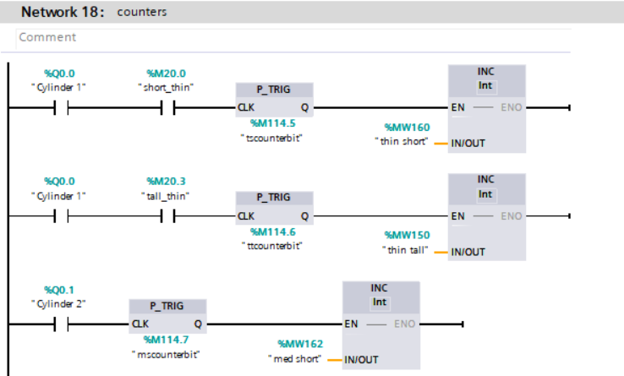
Figure-29.

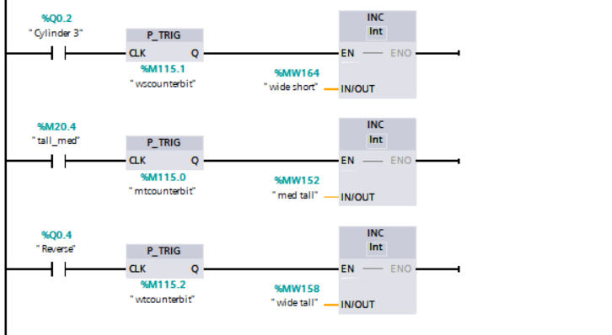
Figure-30.

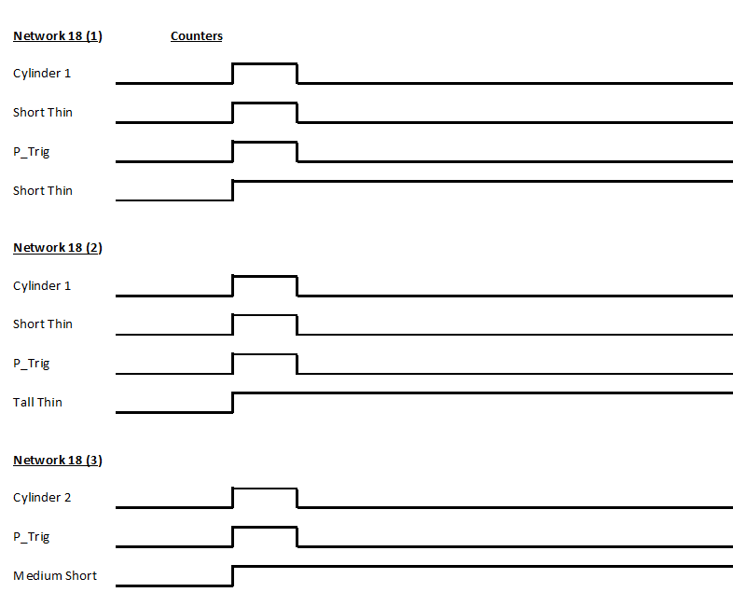
Figure-31.
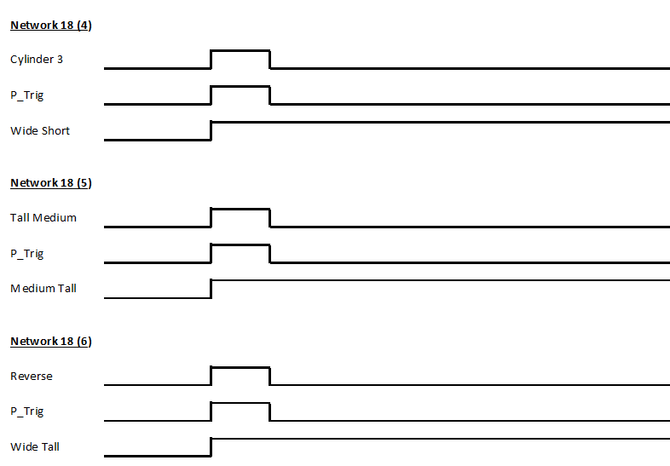
Figure-32.

Network 19
If mode1, valid and opt2_lock is set, and the conveyor speed is out of parameters after delay finishes, an error/warning will flag. Delay is required here to allow for the conveyor speed to be measured correctly.
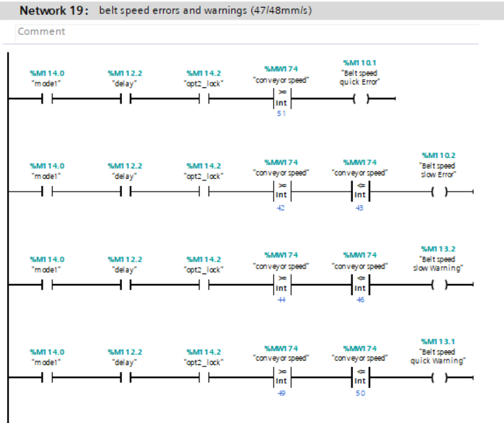
Figure-33.
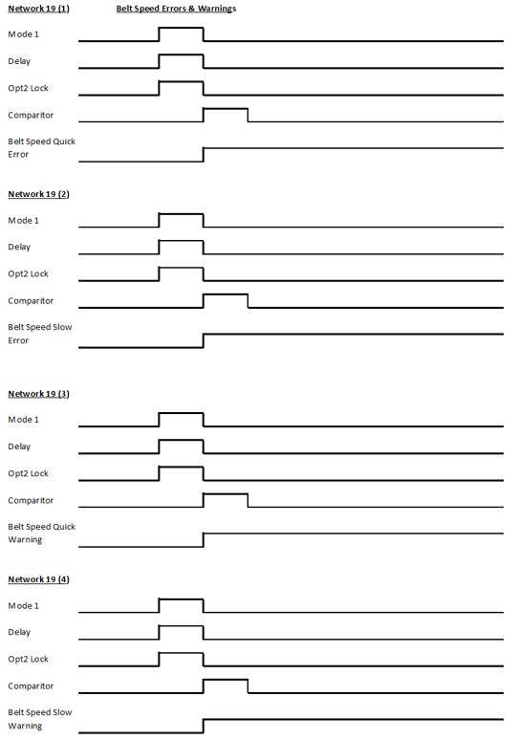
Figure-34.

Network 20
If cylinder 1, 2 or 3 extends and does not retract after the 1s timer, an error will be set.
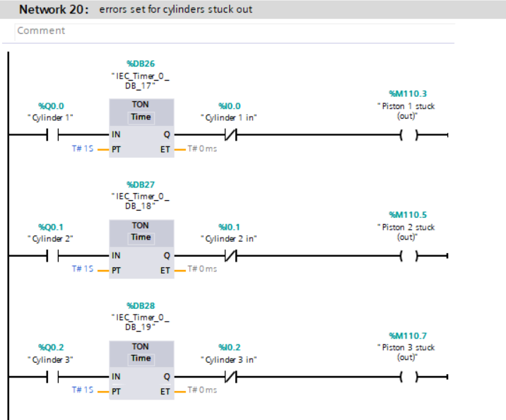
Figure-35.

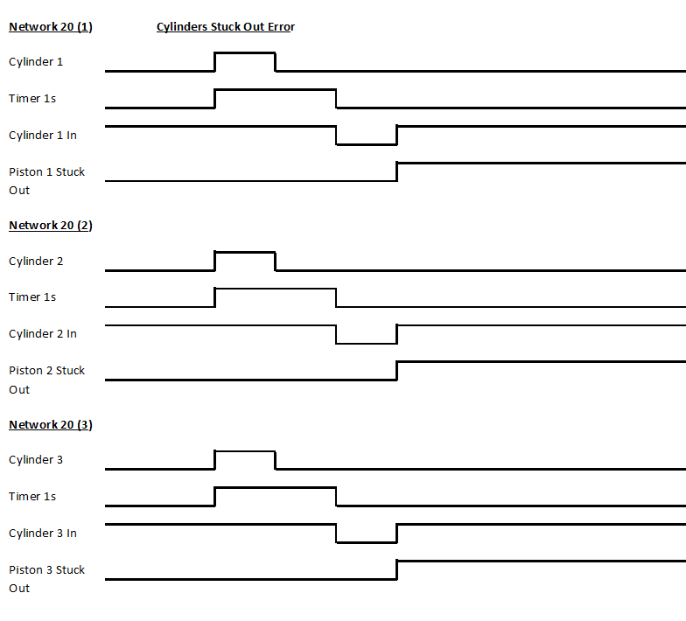
Figure-36.

Network 21
For example, cylinder 2 should extend after 3.9s so if mode1 and short_med are set and cylinder 2 does not fire after 4.2s an error will be set because a problem may be present.
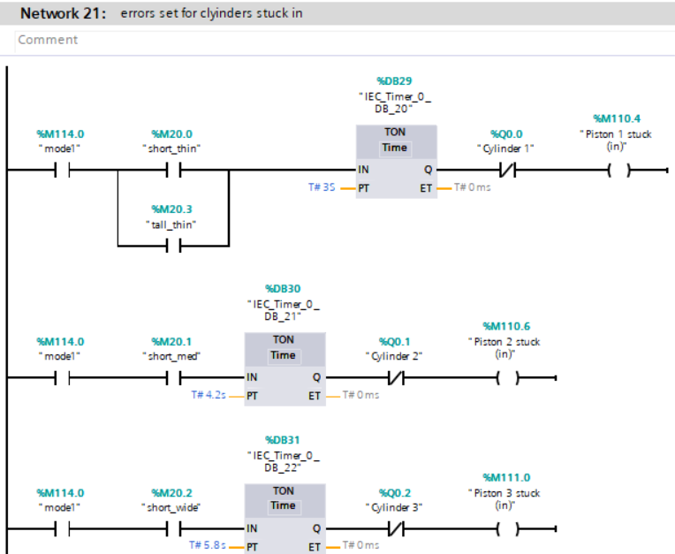
Figure-37.

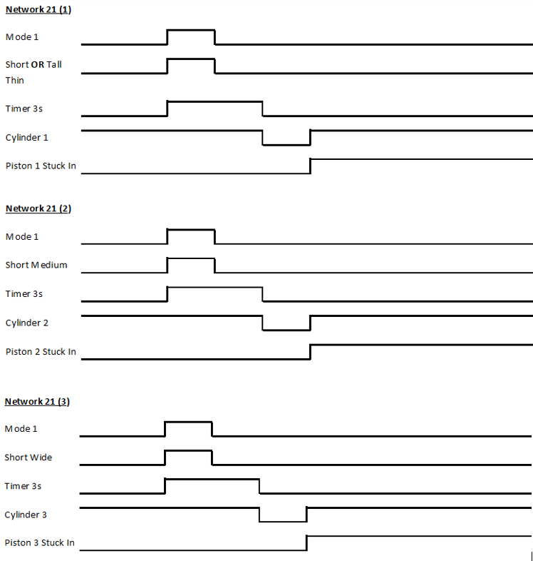
Figure-38.

Network 22
If the conveyor is set and mode1 is not activated after 60s, a warning is flagged.
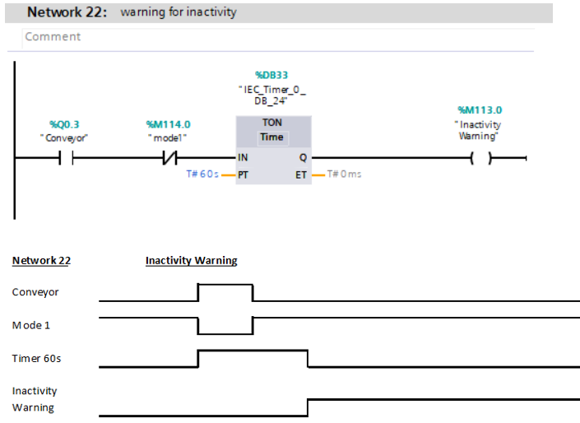
Figure-39.

Network 23 & 24
Cylinders retracting will increment a counter. When the counter reaches 7/8 then a warning/error will be set. The counter is reset by pushing the bins empty button on the HMI error screen.
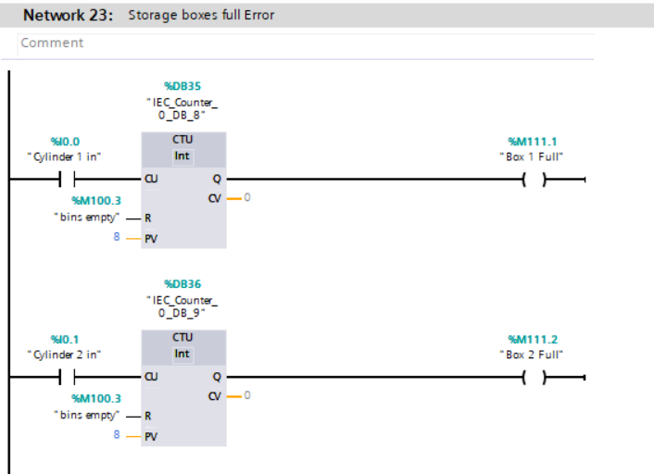
Figure-40.

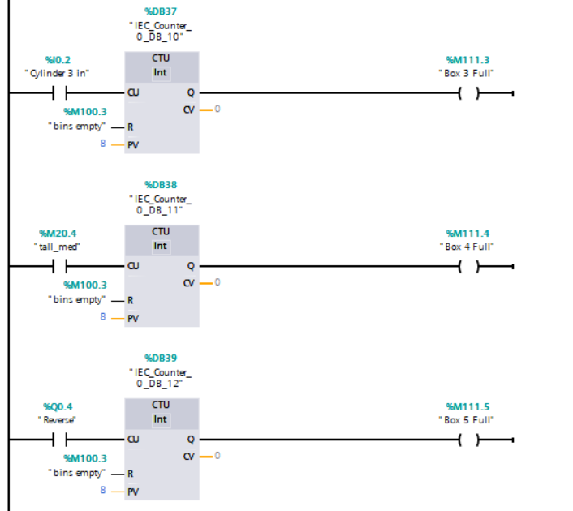
Figure-41.

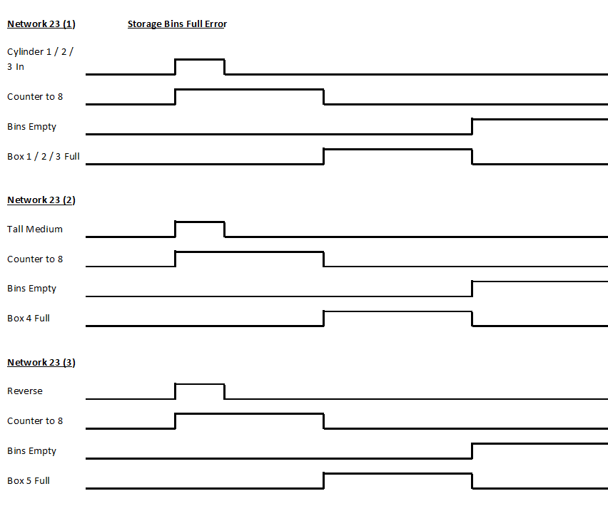
Figure-42.

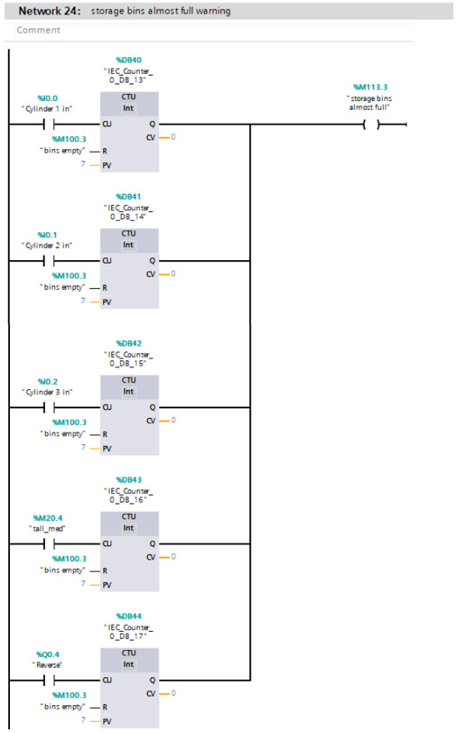
Figure-43.

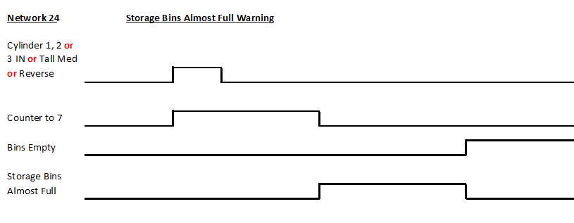
Figure-44.

Network 25
Pushing the red and green button at the same time will reset the counters and errors.
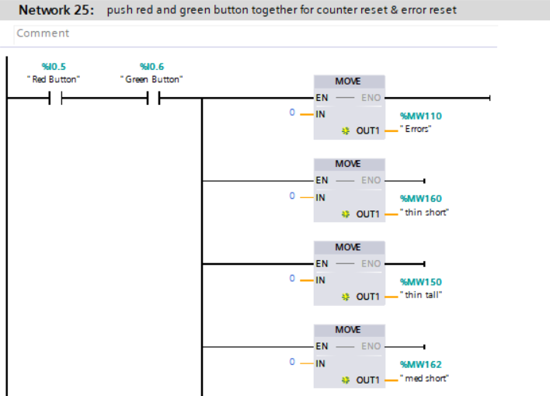
Figure-45.

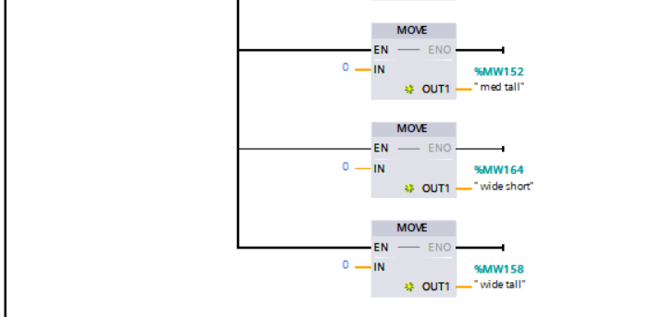
Figure-46.

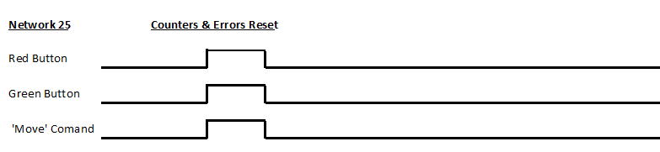
Figure-47.

HMI Home Screen Design
The HMI screens are intended to meet the specification and have a clear design with simple screen navigation. If an error/warning should occur, it should be immediately displayed clearly. The following section will show the design of the HMI screens, an error procedure and the images of the final HMI designs.
Figure 48 shows the home screen design of the HMI. The start/stop buttons will start/stop the conveyor. When the start/stop buttons are pressed, the green/red running LED will come on. The navigation buttons on the left will be installed on every screen so that transportation between screens is easy. The belt speed and emergency stop will be found on this screen along with the puck counters. If an error/warning occurs in the system, the LED lights at the bottom will activate. To further diagnose the error/warning, the user must continue to the error/warning screen.
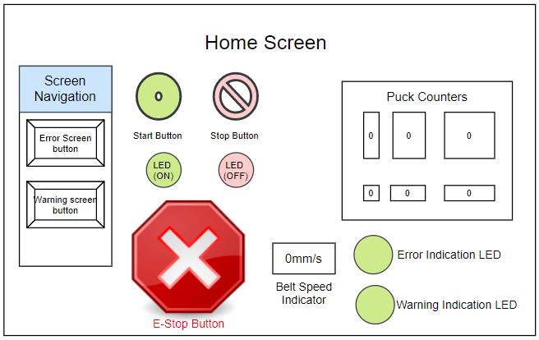
Figure 48.

HMI Error and Warning Screen Design
Figure 49 and 50 show the error and warning screen designs. Each light will be assigned an appropriate error/ warning tag on the PLC and will be clearly labelled on the HMI. The master error and storage bin reset buttons are located at the bottom of the error screen.
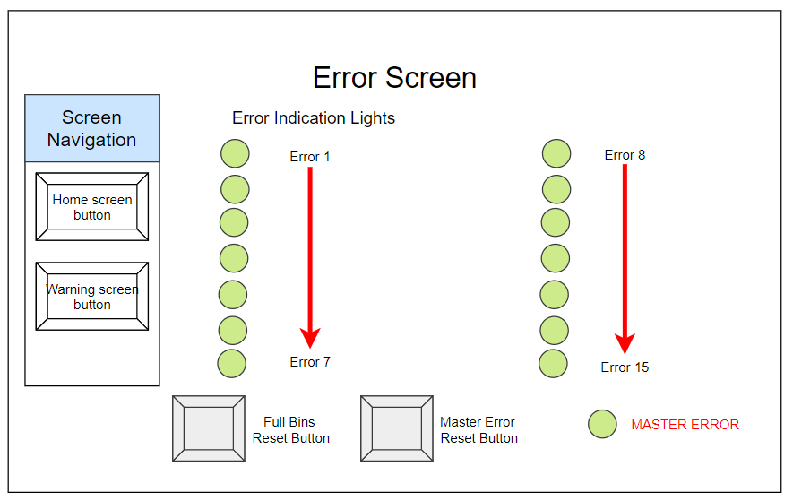
Figure 49.

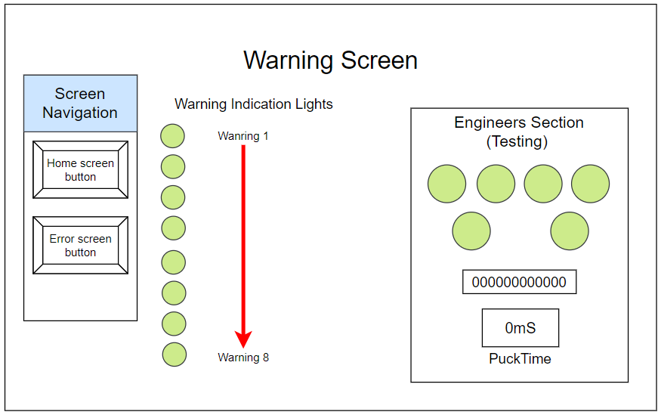
Figure 50.

Demonstration of the Error Procedure
If an error occurs, the ‘Error Indication LED’ on the home screen will turn red along with the appropriate error light on the error screen along with the master error light shown in figure 51.
When the user is ready to start the conveyor, the ‘master error reset button’ must be pressed which will clear the errors. The conveyor is now able to start.
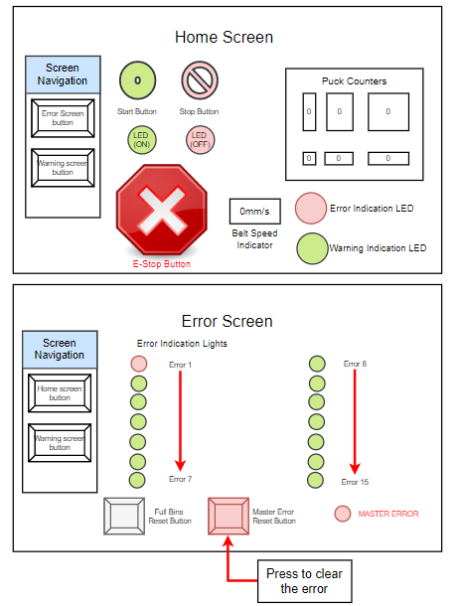
Figure 51.

Demonstration of the Warning Procedure
If a warning occurs, the ‘Warning Indication LED’ on the home screen will light up red along with the appropriate warning light on the warning screen as shown in figure 52. The warnings will not be able to stop the conveyor when activated, their purpose is just to notify the user.
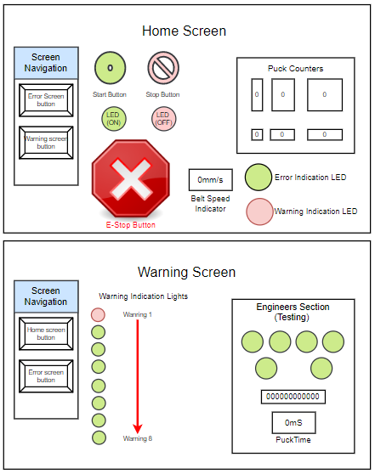
Figure 52.

Operator Check Procedure
Figure 53 outlines the steps required when an error or warning occurs in the system. This ‘traffic light’ system applies for every error and warning.
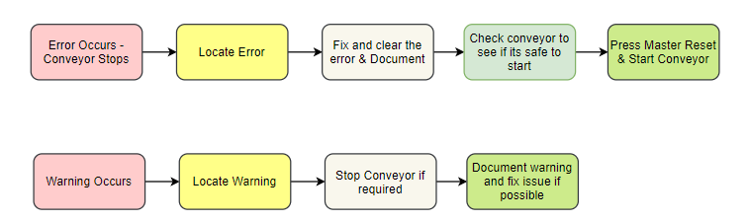
Figure 53.

HMI Final Designs
The following section will show the final look of the HMI screens within TIA V16.
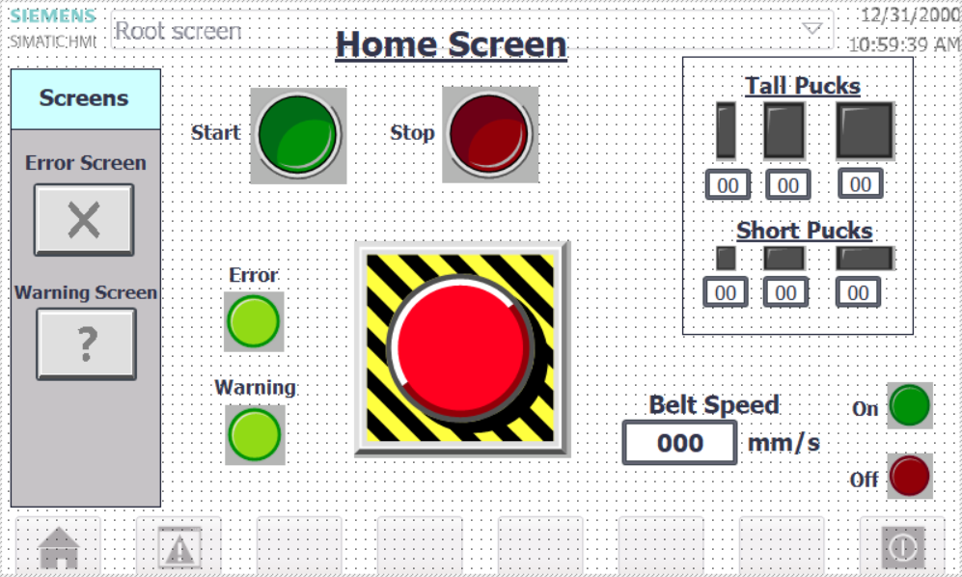
Figure 54.
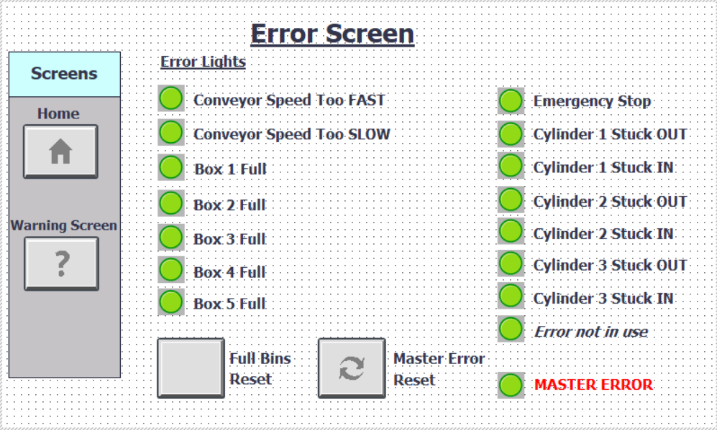
Figure 55.

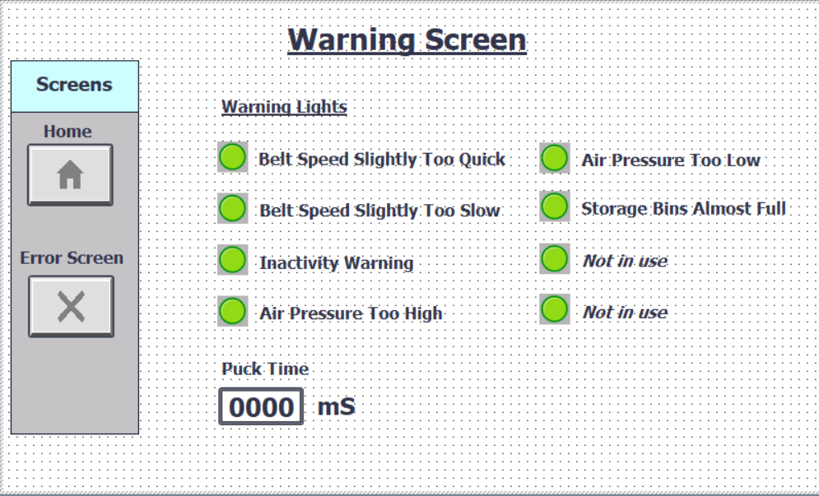
Figure 56.

Audit Document
Errors and warnings are essential for the system to operate safely and efficiently. Table-3 outlines an audit document naming each of the errors and warnings along with a description.
Fault Code | Fault Description | Re-start User Requirements
Error - Emergency Stop | Emergency stop button located on HMI screen. When pressed, error is triggered. | Disengage e-stop button.
Error - Belt speed quick error | If the conveyor speed surpasses 51mm/s an error will flag. | Check conveyor motor for fault & check conveyor for blockages.
Error - Belt speed slow error | If the conveyor speed goes below 42-43mm/s an error will flag.
Error - Piston 1 stuck (out) | If cylinder 1 extends but does not retract within 1s an error will flag. | Check air pressure & C1 for debris/blockages.
Error - Piston 1 stuck (in) | If cylinder 1 does not extend when the associated puck is flagged after 3s, an error will flag.
Error - Piston 2 stuck (out) | If cylinder 2 extends but does not retract within 1s an error will flag. | Check air pressure & C2 for debris/blockages.
Error - Piston 2 Stuck (in) | If cylinder 2 does not extend when the associated puck is flagged after 4.2s, an error will flag.
Error - Piston 3 stuck (out) | If cylinder 3 extends but does not retract within 1s an error will flag. | Check air pressure & C3 for debris/blockages.
Error - Piston 3 stuck (in) | If cylinder 3 does not extend when the associated puck is flagged after 5.8s, an error will flag.
Error - Box 1 full | If storage box 1 reaches 8 pucks, an error will flag. | Empty storage bins then press ‘Full bins reset’ button.
Error - Box 2 full | If storage box 2 reaches 8 pucks, an error will flag.
Error - Box 3 full | If storage box 3 reaches 8 pucks, an error will flag.
Error - Box 4 full | If storage box 4 reaches 8 pucks, an error will flag.
Error - Box 5 full | If storage box 5 reaches 8 pucks, an error will flag.
Warning - Inactivity | If the conveyor is running for more than 60s and mode 1 is not activated, a warning will flag. | Switch conveyor off if possible.
Warning - Storage bins almost full | If one of the storage boxes reaches 7 pucks, a warning will flag. | Empty storage bins.
Warning - Air pressure too high | Warning lights/tags in place but no function has been created. | Check air pressure.
Warning - Air pressure too low
Table-3.

Suggested Improvements
Although the PLC system created worked correctly, there are several ways in which it could be improved. Currently, tall pucks are required to break sensor 2 and to calculate speed. If no tall pucks pass through, the conveyor speed errors and warnings would become inactive. Adding a speed encoder for speed measurement or another low optical sensor near optical 2 would solve this issue.
The use of a Bluetooth connection or a Wi-Fi connection could be used to remotely access the system. This would be useful because the user could monitor the system from a different location.
Another improvement could be speed control. If the speed could be changed then this could speed up the sorting process making it more efficient. However, the timing functions for the puck storage process will have to be altered for this to work correctly.
Adding alarm sounds to the errors and warnings which would notify the user more effectively.
An air pressure sensor could be used. Numerous times during the testing process there has not been enough air pressure in the cylinders. As a result, the cylinders fail to extend properly resulting in the pucks failing to be stored correctly. An air pressure sensor would immediately flag an error/warning if the cylinders do not have enough air pressure, making the system more efficient.
The cylinders could be connected to a small compressor. Currently the cylinders are connected to a hand pump to pressurise the cylinders. A compressor would ensure that the cylinders constantly have enough air pressure to operate correctly. A compressor would also make the air pump redundant; this will save time and effort.
An error to flag objects that are outside the pucktime parameters could improve the system. Currently if an object fails to meet the pucktime parameters, then the object would travel the length of the conveyor and into bin 4 which would be problematic.
If there are puck sensors before each storage bin, then the system could be notified when the selected puck enters the correct storage bin. For example, if a medium short puck is flagged, cylinder 2 would push the puck through the bin sensor 2 and into storage bin 2. A sensor by each bin would be beneficial because if cylinder 2 extends but the puck fails to enter bin 2 then the sensor will not activate. A function could then be created to flag an error if this occurs.
Lastly there seemed to be an issue with the lights on the puck counters. It is possible that increasing the ‘delay’ timer on network 1 may solve this issue but a final test was not possible to prove it.

Bibliography

[1] | “Engineering,” 02 05 2020. [Online]. Available: http://www.ljcreate.com/uk/programs/engineering/control-and-instrumentation/hardware/318/industrial-control-teaching-set-siemens-detail.

