
Programme: Master Of Business Administration
Module: International Marketing: Principles And Practices
Assignment
Title: INTERNATIONAL MARKETING MIX REPORT
Mercedes-Benz in Germany and India
Student Name: Harsh Deep Singh
Student Id: 2436567
Submission Date: 24.6.2026
Word Count: 6800

Contents
SECTION:1 3
1 Introduction 3
1.2 Company background 3
2.Comparative Market Analysis using the PESTEL Farmwork 5
2.1 political factors 6
2.2Economic factors 6
2.3 Social factors 7
2.5 Environmental factors 8
2.6 Legal factors 8
3 STP Analysis 9
3.1 Segmentation 9
3.2 Targeting 9
3.3 Positioning 9
4. Marketing mix(7ps) 9
4.1 Product strategy 9
4.2 Pricing strategy 10
4.3 place 10
4.4 Promotion strategy 10
4.5 people 10
4.6 process 10
4.7 physical evidence 11
5. Directional development strategy (India) 11
6. Ethical issues 11
7. Recommendations 12
8. Conclusion 12
Section 2 reflective account 12
References 14

SECTION:1

1 Introduction
Operating under Mercedes-Benz Group AG Mercedes-Benz is one of the most well -known luxury car manufacturers in the world of automobiles. The company has continuously upheld its reputation for superior quality, creativity , and engineering powers. Its ability to successfully function in a variety of economic, cultural, and regulatory contexts is largely responsible for its success on a worldwide scale.
This study examines Mercedes-Benz’s foreign marketing tactics in Germany the company’s home and highly developed market, and India, an emerging economy that is expanding quickly. This paper aims to investigate how marketing strategies are influenced by macroenvironmental factors and how the company adjusts its marketing mix positioning targeting and segmentation in these two disparate markets. The paper also assesses ethical issues strategic development and offers suggestions for the future

1.2 Company background
With its headquarters located in Stuttgart Germany, Mercedes-Benz was formally founded in 1926. Operating under Mercedes-Benz group AG, it is recognized as a pioneer in automobile industry and is credited for creating first car that rained on gasoline (statista, 2024). With Operations in over 130 countries and a wide variety of vehicles, and sports automobile the corporation has established a strong worldwide presence throughout the years.
The following are the companies primary brand values:
leadership in innovation and technology.
safety and superior engineering.
elegance and super quality
future transportation and sustainability
Mercedes-Benz has put more of an emphasis on digital transformation and electrification, specially with its EQ electric car line. Global trend towards sustainability and more stagnant environmental law are reflected in this strategic change (Daimler, 2023).

Operations in India versus Germany the company's home market and main centre for R&D and innovation is Germany. The market is well established with a high level of brand loyalty and a robust desire of cutting edge, environmental friendly automobiles (OECD, 2023).
Mercedes-Benz has been growing in India, a higher growth emerging market, by using localization technique including domestic production and product adaption tailored to the local market. To cut expense and increase accessibility, the corporation set up production facility in India( IBEF, 2023) strategic significance. India offer potential for growth whereas Germany offers stability and innovation. They are perfect markets to analyze international marketing technique because of this disparity.

- GDP per capita comparison

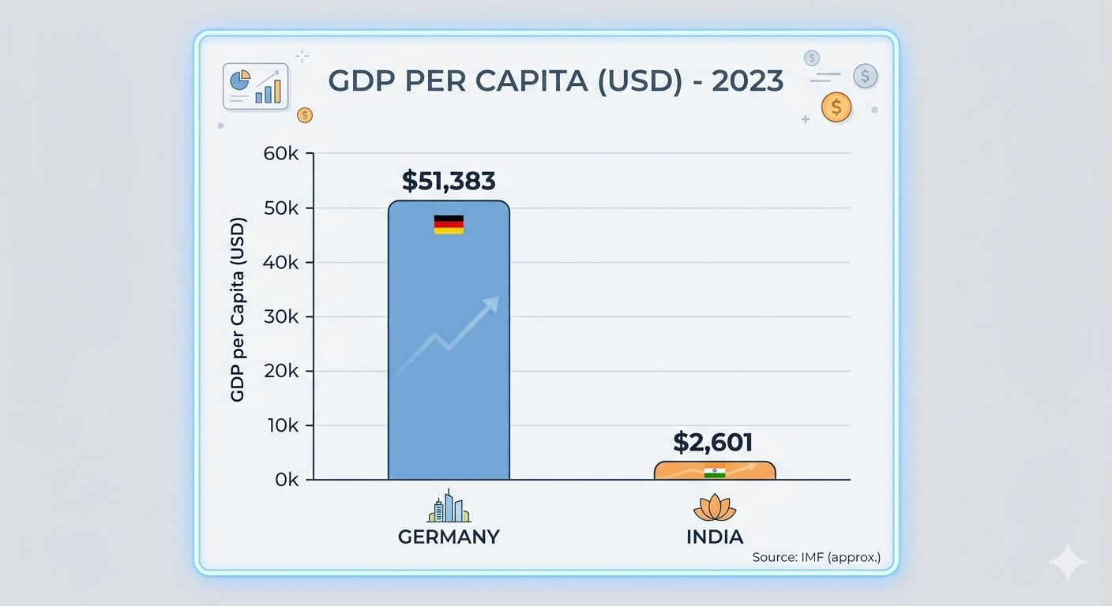
Source :-Gemini

Germany versus India GDP per capita
Due to greater purchasing power and economic maturity, Germany’s GDP per capita is substantially larger than India's (world bank, 2024). Mercedes-Benz price strategy and target market are directly impacted by this differential because Germany consumer can afford luxury car better than those in India, where demand is concentrated among wealthier sectors.

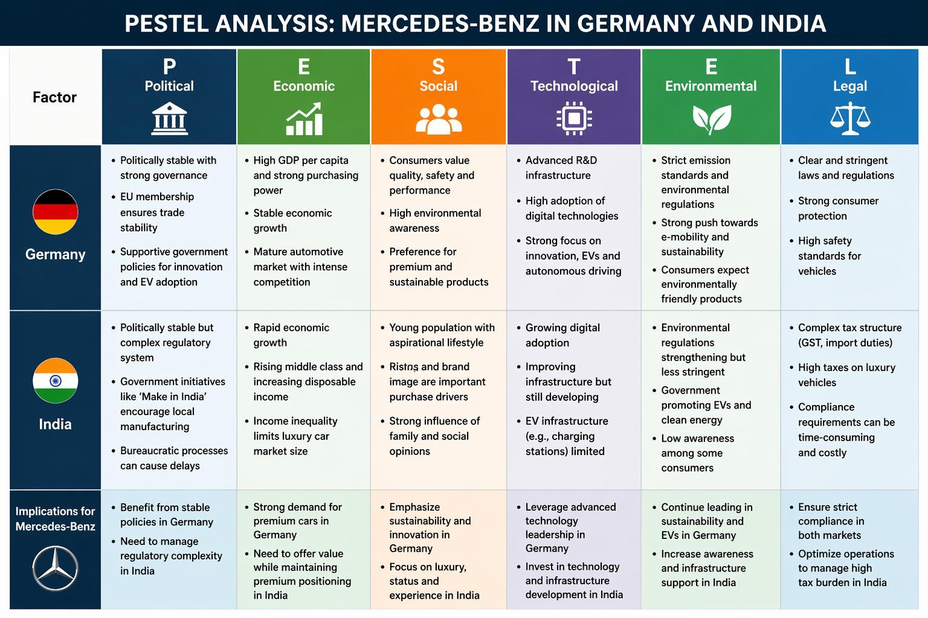

Figure 1 Mercedes-Benz pastel analysis in Germany and India
A thorough analysis of the macro environmental element influencing Mercedes-Benz in both market is given in Figure 1. It emphasized that although India offers economic prospect coupled with complicated regulation and limited infrastructure, Germany offer a stable, technological advanced, and environmental regulated environment. Due to this variations, Mercedes-Benz must implement an adaptable and AGILE global marketing strategy (Kotler et al., 2020)

2.Comparative Market Analysis using the PESTEL Farmwork
An organized method for examining the macroenvironmental elements influencing corporate operations is the PESTEL farmwork.
Mercedes-Benz’s worldwide marketing strategies are shaped by the significant variations between Germany ad India

2.1 political factors
Germany’s participation in the European Union and robust governance systems provide a very stable political environment. In general, policies are open and encouraging of innovation, especially when it comes to green technologies and sustainability. Mercedes Benz and other automakers have accelerated their electrification efforts due to government subsidies for electric vehicles. Stable political regimes according to Hill (2021) lessen uncertainty and make long term strategic planning easier.
India, on the other hand, offers a more complicated political landscape. It is marked by bureaucratic processes and regulatory difficulties despite being politically stable. Policies like the “Make in India” campaign encourage international companies to set uo local production facilities in order to support domestic manufacturing. Mercedes-Benz’s choice to increase manufacturing base in India has been directly impacted by this However administrative hold-ups and inconsistent regulation can rise operating expenses and make plan execution more difficult ( Kotler et al., 2020)

2.2Economic factors
Germany represents a mature and high income ignore me with strong purchasing power and well developed infrastructure due to their relatively higher discretionary Earnings , German consumer are you able to purchase luxuries like high end cars
demand is driven by quality performance and technical innovation in this FIERCELY competitive but steady market
India on the other hand has growing middle class and fast economy growth. The extent of luxury car market is constrained By the substantial income inequality that still exists notwithstanding this growth. High net worth individual and wealthy consumers are the main buyer of luxury cars, which continue to be aspirational products . According to STATISTA 2024, while the Indian luxury car market is expanding it remains relatively small compared to download the markets. Because of this economic gap, rigorous pricing and product strategies are required to strike a balance between accessibility and exclusivity.

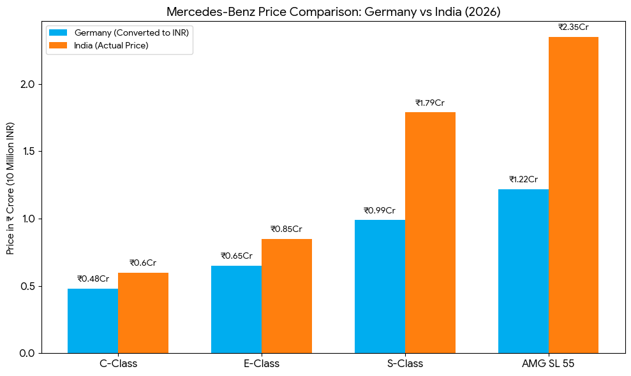

Source:- Google
Due to import taxes and levies, prices are much higher in India. In order to stay competitive, localization measures are needed as they are lower affordability.

2.3 Social factors
Consumer behavior is significantly influenced by social and culture factors. Functionality efficiency, and sustainability are typically given top priority by German consumers. Purchase decision are influenced by high culture emphasis one environmental responsibility specially in the car industry. environmentally friendly technology and electric automobile are becoming more and more popular among German consumers. According to Hofstede’s culture Dimensions, customers in Germany preferred dependable and well engineered products because of the countries high level of individuality and uncertainty avoidance (Hofstede, 2011).

Social dynamic are very different in India the population is younger and aspirational value of social standing have a big impact on consumer behavior rather than being merely useful vehicle luxury car are sometimes seen as a status and success makers. Because of this cultural emphasis on status consumption branding and image have significant impact one consumer choice. Because of this Mercedes-Benz’s marketing tactic in India place a great emphasis on lifestyle positioning and emotional appeal.

2.4 Technological factors
Thanks to significant investment in R&D Germany is a global leader in automotive innovation. The nation is at forefront of autonomous driving technologies and has sophisticated infrastructure for electric mobility. This ecosystem helps Mercedes-Benz create and implement cutting edge technology.
India is rapidly advancing its technology capabilities especially in the areas of digitalization and mobile communication but the infrastructure need it for electric vehicles to be widely used still evolving according to Deloitte (2023), Physical infrastructure is still a barrier even though digital adoption in India is quickening. The Rate At which cutting edge automobile innovation can be introduced in the Indian market is impacted by these technological divide.

2.5 Environmental factors
The global automotive sector is becoming more and more impacted by environmental issues. Strict emission requirements and sustainability promoting policies are just two of the environmental law that Germany enforces. Manufacture are required by these requirement to invest in electrical mobility solution and give low emission vehicle priority.
Although exhaustion is not as rigid, India is likewise moving towards more stringent environmental restriction. Although government programs encouraging electric cars are gaining traction, adoption is still restricted because of infrastructure issues high prices. As a result Mercedes-Benz needs to strike a compress between local market realities and its global environmental goals.

2.6 Legal factors
Germany has a wealth established legislative system that guarantees high safety standard and robust consumer protection. Although adhering to these rules boosts customer confidence, it also rises operating expenses
India has more complicated legal system, and pricing method are greatly impacted by hefty taxes and important levies. Although the good service tax has somewhat simplified taxation luxury car continued to be subject to high tax rate. Mercedes-Benz must modify its pricing and production plans in order to stay competitive due to this regulatory complication.

3 STP Analysis

3.1 Segmentation
Mercedes-Benz divides the German market according to lifestyle environmental conscience, and income level. High income professionals, business clients, and environmental conscious customer looking for sustainable mobility option make up the main market categories.
Because the luxury market in India is smaller, segmentation Is more targeted. The business caters to wealthy people, business owners, and an increasing number office and professional with large disposable incomes. Psychographic segmentation is important because consumers are motivated by social status and goals.

3.2 Targeting
Mercedes-Benz has a strategy of differentiated targeting. The company target a wide range of luxury client in Germany, including both typical luxury purchaser and buyer who care about environment. In India, and each market made-up high net worth individuals newly affluent customers is the focus. The organization is able to adopt local market situation while maintaining its premium positioning thanks to this focus strategy.

3.3 Positioning
Mercedes-Benz is regarded as a representation of luxury, ingenuity, and excellent engineering on a global scale. In line with consumer values, Germany plays a stronger focus on sustainability and technological superiority. The brand is positioned as status symbol in India emphasizing exclusivity distinction and lifestyle appeal. The company's capacity to modify it's brand messaging for various cultural situation is demonstrated by this dual positioning strategy.

4. Marketing mix(7ps)

4.1 Product strategy
Mercedes-Benz uses a product strategy that is mostly standardized with a few exceptions. Electrical cars and cutting edge model make up a large portion of Germanys product line. In response to customer desire for innovation and personalization, the company provides a wide range of customization choice.
Product adoption is more noticeable in India. Long wheelbase models and improved rear seat comfort are example of how cars are made to accommodate regional tastes. Although corporation is progressively growing its EV line, the availability of electrical vehicle is more restricted because of infrastructure limitations.

4.2 Pricing strategy
The two markets have quite different pricing practices. Rising in Germany is competitive within the luxury market while being in line with the brand premium attributes. Value and quality are important to consumers than pricing.
Due to important taxes and levies prices are significantly higher in India. Mercedes-Benz addressed this issue by boosting domestic production, which lowers the expenses. Price sensitivity is still a significant element affecting consumer behavior though.

4.3 place
Mercedes-Benz has a vast and well established distribution network in Germany that is backed by both physical store and online platforms. Convenience and accessibility for customers are improved when online and offline channel are integrated the geographic concentration of wealthy consumer in India is reflected in the distribution concentration in large cities to meet growing demand the business is progressively growing into Tier 2 cities. In order to reach tech savvy customers, digital Ave. are also being more crucial.

4.4 Promotion strategy
The two markets have rather different promotional tactics. Innovation sustainability, and superior engineering are highlighted in German marketing communication. Campaigns frequently the advantage of technology and the environment
promotional activities in India and status. Celebrity endorsement and aspirational images are often used in advertising efforts to appeal consumer needs for social recognization. Social media and digital marketing are essential for reaching younger people.

4.5 people
in order to deliver the brand experience, employ play a crucial role. The emphasis on product knowledge and engineering quality is reflected in the highly trained and technical proficient staff in Germany
customer service and relationship management are main priorities in India. In order to create enduring customer relationship and improve the entire brand experience, personalized service is crucial.

4.6 process
Germanys operational producers are quite effective and standardize guaranteeing dependability and consistency. Process in India are modified to meet local consumer expectations, which may initial lengthier decision making cycle and a strong focus on face to face communication.

4.7 physical evidence
brand positioning is reinforced in a large part by tangible proof. Showroom in Germany are made to be efficient and minimalist, with an emphasis on the product. Showroom in India are more urgent and opulent, fostering an atmosphere that appeals to customers demand for exclusivity and supports the brand premium image

5. Directional development strategy (India)
One way to describe Mercedes-Benz approach in India as market development. By launching new items and focusing on new clientele , the corporation aims to increase its market share. Increasing local production, and improving digital capability are important efforts. The business is also making investment in electric vehicles however due to infrastructure obstacle development is slow.
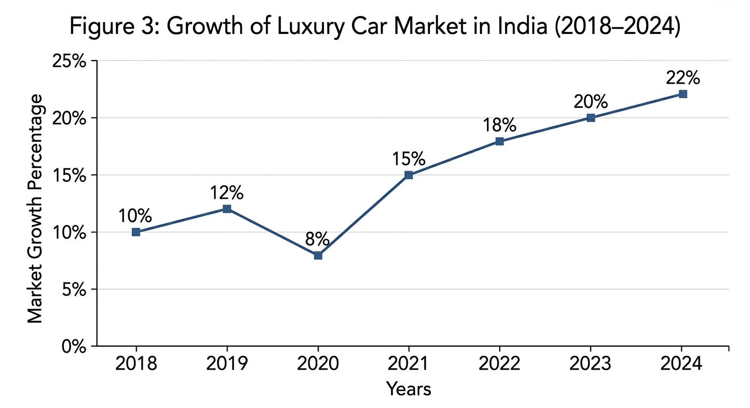
India's luxury car market growth (2018 to 2024)
The market for luxury cars in India has been steadily expanding, S seen in the figure, which highlighted increased consumer demand brought on by rising disposable income and aspirational buying behavior. This increasing trend support long term investment and expansion choice by highlighting India's strategic significance for Mercedes-Benz marketing development strategy. (IBEF, 2023)

6. Ethical issues
in international marketing, ethical issues are becoming more and more crucial . Mercedes-Benz must deal with a number of moral dilemmas, suggest pricing policies, social responsibility, and the influence on environment. Although the environmental impact of industrial process is still a problem, the shift to electric vehicles show a commitment to sustainability. While luxury marketing may exacerbate societal divisions, higher prices in India create concern about accessibility and inequality.

7. Recommendations
In addition to investing in charging infrastructure through partnership Mercedes-Benz should keep growing its line of electric vehicle in India. Increasing domestic production can lower expenses and boost accessibility. In order to improve client involvement and customize the purchasing experience, the business needs also bluster its digital marketing tactics. Lastly, putting more of an emphasis on corporate social responsibility and sustainability can improve brands reputation and fit in with international trends

8. Conclusion
this study shows how Mercedes-Benz successfully modify its global marketing tactics to suit various market circumstance India has sustainable development potential due to aspirational consumer while Germany is a mature market by sustainability. The company sustained success depends on its capacity to strike a balance between local adaption and global uniformity

Section 2 reflective account
- Description
For this assignment Mercedes-Benz in two different markets haws subject of two investigation of worldwide tactics. The application of theoretical framework like PESTEL, STP, end marketing mix was necessary for the study Process.
- Feelings
the intricacy of the subject and the amount of necessary research were difficult at start of the task. But as the study went on, confidence grew and the framework became easier to use.
- Evolution
research and analytical skills were successfully developed as a result of the assignment. Accessing current data and guaranteeing necessary depth in comparison, however, presented difficulties.
- Analysis
the study emphasized how circular culture and economic variation are in determining marketing tactics. It also illustrated how useful theoretical framework are organizing analysis
- conclusion
understanding of worldwide marketing and strategic decision making was much improved by the task

- action plan
further research, better time management, and a stronger focus on critical review will be part of future efforts.

References
Automotive industry statistics. World Bank (2024) World Development Indicators.
De Mooij, M. and Hofstede, G. (2010) ‘The Hofstede model’, International Journal of Advertising, 29(1), pp. 85–110.
Available at: https://doi.org/10.2501/S026504870920104X (Accessed: 22 April 2026).
Hofstede, G. (2011) ‘Dimensionalizing cultures’, Online Readings in Psychology and Culture, 2(1). Available at: https://doi.org/10.9707/2307-0919.1014 (Accessed: 22 April 2026).
Kotler, P. and Keller, K.L. (2016) Marketing Management. 15th edn. Pearson.
Li, X. (2022) ‘An analysis of Mercedes-Benz marketing strategy’, Frontiers in Business, Economics and Management, 6(1), pp. 87–89.Available at: https://doi.org/10.54097/fbem.v6i1.2287 (Accessed: 22 April 2026).
Li, Y. and Wang, Y. (2021) ‘Marketing strategies of Mercedes-Benz’, Proceedings of ICEMCI Conference. Available at: https://doi.org/10.2991/assehr.k.211209.106 (Accessed: 22 April 2026).
Okonkwo, U. (2009) ‘Sustaining luxury brands’, Journal of Brand Management, 16(5), pp. 302–310.
Available at: https://doi.org/10.1057/bm.2009.2 (Accessed: 22 April 2026).
Steenkamp, J.B.E.M. and Ter Hofstede, F. (2002) ‘International market segmentation’, International Journal of Research in Marketing, 19(3), pp. 185–213. DOI: 10.1016/S0167-8116(02)00076-9.
Sudhir, K. (2001) ‘Competitive pricing behavior’, Marketing Science, 20(1), pp. 42–60.
Available at: https://doi.org/10.1287/mksc.20.1.42.10197 (Accessed: 22 April 2026).
Tellis, G.J. (1986) ‘Beyond the many faces of price’, Journal of Marketing, 50(4), pp. 146–160.
Available at: https://doi.org/10.1177/002224298605000412 (Accessed: 22 April 2026).
Wichmann, J.R.K., Wiegand, N. and Reinartz, W.J. (2022) ‘The platformization of brands’, International Journal of Research in Marketing, 39(2), pp. 502–521. Available at: https://doi.org/10.1016/j.ijresmar.2021.09.001
(Accessed: 22 April 2026).

