

PROGRAMME: BA (HONS) LEADERSHIP AND MANAGEMENT SKILLS FOR THE WORKPLACE
MODULE: MANAGING BUSINESS INFORMATION
MODULE CODE: LCLM 5004

Assignment Title: Component 2- Individual report- Information Systems Improvements

Student Name: Nicoleta Busu
Student ID:
Table of Contents
1.0 Introduction 3
1.1 Overview of the business case 3
1.2 Identification of key challenges faced by the business 3
2.0 Evaluation of the existing systems 4
2.1 Analysis of the current information systems in place 4
2.2 Identification of inefficiencies and gaps 5
3.0 Recommended solution 6
3.1 Proposal of a new or upgraded information system 6
3.2 Justification of the recommendation 7
3.3 Explanation of how the system will improve operations, data management, and decision-making 8
4.0 Implementation Plan 9
4.1 Steps for implementing a new system 9
4.2 Consideration of certain challenges 10
5.0 Conclusion 11
References 12

1.0 Introduction

1.1 Overview of the business case
The enterprise Kalori Ltd has been operating as a consumer electronics retailer through 30 physical stores located in convenient, consumer-accessible locations, and its e-commerce division that caters to the needs of other buyers. Their efficiency is hindered due to the poor execution of information systems. This is primarily because the company continues to rely on outdated systems, along with manual delivery of processes that carry customer data, inventory records, and departmental exchanges of information. Hence, there exists a need to improve their information system as a whole.

1.2 Identification of key challenges faced by the business
Some of the challenges which are visible from the case study are as follows.
Firstly, Kalori Ltd rely on manual inventory tracking, which creates perpetual problems to track stock, especially when tallying with physical store contents and those available for online giveaways (Vaka, 2024). Such confusion leads the consumer to become dissatisfied with purchases from the company and initiate refunds.
Secondly, data fragmentation is another concern for Kalori Ltd, with customer information becoming scattered around disconnected systems (Steininger et al., 2022). This prevents the customer management department from executing better relationship maintenance routines with consumers.
Thirdly, sales records are compiled using Excel spreadsheets, which create deficiencies during compilation, resulting in outdated data and an impediment to decisions. Such data also remains non-compliant with GDPR (Smirnova and Travieso-Morales, 2024).
Finally, there exists poor coordination between departments, including their integration of inter-departmental data (Smirnova and Travieso-Morales, 2024). As a result, communication breaks down between finance, sales, and other inventory management groups.

2.0 Evaluation of the existing systems

2.1 Analysis of the current information systems in place
The current information systems managed by Kalori Ltd are reflected by characteristics like fragmentation of legacy architecture, including misalignment between the firm's need for growth and the available resources at hand (Sunarta and Dwi Astuti, 2023). As a result, the information system could be better understood with respect to a theory forwarded by William Delone and Ephraim Mclean, also known as the ‘information systems success model’ established during 2003 (Sunarta and Dwi Astuti, 2023).
Theoretically, the case of Kalori Ltd reveals that the company's overall system quality, service efficiency, and information integration are heavily compromised (Fu et al., 2022). This results in a mismatch between their implementation usage and overall satisfaction garnered from its usage, which reduces the final net systems benefit (Sunarta and Dwi Astuti, 2023). Therefore, the theory states that for any information system to be successful, the system management based on the above-mentioned factors becomes critical (Steininger et al., 2022).
However, as witnessed for Kalori Ltd, their manually directed inventory handling, followed by spreadsheet-dependent reporting, and misaligned customer databases, creates all the necessary factors for a breakdown of communication and information-specific collaboration between departments (Pearlson et al., 2020, p 62-228). This limits any scope through which they can work for generating a real-time processing capacity, or even maintaining consistent data handling (Fu et al., 2022).
Kalori Ltd also relies on spreadsheets for tabulating customer information, without depending on any MIS-based software. A PwC report on data analytics executions around the world shows that 62% executives rely on experience for better managing customer data, but such experience is catered by better robust software mechanics (PricewaterhouseCoopers, 2020). That is lacking within Kalori Ltd.
Moreover, Kalori Ltd experiences major fragmentation of its CRM data or customer relationship management-based information. This prevents the business from understanding its customers in a better manner, while looking to serve products and services as per their preferences. For instance, with 71% customers often switching brands, lifestyles, and affording patterns, up to 66% of them believe that sharing details with companies about their interests can better enable a firm to respond to their requests (Salesforce, 2022). This is better recognisable in Figure 1. However, the same is difficult in the case of Kalor Ltd, which, due to its scattered data, fails to understand its customers (Salesforce, 2022).
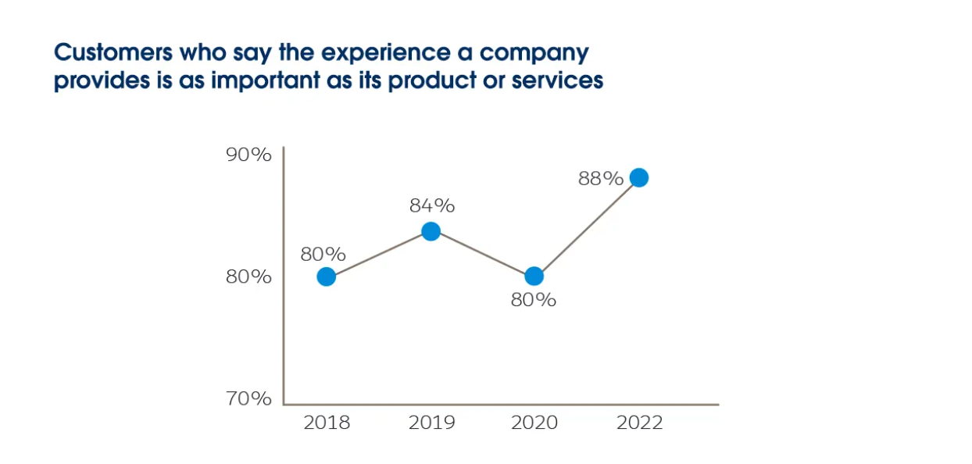
Figure 1: Customer belief in information exchange
(Source: Salesforce, 2022)

2.2 Identification of inefficiencies and gaps
The gap and inefficiency in Kalori Ltd's information system makeup arise from its data governance complications and lack of better regulatory compliance. As the organisations have weak access controls, there is a greater likelihood that they will fail to secure the current data which they deal with daily. This exposes them further to GDPR posed risks. For instance, since 2018, companies with a non-commitment attitude towards GDPR policies and guidelines have had to experience significant fines (Chee, 2025). An e-commerce giant, Amazon, had to give way to an $812 million penalty, as imposed by Luxembourg's data protection establishment (Chee, 2025). This was mainly because the company had inadequate data security measures in place to manage risks. A similar fate can also befall Kalori Ltd.
Furthermore, there is a lack of value-activity linking on the part of Kalori Ltd's departments, viz., finance, sales, and inventory management. This leads to increasing operational costs, which can be incurred towards an improved ERP system (Pearlson et al., 2020, p 62-228). That allows better functionality as a whole for the firm.

3.0 Recommended solution

3.1 Proposal of a new or upgraded information system
To understand the scope of improving its existing information system, it will be important for Kalori Ltd to look at its innovation challenges through the spectrums of scholars Michael Porter and Victor Millar, who proposed the 'value-chain theory' in 1985 (Chou and Shao, 2022).
The theory expressed the opinion that technologies often lead to a competitive advantage for an organisation, when their internal capabilities or primary responsibilities look to link with other support activities (Suharman et al., 2023).
As a result, with the same linkage lacking in the case of Kalori Ltd, an ERP system connection including CRM specialities and cloud service distribution could ensure their departments, featuring finance, sales, and inventory, along with customer management, work together in coordination as expressed in Figure 2 (Suharman et al., 2023). It will also ensure that any existing manual data handling on the part of the organisation becomes stymied or is permanently eradicated (Siddique, 2025). For instance, a 2022 IDC report stated that when retailers relied on industry-specific ERP systems, they converted their operational efforts to create a 5.3% revenue fulfilment. Previously, the same revenues used to be around 2.9%, courtesy of failing inventory checks, poor customer retention, and better match of sales targets (Siddique, 2025).
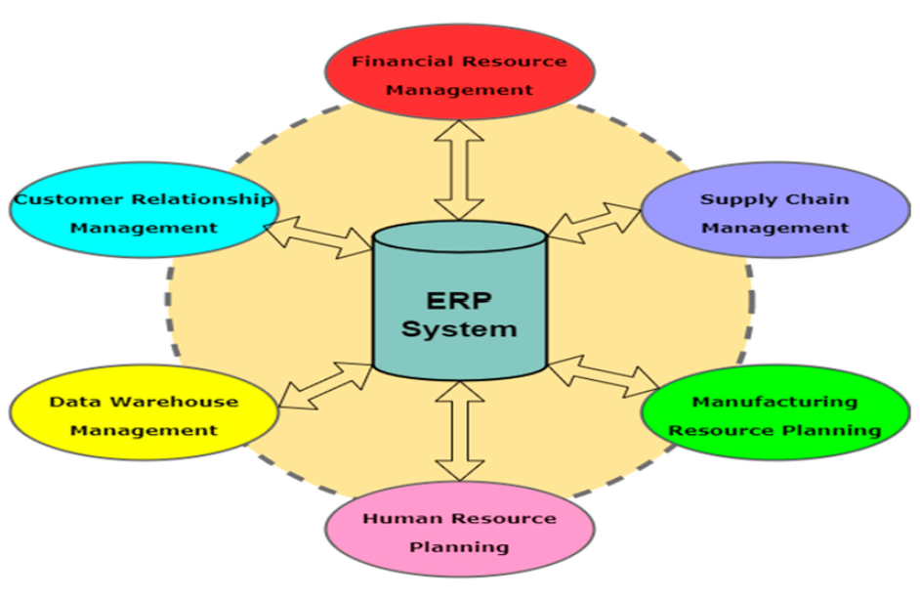
Figure 2: The ERP system permitted coordination between departments
(Source: https://www.researchgate.net/figure/The-framework-of-the-ERP-system_fig3_361488973)

3.2 Justification of the recommendation
An ERP system will not only allow Kalori Ltd to mitigate its supply chain and customer management shortcomings, but it will also provide additional interfaces handling CRM responsibilities, which will enable consolidation of data (Maruf, 2025). This brings ERP to CRM integration for facilitating coordination among all its departments. Its results have always proven successful in the case of other retailers, as revealed below.
Firstly, reputed retailer Walmart managed to overcome their inventory ordeals by switching to ERP processes that utilised RFID tracking (radio frequency identification) to deploy order fulfilment responsibilities (Kay, 2022). It also allowed them to ensure no understocking or overstocking problems plagued them on a going basis (Kay, 2022).
Secondly, Adidas migration into a dependable ERP system of SAP S/4 HANA with a cloud interface allowed them to increase their supply chain visibility, especially by sorting high-demanding clothing or footwear articles and comparing the same with existing supplies (Grill-Goodman, 2021).
Thirdly, another multinational retailer, Best Buy, reaped the benefits of ERP systems through its CRM features, by improving their customer engagement and generating 77000 messages in real-time for tackling customer queries, their need for meetings with customer relationship managers, and understanding its customers' preferences before conversion of ultimate purchase decisions (Debogovich, 2025, p 1-2).

3.3 Explanation of how the system will improve operations, data management, and decision-making
The ERP system with cloud interface and customer management service packages can improve Kalori Ltd's operational commitments, data management responsibilities, and overall decision-making in the following manner (Johansson and Byström, 2024).
Firstly, many retailers have been reported to have witnessed a 20% higher inventory-related turnover, which was witnessed after they installed ERP software. This created a 60% reduction in stockouts, followed by a 30% cut in excess overstocking (Gujral, 2024). As a result, operationally it allowed the company to cater 5% more customers in a better manner (Gujral, 2024).
Secondly, while depending on its ERP systems, which can be custom-modified, Kalori Ltd can automatically ensure seamless compliance through GDPR (General Data Protection Regulations). The application can provide better storage, ensuring privacy of consumer data, restricted access for unprivileged members, and tracking requests (Maruf, 2025).
Thirdly, under ERP embedded data silos, Kalori Ltd can create intelligent dashboards to track any past errors which cropped up from spreadsheets. They can correct such errors and then compare all departmental data together for making decisions (Johansson and Byström, 2024). They can even communicate with their finance, sales, and inventory management departments through the ERP systems (Johansson and Byström, 2024).

4.0 Implementation Plan

4.1 Steps for implementing a new system

Integral Phases | Activities | Responsible Teams handling | Timeline
Discovery phase | Mapping the processes, including POS or point of sale executions, financial considerations, CRM controls, and inventory distribution (Charles et al., 2023) | IT consultant, chief, and operations manager | 4 weeks
Selecting a trustworthy and appropriate vendor | Considering the ERP solution providing vendor, their pricing strategies, and their architectural designs, which can suit the needs of Kalori Ltd (Charles et al., 2023) | Procurement manager and the IT team | 6 weeks
Data migration with pilot testing | Migration of data from existing silos into new interfaced systems, including inventory, customer records, and financial records (Yaseen et al., 2025) | Different store managers, the IT manager and other data handling experts | 10 weeks
Final rollout | API integration using ERP silos to facilitate e-commerce distribution, including regional rollout of the software (Yaseen et al., 2025) | IT department and vendor partner | 6 months
Training facilitation | Departmental training on a phase-wise basis with additional workshops (Yaseen et al., 2025) | IT department trainers and vendor partner trainers | 3 months
Final monitoring | Tracking performances of inventory management, customer data reports, and financial reports (Paulsson and Johansson, 2023) | All company departments | 3 months

4.2 Consideration of certain challenges
Some of the challenges which might be encountered based on the above implementation plan for Kalori Ltd are as follows.
Firstly, Kalori Ltd is a relatively moderate-sized enterprise, and although it has enjoyed healthy sales in the last few years, it is also unlikely that it can come up with higher affordability for its ERP software-related purchases. Thus, the software requirement could stretch their operational budgets (Weerasekara and Gooneratne, 2022). However, the company can rely upon fixed contracts with vendors to ease budgets.
Secondly, initially, their ERP systems can be slow for implementation, which can allow their initial handlers or IT executives to grow impatient and try to accelerate processes within the silos, resulting in further errors (Hustad and Stensholt, 2023). A staged pilot rollout process could help to ease the implementation routine.
Thirdly, existing complexities within legacy systems associated with the current ERP systems used by Kalori Ltd might become too hectic for normal departmental executives to handle despite training regimes (Paulsson and Johansson, 2023). Continuous training can assist the executives in understanding the process of the ERP software.
Fourthly, the company might suffer from adoption gaps, which require key performance indicators to be constantly measured with feedback loops (Paulsson and Johansson, 2023).

5.0 Conclusion
The proposal revealed how Kalor Ltd, despite its initial financial success, was exposed to significant information system-related shortcomings. These included inefficient inventory tracking that relied on manual handling, customer relationship management with fragmented data under manual spreadsheets, limited compliance with GDPR requirements, and an overall miscommunication between departments due to the above reasons. Thus, when the organisation decides to use ERP systems with cloud interface and customer management support modules, it will likely help the firm to centralise its information and cultivate automated processes to increase real-time visibility. It will also likely increase their compliance routines with GDPR claims. However, for the same approach, better budgets, stronger leadership, and responsible training guidance are needed.

References
Charles, O.I., Hamza, O., Eweje, A., Collins, A., Babatunde, G.O. and Ubamadu, B.C. (2023). Business Process Re-engineering Strategies for Integrating Enterprise Resource Planning (ERP) Systems in Large-Scale Organizations. International Journal of Management and Organisational Research, 2(1), pp.142–150. Doi: https://doi.org/10.54660/ijmor.2023.2.1.142-150.
Chee, F.Y. (2025). Amazon loses court fight against record $812 mln Luxembourg privacy fine. Reuters, [online] 19 Mar., pp.1–2. Available at: https://www.reuters.com/technology/amazon-loses-court-fight-against-record-812-mln-luxembourg-privacy-fine-2025-03-19/ [Accessed 10 Feb. 2026].
Chou, Y.-C. and Shao, B.B.M. (2022). An Empirical Study of Information Technology Capabilities to Enable Value Chain Activities and Interfaces. Information Systems Frontiers, 25(4), pp.1533–1547. Doi: https://doi.org/10.1007/s10796-022-10301-5.
Debogovich, G. (2025). Best Buy case study: Social CRM connects customers and drives $5M benefit 1 about Best Buy. [online] cloudfront.net, Richfield, Minnesota, US: D3kjp0zrek7zit.cloudfront.net, pp.1–2. Available at: https://d3kjp0zrek7zit.cloudfront.net/uploads/attachment/file/50924/expirable-direct-uploads_2F8ce65ae8-ffdf-4061-80d6-68a433c80efd_2FLithium-Best-Buy-Case-Study.pdf [Accessed 10 Feb. 2026].
Fu, Q., Rahman, A.A.A., Jiang, H., Abbas, J. and Comite, U. (2022). Sustainable Supply Chain and Business Performance: the Impact of Strategy, Network Design, Information Systems, and Organisational Structure. Sustainability, 14(3), p.1080. Doi: https://doi.org/10.3390/su14031080.
Grill-Goodman, J. (2021). Adidas to Transform Its Business. [online] Consumer Goods Technology. Available at: https://consumergoods.com/adidas-transform-its-business [Accessed 10 Feb. 2026].
Gujral, S. (2024). How ERP Reduces Inventory Costs by Optimising Operations for Manufacturers? - Versa Cloud ERP Blog. [online] Versa Cloud ERP Blog. Available at: https://www.versaclouderp.com/blog/how-erp-reduces-inventory-costs-by-optimizing-operations-for-manufacturers/ [Accessed 10 Feb. 2026].
Hustad, E. and Stensholt, J. (2023). Customising ERP systems: A framework to support the decision-making process. Procedia Computer Science, 219(1), pp.789–796.
Johansson, B. and Byström, M. (2024). The role of organisational culture in ERP implementation – The case of replacing an old ERP in a retail organisation. Procedia Computer Science, 239, pp.1911–1918. Doi: https://doi.org/10.1016/j.procs.2024.06.374.
Kay, M. (2022). Walmart To Use RFID To Improve ‘Store Level’ Inventory Accuracy In Home Goods, Consumer Electronics. [online] Forbes. Available at: https://www.forbes.com/sites/marshallkay/2022/02/09/walmart-to-use-rfid-to-improve-store-level-inventory-accuracy-in-home-goods-consumer-electronics/ [Accessed 10 Feb. 2026].
Maruf, A.A. (2025). A Systematic Review Of Erp-Integrated Decision Support Systems For Financial And Operational Optimisation In Global Retail Business. American Journal of Interdisciplinary Studies, [online] 06(01), pp.236–262. Doi: https://doi.org/10.63125/qgbrmf24.
Paulsson, V. and Johansson, B. (2023). Cloud ERP systems architectural challenges on cloud adoption in large international organisations: A sociomaterial perspective. Procedia Computer Science, [online] 219, pp.797–806. Doi: https://doi.org/10.1016/j.procs.2023.01.353.
Pearlson, K.E., Saunders, C.S. and Galletta, D.F. (2020). Managing and using information systems: a strategic approach. Hoboken, Nj: Wiley, pp.1–600.
PricewaterhouseCoopers (2020). How best to leverage your enterprise data to drive business-intelligent decisions? | PwC Switzerland. [online] PwC. Available at: https://www.pwc.ch/en/services/consulting/sap-enabled-transformation/leverage-data-to-drive-business.html [Accessed 10 Feb. 2026].
Salesforce (2022). Salesforce Report: Nearly 90% Of Buyers Say the Experience a Company Provides Matters as Much as Products or Services. [online] Salesforce News. Available at: https://www.salesforce.com/news/stories/customer-engagement-research/ [Accessed 10 Feb. 2026].
Siddique, I. (2025). Understanding ERP Systems: Key Insights and How They Work. [online] Halsimplify.com. Available at: https://www.halsimplify.com/knowledge-center/overview-how-erp-systems-work [Accessed 10 Feb. 2026].
Smirnova, Y.V. and Travieso-Morales, V. (2024). Understanding challenges of GDPR implementation in business enterprises: a systematic literature review. International Journal of Law and Management, 66(3), pp.326–344. Doi: https://doi.org/10.1108/ijlma-08-2023-0170.
Steininger, D., Mikalef, P., Pateli, A. and Ortiz-de-Guinea, A. (2022). Dynamic Capabilities in Information Systems Research: A Critical Review, Synthesis of Current Knowledge, and Recommendations for Future Research. Journal of the Association for Information Systems, [online] 23(2), pp.447–490. Doi: https://doi.org/10.17705/1jais.00736.
Suharman, H., Hapsari, D.W., Hidayah, N. and Saraswati, R.S. (2023). Value chain in the relationship between intellectual capital and a firm's performance. Cogent Business & Management, 10(1), p.2199482. Doi: https://doi.org/10.1080/23311975.2023.2199482.
Sunarta, I.N. and Dwi Astuti, P. (2023). The Influence of Quality Accounting Information Systems, Quality Accounting Information, and Decision-Making Success. Journal Of Economics, Finance And Management Studies, 6(1), pp.358–366. Doi: https://doi.org/10.47191/jefms/v6-i1-40.
Vaka, D.K. (2024). Integrating inventory management and distribution: A holistic supply chain strategy. International Journal of Managing Value and Supply Chains, 15(2), pp.13–23. Doi: https://doi.org/10.5121/ijmvsc.2024.15202.
Weerasekara, U. and Gooneratne, T. (2022). Enterprise resource planning (ERP) system implementation in a manufacturing firm: Rationales, benefits, challenges and management accounting ramifications. Journal of Accounting and Management Information Systems, 22(1), pp.86–110. Doi: https://doi.org/10.24818/jamis.2023.01005.
Yaseen, H., Quyyum, A., Bajwa, M.T.T., Afzal, M., Fatima, R. and Akhtar, A. (2025). Synergising Cloud Computing and AI for Next-Generation Smart Cities. The Asian Bulletin of Big Data Management, 5(3), pp.229–244. Doi:https://doi.org/10.62019/ajvc2611.

