The impact of Virtual Learning Environment – Moodle on Students´ Learning experience at the University of Wales Trinity Saint David London Campus

MODULE: Digital Skills and Research Methods
(BMSW4003)
Module lecturer: Balendran Kandasemy

Student: Ermelindo Pereira
Number: 2124215

Table of Content

- Introduction…………………………………………………………………..3
- Literature Review……………………………………………………………3
2.1 Virtual Learning Environments in Higher Education…....………..3
2.2 Learning Analytics............................................................................4
2.3 Virtual Learning Environments and Their Relation to Students’ Performance............................................................................................4
2.4 Methodology......................................................................................4
2.5 Results/ conclusion..........................................................................4
- Technology and its application in education…………………………..5
- Primary Research…………………………………………………………...6
- Results…...……………………………………………………………….......7
- Conclusion…………………………………………………………………...10
- References………………………………………………………………......11
- Appendix…………………………………………………………………….12

- Introduction

The introduction of this work could not begin without first defining what technology is, Longo (1984) defines technology as "the body of scientific or empirical knowledge used in the manufacture and commercialization of goods and services." I decided to start this introduction by defining technology, because without it, it would not be possible to use the Moodle platform and enjoy everything it offers today. According to Alves and Gomes (2007), Modular Object-Oriented Dynamic Learning, or Moodle, is a free virtual learning environment developed by Martin Douglas in 2001. The objective of this work is to improve students' digital skills in the workplace using a VLE, raise awareness of the significance of an effective analysis of information as well as its translation into knowledge, improve the learning environment readiness of students at the "University of Wales Trinity Saint David London Campus".
Therefore, I will talk about the evolution of technology and its introduction in education and the impact of Moodle on the lives of students who attend the University of Wales Trinity Saint David London Campus specifically. As I was always online, I created a mini questionnaire to collect some primary data to support the secondary data already obtained through the web search, to demonstrate the results obtained after their analysis.

- Literature Review
Regarding the literature review, make a summary of an article, whose theme is, where they talk about the importance of VLE, ​​analyze it and also talk about its relationship with regard to student performance. I will also talk about the methods used and the results presented.
2.1 Virtual Learning Environments in Higher Education
According to Morais, Alves, and Miranda, the primary potentiality of VLEs is the provision of a set of aiming tools to support content creation and distribution, communication, and assessment of the teaching and learning process. Keeping the highlighted features in mind, the concept of virtual learning environment encompasses several dimensions. The most important are those related to virtual space, team, resources, and strategies. VLEs provide institutions with a wealth of information as well as the ability to collaborate.
  - Learning Analytics
Learning analytics, as defined by Siemens and Gaevi [9], is the "collection, analysis, and communication of data concerning students and their contexts for the purpose of understanding learning and optimizing the environments in which it occurs." Based on this concept, it is necessary to understand what data the system stores and to place it in a context that gives it meaning for the analysis. This will improve understanding and optimization of learning processes within VLEs.
2.3 Virtual Learning Environments and Their Relation to Students’ Performance
Virtual learning environments have had a significant impact on the support and promotion of formal education, as it is in formal education institutions that each country's educational guidelines and curricula are implemented. However, in terms of change and innovation, VLEs may play a critical role in supporting learning in non-formal and informal settings. Today, the concept of innovation implies a need for change or renovation, or a need to try something new. Gaevi, Dawson, Rogers, and Gasevic demonstrated that the relationship between data about students' activities in a VLE and student performance is moderated by teaching conditions.
2.4 Methodology
The desk review was the primary data collection tool used in this study, which was quantitative in nature. The information was gathered from databases linked to the institution's virtual learning environment and student registration system. The data access and acquisition complied with the institution's privacy policy in terms of authorization, data access, and confidentiality. The data refers to 6347 undergraduates, which corresponds to the total number of students enrolled in the group of schools that comprise the institution during the 2014-2015 academic year (September 1, 2014, to July 31, 2015)
2.5 Results/ conclusion
The findings indicate that online students have different approaches to learning, which has implications for various VLEs. Students can use the VLE to learn, read a file, print, or save to their computer for offline use. This study is relevant and useful because it calls into question higher education strategies. The findings of a study involving 6347 undergraduates from a Portuguese higher education institution during the academic year 2014-2015. The study examined the frequency with which students accessed the institution's virtual learning environment (VLE). There is a moderately positive correlation (0.6) between the number of VLE accesses students had and the mean of the grades they received. So, the lower the percentage of students who fail all their course units, the higher the mean of a group's accesses to the virtual environment (VLE). The variables associated with student performance and their access to the VLE have a weak relationship.
- Technology and its application in Education
According to Moran (1995), communication technologies are causing numerous changes in various aspects of people's lives. According to this author, the internet stands out among these communication technologies, as it is currently one of the technologies used not only for research, but also for business, studies, and communication. The internet has always been the same since its inception; what has changed over the years is that it has become more accessible and resourceful for people, allowing for the creation of numerous ways to use it and numerous applications for this tool, and even changing the definition of time and space (MORAN, 1995). I brought this author just to highlight the importance of the introduction of technology in the lives of human beings, in this specific case, in the lives of students, this is because with its introduction, it was possible to create a platform that greatly facilitates student learning and works as a support tool for both students and teachers.
Technology has the potential to significantly transform face-to-face teaching because it allows people to communicate with one another, exchange knowledge, information, and conduct research using electronic media (MORAN, 1997). This author also claims that the ability to connect multiple media, with the possibility of users accessing them at the best time for you, improves education continuous service by allowing for greater contact between teachers and students. We will all have to follow the development of technology over time, because we live in a technological era, in an era in which tasks are easier, where we have the possibility of having access to a large amount of data in an easy and practical way, the Moodle is one of the tools introduced with the emergence of technologies (internet). And we're all blessed to be living in this age.
- Primary Research
I produced a small random sampling using a questionnaire regarding the impact of Moodle on the lives of students at the universities of Wales, a questionnaire composed of only six questions in which the final objective was to know the degree of satisfaction with the platform in question and if in fact the platform has been influencing their level and way of learning. As I was online the whole semester, it was a little difficult to collect data, so I only got 18 responses around the topic.
All ethical rights were respected during data collection, so the data collected through the questionnaire was done to preserve the identity of all those involved.
Despite having been a data collection with only 18 data, it was possible for me to follow up on what was proposed by the work in question, not forgetting to mention that I also resorted to secondary research to improve my work.

- Results

Findings And Analysis

1.Do you think moodle is an easy platform to work with?
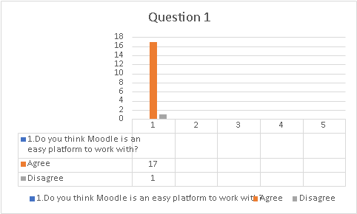

2. Does the Moodle make the students life better?

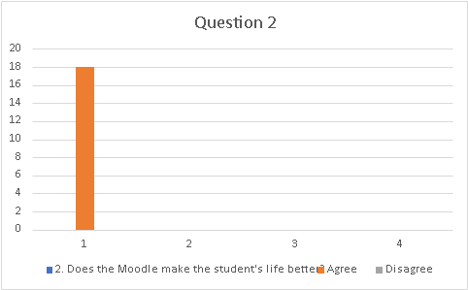

3. Do you think the integration in Moodle is easy?
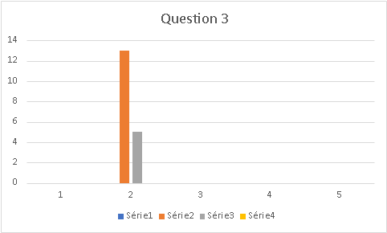

4. Do you think Moodle supports all Students?

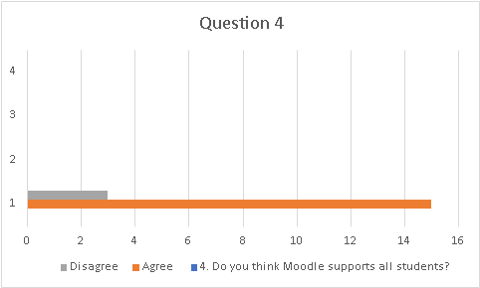

- Would you change any Moodle tool?
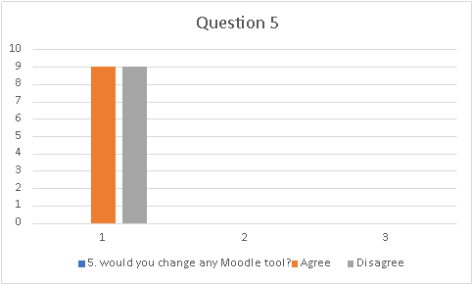

- Do you think Moodle was one of the best platforms of recent times?

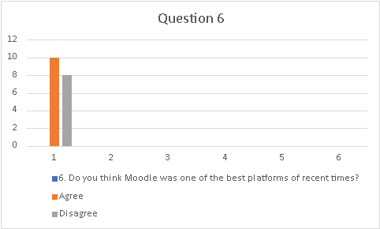

According to the data obtained through the questionnaire made by me to 18 students at the university of Wales Trinity saint David, I could see according with the Question one that most students believe that Moodle is an easily accessible platform for them, and the result shows that only 1(six per cent) of the 18 involved believe that Moodle is a platform that is difficult to access. In Question two, the data collected show that all (one hundred per cent) students think that their life is much better with the introduction of Moodle, and all those involved agreed with the same, which means that students' degree of satisfaction with Moodle is high.
According to question number three, seventy-two percent of students think that integration in Moodle is easy and only twenty-eight percent believe the opposite, question number five was the most competitive, as fifty percent agreed that there was nothing to change in Moodle, but the other fifty percent said the opposite.
In the last question, it was proven that more than fifty percent of the data collected believe that Moodle was one of the best creations of recent times, and forty-four percent believe that it is not. In short, Moodle is an extremely important tool with a great impact on students' lives.

- Conclusion
After analyzing all the data collected, I can conclude that Moodle had and still has a great impact on the lives of students in general and at the university of study, because, despite obtaining some negative responses around the platform, most of the students involved gave positive responses and even more importantly to Moodle and the impact it has on their lives.
It was a job where I had many difficulties in collecting data, because as I had mentioned before, having spent the entire semester online, data collection was weak and with very little data, hence my limitation in terms of the amount of data. information.
The goal will be to try to improve in the next semester, as I will do my best to be in person and be able to do field research around any schoolwork.
Through this work, I learned a lot and increased my knowledge about Moodle, and I could understand the impact that it has on the lives of both students and students, since being online, it was a tool of great help in my learning process so far, I recommend to all students to use Moodle frequently and to contribute in some way to its further development in the future.

- References
- Gašević, D., Dawson, S., Rogers, T., & Gasevic, D. Learning analytics should not promote one size fits all: The effects of instructional conditions in predicting academic success. Internet And Higher Education 2016. 28. pp. 68–84.
- MORAN, J. M. New technologies and the re-enchantment of the world educational technology, vol. 23, no. 126, p. 24-26, 1995.
- Morais, C., Alves, P., & Miranda, L. Valorization of virtual learning environments by higher education teachers. In A. Rocha, L. Reis, M. Cota, M. Painho, & M. Neto (Eds.), Information Systems and Technologies. 8th Iberian Conference on Information Systems and Technologies. Lisbon: AISTI/ISEGI. pp. 289-294. 2013.
- MORAN, J. M. How to use the Internet in education. science of
information, see 26, no. 2, 1997.
- LONGO, W. P. Technology, and national sovereignty São Paulo: Ed. Nobel, 1984.

- Appendix
Figure 1. Survey
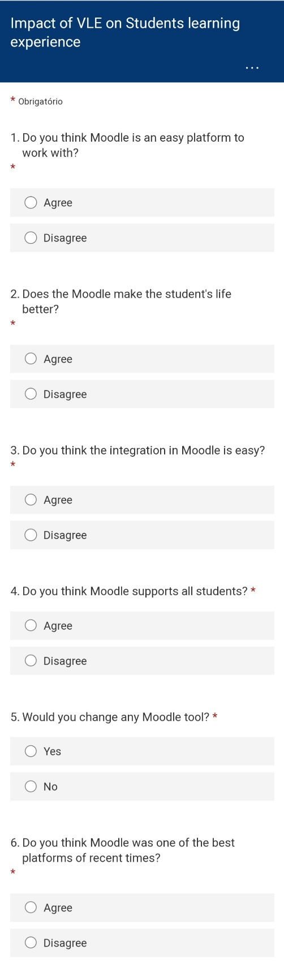

Figure 2. Question 1- Do you think Moodle is an easy platform to work with?
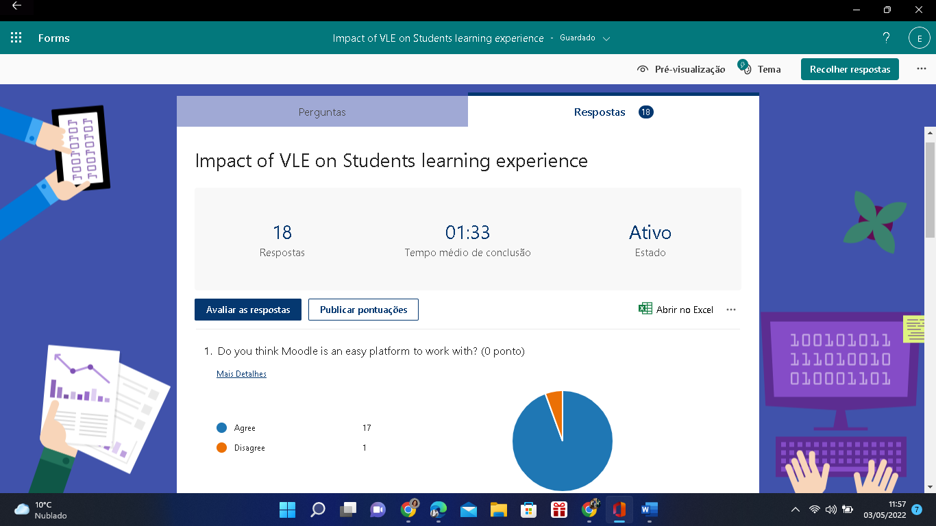

Figure 3. Question 2- Does the Moodle make the students life better? Question 3- do you think the integration in Moodle is easy?
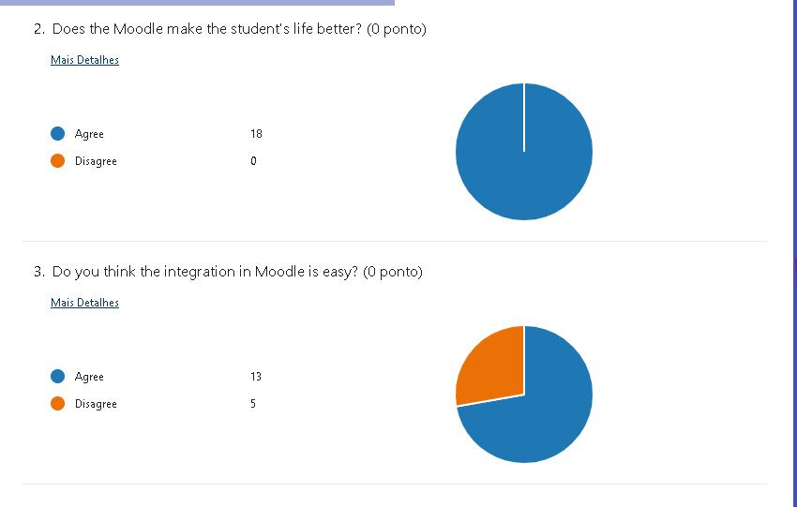

Figure 4. Question 4- Do you think Moodle supports all students? Question 5 – Would you change any Moodle tool?
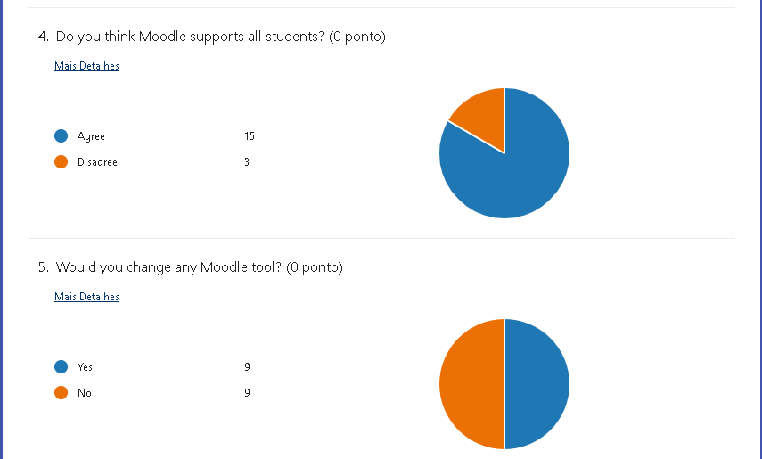
Figure 5. Question 6 – Do you Think Moodle was one the best platforms of recent times?


