
Module – Materials and Introduction to Processing
Module Code – AMCA4000
Lecturer – Dr Mohamed Gabr + Dr Jeremiah McCallister
Assignment Title – Manufacturing processes and defects
Date – 27/01/2025

Abstract
This report examines the material selection and manufacturing processes for three common everyday objects: forks, mugs, and pipes. It explores the characteristics of stainless steel, polypropylene, and wood, comparing their mechanical and thermal properties to determine their suitability for these applications. The report delves into the manufacturing methods for each object, from metal forming for stainless steel forks to injection molding for plastic mugs. Furthermore, it evaluates the longevity and cost-effectiveness of each material, highlighting the trade-offs between durability, performance, and manufacturing complexity. The analysis concludes that material choice should be tailored to the specific use case, balancing functionality with cost considerations.

Table of Contents
Abstract 2
Table of Contents 2
Table of Figures 3
1 Introduction 4
2 Task 1 – Object Introduction 4
2.1 Fork 4
2.2 Mug 5
2.3 Pipe 5
3 Task 2 – Manufacturing Methods 6
3.1 Fork 6
3.2 Mug 9
3.3 Pipe 10
4 Task 3 – Mechanical Properties 11
5 Task 4 – Object Lifespan/Cost 13
6 Task 5 – Why were the objects chosen? 13
7 Conclusion 14

Table of Figures

Figure 1 (Lupion, 2022) 4
Figure 2 (Webstaurant store, n.d.) 4
Figure 3 (Nisbits, n.d.) 4
Figure 4 (Kahla Nature Dinnerware Porcelain Mugs, n.d.) 5
Figure 5 (Amazon, n.d.) 5
Figure 6 (Dunelm, n.d.) 5
Figure 7 (Pipe Extruder Glass Fibre Reinforced Pipe Equipment, n.d.) 5
Figure 8 (Copper pipe fittings, n.d.) 5
Figure 9 (6 Types of PVC Pipes, n.d.) 5
Figure 10 (How Cutlery Is Made, n.d.) 6
Figure 11 (Plastic Injection Molding Process, n.d.) 7
Figure 12 (GLC Fully Automatic Wooden Cutlery Making Machine Disposable Wooden Knife, Fork and Spoon Production Line, n.d.) 8
Figure 13 (IQS Directory, n.d.) 9
Figure 14 (What is Slip Casting?, n.d.) 9
Figure 15 (Research Gate, 2017) 10
Figure 16 (Introduction to material selection charts, n.d.) 12

Introduction
The materials used in everyday objects like forks, mugs, and pipes significantly impact their performance and durability. Each material—stainless steel, polypropylene, wood, or ceramic—has unique benefits and limitations based on its intended use. This report examines these materials, their manufacturing processes, and suitability, focusing on strength, thermal conductivity, and corrosion resistance. By exploring the mechanical properties and lifespan of these objects, the report aims to provide a comprehensive understanding of material suitability in practical use.

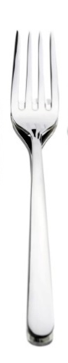
Task 1 – Object Introduction
Figure 1 (Lupion, 2022)

Fork
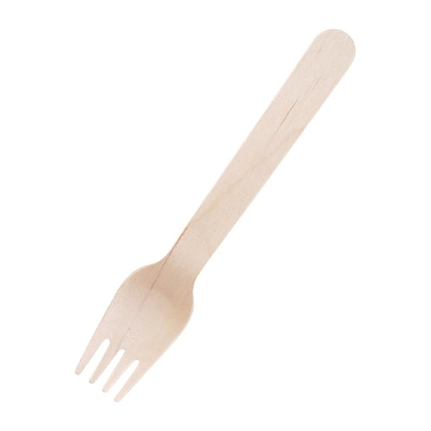
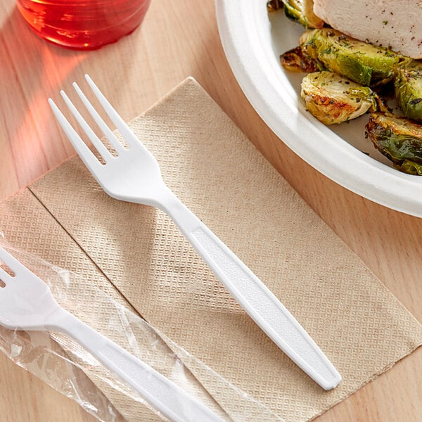
The first object selected was a fork, chosen for its daily use by millions. Forks are mainly made from stainless steel, valued for its strength and durability, ensuring a long lifespan. However, they can also be made from other materials. Plastic (polystyrene or polypropylene) is often used for disposable forks due to its lightweight nature, though it lacks durability and has a shorter lifespan. Wooden forks are also disposable but generally stronger than plastic, making them suitable for food use without breaking or splintering.
Figure 2 (Webstaurant store, n.d.)
Figure 3 (Nisbits, n.d.)

Mug
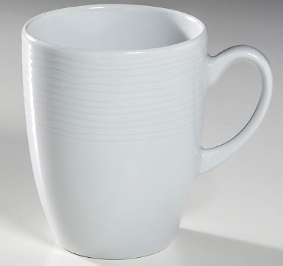
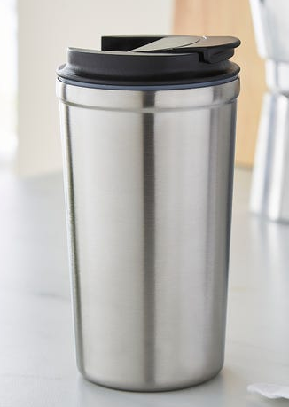
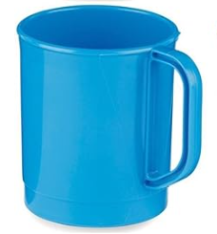
The second object selected was a mug, also used daily worldwide. Various types of mugs are available, depending on the fluid and environment. Stainless steel mugs are strong, durable, and corrosion-resistant, ideal for harsh environments like construction sites. Plastic (polypropylene) mugs are lightweight, cost-effective, and shatter-resistant, making them suitable for children. Ceramic mugs are the most commonly used due to their excellent heat retention and durability, often found in households or offices.
Figure 4 (Kahla Nature Dinnerware Porcelain Mugs, n.d.)
Figure 5 (Amazon, n.d.)
Figure 6 (Dunelm, n.d.)

Pipe
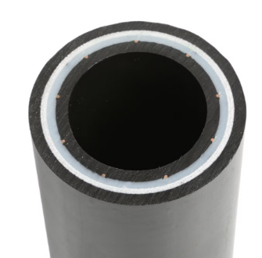
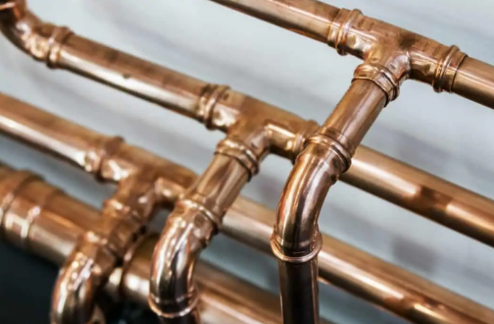
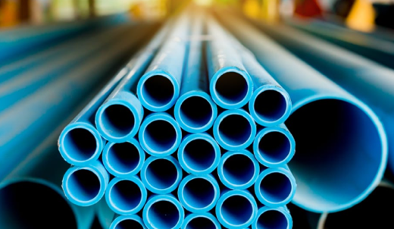
The third object, pipes, are used in various applications due to their properties. Copper pipes are durable, corrosion-resistant, and heat-tolerant, ideal for household water supply. PVC pipes, lightweight and non-conductive, suit plumbing and electrical use at low cost. Composite pipes like fiberglass-reinforced plastic (FRP) excel in harsh environments, offering strength and corrosion resistance, therefore ideal in transporting corrosive fluids.
Figure 7 (Pipe Extruder Glass Fibre Reinforced Pipe Equipment, n.d.)
Figure 8 (Copper pipe fittings, n.d.)
Figure 9 (6 Types of PVC Pipes, n.d.)

Task 2 – Manufacturing Methods

Fork
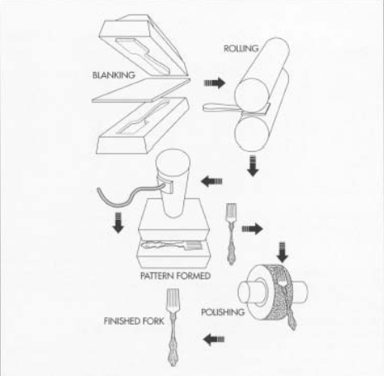
Figure 10 (How Cutlery Is Made, n.d.)
Stainless steel forks are produced through several metal forming processes like cutting, stamping, rolling, annealing, and polishing. A stainless steel sheet is cut into a blank, stamped to form the fork’s rough shape, and pressed to create tines. Rolling refines the shape and ensures proper dimensions, while annealing enhances it’s strength and durability. Polishing removes imperfections, resulting in a smooth finish. Although initial machinery costs are high, automation boosts the process efficiency, making high-volume production necessary for cost-effectiveness. (How Cutlery Is Made, n.d.)
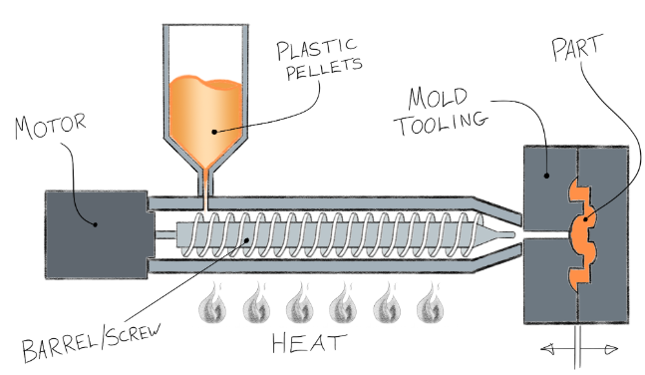
Figure 11 (Plastic Injection Molding Process, n.d.)
For plastic forks, the manufacturing method is injection molding. In this process, molten plastic is injected into a mold under high pressure. Once the mold is filled, the plastic is allowed to cool and solidify before being ejected. While injection molding is an efficient method for mass production, the cost of designing and producing molds can be high.(How Is Plastic Cutlery Made , n.d.)
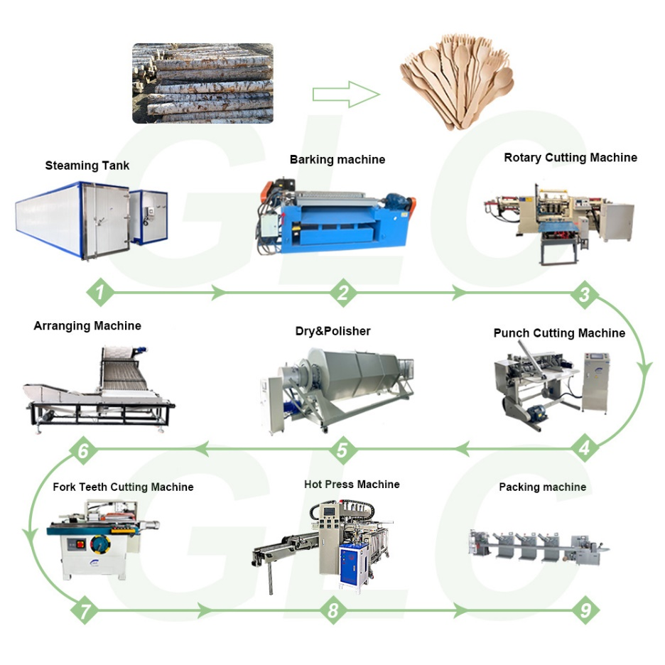
Figure 12 (GLC Fully Automatic Wooden Cutlery Making Machine Disposable Wooden Knife, Fork and Spoon Production Line, n.d.)
Disposable wooden forks are made from logs processed using rotary cutting to create thin, uniform wood veneer sheets. The veneer is shaped into forks through a die press, with a second die cutting stage forming the tines (prongs). Challenges include managing wood grain variations, which can affect cutting precision. Despite these complexities, the process is highly efficient, with die cutting machines producing thousands of forks hourly. While initial machinery costs are high, the high production rates quickly offset these investments. (GLC Fully Automatic Wooden Cutlery Making Machine Disposable Wooden Knife, Fork and Spoon Production Line, n.d.)

Mug
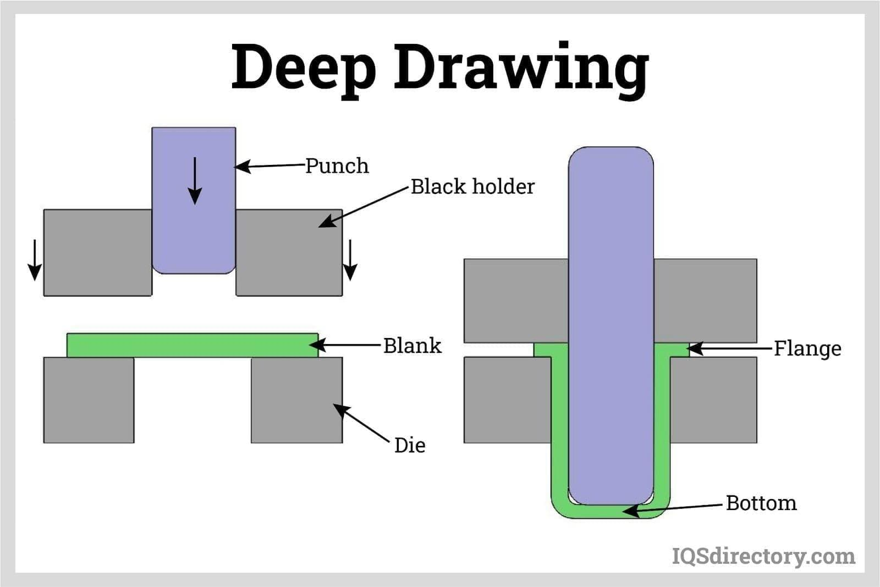
Figure 13 (IQS Directory, n.d.)
Stainless steel mugs are crafted using metal forming processes like deep drawing, where sheet material is cut and shaped into a die cavity via a press machine pressing into the sheet metal to form the mug. This technique minimises material waste and allows high-volume production, but initial costs for die design and press machines are high. Proper machinery maintenance is essential to avoid defective parts with dimensional inaccuracies.
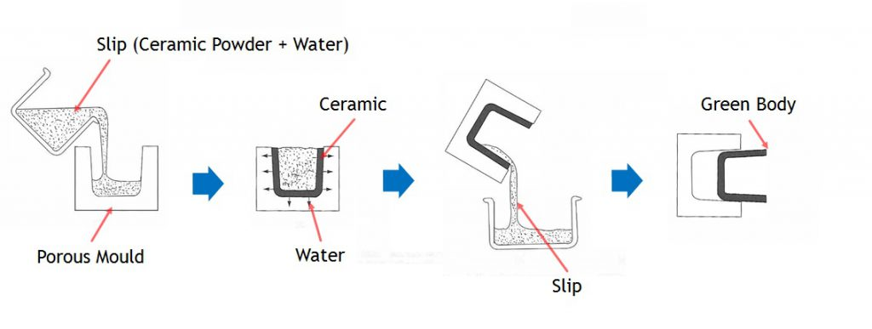
Figure 14 (What is Slip Casting?, n.d.)
Ceramic mugs are made through slip casting, where liquid clay (slip) is poured into plaster molds. The plaster absorbs water, forming a clay layer inside. Excess slip is drained, leaving a hollow form, which is dried, removed, and kiln-fired to harden. The mugs are then glazed and fired again for a smooth finish. Challenges include proper mold filling and drying to avoid cracks. While molds and kilns require significant initial investment, the process allows high production rates and low per-unit costs. (Industrial Processes to make Ceramic Cups, n.d.) (How Coffee Cups are Made, n.d.)
Polypropylene mugs are typically produced through injection molding (Figure 11). Here, molten polymer is injected into a mold, cooled, and ejected as the final product. Challenges include ensuring smooth polymer flow and proper mold filling, addressed by optimising flow rates and mold designs. The material is inexpensive, and although the machines are costly, the process is cost-efficient once operational.

Pipe
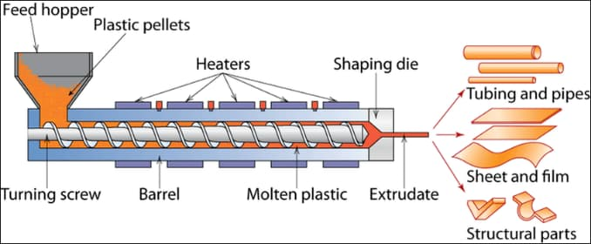
Figure 15 (Research Gate, 2017)
PVC pipes are by made via a process called extrusion. Extrusion is where Plastic Pellets are placed into a hopper, and fed through a barrel via a turning screw, where the pellets are heated. Pellets then turn into molten plastic and are pushed through the shaping die to create the form of the pipe. Once they exit, they are consistent in cross sectional area and are cooled and harden.The rate of production can be very high, as the process is very efficient. It is also a very cost effective process, this is due to low material costs, although initial start up costs for the machine and design of the die can be high. The process can see a few complexities, such as the design of the die must be accurate in order to produce an accurately dimensioned part, as well as the temperature of the plastic as it makes it’s way through the barrel.

Task 3 – Mechanical Properties
Properties | Stainless Steel | Copper | Plastic (e.g., Polypropylene) | Plastic (PVC) | Wood (e.g. Birch) | Ceramic (Porcelain) | Composites (RFP)
Strength | High | Moderate | Moderate | Moderate | Moderate | High | High
Ductility | High | High | Low | Low | Low | Very Low | Low
Formability | High | High | High | High | Moderate | Low | Moderate
Thermal conductivity | High | Very High | Low | Low | Low | Low | Low
Melting temperature | 1400°C | 1084°C | 160°C | 212°C | N/A | Very High | Varies (Dependent on composition)
Corrosive Resistance | High | Moderate | High | High | Low | High | Very High
Table 1 (Introduction to material selection charts, n.d.)
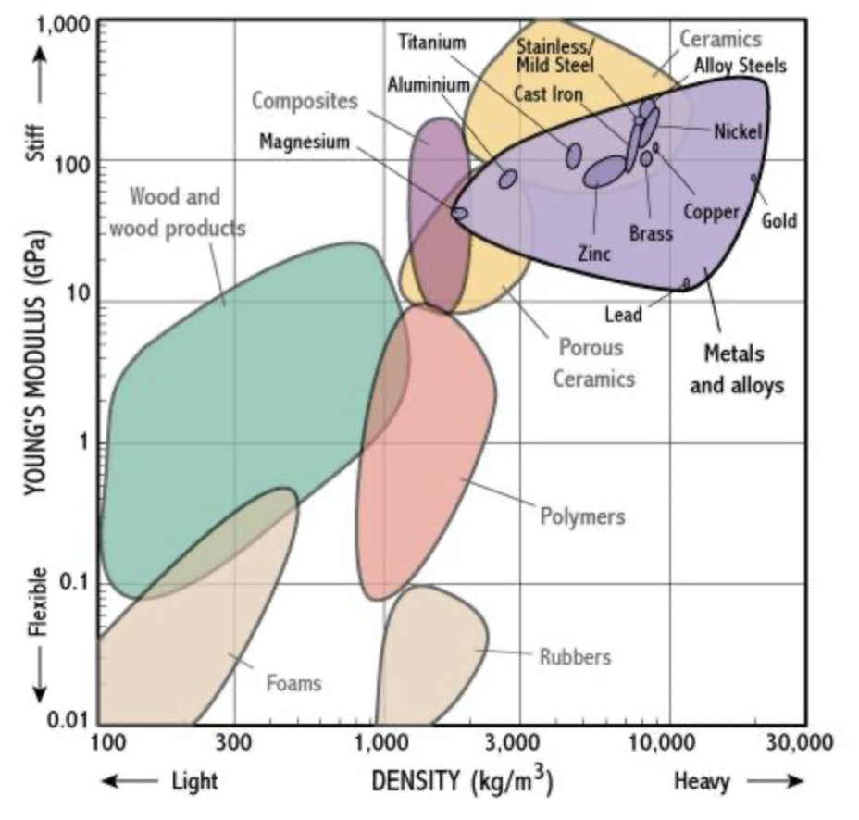
Figure 16 (Introduction to material selection charts, n.d.)
When comparing stainless steel, polypropylene, and wood for forks, each material's properties significantly impact suitability. Stainless steel offers exceptional durability, strength, ductility, high melting temperature, and thermal conductivity, making it ideal for long-term use. In contrast, polypropylene and wood have lower strength and melting points, with wood also lacking corrosion resistance, leading to potential degradation. Stainless steel’s superior durability, thermal properties, and corrosion resistance make it the most suitable option. (Introduction to material selection charts, n.d.)
Stainless steel is commonly used for travel mugs because it can withstand high temperatures and is strong and durable, which is essential for harsh environments. Polypropylene mugs, while shatter-resistant, are suitable for use with children and can also handle high temperatures, though they don't have the same longevity as stainless steel. Ceramic mugs, with low thermal conductivity, are ideal for home use due to their ability to efficiently retain heat, but their low ductility makes them prone to breaking. (Introduction to material selection charts, n.d.)
Copper pipes excel in hot and cold-water systems for their thermal conductivity, durability, and corrosion resistance but pose safety risks in electrical systems due to high electrical conductivity. PVC pipes resist corrosion but lack copper's strength and thermal resistance, making them suitable for cold-water applications. RFP composite pipes offer exceptional strength and corrosion resistance, ideal for transporting chemicals in harsh environments, despite higher manufacturing costs. (6 Types of PVC Pipes, n.d.) (Introduction to material selection charts, n.d.) (Thermal properties of materials, n.d.)

Task 4 – Object Lifespan/Cost
Stainless steel forks are highly durable and long-lasting compared to plastic or wooden alternatives. They resist breaking or melting under heat, making them ideal for repeated use. However, their higher material and manufacturing costs make them less practical for mass production. Businesses often prefer disposable wood or plastic forks for affordability, though these are less durable and prone to breaking, thus a shorter lifespan. (Introduction to material selection charts, n.d.) (Lupion, 2022)
The choice of mugs depends on the environment they are used in. Ceramic, plastic, and stainless-steel mugs all withstand high temperatures, but ceramic mugs are less durable and prone to fracture, making them better suited for households or offices. Stainless steel and plastic mugs are sturdier and better for travel or harsh conditions. Stainless steel is more expensive due to its material and manufacturing, while plastic and ceramic mugs are more cost-effective. (Strength-Cost, n.d.)
In water transportation, copper and PVC pipes both offer excellent durability, wear resistance, and corrosion resistance, ensuring long lifespans. However, PVC pipes cannot handle hot water due to lower thermal conductivity, unlike copper pipes. Composite RFP pipes are even stronger, more durable, and highly resistant to corrosion, making them ideal for harsh environments. Despite these advantages, RFP pipes are more expensive to manufacture than copper or PVC options. (Thermal properties of materials, n.d.) (Strength-Cost, n.d.)

Task 5 – Why were the objects chosen?
Stainless steel is the ideal material for a fork due to its strength, durability, and ability to withstand high temperatures. Unlike other materials prone to fracture, stainless steel ensures reliability in use. Manufacturing involves processes like rolling, cutting, and stamping, which, while effective, require multiple stages, making it less efficient.
For a mug, the material choice depends on the environment. Without restrictions, ceramic is preferred for its excellent thermal properties. Ceramic mugs are made through slip casting, a cost-effective method due to low material costs, though initial setup expenses can be high.
For pipes, the material depends on their purpose. PVC is ideal for electrical use due to its non-conductive properties, strength, and durability, while copper is preferred for plumbing due to its superior thermal conductivity. Without restrictions, PVC would be selected for its versatility and is manufactured using the extrusion process, a highly efficient and cost-effective method.

Conclusion
In this report, the materials and manufacturing processes for forks, mugs, and pipes were analysed to determine their suitability for everyday use. Stainless steel is the most durable material for forks, offering superior strength, corrosion resistance, and thermal properties, albeit at a higher cost. Plastic and wood are cheaper but less durable. Ceramic mugs are ideal for home use due to excellent heat retention, while stainless steel and plastic offer greater durability for travel or harsher environments. Copper pipes excel in plumbing for their thermal conductivity, while PVC is better suited for electrical applications. The choice of material and manufacturing process ultimately balances performance, cost, and durability, ensuring each object meets its intended use efficiently and economically.

Bibliography
(n.d.). Retrieved from Webstaurant store: https://www.webstaurantstore.com/fork-xhvy-wght-wrap-white-1m/130WHFORKWX.html
(n.d.). Retrieved from Nisbits: https://www.nisbets.co.uk/disposable-wooden-forks-pack-of-100/cd903
(n.d.). Retrieved from Dunelm: https://www.dunelm.com/product/travel-mug-stainless-steel-1000216983?defaultSkuId=30846871&msclkid=9ad1a7f14b27132e2e93c07fd15afb8e&utm_source=bing&utm_medium=cpc&utm_campaign=Cook_All%20Cook_%5BBING-LIA-COOK-COOK%5D_new&utm_term=4575755105541949&utm_cont
(n.d.). Retrieved from Amazon: https://www.amazon.co.uk/Poly-Plastic-Camping-Mug-275ml/dp/B00Y9FRB72/ref=asc_df_B00Y9FRB72?tag=bingshoppinga-21&linkCode=df0&hvadid=80126985616145&hvnetw=o&hvqmt=e&hvbmt=be&hvdev=c&hvlocint=&hvlocphy=&hvtargid=pla-4583726543309159&psc=1
6 Types of PVC Pipes. (n.d.). Retrieved from Fenwick Home Services: https://www.fenwickhomeservices.com/blog/6-types-of-pvc-pipes-benefits-drawbacks/
Copper pipe fittings. (n.d.). Retrieved from Watkins Powis: https://watkinspowis.co.uk/products/copper-pipe-fittings-and-press-systems/
GLC Fully Automatic Wooden Cutlery Making Machine Disposable Wooden Knife, Fork and Spoon Production Line. (n.d.). Retrieved from GLC: https://www.glc-tech.com/products_1/35.html
How Coffee Cups are Made. (n.d.). Retrieved from https://kitchensurfers.com/how-are-coffee-mugs-made/
How Cutlery Is Made. (n.d.). Retrieved from https://www.madehow.com/Volume-1/Cutlery.html
How Is Plastic Cutlery Made . (n.d.). Retrieved from Storables: https://storables.com/dining/tableware/how-is-plastic-cutlery-made/
Industrial Processes to make Ceramic Cups. (n.d.). Retrieved from https://www.ehow.com/info_8612872_industrial-processes-make-ceramic-cups.html
Introduction to material selection charts. (n.d.). Retrieved from Mechanical Properties in Physics and Design: http://www-materials.eng.cam.ac.uk/mpsite/physics/introduction/
IQS Directory. (n.d.). Retrieved from Uses and Grades of Stainless Steel 304.
Kahla Nature Dinnerware Porcelain Mugs. (n.d.). Retrieved from Amazon: https://www.amazon.co.uk/Kahla-Nature-Dinnerware-Porcelain-300ml/dp/B0865ZBGZ5/ref=asc_df_B0865ZBGZ5?tag=bingshoppinga-21&linkCode=df0&hvadid=80470608884505&hvnetw=o&hvqmt=e&hvbmt=be&hvdev=c&hvlocint=&hvlocphy=&hvtargid=pla-4584070148460818&psc=1
Lupion. (2022, April 8). Why is cutlery made of stainless steel. Retrieved from Lupion: https://iupilon.com/why-is-cutlery-made-of-stainless-steel/
Pipe Extruder Glass Fibre Reinforced Pipe Equipment. (n.d.). Retrieved from https://jimage.en.made-in-china.com/product/raGpsniFYYhj/China-Pipe-Extruder-Glass-Fibre-Reinforced-Pipe-Equipment.html?pv_id=1ii2p61kd640&faw_id=1ii2p66fp292
Plastic Injection Molding Process. (n.d.). Retrieved from https://www.cdn-inc.com/plastic-injection-molding-process/
Research Gate. (2017, December ). Retrieved from Effect of Ni content on the Hardenability of a Bainitic Steel for Plastics Processing: https://www.researchgate.net/figure/Overview-of-a-plastic-extrusion-machine-with-the-plasticizing-component-in-evidence-The_fig1_321597264
Strength-Cost. (n.d.). Retrieved from http://www-materials.eng.cam.ac.uk/mpsite/interactive_charts/strength-cost/basic.html
Thermal properties of materials. (n.d.). Retrieved from SATHEE: https://sathee.prutor.ai/article/physics/thermal-properties-of-materials/
What is Slip Casting? (n.d.). Retrieved from Syalons: https://www.syalons.com/2018/09/06/slip-casting-sialons/

