Student Journal

(Leading Log)

Dorcas Barden 2127685

HOTEL ADMINISTRATION AND FRONT OFFICE OPERATIONS (BMIH4004)

BMIH4004

Natalie Brailsford

Introduction

A student journal (learning log) that details the knowledge and experience gained on the following topic must be prepared for this small section of the assignment. Despite this, service technologies are now widely employed in the hospitality sector to provide top-notch services and monitor management, which will also be a focus of this research.

What are the primary abilities that needs to work at front desk?
Specifically, front desk technologies enable employees to access large amount of customer information and integrate the information for efficient delivery of service to customers while saving operational time and expense (Chathot, 2007; Stamboulis & Skayannis, 2003). With effective front desk technologies, hotel customers have both timelier and more effective, customize service experiences (Bilgihan, Okumus, K. Nusair, Kwun, 2011). Almost all hotel chains require front desk workers to use a technology system to handle check-in and check-out, assign a room, give a key, and gather passenger information (Bulchand-Gidumal & Melián-González, 2017).
One of the characteristics of a world economy that is becoming more globalised is the apparent assumption that, aside from economic variation reflecting local conditions, those who work in the hospitality industry in Europe, North America, and Asia that need to be use a widely known or general variety of abilities. This, in turn, will require that employees have a similar upbringing in knowledge, education programs, and general level of expertise.
The hotel industry has changed and grown in the last ten years in organisational, product, and market aspects, which has had a substantial impact on the nature of employment in hospitality businesses. The impact of economic, more multiple ownership, and improved hotel chain branding are primarily to blame for the changes in the hotel industry (Go & Pine, 1995; Guerrier et al.,1998). The front office is typically understood to contain all areas of operation that revolve around the reception desk and its supporting facilities, where the key focus is on "meeting and welcoming" visitors, sharing information throughout their stay, and managing their check-in\out, including billing. The amount of activity in front office varies widely from hotel to hotel, depending on the number of rooms, location, and target audience of the business. Regardless of the hotel type, (Vallen & Vallen (2005) defines front office as serving as the primary point of contact for guests inside the establishment. Strategic planning of training is necessary to assist firms in achieving long-term objectives and keeping up with cutting-edge new technology. These days, interactive education is commonly used, (Sloman, 2007) argued that the job of the trainer has changed in the environment of the traditional learning trend to one of facilitating, amplifying, and directing learning interventions that satisfy organisational needs and are fit for the learner. In the hospitality sector, the function of the training professional is crucial for service strategy, customer happiness, and service quality. Getting and keeping business clients is strongly influenced by the value of the training provided and the skill of training specialist (Brotherton & Evans, 2010).
It is the duty of hotel front desk staff to ensure that each visitor has a positive stay. Checking in and out guests, taking reservations, and responding to any inquiries from guests are standard tasks. For hotel front desk and guest service staff, communication is essential. You must also be a good listener if you want to communicate effectively. Listening takes up 45% of communication time. The goal of effective listening is to comprehend the visitor's question and minimise the errors. They converse with visitors on the phone and in person all day, so it's critical that they communicate properly and keep a cheerful attitude. A competent employee must remain composed under pressure since a front desk professional must multitask and handle numerous guests at once. The staff should be able to manage a range of jobs while yet being approachable to guests, even when the hotel is extremely busy. Also, the feel at ease using the system. Meanwhile, as they are frequently the first people a guest encounters when they enter the hotel, the front desk employees must be extraordinarily welcoming. Energy is an area of expertise. The main necessity for your engagement, activity, and problem-solving is your passion. You can gain achievement more quickly if you have energy. You must never display even the tiniest amount of tiredness. You must work hard and smile nicely while performing your duties. You must then

welcome your guest warmly and improve that the hotel's reputation in this way. Which is why, the more positive you are, the more accomplishment will have as a hotel receptionist. A good guest services. Reception staff must be autonomous workers because the front desk is frequently separate from the main office level. Companies need staff members with quick decision-making abilities, strong dilemma abilities, and calm and peaceful personality. Receiving and sorting mail are among the duties associated with providing customer care, along with answering the phone and sending fast emails. Incoming calls must be answered, screened, and sent, and visitors must be directed to the appropriate individual or division.

References
- H. Shin, R. R. Perdue, J. Kang, (2019) https://www.sciencedirect.com/science/article/pii/S0261517719300664 (Accesses 04 Mar 2023)
- Wong, Simon C.K, and Lee P.C (2017) https://www.tandfonline.com/doi/full/10.1080/15256480.2016.1263171 (Accesses 05 Mar 2023)
- Doyle, A. (2020) https://www.liveabout.com/hotel-front-desk-guest-services-skills-list-2062408 (Accesses 05 Mar 2023)
- Vizito, Bv. Written by Jill (2023) https://vizito.eu/blog/the-top-10-skills-that-every-receptionist-needs/ (Accesses Mar 2023)
- R. Half (2022) https://www.roberthalf.co.uk/advice/career-development/7-receptionist-skills-can-impact-entire-company (Accesses 06 Mar 2023)
- Packagex.io. (2021) https://packagex.io/blog/best-receptionist-skills (Accesses 06 Mar 2023)
- Heanley, A. (n.d) https://www.orielpartners.co.uk/blog/receptionist-skills (Accesses 06 Mar 2023)
- Learning, V. (2020) https://www.visiolearning.co.uk/what-qualities-you-should-attain-to-become-a-hotel-receptionist/ (Accesses 06 Mar 2023)

TASK DESCRIPTION COMPONENT TWO
Introduction

Component One:
Contribution to Module Assessment: 25%

In this scenario: Letter of complaint
The letter has been received from an unhappy guest, who departed the hotel without mentioning any issues throughout their stay.
You need to write a coherent, formal 500 written word response demonstrating skills for employment,
ownership and the application of problem-solving skills.

Problem | Why did it happen? | What are you going to do? | How will you prevent this from happening in the future? | What measures would you introduce to improve team effectiveness?
Guest complains.  Room not been cleaned as Premier Inn standards.  Wi-Fi service.  Customer Service.  Noise levels in the Hotel. | Housekeeping Team did not clean the room efficiently and is not checked over by receptionist. | First the guest will have a compensation, such as a free breakfast meal and a free feedback card on his next staying on any Premier Inn Hotel.  Otherwise, a free parking space. | By making sure that the housekeeping team members and the receptionists will get knowledge about the problem, getting further training and for the receptionist a while knowledge of how to check a room properly cleaned. | Making the housekeeping aware of the mistakes that they’re making by showing all the procedure correctly and their correct tools that is applied of a great standard cleaning, by also having team brief regularly to reminding them.

A bad review has the potential to do serious harm to your company. The best way to handle it is to accept responsibility for any problems that arose and to acknowledge the guest's remarks, by responding:

Hi Mrs Joanna,
We thank you for you taking the time to provide us with your feedback. We are sorry to hear that your stay left you feeling let down, and we appreciate you bringing this to our notice. Every visitor should have a pleasant and convenient stay at our hotel, so please do not hesitate to let us know if something isn't right in the future so that we can work to fix it. We value your loyalty and hope to have you visit us once more soon!
Regards,
Old Trafford Premier Inn.

All customer complaints, whether made in-person or emails, must be right away resolutely handled. Instantly addressing a complaint demonstrates a commitment to both customer service and guest happiness. Monitor the progress of guest complaints to make sure the team members are informed and that the issue is addressed. Finally, but just as importantly, giving all staff members training that will help ensure that any guest complaints are handled politely after they are reported. The best way to handle guest complaints is to address them immediately and with empathy. Acknowledge the guest’s feelings, take ownership of the issue, and provide a solution that is fair and satisfactory for both parties (Lavi, T. 2023).

Component Two:
Trip Advisor review
Search and find a positive review for your current placement property. (This will need to be referenced as per the Harvard referencing guidelines).
You will need to write a 150-word response using the underlying concepts and principles of replying to positive feedback.

Old Trafford Premier Inn Trip Advisor review

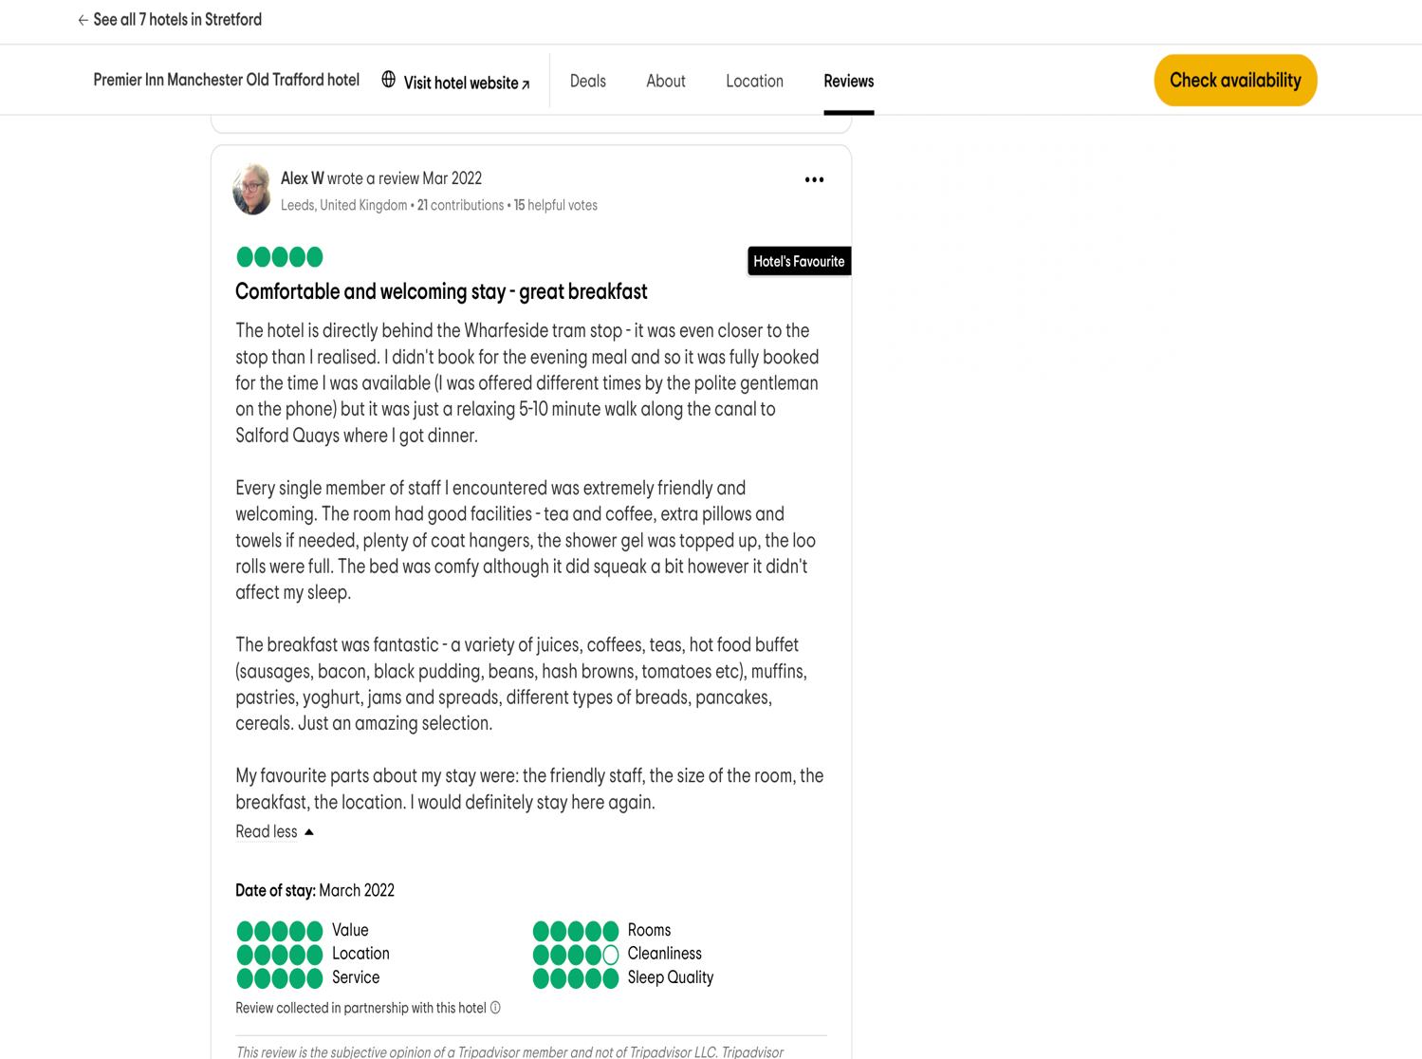

Show the customer that you are always committed to them, by responding:

Hi Alex,
We truly enjoy you taking the time to reach out to us about your experience. We are happy to learn that you thought our personnel was pleasant and that there were enough of options at the breakfast buffet. We are happy that we were able to live up to your expectations because we take pleasure in providing excellent service. We appreciate your nice sentiments once more and hope to see you again soon.
With regards,
Old Trafford Premier Inn.
Whether a review is good or bad, you should always express your gratitude to the customer for taking the time to write it. After that, you can solve the main concerns raised by the client. While responding to every positive review is not necessary, it is crucial to ensure that any comments you do make are sincere, real, and fairly convey the guest's experience.
When a review is positive, emphasise the areas of your business that the client found enjoyable. Posting positive comments on online presence or social media accounts, is also a very wise move. This demonstrates to prospective guests that hotels operate with happy guests.

Reference:
According to www.cvent.com. (2022). We can determine that Handling Guest Complaints: The Complete Guide for Hotels | Cvent Blog. [online] Available at: https://www.cvent.com/uk/blog/hospitality/handling-guest-complaints.
According to eZee Editorial Team (2020). We can determine that How to Handle Hotel Guest Complaints? [online] eZee Absolute. Available at: https://www.ezeeabsolute.com/blog/how-to-handle-hotel-guest-complaints/.
According to Lavi, T. (2023). We can determine that How to Deal with Guest Complaints in the Hospitality Industry. [online] Duve. Available at: https://duve.com/how-to-address-the-most-common-guest-complaints-in-the-hospitality-industry/.
According to Whitbread PLC. (n.d.). we can determine that, Home. [online] Available at: https://www.whitbread.co.uk
According to TripAdvisor. (n.d.). we can determine that PREMIER INN MANCHESTER OLD TRAFFORD HOTEL - Updated 2024 (Stretford). [online] Available at: https://www.tripadvisor.co.uk/Hotel_Review-g2433765-d209231-Reviews-Premier_Inn_Manchester_Old_Trafford_hotel-Stretford_Trafford_Greater_Manchester_Englan.html [Accessed 27 Feb. 2024].
According to wild, A. (2013). Alex W we can determine that | @alexwild95 | Profile on TripAdvisor. [online] www.tripadvisor.co.uk. Available at: https://www.tripadvisor.co.uk/Profile/alexwild95 [Accessed 27 Feb. 2024].
According to Mitu, C. (2022). We can determine that the best list of positive review response examples | Usersnap. [online] Usersnap Blog. Available at: https://usersnap.com/blog/positive-review-response-examples/.
According to roelen blasberg, T. (n.d.). We can determine that Tobias Roelen-Blasberg · Codebase – Webflow HTML website template. [online] www.mara-solutions.com. Available at: https://www.mara-solutions.com/team/tobias-roelen-blasberg [Accessed 27 Feb. 2024].

Component 3 PORTAFOLIO 4 ELEMENTS

- Customer service skills.
- Communication skills.
- Organizational skills.
- Problem solving skills.

2.
Communicating efficiently and effectively by written and spoken communication and physical expression is critical to providing excellent customer service in hospitality.
The most important aspect of communication is understanding. As a result, when speaking with guests, you must show real feelings and a keen interest. Ask inquiries, listen to what they say, and answer appropriately.
Communication is fundamental to every marketing purpose. People require excellent written and verbal communication abilities. They must be engaging and engaging over the phone, in person, and in written communications. Whether interacting with clientele to ensure their pleasure or collaborating with staff to offer excellent service, successful communication is critical to the success of any hotel organisation.

Excellent communication skills are especially crucial in the hospitality sector because they may help you build relationships with your visitors, settle problems, and provide over all guest experience.

Clear and short communication aids in avoiding misconceptions and confusion that may delay the progression of activities.
In conclusion,
today, it is normal to reward your guests with attractive gifts, authorizations, offers, and free products to gain their loyalty.
Well, if you offer something truly intriguing, your chances of attracting new clients grow. Simply because referral advertising plays a huge part in these circumstances. It is usual today to make your customers achieves satisfaction. Guest conversation cannot be easily impacted or led using hard and fast rules.
It can vary depending on the guest and their demands, but after you've established the main standards, you can make room for exceptions.

1.
The customer service department's aim is to be visible and present to guests before, during, and after their stay. Your customer service department's goal is to deliver a great experience to your guests, whether that is through information, assistance, or making them feel comfortable and confident. As a result, they will be able to link exceptional customer service with your property and become repeat customers.
To boost your customer service, you must react to prospective changes in your visitors' conduct along with fresh developments in the hospitality business.
Also, attempt to find out how your customers feel on a frequent basis by checking the results of the feedback survey, reading online customer reviews, or speaking with them at the reception area of your hotel. This will allow you to learn more about their visit, including what they liked and disliked.
The hotel team members symbolise the company's reputation and values. But they cannot be expected to simply understand what that means. They must be taught on everything from the hotel's brand values to the most effective technique to resolve customer service difficulties. Naturally, training extends much further than the first employee handbook and video programmes. Training keeps occurring for all employees, including hotel managers.
To assist your team, looking into participating in hospitality industry training conferences, training classes, and events on occasion. Customer services are beneficial on many levels, but it is critical to ask the correct questions at the right time. Poor customer service may be costly.
In conclusion,
lack of customer service can drain your company's valuable resources.

3.
A hotel's organisational is critical to guaranteeing that it works properly.
Hotels cannot function without organised staff, from hotel administration and payroll to guest check-in and hotel facilities maintenance. If the property is large, hoteliers may need to compensate with more workers, yet smaller properties may require less people per department. This system helps identify roles and duties, allowing your staff to perform their best work. It is also a strategy or major review established by a business owner to help clearly define the tasks and activities of each department, bringing order to all parts of the hotel.
Organisational Culture? Culture emerges anywhere societies are living and working together. Organisational culture encompasses the ideas, values, and attitudes that characterise an organisation. Organisational culture, like all cultures, evolves naturally, whether it remains intact or not, because hospitality professionals serve people, every interaction between them and your business provides, your consumers, and a taste of what your company is all about. Managing your hospitality culture, therefore, is critical if you want to make the proper impression on every visit.

4.
When people talk about problem-solving abilities, they frequently mean the capacity to deal with challenging or unanticipated circumstances at work, as well as complicated business difficulties. Businesses depend on individuals who can appraise both types of events and calmly develop solutions. Problem-solving abilities are prized by companies, they are also extremely valuable in other aspects of life, such as building connections and daily decision-making.
What is the definition of problem-solving skills?
Are the abilities to assist you to identify the cause of an issue and devise an appropriate solution. Although problem solving is frequently recognised as a distinct ability. Is essential in every job, at every level. As a result, successful problem-solving may need industry- or job-specific technical abilities such as interaction, imaginative thinking, collaboration, analysis, and active listening.

Conclusion

The goal of this study is to be investigating the prospective roles of training experts in the hotel sector, and to have and see the knowledge way of skills and feature to be a good hotel front desk, by also highlighting the good quality for a front desk team member. Having the desire to learn or ambition to ask questions about a difficult circumstance is the first step in identifying a problem and then finding a solution.
In the hotel sector, communication plays a critical role. Prioritise your contact with your guests; make sure they have clear and accurate information; answer their questions and requests right away; and take care of any problems or difficulties that could come up while they are there in person, online reviews, (negative or positive) social media and many more. All these things can have a big impact on businesses with future profitability.
The study specifically identifies effective strategies meant to meet the actual demands of workers in the hospitality industry in terms of growth.

Reference
Les Roches (2022). Communication skills in the hospitality industry. [online] Les Roches. Available at: https://lesroches.edu/blog/communication-skills-in-hospitality-industry/.
Daoust, C. (2021). The importance of customer service in the hospitality industry. [online] Hotello. Available at: https://hotello.com/en/customer-service-hotels/#:~:text=The%20mission%20of%20the%20customer.
Cornell, J. (2022). What is Hotel Customer Service? [online] ProProfs Help Desk Blog. Available at: https://www.proprofsdesk.com/blog/hotel-customer-service/.
4 (2016). Hotel Customer Service for Best Customer Experience. [online] Zendesk. Available at: https://www.zendesk.co.uk/service/ticketing-system/hotel-customer-service/#:~:text=Hotel%20customer%20service%20is%20the [Accessed 29 Feb. 2024].
Kaushik, V. (2022). 9 Strategies to Master Guest Communication at Your Hotel. [online] eZee Absolute. Available at: https://www.ezeeabsolute.com/blog/hotel-guest-communication/
Burton, L. (2018). Top 8 Skills for a Successful Career in... [online] The Hub | High Speed Training. Available at: https://www.highspeedtraining.co.uk/hub/top-hospitality-skills/
Lacalle, E. (2022). Typical hotel organizational structure | Mews blog. [online] www.mews.com. Available at: https://www.mews.com/en/blog/hotel-organizational-structure#:~:text=Conclusion-
root (2023). Why Your Organization Skills Can Lead to A Job In Hospitality. [online] The Hotel Industry. Available at: https://www.thehotelindustry.com/find-your-story/why-your-organization-skills-can-lead-to-a-job-in-hospitality/ [Accessed 29 Feb. 2024]
Reinhart, C. (2018). Organizational Culture in the Hospitality Industry. [online] Chron.com. Available at: https://smallbusiness.chron.com/organizational-culture-hospitality-industry-12969.html
Jennifer, H. (2018). Problem-Solving Skills: Definitions and Examples | Indeed.com. [online] Indeed.com. Available at: https://www.indeed.com/career-advice/resumes-cover-letters/problem-solving-skills.
Karina (2023). Communication in Hospitality Industry - Skills & Tips 2023. [online] Complete Hospitality Management. Available at: https://completehospitalitymanagement.com/communication-in-hospitality/.

